MODULE OVERVIEW

SKILL: Historical Reasoning | CONTENT (CF reference/concept):
Sourcing and Situation, Claims and Evidence in Sources | Key Concept 6.2 - — Peoples and states around the world challenged the existing political and social order in varying ways, leading to unprecedented worldwide conflicts.

D A Y 1 | Overview  Students will learn how the use of art as propaganda supports the goals of a movement or state through a guided reading about Marxism and Socialist Realism. Students will apply this knowledge to the analysis of a revolutionary song and a Chinese Communist Socialist Realism poster. | SOURCES:  - US Propaganda Images - Uncle Sam, We Can Do It!, Captain America, Superman  - WHDE Reading - Marxism & the Development of Socialist Realism  - Propaganda Poster - Long live the victory of Chairman Mao's revolutionary line in art!  - Song Lyrics - The Internationale  - Propaganda Poster - Protect the Great Leader and the CCWP of Korea!
D A Y 1 | CLASS ACTIVITY (INCLUDING HOMEWORK)  - Guided Reading on Marxism and Socialist Realism  - Small group or partner analysis of propaganda (music and poster)
D A Y 1 | SUMMATIVE ASSESSMENT TASK  How does the propaganda poster reflect Marxism and Socialist Realism?

D A Y 2 | Overview  Students will learn about the North Korean philosophy of Juche. They will then apply this knowledge, as well as their understanding of Marxism and Socialist Realism from day one, to an analysis of North Korean popular music. Students will expand upon their knowledge of the use of propaganda by learning about the history of Korean comics, manhwa, and their use in educating children about the beliefs and priorities of the Kim regime. Lastly, students will apply their knowledge from both days by analyzing a North Korean comic, gurimchaek, to apply their learning about the traits of North Korean propaganda. | SOURCES:  - WHDE Reading - The North Korean Concept of Juche  - North Korea song lyrics - Pochonbo Electronic Ensemble - Our Comrade Kim Jong-Il  - North Korea song lyrics - Pochonbo Electronic Ensemble - My Country Is The Best  - WHDE Reading - History of Manhwa  - Great General Mighty Wing Excerpts
D A Y 2 | CLASS ACTIVITY (INCLUDING HOMEWORK)  - Discuss the concept of Juche and its role in North Korean political philosophy from homework reading  - Apply understanding of Socialist Realism and Juche to analysis of North Korean pop music group Pochonbo Electronic Ensemble.  - Reading on the History of Manhwa  - Apply understanding of Manhwa, Socialist Realism and Juche to analysis of Great General Mighty Wing comic
D A Y 2 | SUMMATIVE ASSESSMENT TASK:  How does the gurimchaek, Great General Mighty Wing, reflect the North Korean socialist realist message of an infallible leader, imperialist enemies, and juche?

D A Y 3 | Overview  As a summative assessment, students will analyze new propaganda sources to evaluate how they represent North Korean application of Socialist Realism and Marxist beliefs. They will have a traditional print visual (poster), another comic, a video of official state media, and a popular song to choose from. | SOURCES:  - Poster - Help make the nation more powerful by rapid advances in the economy, science, and technology! (2006)  - Video - North Korea Vows to Destroy US if Threatened in Propaganda Video (2:28)  - Song lyrics - Pochonbo Electronic Ensemble - This is a Battle of Attack  - Comic - Great General Mighty Wing Excerpts
D A Y 3 | CLASS ACTIVITY (INCLUDING HOMEWORK)  - Essay using 3 of 4 new propaganda sources
D A Y 3 | SUMMATIVE ASSESSMENT TASK:  How does North Korea use propaganda to legitimize and consolidate authority?

D A Y 2
Based on a 60-minute class.

Focus Question

How do states use propaganda to legitimize and consolidate authority?

Historical Reasoning Skill
Sourcing and Situation, Claims and Evidence in Sources

OVERVIEW

DAY 2 OVERVIEW
Students will learn about the North Korean philosophy of Juche and apply their understanding of Juche and Marxism and Socialist Realism from day one to an analysis of North Korean popular music. Students will expand upon their knowledge of the use of propaganda by learning about the history of Korean comics, manhwa, and their use in educating children about the beliefs and priorities of the Kim regime. Lastly, students will apply their knowledge from both days by analyzing a North Korean comic or gurimchaek to apply their learning about the traits of North Korean propaganda.

Materials needed for:
Homework
- WHDE Reading - The North Korean Concept of Juche / KEY
In Class Activity
- North Korea song lyrics - Pochonbo Electronic Ensemble - Our Comrade Kim Jong-Il / KEY
- North Korea song lyrics - Pochonbo Electronic Ensemble - My Country Is The Best / KEY
- Youtube videos for each song - My Country is the Best and Our Comrade Kim Jong-Il
- WHDE Reading - History of Comics in Korea / KEY
- Slide deck in Google Slides - slides five through 11 have day one activities

Assessment
- Great General Mighty Wing Excerpts / KEY

SEQUENCE OF INSTRUCTION:
HOMEWORK OVERVIEW
HOMEWORK (10 MINUTES):
- Students will read about the North Korean ideology of Juche using the Homework Reading - The North Korean Concept of Juche in order to learn about a key feature of the North Korean version of Marxism. Students are asked to:
  - Describe the concept of Juche
  - Answer the question: How does Juche increase the power of the Kim family?
- Discuss student responses to each question. Use the Homework KEY to aid discussion.
Teaching Tip
Consider allowing students time to discuss their reading and questions with a partner for a couple of minutes before engaging in a large group discussion. This strategy may help reluctant students and even though it may aid those who didn’t complete the reading, it will help to build needed knowledge for the rest of today’s activities.

ACTIVITY 1: NORTH KOREAN SONG ANALYSIS
Class Activity (15 minutes):
Students will listen to and read the lyrics for two North Korean Pop songs to analyze how they represent the concepts of Juche and focus on a key feature of North Korean propaganda, the adoration of the Kim family.
- Lyrics Handouts - Pochonbo Electronic Ensemble - My Country is the Best and Our Comrade Kim Jong-IL
- Youtube videos - My Country is the Best and Our Comrade Kim Jong-Il

Teacher Notes:
The Pochonbo Electronic Ensemble is the first North Korean electronic pop group formed in 1985 that performs revolutionary and folk songs. The group’s name comes from the Battle of Pochonbo on 4 July 1937, when Kim Il-Sung attacked Japanese troops in Pochonbo, Korea. This battle is central in the myth-making of Kim Il-Sung, as it brought him fame as an anti-Japanese fighter. He was subsequently hunted by the Japanese and had to retreat into the Soviet Union.
While listening to the songs is most likely a whole class activity, analysis of the lyrics is best in pairs of small groups followed by a large group debrief. Teachers can use the KEY to assist analysis and discussion of the two songs.
➲ Teaching Tips:
You can choose to show the videos so students can see the state’s music videos, but this may distract from the analysis of the actual lyrics. Students will also probably think of the music as dated and not pop music, but this provides a great moment to emphasize the isolated nature of North Korea due its Juche philosophy. You can teach students that what sounds dated to modern American students may have been futuristic and groundbreaking for North Korea in the 1990s. You view the video two times: one with the video turned on, and one to just listen to the lyrics.

ACTIVITY PART 2: HISTORY OF COMICS IN KOREA
Class Activity (15 minutes):
Next, students will learn about the history of the comic in Korea in order to introduce the genre before seeing how it’s used as propaganda. The reading, History of Comics in Korea, differentiates between Japanese manga, South Korean manhwa, and North Korean gurimchaek and is accompanied by reading questions to assist students in recording key understandings.
The reading should be done individually, but pairs or small groups can complete the questions when all have finished reading. Teachers can use the KEY to debrief after all pairs or groups have completed the task.

Teacher Notes:
Students may be familiar with comics as graphic novels, anime or even manga, but they are probably not familiar with their use in South and North Korea as political speech. This may be a point to emphasize to prepare students to view the genre as propaganda in the concluding activity.

ACTIVITY PART 3: THE GREAT GENERAL MIGHTY WING ANALYSIS
Class Activity (20 minutes PLUS HOMEWORK):
The final activity asks students to analyze a North Korean comic or gurimchaek to see how it represents propaganda used to support the North Korean Kim regime. Students will specifically analyze how it shares basic Socialist Realist principles of depicting an infallible leader and imperialism enemies as well as how it incorporates the North Korean ideology of Juche.
The first page of the handout identifies common characters and who they represent in the gurimchaek. Refer students to this page as they read so they understand the symbolism behind the propaganda messages.
On each page, Students are asked to reflect on this question:
How does this gurimchaek reflect the North Korean Socialist Realist message of an infallible leader, imperialist enemies, and juche?
Each frame will not necessarily comment on each aspect of the question, so inform students that it is okay if they only find one of the messages.
Students will most likely need the rest of the class period and homework time to complete. Teachers should consider assigning this for homework and immediately debriefing for the class warm up on day three using the KEY.

Teacher Notes:
The Great General Mighty Wing was first released in 1994, the same year that Kim Il Sung, the creator of Juche and leader of North Korea since its inception, died. North Korea was also experiencing a severe drought that led to the deaths of more than a quarter of a million people by the end of the decade. Provide students this context as they read.
It may also be necessary to give students some basic background information about the Korean War for some of the character choices to make sense. For instance, the United Nations is represented by the spiders as the Korean War was authorized by the United Nations. Furthermore, a United Nations force consisting of soldiers and support personnel from 22 countries opposed North Korea and their Chinese allies. The UN has also been the vehicle for sanctions and other restrictions on North Korea due to its pursuit of nuclear weapons since the 1980s, so it is viewed as an enemy by the North Korean state.
The Japanese and the Americans are together viewed as the major imperialism enemy due to the Japanese history of imperialism in the Korean peninsula and their continued support of and economic ties with South Korea. The United States is South Korea’s major ally and maintains a defense presence in South Korea with 40,000 frontline troops and material.
➲ Teaching Tips:
If students are not familiar with comics and how to read, emphasize that they are to read left to right and generally should start in the top left of a frame and let their eyes take in the visuals in a Z pattern from left to right. After they scanned the visuals in the frame, they should next read the dialogue or other words visible including the sayings that have been added by the author along the edges of each frame.

HOMEWORK MATERIALS

IN CLASS ACTIVITY MATERIALS

THE NORTH KOREAN CONCEPT OF JUCHE
adapted from Zack Beauchamp, “Juche, the state ideology that makes North Koreans revere Kim Jong Un, explained” Vox, Jun 18, 2018
AT FIRST  Marxism was an international movement | VS. | North Korean philosophy of Juche is NOT international
Communist regimes in China, North Korea, Cuba, and Vietnam came from the training and teaching of its leaders like Mao Zedong and Kim Il Sung in the tenets of Marxism by the Soviets | VS. | -Juche translates to “self-reliance” and looks suspiciously like nationalism.  -Juche is the official governing philosophy of North Korea
JUCHE  Its leaders have been elevated to positions of quasi-religious adoration as embodiments of what makes North Korea superior  North Koreans celebrate their weddings in front of a statue of Kim Il Sung.  Juche holds that the only possessor of truly correct consciousness is the “suryong” (literally leader, but more commonly known as Great Leader).  -the only way to make one’s life better was to align your own will with that of the suryong’s, the “Great Leader”, Kim Il Sung.  -when Kim Jong Un came to power after the death of Kim Jong Il in 2011, an 1,840 ft-long propaganda sign was erected that read, "Long Live General Kim Jong-un, the Shining Sun!” | 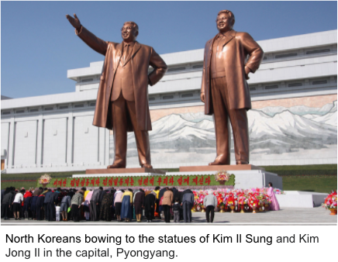  Source: https://commons.wikimedia.org/wiki/File:Mansudae-Monument-Bow-2014.jpg  - Juche ideology demands total obedience and subservience to the leader  - The cult of personality around the Kim family became a program of state rituals  - State media refers to the tomb where Kim Il Sung and Kim Jong Il are interred as the “the sacred temple of juche.”  - In 1997, the Juche calendar was adopted that marks 1912, the year of Kim Il Sung’s birth as Year One. Time was changed to honor the leader.
JUCHE ideal centered on Three Principles
1. IDEOLOGICAL PURITY AND AUTONOMY | 2. ECONOMIC SELF-SUFFICIENCY | 3. MILITARY INDEPENDENCE FROM OUTSIDE POWERS
- Played on racial stereotypes.  - Juche recalls traditional Korean concepts of racial purity to argue against opening to the outside world.  - In North Korea today, people are taught that the first humans emerged in North Korea and their isolation has kept them close to the racial purity of the first men, while the rest of the world has been mongrelized. | - More theory than practice since North Korea depended on large Soviet subsidies throughout most of its history and is now somewhat dependent on support from China | - Paired Marxist language with traditional Korean nationalism, arguing that South Korea was not a legitimate government because it was the tool of the United States and a tool of Korea’s old enemy, the Japanese.

Describe the concept of Juche | How does Juche increase the power of the Kim family?

STUDENT HANDOUT #1:
Pochonbo Electronic Ensemble - My Country Is The Best, Release Date: January 01, 1991
Lalala~
Best is the country that I can call my own!
I’ve seen the exotic flowers bloom in the fields
However, the flowers of my home look better
Looking back on the spacious wide world that we live in
Best is the country that I can call my own!
Lalala~
Best is the country that I can call my own!

I’d drink a cup of water from my foreign friend
But never will it taste sweeter than my country’s
Looking back on the spacious wide world that we live in
Best is the country that I can call my own!
Lalala~
Best is the country that I can call my own!

I love the melody of the song Arirang (traditional folk song)
I’ve sung it everywhere, so far from my home!
Looking back on the spacious wide world that we live in
Best is the country that I can call my own!
Lalala~
Best is the country that I can call my own!

The dear homeland bright under the sun and stars
To it, I came back with the head bowing to it!
Looking back on the spacious wide world that we live in
Best is the country that I can call my own!
Lalala~
Best is the country that I can call my own!
That I can call my own

Pochonbo Electronic Ensemble, Our Comrade Kim Jong-Il, Release Date: January 01, 1994
Ah- ah-
He is our Comrade Kim Jong Il
Under the sky of our happy country
He made the country into a harmonious family
He grew up the people as true brothers
He is our Comrade Kim Jong Il
Ah- our Comrade Kim Jong Il
He always listens to what the people say
He applies their sincere opinions to politics
He calls the people his teachers
And the teacher of teacher is Comrade Kim Jong Il
Ah- ah-
He loves the pеople passionately
He dеvotes his life to serve the people
He believes in the people like the sky
And the sun in that sky is comrade Kim Jong Il
Ah- ah- comrade Kim Jong Il
And the sun in that sky is comrade Kim Jong

Use this graphic organizer to note how these elements of north korean propaganda can be seen in each song
Juche | Kim Leadership

STUDENT READING #1: History of Comics in Korea
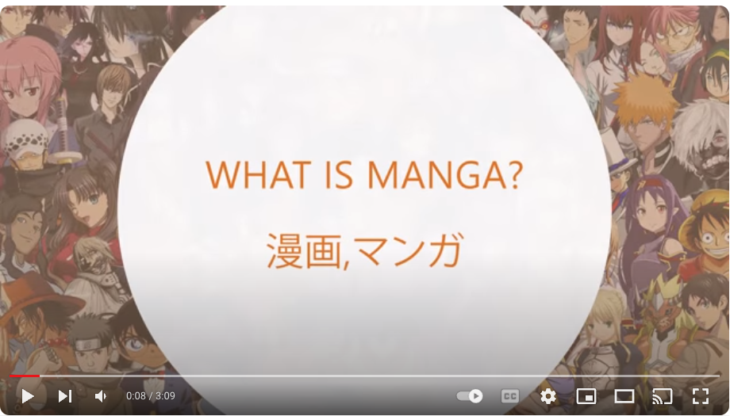

As you watch (image hyperlinked above - web address is https://youtu.be/9ASK-c4WTVI?si=0Kp2Z4ktroQFtG5l ), think about these two questions:
- What is Manga and how does it appeal to young people?
- How might marxist leaders use Manga?

How did Manga get to Korea?

When the Japanese invaded and annexed Korea in 1910, manga were introduced as well. In Korea, comics are referred to as manhwa in the South and as gurimchaek (also spelled kurimch’eak) in the North, which translates to “picture books.” Much like early manga, Korean comics were printed on cheap paper and available in small local corner reading rooms called manhwabangs.These usually told short stories about social and economic struggles and political conflict. Gradually they increased in length, and by the time Japanese occupation ended, they developed into a genre that could support three “manhwa'' newspapers in the 1950s. In the 1950s and 1960s in South Korea,, the manhwabang (literally manhwa or comic room) were popular meeting spots for young people. The comic form of the manhwa continued to be used as vehicles to not only entertain, but subtly critique society at a time when freedom of expression was sometimes curtailed under the Park military regime.

In North Korea, gurimchaek developed into a state-supported and directed medium used by the communist government to educate society chiefly through pictures. Leaders knew the power of images to mold the minds of the people. The second leader of North Korea, Kim Jong Il, discusses their usefulness in his 1991 work, On Fine Art.

The graphic arts presuppose painting. Therefore, they employ condensation [compression of a written or spoken work into more concise form] extensively in their forms and methods of expression. Unlike in other paintings, Condensation in graphic painting, unlike in other paintings, simplifies the representation to intensify the impact. Simple representation is aimed at enhancing the visual sense, so as to bring the essence of the subject matter into the mind of the viewer in an intensive way and make the message appealing. Simplicity of representation and the visual aspect of the work are the important characteristics of the graphic arts. Only when these characteristics are brought into relief can they fulfill their mission and function appropriately. The production of graphic painting should generalize social phenomena to the highest even with simple themes, and thus present a visual representation of the ideological contents of the work in a persuasive form…The power of the poster must manifest itself in stirring up the people’s ideology instantly and encouraging them to undertake positive action. The poster must make its message an occasion for motivating people to action and advance a practical way for them to do so.

Only a timely and highly mobile poster can enable the people to understand the Party’s lines and policies promptly and turn out for the struggle to implement them, and play its role in inspiring the masses to the socially important undertaking under way at the time… Always bearing in mind that a single poster is very powerful in arousing millions of people…In the graphic arts we must direct great efforts to the development of paintings for children so as to produce paintings effectively conducive to their education.
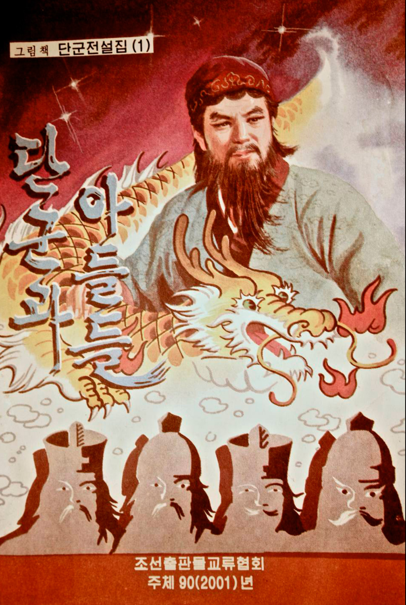
The excerpts above show the power that Kim Jong Il believed images held, referring broadly to them as the graphic arts to shape beliefs and influence actions. Like the more formal Socialist Realism of the Soviet Union, gurimchaek must be created with political ideology in mind, and the artist had to use his or her talents to support the state.

One famous gurimchaek, Dangun, shown to the right from 2001, does this in a less overt way. Dangun was the mythical first king of Korea from the 24th century BCE. This gurimchaek visually depicts the half-god founder of Korea. This might not seem like a tale appropriate to a marxist authoritarian state, but the importance of this myth for the Kim regime is clear. Dangun is believed to be buried in the North, and in fact North Korea claims to have found his tomb outside its capital of Pyongyang. Thus, this gurimchaek links the present North Korean capital Pyongyang, the seat of the Kim family, as the site of this first leader and thus provides legitimacy to the Kim family as the heirs of Korean authority and history.

North Korean gurimchaek like Dangun usually had three common themes or messages. First, the Kims were portrayed as the central feature of life. They are the source of inspiration and even though rarely portrayed directly, symbolically they are dominant. Their philosophy of Juche, or self-reliance, is promoted as the source of North Korea’s strength. It powers their resistance to all enemies and makes North Korea a special place that other societies envy and covet. Juche allows them to fight any enemy and overcome any hardship. In contrast to North Korea, the enemies of the people are the West, particularly the Americans and the Japanese. Visually, the contrast between the depictions of North Koreans and the enemy will be clear in how they both appear and act.

Reading Questions - History of Comics in Korea
Use this graphic organizer to take notes as you read.
What is Manga and how does it appeal to young people?  How might Marxist leaders use Manga? | Describe the history of manhwa in Korea.
What role have comics played in South Korea? | What role have comics played in North Korea?

Describe similarities between North Korean gurimchaek and Socialist Realism.

How are gurimchaek used to support the Kim regime?

STUDENT HANDOUT #2:
The Great General Mighty Wing (1994)
North Korean author: Jo Dyeong-Weon
Art: Lim Wal-Yong
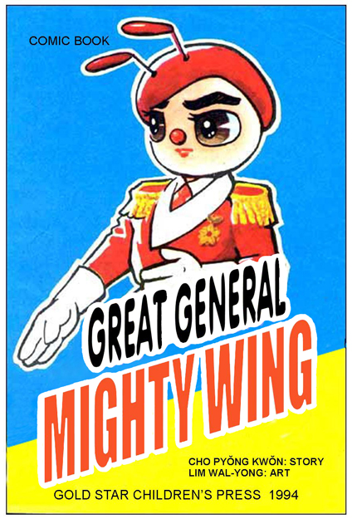
Translated by Heinz Insu Fenkl (permission to use translation by Dr. Fenkl)
This example of North Korean gurimchaek was published in 1994, the same year that the first leader of North Korea, Kim Il Sung, died and the beginning of a four year period of famine and poor economic conditions. These were brought on by a combination of factors that included a severe drought and the earlier 1991 collapse of the Soviet Union, a major patron of North Korea. Propaganda like The Great General Mighty Wing was used to distract the population from their suffering and to provide a counter explanation for the problems of the nation. In general, each issue of the comic pits the Bees, led by their Queen and their champion General Mighty Wing, against the Wasps and their allies who covet the Bees’ kingdom, the Garden of One Thousand Flowers. The Wasps plot and conspire, while the Bees work together under the wise guidance of the Queen, to make their kingdom more secure and beneficial to all who live there.
How does this gurimchaek reflect the North Korean Socialist Realist message
of an infallible leader, imperialist enemies, and juche?

As you read, pay attention to these symbolic representations and think about the choices the authors make to characterize some groups as certain animals. Why honeybees for North Korea, and why wasps for the Americans and Japanese?  Also, think about how the use of animals is particularly meaningful for propaganda aimed at children. | Honeybees = the North Koreans | Queen = Great Leader Kim Il Sung
 | 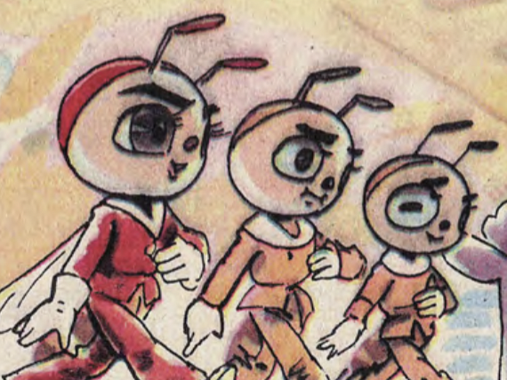 | 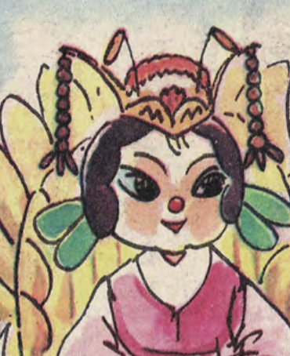
Garden of 1000 Flowers = North Korea | Wasps = the Americans & Japanese | Spiders = the United Nations
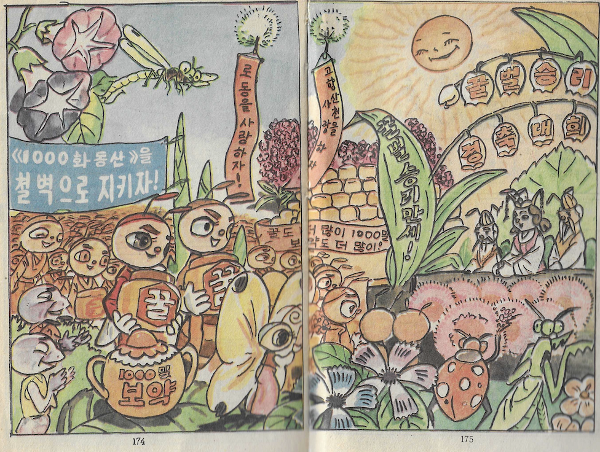 | 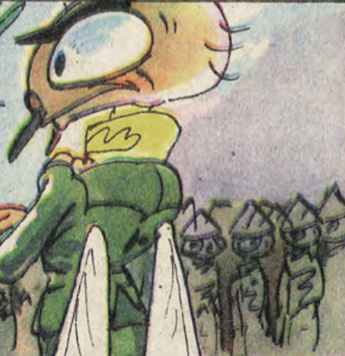 | 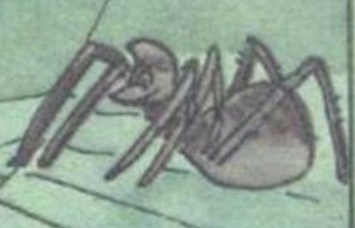

FRAMES 1/2
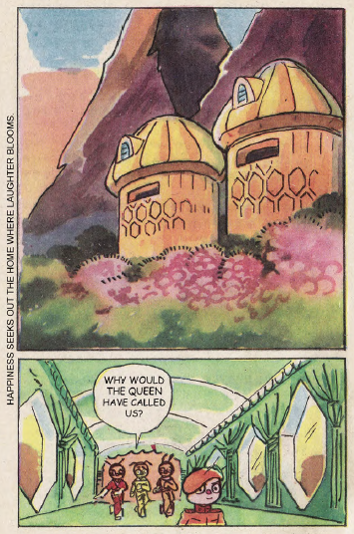 | 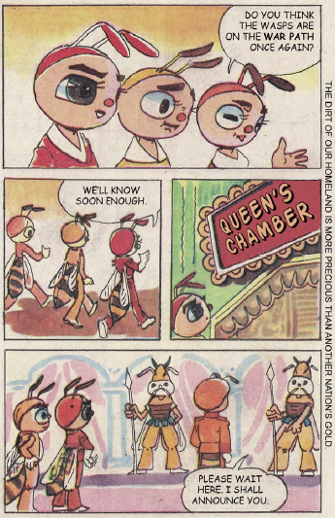

How does this gurimchaek reflect the North Korean Socialist Realist message

of an infallible leader, imperialist enemies, and juche?
North Korean Message | Evidence in the Comic  (not all messages in every comic frame)
Infallible Leader
Imperialist Enemies
Juche

FRAMES 3/4
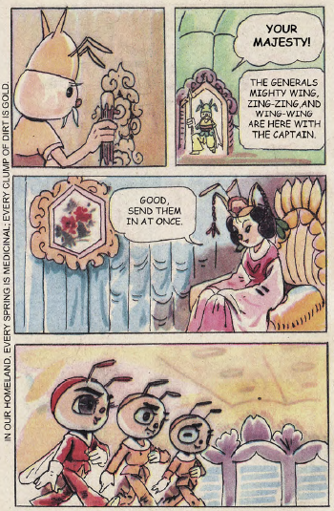 | 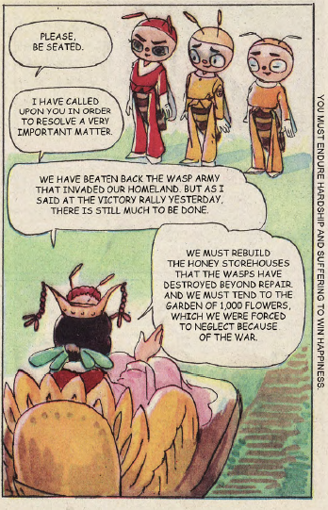

How does this gurimchaek reflect the North Korean Socialist Realist message

of an infallible leader, imperialist enemies, and juche?
North Korean Message | Evidence in the Comic  (not all messages in every comic frame)
Infallible Leader
Imperialist Enemies
Juche

FRAMES 5/6
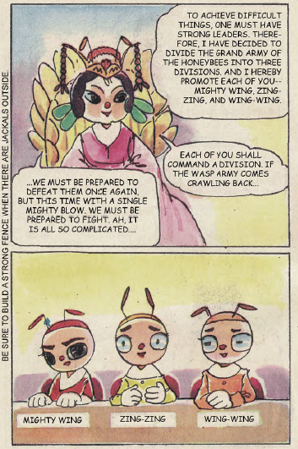 | 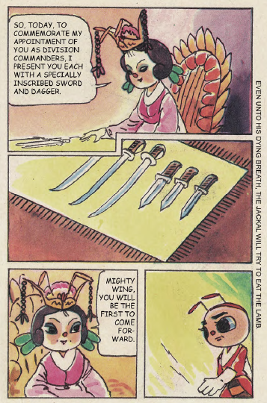

How does this gurimchaek reflect the North Korean Socialist Realist message

of an infallible leader, imperialist enemies, and juche?
North Korean Message | Evidence in the Comic  (not all messages in every comic frame)
Infallible Leader
Imperialist Enemies
Juche

FRAMES 7/8
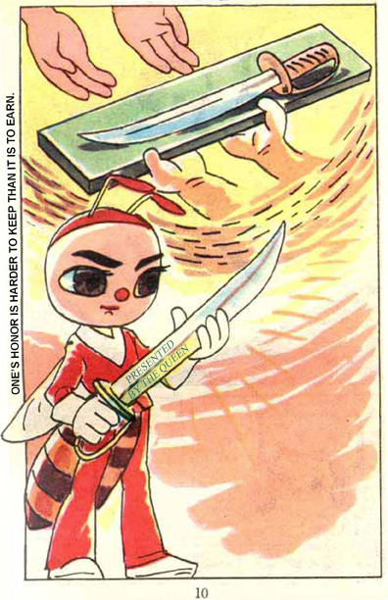 | 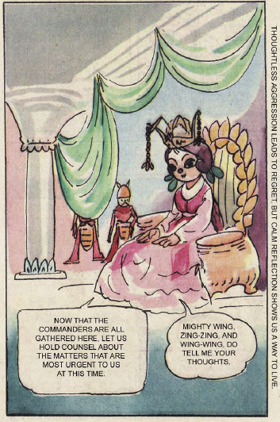

How does this gurimchaek reflect the North Korean Socialist Realist message

of an infallible leader, imperialist enemies, and juche?
North Korean Message | Evidence in the Comic  (not all messages in every comic frame)
Infallible Leader
Imperialist Enemies
Juche

FRAMES 9/10
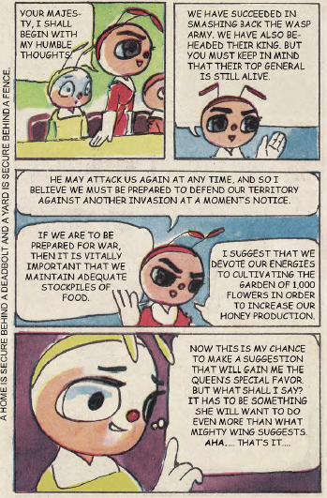 | 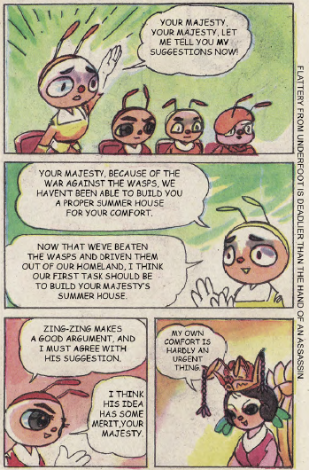

How does this gurimchaek reflect the North Korean Socialist Realist message

of an infallible leader, imperialist enemies, and juche?
North Korean Message | Evidence in the Comic  (not all messages in every comic frame)
Infallible Leader
Imperialist Enemies
Juche

FRAMES 11/12
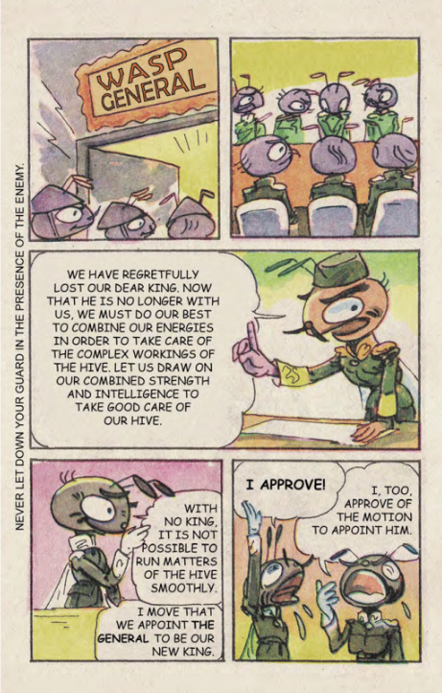 | 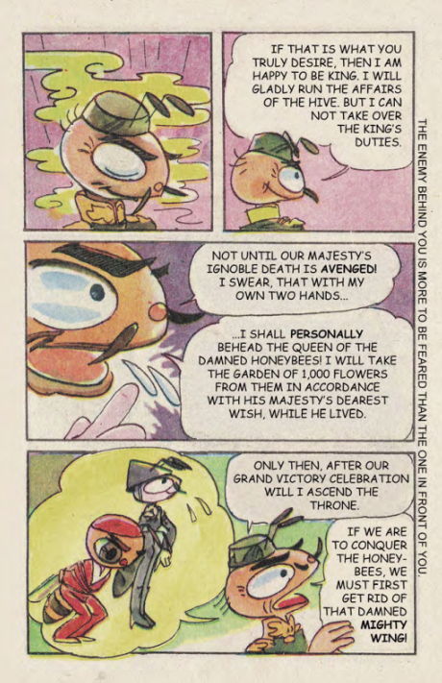

How does this gurimchaek reflect the North Korean Socialist Realist message

of an infallible leader, imperialist enemies, and juche?
North Korean Message | Evidence in the Comic  (not all messages in every comic frame)
Infallible Leader
Imperialist Enemies
Juche

FRAMES 13/14
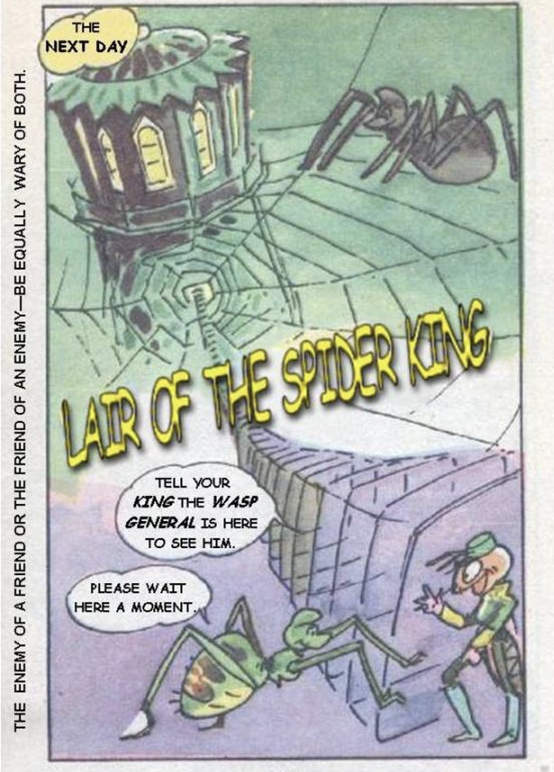 | 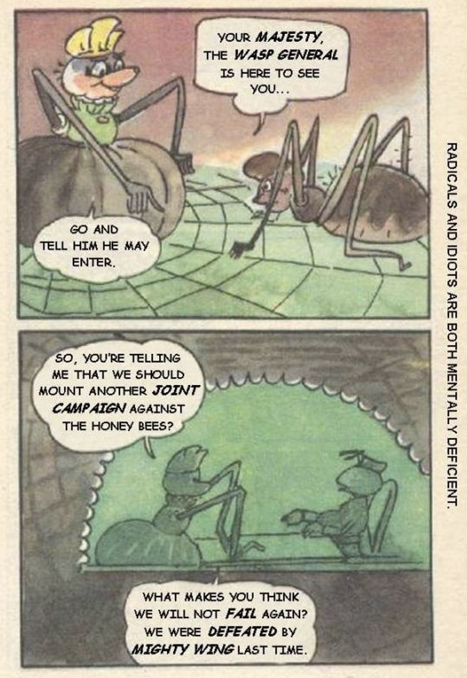

How does this gurimchaek reflect the North Korean Socialist Realist message

of an infallible leader, imperialist enemies, and juche?
North Korean Message | Evidence in the Comic  (not all messages in every comic frame)
Infallible Leader
Imperialist Enemies
Juche

FRAMES 15/16
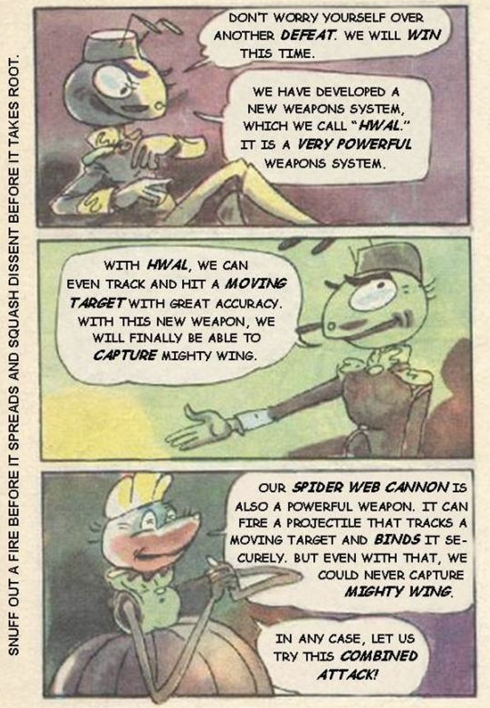 | 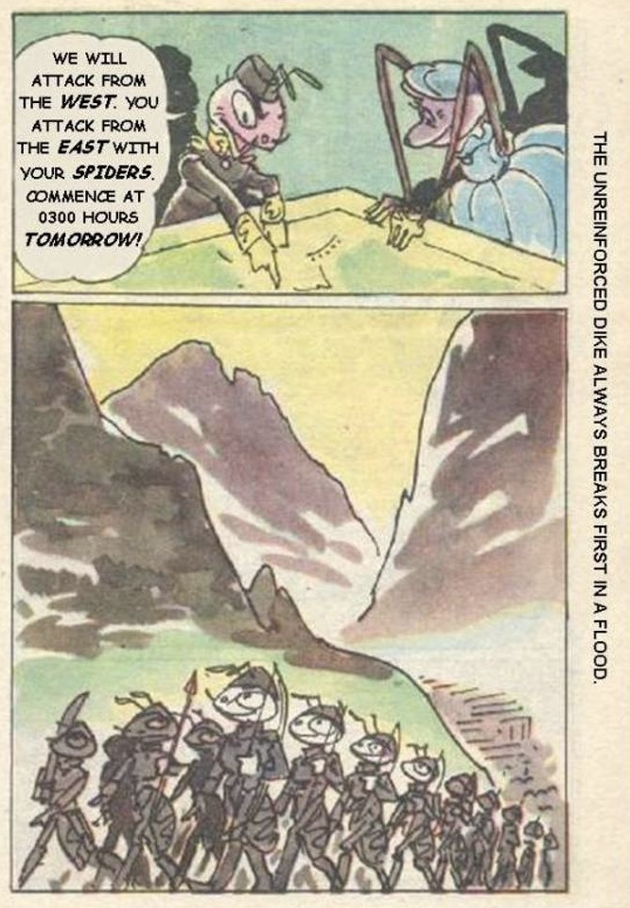

How does this gurimchaek reflect the North Korean Socialist Realist message

of an infallible leader, imperialist enemies, and juche?
North Korean Message | Evidence in the Comic  (not all messages in every comic frame)
Infallible Leader
Imperialist Enemies
Juche

TEACHER KEYS

KEY - The North Korean Concept of Juche Reading

Describe the concept of Juche | How does Juche increase the power of the Kim family?
- Literal translation - self-reliance  - Blends Marxism with Confucianism and traditional nationalism  - North Korea must by separate and independent from the rest of the world  - Emphasizes North Korean purity, economic self-sufficiency, and military independence  - Korean Nationalism emphasizing North Korean independence contrasted with South Korean subservience to the Japanese and Americans  - Isolation as a means of maintaining Korean racial purity | - The concept of soryong - the Great Leader, Dear Leader and Great General - the indispensable and truly correct Confucian leader needed to guide the nation  - To maintain self-reliance, ritual obedience and subservience to the leader is seen as necessary component

KEY - SONG LYRIC ANALYSIS - STUDENT HANDOUT #1:
Pochonbo Electronic Ensemble - My Country Is The Best Release Date: January 01, 1991
Lalala~
Best is the country that I can call my own!
I’ve seen the exotic flowers bloom in the fields
However, the flowers of my home look better
Looking back on the spacious wide world that we live in
Best is the country that I can call my own!
Lalala~
Best is the country that I can call my own!

I’d drink a cup of water from my foreign friend
But never will it taste sweeter than my country’s
Looking back on the spacious wide world that we live in
Best is the country that I can call my own!
Lalala~
Best is the country that I can call my own!

I love the melody of the song Arirang
I’ve sung it everywhere, so far from my home!
Looking back on the spacious wide world that we live in
Best is the country that I can call my own!
Lalala~
Best is the country that I can call my own!

The dear homeland bright under the sun and stars
To it, I came back with the head bowing to it!
Looking back on the spacious wide world that we live in
Best is the country that I can call my own!
Lalala~
Best is the country that I can call my own!
That I can call my own

Pochonbo Electronic Ensemble, Our Comrade Kim Jong-Il, Release Date: January 01, 1994
Ah- ah-
He is our Comrade Kim Jong Il
Under the sky of our happy country
He made the country into a harmonious family
He grew up the people as true brothers
He is our Comrade Kim Jong Il
Ah- our Comrade Kim Jong Il
He always listens to what the people say
He applies their sincere opinions to politics
He calls the people his teachers
And the teacher of teacher is Comrade Kim Jong Il
Ah- ah-
He loves the pеople passionately
He dеvotes his life to serve the people
He believes in the people like the sky
And the sun in that sky is comrade Kim Jong Il
Ah- ah- comrade Kim Jong Il
And the sun in that sky is comrade Kim Jong

Use this graphic organizer to note how these elements of north korean propaganda can be seen in each song
Juche | Kim Leadership
My Country is the Best  - Flowers look better, water tastes better, traditional folk songs can be sung anywhere  - “Best is the country I call my own” | Our Comrade Kim Jong-il  - Made the country a family  - People are his true brothers  - Listens to and loves the people  - Teaches the people and is taught by them  - Devotes his life to the people  - He is the Sun in the sky

KEY - READING QUESTIONS - History of Comics in Korea
Use this graphic organizer to take notes as you view and read.
What is Manga and how does it appeal to young people?  How might marxist leaders use Manga? | Describe the history of manhwa in Korea.
- Manga = whimsical pictures  - Derived from panel illustrations in Japan beginning in 1798  - Many genres and topics to appeal to all interests  - Depicts movement and action which appeals that correspond to japanese sound words  - Uses film techniques to place reader in the action  - Answers will vary, but should say something around using manga as propaganda aimed at the young to support the state | - Japanese manga introduced with invasion in 1910  - Manhwa (South Korea) and gurimchaek (North Korea) that told short stories about political conflict and economic struggles.  - Become more popular after Japanese occupation ends, developing into a genre with newspapers in the 1950s
What role have comics played in South Korea? | What role have comics played in North Korea?
- Manhwabangs were local small reading rooms that become popular meeting spots for young people  - Used as vehicles to express discontent with society especially during the Park regime | - Used by the state to educate the young as images were seen as more impactful than words

Describe similarities between North Korean gurimchaek and Socialist Realism.
- Created with political ideology in mind and the artist has a duty to use his or her talent to support the state

How are gurimchaek used to support the Kim regime?
- Portray Kims as central feature of life as a source of inspiration
- Connects the Kim family to the legendary founding of Korea through use of mythological stories
- Kim philosophy of Juche is taught through the comics as key source of strength

KEY STUDENT HANDOUT #2

How does this gurimchaek reflect the North Korean Socialist Realist message

of an infallible leader, imperialist enemies, and juche?
FRAMES 1/2 | - Uniform homes in first frame surrounded by flowers and greenery could be sign of Juche or self-sufficiency and prosperity  - A queen summoning the three honeybees and those guarding her could allude to the “leader”  - The sayings along the edges both allude to a prosperous homeland thus invoking the idea of Juche
FRAMES 3/4 | - The WASP army is the imperialist enemy that was defeated (this defeat might be an allusion to the Korean War and the unsuccessful invasion by UN forces that was pushed back to the 38th parallel)  - The Garden of 1000 Flowers and calls to tend it could be seen as Juche by emphasizing the need to pay attention to internal improvements  - References to the homeland in the sayings along the frame, and the wealth and riches contained within the homeland invoke Juche as the streams and even the dirt are valuable
FRAMES 5/6 | - References to be prepared for another battle with the WASPs is Juche, being prepared, and alludes to the need to be constant against plotting imperialist enemies  - The pomp and ceremony of the Queen, along with her wise admonitions to always prepare for war, allude to the infallible leader  - The sayings along the border and references to defending against jackals reflect the need to be vigilant against an ever present imperialist enemy
FRAMES 7/8 | - The generosity of the Queen and the duty of the bee Mighty Wing to serve her and maintain to his honor (discussed in the saying) shows the devotion to the infallible leader  - The Queen seeking counsel from her generals also lends itself to the wisdom of the infallible leader
FRAMES 9/10 | - Preparedness to defend against attack shows Juche, as does the saying about deadbolts and fences as signs of security  - Desire to build the Queen a summer house, and Mighty Wings agreement to the plan, shows the desire to serve the needs of the leader  - The Queens refusal of the plan for her comfort shows her wisdom in the face of those who attempt to flatter
FRAMES 11/12 | - The general is put in charge, showing the enemy is controlled by the army  - The imperialist enemy is plotting invasion, discusses beheading the honeybee queen, and takes the garden of 1000 Flowers  - Images show sickly green around the general and images of Mighty Wing bound
FRAMES 13/14 | - The imperialist enemy plots with others; this could also emphasize the need for Juche as the idea of being surrounding by others plotting against you requires self-reliance  - The spider web symbolize the plotting and desire to trap the bees  - Since the spiders represent the United Nations and the WASPS the United States, the conversation about another “joint campaign” is alluding to the first campaign as the UN support for the Korean War
FRAMES 15/16 | - The imperialist enemy is developing new weapons to defeat the bees

