MODULE OVERVIEW
SKILLS: Spatial Relationships, Data Analysis, Source Analysis | CONTENT: Political & Cultural Geography

D A Y 1 | LESSON QUESTION: Which factors act as centripetal and/or centrifugal forces within a country?
D A Y 1 | CLASS ACTIVITY: Understanding Centripetal and Centrifugal Forces at the Country Scale  Students will examine centripetal and centrifugal forces within the United States by examining a series of sources and utilizing a continuum to represent the degree to which the information from each source is divisive or unifying. Students will then use a SPEED (social, political, economic, environmental, demographic) chart to group sources into different factors and synthesize the sources for each factor.
D A Y 1 | CHECK FOR UNDERSTANDING: Exit Ticket  Students will use their understanding of centripetal and centrifugal forces to explain why the United States remains a unified country, providing evidence to support their assertion.

D A Y 2 | LESSON QUESTION: Why is the Korean peninsula divided and what challenges exist for unification?
D A Y 2 | CLASS ACTIVITY: Examining Centripetal and Centrifugal Forces at a Different Scale  Working in teams, students will use their understanding of centripetal and centrifugal forces to examine how physical and cultural characteristics promote or inhibit unity beyond the state level. As they examine sources students will determine why and how the source demonstrates a centripetal and/or centrifugal force within the Korean Peninsula.
D A Y 2 | CHECK FOR UNDERSTANDING: Exit Ticket  Students will identify and explain a centrifugal and centripetal force they find most compelling. Students will also evaluate the degree to which they believe the Korean Peninsula will face continued division or future unity.

 | ASSESSMENT
 | Using their understanding of centripetal and centrifugal forces as well as dynamics within Korea, students will take a position on a unified Korea.

D A Y 1
Based on a 60-minute class

Lesson Question: Which factors act as centripetal and/or centrifugal forces within a country?

Curriculum reference
National Geography Standards: Geography for Life
Geography Standard 13: How the forces of cooperation and conflict among people influence the division and control of Earth's surface
1. The functions and consequences of territorial divisions
2. Cooperation between countries and organizations may have lasting influences on past, present, and future global issues
3. Changes within, between, and among countries regarding division and control of Earth's surface may result in conflicts

AP Human Geography
PSO-3.D.2 Language, ethnicity, and religion are factors in creating centripetal and centrifugal forces.
SPS-4.C.1 Centrifugal forces may lead to failed states, uneven development, stateless nations, and ethnic nationalist movements.
SPS-4.C.2 Centripetal forces can lead to ethnonationalism, more equitable infrastructure development, and increased cultural cohesion.

Geography Skills: Spatial Relationships, Data Analysis, Source Analysis

OVERVIEW
Students will examine centripetal and centrifugal forces within the United States by examining a series of sources and utilizing a continuum to represent the degree to which the information from each source is divisive or unifying. Students will then use a SPEED (social, political, economic, environmental, demographic) chart to group sources into different factors and synthesize the sources for each factor.

Materials needed:
- Source Packet
- Student Handout 1
- Student Handout 2
- Exit Ticket

SEQUENCE OF INSTRUCTION

CLASS ACTIVITY: WARM UP/INTRODUCTION
WARM UP/INTRODUCTION (10 MINUTES): Introducing Centripetal and Centrifugal Forces

ACTIVITY 1:
- Students will be introduced to centripetal and centrifugal forces, key concepts in political geography.
- Pose the question “What makes a country remain together?” Have students first answer individually by writing their response and then, using a whip around (an instructional strategy designed to call on each student around the room to ensure a response from every student), brainstorm a class list of responses.
- Explain that what they have identified are UNIFYING forces. Forces that unify a state are also known as centripetal forces.
- Next ask students “What are some things that cause disunity or division within a country?” Have students first answer individually by writing their response and then, using a whip around, brainstorm a class list of responses.
- Explain that these forces are DIVISIVE forces and are also known as centrifugal forces.
- All countries have both centripetal and centrifugal forces, and today students will explore some of them by looking at the United States.

Teaching Tip

Sometimes students will find it easy to mix up the terms “centripetal” and “centrifugal.” A memory tip is to focus on the “pe” in “centripetal.” PE can stand for “peaceful existence.” If a country has a peaceful existence, then it would suggest that there are unifying forces. For centrifugal focus on the “f”, which can stand for “fight!” If there is fighting within the country, it suggests that there are divisive forces.

CLASS ACTIVITY PART 1:
CLASS ACTIVITY (30 MINUTES): APPLYING CENTRIPETAL AND CENTRIFUGAL FORCES TO THE UNITED STATES

ACTIVITY 1:
- Students will explore different sources for the degree to which they represent a centrifugal or centripetal force within the United States.
- Place students in teams of three to five.
- Distribute the Source Packet and Student Handout 1 to students.
- Examine the first source and completed example on the handout as a class to be sure students understand the task.
- Once students have analyzed and reflected on each source in their team, they should use their analysis and reflection, along with their background knowledge of the United States, to answer the question: What other sources could be useful for determining centrifugal and centripetal forces in the United States? WHY?
- Debrief any challenging sources at the end of the activity. Also consider debriefing any sources that have very different but valid interpretations. For example, source two shows median household income within the United States. The fact that median income varies state to state could be viewed as a centrifugal force, but the overall high median income of the United States could be seen as a centripetal force. The key is students taking a position and supporting their position using a sound understanding of centripetal and centrifugal forces.

Teaching Tip
There are ten sources, counting the one used as an example. You may wish to assign specific sources to specific students for them to take the lead on those sources within their groups. If so, groups of three are recommended with three sources assigned to each student.

CLASS ACTIVITY PART 2:
CLASS ACTIVITY (15 MINUTES): Classifying Factors of Centripetal and Centrifugal Forces

ACTIVITY 1:
- Students will deepen their understanding of centripetal and centrifugal forces as they consider the primary topic of each source and come up with a synthesizing/summary statement.
- Organize students In teams of three to five.
- Distribute and have students complete Student Handout 2
- Explain that students should first classify the sources in the Source Packet as Social, Political, Economic, Environmental, or Demographic. Some sources may be classified in more than one category.
- If students aren’t familiar with the different factors, then have a brief class discussion defining the different factors.
  - Social= Relating to human society, culture, and how we organize ourselves.
  - Political= Relating to the government, public affairs, and electoral system of an area.
  - Economic= Relating to money or finances within an area.
  - Environmental= Relating to the natural world and its impact on society and society’s impact on the natural world.
  - Demographic= Relating to the age, sex, ethnic, etc. composition of a population within an area.
- Once students have classified the sources into the different factor categories, then students should write a synthesizing statement about the factor overall. For example, the United States seems to have a mix of political centripetal and centrifugal forces because, while we are united by symbols such as the flag and support of national teams, there are also a lot of political disagreements.

CLASS ACTIVITY PART 3:
CLASS ACTIVITY (5 MINUTES): Check for Understanding

ACTIVITY 1:
Have students complete the Exit Ticket to display their understanding of centripetal and centrifugal forces to explain why the United States remains a unified country, providing evidence to support their assertion.

IN-CLASS ACTIVITY MATERIALS
SOURCE PACKET
Directions: Use the following sources to complete the student activities.
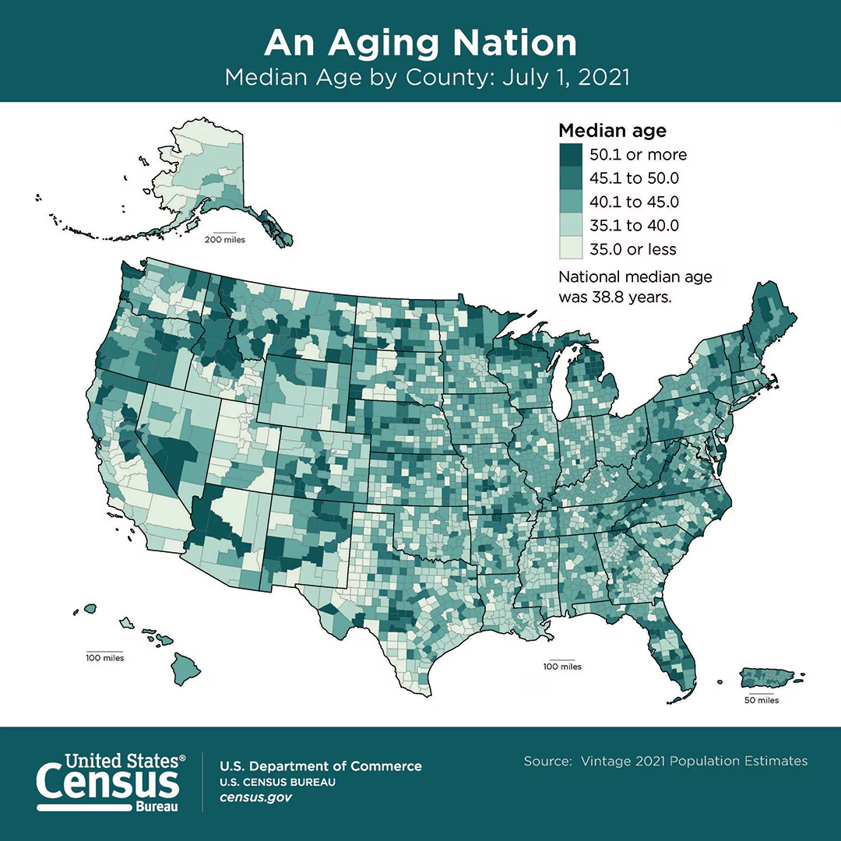
Source 1: Median Age by County

Source: https://www.census.gov/content/dam/Census/library/visualizations/2022/comm/county-median-age.jpg

Source 2: 2020 Presidential Election Map
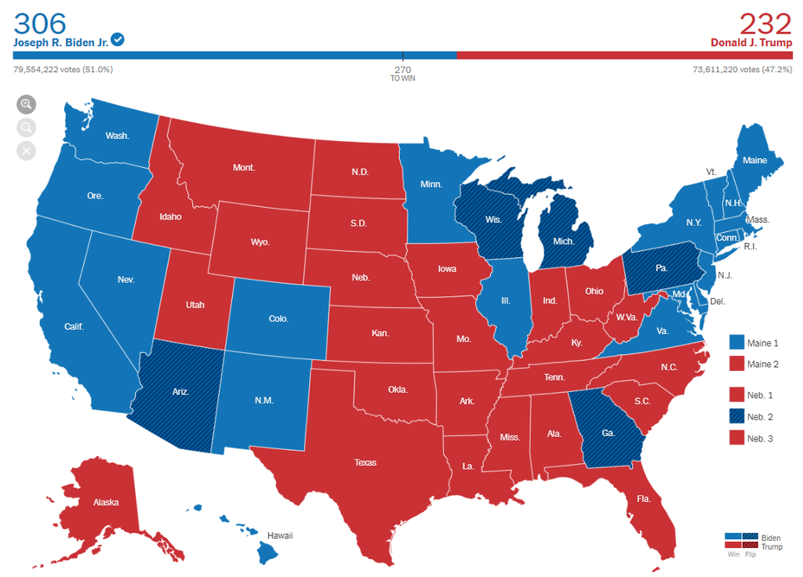
https://www.nytimes.com/2020/11/19/learning/whats-going-on-in-this-graph-2020-presidential-election-maps.html

Source 3: Religious Groups in the United States
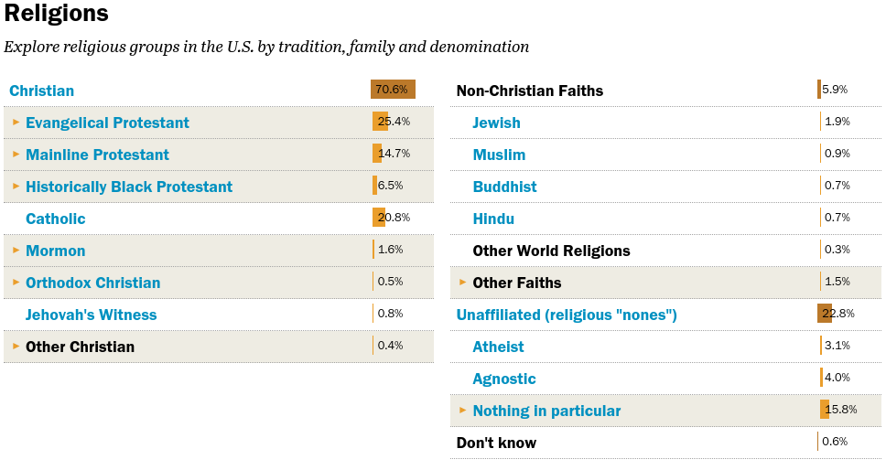
https://www.pewforum.org/religious-landscape-study/

Source 4: Climate Types of the United States
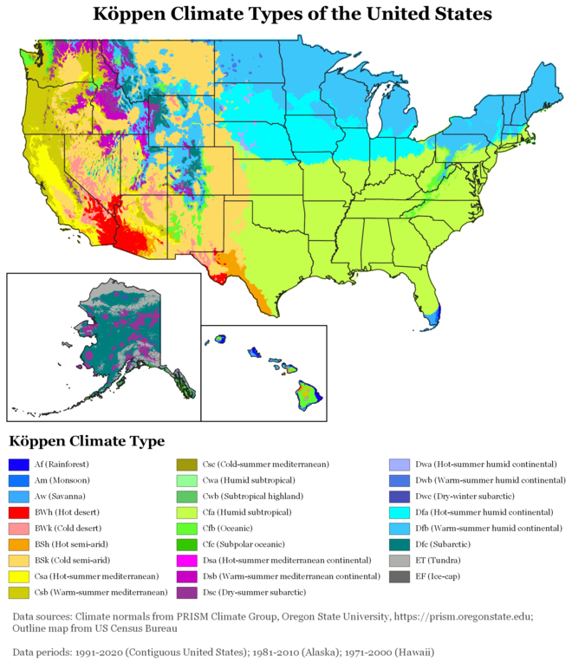
https://upload.wikimedia.org/wikipedia/commons/thumb/7/77/K%C3%B6ppen_Climate_Types_US_50.png/675px-K%C3%B6ppen_Climate_Types_US_50.png

Source 5 : U.S. Flag Waving

https://commons.wikimedia.org/wiki/File:American_Flag_Waving_on_a_Flag_Pole.jpg

Source 6: Median Household Income By State, 2021
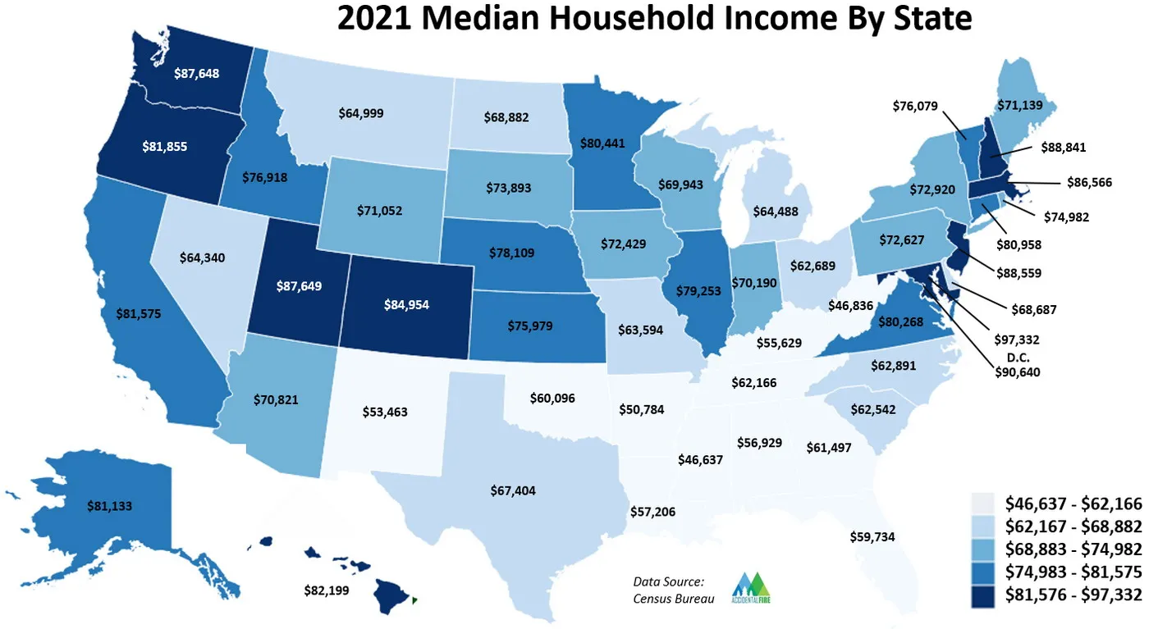
Source: https://i0.wp.com/accidentalfire.com/wp-content/uploads/2022/09/median-income-2021-labeled.jpg?w=1400&ssl=1

Source 7: Most Spoken Languages Among Citizens of the United States
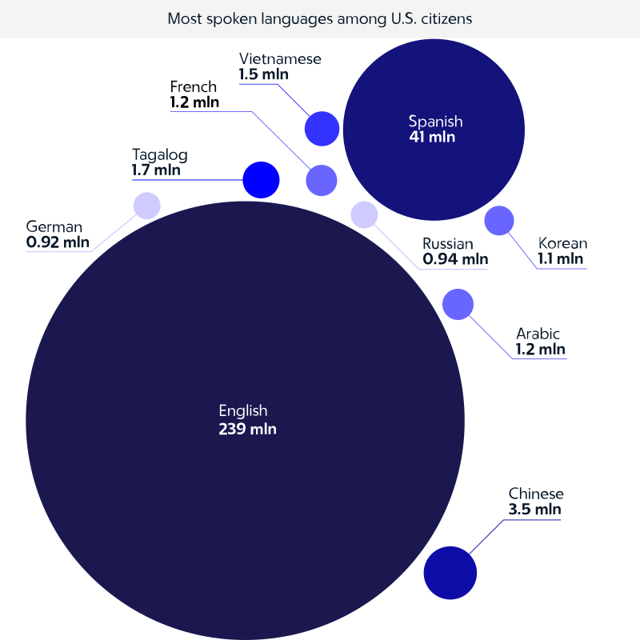
https://en.wikipedia.org/wiki/Languages_of_the_United_States#/media/File:Languages_cp-02.svg

Source 8: Topographical Map of the United States
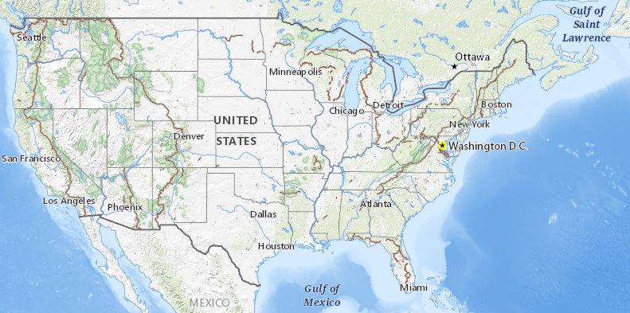
https://apps.nationalmap.gov/viewer/

Source 9: USA Baseball Olympic Team hosts North Carolina National Guard Soldiers

The USA Baseball Olympic Team hosts North Carolina National Guard Soldiers at the USA Baseball National Training Complex in Cary, North Carolina, July 18, 2021. During a ceremony before the game began between USA Baseball and a visiting team of U.S. college all-stars, the soldiers gave each member of the team a flag from their uniform for the baseball players to take to the Tokyo Games later this month. (U.S. Army National Guard photo by Robert Jordan/Released)
https://commons.wikimedia.org/wiki/File:USA_Baseball_Olympic_Team_Hosts_NC_Guard_Soldiers_(6738257).jpg

Source 10: Highway System Map

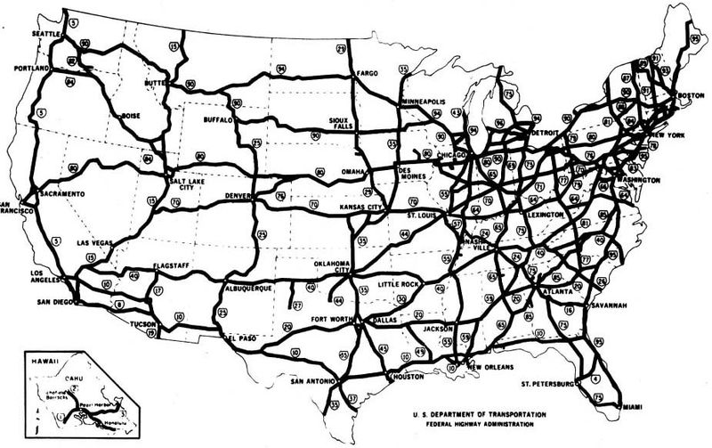
https://commons.wikimedia.org/wiki/File:Interstate_Highway_System_Map.jpg

Student Handout 1
For each stimulus, use an “X” to mark whether it provides evidence of division or unity on the continuum. Explain the placement of your mark.
Centrifugal Force-
Division
Centripetal Force-
Unity
✘

Explanation:
I placed the X closer to the centripetal force side because although the median age varies from county to county within the United States, overall the entire country is dealing with an aging population. The title of the map “An Aging Nation” helps illustrate the unifying characteristic of this demographic challenge.
Centrifugal Force-
Division
Centripetal Force-
Unity
Explanation:
Centrifugal Force-
Division
Centripetal Force-
Unity
Explanation:
Centrifugal Force-
Division
Centripetal Force-
Unity
Explanation:
Centrifugal Force-
Division
Centripetal Force-
Unity
Explanation:
Centrifugal Force-
Division
Centripetal Force-
Unity
Explanation:
Centrifugal Force-
Division
Centripetal Force-
Unity
Explanation:

Centrifugal Force-
Division
Centripetal Force-
Unity
Explanation:

Centrifugal Force-
Division
Centripetal Force-
Unity
Explanation:
Centrifugal Force-
Division
Centripetal Force-
Unity
Explanation:

What other sources could be useful for determining centrifugal and centripetal forces in the United States? WHY?

STUDENT HANDOUT 2
Directions:
- Classify the different sources from the source packet as social, political, economic, environmental, or demographic. You may use more than one category for a source.
- Once you have classified the sources, craft a synthesizing statement that summarizes what you see overall in terms of centripetal and centrifugal forces for that factor. In addition to the sources in the source packet, you may also consider other background information you may know.
FACTOR | SOURCES | SYNTHESIZING STATEMENT
Social
Political
Economic
Environmental
Demographic

Exit Ticket
Using your understanding of centripetal and centrifugal forces, explain why the United States remains a unified country despite having some centrifugal forces. Provide evidence from the sources to support your answer.

Centrifugal Forces- Division
Centripetal Forces-
Unity

TEACHER NOTES/SAMPLE RESPONSES
NOTE: There are MANY possible justifications and even positions regarding centripetal and centrifugal forces. The key is students supporting their reasoning.
FACTOR | SOURCES | SYNTHESIZING STATEMENT
Social | Source 6 (religious groups); Source 7 (languages); Source 9 (baseball) | Overall, centrifugal forces are present in terms of social aspects of the United States.  Sources 6 and 7 show that there is a lot of variety of backgrounds in the U.S. which makes it seem as though centrifugal forces are prominent, but Source 9 illuminates that those differences are often set aside for unifying social traditions such as baseball.
Political | Source 3 (presidential election); Source 5 (flag) | Overall, centrifugal forces are present in terms of political aspects of the United States.  Despite Source 5 showing that people in the United States are unified behind common political symbols, the presidential election map (Source 3) and responses to the flag (e.g., standing or not for national anthem) present a more divided United States.
Economic | Source 2 (median household income); Source 10 (highway) | Overall, a strong economy and infrastructure create centripetal forces in the United States.  Despite Source 2 showing variation in median incomes in the United States, overall incomes (compared with the world) are high, which helps act as a unifying force. Also, the infrastructure of the United States is well-developed, allowing even outlying rural areas to be relatively well-connected with urban core areas.
Environmental | Source 4 (climate map); Source 8 (topographical map) | Overall, environmental factors act more as centrifugal forces within the United States.  Source 4 and Source 8 show there is variation in climate types and topography. Furthermore, the United States is physically divided, with Alaska and Hawaii being physically very separate from the mainland United States.
Demographic | Source 1 (aging nation); source 2 (median household income) | Overall, demographic factors act as centripetal forces within the United States.  Sources 1 and 2 show there is variation, but overall more similarities than differences in demographic situations across the United States. The United States has an aging population with relatively high median incomes, and while ages and incomes do vary, the overall trend is such that it should act as a unifying force in the country. Gender could also be considered as a demographic factor not represented in the sources, and although there are still gender gaps in pay,males and females enjoy relative equality within the United States.

