MODULE OVERVIEW
SKILL: Apply Political Concepts/Processes; Source Analysis, Evaluations | CONTENT: Political and Civic Participation

D A Y 1 | LESSON QUESTION: What are the signs of a Totalitarian State?
D A Y 1 | CLASS ACTIVITY: Source Analysis  While working collaboratively, students will define "totalitarian government" and learn about its core characteristics. Students will work individually and in teams to analyze videos to identify the different ways totalitarian leaders manipulate a society to gain control through the story of a fictional state.
D A Y 1 | CHECK FOR UNDERSTANDING: Assessing a Totalitarian State  Students will use their understanding of the characteristics of a totalitarian leader to assess and rank the characteristics that pose the greatest threat to society.

D A Y 2 | LESSON QUESTION: To what extent is North Korea a totalitarian state?
D A Y 2 | CLASS ACTIVITY: Potential Totalitarianism in North Korea & its Impact on Citizens  Working individually and in teams, students will use their expanded understanding of totalitarianism to apply it to the context of North Korea, examining the extent to which the Kim family uses appeals to Extreme Nationalism, National Emergencies and Scapegoating, Government Control of Media and Technology, Propaganda and Cult of Personality, Bribery and Kickbacks, and Force and Violence to control North Korea. Through a variety of sources, students will investigate and assess North Korean totalitarianism. Students will also watch North Korean defector videos as another way to assess totalitarianism in North Korea.
D A Y 2 | CHECK FOR UNDERSTANDING: Exit Ticket  Students will use the information from primary sources and videos of defectors from North Korea to assess totalitarianism in North Korea and its impact on the individuals who live there. Hearing the voices and stories of defectors provides a unique opportunity to reflect on the state and how lives have been affected by the government.

 | ASSESSMENT: What is an effective policy to shape US-North Korean relations?
 | In light of their analysis of North Korea as a totalitarian state, students will craft a policy recommendation to the President of the United States that will guide US-North Korean relations.
D A Y 1
Based on a 60-minute class

Lesson Question: What are the signs of a totalitarian state?

Curriculum Standards
Texas - Texas Essential Knowledge and Skills High School Government Course
13 Citizenship - The student understands the difference between personal and civic responsibilities. The student is expected to:
(A) describe scenarios where good citizenship may require the subordination of personal desire for the sake of the public good;
(B) explain the responsibilities, duties, and obligations of citizenship such as being well informed about civic affairs, serving in the military, voting, serving on a jury, observing the laws, paying taxes, and serving the public good.

New York: New York State Social Studies K-12 Framework
12.G4 POLITICAL AND CIVIC PARTICIPATION: There are numerous avenues for engagement
in the political process, from exercising the power of the vote, to affiliating with political parties, to engaging in other forms of civic participation. Citizens leverage both electoral and non-electoral means to participate in the political process.
12.G4c In addition to voting, there are many ways in which citizens can participate in the electoral process. These include joining a political organization, donating money, and doing volunteer work on a political campaign.
12.G4e Citizens participate in civic life through volunteerism and advocacy, including efforts such as contacting elected officials, signing/organizing petitions, protesting, canvassing, and participating in/organizing boycotts.
California: History Social Science Content Standards
12.3 Students evaluate and take and defend positions on what the fundamental values and principles of civil society are (i.e., the autonomous sphere of voluntary personal, social, and economic relations that are not part of government), their interdependence, and the meaning and importance of those values and principles for a free society.
1. Explain how civil society provides opportunities for individuals to associate for social, cultural, religious, economic, and political purposes.
2. Explain how civil society makes it possible for people, individually or in association with others, to bring their influence to bear on government in ways other than voting and elections.

Civics Skills: Apply Political Concepts and Processes; Source Analysis

OVERVIEW
While working collaboratively, students will define "totalitarian government" and learn about its core characteristics. After connecting prior knowledge on this topic, students will work individually or in teams to analyze videos and explore the different ways totalitarian leaders manipulate a society to gain control. This builds students' understanding and establishes a foundation to analyze the extent to which totalitarianism is a part of North Korea, a focus of the second day.

MATERIALS NEEDED:
- Video of Adolf Hitler at a Nazi Party Rally (YouTube)
- Student Handout: Video 1 Transcript: Warning Signs of Totalitarianism
- Student Handout: Video 1 Worksheet: Warning Signs of Totalitarianism
- Student Handout: Signs of a Totalitarian State in a Classroom/School
- Student Handout: Video 2 Transcript: The Warning Signs of Totalitarianism Today
- Student Handout: Video 2 Worksheet: Assessing Totalitarian States Today
- Student Handout: Exit Ticket: Ranking the Warning Signs of Totalitarianism
- Teacher Addendum: Connections the Study of Totalitarianism to the English Language Arts classroom


Teaching Tip: The Importance of Context
Setting the pedagogical stage before you begin this module…

We learn best when there are connections to previous knowledge. Given this, it is recommended to teach these lessons before–or in concert–with the following topics. This can create natural segues and context that will allow students to learn new material in this module. Since the three days of this module focus on the warning signs of totalitarianism, the following historical content may provide a connection that allow your students to better absorb the material you’ll be sharing with them:
- The rise of Nazi Germany, fascism in Italy, Stalin’s control over the Soviet Union, or Mao's control in Communist China.
- An exploration of the three branches of government–especially after examining the importance of checks and balances.
- Reading the Federalist Papers on the abuse of power.
- The Korean War (1950-1953), setting the stage for the growth of the North Korean totalitarian state.
- The rise to power of Julius Caesar in the classical world.
- The Age of Absolutism (1550-1800).
- How institutions consolidate and legitimize authority.

SEQUENCE OF INSTRUCTION:

CLASS ACTIVITY 1 of 5: WARM UP/INTRODUCTION (10 Minutes)
What are the signs of a Totalitarian State?

ACTIVITY PROCEDURE: Using Their Prior Knowledge on the Subject
- Have students arrange desks to work in teams of four for this activity.
- Project or write the word “Totalitarian” on the board and ask these questions:
1. What does this word mean to you?
2. How is it generally defined?
3. What root word do you see embedded within it?
- Each group should appoint a spokesperson who will later present a summary of the group’s ideas with the class.
- In their groups, students share ideas on how to answer the three questions listed above.
- Ask for an answer from the spokesperson from each group, writing summaries of their responses on the whiteboard/projector. Consider using their answers to craft a definition similar to the following:
  - TOTALITARIAN: a government that exerts complete power over its citizens that are generally controlled by dictators.
- Play a video of Adolf Hitler at a Nazi Party Rally and ask this question:
  - What parts of Hitler’s speech or its context appear to be totalitarian?
    - Prompt students to focus on the speech as well as what they see in the video.
- The students should then share ideas with a partner or the group to answer this question.
- Then ask for an answer from the spokesperson from each group, writing summaries of their responses on the whiteboard/projector.

Teaching Tip: The Importance of Interdisciplinary Teaching with Literature
Connecting the Study of Totalitarianism to the English Language Arts Classroom
Research, common practice, and common sense all underscore the importance of interdisciplinary teaching that blends Social Studies and Literature. With this in mind, it is highly recommended that educators who utilize this module work with their English Language Arts (ELA)/English colleagues to plan an interdisciplinary unit that surrounds the students with a 360 degree perspective of the topic. Quite simply, by immersing your students in the literature of understanding totalitarianism, you not only make the subject more compelling to the skeptical adolescent mind, but are also making the topic real in a way that conventional social studies teaching practices could not. Fortunately, there are no shortage of options that educators can utilize, either in part or in whole-even if their ELA colleagues can’t join them utilizing the incredibly rich canon of the following titles, with descriptions by reading the addendum in the Materials Needed Section of this Module entitled: Connections to the English Language Arts Classroom Titles Summary (PDF), will benefit your students.

Teacher Notes: The Importance of Precise of Language
While the following definitions all have slightly different meanings, for purposes of simplifying the learning process, the author of this module has linked them together. While of course, higher level learning situations will require that you as an educator explain their nuances, it is important to realize that for most students, this is one of the few times they will ever be exposed to this information. Given that, the thinking here is to keep things relatively straightforward, providing an easily understandable framework that prepares the next generation of civically-engaged citizens who represent a wide background of learners. Given that, this module will be using the following definitions:

- Totalitarian Government: a government that exerts complete power over its citizens that are generally controlled by dictators.

Note: A Totalitarian System has several synonyms, which include the following:

- Dictatorship: a government in which absolute power is exercised by one person.

- Authoritarian Government: a government in which individual freedom is completely controlled by the state.

- Autocracy: a government in which one person has uncontrolled authority over others
(An autocrat is a person who has unlimited authority over a government).

CLASS ACTIVITY 2 of 5: Video Analysis (15 Minutes)

ACTIVITY PROCEDURE: evaluating the signs of totalitarianism
- Distribute the handout entitled Video 1 Transcript: Warning Signs of Totalitarianism
- Mention that this video will build on the basic understanding of totalitarianism and provide an overview of its common characteristics, highlighted by the following:

- Appeals to Extreme Nationalism
- Use of National Emergencies and Scapegoating
- Government Control of Media and Technology
- Use of Propaganda and Cult of Personality
- Bribery and Kickbacks
- Use of Force and Violence

- Play the video entitled The Warning Signs of Totalitarianism: Video 1.
- After its completion, provide the class three to five minutes to read Video 1 Transcript: Warning Signs of Totalitarianism, asking that they underline five thoughts, lines, or concepts that they found relevant or important to consider.
- Ask each group what they found to be interesting. (This verbal summary can be quick, keeping the conversation as concise as possible.)
- Distribute the handout entitled: Video 1 Worksheet: Signs of Totalitarianism.
- Still working in groups, students should complete the worksheet.
  - While the students are working, the teacher should informally check in with each group, to see if they have any questions or comments that need to be addressed.
- Debrief the worksheet and address any questions or answers that were difficult to complete.
  - Note any student work that is exemplary and call on those students to share their ideas/work with the class during this debrief. Different groups and different students may excel and struggle with very different tasks.

CLASS ACTIVITY 3 of 5: Applying this knowledge to a classroom situation (10-15 minutes)

ACTIVITY PROCEDURE: Applying this knowledge to a classroom situation
The purpose of this activity is to encourage the class to apply and process the six characteristics of totalitarianism in the previous activity. Students are asked to take the abstract concepts of totalitarianism to a localized example before returning to thinking at the macro level in Class Activity 4.
- Distribute the student handout: Signs of a Totalitarian State in a Classroom/School.
- Still working with their group, students will do the following:
  - Brainstorm the question: What might totalitarianism look like if it occurred in a classroom or school? (Please note: The teacher should make it clear that this is just a hypothetical exercise; not one that is actually occurring.)
  - Once students have identified what warning signs might look like in a school, have them answer the reflection question: Which of these six signs would potentially be the most dangerous in a school or classroom? Explain your answer.
- After about five minutes of processing and work time, as a summary, randomly ask a couple of groups to share their responses to the class, providing a safe space to share and analyze their responses.

CLASS ACTIVITY PART 4 OF 5: Analysis (10 minutes)

ACTIVITY PROCEDURE: Looking at the warning signs of a totalitarian state
- Inform the class that they will now use their knowledge to analyze the warning signs of a totalitarian state in a fictional country.
- Distribute the handout entitled Video 2 Transcript: The Warning Signs of Totalitarianism Today
  - This could be handed out before or after the video at your discretion.
- Play the video entitled Video 2: The Warning Signs of Totalitarianism Today.
- Provide the class three to five minutes to read Video 2 Transcript: The Warning Signs of Totalitarianism Today, asking them to underline or highlight examples of Warning Signs of Totalitarianism and label each.
- In pairs or small groups, have students share the examples that they found in the transcript. After a few minutes, call on a few students to share their examples.
- Distribute the handout entitled: Video 2 Worksheet: Assessing Totalitarian States Today.
- Have students use the examples they identified and labeled to complete the worksheet (5-10 minutes).
- As a class and/or in small groups, discuss the following questions:
  - What scores did you assign for each category?
  - Which factor concerned you the least? Why? (Provide specific examples from the transcript.)
  - Which factor concerned you the most? Why? (Provide specific examples from the transcript.)

Teacher Notes: The Importance of Enduring Issues
When teaching this unit, it may be helpful to consider the recurrent nature of the human condition. Why is it that totalitarian governments continue to happen? Why do people sometimes even prefer autocratic control and follow demagogues? Why is it that each generation has to learn the lessons of history? Consider sharing these questions with your class as the situation arises since they are at the unspoken core of this lesson.

CLASS ACTIVITY PART 5 OF 5: Check for Understanding (5 minutes)
Exit Ticket

ACTIVITY PROCEDURE:
- As an Exit Ticket, rank how dangerous each warning sign of totalitarianism is from #1-6. While all pose a danger to a free society, which ones make it more likely that totalitarianism will occur?
  - “#1” is the MOST dangerous
  - “#6” is the LEAST dangerous
- If there is not enough time to complete this activity, it can also be assigned as homework.

Video 1 Transcript: Warning Signs of Totalitarianism

Directions: Watch the video entitled “Signs of Totalitarianism.” Underline five thoughts or lines that you find interesting, relevant, or important for the class to consider.

From the rise of Joseph Stalin in the Soviet Union in the 1920s, to Adolf Hitler in Germany in the 1930s, and Mao Zedong in China in the 1940s, history is full of examples of how societies can be manipulated and controlled by those in power. Known as totalitarian leaders, these figures have strived to control the total public and private aspects of life in their countries–from the media citizens consume, to the freedoms they have, to the education that influences them. The good news is that recent historical studies have provided a roadmap that exposes six tools that most totalitarians use to manipulate the people in their country.

Appeals to Extreme Nationalism:
History has shown that totalitarian leaders often use extreme nationalism, which is the belief that their country is the best in human history. These leaders will in turn manipulate and amplify the fears of their people, saying that they alone are the only way of protecting the country from all who oppose it. What is interesting is that almost any society–no matter how educated–can be triggered to give up their freedoms, especially if they feel scared, threatened, or humiliated. This phenomenon is similar to what happened in 1933 in Germany, following the humiliation of losing World War I, millions of Germans voted for the Nazi party and its leader, Adolf Hitler, who appealed to many using language that portrayed Germany as a strong and powerful nation. Other tools that the Nazi Party used to promote Germany as a powerful and unified nation were the swastika, large rallies, and Hitler Youth programs that shaped the younger generation with extreme nationalist ideas.

Use of National Emergencies and Scapegoating:
Totalitarian leaders will frequently scapegoat–or falsely blame–a national crisis on their political opponents, claiming that they alone can protect people from terrorism, refugees, crime, or any other political/social challenge. While it is common for a society to come together when it is under attack, nationalistic leaders will often use the fear that accompanies a national emergency to rally the people for their own advantage– even if the crisis may not even be actually happening or true. For example, in 1933, Hitler consolidated his power by falsely blaming the burning of the Germany’s Reichstag legislature building on his enemies, issuing arrest warrants to those who disagreed with him.

Government Control of Media and Technology:
In the past one hundred years, the rise of mass media, communications, radio, television, internet, and social media have allowed citizens to access information from a variety of sources. This means that if a leader wants to control a society, their first step is to control these means of communications for their own purposes. In the mid-1930s, Hitler attempted this by selling over 12 million “People’s Receiver” radios at a very low cost to middle-class Germans, which featured only local channels that could be controlled by the Nazis–and not by foreign stations that would have criticized him. These radios were so important to the Nazi cause that Hitler himself celebrated their release by speaking from the factory floor that produced them.

Use of Propaganda and Cult of Personality:
Another way totalitarian leaders control the masses is through propaganda, which is when a government uses media to manipulate its people’s fears or hopes. While Hitler and the Nazis set the standard for its use during World War II, since then, other totalitarian leaders have relied upon it to create a superhuman or godlike image that makes them seem capable of solving any problem. Known as the “Cult of Personality, this propaganda technique inflates the leader’s status in a society, providing comfort that a “Father Figure” will be there. In Nazi Germany, Hitler was simply referred to as Der Führer, “the leader.” This was true with other WWII era dictators like Mussolini in Italy, known as Il Duce, and Francisco Franco in Spain, known as El Caudillo, which both also translate to leader. This focus on the individual’s authority as the unquestioned leader created an obedient public conditioned to follow their every command.

Bribery and Kickbacks:
Another tool that totalitarian leaders use is selling off state resources and government businesses to supporters and family who are close to them. Known as “kickbacks,” these relationships provide millions of dollars to a select few, with millions more funneled back to the person in power. This in turn provides a reason why influential people would not challenge the dictator’s power. In Nazi Germany, Hitler received kickbacks from many businesses totaling as much as three billion in today’s dollars. All couples were also given his book Mein Kampf when they married, and the book (which had to be purchased by the local community) profited Hitler once again. The bribery and kickbacks filtered down to other Nazi leaders as well, who accepted bribes from private businesses wishing to secure lucrative government contracts.

Use of Force and Violence:
Once in power, what often keeps totalitarian leaders in place is the destruction of those who disagree with them. For example, during World War II, Hitler used the SS troops and the Gestapo to arrest and kill his enemies. This threat of violence encouraged citizens to support Hitler and oppose any perceived enemies of the state.

Summary:
The writer H.G. Wells said, “Civilization is in a race between education and catastrophe.” These signs are a way for us to identify how totalitarian leaders operate so that we can avoid the mistakes of the past.

Video 1 Worksheet: Warning Signs of Totalitarianism

Directions: After watching the video, “Warning Signs of a Totalitarianism, Video 1,” with your group, complete this chart that summarizes its content based upon the following categories:

SIGNS OF A TOTALITARIAN STATE | DEFINITION OF THIS WARNING SIGN  IN YOUR OWN WORDS | PROVIDE AN EXAMPLE FROM THE VIDEO
Appeals to Extreme Nationalism
Use of National Emergencies and Scapegoating
Government Control of Media and Technology
Use of Propaganda and Cult of Personality
Bribery and Kickbacks
Use of Force and Violence

Signs of a Totalitarian State in a Classroom/School

Student Directions: Apply the six warning signs of totalitarianism to a fictional classroom or school. What might it look like? Use the following worksheet to share your thoughts. A sample answer is provided to help get you started.

SIGNS OF A  TOTALITARIAN STATE | WHAT MIGHT THIS LOOK LIKE IF IT OCCURRED IN A CLASSROOM or SCHOOL?
Appeals to Extreme Nationalism | Sample Answers:  - All students must wear clothes that are school colors every day.  - New students are forced to sit separated/ away from other students.  - All students must sing the school fight song every morning before the start of school.
Use of National Emergencies
and Scapegoating
Government Control
of Media and Technology
Use of Propaganda and Cult of Personality
Bribery and Kickbacks
Use of Force and Violence

For Reflection: Which of these six signs would potentially be the most dangerous in a school or classroom? Explain your answer.

Video 2 Transcript:
The Warning Signs of Totalitarianism Today

Student Directions: Underline or highlight examples of the Warning Signs of Totalitarianism. Label the Warning Sign for each example you identify (such as extreme nationalism, bribery and kickbacks, etc.).

Transcript of Video:
In this situation, the nation we are looking at is known for its vast supply of natural minerals that are controlled by a President who profits from their use. In fact, he has granted mining rights to companies that his friends own, requiring that they provide “kickbacks”--or payments–that will be paid to him. However, businesses outside the mining sector are able to operate freely without government interference.

Even though he was fairly elected, he ran a campaign that focused on how their country stands alone, claiming that they face threats from numerous foreign enemies and even enemies inside their own country.

Over time, this President appears to be seizing more and more political power in the name of national security. Specifically, he has gradually rolled back the freedom of expression that citizens once had. While television networks are available, several channels are run by his close business associates, all who rarely post anything critical of his leadership. Some journalists and social media influencers have been criticized by the president and declared “Enemies of the Nation.” Almost half of the population relies upon Facebook as the primary source of its news.

This intimidation was also directed at the President’s political challengers. In fact, one of his chief critics had acid thrown at his face by a stranger. It should be emphasized, however, that there continues to be relatively unrestricted use of private communication networks like the internet and cell phones.

As for foreign affairs, this leader has recently ordered the military to attack a small neighboring country, accusing them of terrorism and “spreading false information.” He has jailed any protestors who have rallied against him, suggesting that they are supported by that same enemy. At the same time, he has declared himself a hero for protecting his country, proclaiming that he alone has helped it achieve its dominance over the world.

Video 2 Worksheet:
Assessing Totalitarian States Today Worksheet

Student Directions: After watching the video, reread the document entitled “Video 2 Transcript: The Warning Signs of Totalitarianism Today” and complete the following worksheet to assess the risk of totalitarianism in the country.

WARNING  SIGNS | RISK  ASSESSMENT | EVIDENCE FROM THE VIDEO TRANSCRIPT THAT SUPPORTS YOUR ASSESSMENT
#1: Appeals to Extreme Nationalism | HIGH RISK = 10  MEDIUM RISK = 5  LOW RISK = 0  My assessment = __
#2: Use of National Emergencies  and Scapegoating | HIGH RISK = 10  MEDIUM RISK = 5  LOW RISK = 0  My assessment = __
#3: Government Control of Media and Technology | HIGH RISK = 10  MEDIUM RISK = 5  LOW RISK = 0  My assessment = __
#4: Propaganda and Cult of Personality | HIGH RISK = 10  MEDIUM RISK = 5  LOW RISK = 0  My assessment = __
#5: Bribery and Kickbacks | HIGH RISK = 10  MEDIUM RISK = 5  LOW RISK = 0  My assessment = __
#6: Use of Force  and Violence | HIGH RISK = 10  MEDIUM RISK = 5  LOW RISK = 0  My assessment = __
ADD YOUR NUMBERS:  TOTAL RISK = ______ |  | 60= Very High Totalitarian Risk  30 = Medium Totalitarian Risk  0 = No Totalitarian Risk

Exit Ticket:
Ranking the Warning Signs of Totalitarianism

Student Directions: Now that you have an understanding of what the warning signs of totalitarianism are, as an Exit Ticket, rank how dangerous each factor is. While they all pose danger to a free society, which ones make it more likely that totalitarianism will occur?

Ranking the Signs of a Totalitarian State

SIGNS OF A TOTALITARIAN STATE | RANKING of MOST DANGEROUS (#1) to LEAST DANGEROUS (#6)
Appeals to Extreme Nationalism
Use of National Emergencies and Scapegoating
Government Control of Media and Technology
Propaganda and Cult of Personality
Using Bribery and Kickbacks
Use of Force and Violence

Justify or explain your ranking:

MODULE OVERVIEW
SKILL: Comparison and Supporting Arguments with Evidence | CONTENT: Political and Civic Participation

D A Y 1 | LESSON QUESTION: What are the signs of a Totalitarian State?
D A Y 1 | CLASS ACTIVITY: Source Analysis  While working collaboratively, students will define "totalitarian government" and learn about its core characteristics. Students will work individually and in teams to analyze videos to identify the different ways totalitarian leaders manipulate a society to gain control through the story of a fictional state.
D A Y 1 | CHECK FOR UNDERSTANDING: Assessing a Totalitarian State  Students will use their understanding of the characteristics of a totalitarian leader to assess and rank the characteristics that pose the greatest threat to society.

D A Y 2 | LESSON QUESTION: To what extent is North Korea a totalitarian state?
D A Y 2 | CLASS ACTIVITY: Potential Totalitarianism in North Korea & its Impact on Citizens  Working individually and in teams, students will use their expanded understanding of totalitarianism to apply it to the context of North Korea, examining the extent to which the Kim family uses appeals to Extreme Nationalism, National Emergencies and Scapegoating, Government Control of Media and Technology, Propaganda and Cult of Personality, Bribery and Kickbacks, and Force and Violence to control North Korea. Through a variety of sources, students will investigate and assess North Korean totalitarianism. Students will also watch North Korean defector videos as another way to assess totalitarianism in North Korea.
D A Y 2 | CHECK FOR UNDERSTANDING: Exit Ticket  Students will use the information from primary sources and videos of defectors from North Korea to assess totalitarianism in North Korea and its impact on the individuals who live there. Hearing the voices and stories of defectors provides a unique opportunity to reflect on the state and how lives have been affected by the government.

ASSESSMENT: What is an effective policy to shape US-North Korean relations?
In light of their analysis of North Korea as a totalitarian state, students will craft a policy recommendation to the President of the United States that will guide US-North Korean relations.

D A Y 2 Based on a 60-minute class

Lesson Question: To what extent is North Korea a totalitarian state?

Curriculum Standards
Texas - Texas Essential Knowledge and Skills High School Government Course
13 Citizenship - The student understands the difference between personal and civic responsibilities. The student is expected to:
(A) describe scenarios where good citizenship may require the subordination of personal desire for the sake of the public good;
(B) explain the responsibilities, duties, and obligations of citizenship such as being well informed about civic affairs, serving in the military, voting, serving on a jury, observing the laws, paying taxes, and serving the public good.

New York: New York State Social Studies K-12 Framework
12.G4 POLITICAL AND CIVIC PARTICIPATION: There are numerous avenues for engagement
in the political process, from exercising the power of the vote, to affiliating with political parties, to engaging in other forms of civic participation. Citizens leverage both electoral and non-electoral means to participate in the political process.
12.G4c In addition to voting, there are many ways in which citizens can participate in the electoral process. These include joining a political organization, donating money, and doing volunteer work on a political campaign.
12.G4e Citizens participate in civic life through volunteerism and advocacy, including efforts such as contacting elected officials, signing/organizing petitions, protesting, canvassing, and participating in/organizing boycotts.
California: History Social Science Content Standards
12.3 Students evaluate and take and defend positions on what the fundamental values and principles of civil society are (i.e., the autonomous sphere of voluntary personal, social, and economic relations that are not part of government), their interdependence, and the meaning and importance of those values and principles for a free society.
1. Explain how civil society provides opportunities for individuals to associate for social, cultural, religious, economic, and political purposes.
2. Explain how civil society makes it possible for people, individually or in association with others, to bring their influence to bear on government in ways other than voting and elections.

Civics Skills: Apply Political Concepts and Processes; Source Analysis

LESSON OVERVIEW
Working individually and in teams, students will use their understanding of totalitarianism to the context of North Korea, examining how the Kim family potentially uses appeals to Extreme Nationalism, National Emergencies and Scapegoating, Government Control of Media and Technology, Propaganda and Cult of Personality, Bribery and Kickbacks, and Force and Violence. Throughout this activity, students will analyze the North Korean government and its impact on its citizenry.

Materials needed for In-Class Activity:
- Exit Ticket (from Day 1): Ranking the Warning Signs of Totalitarianism
- Student Handout: Possible Warning Signs of Totalitarianism in North Korea Today
- Video: “North Korean Defector: Explaining the Video,” published by the New York Times
- Student Handout: Check For Understanding: Examining the Testimonies of North Korean Defectors
- Video: North Korean refugee Eunsun Kim: 2013 interview SVT/NRK/Skavlan News
- Video: A North Korean defector tells what life was like under a dictatorship, Business Insider
- Video: Horror Stories From North Korea Imprisonment Camps Human Rights Watch/Upworthy
- Video: North Korean defectors reflect on decade of Kim Jong-un's rule BBC News

SEQUENCE OF INSTRUCTION

CLASS ACTIVITY 1 of 4: WARM UP/INTRODUCTION (10 Minutes)
What are the signs of a Totalitarian State?

ACTIVITY PROCEDURE: Using Their Prior Knowledge on the Subject
- Have students arrange desks to work in teams of four for this activity.
- As a way of drawing the students’ attention back to what they learned in yesterday’s class, have them take out the assignment they completed right before they left that’s entitled: Exit Ticket: Ranking the Warning Signs of Totalitarianism (also included at the end of this instruction here).
- Remind them that the Warning Signs of Totalitarianism are the following:
-Appeals to Extreme Nationalism
-Use of National Emergencies and Scapegoating
-Government Control of Media and Technology
-Use of Propaganda and Cult of Personality
-Bribery and Kickbacks
-Use of Force and Violence
- Lead a discussion for several minutes of what students believe are the most dangerous warning signs of totalitarianism in a society.
  - Note: This discussion should end by the teacher mentioning, as a segue, today’s class will have the students use their knowledge to analyze to what extent the government of North Korea might be totalitarian.

CLASS ACTIVITY 2 of 4:

INTRODUCING NORTH KOREA: SHORT VIDEO (10 MINUTES)

ACTIVITY PROCEDURE: Examining A Brief History of North Korea
- As a way of providing the class with some important background information, the students should watch the YouTube video “A Brief History of North Korea.”
- After, the teacher should lead a discussion to debrief the points the students found to be interesting, then segue into the next activity, noting that the information will provide the foundation for their activities to follow.

CLASS ACTIVITY 3 of 4:

EXAMINING POSSIBLE SIGNS OF TOTALITARIANISM IN NORTH KOREA (20 Minutes)

ACTIVITY PROCEDURE: Analyzing Possible Warning Signs of Totalitarianism in North Korea
- Distribute the handout entitled “Possible Warning Signs of Totalitarianism in North Korea.”
- Working in groups, the students should complete the pages of the handout.
- After providing around 10-15 minutes for students to work, review the answer to each resource page as a group. Please note that covering these topics thoroughly could take the rest of the class period.
- Review sources 1-6 to the class (use slide deck a projector if possible), pausing to elicit conversation and discussion on each source, asking the following:
  - What warning sign does the resource show?
  - Why might this sign be of concern?
  - Does this resource reflect a Low, Medium, or High risk of totalitarianism in North Korea?
- After the students complete their examination of the eight sources, briefly recap each source, creating an interactive discussion if possible.

Teaching Tip
Some educators might prefer to hang each source on the walls of their classroom as a Gallery Walk, providing the students the opportunity to physically get up to answer the questions that relate to each. Doing so might provide some physical stretch time, which may be an appealing option to many learners.

Teaching Tip
Depending on the class, students may need a quick refresher on the major tenets of Confucianism. One goal of Source 8 is to briefly have them explore how the religion’s Five Relationships–specifically between ruler and subject–provides a social “power source'' that may indeed position the North Korean people to actually welcome totalitarian rule.

CLASS ACTIVITY 4 of 4: Check for Understanding (5 minutes)
Examining the testimonies of defectors from North Korea

ACTIVITY PROCEDURE:
- To further contextualize the potential connections between North Korea and totalitarianism, share with the class that for homework, they will be looking at the stories of North Korean defectors.
- To capture their attention, the teacher should show this video of a defector attempting to leave North Korea in late 2017: North Korean Defector: Explaining the Video, from the New York Times.
- One purpose of showing this video is to visually explain what a defector is. See below.
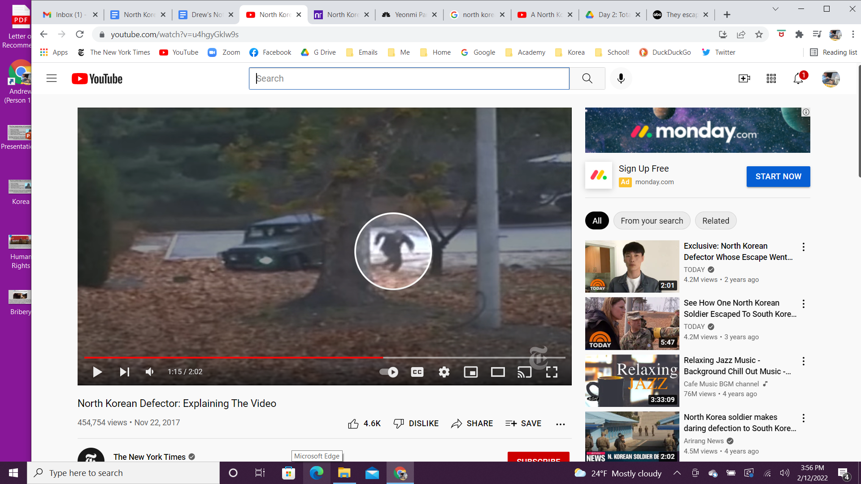
- Distribute the assignment handout “Check For Understanding: Examine the Testimonies”.
- End class by explaining the directions of the assignment. Students should watch two of the videos, then answer the questions, connecting it to the warning signs of totalitarianism.
- This assignment will in turn provide a natural segue to the third day of the lesson.

Student Handout:
Possible Warning Signs of Totalitarianism in North Korea

Student Directions: Examine the following 8 sources that show possible warning signs of totalitarianism, then answer the questions that follow each source.

Source 1: Statues in the Capital of North Korea, Pyongyang
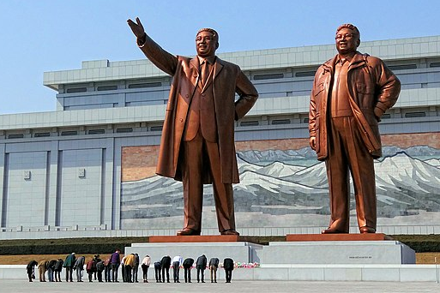

Statues of North Korean leaders Kim Il-sung and Kim Jong-il at the Mansudae-Monument
in Pyongyang, North Korea. Note the people in front of the statues. Source: Wikimedia
Task A: Assessing the Information  Which Totalitarian Warning Signs apply to this source? (Use an “X”.) | Task B: Evaluating the Problem  Evaluate why these signs might be concerning:
  APPEALS TO EXTREME NATIONALISM
  USE OF NATIONAL EMERGENCIES AND SCAPEGOATING
  GOVERNMENT CONTROL OF MEDIA AND TECHNOLOGY
  USE OF PROPAGANDA AND CULT OF PERSONALITY
  BRIBERY AND KICKBACKS
  USE OF FORCE AND VIOLENCE
Task C: Assessing the Risk
Using Tasks A and B for this source, assess the risk of Totalitarianism (circle your ranking below):
LOW RISK MEDIUM RISK HIGH RISK
0 1 2 3 4 5 6 7 8 9 10
Why? _____________________________________________________________________

Source 2: Poster in a North Korean Elementary School

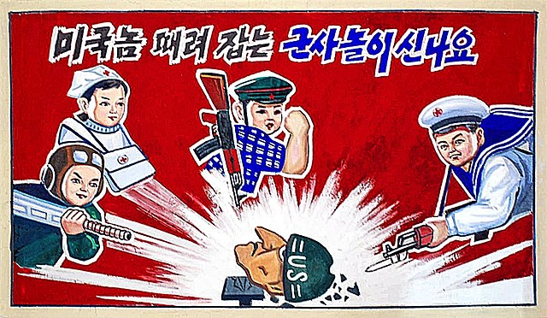
Translation: “It’s exciting to play military games of battering American jerks!”
Source: Wikimedia Commons
Task A: Assessing the Information  Which Totalitarian Warning Signs apply to this source? (Use an “X”.) | Task B: Evaluating the Problem  Evaluate why this sign might be concerning:
  APPEALS TO EXTREME NATIONALISM
  USE OF NATIONAL EMERGENCIES AND SCAPEGOATING
  GOVERNMENT CONTROL OF MEDIA AND TECHNOLOGY
  USE OF PROPAGANDA AND CULT OF PERSONALITY
  BRIBERY AND KICKBACKS
  USE OF FORCE AND VIOLENCE
Task C: Assessing the Risk
Using Tasks A and B for this source, assess the risk of Totalitarianism (circle your ranking below):
LOW RISK MEDIUM RISK HIGH RISK
0 1 2 3 4 5 6 7 8 9 10
Why? _____________________________________________________________________

Source 3: North Korean Government Communications Vehicle, sharing “inspiration for workers to be productive,” sometimes referred to in the West as “propaganda vans.”
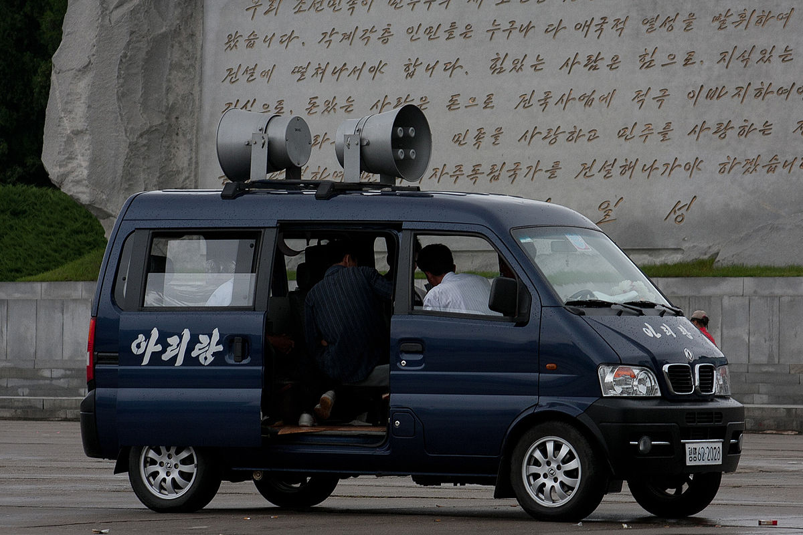
Source: Wikimedia
Task A: Assessing the Information  Which Totalitarian Warning Signs apply to this source? (Use an “X”.) | Task B: Evaluating the Problem  Evaluate why this sign might be concerning:
  APPEALS TO EXTREME NATIONALISM
  USE OF NATIONAL EMERGENCIES AND SCAPEGOATING
  GOVERNMENT CONTROL OF MEDIA AND TECHNOLOGY
  USE OF PROPAGANDA AND CULT OF PERSONALITY
  BRIBERY AND KICKBACKS
  USE OF FORCE AND VIOLENCE
Task C: Assessing the Risk
Using Tasks A and B for this source, assess the risk of Totalitarianism (circle your ranking below):
LOW RISK MEDIUM RISK HIGH RISK
0 1 2 3 4 5 6 7 8 9 10
Why? _____________________________________________________________________

Source 4: The Victorious Fatherland Liberation War Museum mural, September 2008, North Korea.
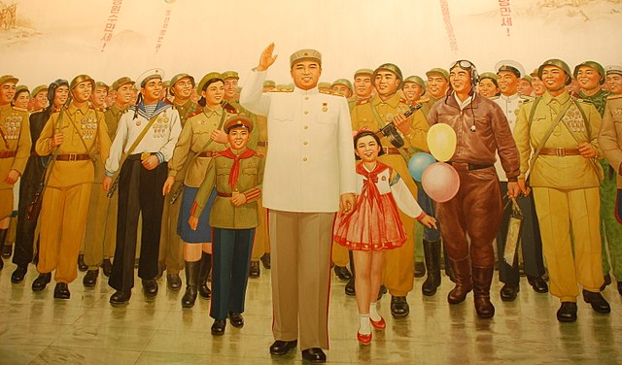
The central figure is Kim Il-Sung.
Source: Wikimedia
Task A: Assessing the Information  Which Totalitarian Warning Signs apply to this source? (Use an “X”.) | Task B: Evaluating the Problem  Evaluate why this sign might be concerning:
  APPEALS TO EXTREME NATIONALISM
  USE OF NATIONAL EMERGENCIES AND SCAPEGOATING
  GOVERNMENT CONTROL OF MEDIA AND TECHNOLOGY
  USE OF PROPAGANDA AND CULT OF PERSONALITY
  BRIBERY AND KICKBACKS
  USE OF FORCE AND VIOLENCE
Task C: Assessing the Risk
Using Tasks A and B for this source, assess the risk of Totalitarianism (circle your ranking below):
LOW RISK MEDIUM RISK HIGH RISK
0 1 2 3 4 5 6 7 8 9 10
Why? _____________________________________________________________________

Source 5: Human Rights Watch*, Report on North Korea
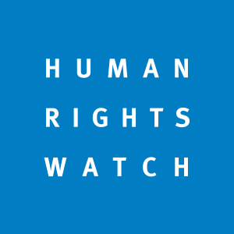
“The government (of North Korea) does not tolerate pluralism, bans independent media, civil society organizations, and trade unions, and systematically denies all basic liberties, including freedom of expression, public assembly, association, and religion. Fear of collective punishment is used to silence dissent. Authorities in North Korea routinely send perceived opponents of the government to secretive political prison camps (kwanliso) in remote regions where they face torture by guards, starvation rations, and forced labor.”

*Human Rights Watch (HRW) is an international non-governmental organization headquartered in New York City that conducts research and advocacy on human rights.The group pressures governments, policymakers, companies, and individual human rights abusers to denounce abuse and respect human rights, and often works on behalf of refugees, children, migrants, and political prisoners. In 1997, it won the Nobel Peace Prize.
Source: Human Rights Watch website, 2-7-22, Logo from Wikipedia
Task A: Assessing the Information  Which Totalitarian Warning Signs apply to this source? (Use an “X”.) | Task B: Evaluating the Problem  Evaluate why this sign might be concerning:
  APPEALS TO EXTREME NATIONALISM
  USE OF NATIONAL EMERGENCIES AND SCAPEGOATING
  GOVERNMENT CONTROL OF MEDIA AND TECHNOLOGY
  USE OF PROPAGANDA AND CULT OF PERSONALITY
  BRIBERY AND KICKBACKS
  USE OF FORCE AND VIOLENCE
Task C: Assessing the Risk
Using Tasks A and B for this source, assess the risk of Totalitarianism (circle your ranking below):
LOW RISK MEDIUM RISK HIGH RISK
0 1 2 3 4 5 6 7 8 9 10
Why? _____________________________________________________________________

Source 6: United Nations High Commissioner for Human Rights, Michelle Bachelet, May 28, 2019.
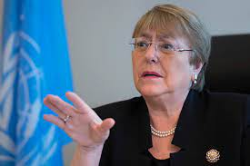
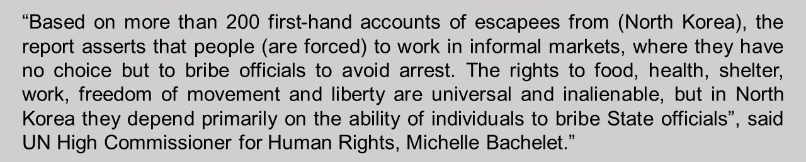
Source: UN News, May 28, 2018, photo from Flickr
Task A: Assessing the Information  Which Totalitarian Warning Signs apply to this source? (Use an “X”.) | Task B: Evaluating the Problem  Evaluate why this sign might be concerning:
  APPEALS TO EXTREME NATIONALISM
  USE OF NATIONAL EMERGENCIES AND SCAPEGOATING
  GOVERNMENT CONTROL OF MEDIA AND TECHNOLOGY
  USE OF PROPAGANDA AND CULT OF PERSONALITY
  BRIBERY AND KICKBACKS
  USE OF FORCE AND VIOLENCE
Task C: Assessing the Risk
Using Tasks A and B for this source, assess the risk of Totalitarianism (circle your ranking below):
LOW RISK MEDIUM RISK HIGH RISK
0 1 2 3 4 5 6 7 8 9 10
Why? _____________________________________________________________________

Source 7: The Impact of Religion and Culture
A passage from Power, Place, and State-Society Relations in Korea, by Dr. Jongwoo Han.

“To describe the various types of relations that exist, Confucius set forth the ‘Five Codes of Conduct’…In short, it is evident in Chinese classical literature that parents and the ruling elites have a status linked to that of Heaven, while the public is regarded as children. In this set of relations, the patriarchal (male-dominated) power relationship within the family automatically extends to the public domain…This Confucian hierarchy has a long history in North Korea that encouraged citizens to obey those in power. In fact, to quote the thinker Michel Foucault, these Confuscian beliefs are the “concrete soil in which their state power is grounded..allowing it to function.”

Task A: Assessing the Information  Which Totalitarian Warning Signs apply to this source? (Use an “X”.) | Task B: Evaluating the Problem  Evaluate why this sign might be concerning:
  APPEALS TO EXTREME NATIONALISM
  USE OF NATIONAL EMERGENCIES AND SCAPEGOATING
  GOVERNMENT CONTROL OF MEDIA AND TECHNOLOGY
  USE OF PROPAGANDA AND CULT OF PERSONALITY
  BRIBERY AND KICKBACKS
  USE OF FORCE AND VIOLENCE

Task C: Assessing the Risk
Using Tasks A and B for this source, assess the risk of Totalitarianism (circle your ranking below):
LOW RISK MEDIUM RISK HIGH RISK
0 1 2 3 4 5 6 7 8 9 10
Why? _____________________________________________________________________

Source 8: Report of the DPRK (North Korea) Association for Human Rights Studies
This excerpt is a summary of the document entitled “Report of the DPRK Association for Human Rights Studies” as published by (North) Korea Central News Agency, September 13, 2014.

Recently, distorted views were floated by anti-North Korean forces about the realities of our country, especially its human rights situation. The United States and its followers are pursuing persistent anti-North Korean human rights campaigns aimed at interfering in our internal affairs and eventually overthrowing the social system by fabricating a “human rights issue” to mislead international opinions and raise it to the United Nations. However, truth will always prevail.

In North Korea, great efforts were exerted to raise people’s living and cultural standards, thus resulting in a great advance in basically meeting their needs for food, clothing, housing, education, cultural activities and health care. Taxation was abolished and systems of universal free medical care and free education have been put in place.

The 60-year long history of the DPRK is a history of self-reliance in which Korean people established and strengthened the people-centered socialist system under the wise leadership of the great President Kim Il Sung and the great leader Kim Jong Il.

The Korean People are convinced that their state and social system guarantees them genuine freedom and rights and place absolute trust in it, making devoted efforts to further consolidate and develop it under the wise leadership of the respected (leader) Kim Jong Un.

Task A: Assessing the Information  Which Totalitarian Warning Signs apply to this source? (Use an “X”.) | Task B: Evaluating the Problem  Evaluate why this sign might be concerning:
  APPEALS TO EXTREME NATIONALISM
  USE OF NATIONAL EMERGENCIES AND SCAPEGOATING
  GOVERNMENT CONTROL OF MEDIA AND TECHNOLOGY
  USE OF PROPAGANDA AND CULT OF PERSONALITY
  BRIBERY AND KICKBACKS
  USE OF FORCE AND VIOLENCE

Task C: Assessing the Risk
Using Tasks A and B for this source, assess the risk of Totalitarianism (circle your ranking below):
LOW RISK MEDIUM RISK HIGH RISK
0 1 2 3 4 5 6 7 8 9 10
Why? _____________________________________________________________________

Check For Understanding:
Examining the Testimonies of North Korean Defectors
Name: ______________________________________________ Period: ________________
Student Directions:
Part 1: Watch the following two videos and complete the tasks. Write a paragraph as if you are one of the defectors. Connect their story to one (or more!) of the six warning signs of totalitarianism.
- Appeals to Extreme Nationalism
- Use of National Emergencies and Scapegoating
- Government Control of Media and Technology
- Use of Propaganda and Cult of Personality
- Bribery and Kickbacks
- Use of Force and Violence

Video 1:  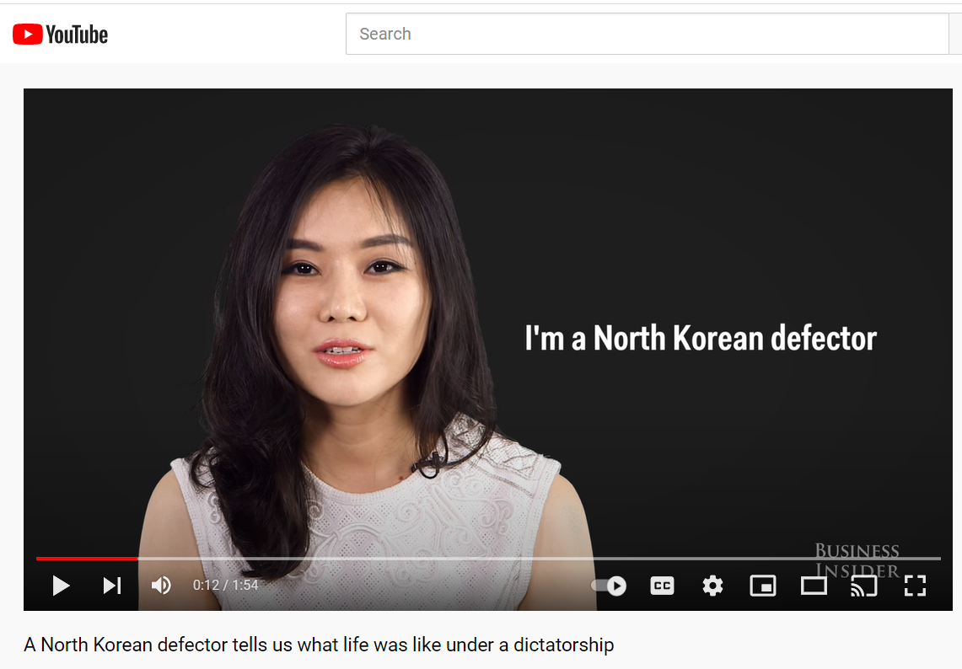  A North Korean defector tells what life was like under a dictatorship  Hyeonseo Lee, Business Insider (1:54) | Paragraph that summarizes their testimony (written as if you were the defector):  What warning sign(s) do they describe?

Video 2:  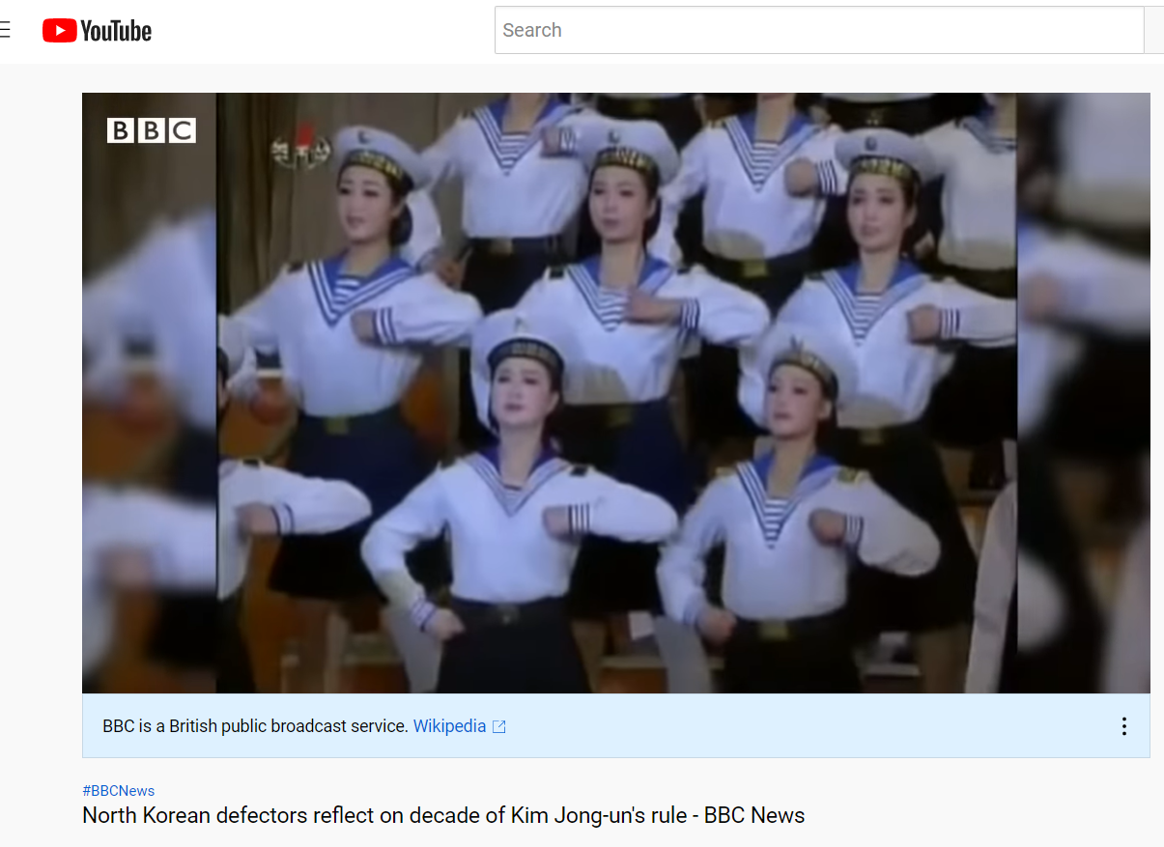  North Korean defectors reflect on decade of Kim Jong-un's rule BBC News (3:15) | Paragraph that summarizes their testimony (written as if you were the defector):  What warning sign(s) do they describe?
OPTIONAL VIDEOS

Optional Video A:  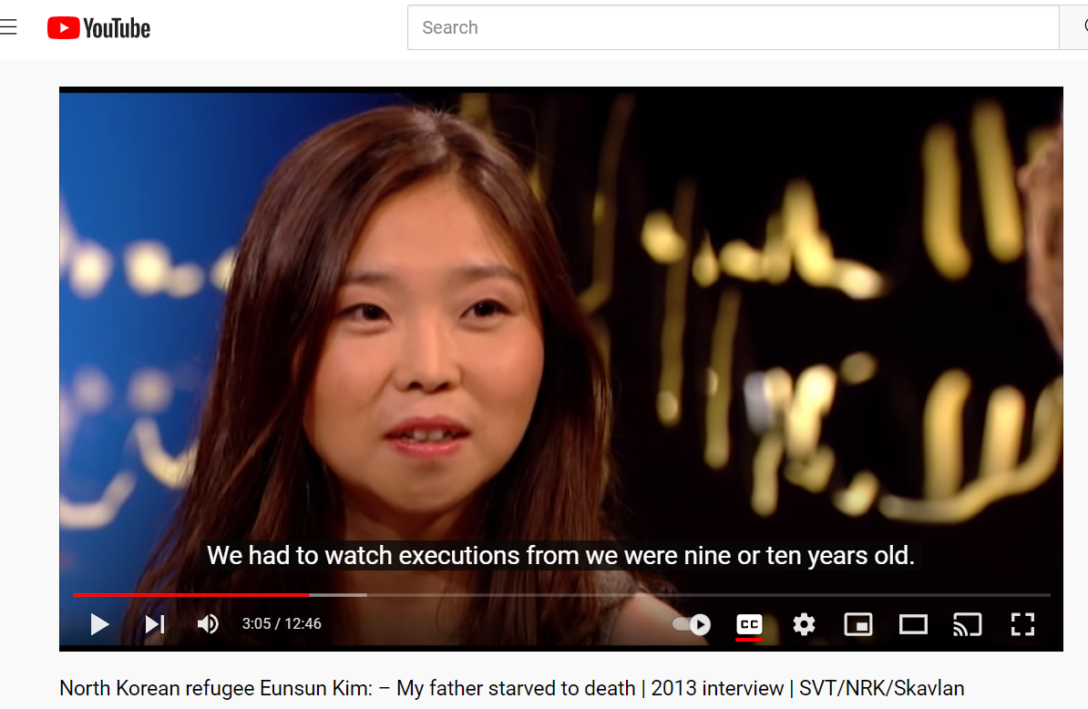  North Korean refugee Eunsun Kim: 2013 interview  SVT/NRK/Skavlan (12:46) | Optional Tasks  Paragraph that summarizes their testimony (written as if you were the defector):  What warning sign(s) do they describe?

Optional Video B:  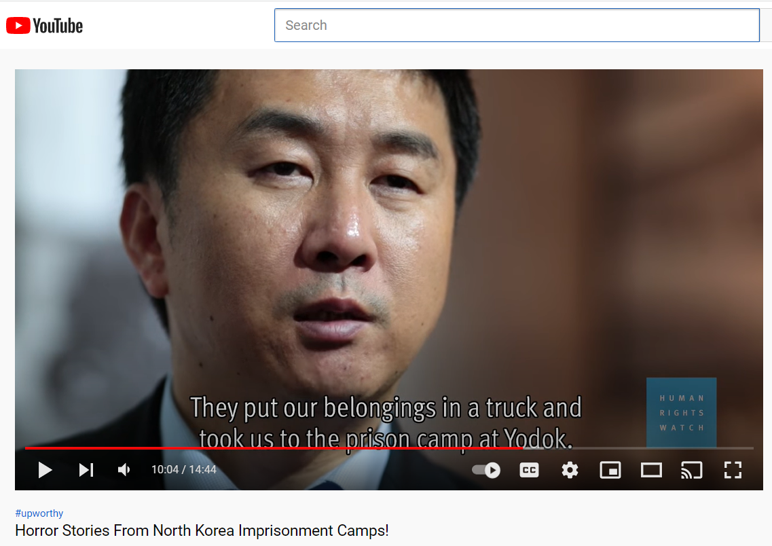  Horror Stories From North Korea Imprisonment Camps  Human Rights Watch/Upworthy (14:44) | Optional Tasks  Paragraph that summarizes their testimony (written as if you were the defector):  What warning sign(s) do they describe?

Exit Ticket (from Day 1):
Ranking the Warning Signs of Totalitarianism

Student Directions: Now that you have an understanding of what the warning signs of totalitarianism are, as an Exit Ticket, rank how dangerous each factor is. While they all pose danger to a free society, which ones make it more likely that totalitarianism will occur?

Ranking the Signs of a Totalitarian State

SIGNS of a TOTALITARIAN STATE | RANKING of MOST DANGEROUS (#1) to LEAST DANGEROUS (#6)
Appeals to Extreme Nationalism
Use of National Emergencies and Scapegoating
Government Control of Media and Technology
Propaganda and Cult of Personality
Using Bribery and Kickbacks
Use of Force and Violence

Justify or explain your ranking:

