
Li
What happened when democracy was tested in Korea?

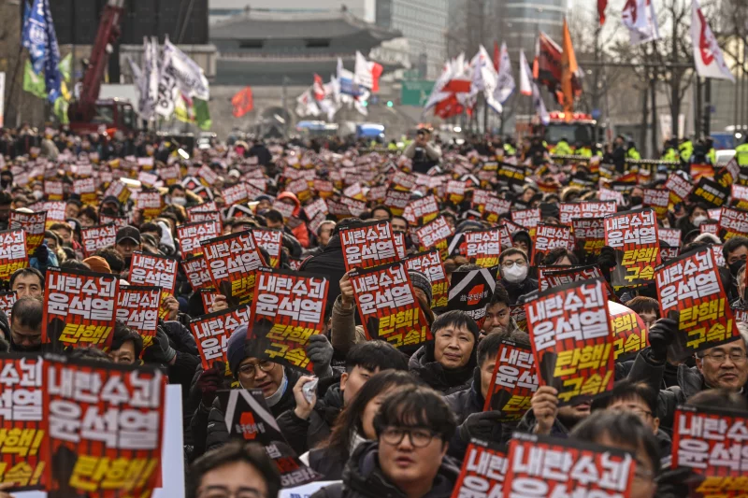

December 12, 2024, outside City Hall in Seoul, South Korea

Supporting Questions

- How should we understand martial law?
- How did South Korean citizens respond?
- How did leaders, political parties, and the government of South Korea respond?
Korean War Legacy Foundation: K-Democracy

What happened when democracy was tested in Korea?
Social Studies Standards and Content | C3 Framework Standards  D2.Civ.3.9-12. Analyze the impact of constitutions, laws, treaties, and international agreements on the  maintenance of national and international order.  D2.Civ.5.9-12. Evaluate citizens’ and institutions’ effectiveness in addressing social and political problems at the  local, state, tribal, national, and/or international level.  D2.His.1.9-12. Evaluate how historical events and developments were shaped by unique circumstances of time and place as well as broader historical contexts  Learning for Justice Standards  8. Students will respectfully express curiosity about the history and lived experiences of others and will exchange ideas and beliefs in an open-minded way.  14. Students will recognize that power and privilege influence relationships on interpersonal, intergroup and institutional levels and consider how they have been affected by those dynamics.
Staging the Compelling Question | What happened when democracy was tested in Korea? Teachers will give students time to analyze and discuss a video of Opposition Leader and current President Lee Jae-myung livestreaming himself jumping a fence, a photograph of National Assembly Speaker Woo Won-shik scaling a fence to enter the parliament building in Seoul, and a video showing how quickly Korean citizens gathered in front of the National Assembly and stood against military. Students will answer two formative questions about these sources which will launch the class discussion into the topic.

Supporting Question 1 |  | Supporting Question 2 |  | Supporting Question 3
How should we understand martial law? |  | How did South Korean citizens respond? |  | How did leaders, political parties, and the government of South Korea respond?
Formative Performance Task |  | Formative Performance Task |  | Formative Performance Task
Students will read and analyze a variety of media sources related to the concept of martial law and the legacy of this concept in Korean history. After answering questions and analyzing the sources, students will use the information to create their own definition of martial law. |  | Students will analyze a variety of media sources including images, narrative, video, and statistics to explore how Korean citizens responded to martial law. After completing source analysis, they will respond to the supporting question using evidence from the sources. |  | Through a structured analysis of three sets of sources, students will evaluate immediate, short-term, and long-term outcomes from the declaration of martial law in the context of government. Students will take a stand on the response of the government following the declaration of martial law.
Featured Sources |  | Featured Sources |  | Featured Sources
Source Set A:  A1: Constitution of the Republic of Korea  A2: Declaration of Martial Law  Source B: South Korea’s history of martial law explained  Source C: BBC News article and timeline of events |  | Source A: Images: South Korean citizens gathered to protest  Source B: Moon Seo-yeon quote  Source C: Andrew Minjun Park narrative  Source D: Ahn Gwi-ryeong text and video  Source E: Citizen protest statistics and demographics  Source F: NBC News Video of citizens protesting |  | Source Set A: Politicians Responding  A1: Current President (then Opposition leader) Lee Jae-myung films the fence jumping  A2: Speaker Woo Won-shik jumping the fence  A3: BBC News Report  Source Set B: Legislative Actions  B1: Resolution to demand Lifting of Extraordinary Martial Law  B2: Transcript of National Assembly session  B3: Vote results  B4: Speaker Woo Won-shik summarizes outcomes  Source Set C: Call for Impeachment  C1: Resign or impeach quote  C2: Impeachment flowchart

Summative Performance Task | ARGUMENT: Students will answer the inquiry question through a traditional essay, infographic, or short video: what happened when democracy was tested in Korea?
Summative Performance Task | EXTENSION: Students will analyze a photo of the fence that opposition leaders scaled to enter the Parliament Building in Seoul and decide on how the fence in Seoul should be memorialized today. In this memorial, students should carefully consider the important and central role that citizens played in the movement and how this too should be remembered.  Students can research the use of K-Democracy as a keyword in President Lee Jae-myung’s administration and speeches. Additional focus on the use of K-Democracy as part of the events when democracy was tested as well as the context of other cultural terms such as K-Pop can provide additional insight.  As another extension, students can research the latest developments on former president Yook Suk Yeol and the legal proceedings that have followed to answer this question: how do the developments since the challenge to democracy influence how we should memorialize or remember the events?
Taking Informed Action | UNDERSTAND: Students can research a local history event or individual who has made a significant impact on democracy in their country. Identifying and sharing their stories is an important step in preserving our democracy.  ASSESS: As a class or in small groups, students can assess the impact that local history events have had and consider how any local history events may be similar to the December 2024 test of democracy in Korea.  ACT: Students can choose a site related to an important event or person from their own state or local communities. They will use evidence to create a poster or slides presentation about how this event should be remembered and memorialized by the public today.
*Featured sources are suggested and links are provided. It may be that these links are broken and we apologize in advance for the inconvenienc

Overview

Inquiry Description

This inquiry leads students through an exploration of the idea of how people react when democracy is challenged. Students will learn about the concept of martial law. Then, they will apply what they learned to the events surrounding the martial law declaration in South Korea in December 2024. Students will analyze sources capturing the reactions of the people and the government.
Specifically, this inquiry guides high school students through an analysis of a variety of primary and secondary sources that highlight various government and civilian stakeholders in South Korea. Students will use a variety of source analysis strategies to make meaning from these sources and build an argument that answers the compelling question. Students will practice source analysis on a variety of mediums including:
- Visual analysis of protest signs;
- Video analysis of live streamed actions;
- Text analysis of narrative reflections;
- Text analysis of government documents/transcripts; and,
- Secondary sources of news events and nonfiction texts.
Content Background: Preparation for this Inquiry
This compelling question opens an inquiry into the complexities of how a country confronts challenges to democracy when it is threatened.
There are several critical pieces of background knowledge students may benefit from having prior to this inquiry. The list below is intended to guide instructional decisions prior to launching the inquiry:
- Students should have familiarity with South Korea, its geography, and a basic understanding of its history, especially related to the Korean War and its aftermath.
- Students should understand fundamental structures (notably a constitution) and processes of a government and more specifically a democratic government.
- Students should be able to identify current and historical protests and explain the purpose and function of a protest including different types of protest (especially the spectrum of peaceful to violent).

Structure of the Inquiry
In addressing the compelling question “What happened when democracy was tested in Korea?” students work through a series of supporting questions, formative performance tasks, and sources in order to explain their new learning.

The Big Idea:
The student understanding at the heart of this inquiry is that government actions can have significant consequences for the people and the country. Moments of crisis - in Korea and beyond - are a test to the strength of a country’s government. In these critical moments, people may protest as a strategy to bring attention to the issue and ultimately hold the government accountable. Actions from ordinary people, leaders, and government bodies are important to parts of any response to a crisis, threat, or challenge, especially when the challenge threatens the nature of a democratic government and the protection of democratic freedoms.

Staging the Compelling Question
In staging the compelling question, the teacher will have students analyze three sources when they enter the classroom. Students will watch a video of one Korean leader, view an image of another South Korean politician, and watch a video of citizen protests..
YouTube Video Link YouTube Video Link
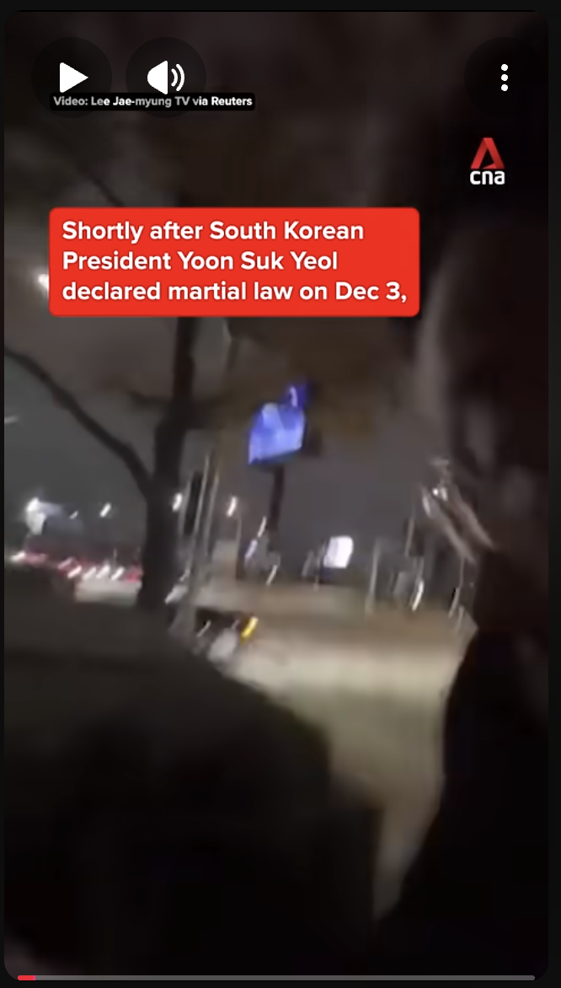
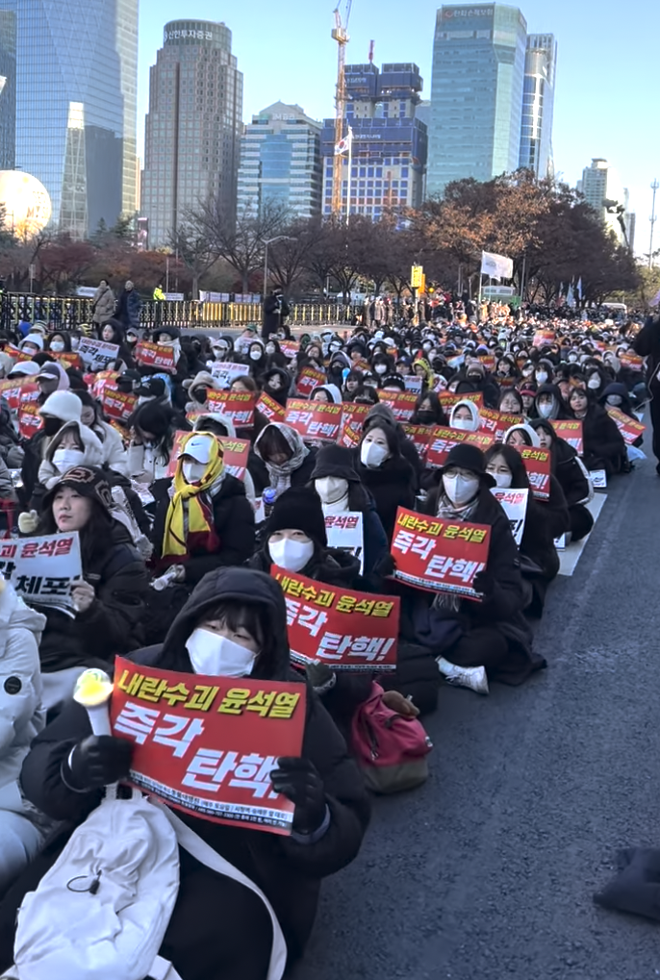
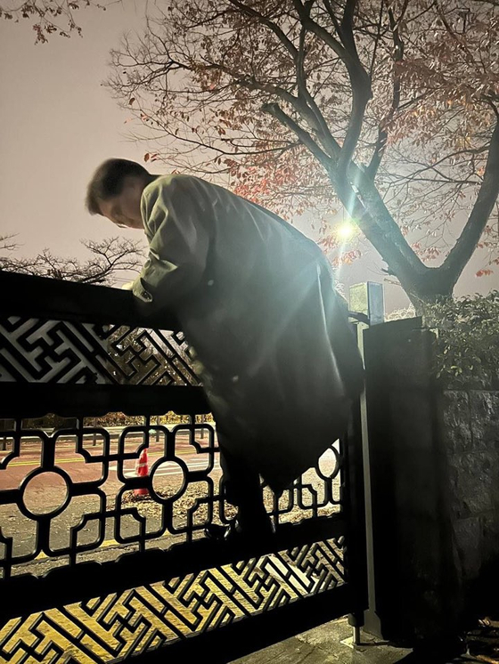

Consider asking students…
- What is happening in the two livestreamed videos and in the picture? Where and when might this have happened? Speculate why this is happening.
The first video was captured on a smartphone by South Korean opposition leader and current President Lee Jae-myung, livestreaming himself jumping the fence to enter the parliament building. The photograph was taken of National Assembly Speaker Woo Won-shik scaling a fence of the parliament building. The third video films the citizen protests that gathered outside of the National Assembly, the parliament building.
After students have had time to analyze the videos and the image, they will answer two formative questions about the document.
- Why do you think huge crowds of citizens were gathering and these lawmakers were scaling barriers to enter the National Assembly in Seoul?
- What do these images convey about South Korean democracy?

Supporting Question 1
Supporting Question 1: How should we understand martial law?
The supporting question has students investigate what the South Korean Constitution says about the legality of declaring martial law and an excerpt of the Declaration of Martial of Law. Students will also view a video clip of the history of martial law in South Korea and an excerpt from a BBC article about the timeline of events that occurred after martial law was declared. The formative task will ask students to analyze the images, text and video sources to create an understanding of the events that led to the mass demonstrations. Then, they will share what they found together as a class after each set of documents. After students have analyzed all of the documents they will come up with a definition of martial law based on what they have learned.
As an extension activity, teachers can choose to have students read an article about other instances of martial law being declared by countries and compare that to what happened in South Korea in 2024. The article is titled “5 Times That Martial Law Was Declared” from history.com. The five comparisons are to the American Civil War (1862-65), Germany (1933-45), Hawaii (1941-44), Philippines (1972-81) and China (1989). Students can select one of those five historical examples of martial law to compare and contrast with South Korea (2024).
Teachers can implement this task with the following procedures:
- In small groups or individually, students will view, read and annotate the sources. Once they have done this they will answer the formative questions.
  - The teacher may choose to have students jigsaw the activity, which would entail each student look at different sources and share back with the group what they have learned about the source they analyzed.
- Individually, in small groups or as a whole class, students will answer the formative questions that accompany each document or set of documents. The documents will scaffold the concept of martial law in South Korea, the history of martial law in South Korea and the unfolding of events in December 2024.
- In small groups or as individuals, students will formulate a definition of martial law based on the evidence they viewed in each of the documents. Students will have the opportunity to share the definitions they formulated with the entire class.

The following featured sources were selected to develop understanding of martial law in general and the declaration of martial law in South Korea in December 2024 in particular:
- Featured Source A1: is the Constitution of the Republic of Korea
- Featured Source A2: is the Declaration of Martial Law
- Featured Source B: is South Korea’s history of martial law explained
- Featured Source C: is a BBC News article and timeline of events

Supporting Question 2

Supporting Question 2: How did South Korean citizens respond?
This supporting question investigates how the citizens of South Korea responded to the declaration of martial law. The formative task asks students to analyze images, text, and video sources to evaluate how the citizens responded to the declaration of martial law. Then, they will share and discuss their findings.
Teachers may implement this task with the following procedures:
- In small groups or as a whole class, students will view, read, and/or annotate sources. Students will explore images, narrative, interview, video, and news sources.
  - The teacher may choose to have students each study a different source and share back, or students may analyze all sources. The teacher may also differentiate based on the learner’s needs to analyze certain sources.
  - As students explore the images, they may choose to focus on the image, the translated text, or both.
  - As students analyze text, they may use highlighters or annotation strategies to mark surprises, key ideas, or significant words.
- In small groups or as a whole class, students will answer questions connected to the sources, reflecting on how the sources illustrate how the citizens of South Korea responded.
  - The teacher may choose to use scaffolds including sentence starters or word banks to make concepts more attainable. The teacher may also choose to have students share their responses with peers to confirm their responses, and also to recognize additional correct responses.
  - In class discussions, encourage students to reflect on how these sources highlight ordinary citizens who participated. For deeper analysis, encourage students to reflect on what makes sources credible or trustworthy and what makes sources less credible or trustworthy. Students may also consider how the location of the news source may impact the story it shares.
- In small groups or as individuals, students will write a short reflection that summarizes their answer to the supporting question. Students may share their reflections with classmates to find common themes in their analyses and hear competing interpretations. Teachers can encourage students to actively listen to the answers and identify the themes and competing interpretations.
The following featured sources were selected to show the responses of the citizens of South Korea:
- Featured Source A: is a collection of images showing South Korean citizens in Seoul, South Korea.
- Featured Source B: is the text from a teenager named Moon Seo-yeon who attended the protests.
- Featured Source C: is the text from a college-age student named Andrew Minjun Park who attended the protests.
- Featured Source D: includes text and video of Ahn Gwi-ryeong, a spokesperson for the opposition Democratic Party
- Featured Source E: shows data about the number of citizens who protested
- Featured Source F: is a news video from NBC about the citizens responding to the events in South Korea

Supporting Question 3

Supporting Question 3: How did leaders, political parties, and the government of South Korea respond?
This supporting question investigates how the government of South Korea responded to the declaration of martial law. The sources are divided into three different source sets:
- Source Set A focuses on the immediate actions of politicians in South Korea as they entered the National Assembly in the midst of the martial law declaration
- Source Set B focuses on the legislative actions of the politicians to overturn the martial law declaration using governmental procedure
- Source Set C focuses on the actions after martial law was lifted, specifically the calls for impeachment for president Yoon.
The formative task asks students to analyze images, text, and video sources to evaluate how the government responded to the declaration of martial law. Then, they will share and discuss their findings.
Teachers may implement this task with the following procedures:
- In small groups or as a whole class, students will view, read, and/or annotate sources. Sources highlight both the reaction of individuals in the government and also actions of the National Assembly.
  - The teacher may choose to have students focus on Source Set A and B first, and consider returning to Source Set C later.
  - Source Set A presents a variety of sources illustrating key moments. For video links, use Youtube translate feature to make videos accessible in any language. Teacher may choose to only use one source from Source Set A to reveal this portion of the story. Or, teacher may choose to compare how different media representations reveal different aspects of the story.
  - Source Set B includes primary sources that are legislative documents. Students may need support interpreting these, as the format and style may be new for them.
- In small groups or as a whole class, students will answer questions connected to the sources. Questions ask students to consider the significance of these events in the context of Korea’s government.
  - As students analyze these sources, encourage them to consider how these actions were preserving and protecting democracy in Korea.
- In small groups or as individuals, students will write a short reflection that summarizes their answer to the supporting question. Students consider how cause and effect, efficacy, and/or key takeaways inform their understanding of the supporting question.
The following featured sources were selected to show the responses of the government of South Korea:
- Featured Source Set A is …
  - A1: Opposition leader Lee films the fence jumping
  - A2: Speaker Woo Won-shik jumping the fence to the National Assembly
  - A3: Narrative explaining the crisis
- Featured Source Set B is …
  - B1: National Assembly resolution
  - B2: Transcript of National Assembly meeting
  - B3: Vote results
  - B4: Speaker Woo Won-shik summarizes outcomes
- Featured Source Set C is …
  - C1: Resign or Impeach
  - C2: Impeachment Flowchart

Summative Performance Task
At this point in the activity students will have investigated all of the supporting questions. With the knowledge they have learned, students will answer the inquiry question through a traditional essay, infographic, or short video:
What happened when democracy was tested in Korea?
Teachers can provide a variety of options for students to display their learning from all three supporting questions. Students might write a traditional essay analyzing the variety of responses to the declaration of martial law, create an infographic that creates a visual argument answering the question, or develop a short video that includes an analysis of the essential information from all three supporting questions as a summary of K-Democracy.
Extension 1: As an extension, students might also create an argument on how this event should be memorialized today.
- Display a photo of the fence now for students to analyze. This is the same fence that began the inquiry.
- Share the larger question for students to answer:
How should we remember or memorialize this event?
- Using the Handout, students will respond to the prompts individually and engage in a discussion as a class.
- Alternatively the teacher can have students pair-share what they wrote and compare their opinions.

Extension 2: As an optional extension activity or as part of the debrief of the summative performance task, the teacher can ask the class to research the latest developments in the criminal charges against former president Yoon Suk Yeol. To direct student thinking, consider using this question:
- How do the developments since the challenge to democracy influence how we should memorialize or remember the events

Student Handout: Staging the Compelling Question
Featured Source 1a and 1b | View and analyze the video clip and photograph below to answer the two formative questions.
Source 1a: South Korea's opposition leader Lee Jae-myung films himself jumping a fence to enter the National Assembly.
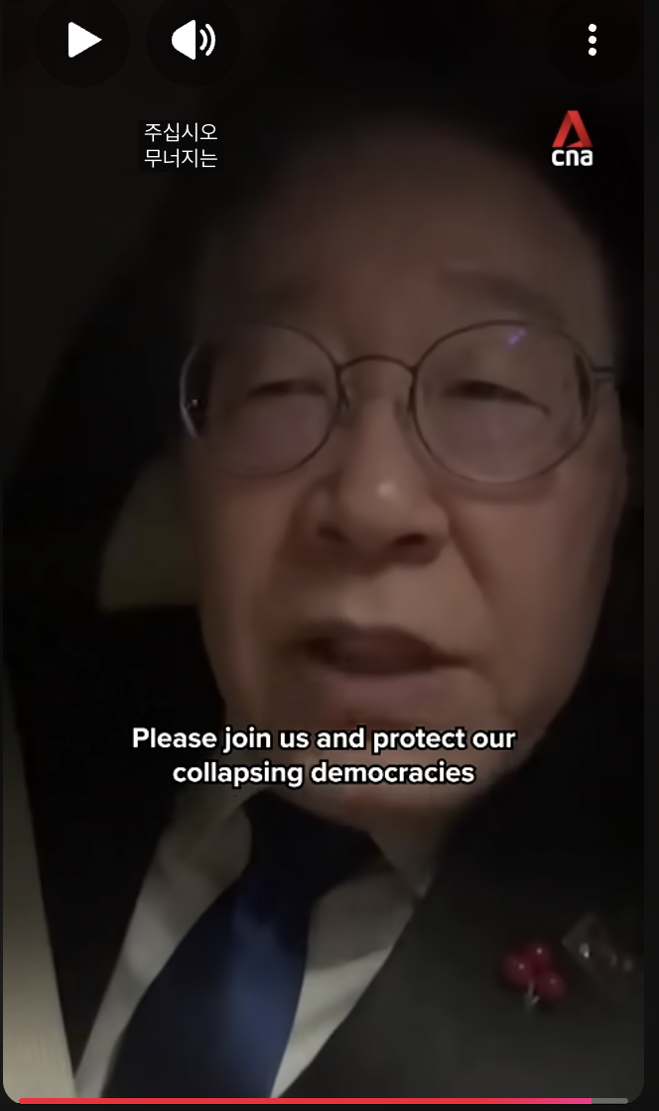

Source: YouTube video.
Source 1B: National Assembly Speaker Woo Won-shik scales a fence of the parliament building in Yeouido, western Seoul, on Tuesday to circumvent blockage by police to enter parliament.
Source: Fence-hopping Assembly speaker springs into action after declaration of martial law

Formative Questions:
Why do you think these lawmakers were scaling barriers to enter the National Assembly in Seoul?
What do these images convey about South Korean democracy?

Student Handout: Supporting Question 1
Featured Source A | Constitution of the Republic of Korea and Declaration of Martial Law

Source A1: Constitution of the Republic of Korea
Article 77

- When it is required to cope with a military necessity or to maintain the public safety and order by mobilization of the military forces in time of war, armed conflict or similar national emergency, the President may proclaim martial law under the conditions as prescribed by Act.
- Martial law shall be of two types: extraordinary martial law and precautionary martial law.
- Under extraordinary martial law, special measures may be taken with respect to the necessity for warrants, freedom of speech, the press, assembly and association, or the powers of the Executive and the Judiciary under the conditions as prescribed by Act.
- When the President has proclaimed martial law, he shall notify it to the National Assembly without delay.
- When the National Assembly requests the lifting of martial law with the concurrent vote of a majority of the total members of the National Assembly, the President shall comply.

Source A2: Declaration of Martial Law, Republic of Korea, December 3, 2004.

"In order to protect liberal democracy from the threat of overthrowing the regime of the Republic of Korea by anti-state forces active within the Republic of Korea and to protect the safety of the people, the following is hereby declared throughout the Republic of Korea as of 23:00 on December 3, 2024:
1. All political activities, including the activities of the National Assembly, local councils, and political parties, political associations, rallies and demonstrations, are prohibited.
2. All acts that deny or attempt to overthrow the liberal democratic system are prohibited, and fake news, public opinion manipulation, and false propaganda are prohibited.
3. All media and publications are subject to the control of the Martial Law Command.
4. Strikes, work stoppages and rallies that incite social chaos are prohibited.
5. All medical personnel, including trainee doctors, who are on strike or have left the medical field must return to their jobs within 48 hours and work faithfully. Those who violate will be punished in accordance with the Martial Law.

Formative Questions:

When does the President have power to proclaim martial law?
How are the rights of the people limited under martial law?
What are the two most important words or phrases from the excerpts of Korea’s Constitution? Why are they important?
What questions does the Declaration of Martial Law (A2) raise for you?

Student Handout: Supporting Question 1
Featured Source B | ABC News (Australia), “South Korea’s history of martial law explained.” 12/5/24

Watch this short video and answer the questions that follow: “South Korea's history of martial law explained”

Formative Questions:
When was the last time martial law was declared in South Korea? How did this event play a significant role in the development of South Korean democracy?
How does South Korea's history of martial law impact the way South Koreans might view the declaration of martial law in 2024? Cite evidence from the video and history to support your answer.

Student Handout: Supporting Question 1
Featured Source C | BBC News “Fear, fury and triumph: Six hours that shook South Korea .” 12/4/24

The announcement
On Tuesday night, at 23:00 local time (14:00 GMT) President Yoon, seated in front of blue creaseless curtains, made an unexpected address to the nation.
He said he was imposing martial law to protect the country from "anti-state" forces that sympathised with North Korea. The embattled leader is in a deadlock over a budget bill, dogged by corruption scandals and investigations into his cabinet members.
What followed was a sleepless night for Seoul.
Shortly after Yoon’s announcement, police lined the white metal gates outside the National Assembly building in the heart of Seoul, the building that the country’s tourism authorities have framed as “the symbol of Korean democracy”.
The military then announced that all parliamentary activity was suspended under martial law. But neither that nor the heavy security presence stopped thousands from gathering in front of the assembly in concern and fury.
It is easy to forget that South Korea - now a vibrant democracy - had its last brush with authoritarianism in the not-too-distant past - it only emerged from military rule in 1987. Martial law was last imposed in 1979.
This was “a move I never expected to see in the 21st century in South Korea,” university student Juye Hong told BBC World Service's OS programme from Seoul.
The scramble
Soon after Yoon's shock announcement, the opposition's Democratic Party leader Lee Jae-myung, hosted a live stream urging people to assemble at the National Assembly and protest there.
He also asked his fellow lawmakers to make their way to the assembly to vote down the order.
Hundreds of South Koreans responded.
Signs in picture: “Condemn the Illegal Martial Law” (left); “Fulfill People’s Sovereign Power” (right)
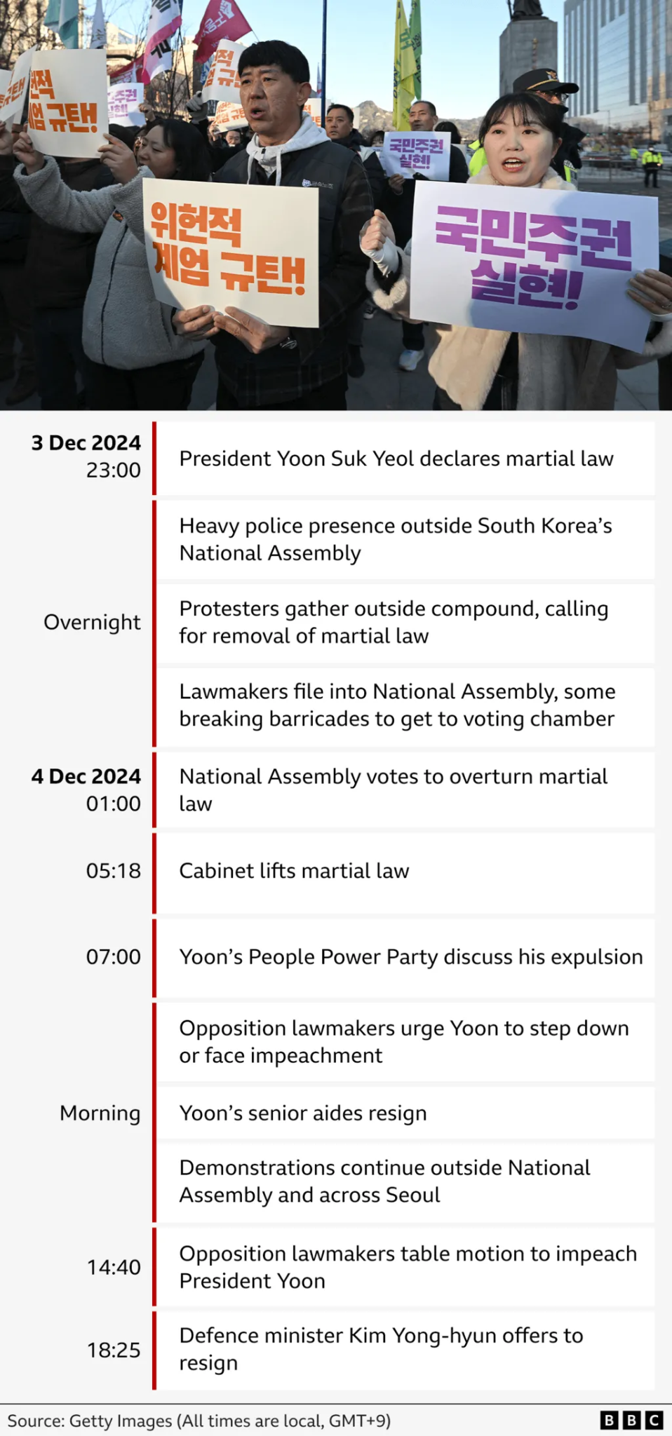
Source: Fear, fury and triumph: Six hours that shook South Korea

Formative Questions:
According to the article, why did the President declare martial law? What do you think were his actual motivations for declaring martial law?

Supporting question 1 wrap-up task: How should we understand martial law?

Using information from the sources, write your own definition of martial law.

Student Handout: Supporting Question 1 Extension Activity
Featured Source | History.com “5 Times That Martial Law Was Declared .” 12/4/24

Extension Activity: 5 Times That Martial Law Was Declared

Using the above article, compare and contrast the 2024 declaration of martial law in South Korea to one of the 5 examples from the article.

.

Student Handout: Supporting Question 2
Featured Source A | Collection of images from Seoul, South Korea in December 2024

Source A1: Gathering of citizens in Gwanghwamum Square in Seoul on December 4, 2024.
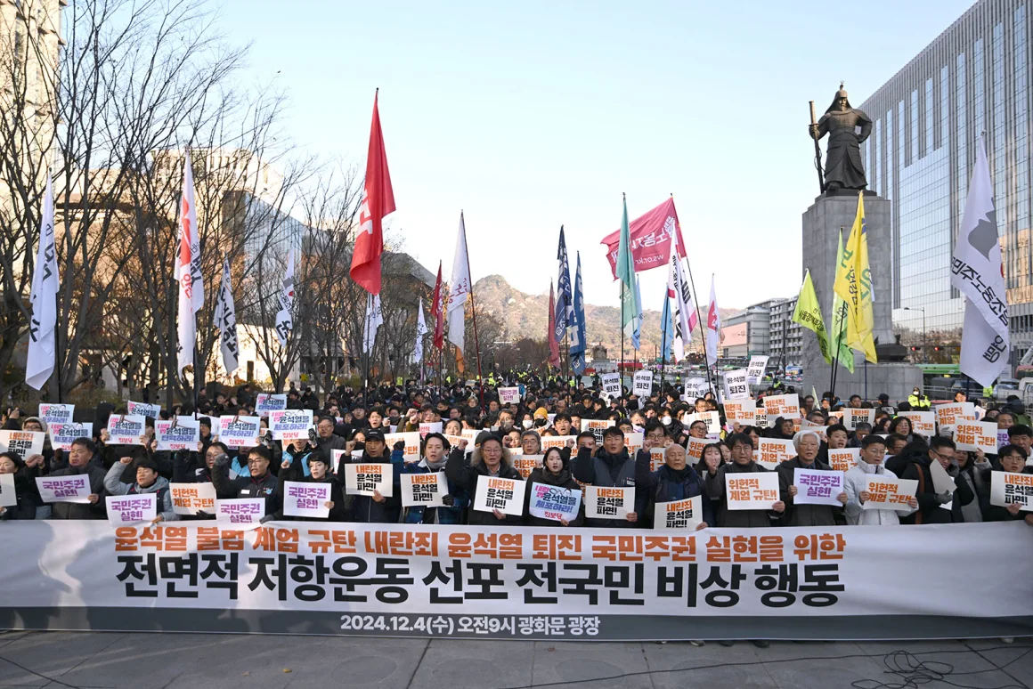
Translations of the banner:
Orange text: “Condemning Yoon Suk Yeol’s Illegal Declaration of Martial Law and Accomplishing People’s Sovereign Power by Removing Treasonous Yun”
Black text: “All Citizens’ Emergency Actions for the Declaration of a Full-scale Resistance Movement”
Source: CNN, American news company, December 5, 2024

Source A2: A gathering on the evening of December 4, 2024 in Seoul.
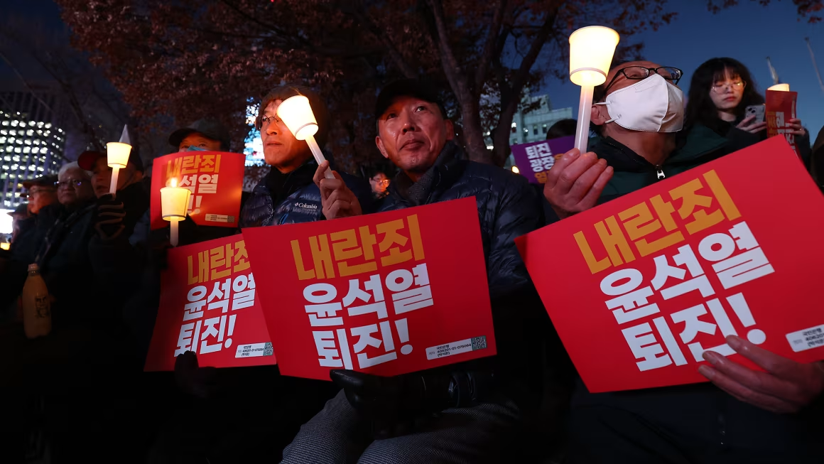

The signs read: “Resign, Treasonous Yoon Suk Yeol!

Source : CNN , American news company, December 4, 2024

Source A3 : Citizens continued to gather after the declaration of martial law. This image shows people outside of Seoul’s City Hall on December 12, 2024.
Signs read: “Treasonous Boss Yoon Suk Yeol, Impeach! And Imprison!”

Source: NPR, American public broadcasting organization, December 12, 2024

Formative Questions:

What do the photos demonstrate about the magnitude (scale) of the protests? Cite evidence to support your claims.
Based on these images, how did citizens react to the declaration of martial law?
Do these images suggest the protests were more peaceful or more violent? Cite evidence to support your claim.
What questions do these images raise?

Student Handout: Supporting Question 2
Featured Source B | Quote from Moon Seo-yoon, who participated in the protests

People of many ages joined in the protests. Fifteen year old Moon Seo-yeon joined the rallies on the evening of Wednesday, December 4..
“During Yoon’s term, there have been many significant events that were either poorly handled or not addressed at all. It feels like there’s been no progress, or worse, steps backward. . . I may not be old or very knowledgeable, but since the country is in a state of emergency, I want to contribute, even if it’s just a small effort.”
-Moon Seo-yoon
Source: CNN, American news company, December 4, 2024

Formative questions:

How does Moon argue that the protests were about something greater than just the martial law declaration?
Create an argument on both sides:
- Moon’s actions were very significant.
- Moon’s actions were relatively insignificant.

Student Handout: Supporting Question 2
Featured Source C | Narrative from Andrew Minjun Park, a college student who attended the protests

Andrew Minjun Park is a graduate student at a university in Seoul. He is 27 years old. He joined in the protests from 11:45pm on Tuesday night (December 3) until the morning of December 4. He protested the declaration of martial law outside the National Assembly building in Seoul.

At first, I thought it was fake news. Putting the country under martial law is something that's often associated with the authoritarian governments South Korea had in the '70s and '80s. But after watching the president's address on YouTube, I realized he was dead serious….
Initially, I didn't want to join the protests that were forming outside the National Assembly building. There was a possibility the protests could turn violent. You could also get arrested since protests are illegal under martial law. But as more and more photos of security forces descending on the building came in, it began to dawn on me that this situation couldn't be taken lightly. The president had crossed the line when he got the military involved. What he had done posed a risk to democracy. To me, this was a critical moment in Korea's modern history. I knew I would regret it for the rest of my life if I didn't head down to the National Assembly….
I took the subway to the National Assembly. Unlike most nights, the train was packed. I think a few hundred people got off with me at the station when we arrived. By the time I got to the building, it was around 11:45 p.m. There was a police bus parked in front of the building's gate to prevent protesters from entering the National Assembly. I also saw helicopters flying over the building.
…At around 12:30 a.m. or so, I started to see families and students arriving in larger numbers. Some parents brought their children along. This was my first protest, and I wasn't prepared for the physical aspects of it. It was really cold, and my hands hurt from trying to hold up a banner I had made. And because it was so crowded, I kept bumping into people.
When the National Assembly voted unanimously to block the president's decree, the protests' agenda began to shift toward calling for the arrest and impeachment of President Yoon. The protests took place in a peaceful manner. At around 4:30 a.m. or so, the president announced he would lift martial law and withdraw the troops. Cheers broke out among the protesters. That was when I decided to take a cab back home.
After getting home, I called my parents to tell them I had gone to the protests. I had originally told them that I wasn't going to participate in the protests because I could tell they were worried. They told me I had made the right decision in going. Both of my parents lived through martial law when they were young. If there are more protests calling for Yoon's removal, I think I will definitely be there, too.

Source: Business Insider , American news company, December 4, 2024

Formative questions:

Provide 3 bulleted details for each stage of the protest.
Before the protest…

During the protest…

After the protest…

Student Handout: Supporting Question 2
Featured Source D | Text and video from Ahn Gwi-ryeong, a spokesperson for the opposition Democratic Party

Source D1
Ahn Gwi-ryeong is a politician and media personality from South Korea. During the protests, she pulled at the barrel of a soldier’s rifle. The soldier was upholding the martial law declaration; she was protesting the declaration. The moment was filmed and widely viewed online, though controversy around the event exists.

"I wasn't thinking about anything intellectual or rational, I was just like, ‘We have to stop this, if we don't stop this, there's nothing else,’’ she told the BBC. "To be honest, I was a bit scared at first when I first saw the martial law troops. I thought, ‘Is this something that can happen in 21st century Korea, especially in the National Assembly?" "After such a storm last night, it was hard to get back to reality," she added, recalling the previous night. "I felt like I was witnessing the regression of history."
Source: BBC, British public-service broadcaster, December 4, 2024

Source D2
Video: Defiant woman grabs South Korean soldier’s gun during protests against martial law
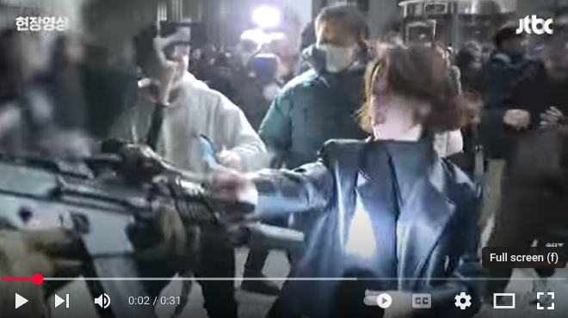 | In this video, Ahn Gwi-ryeong confronts the soldiers who were enforcing martial law. She says “Aren’t you ashamed?” while grabbing the soldier’s weapon. It is dark outside. There are many people filming or photographing.
Source: CTV , Canadian news organization, December 4, 2024
Link: https://tinyurl.com/koreaprotestctv

Formative questions:
How does this source corroborate other sources on Korean citizens’ reactions?
There has been controversy concerning this event. Some claim the event was staged and that she even applied makeup before the filming. Do these claims change the way we should understand this viral video? Why or why not?
How does this source challenge, deepen, or expand perspectives about the citizens’ reaction?

Student Handout: Supporting Question 2
Featured Source E | Statistics and Demographics

In South Korea’s most recent election, Yoon Suk Yeol was elected with 48.56% of the vote. Lee Jae-myung (quoted below) received 47.83% of the vote. Concrete statistics on the number of Korean citizens who joined in rallies to protest the martial law declaration in December 2024 are not known.

“The people should defend this nation,” Mr. Lee said during a live broadcast on social media on his way to the National Assembly in Seoul. “Please come to the National Assembly.” Thousands did.
Source: New York Times, US Newspaper, December 3, 2024

“Organisers claimed that more than 500,000 people participated in the rally, which took place amid a large police presence.”
Source: The Guardian , British newspaper, December 28, 2024

Some media estimates suggest that as many as 40% of the demonstrators were women in the age group late teens to 40s. Analysts say this emerging generation of women may be ready to play a bigger part in setting the nation's agenda.
"Women have historically been outsiders in political discourse," admits Hyobin Lee, an adjunct professor of politics and ethics at Chungnam National University. "South Korea's proportion of female politicians is dismally low, with only 17.1% of National Assembly members women.
"This reflects the deeply entrenched exclusion of women from politics," she told DW.
Source: DW, Germany’s international broadcaster, December 24, 2024

Formative questions:
What makes each of these sources trustworthy or convincing? What makes them less trustworthy or less convincing?
The Guardian relies on data from protest organizers. How might this affect our understanding of this excerpt and the statistics cited?
What new insights about Korean culture and politics do we learn from DW the German source?

Student Handout: Supporting Question 2
Featured Source F | News video from NBC News: December 5, 2024

Video: Citizen protesters erupt in South Korea to impeach president over martial law attempt

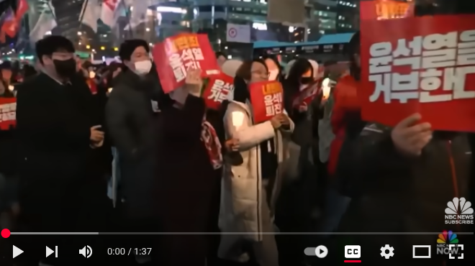 | Key moments from the transcript:  0:15-0:33: Since [the declaration of martial law], protests against him are growing louder. Thousands are joining rallies. They’re chanting Yoon Suk Yeol must resign. The crowd, a mix of generations equally outrated by attempts to upend democracy.
Source: NBC News, American media company, December 5, 2024
Link: https://tinyurl.com/koreaNBCreport (see 0:15-0:33 for important segments)

Formative questions:

How did American news organizations report on this event? To what degree do American news reports corroborate, challenge, or deepen perspectives on the citizen protests?
According to this source, how and why did citizens join the protests?

Supporting question 2 wrap-up task: How did South Korean citizens respond?

Answer one of the questions below, then share your responses with a classmate.

Option 1: Answer the supporting question by creating a metaphor that summarizes the citizens’ reaction:
“The response of Korean citizens was like _____ for these three reasons:
- _________
- _________
- _________. “
Option 2: Create a five-word story poem to capture the citizens’ response:
- Line 1: 5 words describing the cause or setting
- Line 2: 5 words describing the people involved
- Line 3: 5 words showing what they did
- Line 4: 5 words showing why it mattered or the impact of their action

After completing the wrap up task: compare your writing with the writing of a classmate. What overlapped in your wrap up? What differences did you highlight?

Student Handout: Supporting Question 3
Source Set A | Source A1: Opposition leader Jae-myung Lee films the fence jumping  Source A2: Speaker Woo Won-shik jumping the fence to the National Assembly  Source A3: Narrative explaining the crisis

Source A1:
Current President (then Opposition leader of the Democratic Party of Korea) Lee Jae-myung films himself jumping the fence to enter National Assembly
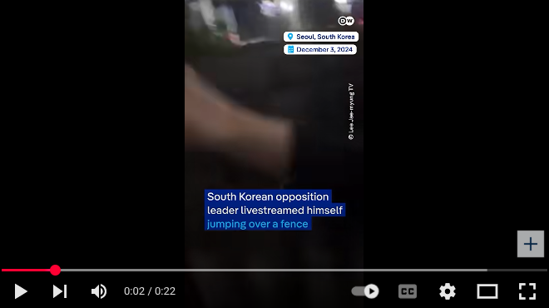  Source: DW News,, Germany’s international broadcaster, December 4, 2024  Link: https://tinyurl.com/korearesponse | Key quotes from transcript:  0:00-0:22: South Korean opposition leader livestreamed himself jumping over a fence to enter the parliament after President Yoon Suk Yeol declared martial law. Lee Jae-myung and other parliamentarians voted to declare the martial law invalid forcing President Yoon to reverse his decision.
Video: Lee Jae-myung is live streaming  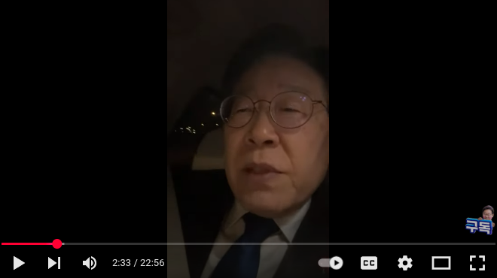  Source: Lee Jae-myung, verified account of opposition leader, December 3, 2024  Link: https://tinyurl.com/korealivestream (see 1:05-1:44; 14:43 for important segments) | Key quotes from transcript:  1:05-1:44: I'm also going to the National Assembly now…The National Assembly can decide to lift the emergency martial law, to strengthen democracy in this country so that the people can protect themselves. Please give me your strength….Everyone, please come to the National Assembly now. You must protect the National Assembly. This country - It is the last bastion of democracy. Respected and beloved citizens  14:43: Jumps over the fence to go to the National Assembly
Lee, while filming in his car, urged Koreans to join lawmakers at the National Assembly:
“The National Assembly must vote to lift martial law…There is a very high possibility that the military will be mobilized to arrest members of parliament…Please come to the National Assembly. Though it’s very late, it’s up to our citizens to protect this country. We will also risk our lives to protect the democracy of this country.”
Source: Associated Press / Politico , American news source, December 4, 2024

Source A2
National Assembly Speaker Woo Won-shik left his house immediately following the declaration of martial law. He arrived at the National Assembly building at 10:56pm. The gate he wanted to enter was blocked by police. To get into the building, he climbed over the gate.
Source: Korea JoongAng Daily (image) Korea JoongAng Daily (article); Korean newspaper; December 5, 2024

Source A3
Lee Jae-myung, the leader of the South Korean opposition, went viral across various social media platforms after he climbed over a fence to enter the parliament building, while live-streaming it.
In the video, Lee Jae-myung can be seen making a striking entrance into the National assembly, to cast his critical vote against the emergency martial law declaration that was proposed by President Yoon Suk Yeol.
He described the president's measures as "illegal" and expressed his deep concerns for the nation by stating, "The economy of the Republic of Korea will collapse irretrievably. My fellow citizens, please come to the National assembly." This captivating video has amassed millions of views across an array of online platforms.
In light of the escalating crisis, approximately 190 lawmakers gathered in the National Assembly, where they unanimously voted against the martial law declaration and urgently called for its immediate repeal. This controversial declaration, which was allegedly intended to protect the nation from threats posed by North Korea and to eliminate what was labeled as "antistate elements," sparked widespread outrage throughout the nation.

Source: Times of India, Indian daily newspaper, December 5, 2024

Formative questions:
Lee made two bold choices: to jump the fence and to livestream his actions. What message is Lee likely trying to send? What message is likely to be received from the Korean people who view this?
What is the significance of leaders like Lee and Woo Won-shik’s decision to livestream the fence jumping? Why is this important?

Student Handout: Supporting Question 3
Source Set B | Source B1: National Assembly resolution  Source B2: Transcript of National Assembly meeting  Source B3: Vote results  Source B4: Speaker Woo Won-shik summarizes outcomes

Source B1

Note: To overturn the martial law declaration, the National Assembly created a resolution that needed approval from the members of the National Assembly.

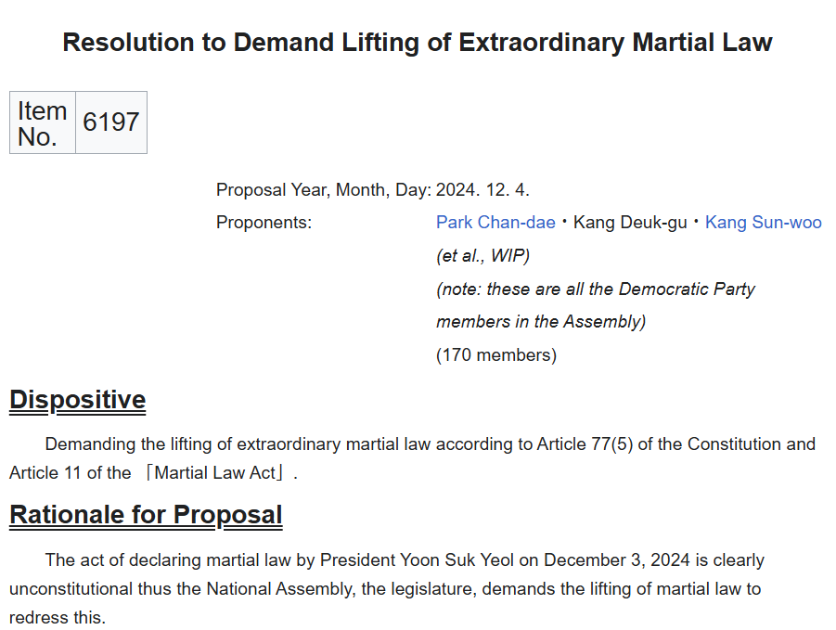

Source: Wikisource December 4, 2024

Source B2
Speaker Woo Won-shik presided over the early morning session at 1am on Wednesday, December 4, 2024.
Quorum is the minimum number of representatives needed to make the meeting valid.
Plenary session is an official meeting.

As we have met quorum, I will call the 15th plenary session to order….
No citizen has expected this incident and it is very difficult to agree on why martial law must be declared…. So our Assembly will also deal with this problem in an extraordinary manner.
Then we will put No. 1 on the Order of Business, Resolution to Demand Lifting of Extraordinary Martial Law to a vote. Please vote.
Have you finished voting? Then the vote will be concluded. I will announce the voting results.
Of 190 present, with 190 in favour, I declare the Resolution to Demand Lifting of Extraordinary Martial Law passed.
…Following the passage of the resolution by the Assembly, the president must lift the extraordinary martial law immediately. The declaration of extraordinary martial law is now void. My fellow citizens, please be reassured. The Assembly will defend democracy together with the citizens. To the military personnel and police that are in the Assembly grounds, please leave the Assembly immediately. That’s all for now….

Source: Wikisource, December 4, 2024, 1am

Source B3
There are 300 members in South Korea’s National Assembly.
This image shows the results of the vote. Green dots show votes in favor (190); pink dots show votes against (0); gray dots show not present (110).
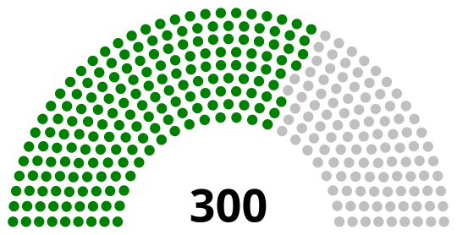
Source: Wikimedia , December 4, 2024

Source B4
In an article three weeks after the incident, Speaker Woo reflects on the actions he took:
“I knew we had the constitutional authority to lift martial law… I didn’t hesitate. I had to get inside the assembly, no matter what….In moments like this, following the correct procedure without error is even more vital…I heard young people call me the “National Assembly Thor.” I find it amusing…. South Korea is strong. Its people are resilient. While the world may have been startled by the martial law declaration, South Korea remains secure, stable, and confident in its future.”
Source: Al Jazeera , international news organization, December 27, 2024

Formative questions:

What actions did the government take following the declaration of martial law?
What are the two most important claims Speaker Woo makes as he reflects on the events? Why?

Student Handout: Supporting Question 3
Source Set C | Source C1: Resign or Impeach  Source C2: Impeachment Flowchart

Source C1
Impeach means removal from office because of misconduct or unconstitutional behavior.
Following the legislative action to overturn martial law, calls for Yoon’s impeachment mounted.
“We are a strong democracy…But Korean people want to be safe - President Yoon must resign or be impeached,” Yang Bu-nam, a Democratic Party politician, told the BBC.
Source: BBC, British public-service broadcaster, December 4, 2024

Source C2
The process for impeachment includes multiple steps requiring support from different branches of government in Korea.
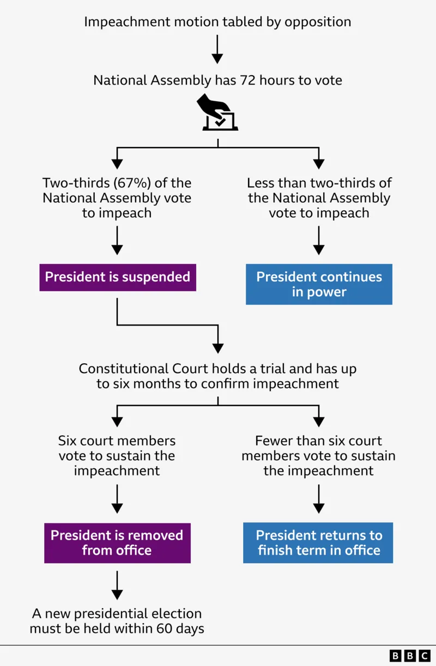
Source: BBC, British public service broadcaster, December 4, 2024

Formative questions:
What are the pros and cons of the impeachment process having multiple steps?
What do we learn about Korean government and their processes from these sources?
Yoon Suk Yeol was impeached on December 14, 2024 and removed from office on April 4, 2025. Do you think this outcome was justified? Why or why not?

Supporting question 3 wrap-up task: How did leaders, political parties, and the government of South Korea respond?
Answer one of these prompts:
- What lessons do you think politicians can learn from how South Korea’s government handled the martial law crisis? Write a letter to a politician or newspaper outlining what South Korea’s government did and what can be learned from it.
- Grade the response of the South Korean government (A to F). Explain your assessment and provide evidence from at least 3 sources. Be sure to be precise in your assessment of different government roles, functions, and people. .
- Create a flow chart showing at least five important events or actions of the Korean government following the declaration of martial law. For each transition, explain how the action or event caused or impacted the next.

Student Handout: Summative Performance Task
What happened when democracy was tested in Korea?
Directions: Using your analysis of the sources and your work for all three supporting questions, answer the inquiry question through a traditional essay, infographic, or short video.
What happened when democracy was tested in Korea?

Student Handout: Extension 1 - Summative Performance Task
How should we remember or memorialize this event?
The Fence Today
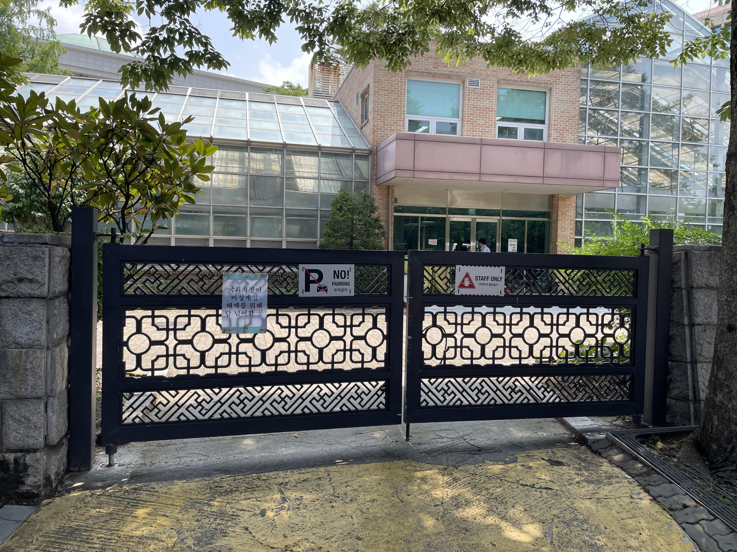

This is a photo of the fence that National Assembly Speaker Woo Won-shik scaled to enter the parliament building.
- How should this site in Seoul memorialize the events that threatened Korea’s democracy?
- How should the role of Korean citizens be remembered as part of the memorial?
- What type of memorial should be constructed and what should be included?

