Resource sheet 8.2B
Facsimile documents used in Lesson 8.2
DOCUMENT 1 – CAB 128/18/1, Labour cabinet minutes, 03/07/50

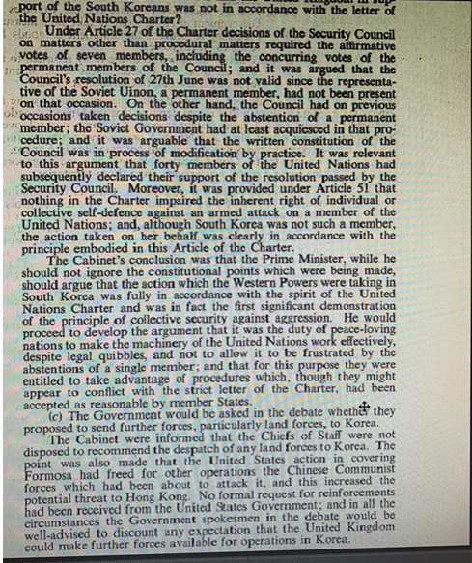
DOCUMENT 2 – DEFE 11/292, Joint Chiefs of Staff discussion, 03/07/50

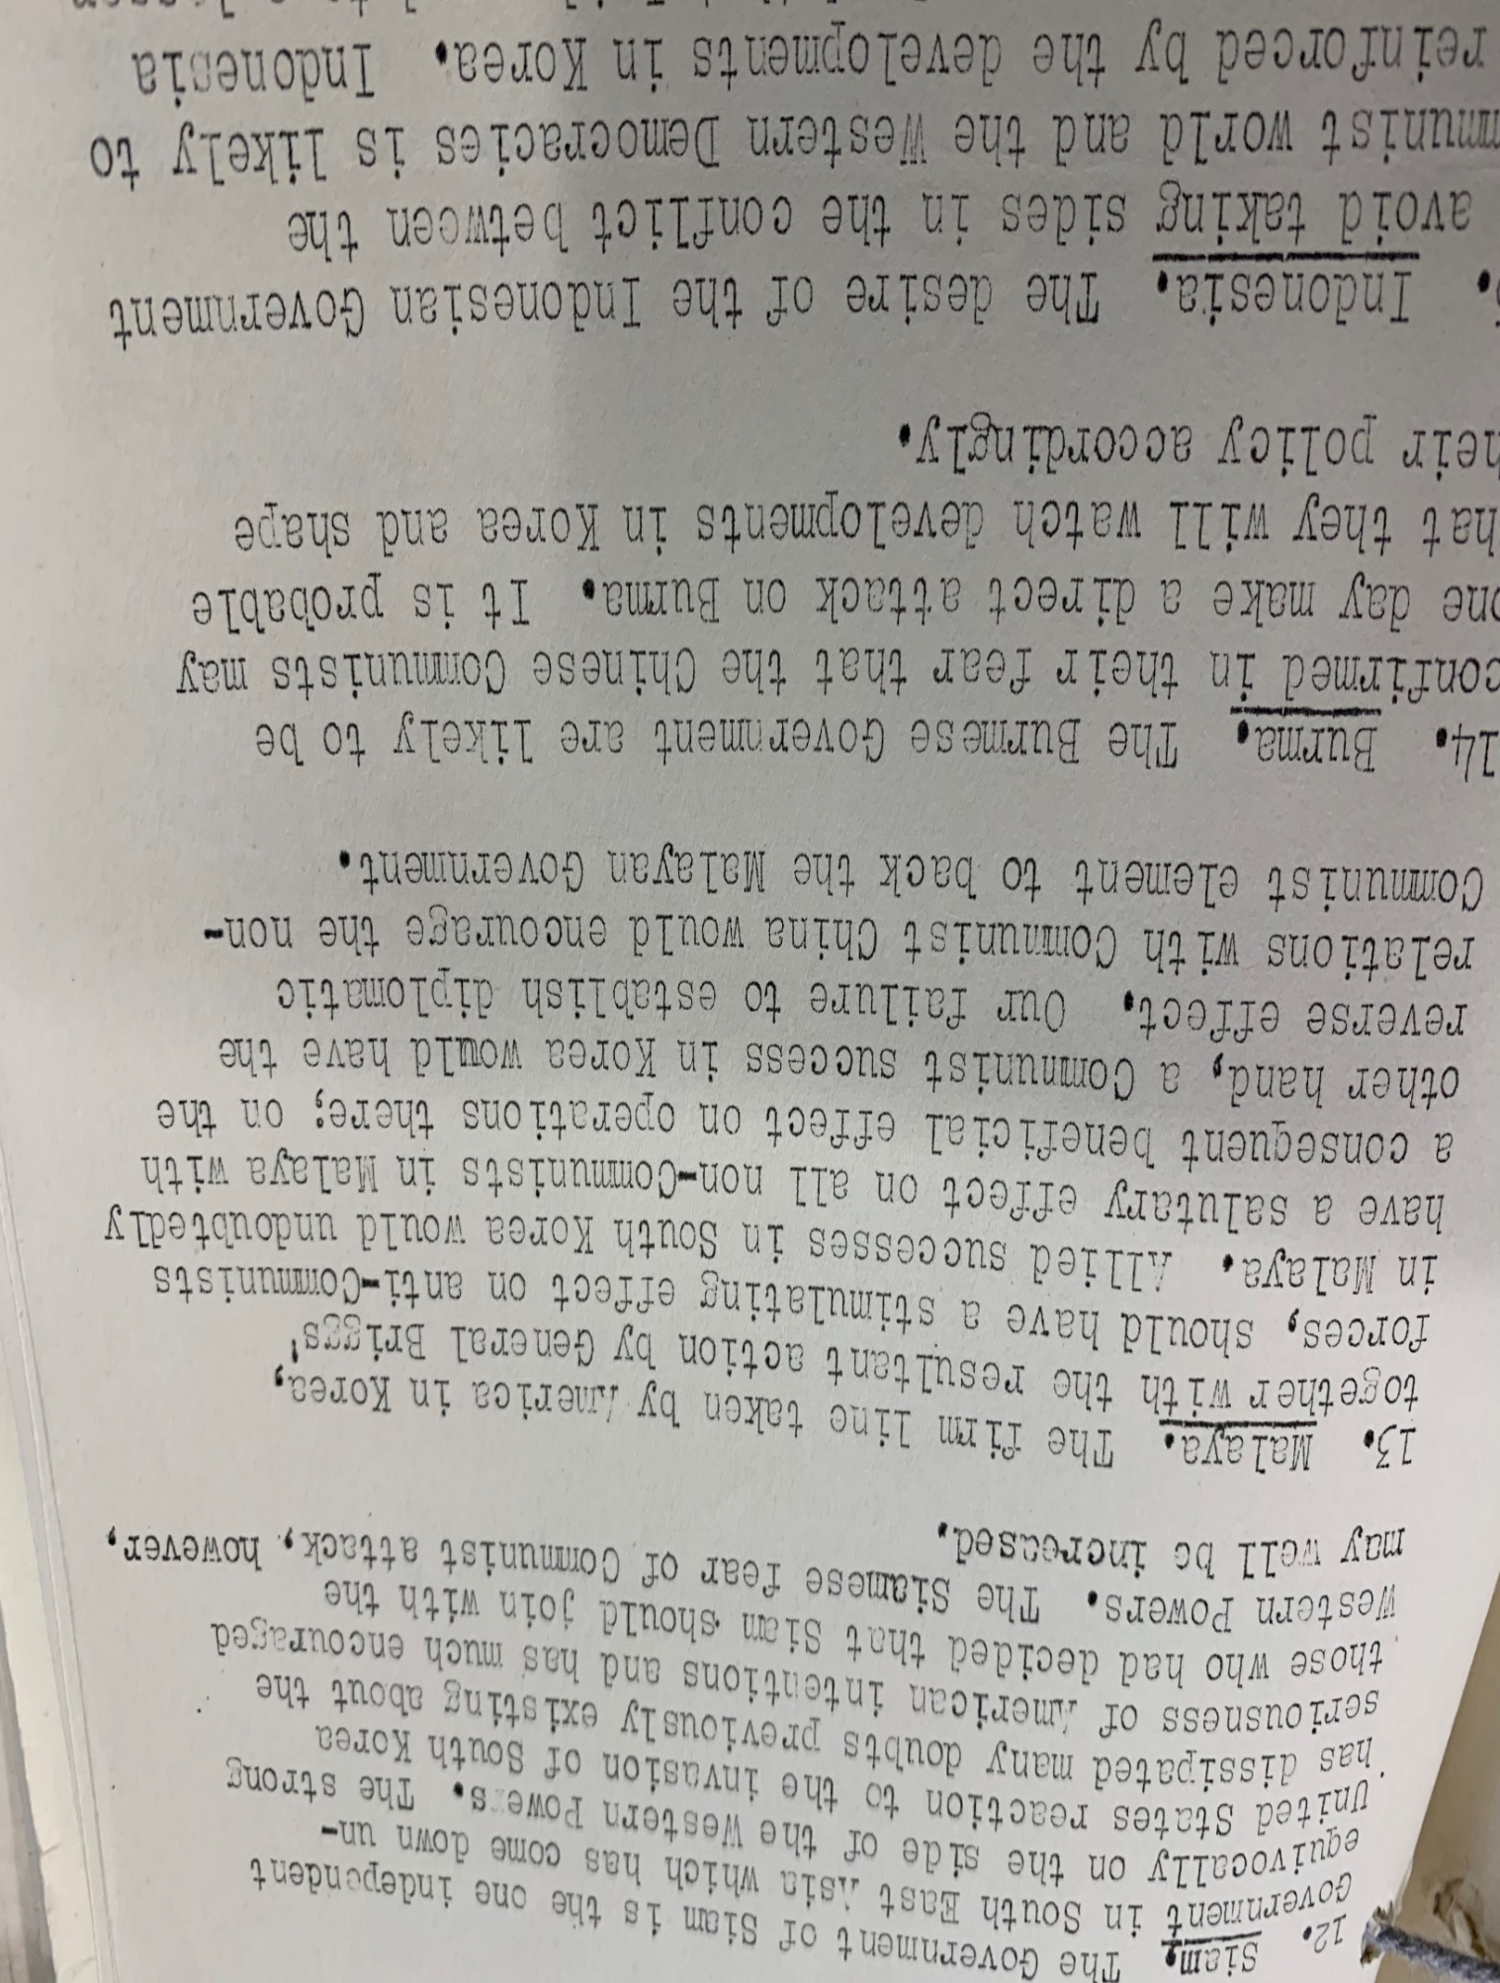
DOCUMENT 3 – DEFE 11/292, Defence Committee discussion, 13/07/50
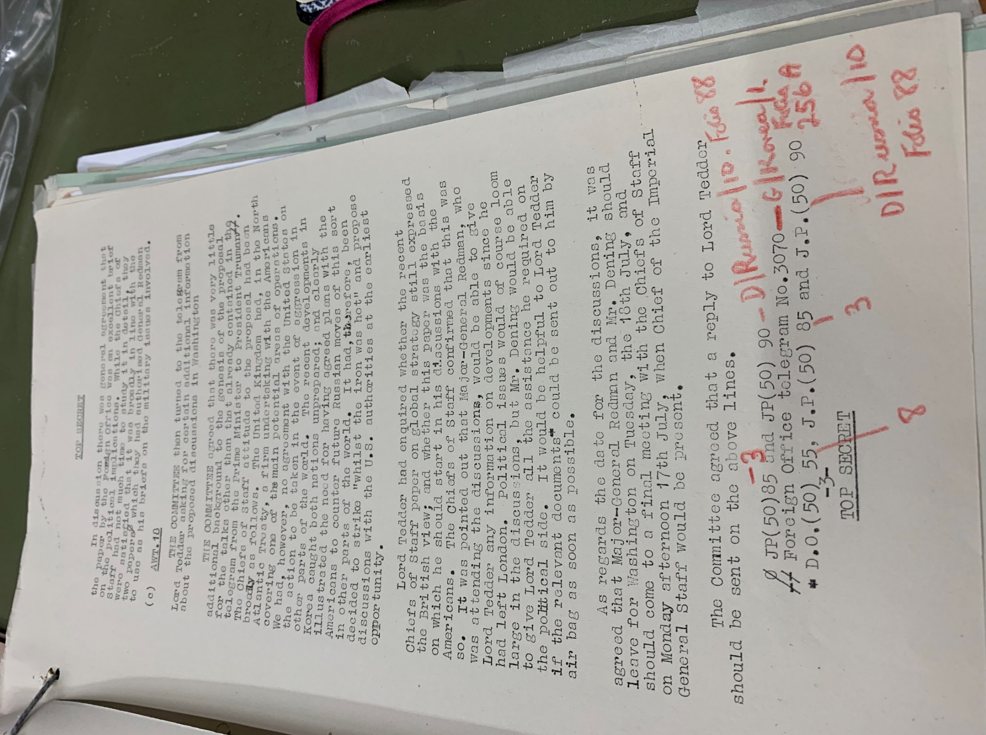
DOCUMENT 4 – FO 371/81655, Oliver Franks’ letter, 23/07/50

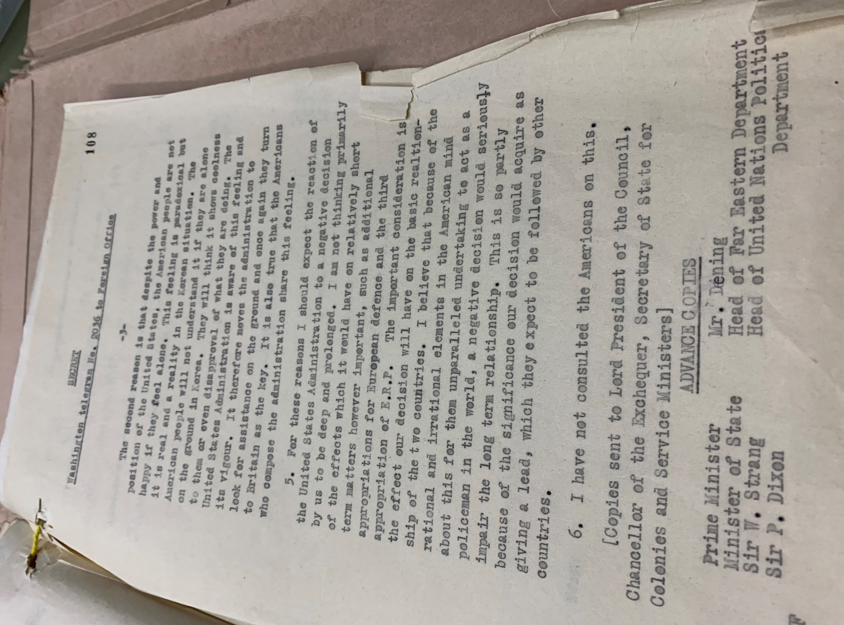
DOCUMENT 5 – CAB 128/18/50, Labour cabinet minutes, 25/07/50

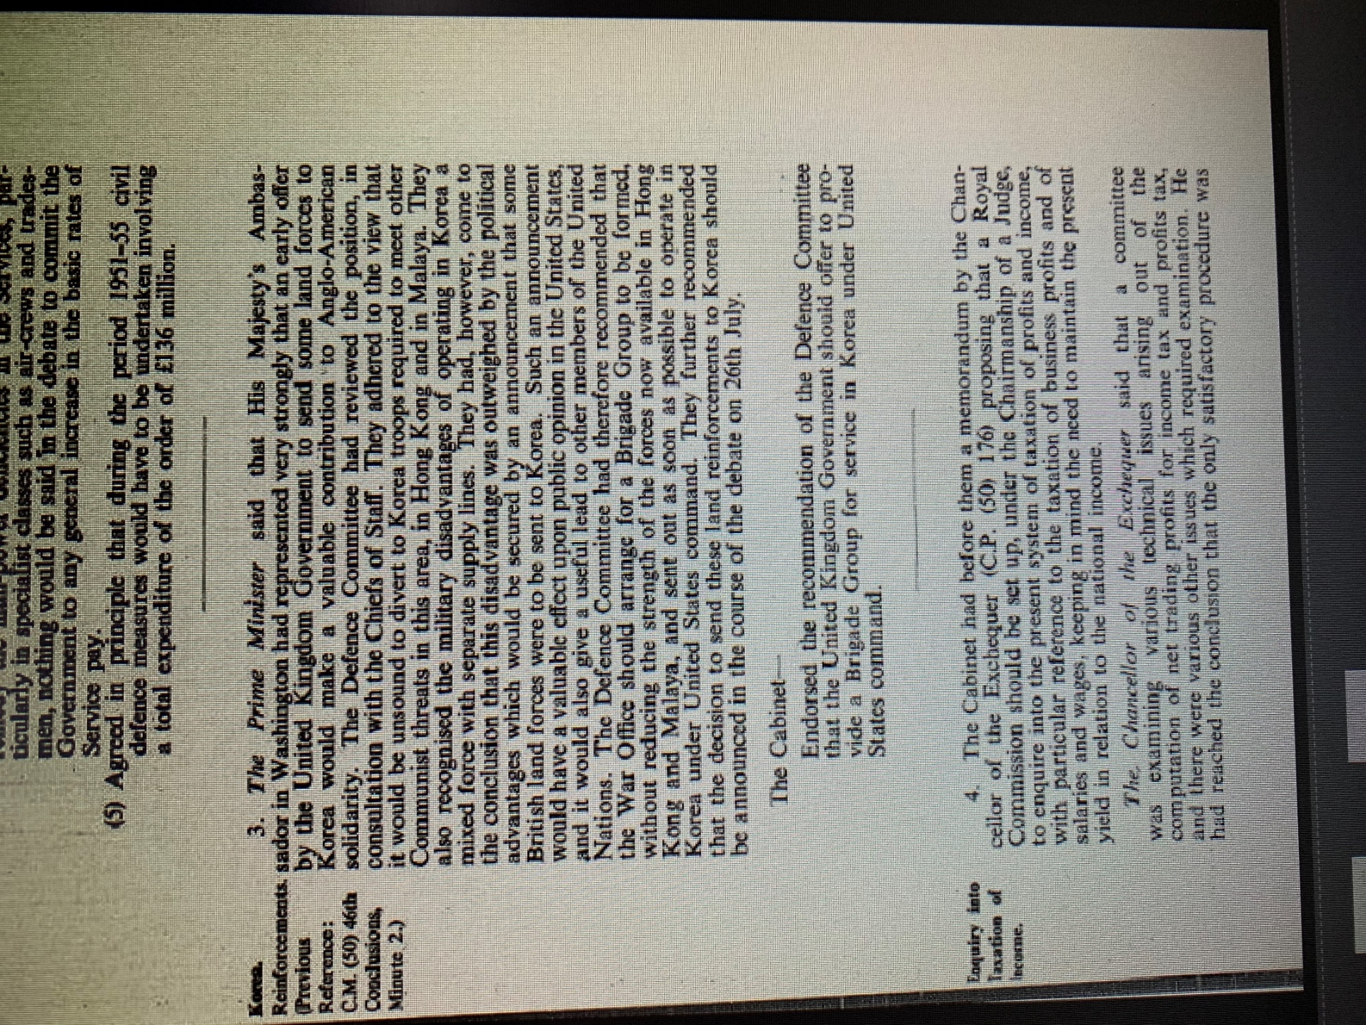

DOCUMENT 6 – FO 371/84091, Oliver Franks’ letter, 21/08/50

