Resource sheet 8.1B
Facsimile Cabinet Office documents used in Lesson 8.1
DOCUMENT 1 – CAB 128/18/1, Labour cabinet minutes, 03/07/50

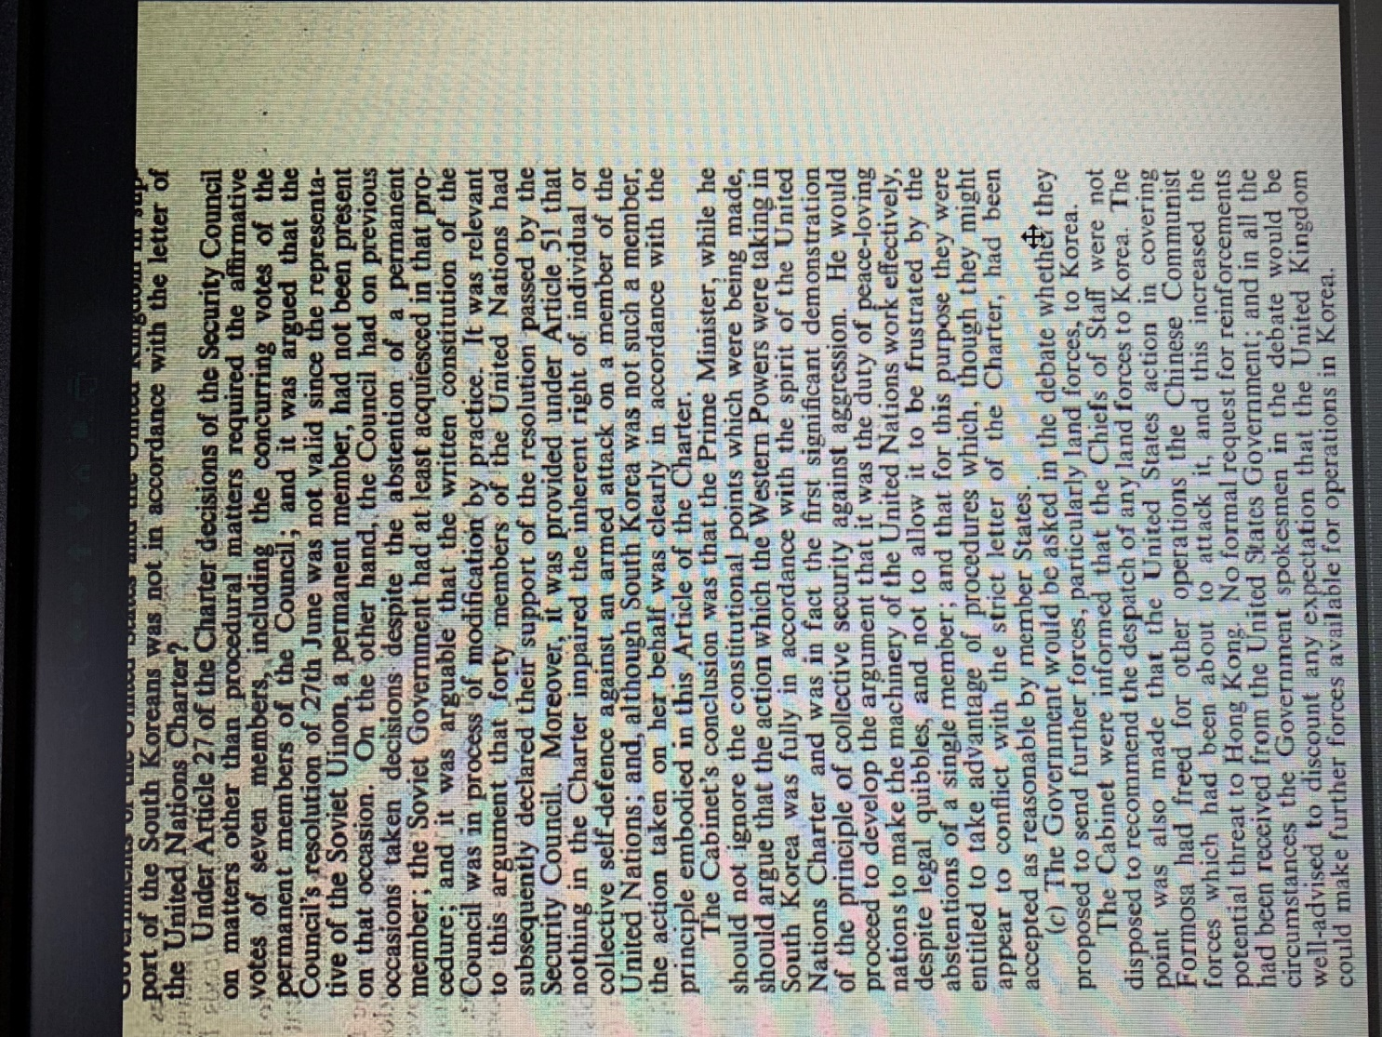
DOCUMENT 2 – CAB 128/18/2, Labour cabinet minutes, 04/07/50

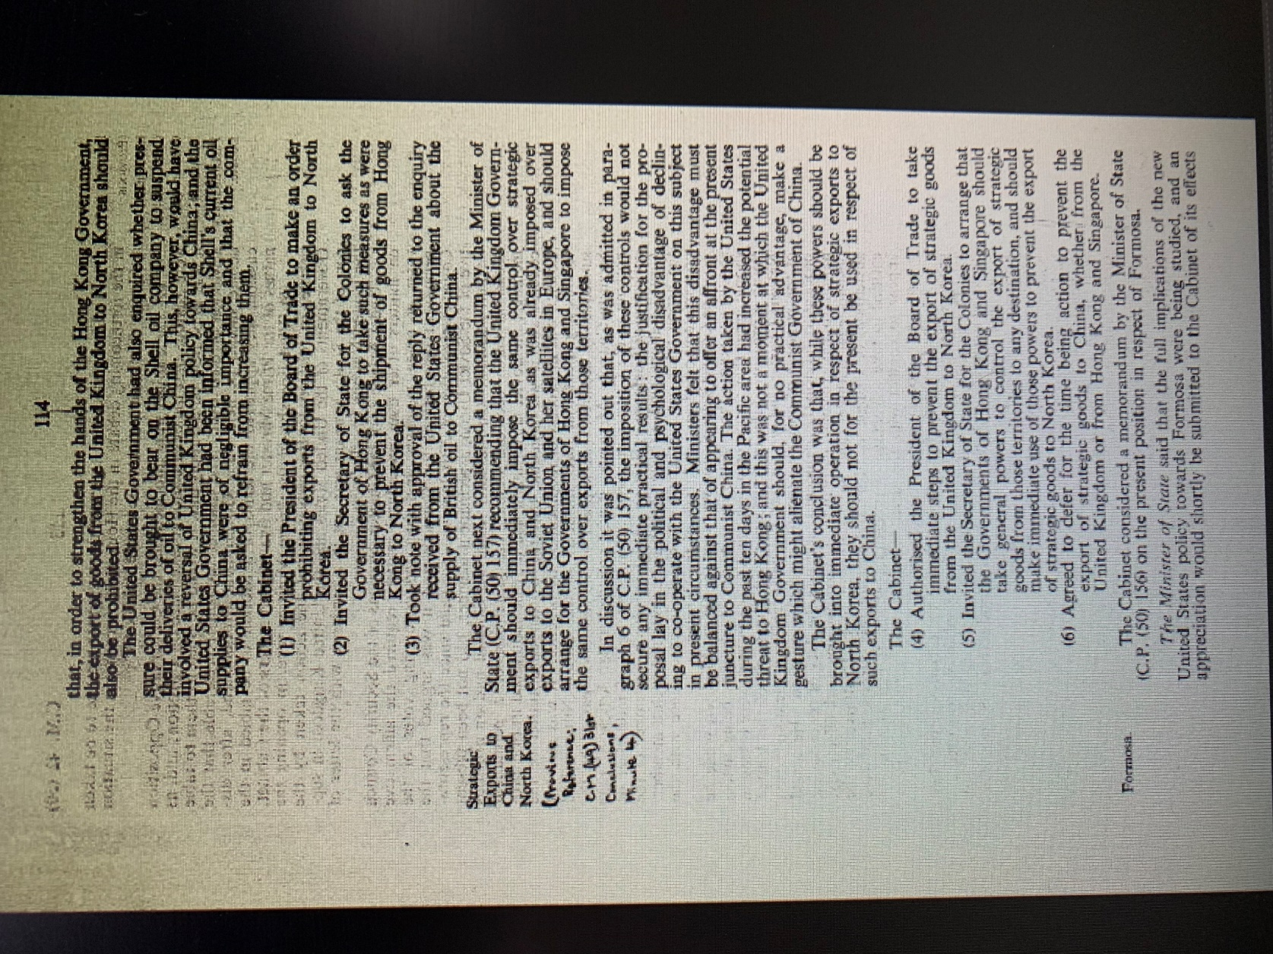
DOCUMENT 3 – CAB 128/18/10, Labour cabinet minutes, 25/07/50

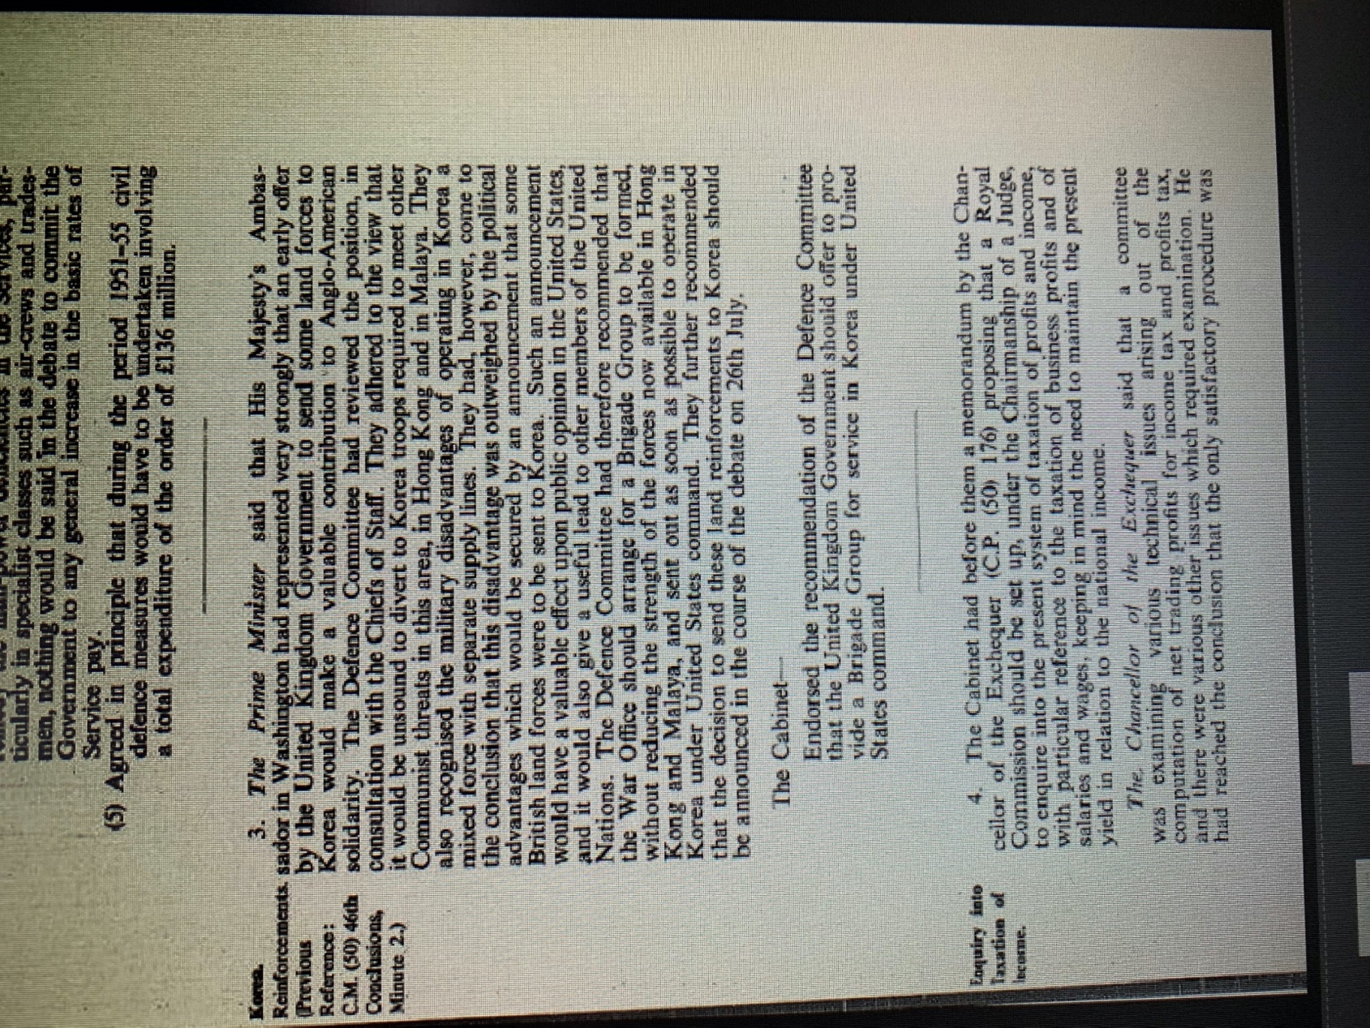
DOCUMENT 4 – CAB 128/23/16, Conservative cabinet minutes, December 1951

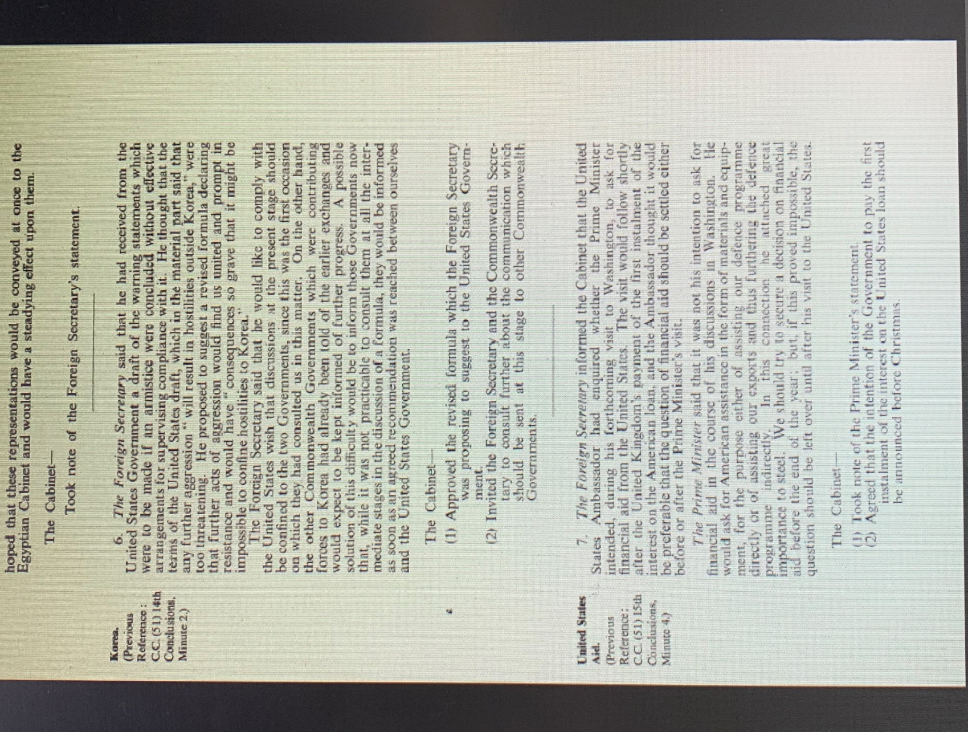

DOCUMENT 5 – CAB 128/23/16, Conservative cabinet minutes, December 1951
