Resource sheet 6.1C (page 1)
Sequencing map (Enlarge to A3 if possible)

Summarise, in 50 words or less (using bullet points or notes format), your answer to the question in each box.

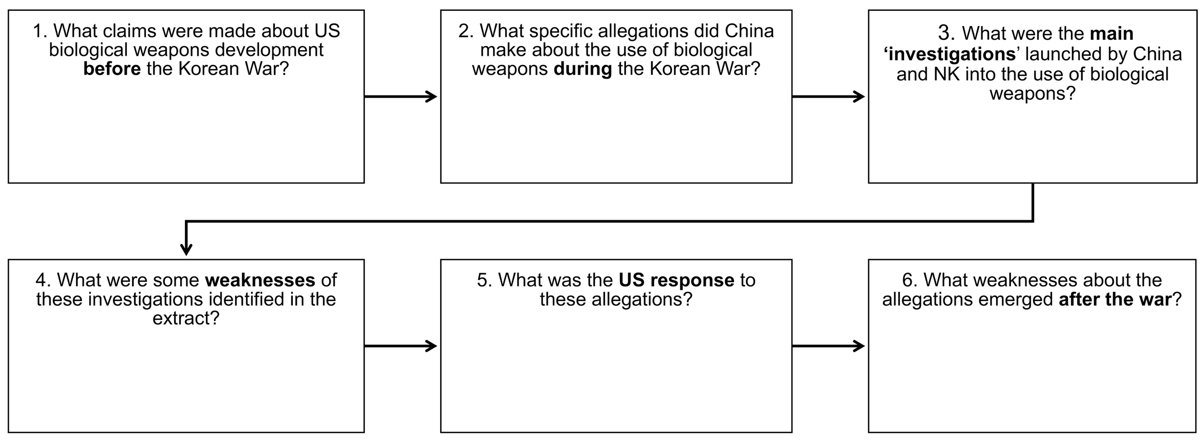

Resource sheet 6.1C (page 2)
Sequencing map support: possible responses

China claimed over 800 attacks on over 70 cities in NK. | Chinese rejected WHO offer of investigation.
Neither did any field investigations of their own. | NK first allege US use of smallpox in May 1951.
Soviets allege US use against Alaskan Inuits. | Soviets raised the issue at UN.
They criticised the ISC report and said that the insects  in the allegations would not have been able to carry  those disease. | They denied them publicly at the UN.
They accepted Chinese and North Korean evidence  fairly uncritically. | There were reports that paper packets of insects had been placed in the snow by Chinese soldiers.
Chinese say that US colluded with Japanese WW2  General Ishii who had used germ warfare in that conflict against China. | NK then claims US dropped plague- and  cholera-infected insects by air.
Chinese then commission IADL and ISC investigations – these corroborate allegations. | Some Chinese officials themselves have been  reported at separate times as saying that the claims  were fabricated.

Resource sheet 6.1C (page 3)
Sequencing map support: answers

