KOREAN WAR MODULE
DAY 02

MODULE OVERVIEW
HISTORICAL THINKING SKILLS:  Developments and Processes  - 1.A Identify and explain historical developments and processes.  Claims and Evidence in Sources  - 3.A Identify and describe a claim and/or argument in a text-based or non-text-based source.  Argumentation  - 6.A Make a historically defensible claim. | CONTENT:  People and states around the world challenged the existing political and social order in varying ways, leading to unprecedented worldwide conflicts.

D  A  Y  1 | was the korean war a product of decolonization or the cold war?
CLASS ACTIVITY: Structured Academic Controversy
Students will engage in a Structured Academic Controversy (SAC) to develop historical thinking skills in argumentation. They will develop historically defensible claims supported by specific and relevant evidence.
AP ALIGNED ASSESSMENT: Thesis Statement
Students will analyze primary and secondary sources to construct arguments with multiple claims. They will then create a complex thesis statement that evaluates the extent to which the Korean War was a product of decolonization and/or the Cold War.

D  A  Y 2 | evaluate the extent to which historical developments in the post-war period were caused by decolonization or the cold war?
CLASS ACTIVITY: Gallery Walk
Students will analyze multiple primary and secondary sources while participating in a gallery walk activity. Students will also evaluate to what extent each source reflects the historical developments of the Cold War or the process of decolonization. Students will need to consider issues of sourcing and how the author supports his/her claim.
AP ALIGNED ASSESSMENT: Short Answer Question and Stimulus Based Multiple-Choice Question
Students will complete a short answer question and/or nine multiple-choice questions that focus on whether decolonization or the Cold War played a more significant role in post-war historical developments.

D  A  Y  3 | how did the united states and the soviet union differ in their efforts to influence korea between 1949-1953?
CLASS ACTIVITY: Primary Source Analysis
Students will examine primary sources in order to analyze how the point of view, purpose, historical situation, and audience shape our understanding of what the document says. As an extension activity, students read and listen to veteran interviews in order to analyze how the veterans’ experiences as remembered in oral histories shape our understanding of the causes and effects of the Korean War.
AP ALIGNED ASSESSMENT: Document-Based Question
Document-Based Question: Evaluate the extent to which the United States and the Soviet Union differed in their efforts to influence Korea between 1949-1953.

D  A  Y  4 | explain the extent to which the effects of the cold war were similar in the eastern and western hemispheres.
CLASS ACTIVITY: Argumentation Exercise & Gallery Walk
Students will practice three targeted document-based skills: argument construction, making a claim, and complexity. While developing these targeted document-based skills, students will develop a basic understanding of the historical developments of the Cold War. Teachers may choose to have students write the full AP-aligned DBQ.
AP ALIGNED ASSESSMENT: Document-Based Question
Document-Based Question: Explain the extent to which the effects of the Cold War were similar in the Eastern and Western hemispheres.

MODULE SOURCES

D  A  Y  1 | AUTHOR  Dean Acheson  Soviet Officers  Kim Il Sung  UN Resolution  U.S. Congress  Syngman Rhee  Herb Block | SOURCE  Memo to Harry Truman  Report on Korea  Speech, 1st Congress of Korean Workers Party  The Problem of Independence of Korea  Korean Aid Act of 1949  Correspondence MacArthur to Truman  Cartoon “Those are the Flags…” | DATE  1945  1945  1946  1947  1949  1950  1950

D  A  Y  2 | AUTHOR  Winston Churchill, et al  Terenti Shtykov  Andrei Gromyko  Syngman Rhee  David M. Barrett  Mao Zedong  Dwight Eisenhower  Edwin Marcus  Catholic Cat. Guild  US Depart. of State  Che Guevara  Mao Zedong  Kim Il Sung  US Defense Depart.  Wiki Graphics: Semhur | SOURCE  The Cairo Declaration  Telegram between the Soviets and North Koreans  On American Intervention in Korea  Asian Peoples' Anti-Communist Conference  Sterilizing a "Red Infection"  Minutes of First Meeting with Nehru  Press Conference  Darkest Africa  The Red Iceberg  Memo from Rusk to Kennedy: Congo Crisis  Pasajes de la Guerra Revolucionaria  We Hope the Arab Countries Will Unite  Let Us Promote the World Revolution  The Pentagon Papers  Cold War Map, 1959 | DATE  1943  1950  1950  1954  1954  1954  1954  1955  1960  1961  1965  1965  1968  1971  2008

D  A  Y  3 | AUTHOR  Winston Churchill, et al  Joseph Stalin  Captain Vyvyan Holt  Joseph Stalin  Marguerite Higgins  Harry S. Truman  Joseph Stalin  Chart  Harry S. Truman  Jack Whelan  Charles Rangel  Glenn Paige  William F. Honaman | SOURCE  The Yalta Conference/Agreement  Notes of a meeting with Kim Il Sung  Confidential report to Ernest Bevin  Top secret telegram to Mao Zedong  Newspaper article  Public statement  Letter to Klement Gottwald  Troop strength during the Korean War  Memoirs Years of Trials and Hope  Interview, Korean War Legacy Foundation  Interview, Korean War Legacy Foundation  Interview, Korean War Legacy Foundation  Interview, Korean War Legacy Foundation | DATE  February 11, 1945  March 5, 1949  January 30, 1950  May 14, 1950  May 30, 1950  June 27, 1950  August 27, 1950  1950-1953  1955  2019  2013  2012  2018

D  A  Y  4 | AUTHOR  W. Churchill, et al  Clark Clifford  CIA  John B. Coulter  Cornell Capa  Patrice Lumumba  Kwame Nkrumah  David Bonoir | SOURCE  Potsdam Conference Proceedings  Certain Aspects of the Euro. Rec. Problem  Factors Affecting the Desirability of a UN  Military Conquest of all of Korea  Letter to South Korean Pres. Syngman Rhee  Photo of billboard in“Guatemala’s Current Situation Can Traced back to the CIA-led Coup”  TASS Interview  Letter to President Lyndon B. Johnson  House Congressional Record Report | DATE  1945  1947  1950  1951  1954  1960  1964  1985

DAY 2
Based on a 60-minute class
Lesson Question: To what extent were historical developments in the post-war period caused by decolonization or the Cold War.

AP Curriculum Framework Reference
Unit 8 Learning Objective A: Explain the historical context of the Cold War after 1945.
Unit 8 Learning Objective C: Compare the ways in which the United States and the Soviet Union sought to maintain influence over the course of the Cold War.
Unit 8 Learning Objective K: Explain the extent to which the effects of the Cold War were similar in the Eastern and Western Hemispheres.

Historical Reasoning Skills: Causation
OVERVIEW
Students will explore ten sources related to late 20th-century global historical developments. The students will work in small groups to analyze and discuss each source to determine to what extent the events in the sources were more influenced by the Cold War or by the process of decolonization. The students will participate in a gallery walk where they will annotate significant evidence from each source on large Post-It easel pads or butcher paper. Students will rotate through all ten sources adding to the annotations as they go through the source sequence. After the analysis of each source, students will evaluate whether the events in each source were more an effect of the Cold War or decolonization.

Materials needed for:
Homework
- Crash Course World History #39 - USA vs. USSR Fight! the Cold War (12:15 length)
- Crash Course World History #40 - Decolonization and Nationalism Triumphant (12:48 length)

In-Class Activity
- Large Post-It easel pads (10 pieces) or butcher paper
- Source 1-10 in the student handout packet
- Source 1- 10 individually printed for posting on easel pad/butcher paper
- Glue or tape
- The Cold War and Decolonization Scale (10 Copies)
- Markers and highlighters

SEQUENCE OF INSTRUCTION
HOMEWORK OVERVIEW
HOMEWORK (30 MINUTES):
- Students will watch each video to construct an understanding of decolonization and the Cold War. As students watch the videos, they should note any evidence from the videos that help them understand the Lesson Question and the question of causation.
- Students should also take notes on the basic causes and effects of each historical development.
Teacher Notes
If you have covered decolonization and the Cold War prior to the lesson and feel your students have the basics or big picture of each historical development, then the videos may not be necessary.

Teaching Tip

Crash Course with John Green can sometimes be too fast for students. Turning on the subtitles can help students follow the information.

CLASS ACTIVITY: WARM-UP/INTRODUCTION
WARM-UP/INTRODUCTION (10 MINUTES):
ACTIVITY 1: COLD WAR AND DECOLONIZATION RECALL. Quickly review and/or discuss a timeline (projected or on the board) that plots the following 20th-century events:
Event | Dates
End of World I  League of Nations Mandates  End of World War II  Indonesian Independence Struggle from the Netherlands  Vietnam War  Independence and Partition of India  Creation of the State of Israel  Berlin Blockade Airlift  NATO formation  End of Chinese Civil War / Creation of People’s Republic of China  Korean War  Warsaw Pact formation  Independence of Ghana from Great Britain  Cuban Revolution  Independence of Congo from Belgium  Independence of Algeria from France  Independence of Kenya from Great Britain  Soviet Invasion of Afghanistan  Perestroika and Glasnost  Tiananmen Square  Fall of the Wall  End of Soviet Union | 1918  1919  1945  1945 to 1949  1945-1975  1947  1948  1948  1949  1949  1950-53  1955  1957  1959  1960  1962  1963  1979  1987  1989  1989  1991
Have students recreate the timeline in their notes (or print this chart out). Using two colors, one for the Cold War and one for decolonization, ask students to categorize or label each event as more related to the Cold War or more related to decolonization. After this individual labeling in their notes, have students annotate at least one reason for their labeling of the Vietnam War, the Korean War, and Independence of Congo from Belgium. Have some students share their answers. Tell the class that the lesson today will test the extent to which many of these events were impacted by decolonization and/or the Cold War.
Teacher Notes
Students can reference their notes from the videos or prior knowledge from readings, class lectures, or other sources. The goal is to have a timeline that shows the process of decolonization and the Cold War rooted in the post-WWII era. Be ready to provide or have other students provide alternate rationales for all three of these events as possibly tied to decolonization and the Cold War. Most students will put the Vietnam War and the Korean War as the Cold War and Independence in the Congo as decolonization. Alternate explanations could show the process of French, American, and Japanese withdrawal from Vietnam and Korea, respectively, as aspects of decolonization. Some may view Independence in the Congo as an element of the Cold War due to the removal of Patrice Lumumba over his support for socialism and overtures toward the Soviet Union.

CLASS ACTIVITY PART 1: Decolonization or the Cold War? Gallery Walk
CLASS ACTIVITY (45 MINUTES):
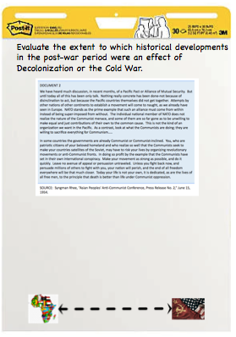
ACTIVITY 1: Gallery Walk source Analysis
Students will start in small groups at one of the 10 source posters. Give students 5 minutes per station to read and analyze each source. They should annotate on the poster one key piece of evidence from the source that shows an aspect of either decolonization or the Cold War. They should indicate on the scale on their handout to what extent the source reflects the process of decolonization or the Cold War and record justification for that evaluation. Example of poster above.

Teaching Tip
As students rotate to a new source, they will look for an additional piece of evidence that is different from what they already recorded. If groups later in the rotation cannot find additional evidence that has not already been identified, they can add their own justifications for previously identified evidence. As students note evidence, they need to ensure that their evidence helps them make a historical claim in a “to what extent” framework. The scale is to visually demonstrate the strength of the claim based on evidence.

CLASS ACTIVITY PART 2: Making a claim
CLASS ACTIVITY (5 MINUTES):
ACTIVITY 1: Review of all sources
After rotating through each source, have students rewalk each briefly to see annotations of other groups. Ask students to note if these annotations change their position on the decolonization to Cold War scale? If so, have students indicate this on their handout.

Have students write a final claim that answers the lesson question of the day: Evaluate the extent to which historical developments in the post-war period were caused by Decolonization or the Cold War.

ASSESSMENT: Short Answer Question (SAQ) or Stimulus Based Multiple Choice

Teaching Tip

Depending on the length of the class period, teachers may decide to assign either assessment piece as homework or at the beginning of the next class period. As this lesson is most likely coming weeks before the AP Exam, holding students to the 10-12 minutes timeframe for the SAQ is good practice. For the same reasons, consider using 9-10 minutes for the Multiple Choice questions.

IN-CLASS ACTIVITY MATERIALS
Directions
As your group concludes its analysis and annotations for each source, come to a final conclusion as to whether the events described in each source were more an effect of decolonization or the Cold War. Since the image is a scale, feel free to go as far to the left (decolonization) or right (Cold War) as you feel is warranted by your analysis. Write a short 1-2 sentence justification under the scale that explains your reasoning.

Source 1 - “The Cairo Declaration” November 26, 1943
To what extent…..

Source 2 - “Telegram from Soviet Ambassador Shtykov on a Luncheon at the Ministry of Foreign Affairs of the North Korea,” January 19, 1950
To what extent…..

Source 3 - Syngman Rhee, “Asian Peoples' Anti-Communist Conference, Press Release No. 2,” June 15, 1954.
To what extent…..

Source 4 - David M. Barrett. “Sterilizing a ‘Red Infection’: Congress, the CIA, and Guatemala,” 1954.
To what extent…..

Source 5 - Marcus, Edwin, Artist. Darkest Africa, 1955.
To what extent…..
Source 6 - Catholic Catechetical Guild, an anti-communist organization, “The Red Iceberg,” 1960.

To what extent…..

Source 7 - Memorandum From Secretary of State Rusk to President Kennedy, Congo Crisis, 1961.
To what extent…..

Source 8 - Excerpt from Che Guevara's “Pasajes de la Guerra Revolucionaria (Congo),” February, 1965.
To what extent…..

Source 9 - Mao Zedong, “We Hope the Arab Countries Will Unite,” March 23, 1965.

To what extent…..

Source 10 - Kim Il Sung, “Let us Promote the World Revolution,” October 8, 1968.

To what extent…..

Source 11 - U.S. Department of Defense, “US Involvement in the Franco-Viet Minh War, 1950-1954,” The Pentagon Papers, 1971.
To what extent…..

Gallery Walk Document Set

SOURCE 1
DOCUMENT | Joint statement from President Roosevelt, Prime Minister Churchill, and Chairman Jiang Jieshi (Chiang Kai-shek), "The Cairo Declaration," November 26, 1943. https://digitalarchive.wilsoncenter.org/document/122101
The three great Allies are fighting this war to restrain and punish the aggression of Japan. They covet no gain for themselves and have no thought of territorial expansion. It is their purpose that Japan, shall be stripped of all the islands in the Pacific which she has seized or occupied since the beginning of the first World War in 1914, and that all the territories Japan has stolen from the Chinese, such as Manchuria, Formosa, and the Pescadores, shall be restored to the Republic of China. Japan will also be expelled from all other territories which she has taken by violence and greed. The aforesaid three great powers, mindful of the enslavement of the people of Korea, are determined that in due course Korea shall become free and independent.

SOURCE 2
DOCUMENT | Terenty Shtykov, Soviet Union Ambassador to North Korea, “Telegram on a Luncheon at the Ministry of Foreign Affairs of North Korea,” January 19, 1950.
ANNOTATION | Shtykov was the head of the military occupation of North Korea following World War II from 1945-48 and the first Soviet Ambassador from 1948-1950. Here, he reports on a meeting in which Kim Il Sung, the leader of North Korea, is speaking to both Soviet, Chinese and Korean delegates.
The people of the southern portion of Korea trust me and rely on our armed might. Partisans will not decide the question. The people of the south know that we have a good army. Lately, I do not sleep at night, thinking about how to resolve the question of the unification of the whole country. If the matter of the liberation of the people of the southern portion of Korea and the unification of the country is drawn out, then I can lose the trust of the people of Korea.

SOURCE 3
DOCUMENT | Syngman Rhee, “Asian Peoples' Anti-Communist Conference, Press Release No. 2,” June 15, 1954.
ANNOTATION | Syngman Rhee was president of the Republic of South Korea from its founding in 1948 through 1960. He spent much of the early twentieth century in exile in the United States due to his political activities in opposition to the Ancient Regime in Korea and then Japanese occupation. At the end of World War II, Rhee returned to Korea and assumed a leading role in the South. He was elected to four terms as president, but resigned amid protests at alleged electoral corruption and spent the remaining five years of his life in exile in the United States.
In some countries, the governments are already Communist or Communist-inclined. You, who are patriotic citizens of your beloved homeland and who realize so well that the Communists seek to make your countries satellites of the Soviets, may have to risk your lives by organizing revolutionary movements or anti-Communist fronts. In doing so profit by the example that the Communists have set in their own international conspiracy. Make your movement as strong as possible, and do it quickly. Leave no avenue of appeal or persuasion untraveled. Unless you fight back now and persuade millions of others to fight with you, your nation will perish, and the end of all freedom everywhere will be that much closer. Today your life is not your own, it is dedicated, as are the lives of all free men, to the principle that death is better than life under Communist oppression.

SOURCE 4
DOCUMENT | David M. Barrett. “Sterilizing a ‘Red Infection’: Congress, the CIA, and Guatemala,” 1954.
ANNOTATION | In the early 20th century, Guatemala was ruled by dictators who supported foreign business interests. In the 1940s and 1950s, dictatorship ended and Guatemala held democratic elections won by socialist-leaning candidates who supported land reforms that threatened traditional elites and foreign businesses. Frequent military coups were also attempted but failed until a 1954 US-backed coup against the government of Jacobo Arbenz.
Following its 1944 revolution, which brought democratically elected leftist governments to power, this Central American government faced an increasingly hostile neighbor to the north, the United States. Guatemala's treatment of US-based corporations, especially the United Fruit Company, in expropriating land and other assets, did nothing to improve relations. Elites in Guatemala helped persuade US journalists and members of Congress, not to mention the executive branch, that their government was veering further and further leftward toward Communism in the early 1950s.
Late in the Truman presidency, the US government aborted an attempt to support Guatemalans who aimed to overthrow President Jacobo Arbenz. Those at CIA Headquarters who were involved in the effort felt "grimly" about that "horrifying" turn of events, one Agency leader noted in his diary. But, not surprisingly, new administration leaders--President Dwight Eisenhower, Secretary of State John Foster Dulles, and DCI Allen Dulles--also persuaded themselves that the Guatemalan government was "red." The CIA leader had help from the Board of National Estimates, which informed him on 22 April 1954 that "The Communists now effectively control the political life of Guatemala." A deal made by Arbenz's government to purchase Soviet-made armaments from Czechoslovakia that spring only sealed the matter in the American leaders' minds.

SOURCE 5
DOCUMENT | Edwin Marcus, artist. Darkest Africa, 1955.
ANNOTATION | European powers after World War II while attempting to recover and rebuild at home, also sought to maintain their colonial empires while being challenged by the growing Soviet and American rivalry. In most cases, these attempts at reimposing control were met with resistance by independence movements that were themselves influenced in kind by the growing superpower competition. In Africa, the British Gold Coast became the new Ghana in 1957 after a successful campaign for independence led by Kwame Nkrumah.
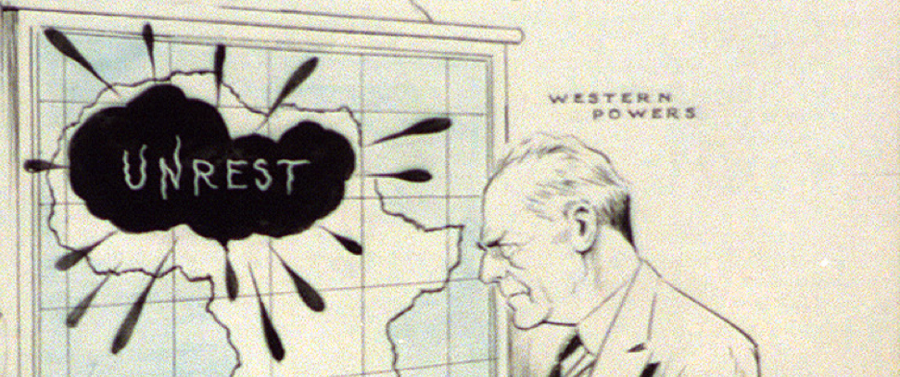

SOURCE 6
DOCUMENT | Catholic Catechetical Guild, an anti-communist organization, "The Red Iceberg", 1960.
ANNOTATION | This is the cover of a 1960 comic book published by Impact, an imprint of the anti-communist Catholic Catechetical Guild. The comic was distributed to thousands of Catholic school children in the United States.
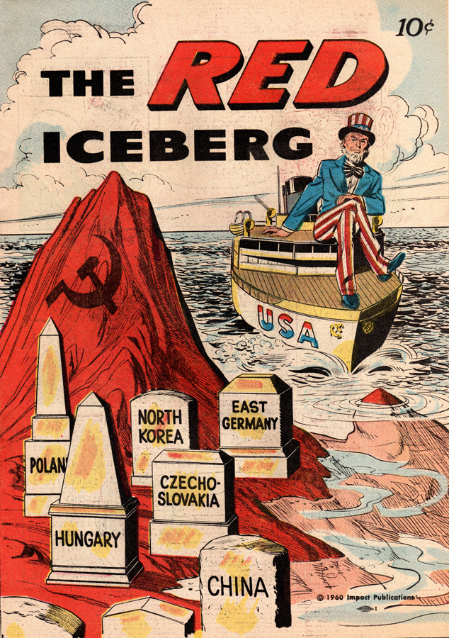

SOURCE 7
DOCUMENT | David Rusk, United States Secretary of State, Memo to President John F. Kennedy, Congo Crisis, 1961.
ANNOTATION | The Congo Crisis was a period after Congo’s independence from Belgium (1960-1965). Many factions existed after the Belgian withdrawal claiming legitimacy. The largest faction was led by Patrice Lumumba who led a central government for a time before being overthrown and executed in a military coup by the eventual victor in the civil war, Joseph Mubutu, who was backed by the United States and remained the leader of Zaire (the Congo) from 1965-1997.
...the United States must look to new policies in order to stem the present drift towards fragmentation in the Congo which would solidify Gizenga's control over Orientale**, turn this area into a Communist stronghold, and become a cancerous sore which could spread, with Communist assistance, to other parts of the Congo and Africa. We must alter the present policy since it is largely discredited in Africa and in Asia.
The United States objective in the Congo is the establishment and maintenance of a stable unified Congo with reasonable safeguards against a Communist takeover. The following three-point program is directed to this end. While there are a number of serious difficulties and risks which must be carefully weighed, the following program would [sic]provide a basis for a fresh start; it would constitute a positive initiative by the Kennedy Administration which offers reasonable hope for a solution of the Congo problem of regaining the United States position in Africa and Asia, and of placing the United States behind a more decisive United Nations program which, if successful, could strengthen the Organization as an instrumentality for peace. It is envisaged that the following three steps would be implemented simultaneously.
**Gizenga was an ally of Lumumba who led a rebellion in the Eastern Congo after Lumumba’s execution by elements of the army and the future dictator Mubutu.

SOURCE 8
DOCUMENT | Che Guevara, Pasajes de la Guerra Revolucionaria (Episodes of the Cuban Revolutionary War - Congo), February, 1965.
ANNOTATION | Che Guevara was an Argentine Communist and a leader in the Cuban Revolution. In 1965, Guevara left Cuba to support armed communist revolts in the Congo and later Bolivia where he was killed in an armed struggle in 1967 by CIA backed Bolivian forces.

I proposed to them, therefore, that the training not take place in faraway Cuba, but in nearby Congo [Che is therefore proposing that the recruits of non-Congolese guerrilla movements fight in the Congo] ... I explained to them why we considered the war for the liberation of the Congo to be of fundamental importance: victory there would have repercussions throughout the continent, as would defeat. Their reaction was more than cold; even though most refrained from making any comment, some bitterly reproached me. They stated that their people, ill-treated and abused by the imperialists, would object if they were to suffer losses to free not their own, but another country. I tried to make them understand that the real issue was not the liberation of any given state, but a common war against the common master, who was one and the same in Mozambique and in Malawi, in Rhodesia and in South Africa, in the Congo and in Angola, but not one of them agreed. Their goodbyes were polite and frosty.

SOURCE 9
DOCUMENT | Mao Zedong, “We Hope the Arab Countries Will Unite,” March 23, 1965.
ANNOTATION | Mao Zedong led China from 1949 until his death in 1976. He began revolutionary activities in the 1920s fighting against anti-communist Chinese nationalist forces and later the Japanese. After the defeat of the Japanese in 1945, Mao successfully led communist forces to victory in the Chinese Civil War, creating the modern communist Chinese state.
All revolutionaries and political parties in Asia should unite against imperialism. The strength of one or two countries is insufficient, but they can become a formidable force by uniting together. The entire Arab world is confronting imperialism. We hope the Arab countries will unite...
In resisting Japanese imperialism we stood together with the U.S., U.K. and France. After the surrender of Japan the U.S. helped Chiang Kai-shek launch the civil war to attack us. The U.K. and France were at that time powerless to bother about our affairs. The United States didn't directly participate in the war, only stationed some troops in harbors along the Chinese coast. They withdrew after we had annihilated Chiang Kai-shek's several million troops and when we were about to liberate those harbors. We later encountered them again on the Korean battlefield and fought for three years. The Vietnamese people have also met them now. It seems that the United States is fond of making war. Korea and Vietnam are so distant from the U.S., yet it still sent troops there…
In fact, such behavior by the U.S. is teaching the Asian people they must unite and carry on a resolute struggle. For example, the Vietnamese people didn't know how to fight a war before, but they are able to do so now. This is the advantage rendered us by imperialism. Imperialism also has its good side, don't you agree?

SOURCE 10
DOCUMENT | Kim Il-sung, “Let us Promote the World Revolution,” October 8, 1968.
ANNOTATION | Kim Il-sung was the leader of North Korea from its founding in 1948 until his death in 1994. Kim fought the Japanese as a member of the Chinese Communist Party and, beginning in World War II, worked closely with the Soviet Union. He led an invasion of US backed South Korea in 1950 in an attempt to unify the peninsula under communist rule.

The triumph of the Cuban Revolution is the first victory of the socialist revolution in Latin America and a continuation of the Great October Revolution in Latin America. With the Cuban Revolution emerging victorious, the Red banner of socialism now flies high over Latin America which was regarded as a hereditary estate of U.S. imperialism only until recently, and the socialist camp has extended to the Western Hemisphere and grown in strength a great deal. Today the Republic of Cuba which marches on firmly in the forefront of the Latin American revolution is the lighthouse of hope for the fighting Latin American peoples and throws the rays of victory on the road of their struggle. The triumph of the Cuban Revolution shook the colonial system of the U.S. imperialists to its very foundation in the Western Hemisphere and has thrown the whole Latin America into a revolutionary tempest, forcefully arousing the peoples in this area to the sacred struggle for independence and freedom. The triumph of the Cuban Revolution signified, indeed, the beginning of the disintegration of the U.S. imperialist system of colonial rule in Latin America, the stern judgment on U.S. imperialism which had exploited and oppressed the peoples in this area for a long period and its condemnation to ruin.

SOURCE 11
DOCUMENT | U.S. Department of Defense, “US Involvement in the Franco-Viet Minh War, 1950-1954”, The Pentagon Papers, 1971.
ANNOTATION | The Pentagon Papers was the name given to a leaked copy of a top secret US Defense Department internal study of the history of US involvement in Vietnam from 1945-1967, commissioned by members of the Johnson administration. The exact reason for the study is not known, but when it was leaked in the early 1970s, it exposed many contradictions between what US Governments in multiple administrations did and what they said to the public. In all, it exposed how multiple US Presidential administrations misjudged the situation in Southeast Asia and continued policies that only deepened the US involvement in the conflict in Vietnam.
American thinking and policy-making was dominated by the tendency to view communism in monolithic terms. The Viet Minh was, therefore, seen as part of the Southeast Asia manifestation of the world-wide communist expansionary movement. French resistance to Ho Chi Minh, in turn, was thought to be a crucial link in the containment of communism. This strategic perception of the communist threat was supported by the espousal of the domino principle: the loss of a single nation in Southeast Asia to communism would inexorably lead to the other nations of the area falling under communist control. The domino principle, which probably had its origin at the time of the Nationalist withdrawal from mainland China, was at the root of U.S. policy. Although elements of a domino-like theory could be found in NSC papers before the start of the Korean War, the Chinese intervention in Korea was thought to be an ominous confirmation of its validity. The possibility of a large-scale Chinese intervention in Indochina, similar to that in Korea, was feared, especially after the armistice in Korea.

ASSESSMENT MATERIALS

SAQ
Directions
Answer Question 1.
In your responses, be sure to address all parts of the questions you answer. Use complete sentences; an outline or bulleted list alone is not acceptable.
The Communist problem is not just a problem of one or two countries, but a world problem. It has reached a critical state of affairs because for forty year the United States and all the so-called democratic nations paid no attention at all, even though the Bolsheviks declared publicly that their aim was to have an International Revolution (which means devolution for every country). Their aim is to conquer the whole world and make it one world - no nations, no Korea, no Indo-China… Communists say that if they fail to win the world by ideological means they will conquer militarily any nation or people who refuse to join the cause for one world. So Russia has prepared a great military might and if ignored long enough will very soon conquer all nations and all peoples.

Statement by President Syngman Rhee at the Fourth Session of the
Asian Peoples' Anti-Communist Conference, June 16, 1954

Historically, all of us, people of the East, have been bullied by Western imperialist powers. Although Japan is located in the East, it was also an imperialist power that bullied other countries of the East. Now, however, even Japan is being bullied. China was bullied by Western imperialist powers for over one hundred years. Your country was bullied even longer, for more than three hundred years. Now the Japanese people are also being oppressed. Therefore, we, people of the East, have instinctive feelings of solidarity and protecting ourselves. Ambassador Raghavan has served in China for a few years, and he surely understands the Chinese people’s patriotism and their feelings for the Indian people and the people of other countries in the East. In spite of differences in our ideologies and social systems, we have an overriding common point, that is, all of us have to cope with imperialism. Prime Minister Nehru should not think that China has attained complete independence and has no problems.
Minutes of Chairman Mao Zedong’s First Meeting with Nehru, October 19, 1954

Using the excerpts above, answer (a), (b), and (c).
a. Identify a piece of historical evidence that supports the views of the author in the first excerpt.
b. Explain how the second source offers a different interpretation of historical developments in Asia in the latter half of the 20th century.
c. Describe a historical development outside of Asia in the latter half of the 20th century that supports the view of the author of the second source.

SAQ Scoring Guide
The examples below are not exhaustive of all possible correct examples.

- Identify a piece of historical evidence that supports the views of the author in the first excerpt.
Examples of responses that would earn credit for Part A:
- The creation of communist states in Eastern Europe, such as Poland, East Germany, and Hungary, after World War II at the behest of the Soviet Union.
- The successful communist revolution in China in 1949, supported by the Soviet Union.
- The creation of a communist North Korea in 1948, supported by the Soviet Union and later China.
- The existence of the Comintern, or Communist International organization, backed by the Soviet Union from 1919 to 1943 that actively sought to encourage communist revolutions across the globe.
- Explain how the second source offers a different interpretation of historical developments in
Asia in the later half of the 20th century.
Examples of responses that would earn credit for Part B:
- Source implies that resistance to imperialism is the common historical development in Asia and not necessarily communist revolution.
- Source implies that Indian Independence and the Communist revolt in China are all similar reactions to western aggression of prior centuries.
- Source implies that conflict between communism and capitalism/democracy is not the root of problems in Asia but instead is resistance to imperialism.
- Describe a historical development outside of Asia in the latter half of the 20th century that supports the view of the author of the second source.
Examples of responses that would earn credit for Part C:
- The Cuban Revolution of 1959 overthrows a dictator supported by western businesses.
- The Mau Mau Uprising in Kenya in the 1950s and eventual independence from Great Britain in 1963 saw a native people resist and gain independence from an imperial power.
- The creation of the nation of Ghana in 1957 saw a native people resist and gain independence from an imperial power, the British.
- The Algerian War of Independence from 1954 to 1962 saw a native people resist and gain independence from an imperial power, the French.

Stimulus Based Multiple Choice Questions
Directions:
Each of the questions or incomplete statements is followed by four suggested answers or completions.
Select the one that is best in each case.
Source materials have been edited for the purpose of this exercise.
Question 1-3 refer to the image below:

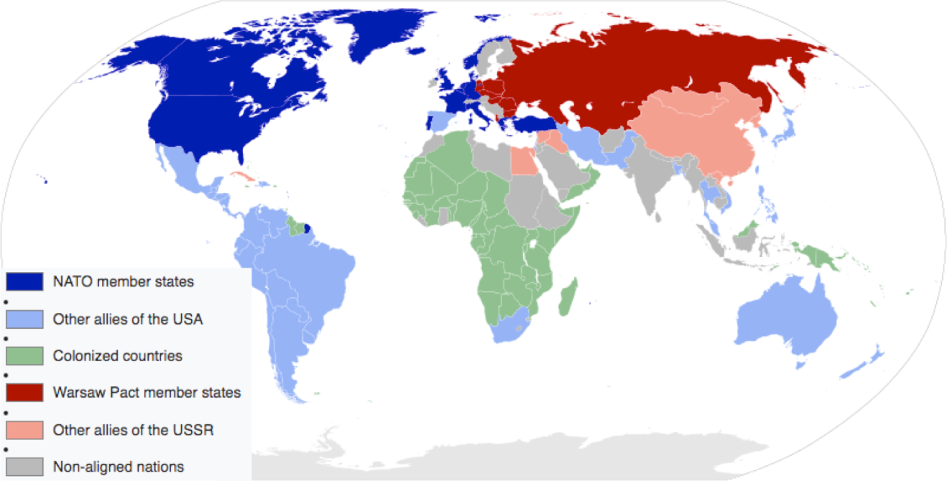
Cold War Map 1959. Wiki Commons.
https://commons.wikimedia.org/wiki/File:Cold_War_Map_1959.svg

- Which of the following ways the United States and the Soviet Union sought to maintain influence over the course of the Cold War is best depicted in the map?
- The proliferation of nuclear arms
- The development of proxy wars between and within postcolonial states
- The creation of new military alliances
- The redrawing of political boundaries

- Which of the following best explains the reason for the existence of the non-aligned nations depicted in the map?
- The global balance of economic and political power shifted after World War II to the south.
- Groups opposed and promoted alternatives to the existing economic and political order.
- Regional, religious, and ethnic movements challenged colonial rule.
- States responded in various ways to the economic challenges of the era.

- All of the following 19th-century historical developments continue to impact the world in the period depicted on the map EXCEPT?
- Industrialism
- Nationalism
- Imperialism
- Mercantilism
Each of the questions or incomplete statements is followed by four suggested answers or completions. Select the one that is best in each case.
Source materials have been edited for the purpose of this exercise.
Question 4-6 refer to the passage below:

“Question from Robert Richards, Copley Press: Mr. President, would you mind commenting on the strategic importance of Indochina to the free world? I think there has been, across the country, some lack of understanding on just what it means to us.

THE PRESIDENT... First of all, you have the specific value of a locality in its production of materials that the world needs. Then you have the possibility that many human beings pass under a dictatorship that is inimical to the free world. Finally, you have broader considerations that might follow what you would call the "falling domino" principle. You have a row of dominoes set up, you knock over the first one, and what will happen to the last one is the certainty that it will go over very quickly. So you could have a beginning of a disintegration that would have the most profound influences. Now, with respect to the first one, two of the items from this particular area that the world uses are tin and tungsten. They are very important. There are others, of course, the rubber plantations and so on. Then with respect to more people passing under this domination, Asia, after all, has already lost some 450 million of its peoples to the Communist dictatorship, and we simply can't afford greater losses. But when we come to the possible sequence of events, the loss of Indochina, of Burma, of Thailand, of the Peninsula, and Indonesia following, now you begin to talk about areas that not only multiply the disadvantages that you would suffer through loss of materials, sources of materials, but now you are talking really about millions and millions and millions of people. Finally, the geographical position achieved thereby does many things. It turns the so-called island defensive chain of Japan, Formosa, of the Philippines and to the southward; it moves in to threaten Australia and New Zealand.”

US President Dwight Eisenhower, News Conference, April 7, 1954

- Which of the following developments best explains the historical context for the attitudes expressed in the passage?
- The Russian Revolution
- World War II
- The Korean War
- The Chinese Great Leap Forward

- The primary reason for the policy alluded to in the passage is
- Fear of Chinese domination of Japan
- Fear of communist expansion
- Fear of a renewal of World War II hostilities
- Fear of renewed European colonial rule

- The sentiments expressed in the passage by the President could be similarly stated by critics of which 19th-century historical development?
- Internationalism
- Imperialism
- Marxism
- Ethnic Nationalism

Each of the questions or incomplete statements is followed by four suggested answers or completions. Select the one that is best in each case.
Source materials have been edited for the purpose of this exercise.
Question 7-9 refer to the passage below:
“On October 31, 1949, Sin Sen Mo, Defence Minister of the Syngman Rhee government, also told newspaper correspondents that the South Korean troops were strong enough to act and take Pyongyang within a few days. Only one week before the provocative attack of the South Korean troops on the frontier areas of the Korean People's Democratic Republic, Syngman Rhee said, in a speech on June 19 in the so-called "National Assembly" where Mr. Dulles, adviser to the U.S. State Department, was present: "If we cannot protect democracy in the cold war, we shall win in a hot war."

...The United States Government tries to justify armed intervention against Korea by alleging that it was undertaken on the authorisation of the Security Council. The falsity of such an allegation strikes the eye. What really happened? It is known that the United States Government had started armed intervention in Korea before the Security Council was summoned to meet on June 27, without taking into consideration what decision the Security Council might take. Thus the United States Government confronted the United Nations Organisation with a fait accompli, with a violation of peace….

The illegal resolution of June 27, adopted by the Security Council under pressure from the United States Government, shows that the Security Council is acting, not as a body which is charged with the main responsibility for the maintenance of peace, but as a tool utilised by the ruling circles of the United States for unleashing war. This resolution of the Security Council constitutes a hostile act against peace.

If the Security Council valued the cause of peace, it should have attempted to reconcile the fighting sides in Korea before it adopted such a scandalous resolution. Only the Security Council and the United Nations Secretary-General could have done this. However, they did not make such an attempt, evidently knowing that such peaceful action contradicts the aggressors' plans.”

Statement by Andrei A. Gromyko, Deputy Minister of Foreign Affairs of the USSR, July 4, 1950.

- Which of the following best describes the main argument of the passage above?
- To undermine the legitimacy of United Nations actions on the Korean Peninsula.
- To justify the invasion of South Korea by North Korea.
- To defend the actions of the United States in support of South Korea.
- To condemn Soviet interference in the affairs of North Korea.

- A historian researching global conflict would most likely find the document useful as a source of information for which of the following 20th-century historical developments?
- Governments often took on a strong role in guiding economic life to promote development.
- Militarized states often responded to the proliferation of conflicts in ways that further intensified conflicts.
- New international organizations formed with the stated goal of maintaining world peace and facilitating international cooperation.
- The redrawing of political boundaries after the withdrawal of former colonial authorities led to the creation of new states.

- Which of the following led directly to the historical development that is the subject of the passage?
- Political disputes resulting from decolonization.
- Communist victories in Asia and Eastern Europe.
- US efforts to contain the spread of communism.
- New military alliances and nuclear proliferation.

