World History Digital Education
Lesson Plan

Nuclear Attack on Seoul and Tokyo – Teaching About the Crisis with North Korea
AUTHOR INFORMATION

Author: Thomas Mueller, Ph.D., GISP
GENERAL INFORMATION

Lesson Grade Span: Secondary (9-12)
Targeted Grade Level/Course: (Grade 12: World Geography)
Estimated Time to Complete Lesson: (90 minutes)

FOCUSED QUESTION

A potential first strike against North Korea could lead to an attack on Seoul and Tokyo. What are the possible impacts?

SOCIAL STUDIES STANDARDS

National Geography Standards Standard 1: How to use maps and other geographic representations, geospatial technologies, and spatial thinking to understand and communicate information

Standard 13: How the forces of cooperation and conflict among people influence the division and control of Earth's surface

STUDENT OUTCOMES & LESSON TARGETS

After this exercise, the students should be able to…
- Analyze maps to examine spatial patterns
- Understand Buffers
- Analyze data and draw conclusions
LESSON OVERVIEW

Preparation before Exercise
The teacher should begin discussion about the crisis with North Korea by having students watch Secret State: Inside North Korea, PBS Frontline. The link is in the Background knowledge of the Teaching About the Crisis with North Korea.

The teacher should also show a map of East Asia (Highlighting North Korea, South Korea and Japan).

A potential first strike against North Korea could lead to an attack on Seoul and Tokyo. Let’s examine the possible impacts.

Why are we choosing 250 KT? Show the following article in class. https://www.popularmechanics.com/military/weapons/a27758417/north-korea-nuke/

PROCEDURES

Exercise
- Teachers might want to go over NUKEMAP using the steps as an example.
- The class can be divided into groups based on the table below:
- Seoul 250 KT (20% Success of Nuclear Weapon)
- Seoul 250 KT (50% Success)
- Seoul 250 KT (80% Success)
- Tokyo 250 KT (20% Success)
- Tokyo 250 KT (50% Success)
- Tokyo 250 KT (80% Success)
- Each group would navigate to the NUKEMAP website - https://nuclearsecrecy.com/nukemap/
- They would enter the following information
- In the Number 1 – Select your City – either Seoul and Tokyo
- In the Number 2 – Enter a yield 250
- In the Number 3 – Choose Airburst and Causalities
- In the Number 4 – Click Detonate
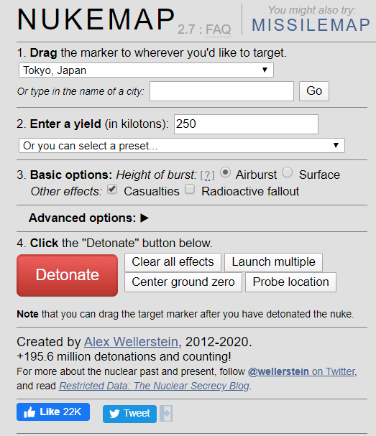
- Write down the following information
- Estimated fatalities
- Estimated Injuries
- Then based on your assigned percent, compute the new estimated fatalities and injuries.
- For example, if your group is 20% then 120 fatalities should be multiplied by 0.20
- 120 * 0.20 = 24 Fatalities
- Students should also read take notes on the Effect Distances of each buffer.
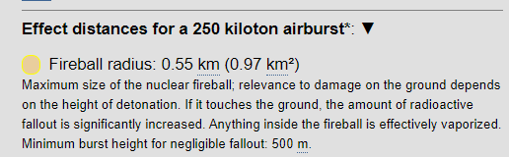
- The teacher can discuss Buffers at this time. Here is an article - https://www.gislounge.com/buffers-in-gis/
- Students then Click the Layers tool and choose Satellite
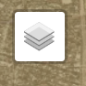
- Then students zoom into the impacted area and examine the Landscape. Write down a description of the Landscape by Effect Distances – Buildings, Farms, etc. How close are the buildings?, etc
- Zoom out
- Groups should click Launch Multiple
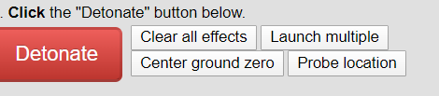
- Move the cursor to a new location around Tokyo, Japan
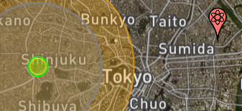
- Click Detonate
- Write down the following information
- Estimated fatalities
- Estimated Injuries
- Then based on your assigned percent, compute the new estimated fatalities and injuries.
- Repeat Steps 11 – 15 to complete an another attack
- Zoom in again and examine the landscape.
- Click the Layers button again to clearly visualize the buffers.
- Zoom out to take a screen shot of your area.
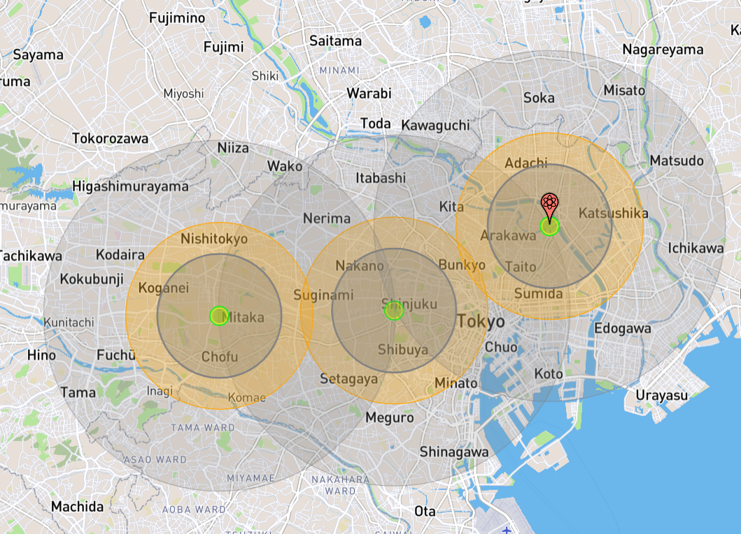
- Students should then research the human fatalities, injuries and way of life after the bombing of Hiroshima and Nagasaki in World War II
- After all the information has been gathered then groups with the same city (All Tokyo groups) should meet (via Zoom) to discuss similarities and differences on location of missiles. They should also discuss the differences in fatalities and injuries.
- How does this impact their decision on an initial attack on North Korea? Why?
- Students should be given time to return to their groups and create a presentation.
- Each group will present their findings and thoughts (maybe PowerPoint) during a Zoom session.

FORMATIVE ASSESSMENT

Content accuracy ______ / 30

- presentation covers basic concepts and background related to topic
- material is on topic and correct
+ Explains the information on the maps
+ Explains the buffers and material related to the buffers
- incorporation of Background information
- handles difficult concepts related to topic
- hits subtleties of the topic
- uses information to draw conclusions

Aesthetics _______ / 10

- good use of color
- clear images
- legible
- uncluttered
- few errors

Communication ______ / 10

- communication of project demonstrates understanding
- eye contact
- clarity
- preparedness for answering questions

RESOURCE LIST

Teaching About the Crisis with North Korea – Background section. https://www.teachingaboutnorthkorea.org/background-knowledge/

NUKEMAP by Alex Wellerstein https://nuclearsecrecy.com/nukemap/

Buffers in GIS by Caitlin Dempsey in the GIS Lounge -
https://www.gislounge.com/buffers-in-gis/

North Korea’s Latest Nuclear Test Was More Powerful Than We Thought by Kyle Mizokami – in Popular Mechanics. https://www.popularmechanics.com/military/weapons/a27758417/north-korea-nuke/

MODIFICATIONS & EXTENSIONS (OPTIONAL)

Extended Assignment
Students could take the number of fatalities and compute the percent of population in the areas would perish.
According to the World Urban Areas 15th Edition - http://www.demographia.com/db-worldua.pdf
- Tokyo-Yokohama = 38,505,000
- Seoul-Incheon = 24,315,000

For Homework have them read the following article – A Hypothetical Attack on Seoul and Tokyo: The Human Cost of War on the Human Peninsula. https://www.38north.org/2017/10/mzagurek100417/

Post – Exercise
The teacher then could continue using the Teaching about North Korea website, specially the section in the Classroom Toolkit called Go Inside the Situation Room of the White House. As students discuss a Policy Essay using the information they learned from this exercise.
- Act Tough to Deter North Korea
- Impose More US Sanctions Against North Korea or China
- Launching a Preventive Attack on North Korea
- Using Diplomacy and Negotiation

