World History Digital Education
Lesson Plan

Coming Together: How cultural values can help explain the central role of government in Korean society

AUTHOR INFORMATION

Author: Andrew Levin

GENERAL INFORMATION

Lesson Grade Span: Secondary (9-12)
Targeted Grade Level/Course: 10-12 in Sociology; could also be taught in Economics or Broad Social Studies courses
Estimated Time to Complete Lesson: 80-90 minutes

FOCUSED QUESTION

Why does the South Korean government take such an active role in society?
SOCIAL STUDIES STANDARDS

Relevant Illinois Learning Standards:

SS.Soc.1.9-12 Identify and apply the sociological perspective and a variety of sociological theories.

SS.Soc.2.9-12 Analyze the impact of social structure, including culture, institutions, and societies.

SS.Soc.5.9-12 Explain the social construction of self and groups and their impact on the life chances of individuals.

STUDENT OUTCOMES & LESSON TARGETS

- Students should know about the cultural underpinnings of Korea’s economic “miracle” and the government’s response to COVID-19.

- Students should be able to analyze graphs in order to compare and contrast government responses to COVID-19.

- Students should be able to read documents through a sociological lens.

LESSON OVERVIEW

This lesson is designed to fit into the culture unit of a typical high school sociology class. It focuses cultural values, especially on how much a society values individuality relative to collectivism. As an extension, students can also apply sociological perspectives that students learned in the previous unit. Students will look at two events in modern Korean history: the economic “miracle” and the incredibly active response to COVID-19 through a sociological lens. Through graphs and reading excerpts, students will investigate and reach conclusions as to how Korea’s collectivistic culture explain these events.

PROCEDURES

Due to uncertainty regarding when classroom-based learning will restart, this assignment is designed to be location agnostic. This can be used with you in the classroom or through asynchronous e-learning.
- Prior to the lesson, upload the “Coming Together Accompanying Student Worksheet” into your Course Management System (e.g. Schoology or Google Classroom) as an assignment for each student. Create a clear deadline for the assignment.

If you do not have access to an assignment feature on your CMS, you can share or email the file. Students can then make a copy or print the file and return a completed version by a clear deadline that you set.

In the event you or students lack high-speed internet, you could also print and deliver to students the “Coming Together Accompanying Student Worksheet” as well as all other resources listed in this lesson’s Resource List. Then students can complete the worksheet and return a completed version by a clear deadline that you set.

- Students will begin by opening the “Coming Together Accompanying Student Worksheet” and reading the inquiry question and reviewing key sociology terms. It important that you remind them to review these sociology terms are they play a central role throughout the assignment.

- Students should keep open the “Coming Together Accompanying Student Worksheet” because this is where they will answer questions that will be turned in later.

- Activity 1 has students analyze the “Coronavirus Data” graphs on page 5 of “COVID Day 3 Student Handout.” Their student worksheet has a link to the relevant WHDE website page. Students analyze the graphs and then write their observations in Questions 1-2 in their student workbook. Continuing in their workbook, Question 3 will have students apply the graphs’ trends to determine that the US will likely pass Korea in total cases soon. Finally, Question 4 will have students make an initial hypothesis as to why Korea has managed the COVID-19 very well relative to the other two countries shown. This can be required for all students or an option for differentiation.

- While keeping open the student workbook, students will now open “Causation and Continuity and Change over Time Day 2” to page 8. Activity 2 focuses on the Korean economic “miracle.” Note that I put quotes around miracle to emphasize that while LDCs rarely become rich countries, it is not a miracle at all but a result of sustained government policies. However, your students will learn from this activity that economic policy is not made in a vacuum – institutions interact and react to cultural values of their society. This activity begins with a comparison of Korea in 1953 during the War and then again today. Students reflect on what changes they observe.

- Activity 2 continues with an analysis of three documents found on pages 15-16, which will help students better understand Korean cultural values. Document 7 addresses ways that Korean government began its economic policies in the 1960s. Document 8 addresses the willingness of Korean society to sacrifice for the greater good during the Asian Financial Crisis. Finally, Document 9 emphasizes that Korea has a “can-do spirit.”

- Students will complete Activity 2 questions 1 and 2 through close reading. Then, question 3 will ask students whether they feel the readings suggest an individualistic or collectivistic society. Collectivism is the stronger claim since it relates back to all three documents. From Document 7, students should takeaway that the government used inclusive committees that included experts outside of the government and military and created “scientific analyses.” The article also mentions the country’s “Confucian tradition.” Document 8 mentioned that the population gathered gold to keep the country’s economic stable, and workers agreed to “no raises.” Businesses also sacrificed capital in order to expand exporting, a government economic strategy. Document 9 provided more support to some of the claims from the previous documents. Similar to Document 7, it describes the goal-oriented nature of government and high education of its bureaucrats. It also supports Document 8’s reference to the sacrifice of workers.

- Armed with more knowledge of Korea’s culture, we now move back to of “COVID Day 3 Student Handout.” Students turn to pages 7-8 and read the country’s responses to COVID-19. This provides context for the graphs, and students should take notes through a Venn diagram. It is hard to write on the Venn diagram in the workbook, so students are asked to just take notes on a Venn diagram that they draw on scratch paper. If you want this turned in, make sure to ask that students take a picture of their work and send it to you. Here is an example:
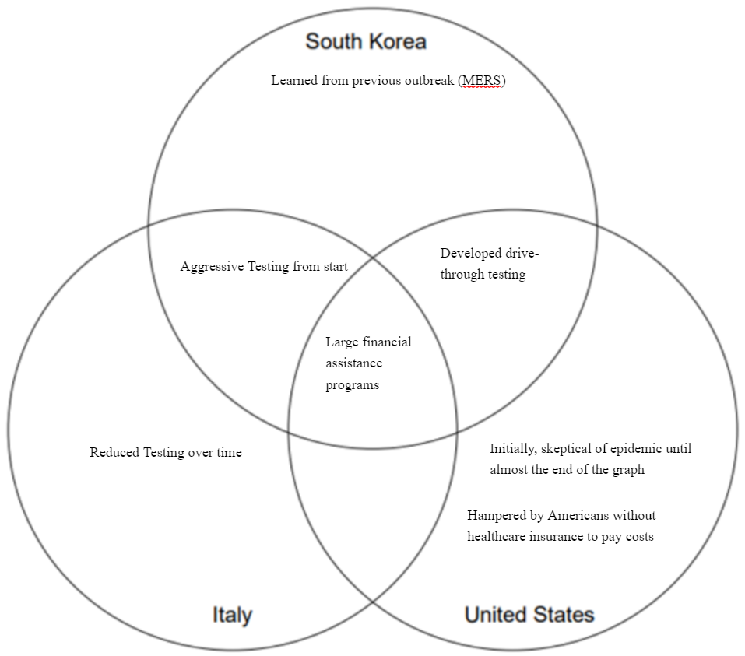
- After drawing the Venn diagram notes, students are ready to answer the final three questions. For question 1, students will probably note that Korea had learned from a previous epidemic and had a plan ready. Furthermore, they tested heavily throughout and all citizens had access to free treatments. Neither the US nor Italy did this to the same degree. For question 2, we are now asking students to explain how Korean culture might explain that result. The tradition of planning might be brought up or that Koreans might be more willing to get tested when the government says to do so since they have experience sacrificing. Finally, question 3 can be made optional for advanced learner or required. It asks students to determine which perspective better explains Korea’s response: functionalism or conflict. Unlike the US where Americans have unequal access to the health insurance and testing, Korea took a well-planned approach with lots of testing – functionalism.

- Finally, students turn to the Synthesis Question located on the last page of their worksheet. Students will apply what they have learned about Korean culture to answer the inquiry question. Given the amount of information provided, students should be provided 10-20 minutes and the resulting essay will range from 1-3 paragraphs.

- Students should then turn in their worksheet electronically or in-person.

- After collecting, grade the Synthesis Question on a 10-point scale:
- 3 points: 1 point for each Activity referenced in the response
- 4 points: The quality of the explanation and its use of cultural values. 1 point for an explanation lacking any cultural reference. 2 points for a basic or minor reference to culture in the explanation. 3 points for a proficient answer that includes significant references to culture. 4 points for an exceptional answer that includes significant references to culture.
- 1 point: for aesthetics such as spelling and grammar
FORMATIVE ASSESSMENT

Coming Together Accompanying Student Worksheet
- 3 formal assessments (1 per Activity): each assessment includes two questions testing lower level thinking (knowledge/understanding) and 1-2 questions that require upper level thinking (analysis/application):
-Questions in Activity 1 & 3 address Target 2.
-Questions in Activity 2 address Target 1 & 3.
- Synthesis Question: students use their knowledge gained about Korean culture and resulting government policies to answer the inquiry question. This will demonstrates Target 1.

RESOURCE LIST

Coming Together Accompanying Student Worksheet
(Attached)
Also, it can found at:
https://docs.google.com/document/d/1O3TuJkunOJmnd9Njfa1HswQAOT62AhZ64eg0OKlc1rI/edit?usp=sharing

COVID-19 Day 3 Student Handout, “Coronavirus Data” (Page 5), “Government Approaches to Address the Spread of COVID-19” (Page 7-8), and Venn Diagram (Page 12)
http://www.worldhistoryde.org/wp-content/uploads/2020/03/Day-3-COVID-19-Geography-Globalization-Econ-STUDENT.pdf

Causation and Continuity and Change over Time Day 2, “Homework Materials (Part I)” Page 8 and “Expert File 3: Citizens” (Pages 15-16):
- Park Chung-hee, president of South Korea, To Build a Nation, 1971
- Kim Dae-jung, Presidential Inaugural Address, 1998
- Park Chang-seok, managing editor of the English language newspaper The Korea Times, excerpt from the scholarly article “Mr. President: A Kingpin in Nation Building," 2010
https://www.worldhistoryde.org/wp-content/themes/whde/APModules/CCOTDay2.pdf

MODIFICATIONS & EXTENSIONS (OPTIONAL)

MODIFICATIONS

Activity 1 and 3 have a question (Question 4) that be an optional challenge question for advanced learners.

The Synthesis question can be made less challenging by requiring that students only use evidence from 1 or 2 Activities (rather than all 3). To make the question more challenging, students can be asked to address sociological perspectives and/or sociological imagination.

EXTENSIONS

Students can work to make a more collectivistic culture at their school: Collaboration, community, and learning for the sake of learning are all cultural values that will make their school a better place. Students can be tasked to redesign the school motto or PBIS statement using Korean cultural values. Alternatively, they can create a promotion campaign with student-designed posters that encourage positive cultural values.

Coming Together: How sociology can help explain the central role of government in Korean society
Name: _______________________

Why does the Korean government take such a central role in society?

In this worksheet, you will work individually to address the focused question above. As you work through this worksheet you will see the Korean government’s responses to COVID-19 and to poverty. Your mission will be to analyze these documents through a sociological lens. By the end of the worksheet, you will be prepared to explain how culture can explain the inquiry question.

Once complete, this worksheet will be submitted to your teacher.

KEY SOCIOLOGY TERMS FOR THIS LESSON

Culture: The customs and way of life for a group of people.
- Individualistic Cultures strongly value individual goals and successes.
- Collectivistic Cultures strongly value the needs of the group.
- Confucianism is all-encompassing way of life based on a set of philosophical and moral principles originating in ancient China, which includes a collectivistic society and an emphasis on learning and teaching.

Sociological Perspective: An overarching theory for understanding why society works in a particular way.
- Functionalism: A theory that posits that society generally works together with different people and institutions all playing manifest or latent roles. When society does have problems, this is dysfunction.
- Conflict: Society is fueled by dissonant groups that are trying to accumulate power from the other groups.

ACTIVITY 1: RESPONSES TO COVID-19 (CORONAVIRUS)

Open COVID-19 Day 3 Students Handout and turn to “Coronavirus Data” (Page 5). Answer the following questions:

- As of March 16th, which country had the most new cases of COVID-19? Which country had the fewest?

- As of March 16th, which country had the most total cases of COVID-19? Which had the fewest?

- Based on the trends in both new cases and total cases of COVID-19? Will any of the answers to questions 1 or 2 likely change in the near future and why?

- (For advanced learners) Using a sociological perspective of your choice, what do suspect explains the relative success of Korea in fighting COVID-19?

ACTIVITY 2: KOREA’S ECONOMIC MIRACLE
Great work! Now you will open Causation and Continuity and Change over Time Day 2 and start by turning to the two pictures on Page 8. What you are viewing is a visual of the economic “miracle” that Korea underwent following the Korean War (pictured at top). Korea went from an impoverished, war-torn country into a high income, technologically advanced country.

What changes do you observe?

Now turn to “Expert File 3: Citizens” (Pages 15-16) and read these three documents that will explain how institutions, society, and culture created the conditions that led to Korea’s economic “miracle.” Answer the following questions:

- According to the excerpt of 1960’s President Park Chung-hee’s book (Document 7), how did culture affect the way that the Korean government approached the economy?

- Using Documents 8 & 9, answer the question below Document 9: How did citizens and other people in South Korea help the country achieve economic success?

- Based on the documents, does Korean have a culture that strongly values individualism or collectivism?

ACTIVITY 3: UNDERSTANDING GOVERNMENT RESPONSES TO COVID-19

Tremendous effort so far! Now return to COVID-19 Day 3 Students Handout from earlier and turn to “Government Approaches to Address the Spread of COVID-19” (Page 7-8). Draw a Venn Diagram like the one below to compare government approaches and then answer the analysis question.
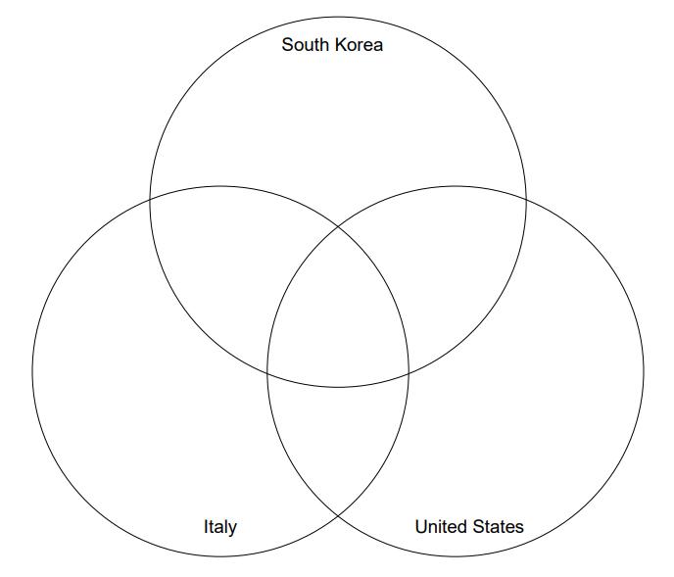
Based on what you have learned so far:
- What actions by the Korean government likely led to its relative success fighting COVID-19?

- How might culture influence the Korean government’s response?

- (For advanced students) Which sociological perspective most clearly explains Korea’s response and why?

SYNTHESIS

SYNTHESIS QUESTION:
Use evidence from
-”Coronavirus Data” in Activity 1
-”Expert File 3: Citizens” in Activity 2
-“Government Approaches to Address the Spread of COVID-19” in Activity 3

Why does the Korean government take such a central role in society?

Make sure to consider cultural values in your answer and follow the rubric.
Rubric for Grading:
- 3 points: 1 point for each Activity referenced in the response
- 4 points: The quality of the explanation and its use of cultural values. 1 point for an explanation lacking any cultural reference. 2 points for a basic or minor reference to culture in the explanation. 3 points for a proficient answer that includes significant references to culture. 4 points for an exceptional answer that includes significant references to culture.
- 1 point: for aesthetics such as spelling and grammar

