Korean War Chapters: Korea: Forgetting and Remembering

AUTHOR INFORMATION

Author: Natia Deisadze
Country: Georgia

GENERAL INFORMATION

Lesson Grade Span: High School (K-12)
Targeted Grade Level/Course: 11th Grade
Estimated Time to Complete Lesson: 90-minute sessions

FOCUSED QUESTION

Why is the Korean War considered one of the most important conflicts of the Cold War and why should we remember it?

STANDARDS

National Curriculum of Georgia ; Standards Framework for Learners
History. XI.4.
The student is able to research issues of political history. Determining the place of Georgia in the world historical process.

Indicators
Selects one of the states and analyzes the external and domestic factors (Korea, Germany, Italy) that determine its unification or disintegration in any epoch;
Chooses one of the most important historical events in the world and writes about the impact it has had on the world (or on the concrete country);
Together with a group of classmates, he selects a political figure and discusses the results of his or her chosen foreign or domestic political course (eg, Stalin, Winston Churchill, Otto von Bismarck);
Selects the political ideas of two figures from different countries (regions), compares them and discusses how each of them has influenced the political development of the world or region;
Distinguishes the state interests of modern word and discusses the political steps taken by political figures in the recent period;
During the simulation game, he presents the position of the proponents of globalization and anti-globalists regarding the political strengthening of the world;
During the group discussion, he discusses individual cases in his own country and in the world, and together with his classmates he creates his own model for solving this problem.
STUDENT & TARGET OUTCOMES

- Students will learn about the Korean War through primary sources (i.e.videos, maps, online tours).
- Students will understand why Korean War is considered as one of the most important conflicts of the Cold War and why is it crucial to remember it.
- Students will realize that history cannot give us a program for the future, but it can give us a fuller understanding of ourselves, and of our common humanity, so that we can better face the future.
- Students will use multimedia software to realize the outcome of the Korean War and consider the mistakes made by the huge country leaders.

LESSON OVERVIEW

The main focus of this lesson is for students to understand why Korean War is considered as one of the most important cold war in the world history and highlight the arguments of remembering it. Students will acquire an intellectual and emotional understanding of the issues surrounding the Korean War. These understandings will come from students’ exposure to a variety of sources including: videos, online tours in Korean War museum, their presentations.
As a result of this lesson, students will study the history of the Korean War, search for and discover the forces that were the causes of those results which will appear before their eyes as historical events. The process of reading, listening, speaking and writing consists in remembering the essentials and forgetting what is less essential.
Students will listen to the short interviews of Korean war veterans and will be introduced a short biographical information about them so that they will be able to see how much damage war can do to humanity. Yet for many of us, war is a phenomenon seen through the lens of a television camera or a journalist's account of fighting in distant parts of the world. Our closest physical and emotional experience may be the discovery of wartime memorabilia in the museums. But even items such as photographs, uniform badges, medals, and diaries can seem vague and unconnected to the life of their owner. For those of us born during peacetime, all wars seem far removed from our daily lives.
The Koreans who went off to war, went in the belief that the values and beliefs enjoyed by Koreans were being threatened. They truly believed that "Without freedom there can be no ensuring peace and without peace no enduring freedom."

Teacher will make a presentation which can be used during the lesson. It will consists information about the Korean War that it was the first armed conflict in the Cold War era. 80% of the industrial and transport infrastructure of both countries has been depleted. Between 280 thousand and 300 thousand people were moved from the south to the north in the period of the war, and vice versa - from 650 thousand to 2 million.
The South Korean command is confident that after the cessation of the war, not all captives in the north have been freed, and some have been beaten for decades. The United States has lost and wounded at least 38 thousand military perssonel. According to some sources, China has lost 390 thousand people, although according to some other sources about 1 million people were either killed or starved to death in the war. Among the victims there was the son of Mao Dzeduni. The military casualties of the South Korean military are more than 137 thousand dead and up to 10 thousand missing, and as for North Korea - more than 112 thousand dead and 120 thousand - missing.
Before the war, if the United States was not going to protect Taiwan, after the Korean War, the island became inaccessible to communist China.
The Korean War was marked by human rights abuses on both sides. Hundreds of people have sacrificed their lives for this cause.
The war in the Soviet Union may have been more unsuccessful, but the example of its great help proved as the meaningful step and many third world countries chose the socialist path to receive Soviet aid. At the same time, the war gave the USSR time to expand its nuclear program while the US was participating in the Korean War. Students hear information about Georgian important figure (at that time Georgia war part of the Soviet Union). In 1947, Alexander Kartvelishvili, a Georgian-American figure, created the Republic F-84 Thunderjet, the first jet fighter to appear in NATO armaments. It was actively used in the Korean War against the Soviet-made MiG-15. It was the first American single-aircraft fighter to carry an atomic bomb.
This Cold War conflict is often seen as an indirect war, on the one hand between the United States and its allies, and on the other hand between the forces of China and the USSR.
The impact of this lesson will extend far beyond the walls of a school building. Friends, families, and social networks will realize that those who served so nobly nearly 70 years ago at home and abroad during the Korean War deserve our respect.

PROCEDURES

1.Warmer activity: What do we remember?
The lesson will begin with a warmer activity to get students' attention, activate prior knowledge and
Prepare them for the day's learning. The teacher will ask students to choose three questions and write
down sentences they remember about Korean War.
- What is a Cold War and when did it start?
- What is the difference between Cold War and Hot War?
- Which country’s interests were exposed during the Cold War?
- Why do you think it was impossible to reach an agreement between the United States and the Soviet Union?
- Why do you think communist ideas became popular in Korea after the war?

Students must write them down in a specified amount of time. Nominate students to share their ideas
in an open class, teacher will use the chance and tell students about the facts given in her presentation.

Activity # 2.
Tell students that the Korean War was fought from 1950-1953, display a map of
Korea and explain that the North Korean People’s Army poured across the 38th parallel, the boundary between the
Soviet-backed Democratic People’s Republic of Korea to the north and the pro-Western Republic of Korea to the south.
American troops entered the war on South Korea’s behalf to protect freedom and democracy. The Korean peninsula is
still divided today.
Explain that they should watch a video that conveys the facts of Korean War chronologically.
Divide the students into groups ( Zoom.us has the button of breakup rooms) Refer them to the problem-cause-solution
exercise for each group so that they focus on target information while watching. Highlight the fact that each group has to
reveal the problem, name three possible causes of the problem and name the original solution of the problem + they have
to name the mistakes that were revealed and imagine themselves in the place of the political leaders and offer their
version of solution to the named problem.

Problem

Cause #3
Cause #1
Cause #2

- After film activity
Nominate each group to present their presentation. The other groups will have assessment rubrics
according to which they have to assess their fellow group members together under the teacher’s supervision.

Group PresGroentation RubGric
 | Excellent  3 pts | Good  2 pts | Fair  1 pts | Poor  1 pts
Organization | Excellent  Presentation was very organized and was very easy to follow. Transitions between group members were well planned and executed cleanly. | Good  Presentation was fairly organized and pretty followable. Transitions might have been slightly discontinuous but did not take away greatly from the overall presentation. | Fair  Presentation was not clearly organized. Transitions between members were  jumpy or awkward. | Poor  Presentation lacked organization. Poor transitions between group members individual parts. Presentation lacked order and very difficult to follow.
Teamwork/Participation | Excellent  The group worked very well with each other and the presentation was shared equally among the group members. | Good  The group worked well with each other and communicated well. Some members participated slightly more than others. | Fair  Group communicated relatively well  with a few lapses in the presentation;  some students dominated the  presentation and others did not  participate much. | Poor  Group did not work well together. There were obvious miscommunications and lapses in the presentation.
Content | Excellent  Group members had a stronghold on the content and content was thoroughly addressed. No mistakes were made with regard to content knowledge. | Good  Most of the group members has a solid understanding of the content. Content missing minor elements or contained minor errors. | Fair  Group members had only a superficial understanding of content. Several  mistakes were made during the  presentation. | Poor  Group members had little to no understanding of the content addressed in the presentation.
Visual Aid(s)  (online) | Excellent  Visual aids used were used effectively throughout presentation. Group members used visual aids as a supplement, not as a crutch. | Good  Visual aids used were somewhat effective, but weren't used consistently thoughout presentation. | Fair  Visual aids used did not support verbal presentation. They lacked information,  or groups members read from them. | Poor  Visual aids were not used at all.

Activity # 3 : Your turn to be a museum guide

3 a:

Let students have a look at the tour builder link to see the online tour of the

War Memorial of Korea which is created from the pictures taken by our school students when they were in South Korea.

Teacher will make a presentation of it.

Some students have little interest in reading about historical events, but when they see an artifact up close of the fellow

humans who endured the concrete historical event and since museums have the ability to draw people into another time

period and show that yes this actually did happen their mind starts working itself.

While most careers require a specific type of education, the reality in our changing world is that students need

to be lifelong learners to continue to grow as the demands change. This activity encourages curiosity which is

necessary for children to become lifelong learners. War Memorial museum seeks out unique links and

relationships that are not always readily present which offers us, the viewer, something new each time we visit.

There is always the possibility for an “ah ha” moment to occur. That encourages teacher to offer students next

Activity

3 b:

Ask students to take turns being the museum guides. The guides in turn highlight the role of NATO

in the fight for South Korean freedom. The 1950-1953 war was started by the Communist Party and threatened the

freedom of South Korea. But for the joint efforts of NATO and its partners, South Korea would be in the same situation

as Vietnam is today. This is the main idea of remembering and not forgetting the facts that should be passed on to the new

generation if you want to fight for freedom and get the help of a country for which a strong state is important.

The guides may choose the weapons and aviation used by NATO member states during this conflict.

Guides should include the result of this assistance is that today South Korea ranks twelfth in economic terms. They may

make a parallel between current time situation as well.
Guides should include in their presentation importance of remembering the service and the sacrifice of all the people
who were victims of the Korean War, by which we recognize the tradition of freedom these men
and women fought to preserve. They believed that their actions in the present would make a
significant difference for the future, but it is up to us to ensure that their dream of peace is realized.
With this tour students acknowledge the courage and sacrifice of those who served their country
and acknowledge their responsibility to work for the peace they fought hard to achieve.
During times of war, individual acts of heroism occur frequently; only a few are ever recorded and
receive official recognition. By remembering all who have served, students recognize their willingly-endured
hardships and fears, taken upon themselves so that they could live in peace.

This activity may be done as homework as well.

https://tourbuilder.withgoogle.com/builder#play/ahJzfmd3ZWItdG91cmJ1aWxkZXJyEQsSBFRvdXIYgIDg2MzM6woM/ahJzfmd3ZWItdG91cmJ1aWxkZXJyJwsSBFRvdXIYgIDg2MzM6woMCxIJUGxhY2VtYXJrGICA4Jjj6vILDA

FORMATIVE ASSESSMENT

RESOURCE LIST

- Breakout Kit: box, folding lockout hasp, and locks: 4-digit lock, key lock, word lock, directional lock
- Breakout Game Clues
- Breakout Game Answer Key
- Pictures from the Korean War (to place inside the Breakout Kit)
- Pictures of memorials which commemorate the service and sacrifice of Americans who have served in the military. Images borrowed from the American Battles Monument Commission at https://www.abmc.gov/cemeteries-memorials
- Korean War Web Quest (created using Google Tour Builder): www.bit.ly/KoreanWarTour
- Korean War Web Quest Handout
- Exit Slip
- Photographs of the Korean War and of the military today. Images borrowed from the Korean War Legacy Project at https://koreanwarlegacy.org/chapters/ and from the U.S. Department of Defense at https://www.defense.gov/observe/photo-gallery/
- Korean War Veteran Then and Now Photographs: http://archive.jsonline.com/news/wisconsin/veteran-with-his-own-story-of-heroism-to-help-lead-korean-war-book-talk-b99657611z1-367162011.html/
- Korean War Legacy Project “Interview Archive”: https://koreanwarlegacy.org/interactive-library/
- Biography Research Graphic Organizer
- Biography Research Rubric
- Examples of how we remember the men and women who serve or have served in the U.S. armed forces: poem, painting, statue, garden, essay, and graphic art design.
- Google Slides
- Storyboard Rubric
- Final Reflection
- Final Reflection Checklist

MODIFICATIONS & EXTENSIONS (OPTIONAL)

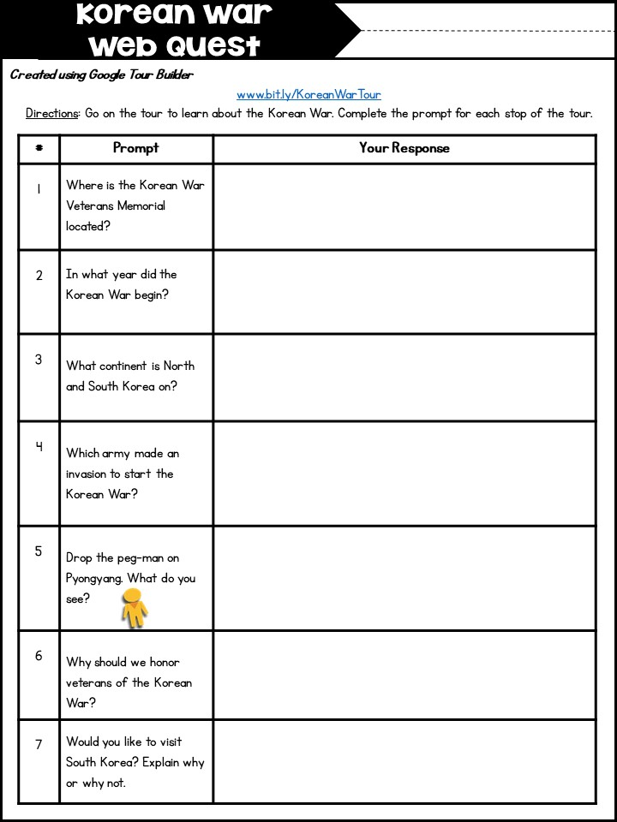
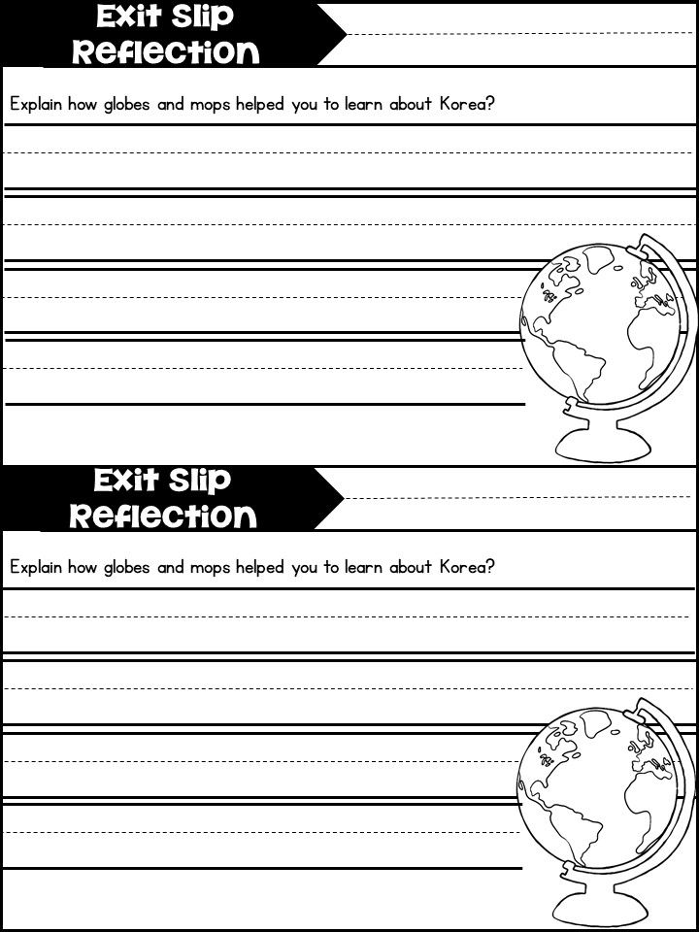
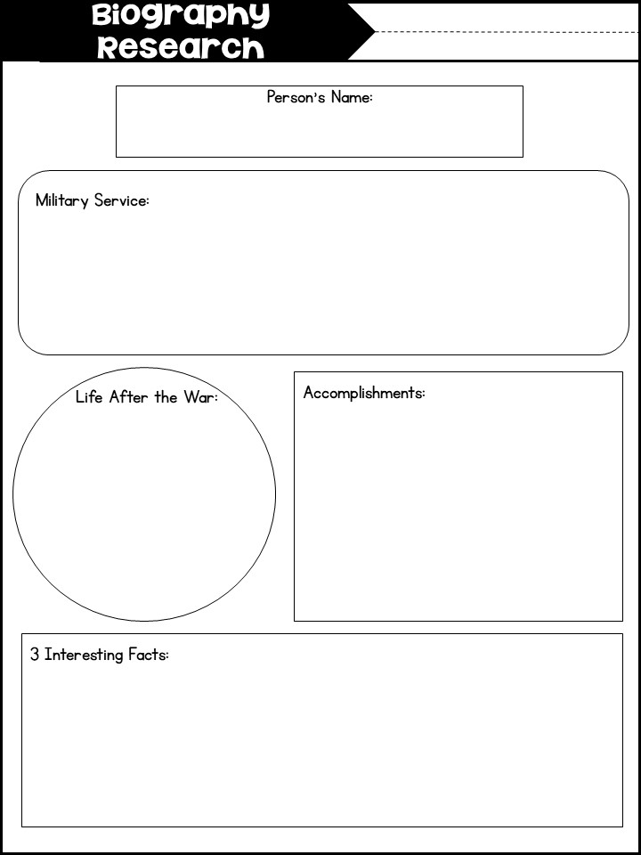
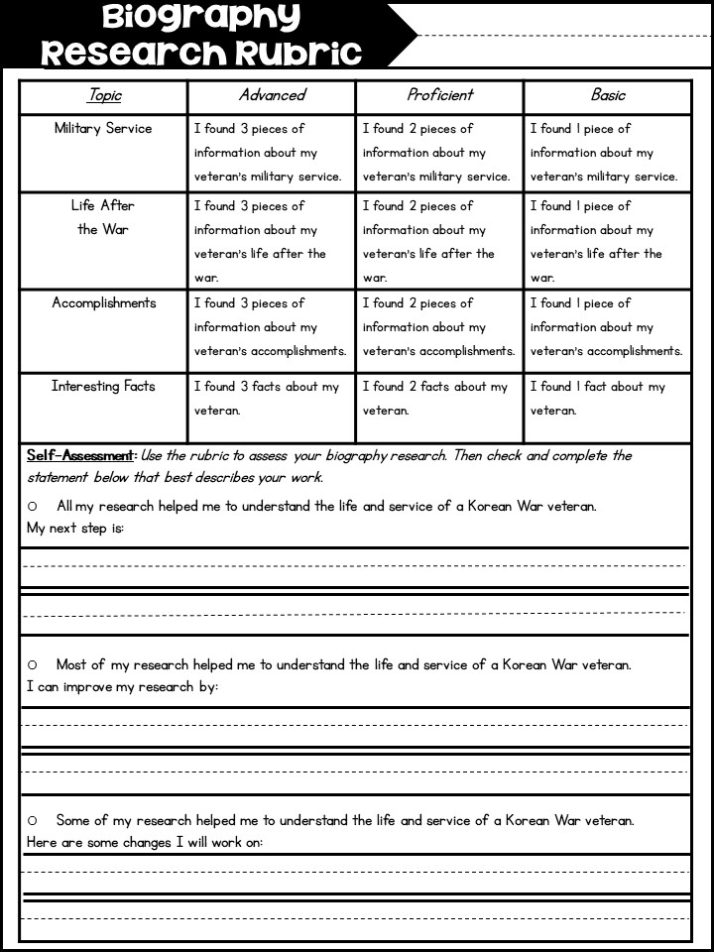

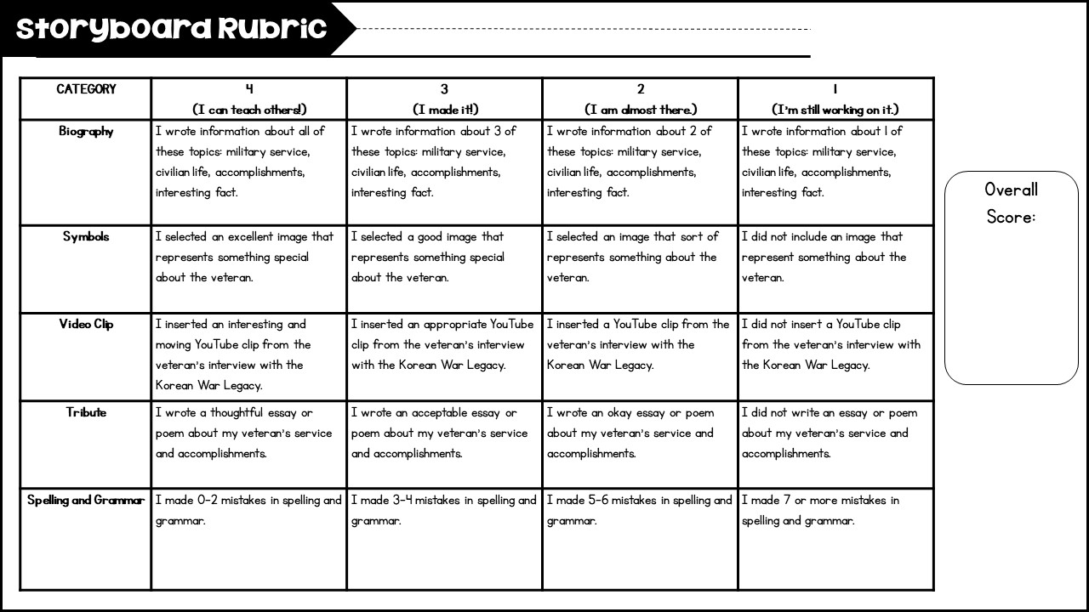

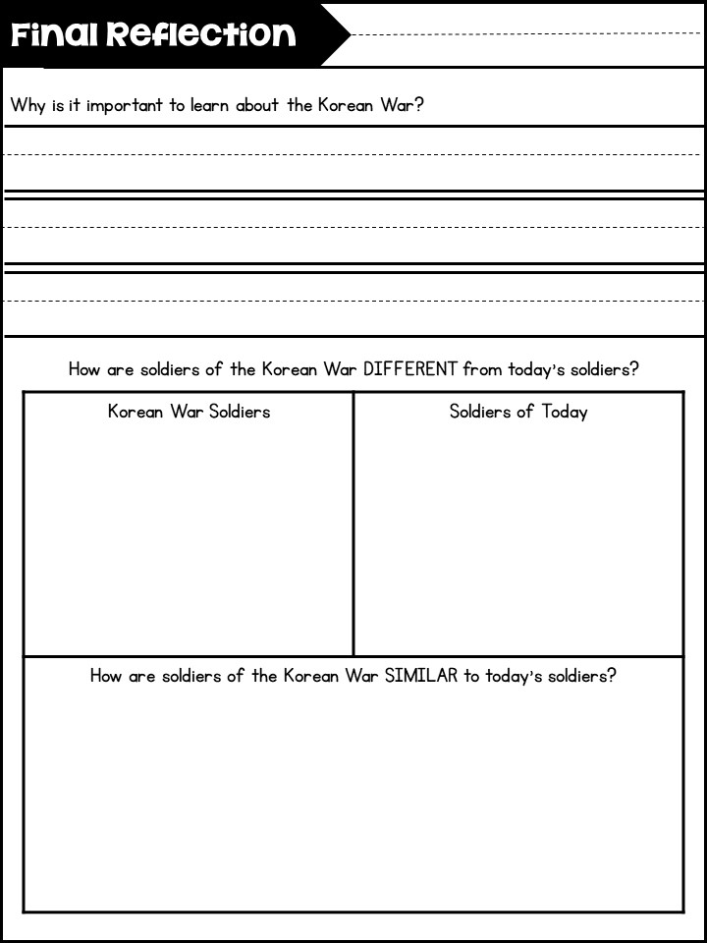
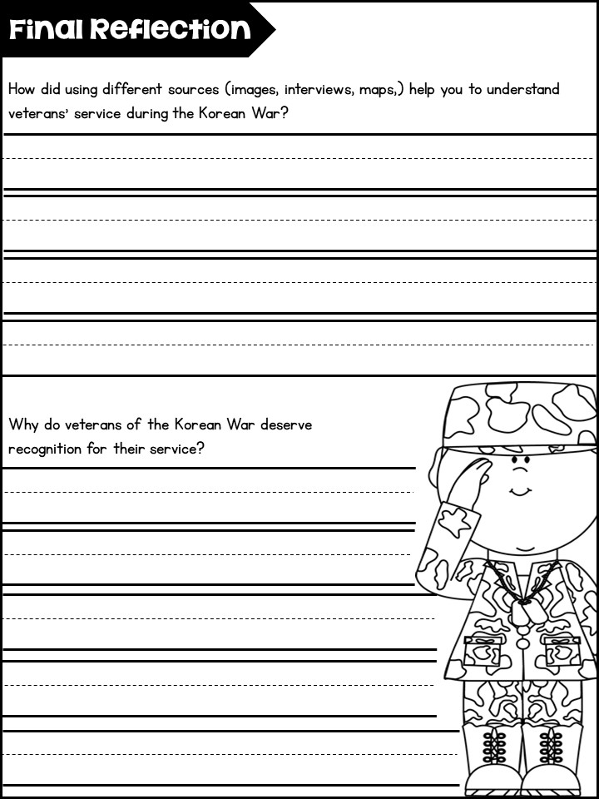
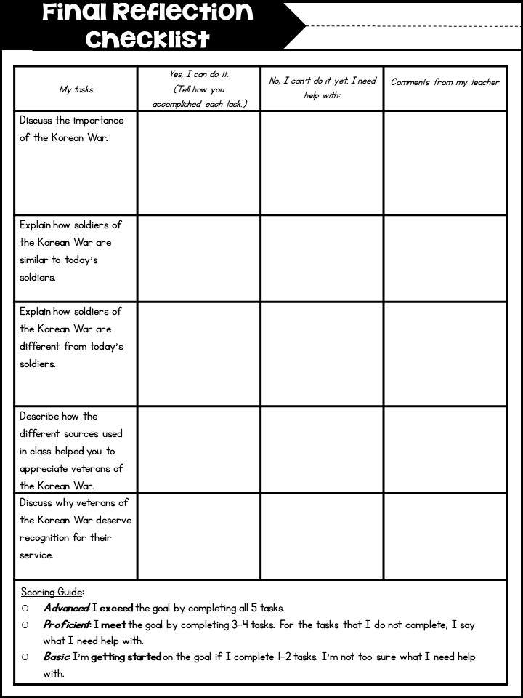
This activity can be done in groups, in pairs or individually, it depends on teachers decision. In our case we offer at class, students work in groups, they divide their work so that each group member should be a guide for a while. Students are given the instruction how to use Tour Builder during their presentation.

