Dokdo as an Important Part of Korean National Identity

AUTHOR INFORMATION

Author: Jacqueline Elyse Williams
State: Texas

GENERAL INFORMATION

Lesson Grade Span: Secondary (9-12)
Targeted Grade Level/Course: AP Human Geography and World Geography Studies
Estimated Time to Complete Lesson: (2) 50-minute class periods

FOCUSED QUESTIONS

Why is Korean sovereignty of Dokdo an important part of Korean national identity?

STANDARDS (STATE/C3)

Objectives from the AP Human Geography Course Description Effective Fall 2015

Unit IV. Political Organization of Space
Enduring Understandings (Students will understand that … )
- The contemporary political map has been shaped by events of the past.
Learning Objectives (Students are able to … )
    - Explain the structure of the contemporary political map.
Essential Knowledge (Students will know that … )
        - Types of political entities include nations, states, nation-states, stateless nations, multinational states, multistate nations, and autonomous regions.
    - Explain the evolution of the contemporary political map.
Essential Knowledge (Students will know that … )
        - Colonialism and imperialism led to the spread of nationalism and influenced contemporary political boundaries.
    - Evaluate the geopolitical forces that influence the contemporary political map.
Essential Knowledge (Students will know that … )
        - Independence movements and democratization have shaped the political map since the end of World War II.
- Spatial political patterns reflect ideas of political power and territoriality and power at a variety of scales.
Learning Objectives: (Students are able to … )
    - Evaluate the nature and function of international and internal boundaries.
Essential Knowledge (Students will know that … )
        - Boundaries are defined, delimited, demarcated, and administered.
        - International boundaries establish the limits of sovereignty and can be the source of disputes.
        - Boundaries can influence identity and promote or prevent international or internal interactions and exchanges.
    - Analyze the spatial relationships between political systems and patterns of culture and economy.
Essential Knowledge (Students will know that … )
        - Political boundaries do not always coincide with patterns of language, religion, ethnicity, nationality, and economy.
- The forces of globalization challenge contemporary political-territorial arrangements.
Learning Objectives: (Students are able to … )
    - Apply the concepts of centrifugal and centripetal forces at the national scale.
Essential Knowledge (Students will know that … )
        - Centrifugal forces can originate in political dimensions, economic dimensions, or cultural dimensions.
        - Centripetal forces can originate in political dimensions, economic dimensions, or cultural dimensions.

STUDENT & TARGET OUTCOMES

- Students will make inferences using primary and secondary sources.
- Students will understand how to apply the definitions of vocabulary terms to real world issues.
- Students will understand how historical forces which have shaped modern-day disputes.

LESSON OVERVIEW

This lesson focuses on "Dokdo", a set of islets in the East Sea, as an important component to Korean national identity, and the source of a tense territorial dispute between Korea and Japan. Students will first analyze maps of this territory and define vocabulary terms. Next students will analyze primary and secondary sources (documents) by answering questions and making inferences about Korean claims to this region, sentiment, and the importance to national identity.

PROCEDURES

Step by Step Instructions for Educators:

- Have students work in pairs or small groups.
- Make a copy of the “Lesson Plan” and the “Student Handout” for each group.
- Students should work with a partner to discuss the brief historical background provided and define the following AP Human Geography vocabulary terms. After defining the terms, watch the video clip "Dokdo, Beautiful Island of Korea" produced by the Ministry of Foreign Affairs, Republic of Korea.
- Next, students should work to make inferences and answer questions about the documents.

FORMATIVE ASSESSMENT

After going through the documents and answering the questions, the group should then write an essay to address the prompt. Please remind your students to cite the documents (a minimum of 5) as they use them in their essays. Remind them also to try and use as many vocabulary terms as possible in their essay and to underline them as they use them.

RESOURCE LIST

Bae, C. (2012). TERRITORIAL ISSUE IN THE CONTEXT OF COLONIAL HISTORY AND INTERNATIONAL POLITICS: THE DOKDO ISSUE BETWEEN KOREA AND JAPAN. The Journal of East Asian Affairs, 26(1), 19-51.
Control is not enough; Dokdo/Takeshima. (2018, September 29). The Economist, 428(911), 44(US).
Dokdo Is Our Land(「독도는 우리땅」). The Encyclopedia of Ulleung, e-ulleung.grandculture.net/Contents?local=e-ulleung&dataType=01&contents_id=EC01500927.
MOFA Dokdo. 외교부 독도, Ministry of Foreign Affairs, Republic of Korea, dokdo.mofa.go.kr/eng/pds/part06_view02.jsp.
Japan says mention of disputed islands on Korean Olympics site... (2017, January 20). Retrieved from https://www.reuters.com/article/us-olympics-pyeongchang-japan-idUSKBN1540CD

South Korea, China condemn Japan over textbooks in latest fight. (2014, April 04). Retrieved from http://www.reuters.com/article/us-korea-japan/south-korea-china-condemn-japan-over-textbooks-in-latest-fight-idUSBREA330GI20140404

Williams, J. E. (2018, July). Comfort Woman Statue[Photograph]. Seoul.

Williams, J. E. (2018, July). “Dokdo Island of Korea in East Sea” Banner[Photograph]. Seoul.

대한민국 외교부 독도. (n.d.). Retrieved from http://dokdo.mofa.go.kr/

대한민국외교부. (2014, February 22). Dokdo, Beautiful Island of Korea. Retrieved from http://www.youtube.com/watch?v=mEF9FDh4nZc. (Ministry of Foreign Affairs, Republic of Korea)

MODIFICATIONS & EXTENSIONS (OPTIONAL)

MODIFICATIONS

The number of documents used can be minimized and essay length requirement can be shortened.

EXTENSION SUGGESTIONS

- Have students make 3-D models of the region, labeling key geographic features and diagraming the dispute.

- Have students research UNCLOS and EEZ (Exclusive Economic Zones) and apply the significance of these concepts to the Dokdo dispute.

- Have students create presentations using media of their choosing to explain the importance of Dokdo to Korea both historically and in the modern-day.

Lesson Overview

This lesson focuses on "Dokdo", a set of islets in the East Sea, as an important component to Korean national identity, and the source of a tense territorial dispute between Korea and Japan. Students will first analyze maps of this territory and define vocabulary terms. Next students will analyze primary and secondary sources (documents) by answering questions and making inferences about Korean claims to this region, sentiment, and the importance to national identity.

Part I: Historical Background, Vocabulary, and Video

Students should work with a partner to discuss the brief historical background provided and define the following AP Human Geography vocabulary terms. After defining the terms, watch the video clip "Dokdo, Beautiful Island of Korea" produced by the Ministry of Foreign Affairs, Republic of Korea.

Historical Background

The Liancourt Rocks, known as “Dokdo” in Korea and “Takeshima” in Japan (referred to as “Dokdo” in this lesson plan), is a territorial dispute between the two countries in the East Sea. The tension over Dokdo escalated in 1905 when “Japan illegally incorporated Dokdo, which was an inherent territory of Korea, through Shimane Prefecture Public Notice No. 40 during its war against Russia” (the Russo-Japanese War in 1905) (Bae). While Dokdo was incorporated into Japan in 1905, the rest of Korea was annexed by Japan in 1910. From Korea’s perspective and the perspective of much of the international community, Japan’s imperialistic aggression and violent actions in the early 20th century violated international laws and the sovereignty of Korea. Korea became independent from Japan in 1945 after Japan’s loss in World War II. The issue over Dokdo’s sovereignty remains a significant issue for Korean national identity and a symbol of strength from their break away from Japanese imperial aggression and cultural suppression of the Korean people.

Vocabulary Terms to Define

- Toponym
- Nationalism
- Imperialism
- Territoriality
- Sovereignty
- Territorial dispute
- Centripetal forces
- Centrifugal forces

Video (5 minutes)

"Dokdo, Beautiful Island of Korea"
Source: 대한민국외교부 Ministry of Foreign Affairs, Republic of Korea. “Dokdo, Beautiful Island of Korea.” YouTube, YouTube, 22 Feb. 2014, www.youtube.com/watch?v=mEF9FDh4nZc.

Part II: Map of Dokdo

Source: Ministry of Foreign Affairs, Republic of Korea
MOFA Dokdo. 외교부 독도, Ministry of Foreign Affairs, Republic of Korea, dokdo.mofa.go.kr/eng/pds/part06_view02.jsp.
- Dokdo consists of two main islands, Dongo and Deodo, and 89 surrounding islets (Total Area : 187,554m2)
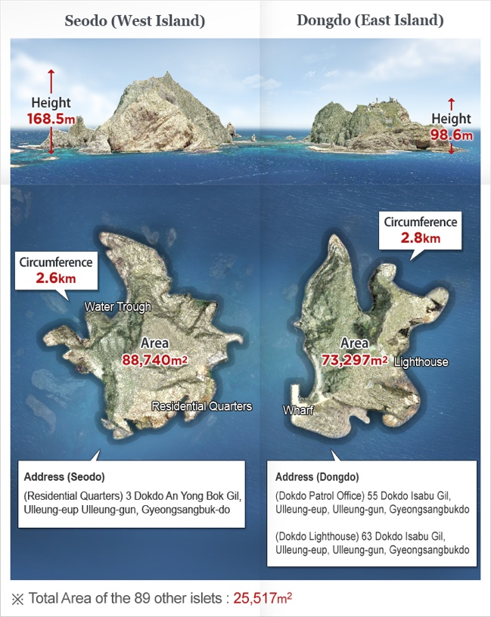
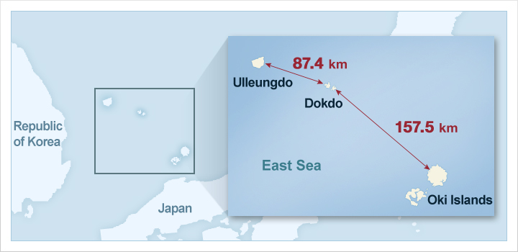
Part III: Document Analysis

The major activity of this lesson is for students to analyze sources to demonstrate their understanding of the Korean perspective in the importance of the Dokdo islets for Korean national identity as well as to understand modern Korean and Japanese attitudes toward the territorial dispute.

Students should work in pairs to read the documents, answer the related questions, and draw inferences about attitudes surrounding Dokdo.

Document 1

Source: Quote in a video clip produced by Ministry of Foreign Affairs, Republic of Korea

대한민국외교부. (2014, February 22). Dokdo, Beautiful Island of Korea. Retrieved from http://www.youtube.com/watch?v=mEF9FDh4nZc.

“Dokdo was the first Korean territory to fall victim to the Japanese aggression.” – Pyun Yung-Tai, Minister of Foreign Affairs, Republic of Korea, October 28, 1954

Document 2

Source: Sejong Sillok, Jiriji (Geography Section of the Annals of King Sejong’s* Reign); published 1454, Korea. (From the Ministry of Foreign Affairs, Republic of Korea website: http://dokdo.mofa.go.kr )

Translation: The two islands, Usan (Dokdo) and Mureung (Ulleungdo**), are in the middle of the sea, due east of the county (Uljin).
The two islands are not far apart; hence each can be seen from the other side on a clear day.

*King Sejong (Sejong the Great) was the fourth king of the Joseon dynasty of Korea from 1397 – 1450.
**Ulleungdo is an island east of Korea and is recognized as having Korean sovereignty.

Document 3

Source: Korean children’s folk song about the Dokdo islets, “Dokdo is Our Land”. Original source unknown.

Dokdo Is Our Land(「독도는 우리땅」). The Encyclopedia of Ulleung, e-ulleung.grandculture.net/Contents?local=e-ulleung&dataType=01&contents_id=EC01500927.

“Dokdo is Our Land”

80 kilometers along the southeast seaway of Ulleungdo Island
There is a lonely isle, the home of sea birds
No matter whoever argues it’s theirs, Dokdo Island is our land.
Dokdo-ri, Ulleung-eup, Ulleung-gun, Gyeongsangbuk-do
East longitude 132 degrees, North latitude 37 degrees
Average temperature 12 degrees, rainfall 1,300, Dokdo Island is our land.
Squid, baby octopus, cod, haddock, turtle
Salmon eggs, sea bird eggs, waiting room for female divers
170 thousand square meters, a spring, a crater, Dokdo Island is our land
the 13th year of the reign of King Jijeung, Usanguk, the island nation
On the third line of page 50 in the Veritable Records of King Sejong, Geography Section
Hawaii belongs to America, don’t know about Tsushima Island, but Dokdo Island is our land
After the Russo-Japanese war, to argue that Dokdo Island belongs to no one is absurd
The Silla* general Isabu derides it from under the ground.
Dokdo Island is our land.

*Silla, an ancient Korean kingdom, 57 B.C.E – 935 C.E.

Document 4

Source: Photograph from a street in Seoul near King Sejong’s Palace.

Williams, J. E. (2018, July). “Dokdo Island of Korea in East Sea” Banner[Photograph]. Seoul.

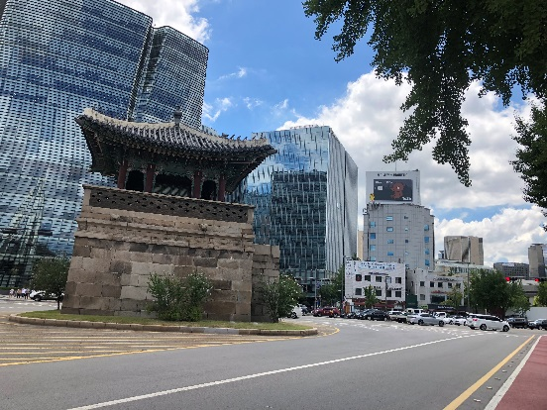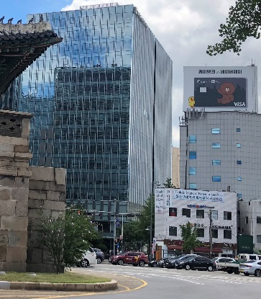
“Dokdo Island of Korea in East Sea”

Document 5

Source: Except from an article in The Economist, an American magazine publication.

Control is not enough; Dokdo/Takeshima. (2018, September 29). The Economist, 428(9111), 44(US).

South Korea craves foreign approval of its claim to two specks in the sea
The two countries of the Korean peninsula may have many disagreements to resolve, but in one respect, they are in perfect accord. Dokdo, a pair of rocks in the sea that separates the peninsula from Japan, both insist, have been an integral part of Korea for centuries. Consequently Japan's claim to the islands, which it calls Takeshima, is imperialism, plain and simple. At the first of three recent summits between Kim Jong Un, the North's dictator, and Moon Jae-in, the president of the South, the mango mousse was decorated with a chocolate map of the peninsula complete with a tasty Dokdo-shaped dot.

Document 6

Source: Except from an article in The Economist, an American magazine publication.

Control is not enough; Dokdo/Takeshima. (2018, September 29). The Economist, 428(9111), 44(US).
Dokdo-ganda is everywhere--even on the train from the airport into Seoul, South Korea's capital. "History knows the truth," flash the screens above the seats, "Japan knows the truth." To rousing martial music, they go on to display a series of yellowing documents and maps with excerpts highlighted in red. These bits of paper, the bleary-eyed visitor is informed, are proof that Dokdo is inalienable Korean territory.
South Korea has the upper hand in the dispute, since it controls the islands. But the authorities are leaving nothing to chance. Primary-school children are taught the song "Dokdo is our land", which celebrates the fauna of the islands and surrounding waters ("squid, beka squid, cod, pollock, tortoise, salmon egg, waterfowl egg") and reminds them that Dokdo was mentioned "in the third line on page 50 in the geography records of King Sejong", a 15th-century ruler. High-school students are appointed "Dokdo keepers" and dispatched on trips to the islets to protect their country's territory. In a recent survey, 98% of South Koreans agreed that the specks were Korean.

Document 7

Source: Except from an article in Seoul, South Korea, reported by Reuters, an international news agency headquartered in London.
“South Korea, China Condemn Japan over Textbooks in Latest Fight.” Reuters, Thomson Reuters, 4 Apr. 2014, www.reuters.com/article/us-korea-japan/south-korea-china-condemn-japan-over-textbooks-in-latest-fight-idUSBREA330GI20140404.
SEOUL/BEIJING (Reuters) - South Korea and China on Friday condemned new Japanese textbooks that say that islands at the centre of separate territorial disputes belong to Japan, the latest in a series of disputes between Tokyo and neighbors Seoul and Beijing.
The elementary school textbooks describe islands called Dokdo in Korean and Takeshima in Japanese as Japan’s “sovereign territory” and say South Korean occupation is unlawful. . .
South Korean First Vice Minister Cho Tae-yong called in Japan’s ambassador to Seoul to protest and the ministry warned of worsening ties.
“If (Japanese) Prime Minister Shinzo Abe who declared just three weeks ago he stands by the ‘Kono Statement’* now tries to conduct education for elementary school children that distorts and hides its history of colonial invasion, he is not only breaking his own promise but also committing the mistake of isolating its next generation from international society,” the ministry said.
*The Kono Statement was released by Japan in 1993 to acknowledge the forcible use of “comfort women” (sex slaves) for the Japanese imperial army in Korea and other occupied territories.

Document 8

Source: Except from an article in Tokyo, Japan, reported by Reuters, an international news agency headquartered in London.

Japan says mention of disputed islands on Korean Olympics site... (2017, January 20). Retrieved from https://www.reuters.com/article/us-olympics-pyeongchang-japan-idUSKBN1540CD

TOKYO (Reuters) - Japanese Foreign Minister Fumio Kishida on Friday objected to mention on the Pyeongchang Olympics website of islands disputed by his country and South Korea, saying it was “unacceptable” and went against the spirit of the international competition.
Ties between Japan and South Korea, host of the 2018 Winter Games in Pyeongchang, have often been fraught over history, especially Japan’s 1910-1945 colonization of the Korean peninsula.
Both claim the disputed islands - known as Takeshima in Japanese and Dokdo in Korean - which are about 200 km east of South Korea in the Sea of Japan, and a little further than that from the southwest coast of Japan’s main island of Honshu.
In an explanation of national culture, the Pyeongchang website refers to Dokdo and “the East Sea,” the Korean name for the Sea of Japan.
“Dokdo holds a special place in the hearts of Koreans as they hold pride in defending Korea’s easternmost reached territory,” the website says.

Document 9

Source: Except from an article in Tokyo, Japan, reported by Reuters, an international news agency headquartered in London.

Japan says mention of disputed islands on Korean Olympics site... (2017, January 20). Retrieved from https://www.reuters.com/article/us-olympics-pyeongchang-japan-idUSKBN1540CD

South Korea sees Japan’s claims to the islands as stemming from its colonization of the Korean peninsula in the first half of last century. Ties between the neighbors have long been marred by what South Korea says is Japanese leaders’ reluctance to atone for its World War Two history.
Japan temporarily recalled its ambassador to South Korea on Jan. 6 over a statue commemorating Korean women forced to work in Japanese military brothels during World War Two. Tokyo said there was nothing wrong with erecting a statue in memory of the women, but that it was inappropriate to place it outside of a Japanese consulate.

Document 10

Source: Photograph from a street in Seoul.
Williams, J. E. (2018, July). Comfort Woman Statue[Photograph]. Seoul.
Photograph of “Comfort Woman”* Statue and accompanying plaque with inscription.

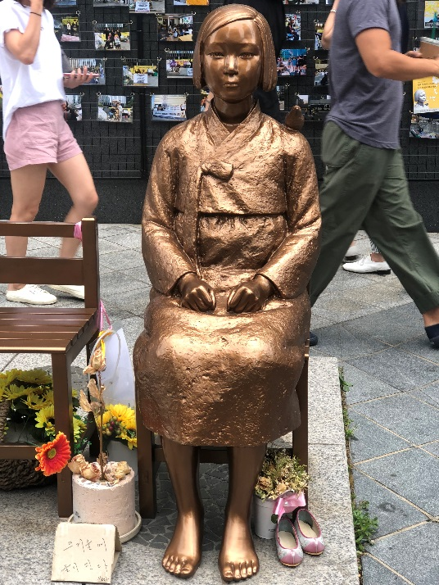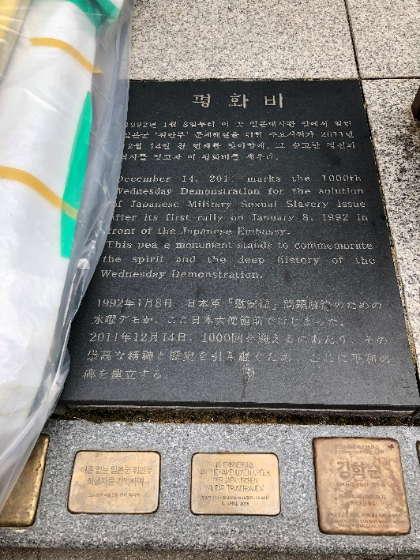
Inscription: December 14, 2011 marks the 1000th Wednesday Demonstration for the solution of Japanese Military Sexual Slavery issue after its first rally on January 8, 1992 in front of the Japanese Embassy. This peace monument stands to commemorate the spirit and deep history of the Wednesday demonstration.

*”Comfort women” were forced sex slaves of the Japanese imperial army during their occupation of territories in East Asia and Southeast Asia in the 1930s and 1940s.

Works Cited

Bae, C. (2012). TERRITORIAL ISSUE IN THE CONTEXT OF COLONIAL HISTORY AND INTERNATIONAL POLITICS: THE DOKDO ISSUE BETWEEN KOREA AND JAPAN. The Journal of East Asian Affairs, 26(1), 19-51.
Control is not enough; Dokdo/Takeshima. (2018, September 29). The Economist, 428(911), 44(US).
Dokdo Is Our Land(「독도는 우리땅」). The Encyclopedia of Ulleung, e-ulleung.grandculture.net/Contents?local=e-ulleung&dataType=01&contents_id=EC01500927.
MOFA Dokdo. 외교부 독도, Ministry of Foreign Affairs, Republic of Korea, dokdo.mofa.go.kr/eng/pds/part06_view02.jsp.
Japan says mention of disputed islands on Korean Olympics site... (2017, January 20). Retrieved from https://www.reuters.com/article/us-olympics-pyeongchang-japan-idUSKBN1540CD

South Korea, China condemn Japan over textbooks in latest fight. (2014, April 04). Retrieved from http://www.reuters.com/article/us-korea-japan/south-korea-china-condemn-japan-over-textbooks-in-latest-fight-idUSBREA330GI20140404

Williams, J. E. (2018, July). Comfort Woman Statue[Photograph]. Seoul.

Williams, J. E. (2018, July). “Dokdo Island of Korea in East Sea” Banner[Photograph]. Seoul.

대한민국 외교부 독도. (n.d.). Retrieved from http://dokdo.mofa.go.kr/

대한민국외교부. (2014, February 22). Dokdo, Beautiful Island of Korea. Retrieved from http://www.youtube.com/watch?v=mEF9FDh4nZc. (Ministry of Foreign Affairs, Republic of Korea)

Understanding Dokdo as an Important Part of Korean National Identity

STUDENT HANDOUT

Student Name(s): _________________________________ Date: _______________ Per: _____

Part I: Historical Background and Vocabulary
Historical Background
- Which imperial power colonized Korea from 1910 until 1945? _____________________________________________________________________

- When did this country “incorporate Dokdo”? _____________________________________________________________________
Vocabulary Terms
Define the following terms by referencing your textbook or sources online. Try and put the definitions in your own words.
- Toponym: _____________________________________________________________________

- Nationalism: _____________________________________________________________________

- Imperialism: _____________________________________________________________________

- Territoriality: _____________________________________________________________________

- Sovereignty: _____________________________________________________________________

- Territorial dispute: _____________________________________________________________________

- Centripetal forces: _____________________________________________________________________

- Centrifugal forces: _____________________________________________________________________

Part II: Map of Dokdo
- In your own words, describe the location of Dokdo. ________________________________________________________________________

- Why do Koreans refer to the body of water between Republic of Korea and Japan as the “East Sea”? What does Japan refer to this body of water as? ________________________________________________________________________

- Why is the “toponym” of the sea important for Koreans and for the Japanese? ________________________________________________________________________

Part III: Document Analysis
Document 1
- Use the quote to explain why Dokdo is of symbolic importance to Korean national identity beyond the fact that they are “just islets”. ________________________________________________________________________

Document 2
- Explain how this document legitimizes the Korean claim that Dokdo is Korean territory. ________________________________________________________________________

Document 3
Identify 3 components within the folk song which showcase the importance of Dokdo to Koreans.
- ________________________________________________________________________

- ________________________________________________________________________

- ________________________________________________________________________

Document 4
- In your own words, make inferences about what this photograph suggests about the significance of Dokdo to Korean society.
_____________________________________________________________________

Document 5
- Explain how the Dokdo issue is a centripetal force between North Korea and South Korea. ________________________________________________________________________

Document 6
- Describe “Dokdo-ganda”. ________________________________________________________________________

- In what ways is Korea making sure Dokdo is not forgotten as Korea’s sovereign territory? ________________________________________________________________________

Document 7
- Beginning in 2014, what did textbooks authorized by the Japanese government state about the Dokdo territorial dispute? ________________________________________________________________________

- In what ways does the Vice Minister of South Korea claim Japanese Prime Minister Shinzo Abe is minimizing Japan’s colonial oppression of Korea? Why does he say will be the result of this? ________________________________________________________________________

________________________________________________________________________

Document 8
- Discuss how the Dokdo issue became a centrifugal force between Japan and Korea during the 2018 Winter Games in Pyeongchang?
________________________________________________________________________

Document 9
- Describe two ways in which South Korea claims Japan has not “atoned” for its World War Two aggression towards Korea.
________________________________________________________________________
________________________________________________________________________

Document 10
- From Korea’s perspective, explain how this statue is connected to the Dokdo territorial dispute.
________________________________________________________________________

Evaluation
Using evidence from the documents to support your claims, answer the following prompt.
PROMPT: Evaluate why the territoriality and sovereignty of Dokdo an important part of Korean national identity.
__________________________________________________________________________________________________________________________________________________________________________________________________________________________________________________________________________________________________________________________________________________________________________________________________________________________________________________________________________________________________________________________________________________________________________________________________________________________________________________________________________________________________________________________________________________________________________________________________________________________________________________________________________________________________________________________________________________________________________________________________________________________________________________________________________________________________________________________________________________________________________________________________________________________________________________________________________________________________________________________________________________________________________________________________________________________________________________________________________________________________________________________________________________________________________________________________________________________________________________________________________________________________________________________________________________________________________________________________________________________________________________________________________________________________________________________________________________________________________________________________________________________________________________________________________________________________________________________________________________________________________________________________________________________________________________________________________________________________________________________________________________________________________________________________________________________________________________________________________________________________________________________________________________________________________________________________________________________________________________________________________________________________________________________________________________________________________________________________________________________________________________________________________________________________________________________________________________________________________________________________________________________________________________________________________________________________________________________________________________________________________________________________________________________________________________________________________________________________________________________________________________________________________________________________________________________________________________________________________________________

