International Conflicts
AUTHOR INFORMATION
Author: Valencia Robinson State: Florida
GENERAL INFORMATION
Lesson Grade Span: Middle
Targeted Grade Level/Course: World History
Estimated Time to Complete Lesson: 5 – 45-minute class sessions.
FOCUSED QUESTION
Who started the Korean War?
STANDARDS (STATE/C3)
Determine the central ideas or information of a primary or secondary source; provide an accurate summary that makes clear the relationships among the key details and ideas.

Cite specific textual evidence to support analysis of primary and secondary sources, connecting insights gained from specific details to an understanding of the text as a whole.
STUDENT & TARGET OUTCOMES
In this lesson, students analyze secondary source documents in an effort to answer the central historical question: Who started the Korean War?
LESSON OVERVIEW
In this lesson, students analyze secondary source documents in an effort to answer the central historical question: Who started the Korean War? The teacher begins by first explaining that textbooks can be biased sources and then uses a brief PowerPoint to show the geography of Korea and why/when war began there. Students then form pairs and read 2 accounts of the war: one from a South Korean textbook and another from a North Korean book. For both, students not only summarize and answer questions, but they must identify which source is which (North or South Korea?) and use textual details to prove it. In a class discussion, students share their answers.

Students will also study the Montford Point Marines. They exceeded expectations and served tenaciously in the Korean War. These African American men were finally recognized by

Congress and received the Gold Medal of Honor as a group on June 28, 2012. Guest speaker will be an academic coach from the school whose father served in the war and she has several primary documents to share with the students about her father’s experience in the war. Our school is primarily African American so I must incorporate the Montford Point Marines in this lesson, especially since a relative of a Korean War veteran works at the school. The conversation will lend itself to African Americans serving in a war and returning home to constant racism.

PROCEDURES- see below
FORMATIVE ASSESSMENT- see below

RESOURCE LIST- see below
Files are attached in addition to this
MODIFICATIONS & EXTENSIONS (OPTIONAL)
EXTENSIONS

Students will view the movie Beyond the Bridge of No Return by the Korean War Legacy foundation as an ending lesson.

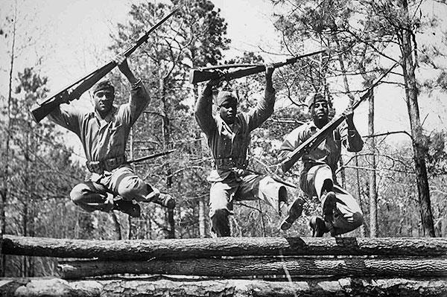

U.S. Marines jump over an obstacle during basic training at Camp Montford Point, N.C. (Courtesy photo/Released)

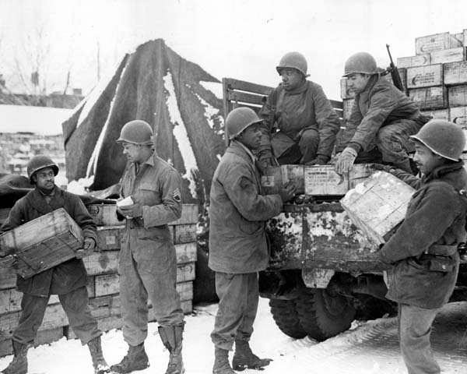

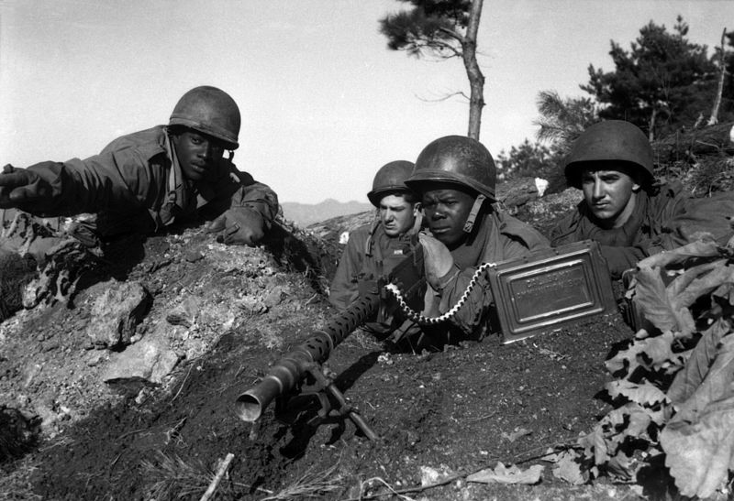

Korean War Lesson Plan
Central Historical Question:
Who started the Korean War?

Materials:
  - Copies of Textbook Excerpts A and B
  - Copies of Korean War Guiding Questions
  - Korean War PowerPoint Slides
  - Optional: Classroom Textbook Excerpt on the Korean War

Plan of Instruction:

- Do Now: Why might textbooks from different countries offer different versions of the same historical events? When textbooks offer conflicting accounts, how do you decide which textbook to believe?

  - Establish that textbooks, like other historical documents we have looked at, have a bias and often offer only one perspective on the past.

  - History textbooks are often influenced by a country’s national perspective and geographic and geo-political relationship to other countries.

- Transition: Today we are going to look at two different textbook accounts of the start of the Korean War and try to figure out where they come from, and which one offers the most trustworthy account. Before we do this, we need some background information.
- Mini-lecture to establish context for the Korean War. Project map of Korean War while lecturing (PPT slide):
  - Korean War was the first hot war of the Cold War: 1950-1953.
  - During Second World War, the Allies decided to divide Korea at the 38th parallel. The North was under the trusteeship of the Soviet Union, the South under the trusteeship of the Americans. Two different countries developed: the North became a communist country, the South a non-communist, democratic country.

  - Both sides wanted to re-unify the country under their own rule.

  - In 1950, after a number of small skirmishes at the border, war broke out between North and South Korea. The US backed and fought with the South, and China fought with a backed the North.

  - Initially, American and United Nations forces pushed deep into North Korea; however, China entered the war and pushed the Americans backed into the South.

  - After three years, the two sides fought to a stalemate and kept the country divided at the 38th parallel.
  - Our job today is think about the question: Who started the Korean War?
- Explain to students that they are going to read two textbook accounts of the Korean War, one from North Korea and the other from South Korea. Pass out Textbook Excerpts A and B and Guiding Questions.
- In pairs, students read textbook excerpts and answer questions.

- Discussion: Students share out answers to questions:

  - According to each textbook, how did the Korean War start?
  - Which of these textbooks do you find more trustworthy? Why?
  - Where else would you look in order to figure out how the Korean War started?
  - Which textbook comes from North Korea? Which comes from South Korea?
- If time remains, have students compare these accounts to the account of the start of the Korean War in their classroom textbooks.

Citations

History of the Revolution of our Great Leader Kim Il-sun: High School. (Pongyang, North Korea: Textbook Publishing Co., 1999), 125-127.
Doojin Kim, Korean History: Senior High. (Seoul, South Korea: Dae Han Textbook Co., 2001), 199.

Textbook A
Upset by the fast and astonishing growth of the power of the Republic, the American invaders hastened the preparation of an aggressive war in order to destroy it in its infancy....The American imperialists furiously carried out the war project in 1950. The
American invaders who had been preparing the war for a long time, alongside their puppets, finally initiated the war on June 25th of the 39th year of the Juche calendar. That dawn, the enemies unexpectedly attacked the North half of the Republic, and the war clouds hung over the once peaceful country, accompanied by the echoing roar of cannons.
Having passed the 38th parallel, the enemies crawled deeper and deeper into the North half of the Republic. the invading forces of the enemies had to be eliminated and
the threatened fate of our country and our people had to be saved.

Textbook B

When the overthrow of the South Korean government through social confusion became too difficult, the North Korean communists switched to a stick-and-carrot strategy: seeming to offer peaceful negotiations, they were instead analyzing the right moment of attack and preparing themselves for it.
The North Korean communists prepared themselves for war. Kim Il-sung secretly visited the Soviet Union and was promised the alliance of the Soviets and China in case of war. Finally, at dawn on June 25th, 1950 the North began their southward aggression along the 38th parallel. Taken by surprise at these unexpected attacks, the army of the Republic of Korea (South Korea) fought courageously to defend the liberty of the country. The
armed provocation of the North Korean communists brought the UN
Security Council around the table. A decree denounced the North Korean military action as illegal and as a threat to peace, and a decision was made to help the South. The UN army constituted the armies of 16 countries—among them, the United States, Great Britain and France—joined the South Korean forces in the battle against the North.

Guiding Questions Name

- According to each textbook, how did the Korean War start?
Textbook A
Textbook B

- Which of these textbooks do you find more trustworthy? Why? (Use specific examples from each text to support your answer).

- Where else would you look in order to figure out how the Korean War started?

Which of these sources is for Textbook A and which is for Textbook B?

Kim, Doojin. Korean History: Senior High. (Seoul, South Korea: Dae HanTextbook Co.), 2001.
Textbook

Provide language from the textbook excerpt to support your answer:

History of the Revolution of our Great Leader Kim Il-sun: High School. (Pongyang, North Korea: Textbook Publishing Co., 1999).
Textbook

Provide language from the textbook excerpt to support your answer:

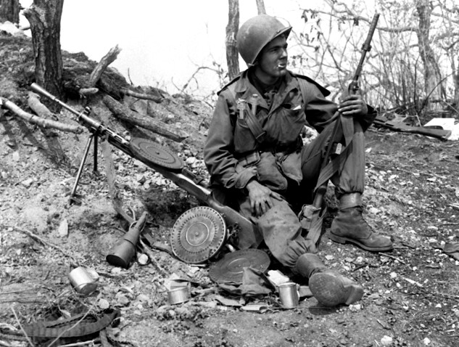

The Korean War: 1950-1953

C I N A

of
I
! Ja an
.
1
L

0 15
I _{I} _{I}
I) 75 50
E3 0
.,.

. '95 □

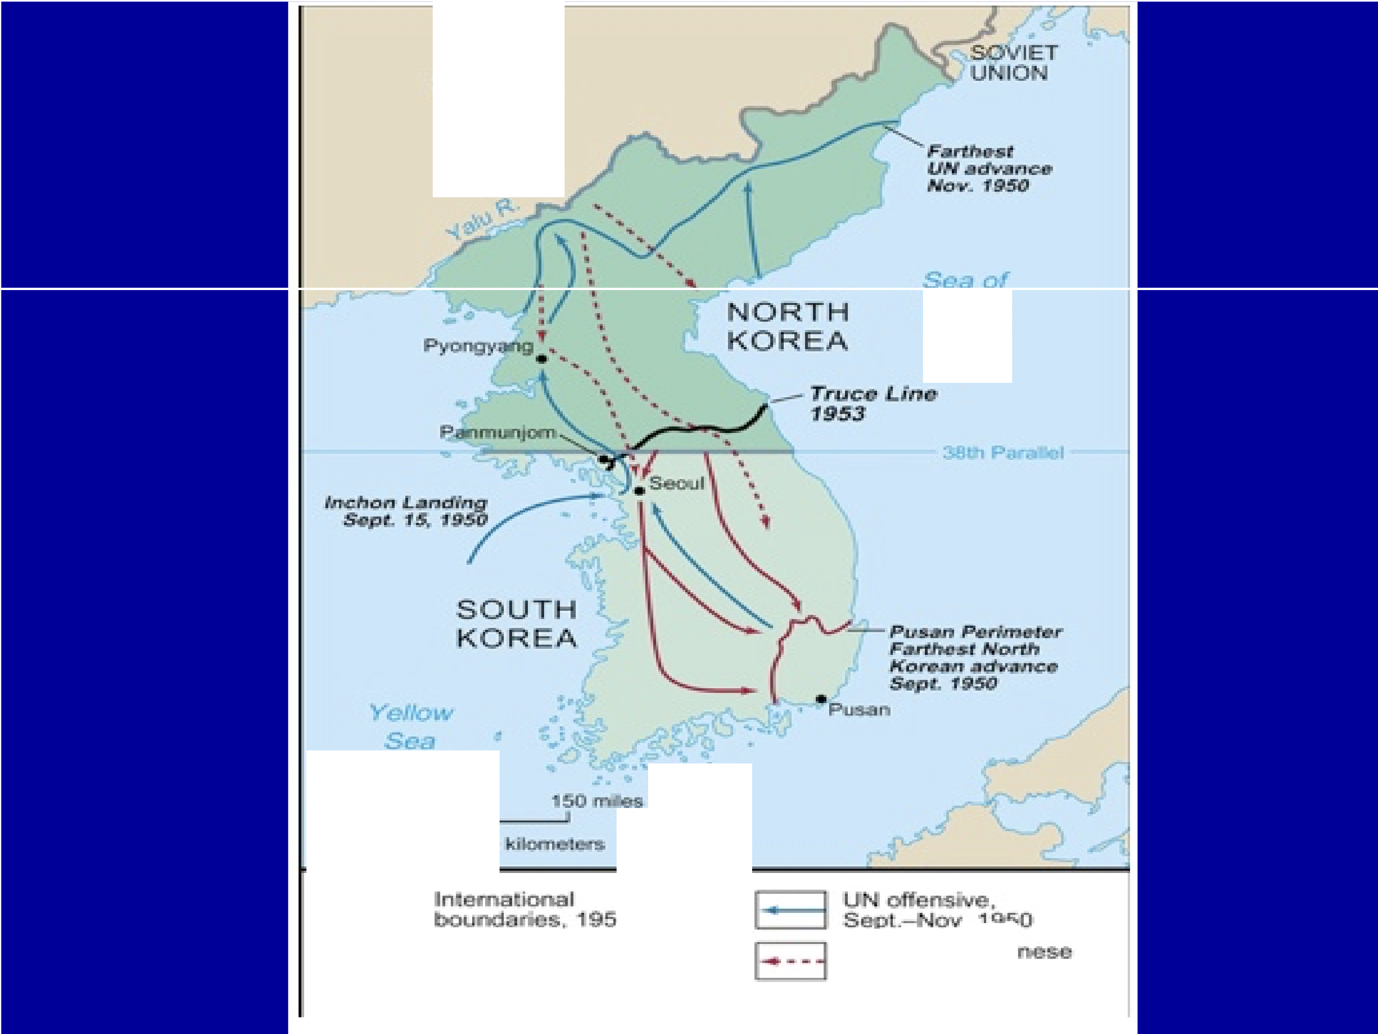
MD1111h !Kori:an n va :sii J u - pl. 9 5(f
Com Ohi
offens:
v. 19 5 0--J'a n_ '9 5

