Geomancy: The Power of Place

AUTHOR INFORMATION

Author: Anthony Roy
State: Connecticut

GENERAL INFORMATION

Lesson Grade Span: Middle (6-8)
Targeted Grade Level/Course: Geography or US History
Estimated Time to Complete Lesson: 3-50 minute classes

FOCUSED QUESTION

How do places represent who we are?

STANDARDS (STATE/C3)

D2.Geo.6.6-8: Explain how the physical and human characteristics of places and regions are connected to human identities and cultures.

STUDENT & TARGET OUTCOMES

Explain how cultural and political priorities shape places.
Compare and contrast the physical and human characteristics of Korean and American communities.

LESSON OVERVIEW

The main focus of this lesson centers on how humans shape and are shaped by the places chosen to develop communities. In Korean culture geomancy plays a major role in shaping communities. Based on a system of beliefs similar to Chinese feng shui, Korea’s pungsu-jiri focuses on creating harmony with nature and is the basis of the formation of what we know today as Seoul. Similarly, throughout the United States and other areas of the world, humans interact with place in a way that illustrates each societies ideals and priorities. In these lessons, the students will examine the similarities and differences between Seoul and Washington, D.C. as they come to understand how physical and human characteristics of places are connected to human identities and cultures.

PROCEDURES

Begin by distributing the images of Gyeongbokgung Palace and the National Mall in Washington, D.C.

Working in pairs, the students create a Venn Diagram comparing and contrasting the two locations. Once the Venn Diagrams are complete, create groups of four so two pairs may compare their work, adding any additional information they may have missed.

**Alternate Activity: Allowing the students to access Google Maps’ street view to complete a virtual tour of Gyeongbokgung Palace and the National Mall.

While completing the Geomancy readings, the students will annotate key details, connections, and questions related to each passage.

The teacher scaffolds questions with the whole class to check for understanding of the key details of each reading and the connections between the two readings, especially as it relates to how cultural characteristics influenced how the built environment was constructed.
Sample question: “What are described as influences for the creation of each city?”

Students then return to their Venn Diagram with a different colored writing implement to contribute additional information related to how cultural characteristics of humans shape the built environment. Using a different color pen or marker with allow the teacher to quickly check for understanding on this particular activity.

Working in pairs, students analyze the maps of Washington, D.C. and Seoul. Again, compare and contrast the sources by adding to the Venn Diagram in yet another color.

Working individually, each student composes a paragraph citing specific evidence to answer the following question: How do places represent who we are?

**Optional: Students work with the rubric to peer review their work prior to submission.

FORMATIVE ASSESSMENT

Assess the Venn Diagram contributions to determine student progress toward comparing and contrasting Korean and American places and cultures.

The completed paragraph will determine the students’ ability to explain how cultural and political priorities shape places.

RESOURCE LIST

(n.d.). AERIAL VIEW OF THE MALL, LOOKING WEST FROM THE CAPITOL TO THE WASHINGTON MONUMENT FROM ABOVE THIRD STREET, NE. – National Mall & Monument Grounds, Washington, District of Columbia, DC. [Photograph]. Retrieved from http://www.loc.gov/pictures/item/dc0787.photos.042661p/
Ehler, Otto Ehrenfried. (1896). Hauptstrasse und Palasttor in Seoul. [Photograph]. Retrieved from https://commons.wikimedia.org/wiki/File:Hauptstrasse_und_Palasttor_in_Seoul.jpg
Evanson, Tim. (2014, April 10). Washington Monument and cherry blossoms – Washington DC. [Photograph]. Retrived from https://commons.wikimedia.org/w/index.php?curid=58282017
Han, Jongwoo. (2014). Power, place, and state-society relations in Korea. New York, NY: Lexington Books.
Kim, Joon-Young. (2006, August 22). Hyangwonjeong in Gyeongbokgung, Seoul. [Photograph]. Retrieved from https://commons.wikimedia.org/wiki/Gyeongbokgung#/media/File:Gyeongbokgung-HyangWonJeong-01.jpg
King of Hearts. (2017, April 1). Jefferson Memorial Washington April 2017. [Photograph]. Retrieved from https://commons.wikimedia.org/wiki/File:Jefferson_Memorial_Washington_April_2017_002.jpg
L'Enfant, P. C., U.S. Coast And Geodetic Survey & United States Commissioner Of Public Buildings. (1791) Plan of the city intended for the permanent seat of the government of the United States: projected agreeable to the direction of the President of the United States, in pursuance of an act of Congress passed the sixteenth day of July, MDCCXC, "establishing the permanent seat on the bank of the Potowmac": Washington D.C. [Washington: United States Coast and Geodetic Survey] [Map] Retrieved from the Library of Congress, https://www.loc.gov/item/88694194/.
Selman, Will. (2018, February 21). L’Enfant’s sacred design for Washington DC. Public Square: A CNU Journal. Retrieved from https://www.cnu.org/publicsquare/2018/02/21/l%E2%80%99enfant%E2%80%99s-sacred-design-washington-dc
Se-ul and Environs (1912). Perry-Castañeda Library Map Collection. The University of Texas at Austin. Retrieved from https://legacy.lib.utexas.edu/maps/historical/se_ul_environs_1912.jpg
Tiseb. (2006, October 22). Gwanghwamun, a gate to Gyeongbokgung in Seoul, South Korea. [Photograph]. Retrieved from https://commons.wikimedia.org/w/index.php?curid=11416027

MODIFICATIONS & EXTENSIONS (OPTIONAL)

MODIFICATIONS
In some cases, the use of one Venn Diagram with a variety of colors to show the development of thinking after working with a new source might be daunting. In this case, have students create a new Venn Diagram for each set of sources.

Allowing some students the ability to complete a graphic organizer in lieu of writing a paragraph may modify the written aspect of this assignment. Additionally, a graphic organizer could be used as a scaffold for this assignment.

EXTENSIONS

Redesign an area of the school (library, cafeteria, common space, etc.) to match the school values. Students can make proposals and the class can vote. Present the winning plan to an administrator.

L’Enfant’s sacred design for Washington DC

Will Selman, Public Square: A Congress for New Urbanism (CNU) Journal,
February 21, 2018
Adapted from https://www.cnu.org/publicsquare/2018/02/21/l%E2%80%99enfant%E2%80%99s-sacred-design-washington-dc

As would any land planner, Pierre Charles L’Enfant began work in 1791 by surveying the land and analyzing the topography, making note of the high points and wetlands in the area. He spent an enormous amount of time getting to know every corner of the land he was given to work with. One of his first steps was to determine the central point of beginning, from which all other work of the design would grow. L’Enfant chose Jenkin’s Hill as his starting point, the highest elevation in the area; we now know this as Capitol Hill. This makes the Capitol Building the centerpiece– pointedly, not the White House. The Capitol Building is where legislators meet to make laws. They represent the citizens in their states and towns. This location symbolically reflected the central place of the citizen in the new democracy. Next, L’Enfant created two streets emanating from this central point; one running north-south, another running east-west. Today we know these as North and South Capitol Streets, East Capitol Street, and The Mall. This process follows the method of the ancient Romans, who as city planners used a central point to create what was known as the Cardo, the main street running north-south, and its companion known as the Decamanus, running east-west.
From this center point the remainder of the city was drawn. As his work progressed, L’Enfant became angry with the process and left the job abruptly. His work was finished by other city planners of the time. In the ensuing decades of the 19th Century, the L’Enfant Plan was unfulfilled. In 1901, the McMillan Commission was appointed to re-invigorate the original plan. It succeeded in many ways, most emphatically by gifting us with the Mall and “monumental core” that we know and love today.

Pungsu-Jiri and the Power of Place

Adapted from Jongwoo Han. (2014). Power, place, and state-society relations in Korea, 44, 108-110.

From the beginning of human civilization, place and power have been inseparable. Kings and ruling elites believed that they could maximize their political legitimacy by locating the palace and the capital city in a site where they believed the Will of Heaven is shown in a landscape that is sacred. Human understanding of the cosmos was reflected in the chinese philosophy of Taoistic yin-yang as well as the belief of geomancy (feng shui) which was used specifically for finding connections to the gods and other celestial bodies on earth. In China geomancy is called feng shui, but in Korea it is known as Pungsu-jiri.
The essence of geomancy is that the relative configurations of the landscape and water flows are regarded as directing the flow of the universal qi, or “cosmic current.” When studied and purposefully used to decide where to place cities, palaces, buildings, markets, and other manmade structures, the qi can be harnessed in a way that creates the optimum advantage for a person in terms or wealth, happiness, and longevity. When the people of Baekje, one of three kingdoms of Korea, decided to found what we know today as Seoul in 18 BCE, it was understood that establishing the city in that place would bring prosperity to the kingdom and help to block unforeseen and uncontrollable consequences. The flow of qi is influenced by all natural bodies and human constructions which can repulse, redirect, or catch the qi. Furthermore, throughout time the various buildings, temples, and palaces throughout the sacred areas of Seoul were also built in specific sites to align with stars and planets in the sky. Many in Korea believe that adhering to Pungsu-Jiri helped create centuries of economic and political success.

Ehlers Gwanghwanum

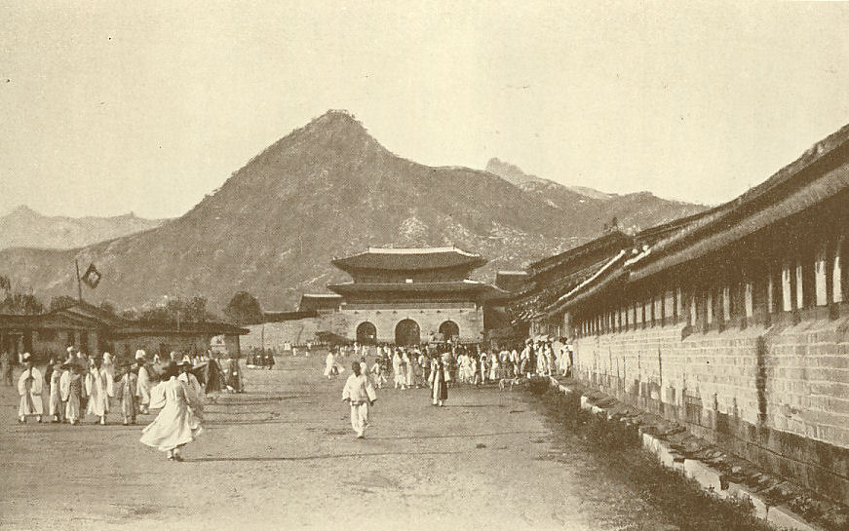

Evanson Chery Blossom

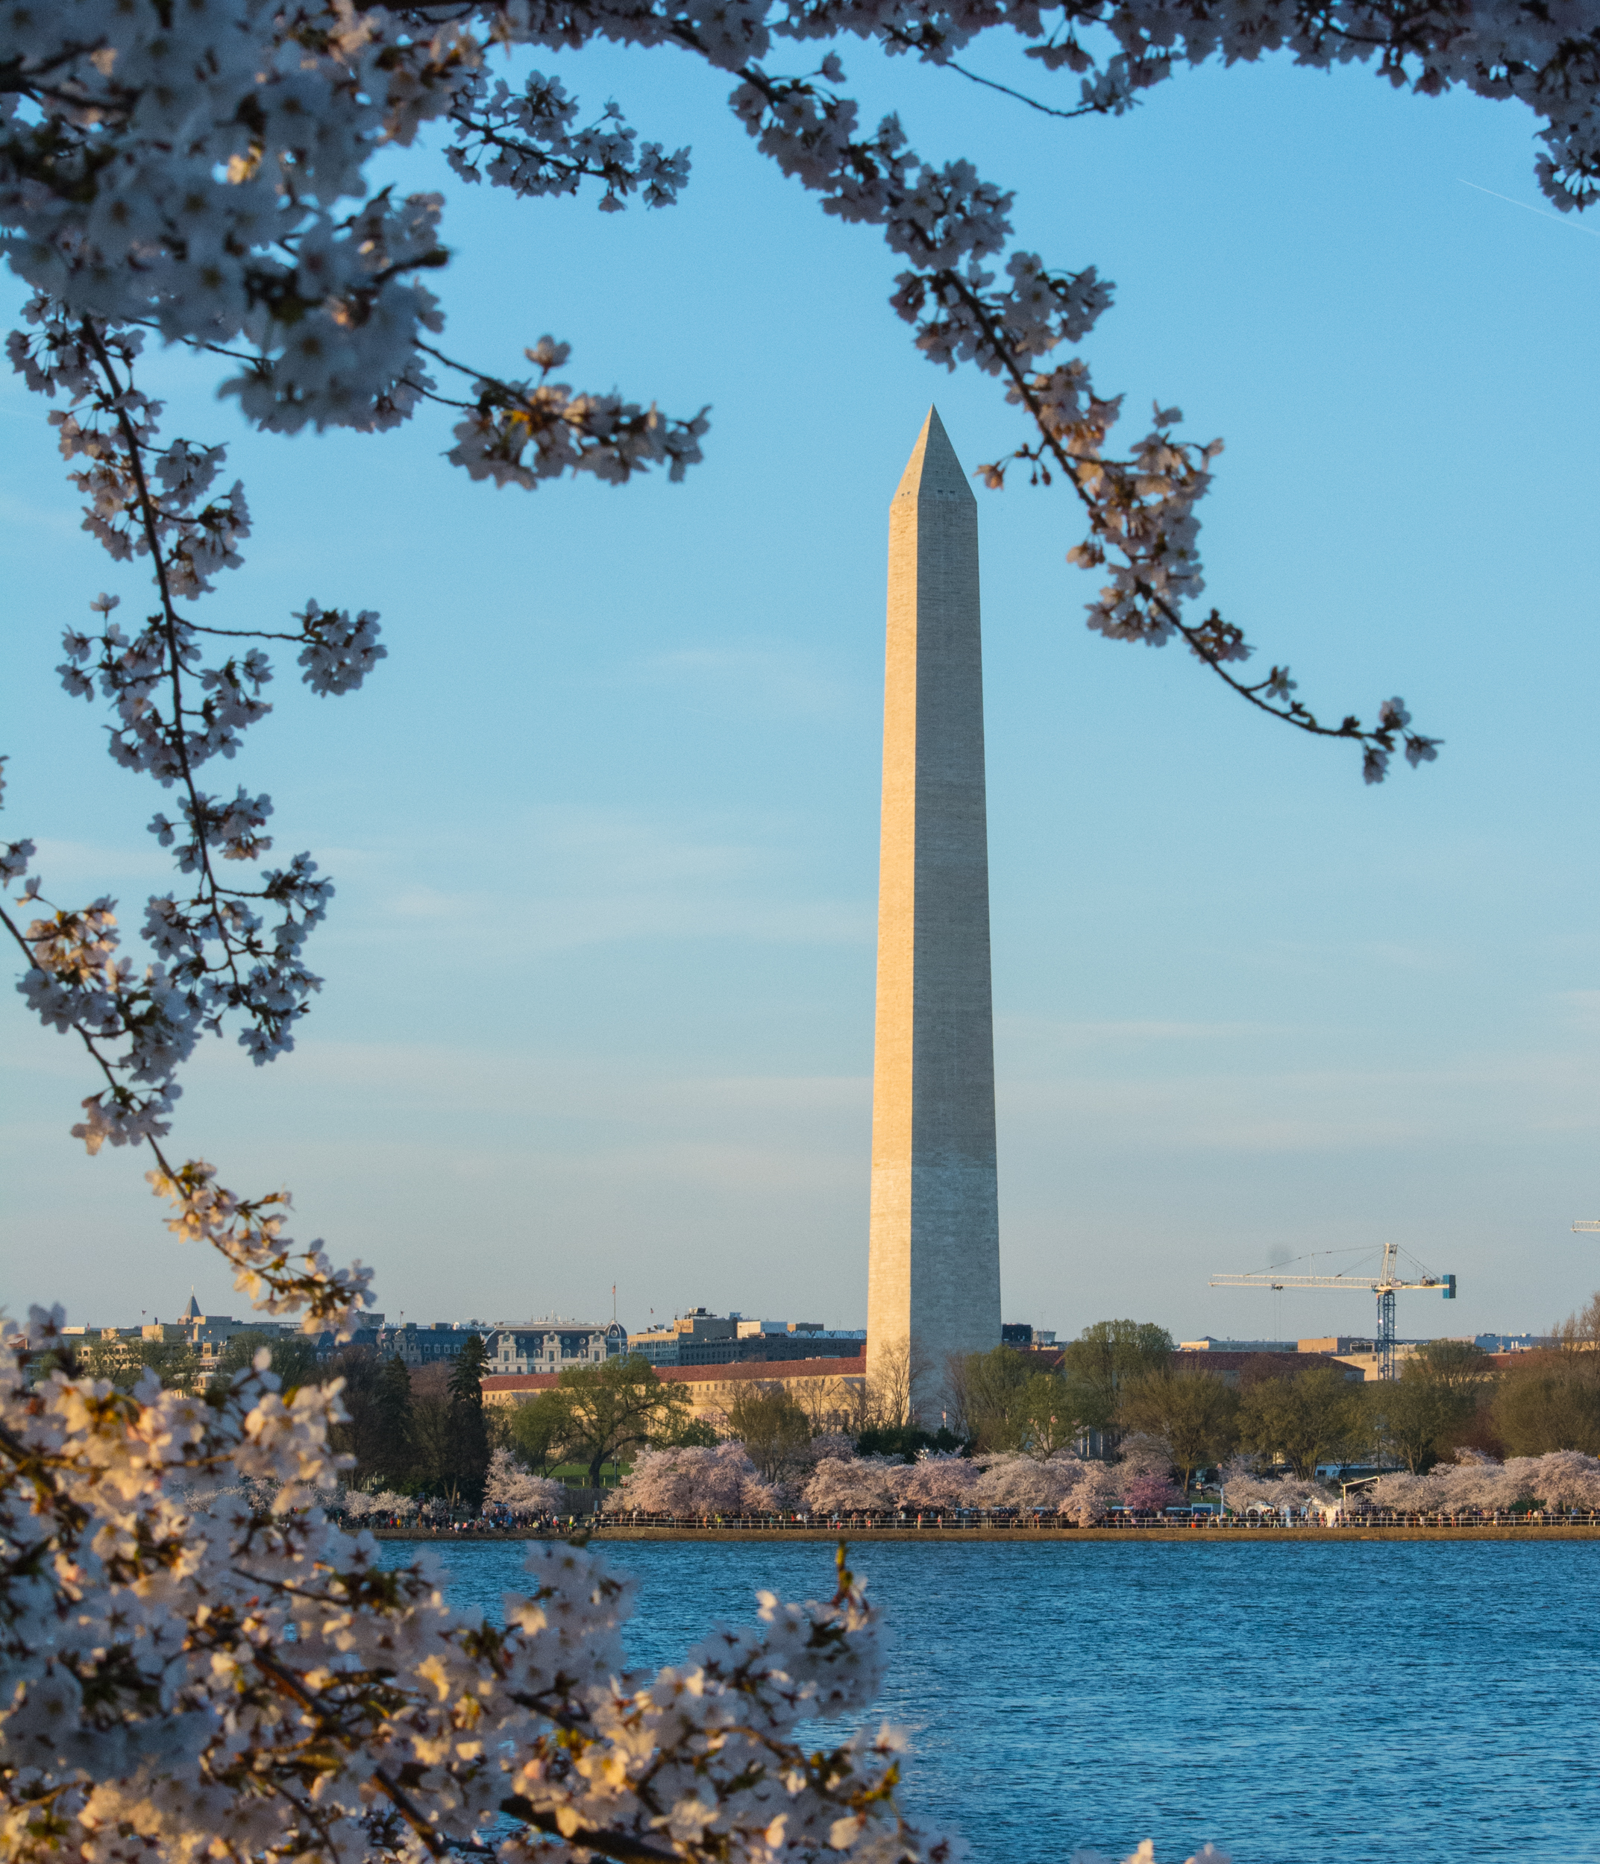

Kim Hyang Won Jeong
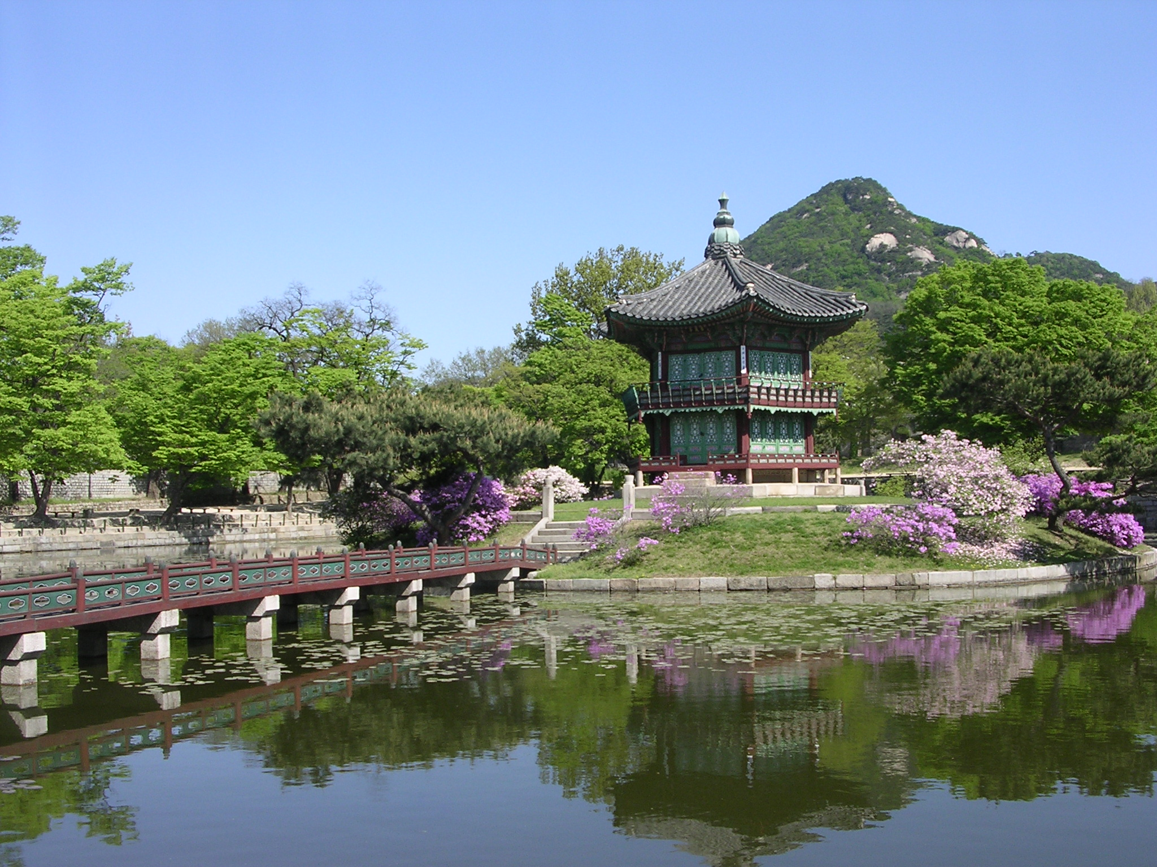

King- Jefferson Memorial

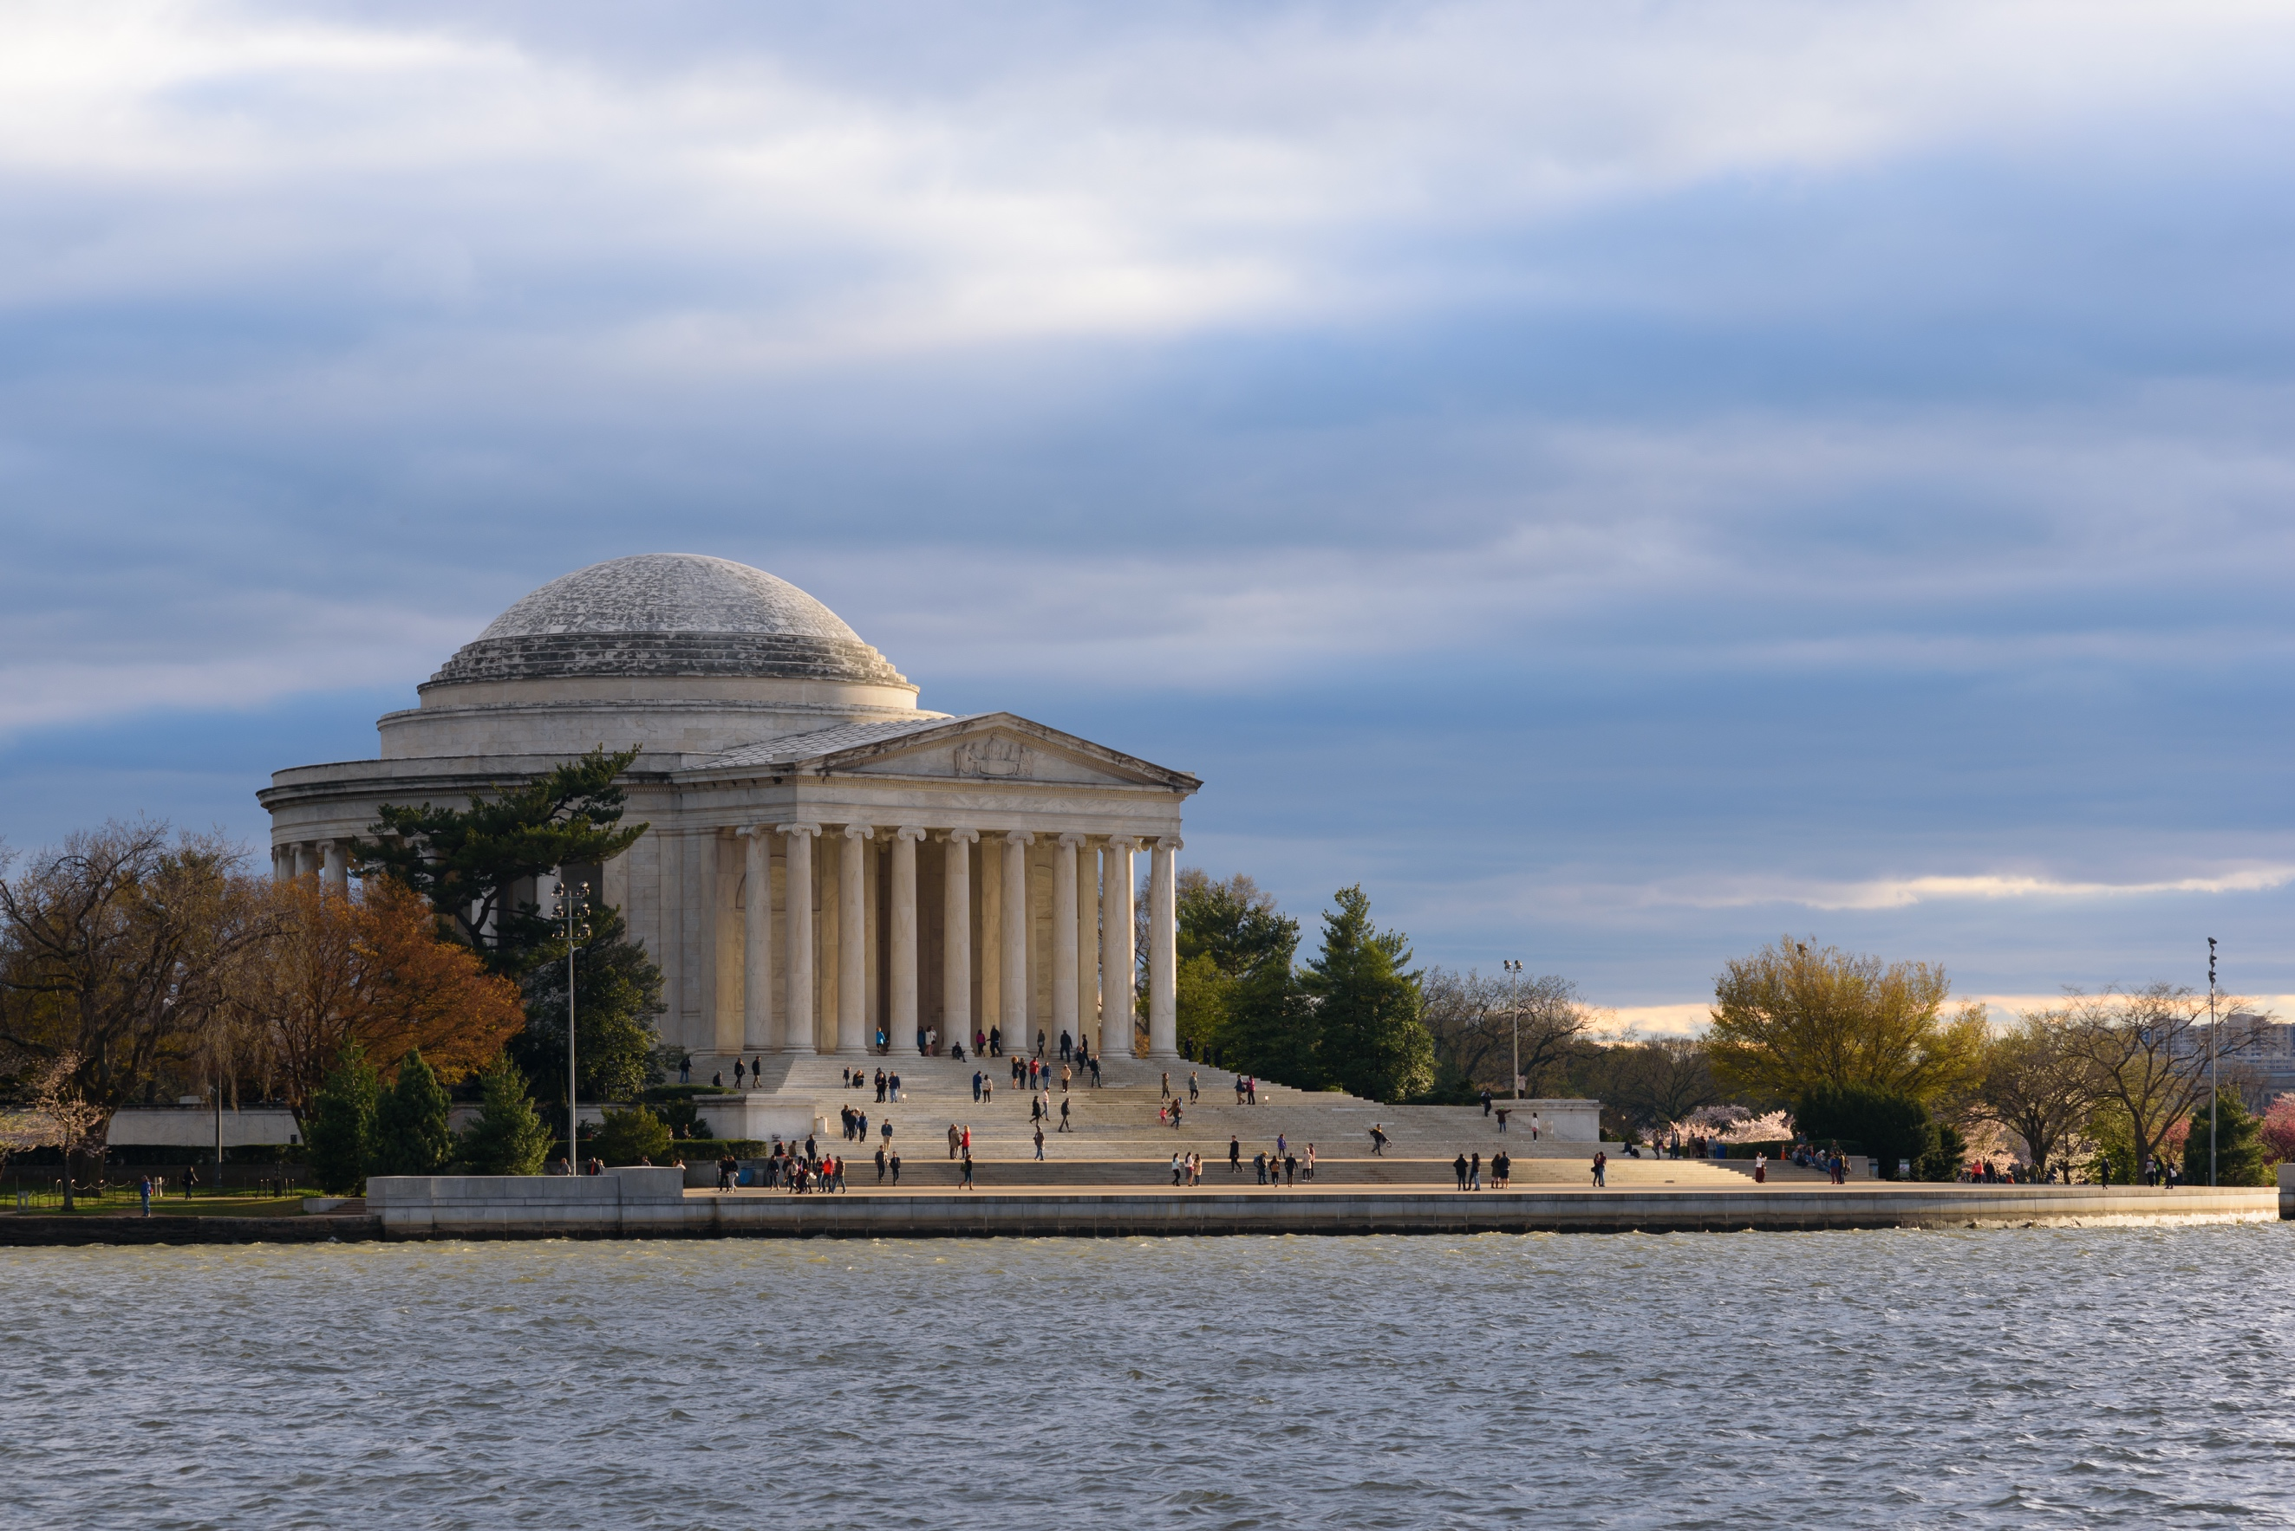

L’Enfant DC Map

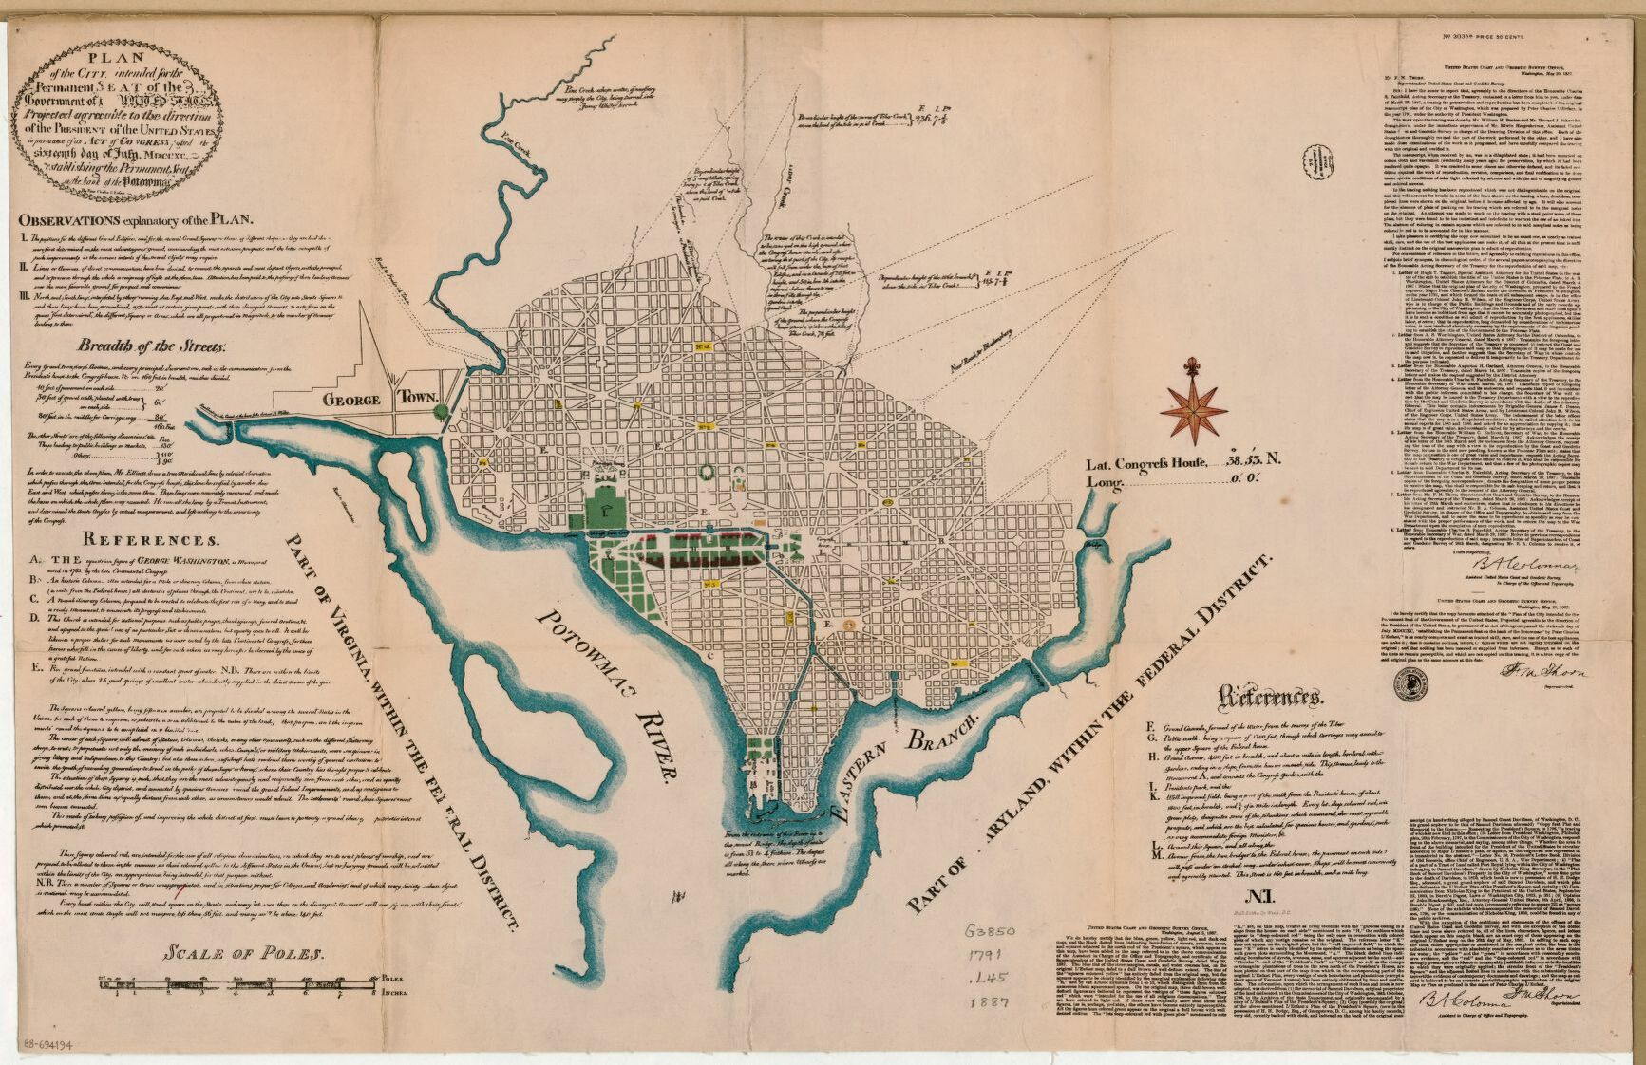

LOC National Mall
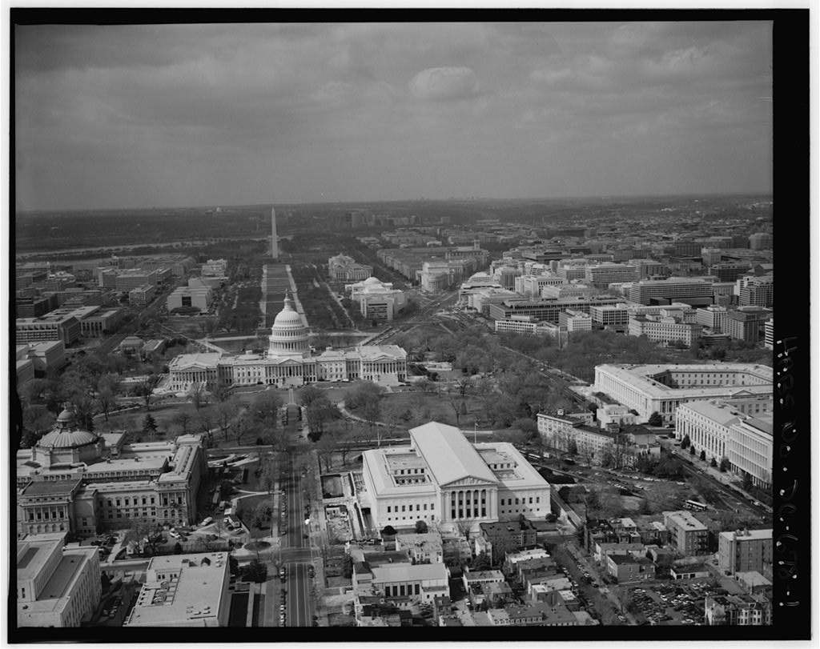

Se-Ul Map
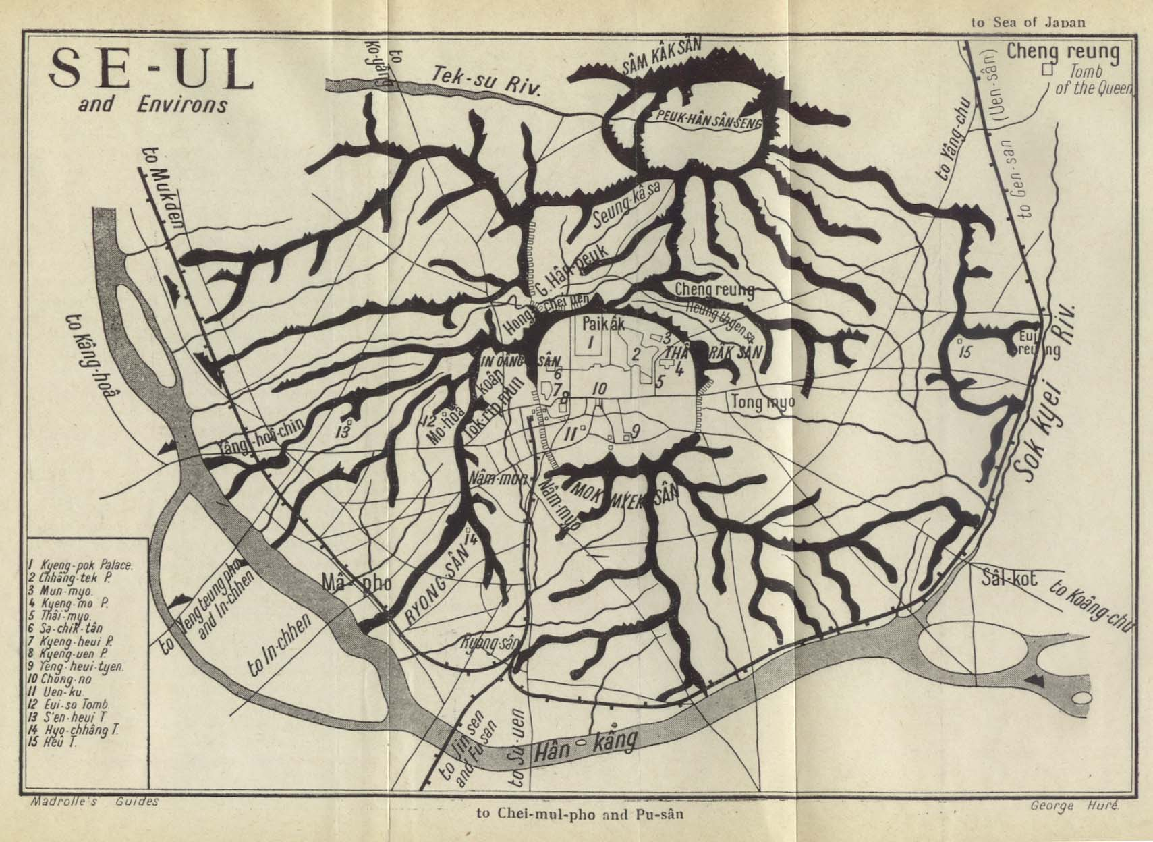

Seoul Gwanghwamun 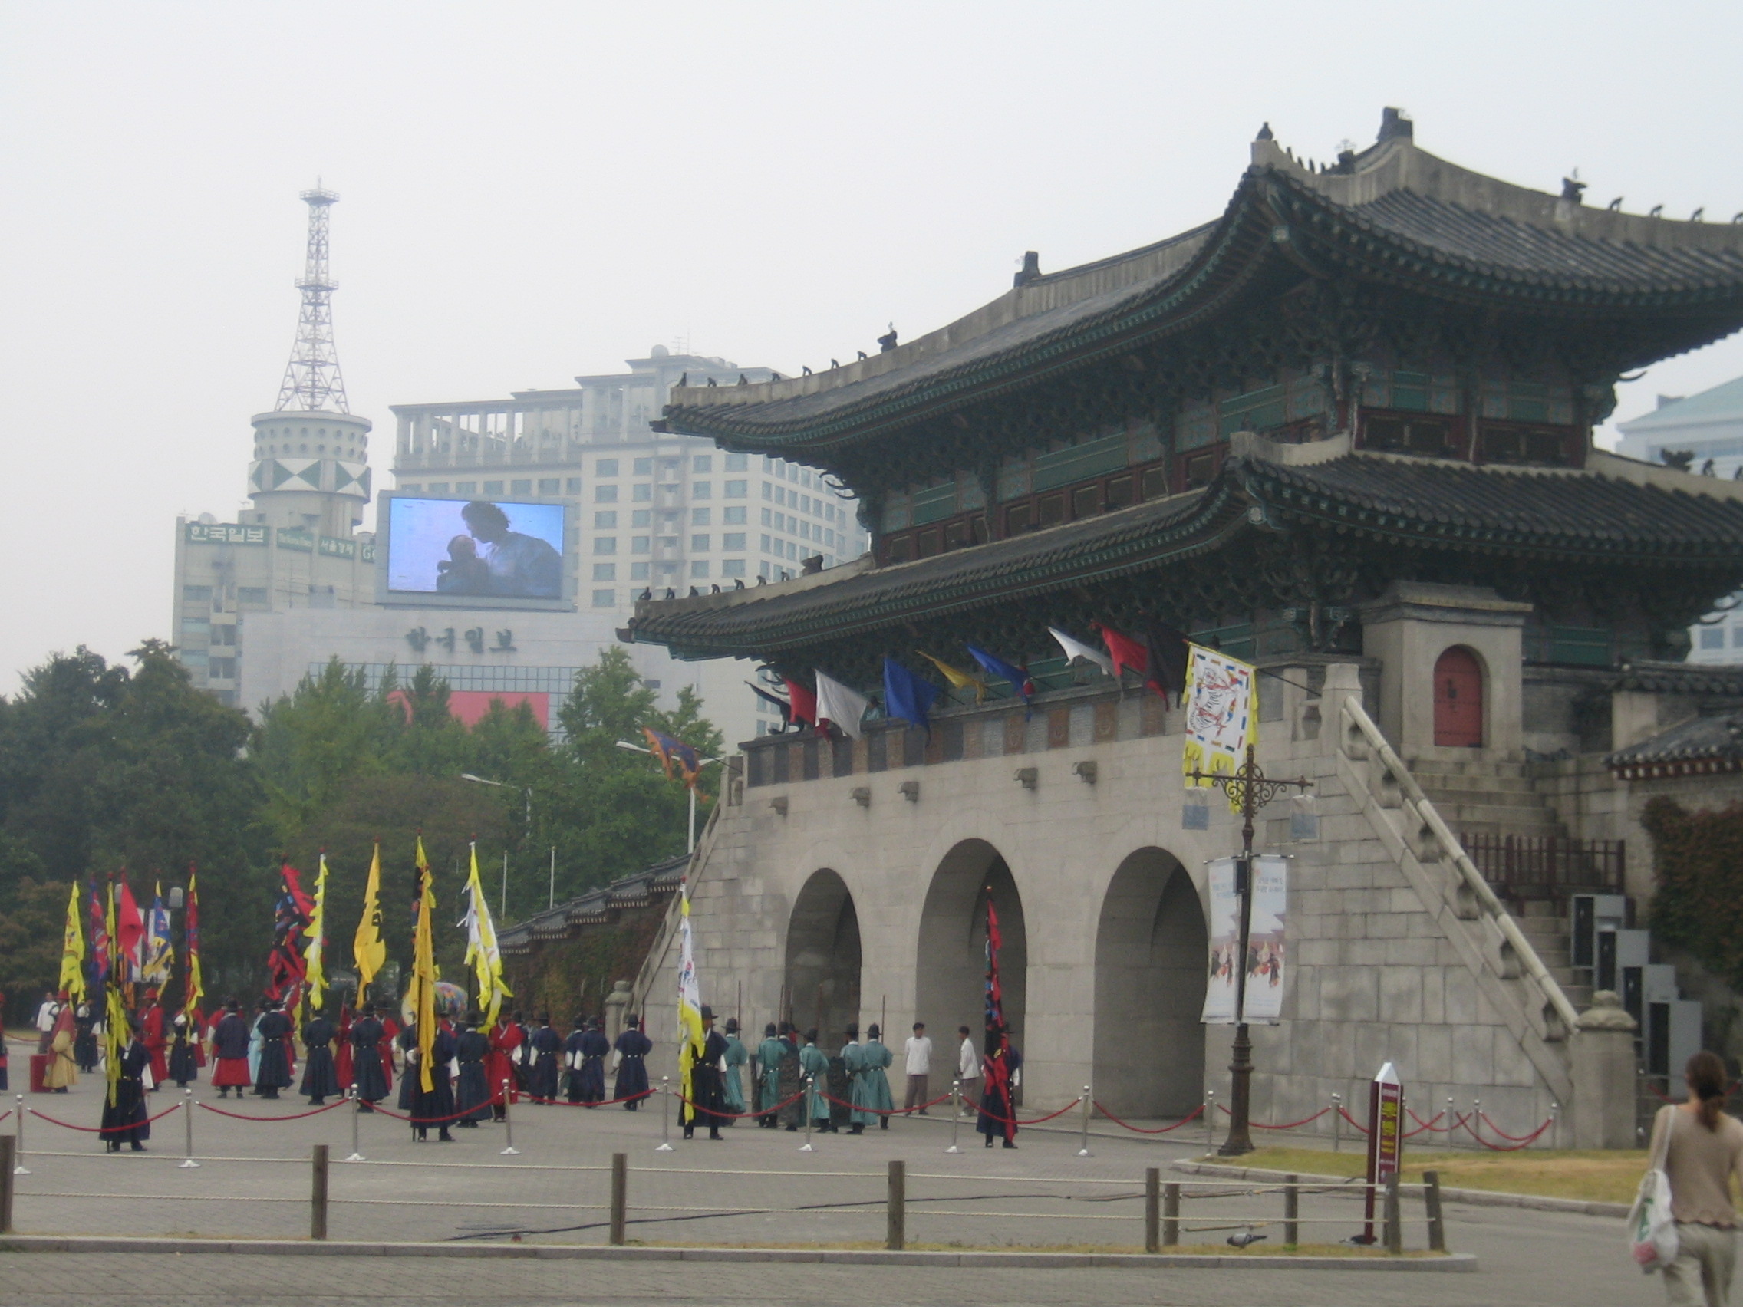

Geomancy: Power of Place Paragraph Rubric

 | 4 | 3 | 2 | 1
Main idea (Claim) | The answer to and context* of the problem is completely addressed in the claim. | The answer to and context* of the problem is mostly addressed in the claim. | The answer to and context* of the problem is somewhat addressed in the claim. | The answer to and context* of the problem is minimally addressed in the claim.
Evidence  - Introduce  - Cite  - Explain | Evidence strongly supports the claim, is clearly introduced, accurately cited, and thoroughly explained | Evidence mostly supports the claim, is clearly introduced, accurately cited, and mostly explained | Evidence partially supports the claim, is clearly introduced, accurately cited, and partially explained | Evidence minimally supports the claim, is clearly introduced, accurately cited, and minimally explained
Analysis (Reasoning) | Reasoning completely explains why the evidence supports the claim. | Reasoning mostly explains why the evidence supports the claim. | Reasoning somewhat explains why the evidence supports the claim. | Reasoning minimally explains why the evidence supports the claim.
Link | The link (final sentence or sentences) strongly adds context* to, clarifies, or connects to main idea | The link (final sentence or sentences) mostly adds context* to, clarifies, or connects to main idea | The link (final sentence or sentences) partially adds context* to, clarifies, or connects to main idea | The link (final sentence or sentences) minimally adds context* to, clarifies, or connects to main idea

* The circumstances that form the setting for an event, statement, or idea; the group of conditions that exist where and when something happens. synonyms: circumstances, conditions, factors, state of affairs, situation, background, scene, setting

Grade: ____ Comments:

