Artistic Expression vs. Historic Memory: A Controversial Mural Ignites Debate in Koreatown

AUTHOR INFORMATION

Author: Isabel Morales
State: California

GENERAL INFORMATION

Lesson Grade Span: Secondary (9-12)
Targeted Grade Level/Course: 10th Grade World History or 12th Grade Civics
Estimated Time to Complete Lesson: Two 60-minute periods

FOCUSED QUESTION

How do we balance artistic expression and sensitivity of historic trauma rooted in Korea's colonial past?

STANDARDS (STATE/C3)

C3: D2.Civ.14.9-12. Analyze historical, contemporary, and emerging means of changing societies, promoting the common good, and protecting rights.

STUDENT & TARGET OUTCOMES

- Students will be able to explain the experiences of Koreans living under Japanese occupation.
- Students will be able to analyze the multiple meanings of the Japanese imperial flag.
- Students will be able to understand the multiple perspectives surrounding the Koreatown mural.
- Students will be able to develop written and verbal arguments about the mural's future, grounded in factual evidence.

LESSON OVERVIEW

At the Robert F. Kennedy Community Schools, a mural ignited a firestorm of debate. The mural depicts the history of the school site, which was formerly home to the historic Ambassador Hotel. The background design of the mural is a series of red rays radiating outward. Local Korean organizations wrote letters to the school district, demanding that the mural be taken down, as it looked too much like the Japanese imperial flag. The artist claimed that the background design was not intended to evoke that history, and that it was a common design motif used in art. The school district agreed to paint over the mural, but the teachers and artist fought back, on the grounds of creative freedom and censorship. After enough pressure from a prominent artist, the district backed down.

In this lesson, students will read statements put out by various groups, to learn more about the competing issues at play. They will read about Korea's history under Japanese rule, compare and contrast the mural and Japanese imperial flag, read about the censorship concerns, and develop a solution that is grounded in factual evidence.

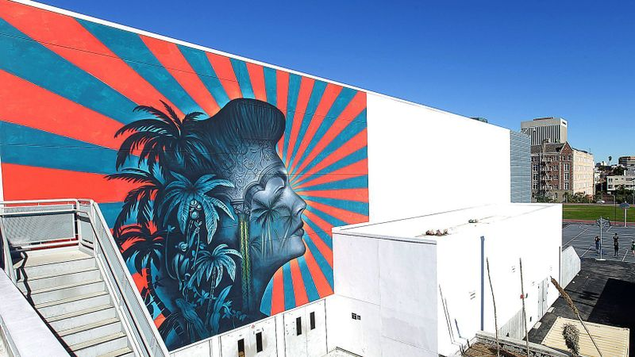

PROCEDURES

1. Display the Koreatown mural for students, and ask them to list what they see.

2. Tell students that members of the community want this mural taken down because it looks a lot like "Image #2." Show students the Japanese Imperial Flag, without telling them what it is. Give students 5 minutes to develop questions about both images, and ask them to share the questions out loud. Chart these questions on the board.

3. Tell students that they are tasked with coming up with a solution that takes into account competing perspectives. Provide them with copies of the statements by the National Coalition Against Censorship and the Wilshire Community Coalition. As they read, they will create a T-chart that demonstrates the arguments made by both sides.

4. Ask students to use their T-charts to discuss the questions posed by the class in step #2. They should discuss in groups of 2-3 first, and then share out in a whole class discussion.

Make sure that these questions are part of the discussion:
- What is the historic significance of the flag, and why is it problematic?
- How are the mural and the flag similar and different?
- This mural is located in Koreatown, a community with the highest population of Koreans in the United States. Why does that matter in this controversy?
- What are that multiple perspectives in this debate?

5. With their partners, students will brainstorm solutions to this controversy. They will share out their solutions, and discuss how the short-term and long-term impacts of their proposals.

6. As an exit pass, students will write an individual proposal to the school board about the mural's future. The students must explain how their solution thoughtfully weighs the multiple perspectives provided in the readings.

FORMATIVE ASSESSMENT

T-chart demonstrates reading comprehension, and an understanding of the multiple issues in this debate.

As students discuss with partners and in a whole class discussion, teacher will monitor and check for understanding.

Students' written proposals will assess students' abilities to understand the multiple perspectives of the controversy, their understanding of the Japanese imperial flag's historic meaning, and their ability to support a claim with evidence. (Teachers can use the Evidence-based Writing Rubric to assess student writing.)

RESOURCE LIST

For access to all of the resources, go to: https://drive.google.com/open?id=1g3wAsQ7t_RIaKZKTUGNxQfHBh1mEoxPx

Blume, Howard. "A mural at a Koreatown school pays homage to classic Hollywood. Some say it's as offensive as a swastika." Los Angeles Times. Dec 11, 2018. https://www.latimes.com/local/education/la-me-edu-lausd-ava-gardner-mural-20181211-story.html

National Coalition Against Censorship. "NCAC opposes removal of mural at Los Angeles school." December 7, 2018. https://ncac.org/news/ncac-opposes-removal-of-mural-at-los-angeles-school

Wikipedia. Japanese Imperial Flag image. https://en.wikipedia.org/wiki/Rising_Sun_Flag

Wilshire Community Coalition. "Joint letter to Robert F. Kennedy Community Schools, LAUSD." November 15, 2018. https://wilshirecommunity.org/author/wilshirecc/

MODIFICATIONS & EXTENSIONS (OPTIONAL)

MODIFICATIONS

The NCAC and WCC statements can be excerpted or assigned for homework if time is short.

EXTENSIONS

Students can speak about current controversies on social media, blogs, school board meetings, and town halls.

Students can hold meetings to educate the school community about the various issues at play, including Korean history and artistic freedom.

Mural at the Robert F. Kennedy Community Schools complex by Beau Stanton
Image from Los Angeles Times

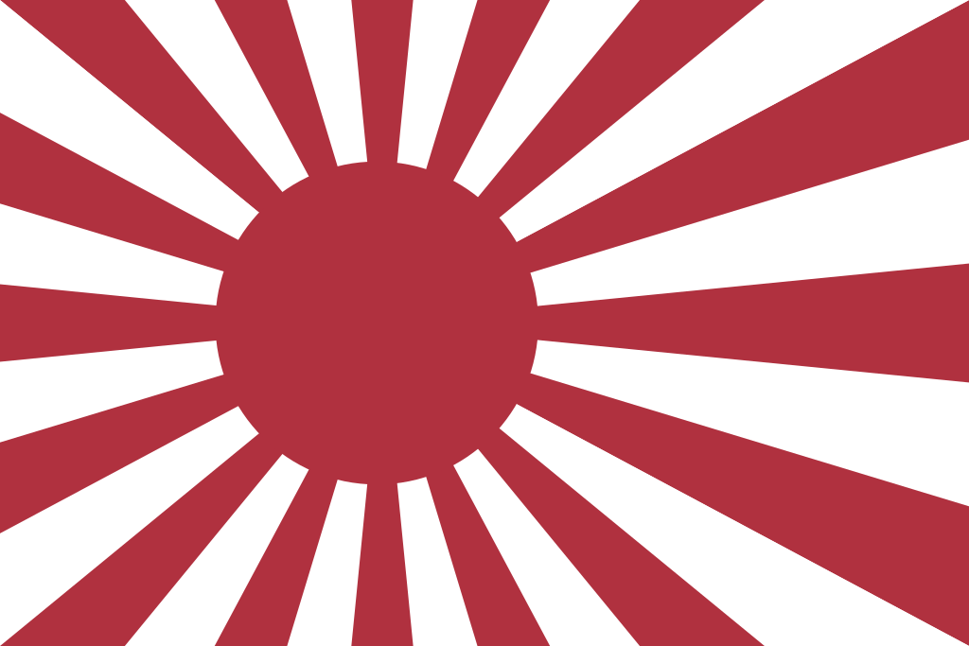
Image #2
Source: Wikipedia

