A Gallery Walk of Ancient Korea

AUTHOR INFORMATION

Author: Mariah Pol
State: Indiana

GENERAL INFORMATION

Lesson Grade Span: Middle (6-8)
Targeted Grade Level/Course: 7th Grade Eastern World History
Estimated Time to Complete Lesson: 1 75-minute class

FOCUSED QUESTION

How did Korea’s location impact its history and culture?

STANDARDS (STATE/C3)

Indiana 7th Grade Social Studies Standards:
- 7.1.2 Describe, compare, and contrast the historical origins, central beliefs and spread of major religions.
  - Example: Hinduism, Buddhism, Judaism, Christianity and Islam
- 7.1.4 Describe the importance of the Silk Road on the histories of Europe, Africa, and Asia.
- 7.1.7 Trace the rise, spread and influence of the Mongols.
- 7.2.2 Compare and contrast historical and contemporary governments in Africa, Asia, and the Southwest Pacific.
  - Examples: Japan, North Korea, India, South Africa, and China

STUDENT & TARGET OUTCOMES

I can…
- Interpret how Korea’s geography impacted its history.
- Analyze how Korea’s neighbors influenced its history and culture.
- Compare how Korea’s history and culture is unique from its neighbors.

LESSON OVERVIEW

This lesson can serve as an introductory lesson to a unit on Korea. In this lesson, students will be interacting in a photo gallery walk activity. In various places around the classroom, there will be exhibit stations that pertain to different factors regarding Ancient Korea’s geography, history, and culture. Students will work in pairs or small groups. They will have 3 minutes at each station to read the descriptions, analyze images, and answer questions about Korea. Afterwards, students will come together as a class to discuss the new information they learned.

PROCEDURES

Part I - Introduction
- As students walk in, for a Bell ringer have students create a KWL chart and answer the first two columns, “What do I already know about Korea?” and “What do I want to learn about Korea?” Have students share their responses with the class.
- Two students will read out loud the “Focused Question” to class to remind students the purpose and objective of today’s lesson.
- Inform students that they are about to tour a photo gallery of Ancient Korea where they will examine objects and places that are important to Korean people and its history.
- Inform students that they will be divided into pairs or small groups. Each group will begin at a different “exhibit” (i.e., image sheet that the teacher attached to the walls before class). At each exhibit they must fill in a row of the “Photo Gallery Worksheet” by recording the name of the image in the first column, its connection to Korea in the second column, and their answer to the question below each image in the final column.
  - Teacher can model one exhibit (image sheet) and worksheet for class to clarify activity expectations.
- Instruct students to discuss the information and their answers with their group members before filling in the worksheet. Tell them that they will only have 3 minutes at each exhibit, so they will need to stay focused and write their answers quickly.
- Divide students into pairs or 3 individuals. The number of groups should not exceed the number of image sheets (it is preferable to increase the group size).

Part 2—The Tour
- Send each group to a different “exhibit” (image sheet). Once all the groups are in front of an image tell students to look at the image, read the description and begin filling out their worksheet.
- Remind students that they will change “exhibits” every three minutes.
- Time three minutes and instruct students to rotate clockwise to the next exhibit.
  - It is helpful to have timer projected on overhead screen.
- Repeat step 3 until students have rotated through all the exhibits.

Closure
- Once students are seated at their desks, have student volunteers share their answers to the questions on each of the exhibits to generate discussion about Korea’s geography, history, and culture.
- Ask students to identify their favorite image and explain why they like it.
- Have students return back to the Bell Ringer activity and fill in the final column of the KWL chart about what new information they learned about Korea reminding them of the focused question “How did Korea’s location impact its history and culture?”

FORMATIVE ASSESSMENT

To formally assess students, the teacher can use students answers on their worksheets to see if they were properly analyzing and making inferences to the questions proposed on each of the exhibit stations.

The teacher can also use the student responses to what new information was learned about Korea on the last column of the student KWL charts to see how the learning goal of “How did Korea’s location impact its history and culture?” was achieved.

RESOURCE LIST

Korea's Geography and Society. (2019). In World History Social Studies Techbook (pp. 1-7). Discovery Education. Retrieved from https://cleversso.discoveryeducation.com/learn/techbook/units/d1792c7c-3a18-4d7e-95b2-86f2ade7e64b/concepts/cce13ee6-590c-41b8-a837-1d07f177e61e

Pungsu, the Art of Korean Geomancy. In Open Ended Social Studies. Retrieved from https://openendedsocialstudies.org/2016/06/25/pungsu-the-art-of-korean-geomancy/

MODIFICATIONS & EXTENSIONS (OPTIONAL)

MODIFICATIONS

To modify the assignment, higher level students can be paired with struggling students to assist them in reading, responding, and analyzing each exhibit station. The timer can also be adjusted based on the time needed for students to do their best at the exhibit station. The teacher can also choose to model more than one exhibit (image sheet) and worksheet questions.

EXTENSIONS

This lesson is designed to be an introductory lesson in a larger unit about Korea. It will provide students with further background information to compare Korea to other East Asian cultures studied in the school year. It also will allow students to conceptualize Korean culture as unitary and empathize with Koreans’ perspectives about its separation during the Korean War and the implications of that today. Possible ideas further in the unit can involve having students create History Day Projects about various aspects to Korean history, writing letters to their Congressman about Modern Korea, or writing a journal entry about what they think it means to be “Korean” regarding history and culture.

Korea’s Geography

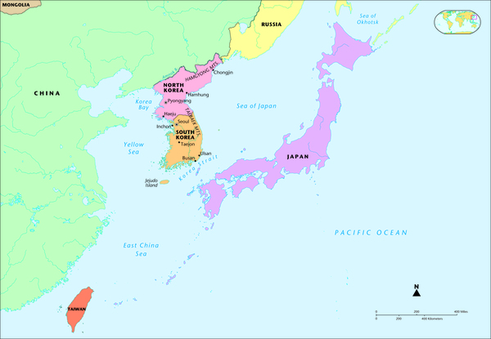

Korea is on the continent of Asia. Today, Korea is divided into two countries, North Korea and South Korea. Both countries rest upon a peninsula. A peninsula is a piece of land almost surrounded by water or projecting out into a body of water, like the US state of Florida. Korea is filled with mountains. The Korean people use the rivers on the peninsula to make transportation and trade easier. Koreans have also used the rivers also serve as natural boundaries for protection. The rivers empty into the large bodies that surround Korea like the East Sea (also called the Sea of Japan), East China Sea, and Yellow Sea. Most Koreans settled near the mouth of these rivers, which are to the Southern and Western parts of the peninsula.

What countries neighbor Korea? How do you think they might affect Korean civilization?

Joseon (Chosŏn) Dynasty
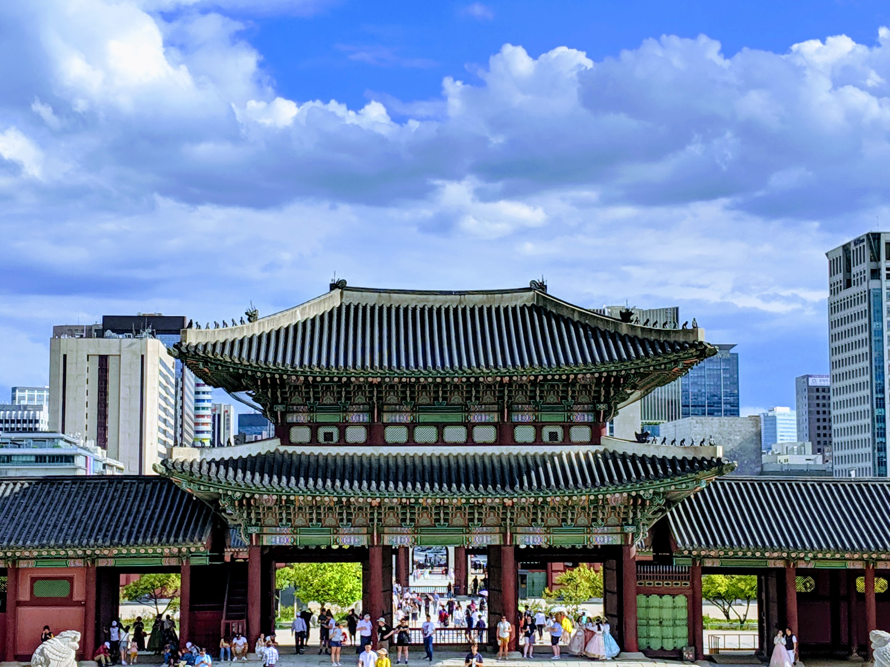

Korea’s first empire was the Joseon (Chosŏn) dynasty. The empire’s capital was in Northern Seoul, which is still the capital of modern South Korea. The image above is a rebuilding of the entrance gates to the Gyeongbokbung Palace, the former royal palace of the Joseon, that were destroyed during the Japanese occupation of Korea. The legend is that the first leader of the Joseon was believed to be the child of the son of heaven and a bear in the form of a woman. Later, the Joseon dynasty was overthrown by China’s Han dynasty. The Joseon dynasty then became a satellite state to the Chinese, still governing the Korean peninsula but a part of greater Han China. This is just one of many instances (over 1000) that Korea would be invaded by its neighbors.

How does the creation story of the Koreans compare to China and Japan?

Hunmin Chongum
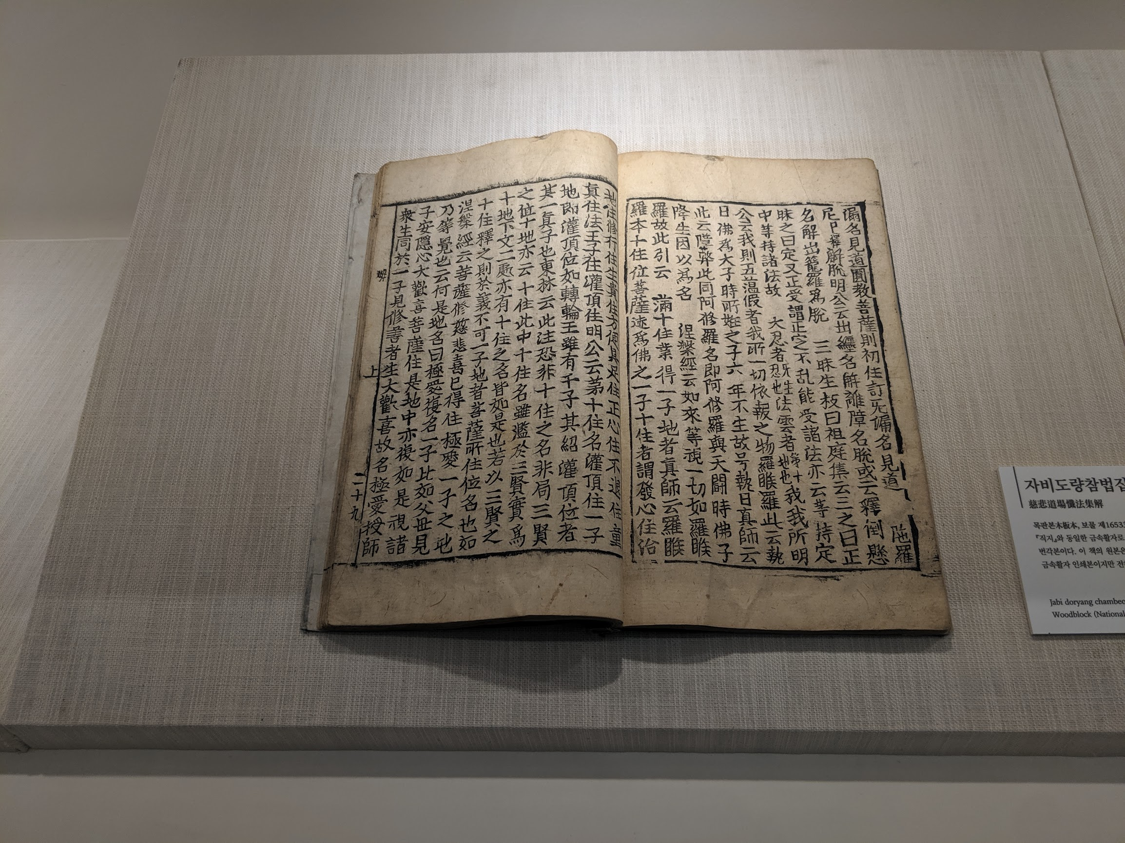

After the Joseon dynasty fell to the Chinese, for a time, Korea separated into various tribal states to resist Chinese influence. The most notable kingdoms that arose during this period are the Koguryŏ (GO-gur-yo) (which Modern Korea is named after) and the Silla (SHIH-lah). Although these kingdoms were centered in various locations among the Korean peninsula and had different strengths and weaknesses, as well as cultural differences, they shared the same writing system called Hunmin Chongum. Hunmin Chongum evolved from Chinese writing but instead of pictographs, it uses symbols to instruct sounds. Koreans also write vertically from right to left.

How is the Korean alphabet similar and different to our own?

Buddhism
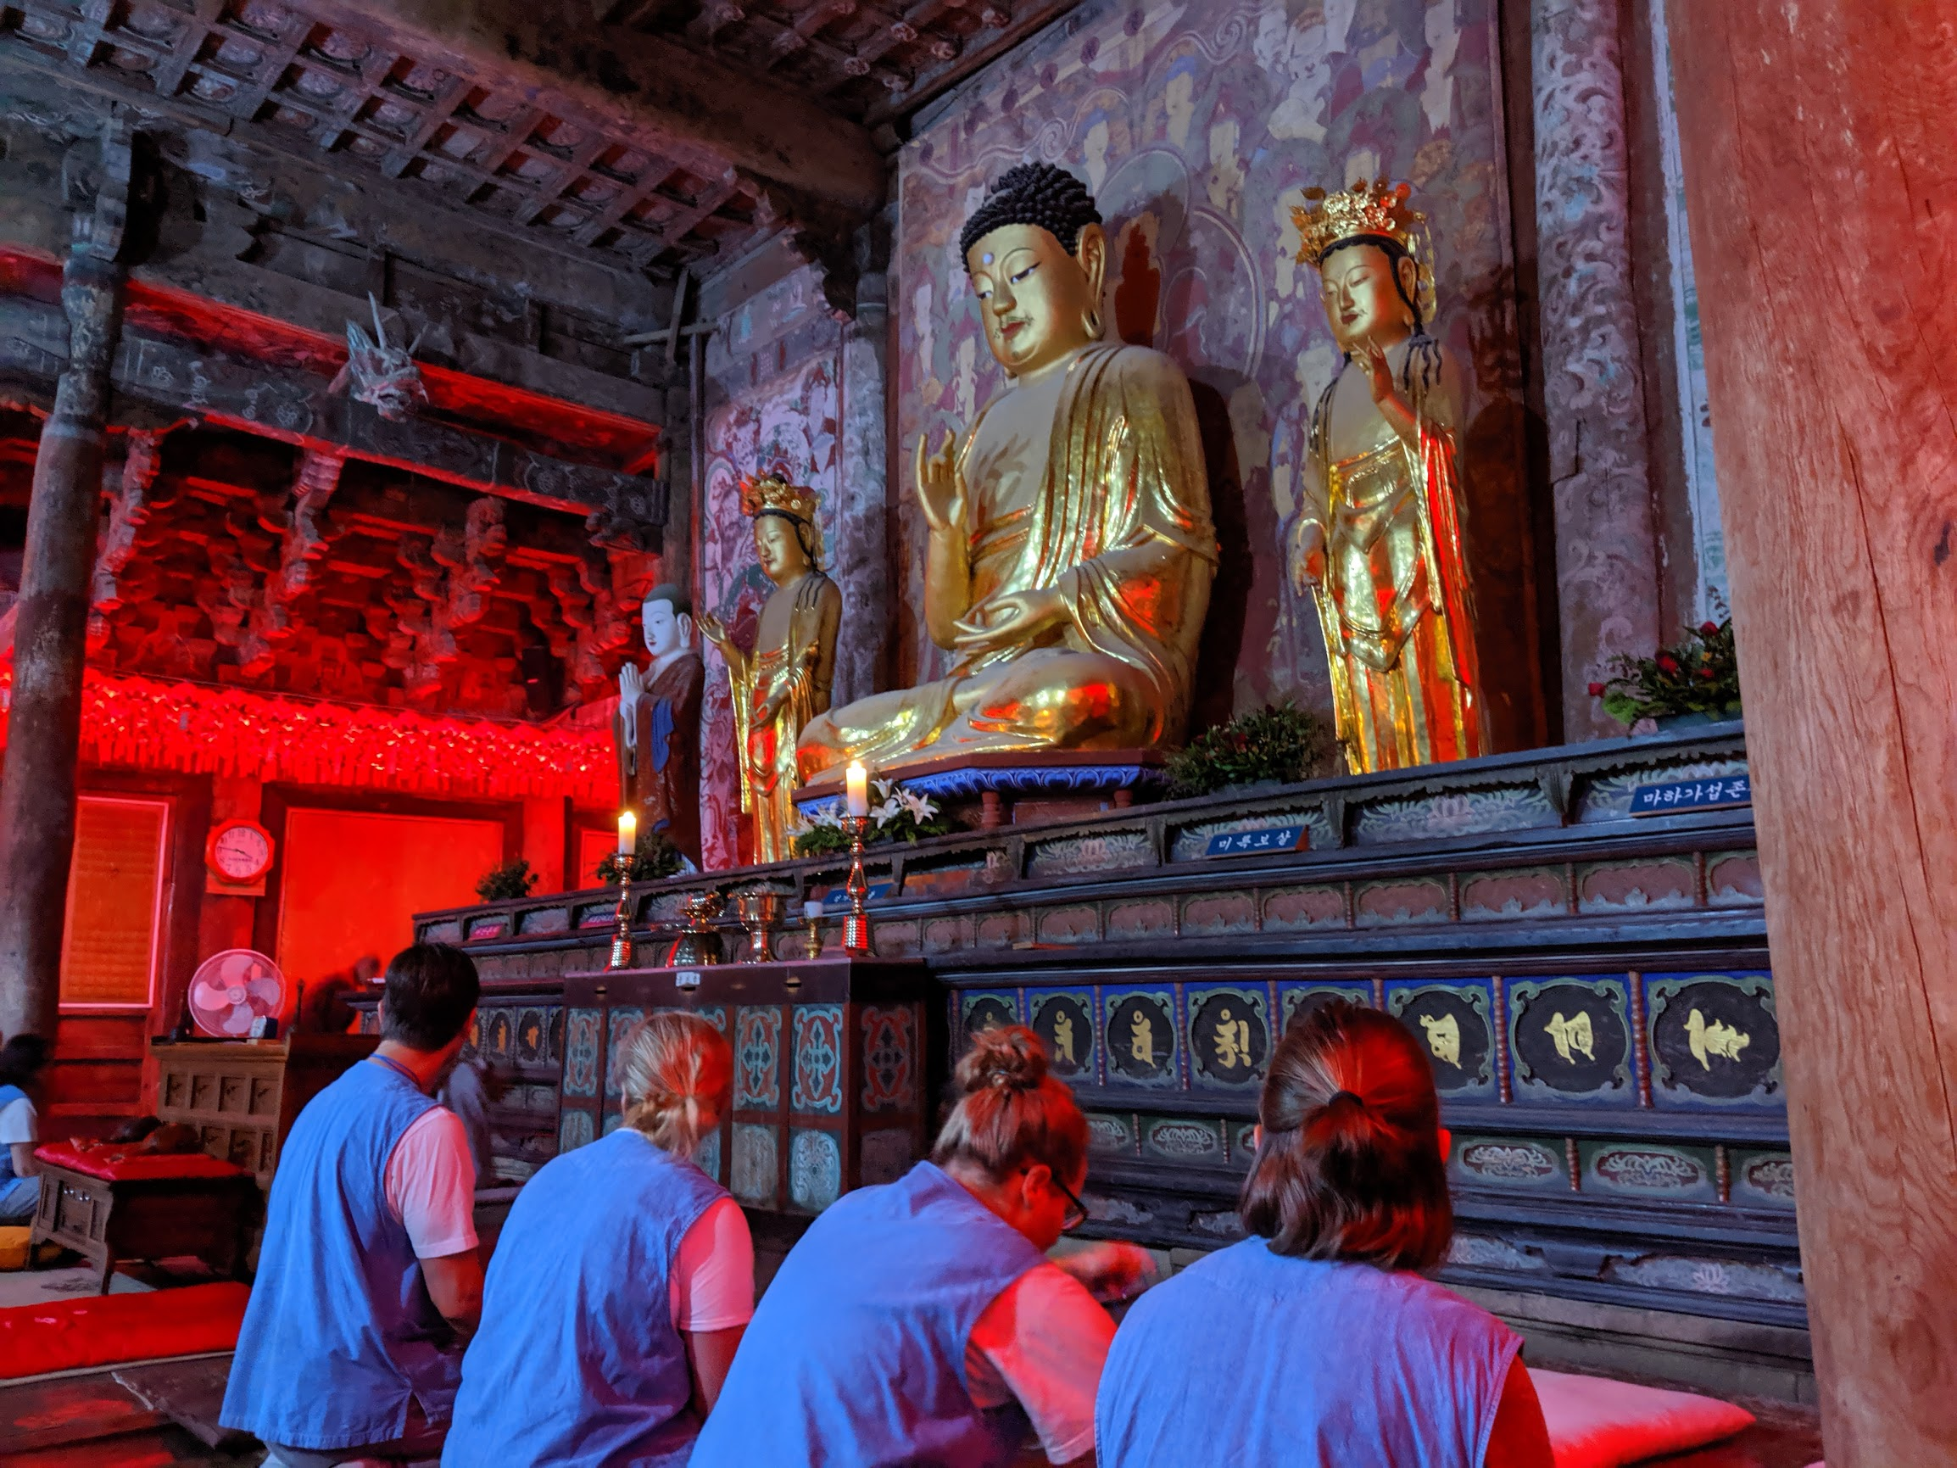

Buddhism is originally from India but spread into China and eventually to Korea via the Silk Korea. Buddhism was very popular in Korea by the year 500 CE. The Silla dynasty in Korea really promoted the religion and philosophy and had it become the dominant religion of their reign. Buddhism is still practiced by many Koreans today. Buddhism teaches that life involves suffering and that freedom from suffering can only be reached by turning away from our desires. Today in Korea, there are still many monasteries where monks live. These monasteries are typically in the mountains away from metropolitan areas. In monasteries, big temple bells signal the call to prayer and enhance nature’s beauty. Buddhist monks do not eat meat, and typically eat in silence and use it as a time to cleanse the soul. Monks live in housing without lavish furniture. They typically spend the day praying, chanting, reading scriptures, prostration exercises, mountain hikes, and meditating. Many Koreans do retreats to monasteries to clear their mind of negative energy and find a Middle Way between human desires and suffering.

Why do you think the Buddhist Monasteries are in the middle of nature?

Celedon

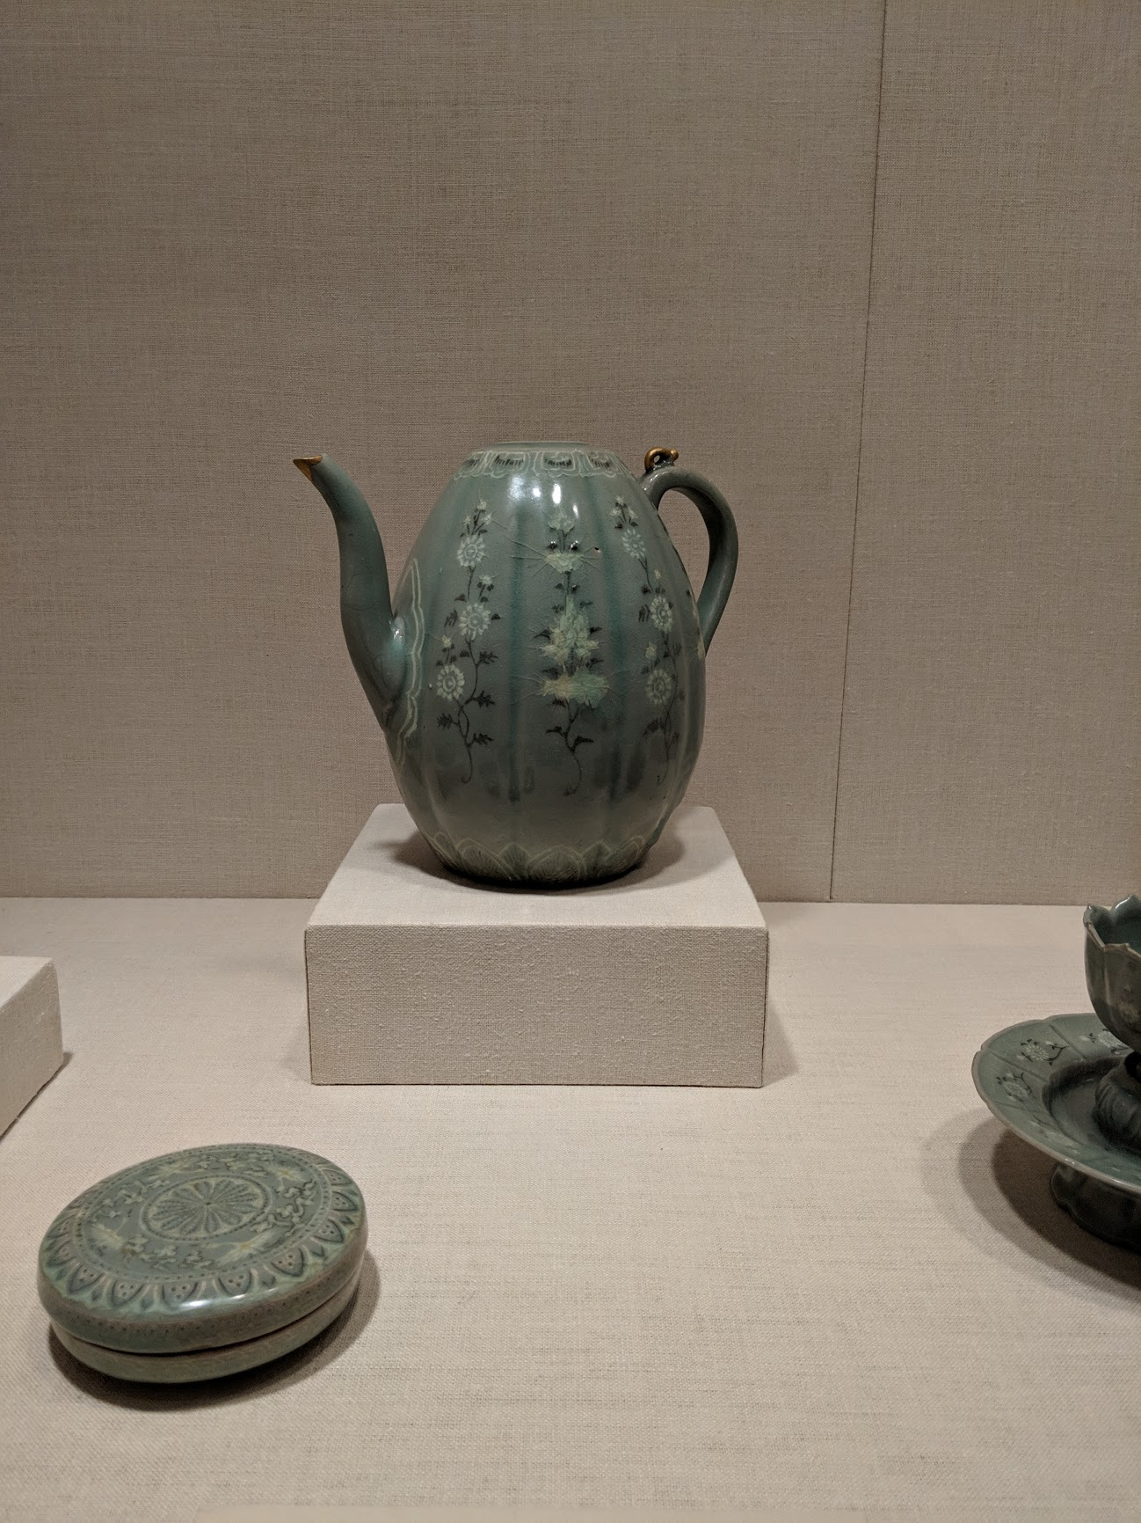

By the 900s, the Koryŏ dynasty became the most powerful in Korea and reunited all the various Korean kingdoms into one. Modern Korea is named after this dynasty. The Koryŏ had an organized system of government following China’s Confucianism model of having civil service exams for government works to get jobs.

One legacy of the Koryŏ was its unique pottery called Celadon. Celadon is typically blue or green in color and the original pottery was made by Buddhist monks for their ceremonies. Later, Korean artists added copper glazing and detailed designs on top of the pottery.

How were the Koryŏ influenced by the Chinese? How do you think the Koreans learned of Chinese ideas?

Jikji
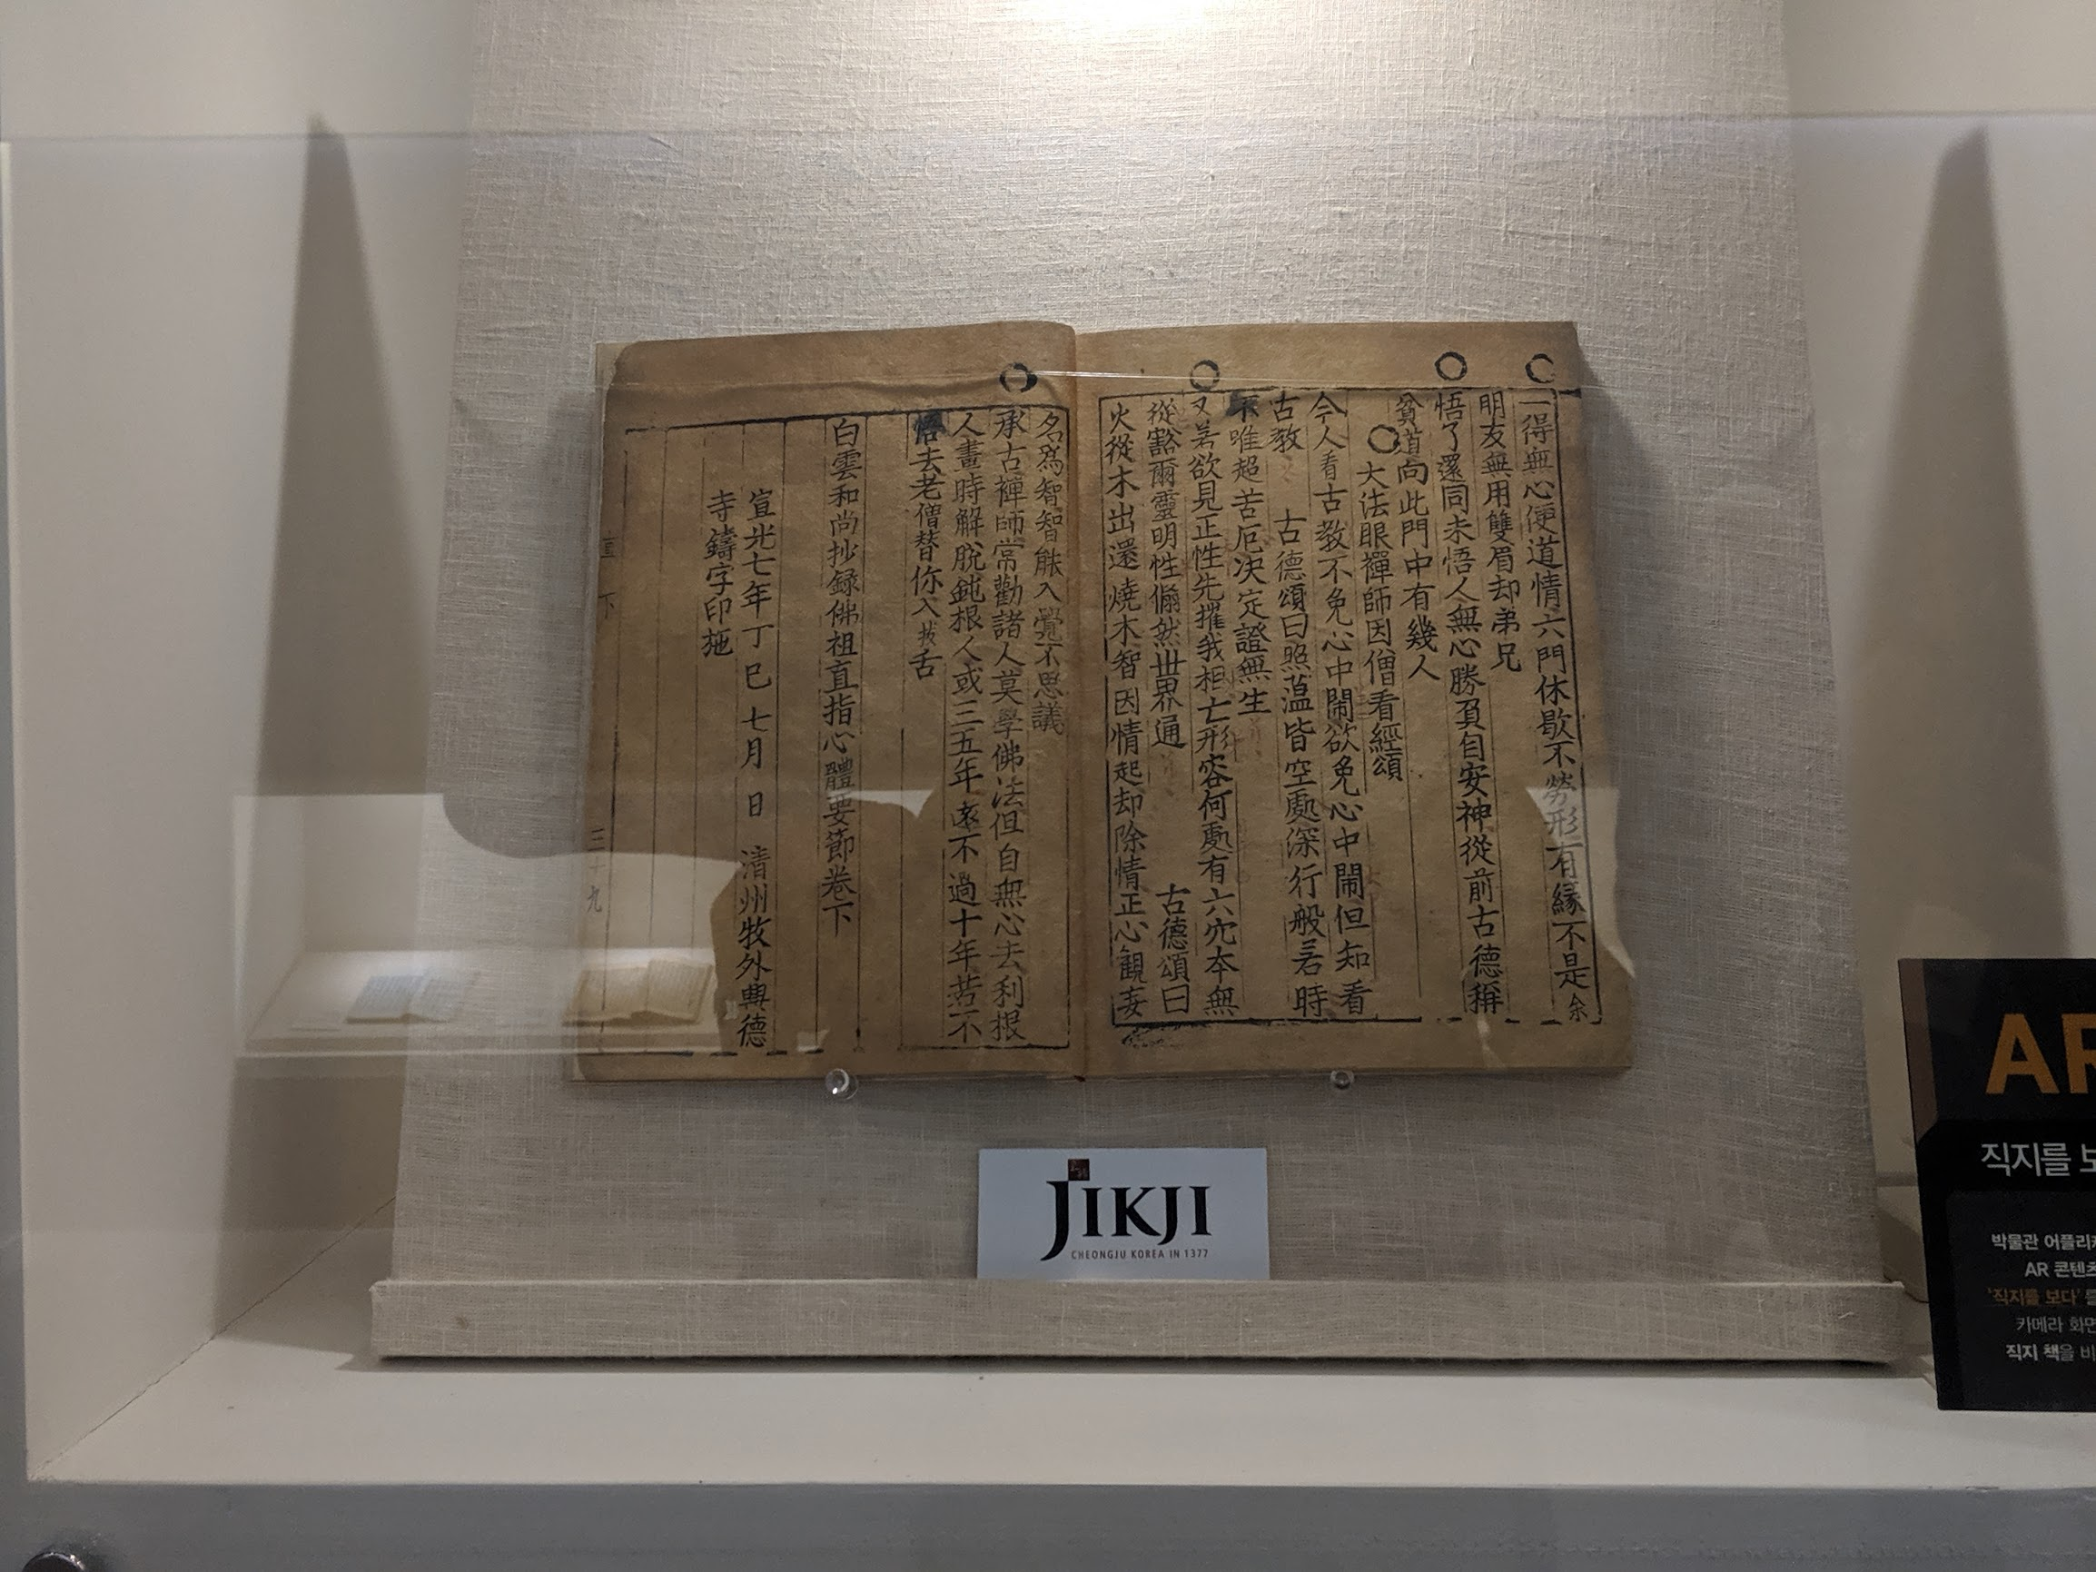

Jikji is the world’s oldest book printed by metal movable type. Koreans were the first in the world to create metal movable type that made printing books faster and cheaper. They created these 70 years before Europeans were able to print books such as the Bible. The Jikji was a religious text as well focusing on Buddhist priests teachings. There once was two volumes to the Jikji, but today, only Volume Two remains. Movable type works by using character stamps and placing them on a press. Ink is then smeared over the press above the character stamps. Paper is placed above and smoothed over to copy the text. They are then able to make multiple copies of a page at once. Jobs were divided to include: stamp makers, paper copies, book binders, previewers, etc.

What are the advantages to being to print pages rather than writing books by hand?

Silk Road
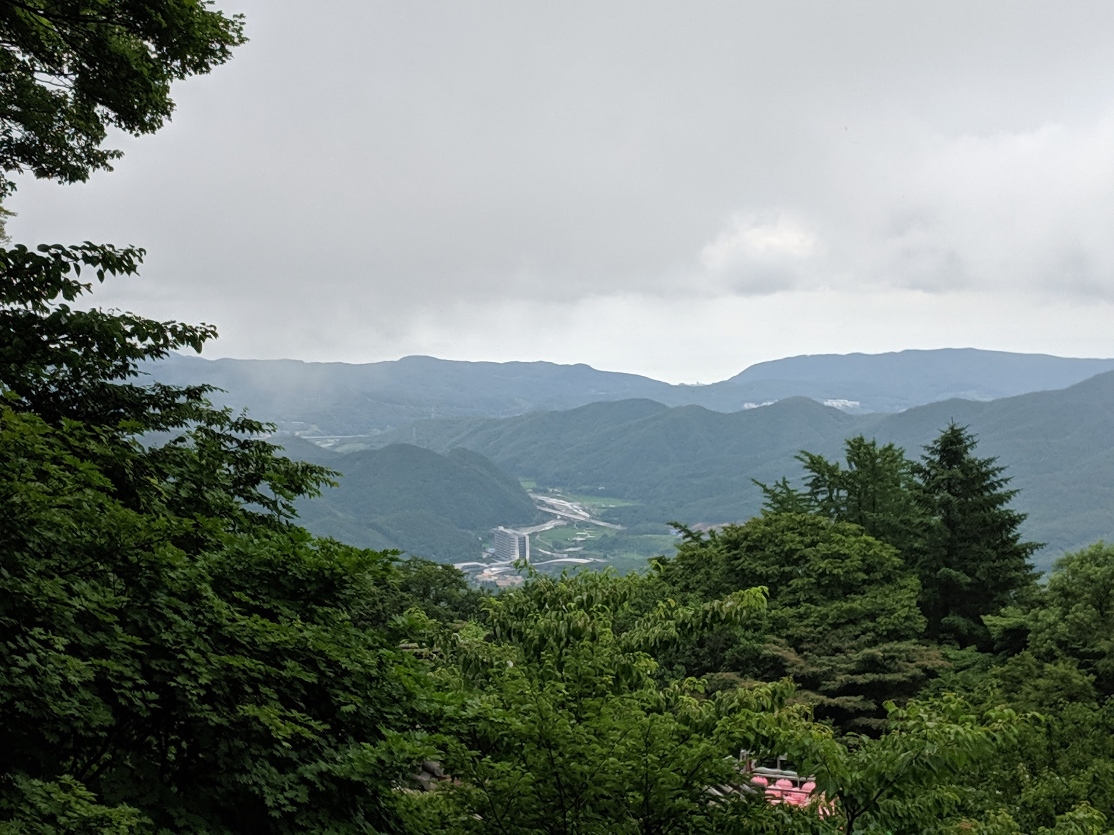

In 1259, The Mongols, nomadic people from the north of China took control of Korea. They had already conquered much of Europe and Asia when they entered the Koryŏ Dynasty. The Koreans fought back for nearly 30 years but under the treaty signed with the Mongols, the Korean kings could keep some of their authority.

Korea was successful during the years of the Mongols. The Mongols connected Korea to the Silk Road, which is a huge network of land- and sea-based trading routes that connected Asia and Europe. Korean exports and ideas spread throughout Asia and Europe along the Silk Road. In turn, Koreans imported goods and learned of new ideas from around the world.

Assessing Prior Knowledge: What type of goods and ideas were traded on the Silk Road?

King Sejong the Great
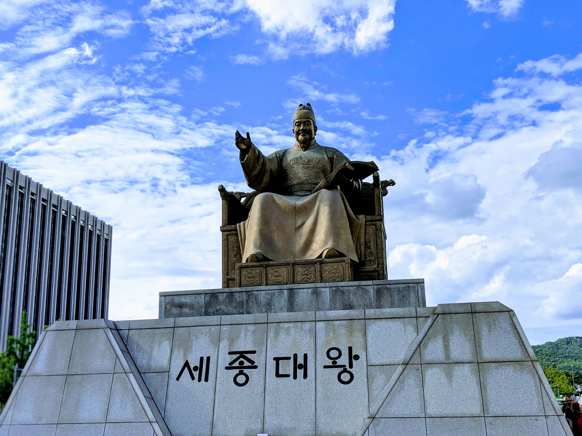

In the 1300s, Confucianism was reintroduced into Korea. Confucianism was originally brought into Korea from China. King Sejong of Korea heavily promoted its spread. The philosophy teaches the importance of doing good in one’s private and community life. This is the path that helps human beings improve and become perfect. Because Confucianism is a philosophy, it can be practiced alongside other religions such as Buddhism. The philosophy places a strict structure on respecting one’s elders as well as one’s education level. To become a higher class government worker, it placed importance on Civic Examinations. In Confucian society, teachers were as highly regarded as kings.

Confucianism helped Koryŏ’s officials to not lose direction and control of society. The empowered middle class founded the new Chosŏn dynasty in 1392. Chosŏn was run by the yangban, a class of nobles. Members of the yangban studied Neo-Confucianism, a branch of Confucianism that joined parts of Buddhism and Daoism. They established a social and political order that would become the longest-lasting dynasty in world history. It did not end until 1910.

What are some basic beliefs of Confucianism?

Japanese Invasion

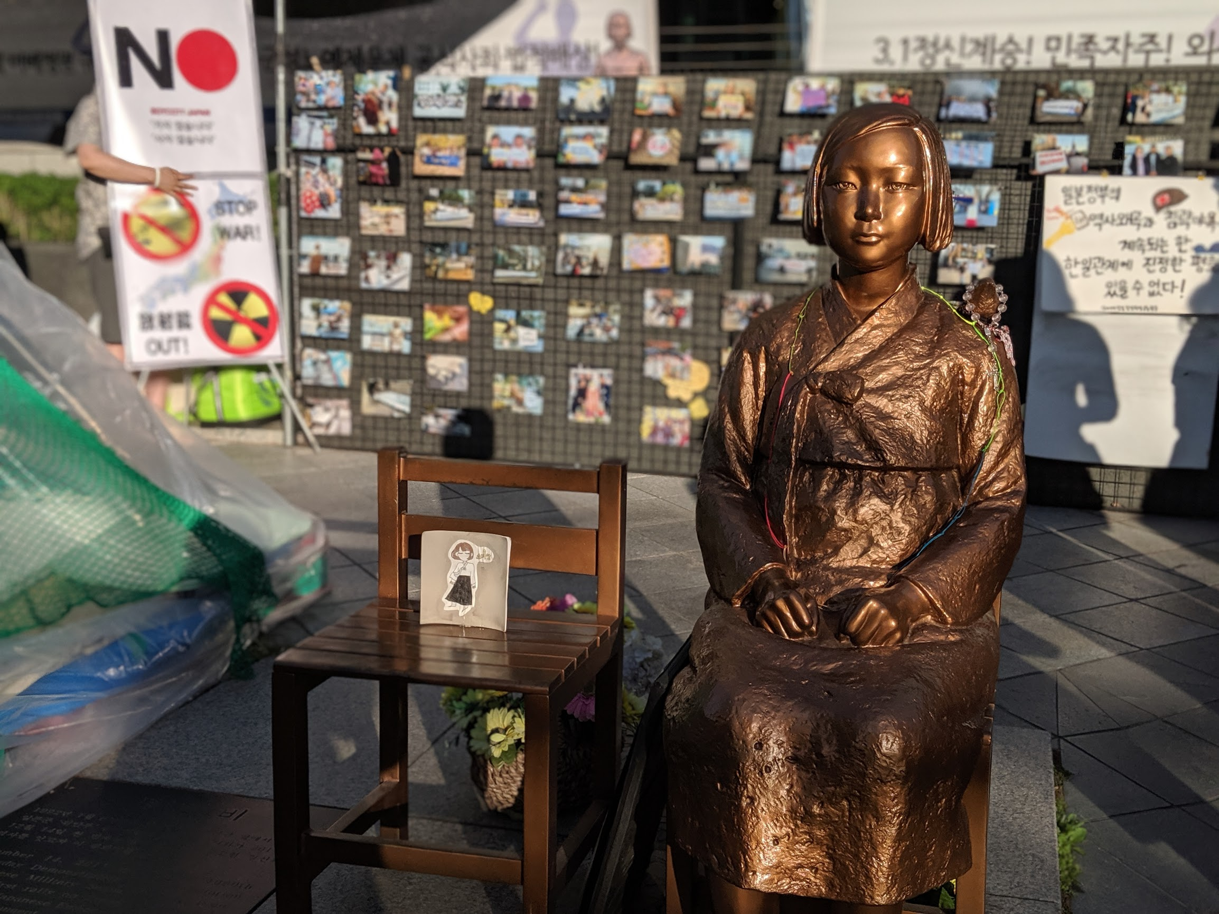
Korea also has a long history with Japan, pushing back from its invasions. Early invasions include in 1592, Japan entered Korea, wanting to use it as a base from which to attack China. Chosŏn joined forces with China’s Ming dynasty and drove Japan back in 1598.

During this invasion, Japan learned about Korea’s metal movable type. They brought this invention back to Japan to improve and spread printing. Korean metalworkers also traveled to Japan to teach them more about printing, creating a further sharing of culture and ideas. This helped both to shape Korea as well as Japan.

Before WWII, Japan invaded Korea again making it a colony on its conquest to conquer the Pacific world. The Japanese during this time were brutal to the Koreans. The monument above memorializes Korean comfort women who were forced to become sex slaves to the Japanese during the occupation. Behind the statue, is a sign asking civilians to boycott Japanese goods because of this legacy.

How is Korea’s history with Japan complicated?

Geomancy

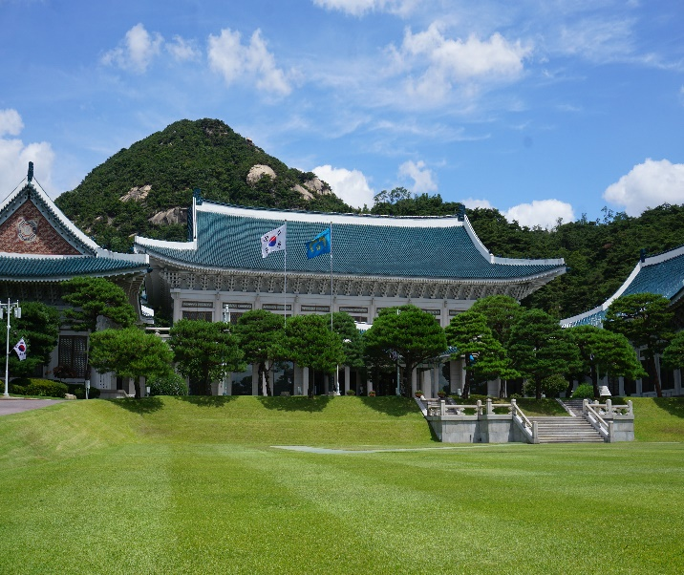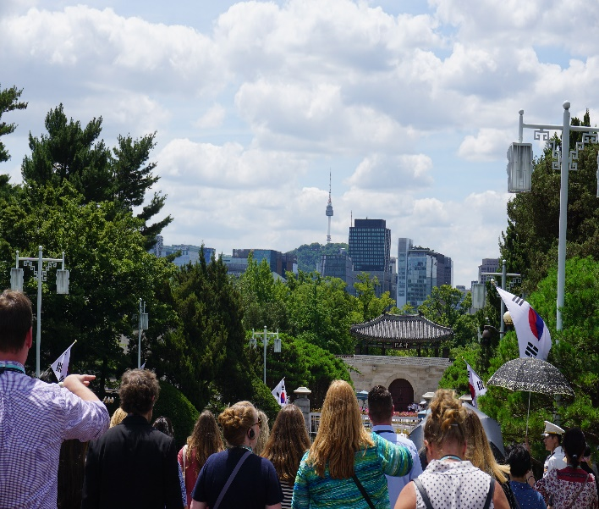

In Korea, much of the structures are purposefully placed to achieve Geomancy. Geomancy is an ancient practice of symbolically placing locations for spiritual reasons. The pictures above showcase the Presidential Palace in Seoul, South Korea. As you can see in both images, the Presidential Palace and the city of Seoul are placed in between mountains. Geomancy is based on understanding the flow and balance of energy through and over the earth. Physical features such as: the shape of the land, mountains, hills, rivers, and plains impact the fortunes of things. The futures and fortune of villages, homes, and graves can all be impacted based on their location. The Korean word for geomancy is pungsu, which means wind and water.

Places are purposefully placed to achieve a harmonious balance of natural counterparts such as heaven and earth, fire and water, north and south, east and west. A balanced, ideal site is called a myongdang.

Why would the city of Seoul and the Presidential Palace be placed where they are at?

Name: ________________________________ Period: _____ Date: _____________________

Ancient Korea Gallery Walk

Directions: As you rotate around the room, record your responses for each exhibit in the rows on the organizer. Thank you!

Image Name | Connection to Korea | Answer to Question

Name: _________________________________________ Period: _____ Date: _____________________________________

Korea KWL Chart
Focused Question: How did Korea’s location impact its history and culture?

Know | Want | Learned

