What would we do without printing?

AUTHOR INFORMATION

Author: Lisa Kissinger
State: New York

GENERAL INFORMATION

Lesson Grade Span: Middle (6-8), Secondary (9-12)
Targeted Grade Level/Course: World History
Estimated Time to Complete Lesson: 1 50-minute lesson

FOCUSED QUESTION

Why invent a printing press?

STANDARDS (STATE/C3)

New York State
Social Studies Practices Grades 9-12
C. Comparison and Contextualization
3. Identify and compare similarities and differences between historical developments over time and in different geographical and cultural contexts.

STUDENT & TARGET OUTCOMES

Students will be able to:
- Identify and compare similarities and differences between historical developments over time in Mesopotamia, Korea and Europe

LESSON OVERVIEW

In this lesson, students will analyze primary and secondary sources which depict three different printing technologies. Background knowledge for this lesson includes the purpose and significance of cuneiform and the Gutenberg Bible. Students will analyze images of primary sources and artifacts in order to compare the origins and purpose of printing technology.

PROCEDURES

- Bellringer/Hook: In a quick “turn and talk”, ask students to discuss: How would the world be different if printing had not been invented?
- Reference the learning target.
- Review the purpose and significance of cuneiform and the Gutenberg Bible (Resource 1).
  - With the images in Resource 1, ask students to analyze:
    - Describe the artifacts. What do you see?
    - What were the advantages of this type of technology?
    - What were the disadvantages of this type of technology?
    - How did cuneiform affect Sumerian society? How did the Gutenberg Bible affect medieval society in Europe?
- Explain that in this lesson, students will learn about the invention of metal movable type in Korea - which actually happened earlier than in Europe.
  - If necessary, locate Korea on a world map. Depending on the background of your students, it may be necessary to provide a brief background of Korean history. For example, The Asian Society essay on Korean History and Political Geography, https://asiasociety.org/education/korean-history-and-political-geography.
- Introduce to students that the Koreans invented metal movable type in the 1300s.
  - Examine images of Jikji, the Buddhist text printed in 1377. (Resource 3)
  - With the images in Resource 3, ask students to analyze:
    - Describe the artifact. What do you see?
    - What were the advantages of this type of technology?
    - What were the disadvantages?
  - View the Google Arts and Culture stories about Korean early printing. https://artsandculture.google.com/partner/cheongju-early-printing-museum

- Complete a Venn Diagram (Resource 4) to compare the purpose and significance of the printing technologies.

FORMATIVE ASSESSMENT

- Evaluate the Venn Diagram.

RESOURCE LIST

Peterson., M., Margulies, P., A Brief History of Korea. Facts on File, Infobase Publishing. 2010.
Google Arts and Culture websites: https://artsandculture.google.com/partner/cheongju-early-printing-museum
EXTENSIONS

Investigate where the Jikji is currently located. Discuss whether or not this artifact should be returned to Korea. (Peterson, pg. 121)

Resource 1

History of Printing

Cuneiform
Cuneiform was first created around 3200 B.C. by Sumerian scribes in the ancient city-state of Uruk, in present-day Iraq, as a means of recording transactions. Cuneiform writing was made with a reed stylus to make wedge-shaped marks in clay tablets. The technology developed as scribes would chisel cuneiform into stone. Called pictographs, these marks would be combined to represent syllables and later words. Scribes recorded business transactions, laws, This writing system lasted 3,000 years and was used throughout the Assyrian and Babylonian Empires.

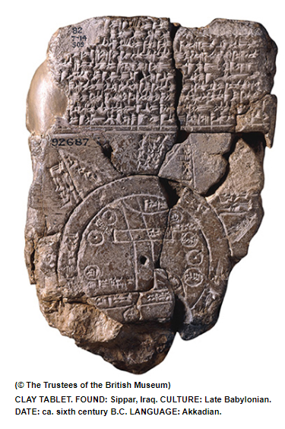 | Cuneiform tablets were long used for making maps and plans of towns, rural areas, and houses, but rarely for anything larger or without commercial interest. A unique tablet, thought to have come from Sippar in present-day Iraq and dating to around the sixth century B.C., shows much more and reflects something of how ancient Babylonians saw themselves in the world. This Mesopotamian mappa mundi consists of a circular map surrounded by triangles, with explanatory text above and on the opposite face.The central circle shows the Babylonian realm, bisected by the Euphrates, which is straddled by Babylon itself. Several other geographical areas are labeled by name, and the continent is surrounded by a ring called the “ocean” or “Bitter River.”  Source: Archaeology Magazine, MayJune 2016, https://www.archaeology.org/issues/214-features/cuneiform/4365-cuneiform-mapsArchaeological Institute of America, retrieved December 19, 2019

Gutenberg Bible
The Gutenberg Bible is the earliest full-scale work printed in Europe using moveable type. Before Gutenberg, every book in Europe was copied by hand. The Gutenberg Bible was printed in 1455. Forty-eight copies of the Bible survive. In the 50 years after Gutenberg began printing, printed books spread along the trade routes of Western Europe. Books did not become cheap immediately after the appearance of Gutenberg's printed works, but prices soon began to fall. By 1500 access to books had changed profoundly.
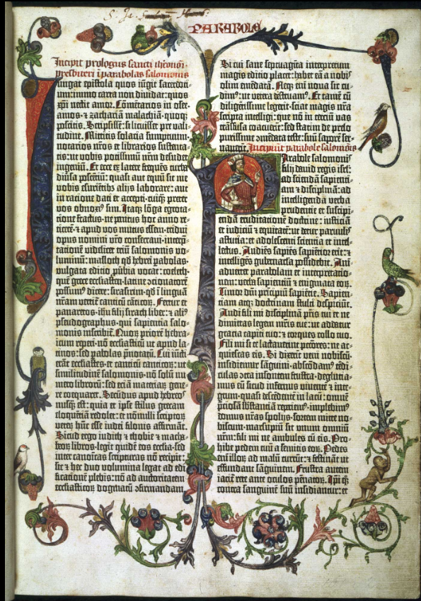 | The Gutenberg Bible  Many copies of the Gutenberg Bible married the old technology of printing with the old, and contain hand-painted decorations to imitate the appearance of an illuminated manuscript. Gutenberg's main inventions were the printer's ink, the making of type, the use of a press and perhaps most importantly the production process itself which combined these techniques to produce printed books. This opening page begins with the large letter “I” which fills most of the left-hand margin. Similarly, in the second column the letter 'P' extends into the space between the columns. Inside the letter is King Solomon wearing a white crown and red-and-white cape. In addition, the page is decorated with birds and a climbing monkey.  Source: Biblia latina, 42 lines, (Mainz: Johann Gutenberg and Johann Fust, about 1455). On paper. Held by the British Library. https://www.bl.uk/collection-items/gutenberg-bible. Retrieved on December 19, 2019.

Resource 3

The Invention of Metal Movable Type in Korea

Metal Movable type technology was invented in the 1300s in Korea. The oldest book printed using metal movable type that survives was printed in 1377. This book, called Jikji, included the teachings of an important Korean Buddhism. Jikji was printed at the Heungdeoksaji Temple site. Volume I of the Jikji has been lost. Volume I is preserved in the National LIbrary of France. Jikji is included in the UNESCO Memory of the World List in 2001 in recognition of its valuable effect on the history of human civilization as the best movable metal type existing in the world.

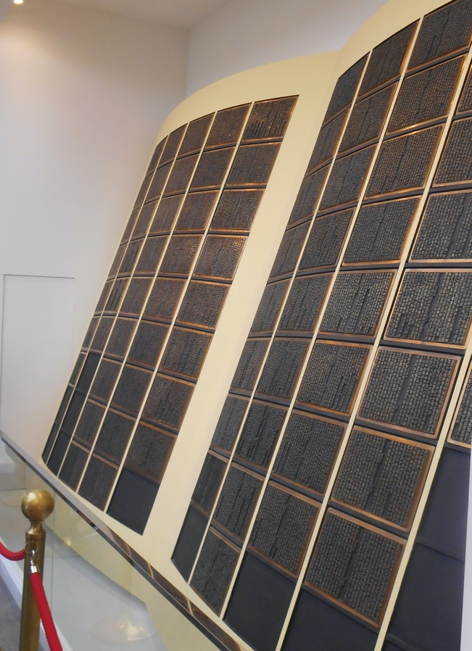

Reproduction of metal movable type to print Jikji,
Cheongju Early Printing Museum
July 2019, Photograph by Lisa Kissinger

Model of Monks Producing Jikji
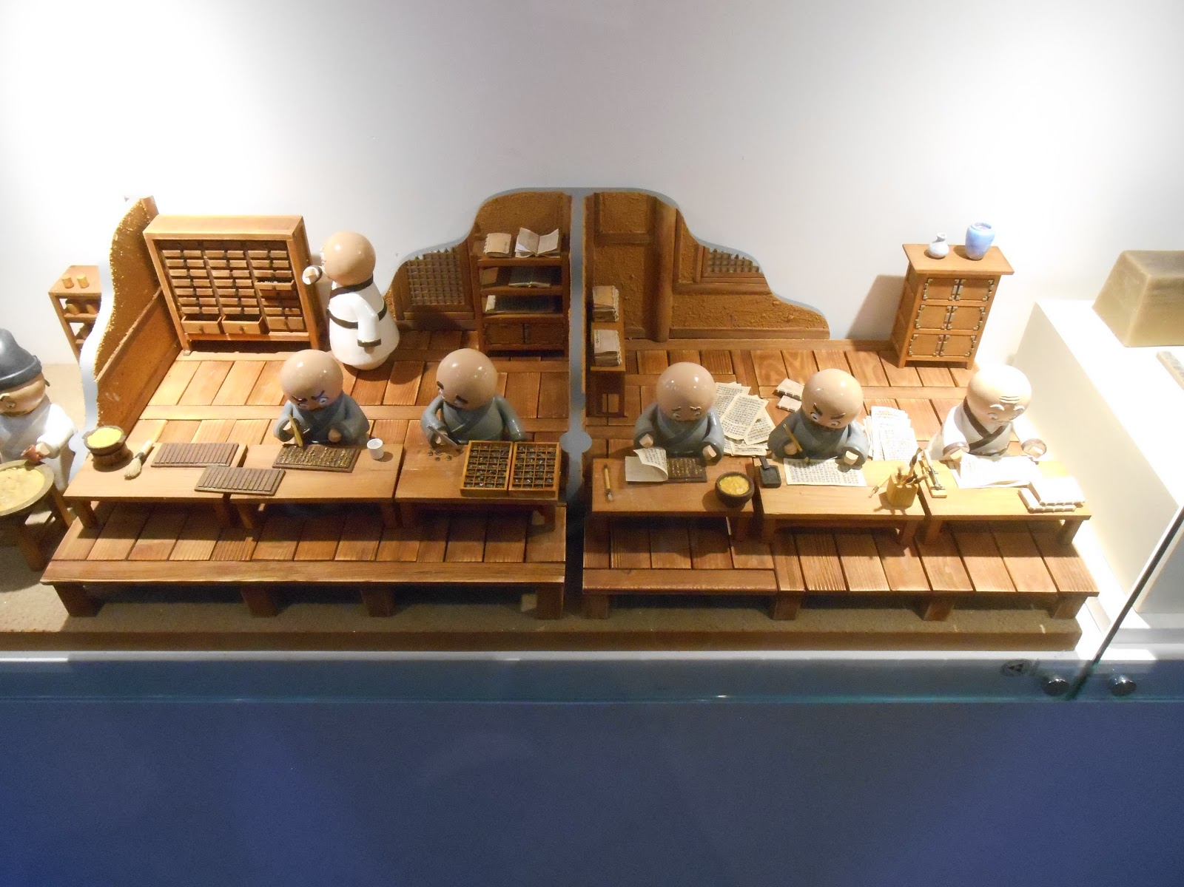
Cheongju Early Printing Museum
July 2019, Photograph by Lisa Kissinger

Resource 4

Comparing the Purpose and Significance of Printing

