North Korean Defectors: An Analysis of the Human Side of the Story

AUTHOR INFORMATION

Author: Randy Martin, NBCT
State: New Mexico

GENERAL INFORMATION

Lesson Grade Span: Middle and High School, Grades 8-12
Targeted Grade Level/Course: 8-12 Grade Social Studies/Current Events
Estimated Time to Complete Lesson: Three 60 Minute Classes

ESSENTIAL/FOCUSED QUESTIONS

1. What makes people want to leave their homes, cities, or nations? What would make you choose to leave, even if it puts your life at risk?

2. Why is the Korean Peninsula divided?

3. What is the legacy of the division of the Korean Peninsula?

4. Why do you think some people would risk their lives to leave North Korea?

STANDARDS (STATE/C3)

New Mexico State History Standards:
STRAND : History Content Standard I: Students are able to identify important people and events in order to analyze significant patterns, relationships, themes, ideas, beliefs, and turning points in New Mexico, United States, and world history in order to understand the complexity of the human experience. Students will:

5-8 Benchmark 1-D. Skills: research historical events and people from a variety of perspectives:

1. Demonstrate understanding and apply problem-solving skills for historical research, to include: use of primary and secondary sources; sequencing, posing questions to be answered by historical inquiry; collecting, interpreting and applying information; gathering and validating materials that present a variety of perspectives.

9-12 Benchmark 1-C. World: analyze and interpret the major eras and important turning points in world history from the age of enlightenment to the present, to develop an understanding of the complexity of the human experience:

6. Describe and analyze the geographic, political, economic, religious and social structures of the civilizations of east Asia;

9. Analyze and evaluate international developments following World War II, the cold war and post-cold war, to include:
g. national security in the changing world order; h. technology’s role in ending the cold war; i. fluidity of political alliances; j. new threats to peace; k. reasons for the collapse of the Soviet Union and the end of the cold war; l. use of technology in the information age;

12. Explain how world history presents a framework of knowledge and skills within which to understand the complexity of the human experience, to include:
a. analyze perspectives that have shaped the structures of historical knowledge;
b. describe ways historians study the past;
c. explain connections made between the past and the present and their impact.

9-12 benchmark 1-D. Skills: use critical thinking skills to understand and communicate perspectives of individuals, groups and societies from multiple contexts:
1. Understand how to use the skills of historical analysis to apply to current social, political, geographic and economic issues

STRAND : Geography Content Standard II: Students understand how physical, natural, and cultural processes influence where people live, the ways in which people live, and how societies interact with one another and their environments. Students will:

9-12 Benchmark 2-E: analyze and evaluate how economic, political, cultural and social processes interact to shape patterns of human populations and their interdependence, cooperation and conflict:
3. Analyze the interrelationships among settlement, migration, population-distribution patterns, land forms and climates in developing and developed countries;
4. How cooperation and conflict are involved in shaping the distribution of political, social and economic factors in New Mexico, United States and throughout the world (e.g., land grants, border issues, United States territories, Israel and the middle east, the former Soviet Union, and Sub-Saharan Africa);
5. Analyze how cultures shape characteristics of a region;
6. Analyze how differing points of view and self-interest play a role in conflict over territory and resources (e.g., impact of culture, politics, strategic locations, resources); and
7. Evaluate the effects of technology on the developments, changes to, and interactions of cultures;

Strand: Economics Content Standard IV: Students understand basic economic principles and use economic reasoning skills to analyze the impact of economic systems (including the market economy) on individuals, families, businesses, communities, and governments. Students will:

9-12 Benchmark 4-B: analyze and evaluate how economic systems impact the way individuals, households, businesses, governments and societies make decisions about resources and the production and distribution of goods and services:
1. Analyze the historic origins of the economic systems of capitalism, socialism and communism;
2. Compare the relationships between and among contemporary countries with differing economic systems;
3. Understand the distribution and characteristics of economic systems throughout the world, to include: (e.g., characteristics of command, market, and traditional economies; how command, market and traditional economies operate in specific countries; comparison of the ways that people satisfy their basic needs through the production of goods and services);

Common Core State Standards

Key Ideas and Details:
CCSS.ELA-LITERACY.RH.6-8.1
Cite specific textual evidence to support analysis of primary and secondary sources.
CCSS.ELA-LITERACY.RH.6-8.2
Determine the central ideas or information of a primary or secondary source; provide an accurate summary of the source distinct from prior knowledge or opinions.
CCSS.ELA-LITERACY.RH.6-8.3
Identify key steps in a text's description of a process related to history/social studies (e.g., how a bill becomes law, how interest rates are raised or lowered).

Craft and Structure:
CCSS.ELA-LITERACY.RH.6-8.4
Determine the meaning of words and phrases as they are used in a text, including vocabulary specific to domains related to history/social studies.
CCSS.ELA-LITERACY.RH.6-8.5
Describe how a text presents information (e.g., sequentially, comparatively, causally).
CCSS.ELA-LITERACY.RH.6-8.6
Identify aspects of a text that reveal an author's point of view or purpose (e.g., loaded language, inclusion or avoidance of particular facts).

Integration of Knowledge and Ideas:
CCSS.ELA-LITERACY.RH.6-8.7
Integrate visual information (e.g., in charts, graphs, photographs, videos, or maps) with other information in print and digital texts.
CCSS.ELA-LITERACY.RH.6-8.8
Distinguish among fact, opinion, and reasoned judgment in a text.
CCSS.ELA-LITERACY.RH.6-8.9
Analyze the relationship between a primary and secondary source on the same topic.

Range of Reading and Level of Text Complexity:
CCSS.ELA-LITERACY.RH.6-8.10
By the end of grade 8, read and comprehend history/social studies texts in the grades 6-8 text complexity band independently and proficiently.

Key Ideas and Details:
CCSS.ELA-LITERACY.RH.9-10.1
Cite specific textual evidence to support analysis of primary and secondary sources, attending to such features as the date and origin of the information.
CCSS.ELA-LITERACY.RH.9-10.2
Determine the central ideas or information of a primary or secondary source; provide an accurate summary of how key events or ideas develop over the course of the text.
CCSS.ELA-LITERACY.RH.9-10.3
Analyze in detail a series of events described in a text; determine whether earlier events caused later ones or simply preceded them.

Craft and Structure:
CCSS.ELA-LITERACY.RH.9-10.4
Determine the meaning of words and phrases as they are used in a text, including vocabulary describing political, social, or economic aspects of history/social science.
CCSS.ELA-LITERACY.RH.9-10.5
Analyze how a text uses structure to emphasize key points or advance an explanation or analysis.
CCSS.ELA-LITERACY.RH.9-10.6
Compare the point of view of two or more authors for how they treat the same or similar topics, including which details they include and emphasize in their respective accounts.

Integration of Knowledge and Ideas:
CCSS.ELA-LITERACY.RH.9-10.7
Integrate quantitative or technical analysis (e.g., charts, research data) with qualitative analysis in print or digital text.
CCSS.ELA-LITERACY.RH.9-10.8
Assess the extent to which the reasoning and evidence in a text support the author's claims.
CCSS.ELA-LITERACY.RH.9-10.9
Compare and contrast treatments of the same topic in several primary and secondary sources.

Range of Reading and Level of Text Complexity:
CCSS.ELA-LITERACY.RH.9-10.10
By the end of grade 10, read and comprehend history/social studies texts in the grades 9-10 text complexity band independently and proficiently.

Key Ideas and Details:
CCSS.ELA-LITERACY.RH.11-12.1
Cite specific textual evidence to support analysis of primary and secondary sources, connecting insights gained from specific details to an understanding of the text as a whole.
CCSS.ELA-LITERACY.RH.11-12.2
Determine the central ideas or information of a primary or secondary source; provide an accurate summary that makes clear the relationships among the key details and ideas.
CCSS.ELA-LITERACY.RH.11-12.3
Evaluate various explanations for actions or events and determine which explanation best accords with textual evidence, acknowledging where the text leaves matters uncertain.

Craft and Structure:
CCSS.ELA-LITERACY.RH.11-12.4
Determine the meaning of words and phrases as they are used in a text, including analyzing how an author uses and refines the meaning of a key term over the course of a text (e.g., how Madison defines faction in Federalist No. 10).
CCSS.ELA-LITERACY.RH.11-12.5
Analyze in detail how a complex primary source is structured, including how key sentences, paragraphs, and larger portions of the text contribute to the whole.
CCSS.ELA-LITERACY.RH.11-12.6
Evaluate authors' differing points of view on the same historical event or issue by assessing the authors' claims, reasoning, and evidence.

Integration of Knowledge and Ideas:
CCSS.ELA-LITERACY.RH.11-12.7
Integrate and evaluate multiple sources of information presented in diverse formats and media (e.g., visually, quantitatively, as well as in words) in order to address a question or solve a problem.
CCSS.ELA-LITERACY.RH.11-12.8
Evaluate an author's premises, claims, and evidence by corroborating or challenging them with other information.
CCSS.ELA-LITERACY.RH.11-12.9
Integrate information from diverse sources, both primary and secondary, into a coherent understanding of an idea or event, noting discrepancies among sources.

Range of Reading and Level of Text Complexity:
CCSS.ELA-LITERACY.RH.11-12.10
By the end of grade 12, read and comprehend history/social studies texts in the grades 11-CCR text complexity band independently and proficiently.

STUDENT & TARGET OUTCOMES

Objective 1: Students will understand the origins and outcomes of the Korean War

Objective 2: Students will understand that the people of a country may not share the same views as their government

Objective 3: By analyzing differentiated primary and secondary sources from North and South Korea, students will comprehend the human side of the division of Korea and its impact on families on both sides of the border.

LESSON OVERVIEW

This lesson analyzes sources related to historical and current events on the Korean peninsula, focusing on the stories and experiences of North Korean refugees and defectors. Using differentiated primary and secondary sources, students will review the history of Korea in the 20th century, the division of the Korean Peninsula, the and major events up to the present day in order to better understand the background behind the division of Korea as it stands today. Students will then use this background knowledge to understand the setting and circumstances behind the stories of real North Korean defectors.

PROCEDURES

Day 1: Building Background Knowledge

1. Introduction: Using “Source C: Map of Korean Peninsula” from the Korean War Legacy Foundation (https://koreanwarlegacy.org/teaching-tools/), Google Earth, an atlas, or the attached maps, show a map of Korea before it was divided, and then show a map of present-day North and South Korea to the class. As a whole group, ask students the following questions:
a. What do you notice about Korea in these maps?
b. Why do you think Korea is divided today?
Let the students respond to the questions out loud, as a class, in small discussion groups, or with a partner. (10 minutes)

2. After allowing the students to answer the questions to the best of their knowledge, have them visit The Korean War Legacy Webpage https://koreanwarlegacy.org/chapters/prewar-context-western/ in order to read the article “Prewar Context: Western”. If internet access is not available for all students, print out enough copies for each student. Have the student write down or highlight sections of the article that answer the question: “Why do think Korea is divided today” (15 Minutes)

3. After reading the article “Prewar Context: Western”, have the students visit https://koreanwarlegacy.org/chapters/the-legacy-chapter/ and read the article “The Legacy”. If internet access is not available for all students, print enough copies for each student. Have the student write down or highlight sections of the article that answer the questions: “Why do think Korea is divided today”, and “what is the legacy of the division of the Korean Peninsula”? (15 Minutes)

4. Final discussion/putting it all together: Ask the students the following three questions. They may answer them in writing, out loud, or in small groups.
a. Why do you think Korea is divided today?
b. What is the legacy of the division of the Korean Peninsula?
c. Why do you think some people would risk their lives to leave North Korea? (this will set up the lesson for the next two days) (20 Minutes)

Day 2: Primary Source Analysis: The Escape of Sergeant Oh

1. Watch defector (Sergeant Oh) videos (10 Minutes)
https://www.nbcnews.com/news/world/north-korean-defector-oh-chong-song-doesn-t-blame-comrades-n994441

2. After viewing the videos, have students read the attached NBC article, “North Korean defector Oh Chong Song doesn't blame comrades who shot him” and answer the questions. (30 Minutes)

3. Have students share and discuss their responses out loud. Ask the students to respond verbally to the following essential questions as part of the discussion: 1. What makes people want to leave their homes, cities, or nations? What would make you choose to leave, even if it puts your life at risk? (20 Minutes)

Day 3: Meeting North Korean Civilians

1. Print out the article “Escape from North Korea: Journey of faith lands couple in Utah (Excerpt)” and have the students read it. As the students read the excerpt, have them fill out the “Who, What, When, Where, Why, How” Article Analysis Form (attached, 20 Minutes)

2. After the students fill out the “Who, What, When, Where, Why, How Article Analysis Form”, have them discuss the “how” portion out loud as a class. This will serve as a transition into the optional summative assessment activity (10 minutes)

3. Optional Summative Assessment Activity:
- Show the students the image of the artwork “Friend” by Park, Sung Sik (attached). Ask them to respond to the “How” question: “How does this make you feel? Does it have a perspective or bias that it is presenting?
- Have the students create their own artwork that expresses a perspective (or multiple perspectives) of someone separated by the division of the Korean Peninsula.

FORMATIVE ASSESSMENT

Formative Assessment 1: Korea map question answers and discussion (Day 1)

Objective 1: Students will understand the origins and outcomes of the Korean War

Formative Assessment 2: Discussion of articles “Prewar Context: Western” and “The Legacy” (Day 1)

Objective 1: Students will understand the origins and outcomes of the Korean War

Formative Assessment 3: “North Korean defector Oh Chong Song doesn't blame comrades who shot him” questions and discussion (Day 2)

Objective 2: Students will understand that the people of a country may not share the same views as their government

Objective 3: By analyzing differentiated primary and secondary sources from North and South Korea, students will comprehend the human side of the division of Korea and its impact on families on both sides of the border.

Formative Assessment 4: “Who, What, When, Where, Why, How” Article Analysis Form on the article “Escape from North Korea: Journey of faith lands couple in Utah (Excerpt)” (Day 3)

Objective 2: Students will understand that the people of a country may not share the same views as their government

Objective 3: By analyzing differentiated primary and secondary sources from North and South Korea, students will comprehend the human side of the division of Korea and its impact on families on both sides of the border.

RESOURCE LIST

Atlas of South Korea – Wikimedia Commons. (2019). [Illustration]. Retrieved from
https://commons.wikimedia.org/wiki/Atlas_of_South_Korea#/media/File:MapofKorea.png

Evans, E. (2018, February 8). Escape from North Korea: Journey of faith lands couple in Utah.
Retrieved November 3, 2019, from https://www.deseret.com/2018/2/8/20639771/escape-
from-north-korea-journey-of-faith-lands-couple-in-utah#donghyun-kim-helps-his-wife-
jiyeon-song-with-her-coat-as-they-get-ready-to-go-outside-as-they-talk-about-their-story-of-
love-and-how-they-escaped-north-korea-on-saturday-feb-3-2018-the-couple-asked-that-
their-faces-not-be-identified-to-protect-family-living-in-north-korea

File:Map Korea English Lables.png. (2009). [Illustration]. Retrieved from
https://commons.wikimedia.org/wiki/File:Map_korea_english_labels.png

Kim, S, et al. (2019). North Korean defector Oh Chong Song doesn’t blame comrades who shot
him. NBC News. Retrieved from
https://www.nbcnews.com/news/world/north-korean-
defector-oh-chong-song-doesn-t-blame-comrades-n994441

Korea War Lesson Plans - Free Resources - Korean War Legacy. (2019, October 7). Retrieved
November 3, 2019, from https://koreanwarlegacy.org/teaching-tools/

Martin, R. (2019). Who, What, When, Where, Why, How Article Analysis Form. Albuquerque,
NM, USA.

Park, S. S. (2017). Friend [Painting].

Prewar Context: Western - Korean War Legacy. (2019, October 27). Retrieved November 3,
2019, from https://koreanwarlegacy.org/chapters/prewar-context-western/

The Legacy - Korean War Legacy. (2018, October 17). Retrieved November 3, 2019, from
https://koreanwarlegacy.org/chapters/the-legacy-chapter/

MODIFICATIONS & EXTENSIONS (OPTIONAL)

MODIFICATIONS

Follow all IEP modifications as needed

Some complex text may be abbreviated or chunked

Journal questions may be answered verbally, rather than in writing

Students may be partnered when reading complex texts

Define Tier II and III academic vocabulary from texts

Abbreviate complex texts as needed

EXTENSIONS

OPTIONAL SUMMATIVE ASSESSMENT: Art Piece

- Show the students the image of the artwork “Friend” by Park, Sung Sik (attached). Ask them to respond to the “How” question from the article analysis form: “How does this make you feel? Does it have a perspective or bias that it is presenting?

- Have the students create their own artwork that expresses a perspective (or multiple perspectives) of someone separated by the division of the Korean Peninsula.

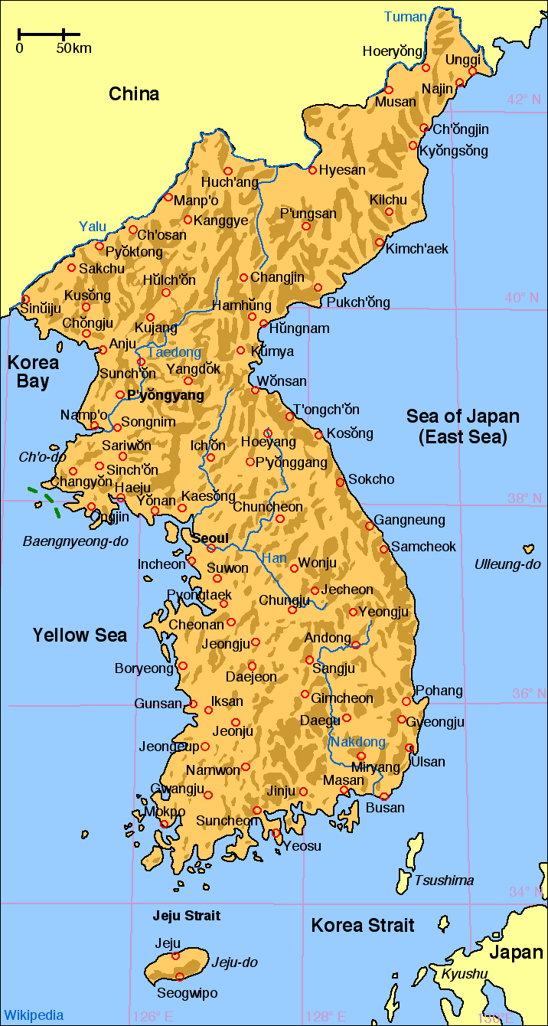

https://commons.wikimedia.org/wiki/Atlas_of_South_Korea#/media/File:MapofKorea.png
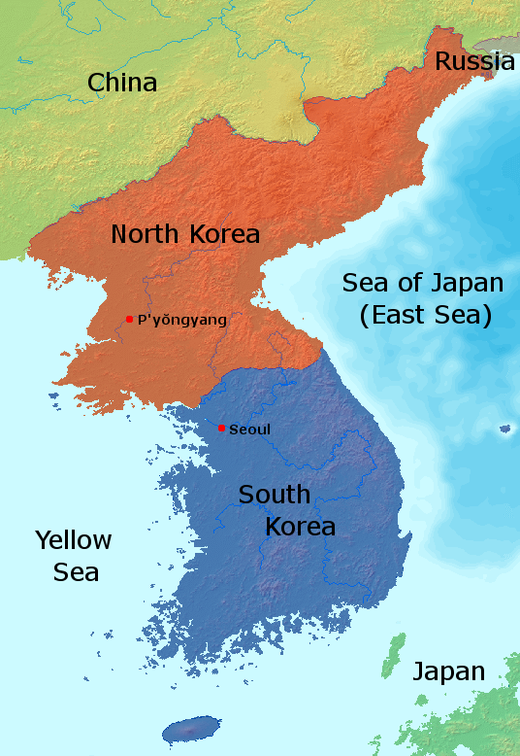

https://commons.wikimedia.org/wiki/File:Map_korea_english_labels.png

Name __________________________________________ Date ______________ Class _______
North Korean defector Oh Chong Song doesn't blame comrades who shot him
"If I were in their shoes I would have done the same thing," he told NBC News, recalling his 2017 escape.

By Stella Kim and Alexander Smith

SEOUL, South Korea — It was a dash for freedom that was caught on camera and captivated the world: a North Korean defector being peppered with bullets as he tried to flee his authoritarian homeland. But in his first television interview with a U.S. broadcaster, the defector, Oh Chong Song, said he does not blame his former colleagues for shooting him five times ​as he ran for the border in November 2017​. "In their situation I would have fired the gun. It's not a matter of friendship," he told NBC News on Monday, almost 18 months after his dramatic escape. "I understand them because if I were in their shoes I would have done the same thing."
The incident played out at the ​Demilitarized Zone,​ one of the world's most fortified frontiers separating North and South Korea. It was ​a time of knife-edge tension​ on the peninsula. A month before Oh made his dash, Kim
Jong Un's regime ​conducted its most powerful​ ​nuclear test to date​. And two weeks after Oh crossed the DMZ,
Pyongyang test-fired ​its second intercontinental ballistic missile​, which came down on the other side of Japan.
Analysts extrapolated that this rocket was theoretically capable of hitting the mainland United States. The two Koreas are technically still in a state of war since the 1950-53 conflict ended in an armistice rather than a peace treaty. Today, Kim Jong Un's regime is accused of some of the world's worst human rights abuses, controlling almost every aspect of public life and keeping tens of thousands of people in labor camps. A United Nations report in 2014 said that ​these crimes were "strikingly similar"​to the atrocities carried out by the Nazis.
On Nov. 13, 2017, surveillance cameras captured the moment Oh smashed through a military checkpoint in a green jeep and raced toward the DMZ, members of his own unit chasing him down. Had he been caught, Oh says he "would have been either sent to a concentration camp for political prisoners or, worse, executed by firing squad." According to South Korea, around 30,000 people have defected since the Korean War. As a soldier and the son of a general, Oh knew that his friends were lawfully allowed to shoot him if he tried to cross the border. "As the situation was urgent, I was not in the right mind while driving," he recalled, watching the footage this week. "I was driving at a very high speed. ... I was escaping." His escape bid crunched to a halt yards from the boundary as his jeep became stuck in a ditch. With the chasing North Korean soldiers almost upon him, he climbed out of the car and started to run, the border just yards away. "I was extremely terrified," he said. "I watch this video once in a while and every time I see it, I realize the fact that I am alive is a miracle. Even I can't believe something like this happened. ... I can't believe it's me in the video." The footage shows Oh running between two trees, just as several North Korean soldiers scramble to take up positions behind him and open fire. The hail of bullets tore through Oh, at least five shots hitting him directly. "I was wearing a padded jacket and the bullet penetrated through here and came out this way," he said, showing the path the bullets took. "Because of that penetration wound, the muscle there was blown apart and I could feel the warmth of the blood flowing underneath me. I still ran." It took a moment for South Korean soldiers to crawl to him and drag him to cover. "I did think that I was going to die as I was lying there," he said. "At this point, when they were coming to rescue me, I was unconscious."
Doctors who operated on Oh said it was a "miracle" he survived. They also found parasitic worms as long as 11 inches in his bowel, possibly a result of North Korea's poor food standards and hygiene. Oh, who spent eight years in the military, said his decision to escape was spontaneous. "I crossed the border at 3:15 p.m., but even at that morning I had no thought of going to the South," he said. Among those credited with saving his life was Sgt. 1st Class Gopal Singh of San Antonio, Texas, a member of the medevac crew who flew Oh to a hospital in Suwon, South Korea. "I am truly grateful to him and I hope there will be an opportunity for me to meet him," Oh said. "If I do, I want to thank him in person for everything."
- Why do you think Sergeant Oh decided to flee North Korea?

- What could have happened to Sergeant Oh if he was caught by his North Korean comrades?

- What does Sergeant Oh’s escape tell you about life in North Korea?

Kim, Stella, and Smith, Alexander. “N. Korean Defector Whose Escape Went Viral Understands Why He Was
Shot.” ​NBCNews.com​, NBCUniversal News Group, 15 Apr. 2019, www.nbcnews.com/news/world/north-korean-defector-oh-chong-song-doesn-t-blame-comrades-n994​441.

Escape from North Korea: Journey of faith lands couple in Utah (Excerpt)
By Erica Evans@Erica_Lee_Evans Feb 7, 2018, 11:09pm MST

The decision to leave
In 2009, standing on the train platform before his departure from North Korea, Kim studied his wife’s expression. Her broad cheekbones were weighed down by her somber round eyes. They had been married for two years, and she thought he was leaving for a 15-day business trip, but he knew it might be the last time he ever saw her. He was taking the train to a border city where he would meet an escape broker and prepare to leave the country.
He wanted to clutch her close, to give sound to the fear inside him and to promise he would send for her once he got out, but a dramatic display might reveal his plan, and any knowledge of it could put his wife in danger. So he continued watching for the train, grasping his wife’s hand more firmly in an attempt to calm his racing heart.
“We don’t have to stay here, you know,” Kim recalled saying. “What if there was a better place for us? We could go live there.”
Song nodded. Another city in North Korea maybe, she remembers thinking at the time.
Despite everything he had to lose, something was calling Kim away. Maybe it was God. It started after high school when he began to doubt the supreme leadership of the Kim dynasty. His family was comfortably middle class and always had enough to eat. Kim’s father was a military officer and owned a business. But he saw other families who were starving; hospitals that offered free health care but had no medicine; schools and media whose only purpose was cultivating loyalty to the regime; and desperate people publicly executed for petty crimes. A desire for freedom began to haunt him.
One night in 2005, when Kim was 23, he was awakened by the sound of dogs barking. He looked out his window to see dozens of armed soldiers and policemen, made visible by the hazy moonlight and moving flashlight beams. They entered several of the neighborhood homes and emerged dragging whole families — parents and children still wearing their pajamas — into the street. Blood soaked through their shirts where the soldiers beat them with the butts of their guns. One by one, they pushed the people forward with kicks and shoves, and loaded them into several green trucks, tossing the children like packages.
Kim watched the scene in stunned silence, trying to imagine what horrible crime they must have committed when, spontaneously, the people began to sing. It was a song he had never heard with lyrics that were completely foreign. “Hananim,” “Yeongsaeng,” they wailed. “God,” “eternal life.” It was vocabulary he did not understand.
As the sound of their singing grew, the soldiers responded with greater violence, but the people who were certainly facing death or life in a labor camp looked dignified and noble to Kim. He wanted to know what that song meant.
In 2011, an eccentric young man named Kim Jong Un became the leader of North Korea. The country’s average citizens had never heard of him, nor did they have any say in his ascension to power. But he was the son of Kim Jong Il and the grandson of Kim Il-sung, the country’s previous two communist dictators, and he was held up by the government like a king. Kim decided it was time to get out.
Waiting
Kim never returned from his “business trip.” His 25-year-old wife was completely unaware of his plans. All at once, Song mourned for his death, his imprisonment, his kidnapping and her abandonment. She waited for a month, then two, then eight. She avoided going outside. With nothing but her crying to fill the silence in their home, she surrounded herself with the things he touched: his clothes, pictures, blankets, his favorite chair.
Then one day, Song got a phone call.
“I’ve met your husband Donghyun Kim and he wants to know if you’re OK,” said the voice of a stranger. She recalled that hearing her husband’s name was like waking up from a dream.
“Hello! Hello!” she begged, but the man had hung up. She felt choked by a mixture of joy and devastation. Her husband was alive somewhere where he couldn’t call her, and that meant he had escaped from North Korea. But that meant she would never be able to see him again.
She waited painfully for another call. The stranger, a young broker who helped people escape from North Korea for money, finally called back a few days later and told Song to meet him in a northern city near the Chinese border. There, he brought her to the top of a mountain where she was finally able to call her husband using a Chinese cellphone.
“Hello?” Her husband's voice cut through the sorrow and fear of the past year and the emotion burst out of her in raw sobs, she recalled.
After several minutes of trying to speak peace to his wife, Kim asked, “Jiyeon, do you want to come to me?”
It meant risking her life and leaving everything behind. The price of escape was about $8,000, but without hesitation, her answer was yes.
A day before she was scheduled to leave, Song talked to Kim again. Quietly, he told her, “Jiyeon, you need to pray to God. Pray to him and ask him to bring you safely to me. If you do, he will hear your prayer.”
Song was confused by the strange beliefs her husband had developed since leaving. What was God? What was praying? He explained that God lives in the sky and asking him for the things we need most is called praying. It was odd, she thought, but Song trusted her husband and promised to do it.
“One more thing,” Kim said. “Whatever happens, whatever terrible situation you find yourself in, please don’t end your life.”
Kim knew the thoughts would come. When he was hiding in a fifth-floor apartment in China, he vowed to jump out the window if he was caught and not face a life of imprisonment. But he could not imagine that fate for his wife: “Wherever you are in the world — whatever happens to you — I will come and save you.”
“I would never die before I can see you again,” Song answered
The escape
The next night, Song walked with the broker about a mile to the border. The December sky was dark, without stars, and the Yalu River, which separates North Korea from China, was frozen over. Song was dressed in her warmest winter clothing, a gray coat and boots. At any moment, soldiers might appear and shoot them.
“You must cross here,” the broker said. “A Chinese broker will meet you on the other side.”
Alone and seized with fear, Song walked to the riverbank, straining her eyes to see 60 meters across to the other side. As she stepped on the ice, a loud cracking sound echoed in the brittle air, but the ice did not break. With no time to think, she took another step. With each movement, the sound of the ice splintering under her weight was like thunder in her ears. Or was it the sound of gunshots? She wasn’t sure. Staring straight ahead, she continued putting one foot in front of the other.
“I am still alive; I am still alive,” she repeated to herself.
Using all her strength, she clambered up the river bank on the other side, until she came to a 3-meter barbed wire fence that stood in her way. Without pause, she began to climb. She has no memory of how exactly she got over it. All she remembers is looking up at the fence one minute and then standing on the opposite side the next, hands bloody and clothes torn.
Song was out of North Korea, but the journey was far from over. From China, she would travel by boat, bus, auto and on foot with the help of brokers to Laos and then to Thailand, hiding from authorities and battling the elements, sickness and fear before finally arriving in South Korea three months later.
A new life
Kim and Song describe the day in 2011 when they were reunited in Seoul as the happiest of their lives. They met at a National Intelligence Service building where Song was being held and interrogated to make sure she was not a spy — a normal part of the defector resettlement process. It had been a full year since their separation, and the trauma they endured melted into a puddle of relief as they embraced without words.

Who, What, When, Where, Why, How Article Analysis Form
Created by Randy Martin, NBCT

As you read the article, answer the questions related to the “Five W’s and an H” in the chart below.

Who are the primary people in the article?
What is the article about? What is happening?
When was the article written? When did the subject of the article take place?
Where is the setting for this article/where do the events in the article occur?
Why was this article written?
How does this article make you feel? Does it have a perspective or bias that it is presenting?

“Friend” Park, S. S. (2017)
