Cold War Divisions: Berlin and the DMZ

AUTHOR INFORMATION

Author: Laura Huffman
State: North Carolina

GENERAL INFORMATION

Lesson Grade Span: Secondary 9-12
Targeted Grade Level/Course: AP World History: Modern
Estimated Time to Complete Lesson: 60 minutes to complete DBQ

FOCUSED QUESTION

How can we compare and contrast two countries divided by the Cold War: Germany and Korea?

STANDARDS (STATE/C3)

C3: D2.His.1.9-12
D2.His.2.9-12
D2.His.5.9-12
D2.His.6.9-12
D2.His.11.9-12
D2.His.16.9-12
STUDENT & TARGET OUTCOMES

Following instruction on the Cold War, students will complete a Document Based Question essay about the Berlin Wall and the DMZ. In their essay, students may choose how to evaluate the sources through the lens of causation, comparison, or continuity and change over time.

LESSON OVERVIEW

This is a DBQ that may be used as a summative assessment for AP World History courses, or for any upper-level class that focuses on modern world history.

The end of the Second World War saw two nations divided along ideological lines: Germany and Korea. While each nation had similarities in their divisions, e.g. the ideology behind them, physical deterrents for crossing borders, and the threat of arrest or death as a result of attempted escape ;the primary difference is that while Germany was an enemy combatant state during the Second World War, Korea was a colony of another, Japan, and was itself a victim of oppression and occupation. While initially occupied by the United States at the end of the War, Japan remained whole, while Korea remains divided today.

The point of this assessment is to hopefully bring together the European and Pacific Theatres of the post-war period and the early Cold War period. the DMZ was created in 1953, at the end of the Korean War, and the Berlin Wall was erected in 1962, as a response to the mass migration of Eastern Germans looking to escape to the West. However, while the Berlin Wall fell in 1989 and Germany (the original combatant) is now a unified, successful, democratic nation, Korea remains divided today, and the Demilitarized Zone between the ‘two Koreas’ remains one of the most militarized places on earth. This assessment, or if used as part of an in-class activity/lesson, allows students to analyze the reasons why.

PROCEDURES

This DBQ may be used as a summative assessment for a Cold War Unit, or as part of a lesson on the early Cold War. If used as originally intended, as a summative assessment, students would complete formal instruction on the Second World War, Korean War, and potentially the Cold War before completing this essay.

FORMATIVE ASSESSMENT

This lesson serves as a summative assessment for a unit on the Cold War.

RESOURCE LIST

Charles River Editors, The Berlin Wall: The History and Legacy of the World’s Most Notorious
Wall. Print.
The DMZ: Dividing the Two Koreas. (Seoul: The Korea Foundation, 2010).
The sources for the 7 documents on the DBQ are listed underneath each source on the DBQ.

MODIFICATIONS & EXTENSIONS (OPTIONAL)

MODIFICATIONS

This lesson plan may also be used as a classroom activity, may be done in pairs/small groups, or in any way that will aid the instructor and learners.

EXTENSIONS
Class discussion: Why has the Berlin Wall come down, but Korea remains divided?

Document-Based Question

Suggested reading and writing time: 1 hour
You should spend 15 minutes reading the documents and 45 minutes writing your response.
Note: You may begin writing your response before the reading period is over.
Directions
Question 1 is based on the accompanying documents. The documents have been edited for the purpose of this exercise.
In your response, you should do the following.
- Respond to the prompt with a historically defensible thesis or claim that establishes a line of reasoning.
- Describe a broader history historical context relevant to the prompt.
- Support and argument in response to the prompt using at least six documents.
- Use at least one additional piece of specific historical evidence (beyond that found in the documents) relevant to the argument about the prompt.
- For at least three documents, explain how or why the document’s point of view, purpose, historical situation, and/or audience is relevant to the argument.
- Use evidence to corroborate, qualify, or modify an argument that addresses the prompt.

- Evaluate the extent to which the Berlin Wall and the Korean Demilitarized Zone are reflections of the Cold War.

Document 1
Source: Report of the United Nations on Korea, 1950.
C. Prospects of unification. The Korean people, one in race, language and culture, fervently desire to live in a unified and independent Korea. Unification can be the only aim regarding Korea. It did, however, appear to the Commission, before the aggression took place, that unification through negotiation was unlikely to be achieved if such negotiation involved the holding of internationally-supervised elections on a democratic basis in the whole of Korea. Experience suggested that the North Korean authorities would never agree to such elections.
It was hoped that, at some stage, it might be possible to break down the economic and social barriers between the two political entities as a step toward unification. That too proved illusory, as the North Korean authorities persisted ill their policy,' of aiming at the overthrow of the Republic of Korea.
After the consolidation of the division of Korea, propaganda and hostile activities on the part of the North Korean authorities accentuated tension which, in turn, stiffened the attitude of the Government and people of the Republic of Korea, and even further prejudiced such possibility, of unification by negotiation as might have remained. Notwithstanding the continued efforts of the Commission, it appeared on the eve of the aggression that the Korean peninsula would remain divided indefinitely, or at least until international tension had slackened.
https://sourcebooks.fordham.edu/mod/1950-korea-un1.asp

Document 2

Source: Letter from Walter Ulbricht (First Secretary of the Socialist Unity Party, German Democratic Republic) to Nikolai Khrushchev (Premier of the Union of Soviet Socialist Republics) on closing the border around West Berlin – September 15, 1961.

The implementation of the resolution on the closing of the border around West Berlin went according to plan. The tactic of gradually carrying out the measures made it more difficult for the adversary to orient himself with regard to the extent of our measures and made it easier for us to find the weak places in the border. I must say that the adversary undertook fewer counter-measures than was expected. The dispatch of 1500 American bandits would bother the West Berliners more than we do. The drawing-up of the Soviet troops into a position of readiness as well as the employment of units of the National People's Army in Berlin had a very sobering effect on the adversary. It was of decisive significance that the Warsaw Pact states acted unanimously under Soviet leadership and that the Soviet press reported comprehensively after August 13 and took a position supporting the GDR measures.

We achieved the following things by closing the border around West Berlin:

1.) The protection of the GDR against the organization of a civil war and military provocations from West Berlin.

2.) The cessation of the economic and cultural undermining of the capital of the GDR by the West Berlin swamp.

3.) A change in the political situation will occur. The Bonn government has understood that the policy of revanch and the plan to roll back the GDR by the organization of a civil war and a small war has been destroyed for all time. This will later have great effects on the tactics of the Western powers regarding Poland and Czechoslovakia.

4.) The authority of the GDR state, which was weakened by its tolerance towards the subversive measures from West Berlin, was strengthened and a revolution in the thinking of the population of the capital and the GDR has occurred.

The experiences of the last years have proven that it is not possible for a socialist country such as the GDR to carry out peaceful competition with an imperialist country such as West Germany with open borders.

https://digitalarchive.wilsoncenter.org/document/116212

Document 3
Source: Between the Brandenburg Gate and Potsdamer Platz, a no-man's-land with various barriers evolved which would define the appearance of the border area during the first decade of the [Berlin] Wall. It was a maze of fencing, barbed wire, heavy-duty vehicles and wooden watchtowers. 1965.

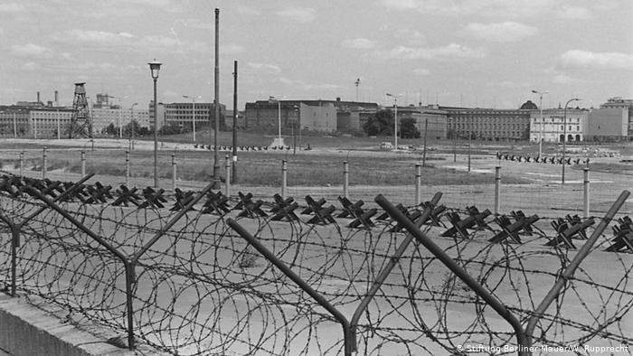
https://www.dw.com/en/berlin-wall-now-down-for-as-long-as-it-once-stood/a-42456108

Document 4

Source: Note on the farewell visit of Polish Ambassador to the DPRK, Comrade Naperei, with Comrade Jarck on 26 July 1968.
I asked Comrade N. whether he could provide some information about the current situation along the DMZ. In summary, Comrade N. made roughly these statements:
The Polish comrades view the situation at the DMZ continuously as one characterized by tenseness and nervousness on both sides.
Over the last six weeks there have been armed clashes resulting in about 30 deaths at the South Korean-American side of the border. Contrary to previous customs there was nothing published in the Korean press. A reason for this non-publication is not evident to the Polish comrades. We have to see whether this pattern continues, or whether it is only a temporary phenomenon possibly caused by an upcoming anniversary.
There are still ongoing attempts to infiltrate armed units into the South. It is, however, getting ever more difficult to actually accomplish this, as the entire land border is basically hermetically sealed. Yet it is said that recently four small units were still infiltrated through the border. In response, there was a large search effort launched in the South in the areas North of Seoul. Allegedly some members of these groups have been captured when they had to surrender due to lack of food.
Comrade N. continued that the Polish comrades given their local expertise do not exclude the option that, in light of complications to infiltrate groups, the DMZ might be breached through a much larger [DPRK] armed unit. This breach could be utilized for infiltration into South Korea, and the larger unit could then withdraw behind the DMZ. However, Comrade N. added so far there is no evidence whatsoever for such intentions.
https://digitalarchive.wilsoncenter.org/document/116684

Document 5
Source: The Guardian (British newspaper) The Berlin Wall falling under the gaze of the East German Police, November 1989.

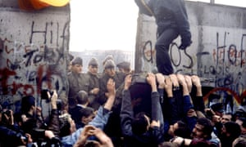

https://www.theguardian.com/commentisfree/2014/nov/05/25-years-on-berlin-wall-far-right

Source 6
Source: North Korean Propaganda Poster reads: “Let us pass on the united country to the next generation!” 2005.

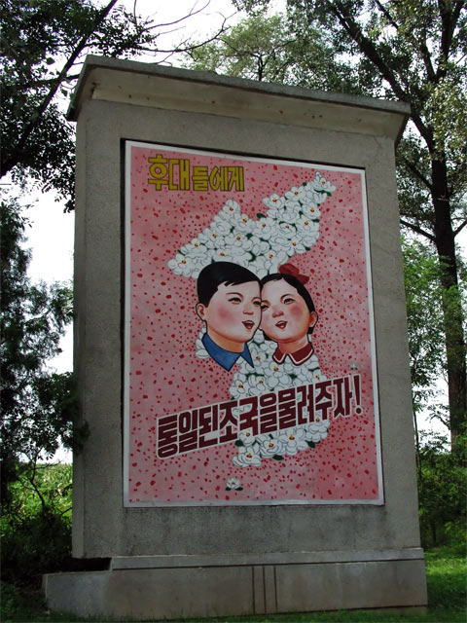

https://kids.kiddle.co/Korean_Demilitarized_Zone

Document 7
Source: Address by President Moon Jae-in at 74th Session of United Nations General Assembly – September 24, 2019.

The DMZ is a colossal green zone that stretches 250 km from east to west and 4 km from north to south. Its borders define a tragedy spawned by 70 years of military confrontation, but paradoxically, it has become a pristine ecological treasure trove. It has also become a symbolic space steeped in history, which embraces both the tragedy of division as embodied by the Joint Security Area, guard posts and barbed-wire fences as well as the yearning for peace.

The DMZ is the common heritage of humankind and its value must be shared with the whole world. Once peace is established between the two Koreas, I will work together with North Koreato inscribe the DMZ as a UNESCO World Heritage Site.

If we designate the area connecting Panmunjeom and Gaeseong in North Koreaas a Peace and Cooperation District and transform it into a zone where both Koreas and the international community can jointly explore the path to prosperity on the Korean Peninsula,-and if the DMZ comes to house UN offices already stationed in the two Koreas and other international organizations related to peace, ecology and culture and emerge as a center for research on peace, peacekeeping, arms control and trust building -it can become an international peace zone in name as well as substance.

Approximately 380,000 anti-personnel mines are laid in the DMZ, and it is expected to take 15 years for South Korean troops to remove them on their own. However, cooperation with the international community, including the United Nations Mine Action Service, will not only guarantee the transparency and stability of demining operations, but also instantly turn the DMZ into an area of international cooperation.

http://statements.unmeetings.org/GA74/KR_EN.pdf

