The Republic of Korea and the Miracle of the Han River

AUTHOR INFORMATION

Author: Julie Cross
State: Minnesota

GENERAL INFORMATION

Lesson Grade Span: Secondary 9-12
Targeted Grade Level/Course: 12th Grade Economics
Estimated Time to Complete Lesson: 2 fifty-minute class periods

FOCUSED QUESTION

How can the overall performance of an economy be influenced by government fiscal policies? Example: the Republic of Korea post the Korean War. Why should we be teaching about Korea?

STANDARDS (STATE/C3)

MN State Standard Economics: 9.2.5.11.3

STUDENT & TARGET OUTCOMES

Students will study the events of Korea from the Japanese Occupation to devastation after The Korean War. Reading about the Government efforts to rejuvenate Korean economy, Student will be able to list policies that led to a vibrant economy from the 1970s to present.

LESSON OVERVIEW

The Republic of Korea is a major player in Global Economics today. Students should be aware of the history of occupation and war that plagued Korea in the first half of the 19th century. Korea is a good example of how Government policy shifted the country from one of an aid recipient to a leading power.

In the next lesson students will build on their learning by reading excerpts about Korea and the events that led to it becoming an aid nation, while answering questions. the teacher will guide students through readings that explain how government policy changed the outcome in South Korea allowing them to build upon the strong culture of education and hard work. Students will complete activities in the packet that clarify this process.

PROCEDURES

To get the background students will view a PowerPoint made by the instructor on a visit to Korea. Teacher will supply the background and discuss the slides. Next, the students will map Korea in order to enhance their physical knowledge of the area.

In the next lesson students will build on their learning by reading excerpts about Korea and the events that led to it becoming an aid nation, while answering questions. The teacher will guide students through readings that explain how government policy changed the outcome in South Korea allowing them to build upon the strong culture of education and hard work. Students will complete activities in the packet that clarify this process. Finally, students will build on their learning by reading excerpts about Korea and the events that led to it becoming an aid nation, while answering questions. The teacher will guide students through readings that explain how government policy changed the outcome in South Korea, allowing them to build upon the strong culture of education and hard work. Students will complete activities in the packet that clarify this process. Once they are done with the packet the teacher and students will discuss the answers and determine why Korea is a good example of Government intervention and policy.

FORMATIVE ASSESSMENT

The packet of readings and questions will be used as a formative assessment.

Please attach rubric as a separate file.

RESOURCE LIST

https://en.wikipedia.org/wikEconomu-of-South-Korea

https://www.thebalance.com/korean-war-facts-definition-costs-and-timeline-4153091

https://www.history.com/news/8-things-you-should-know-about-the-korean-war

https://asiasociety.org/global-cities-education-network/south-korean-education-reforms

MODIFICATIONS & EXTENSIONS (OPTIONAL)

MODIFICATIONS

Anything that may need to be modified, excerpted, or annotated for differing reading levels or abilities.

EXTENSIONS

Is there any way the overall purpose of your lesson can have an impact as part of a larger school or community function?

The Miracle of the Han River/ South Korea’s Policy Choices That Led to a Vibrant Modern Economy
Name_______________________________Period____________
Using your Atlas freehand a drawing of North and South Korea making sure to include the border and the capital of both countries. Include China, the Yellow Sea and the Sea of Japan.

Can you see why South Korea feels like an island to the Koreans today?
Background:

1. Korea was split in half after World War
Japan ruled over Korea from 1905 until the end of World War II, after which the Soviet Union occupied the northern half of the peninsula and the United States occupied the south. Originally, they intended to keep Korea together as one country. But when the United Nations called for elections in 1947, the Soviet Union refused to comply, instead installing a communist regime led by Kim Il-Sung. In the South, meanwhile, strongman Syngman Rhee became president. Both Kim and Rhee wanted to unify Korea under their rule and initiated border skirmishes that left thousands dead.

Give another example of a country that was split apart after World War II. Explain how this situation was different from the example.

The U.S. Congress never declared war, thereby establishing a precedent.
On June 25, 1950, North Korea launched a full-scale invasion of the South after receiving the go-ahead from Soviet dictator Joseph Stalin. Until that point, the United States appeared disinclined to intervene. The year before it had removed its last remaining troops from Korea, and that January U.S. Secretary of State Dean Acheson had given a speech in which he excluded Korea from America’s defense perimeter. Nonetheless, the United States got involved in the Korean War almost immediately. On June 27, as North Korean troops reached the outskirts of Seoul, the South Korean capital, U.S. President Harry S. Truman ordered naval and air forces into action. Then, three days later, he approved the use of ground troops. Though the Constitution gives Congress the power to declare war, it did not do so in this case. “If a burglar breaks into your house, you can shoot him without going down to the police station and getting permission,” Senator Tom Connally told Truman when asked if Congressional approval was necessary. As a result, Congress has not formally declared war since World War II.
Do you think the United States was justified in defending South Korea without declaring war? Explain:

What precedent did this operation begin in America?

The fighting ended in 1953 with the Demilitarization Zone declared between North and south Korea. The country was never unified, and peace has not been achieved. The Japanese occupation had left greater infrastructure in the North of Korea. The South had been the rice producer but was left in ruins with few resources for recovery
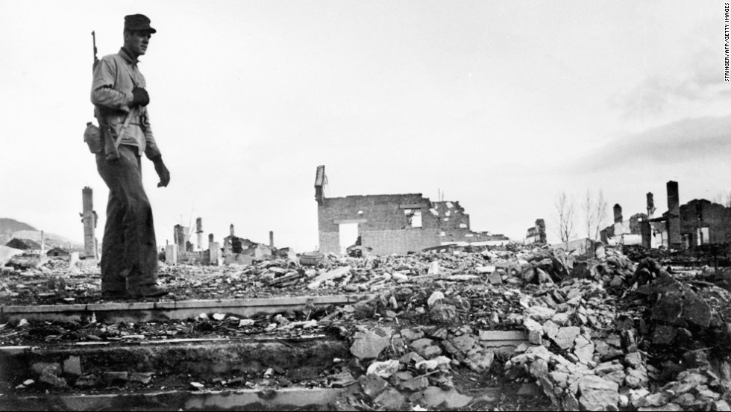
The early struggle
“I remember what it was like growing up in Korea in the 1950s and 1960s. Per capita income was less than $100 – about what it is today in the poorest south Asian and African countries. The Korean War of 1950-1953 devastated the country, killing and injuring millions of people and scaring those who survived. In the early days of the war North Korean soldiers poured across the border and swept through most of South Korea, and in the aftermath of the war the economy was ruined and millions of families were separated and relocated. Our family, which had come down from the North before the war, fled to Busan at the southern tip of the peninsula to escape retribution from the North Koreans. Food was sometimes scarce in the 1950s. In the springtime, after the autumn harvest had been eaten and before new crops could be gathered, poor people would scour the hills for edible herbs and plants – just as they do in North Korea today. Schoolrooms lacked desks and chairs and had little heat in the winter. Many school children depended on foreign food donations like powdered milk for their lunch.
Why do you think the North Koreans swept across the border of North and South Korea after the war if there wasn’t enough food in the south?

After the Korean war, South Korea was one of the world's poorest countries with only $64 per capita income. Economically, in the 1960s it lagged behind the Democratic Republic of the Congo (DRC) – currently holding elections marred by violence . Since then the country's fortunes have diverged spectacularly. South Korea now belongs to the rich man's club, the OECD development assistance committee (DAC). The DRC has gone backwards since independence and, out of 187 countries, ranked bottom in the 2011 Human Development Index.
South Korea, however, benefited from big injections of foreign aid, first from the US, then Japan. A briefing paper from KoFID, a South Korean network of civil society organisations, and ReDI, a South Korean thinktank, points out that the US offered about $60bn in grants and loans to South Korea between 1946 and 1978. In the same period, the total amount of aid provided by the US to the entire African continent was $68.9bn. Korea – considered by the US an important ally during the cold war – indisputedly used the aid well. Seoul was not afraid to stand up to the US when they differed on development strategy as well.
Use the graph to add together the aid from the Unites States and Japan over 30 years:
The first observation is that as a country South Korea was the recipient of one of the most consistent and extensive aid packages in the world; from the end of World War II until 1975, South Korea benefitted from unprecedented amount of aid (Table 1).
Table 1 Aid From US and Japan 1945-83 ($ millions)
Aid | 1946-52 | 1953-61 | 1962-69 | 1970-76
US Economic Assistance | 666.8 | 2,579.2 | 1,658.2 | 963.6
Japanese Aid | 0 | 0 | 500 | 672.9
Source: Steinberg (1985)
In contrast, developing countries have continued to receive much smaller amounts of aid on average with little evidence of consistency over long term periods. The sheer scale and consistency of Korea’s transformative aid project can be understood through comparison:
‘The Korean total of $6 billion in U.S. economic grants and loans, 1946-1978, compares to $6.89 billion for all of Africa, and $14.89 billion for all of Latin America’ (Woo 1991:45).
Why do you think the United States gave so much aid to south Korea after the war? Why did it give Korea more aid than in Africa and other places? Explain:

There is widespread consensus about the role of aid in fueling the modern industrial sector of Korea (Amsden 1989, Mason et.al 1980, Cole 1980). Economic modernization under the controversial Park Chung Hee was a period of high aid dependency. Nearly 20% of foreign aid during 1953-1972 was used for the import of goods and services (Chung,Y 2007:318 ). Over 87% of the total project aid was used for the industrial sector, concentrating on sectors such as mining, manufacturing and transport (Ibid). Textiles and commodity producers were dominant beneficiaries while traditional sectors such as agriculture and fishing only benefited from selective funnelling of aid for activities including the construction of irrigation dams. Foreign assistance also enabled the framework for the long standing alliance between the big business and the state by freeing up domestic resources to cultivate a private business elite (Amsden 1989:39). The new entrepreneurial elite, already in various positions of office through support for the American military had invested in a range of profitable sectors ranging from consumer goods to light industry such as manufacturing. The state directed investment in heavy industry was possible through incentives such as tax holidays and subsidised loans, which could not have been possible if aid was not available for other sectors.
Give two specific examples of how Korea built up industry with aid money?

How were entrepreneurs built in from the system? How did they impact small business?

What incentives were used to get investment in industry?
To begin, a long tradition of Confucianism has established a society in which the scholar sits at the top of the social hierarchy and the attainment of knowledge is considered a priority. The educated person in Korea, thus, is highly respected. However, even ordinary Koreans could enjoy the respect and privileges of this highest class by passing the Kwageo (a rigorous civil service examination that pays little heed to consanguinity and political ties) to become civil servants. This democratization of talent has put great stock in the power of education to transform lives.
Alongside this, a national drive against Japanese occupation from 1910 to 1945 placed a lot of emphasis on the importance of economic self-reliance and national cultivation through education. This resulted in the establishment of approximately 3,000 private schools across the nation, which bolstered the Korean education system. The devastating Korean War that followed left the country bereft of any social, physical, and economic capital. The recovery process was done on Korea’s own terms and through hard work.
Investments in Education
The dramatic growth of the Korean economy has also contributed significantly to the value that Koreans place on higher education. In the past 25 years, the country has realized an extraordinarily high rate of return from education investment, hovering around 10 percent. As Dr. SooBong Uh, from the Korea University of Technology and Education has stated, “It is wiser for young people to invest their money in education than to keep it in the bank.
South Korea invested heavily in education after the war which originated from a long standing cultural respect for education and opposition to foreign conquest.
Please interpret the quotes below and explain how education contributed to Korea’s economic success.
“It is wiser for young people to invest money in education than to keep it in the bank” (remember the entrepreneurs and the Chaebols: small business)

“The recovery process was done on Korea’s own terms and through hard work”

Today the economy of The Republic of Korea is the 4th largest in Asia and the 11th largest in the world. It rose from being one of the poorest countries in the world to one of the richest and is now giving aid to other countries. How did the economic policies of the government contribute to this success?

Miracle of the Han River Packet Rubric

20 Points
_____Mapping complete
_____All questions answered in complete sentences using examples

15 Points
_____Mapping Complete
_____All questions answered but not all in full sentences with examples.

10 Points
_____Mapping somewhat complete
_____Questions answered without full sentences or with examples

5 Points
An attempt on the assignment was made but there is a lack of detail and progress in answers.

