Whose war is the Korean War?

AUTHOR INFORMATION

Author: Matthew Britton
State: Florida

GENERAL INFORMATION

Lesson Grade Span: Secondary (9-12)
Targeted Grade Level/Course: 9th -12th
Estimated Time to Complete Lesson: 135 – 180 min

FOCUSED QUESTION

Why is the Korean War still happening?

STANDARDS (STATE/C3)

SS.912.W.9.2 Describe the causes and effects of post-World War II economic and demographic changes.
SS.912.W.8.3 Summarize key developments in post-war China.
SS.912.W.8.4 Summarize the causes and effects of the arms race and proxy wars in Africa, Asia, Latin America, and the Middle East.
SS.912.W.9.4 Describe the causes and effects of twentieth century nationalist conflicts.

STUDENT & TARGET OUTCOMES

SWBAT:
Understand the difference between Communism and Capitalism and how these ideas impacted countries throughout the world.
Describe the reasoning for involvement from so-called “first world” nations in affairs outside their borders.
Understand the reasoning behind anti-imperialist nations, when creating governments in opposition to imperialist governments.

LESSON OVERVIEW

The main focus of this lesson is to illustrate why each party (South Korea, North Korea, US and China) are engaged in what has become a perpetual war of the Koreas. The lesson attempts to show that each nation has really no reason to end a “war” that for the most part is “bluster.”

PROCEDURES

Step by Step Instructions for Educators:
Plan of Instruction:
Note: Student should be familiar with the Korean War, Imperialism and WWII from the Japanese Imperialist perspective.
This plan is a modified jigsaw and Structured Academic Controversy
1. Introduction:
- Students will read the quick introductory paragraph, either as a class or individually.
- Show the map of the belligerents and explain what a belligerent is.
a. Ask why some countries are in red and others in blue.
- The teacher will show the timeline of leaders to the president.
a. Emphasize the length of the actual war to armistice.
b. Emphasize the number of leaders that had an opportunity to end the conflict.
- Answer the discussion questions as a class to ensure everyone is one the same page before the country perspectives.
2. Group the students in groups of 4. Each student will represent a perspective that they are responsible for.
- Have the students read by themselves and answer the discussion questions for 15 minutes.
3. Move the students from their original group to a group of like countries. Depending on size of class have one or two groups for each country.
- Students during this point will discuss their answers and solidify their perspective within the like nation.
Ex. 1st Group – 4 students (one with North Korea, one with US, one with China and one with South Korea)
2nd Group – just countries to discuss the answers (Just South Korea, Just North Korea, Just China, or Just the US)
- This step is a scaffolding step for all levels of learners to make sure they can coherently argue a perspective.
- The teacher will provide support to students struggling or documents that are difficult.
4. The students will go back to their original group and have civilized discourse. The overall question being answered is Whose war is the Korean War?
- Students are explaining their position to show the other nations are at fault.
- The teacher should explain that using sources and stating specifics is the best. Each person in the groups should talk at-least once before someone can refute. This portion of the lesson should last for 20-30 minutes.
- The teacher will circulate the room to ensure students are on task and providing accurate details.
5. The students will then get in four corners. Students can give up their original position and switch to another country that was more persuasive.
- The teacher will need to make sure all viewpoints are being given.
- This is a great opportunity for an informal assessment and for the teacher to determine student understanding and if anything needs to be re-taught.
- The teacher will need to play “devil’s advocate” and re-teach certain issues.
6. Whole – class discussion of the last document.
- Ask the students the discussion questions and if this document passage changes any opinions.

FORMATIVE ASSESSMENT

Formative Assessment Ideas
- College / AP
- Short Answer Question (SAQ) Prompt
- Paragraph write focusing on A) Introduction w/ Thesis or B) use of sources to prove point
- General Population / Honors
- Short Answer Write for Exit Ticket
- Grade the Discussion questions for accuracy
- Just listen to the discussion. Do the students know the material.

RESOURCE LIST

- Technology (either 1:1 and share the lesson) or a projector for the first 3 documents.
- Copies that students can mark-up for the perspectives.
- Students only need one Country perspective
- A copy of the final document.

MODIFICATIONS & EXTENSIONS (OPTIONAL)

MODIFICATIONS

- Model and scaffold the material as needed.
- Provide the students their individual perspective as homework.
- Provide a translated copy to ESOL students.
- Instead of having group discussion, use separate documents to illustrate POV / perspective.
- Instead of having students read on their own, have the students read the documents as a group in their countries and discuss the answers.

EXTENSIONS

- Possibly write your politician about ending the War in Korea.

Perspectives

Korean War Background
World War II divided Korea into a Communist, northern half and an American-occupied southern half, divided at the 38th parallel. The Korean War (1950-1953) began when the North Korean Communist army crossed the 38th Parallel and invaded non-Communist South Korea. As Kim Il-sung's North Korean army, armed with Soviet tanks, quickly overran South Korea, the United States came to South Korea's aid. Although Korea was not strategically essential to the United States, the political environment at this stage of the Cold War was such that policymakers did not want to appear "soft on Communism." Nominally, the US intervened as part of a "police action" run by a UN (United Nations) international peace- keeping force; in actuality, the UN was simply being manipulated by US and NATO anti-Communist interests.
Source: https://www.sparknotes.com/history/american/koreanwar/summary/
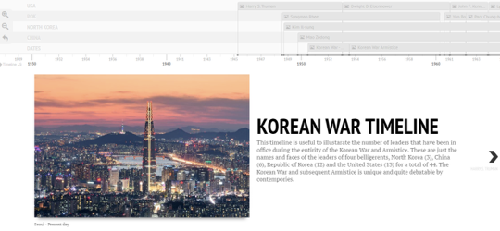

Timeline of Leaders Link if Picture Link does not work.
https://cdn.knightlab.com/libs/timeline3/latest/embed/index.html?source=1ENGu4zjrWMESaF9e-cSD5l_jCjiP7Aid00MiVuqZHbY&font=Default&lang=en&timenav_position=top&initial_zoom=2&height=650

Map of Belligerents in 1950
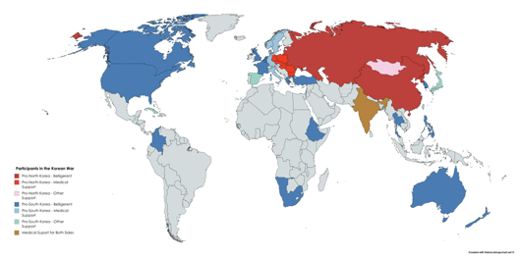

Discussion Questions
- How many different nations were involved?
- Why not call this a World War?
  - Did any one nation act alone?
  - What is a proxy war, and could this be considered a proxy war?
  - How many leaders have perpetuated this conflict?
United States Perspective

Presidential Perspectives

Harry S. Truman - “This attack has made it clear, beyond all doubt, that the international Communist movement is willing to use armed invasion to conquer independent nations. An act of aggression such as this creates a very real danger to the security of all free nations.”
Source: Truman Address on Korea July 19, 1950

Dwight D. Eisenhower - “Documents released today give details on a decision by President Dwight D. Eisenhower's Administration in 1953 to use atomic bombs in North Korea and Communist China, if necessary, to end the Korean War.” “The fact that the Eisenhower Administration was ready to use nuclear weapons is not new. President Eisenhower, in his memoirs, said he came into office prepared to use them, if necessary, to break the deadlock.”
Source: https://www.nytimes.com/1984/06/08/world/us-papers-tell-of-53-policy-to-use-a-bomb-in-korea.html
1. Why does Truman engage the US into war with Communist North Korea?
2. What does Dwight D. Eisenhower threaten North Korea with?
George W. Bush - “The North Korean regime remains one of the world's leading proliferator of missile technology, including transfers to Iran and Syria. The transfer of nuclear weapons or material by North Korea to states or non-state entities would be considered a grave threat to the United States, and we would hold North Korea fully accountable of the consequences of such action.”
Source: https://georgewbush-whitehouse.archives.gov/news/releases/2006/10/20061009.html

Barack H. Obama - has warned North Korea that the United States "will not hesitate to use our military might" to defend allies, condemning the actions of "a pariah state that would rather starve its people than feed their hopes and dreams" and characterizing the 38th parallel dividing the two Koreas as "freedom's frontier".
Source: https://www.reuters.com/article/us-korea-north-usa/obama-reminds-north-korea-of-u-s-military-might-idINKBN0DC03320140426
Donald J. Trump - “Just heard Foreign Minister of North Korea speak at U.N. If he echoes thoughts of Little Rocket Man, they won’t be around much longer!
Source: Twitter, Donald J. Trump, @realDonaldTrump, September 23, 2017
3. What are the complaints of President Bush and President Obama?
4. Why is the US fearful of such a “small” country?
View of Korean Peninsula at night from Space
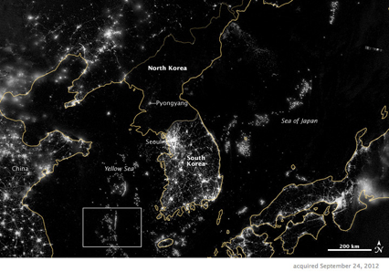
5. What does this image illustrate?
6. How can a capitalist nation like the US use this image to show the positive of capitalism(propaganda)?
Extension
7. What is another document that you would like to see that would help develop your opinion of the US perspective?
Chinese Perspective

Background - Despite these great costs, Mao supported Kim’s war because he was forced into a difficult position by Stalin and Kim. As Thomas Christensen argues, the new Chinese leader was eager to prove his communist credentials to Stalin and the rest of the world, and could not refuse to back what was billed as a revolutionary cause. And once US troops began to cross the 38th parallel in October 1950, Mao directly intervened by sending in Chinese troops to ensure that that the United States would not push into Chinese territory. The slogan employed by the Chinese Communist Party (CCP) during the war, “Resist America, Aid North Korea, and Defend the Chinese homeland”
Source: https://www.thechicagocouncil.org/publication/how-china-sees-north-korea-three-critical-moments-history-and-future-directions
1. How did Mao “intervene” or become involved in the war?
2. Why did Mao become involved in the Korean War?
CCP Government under Mao - “Those who believe that Chinese-[North] Korean cooperation is one-sided assistance and it is just China aiding [North] Korea are fundamentally wrong. Those who believe the aid to [North] Korea will affect our own economic construction are also fundamentally wrong…to defeat American aggression against the Korean people is not just a matter for the Korean people, but is for all peace loving people around the world, particularly the Chinese people, who have a close interest in the matter. The slogan “to resist America and aid Korea and defend the country” fully embodies this sense… The American imperialists fought to the Yalu River. If they hadn’t been pushed back, there would be no guarantee for China’s construction. If the enemy’s aggressive schemes hadn’t been curbed, peace in the Far East and throughout the world would not have been ensured…Because the dividing line at the 38th parallel is a common line of defense for the Chinese and Korean peoples, it also the common line of defense in defending peace in the Far East and throughout the world. In the struggle over this common line of defense, Korea is situated at the first line and China is at the second line. The strong consolidation of the first line has direct and great significance for the second line. The restoration of every village in [North] Korea and every factory is a force for growth and is closely connected to us. Thus, helping the Korean people to heal the wounds of war and restore their national economy is an important task for the consolidation of our common defense.”
Source: https://digitalarchive.wilsoncenter.org/document/114169.pdf?v=0b8576cfa63a0ca1e89a9b671f5ea129
3. What are “American imperialists”?
4. Why is the Government of China fighting in the Korean War?
Council on Foreign Relations, The China-North Korea Relationship
Buffer - China has regarded stability on the Korean Peninsula as its primary interest. Its support for North Korea ensures a buffer between China and the democratic South, which is home to around twenty-nine thousand U.S. troops and marines. “While the Chinese certainly would prefer that North Korea not have nuclear weapons, their greatest fear is regime collapse,” writes Jennifer Lind, a professor at Dartmouth University.
Source: https://www.cfr.org/backgrounder/china-north-korea-relationship
5. What does buffer mean?
6. What kind of buffer would North Korea provide?
The risk of North Korean collapse explains why China can’t control Kim
Humanitarian Crisis - The collapse of North Korea, then, would mean a humanitarian crisis in which millions of refugees are projected to try to stream across the Chinese border — and the likely presence of a rival military presence right on China’s border. Therefore, China can’t credibly threaten to cut off trade in a way that would seriously undermine the government in Pyongyang without risking disaster, and Kim Jong Un knows it.
Source: https://www.vox.com/world/2017/8/29/16079076/north-korea-maps
7. What are refugees and how would this hurt China?
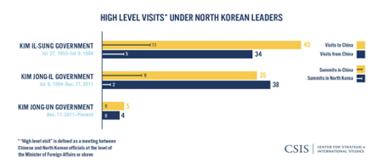
8. To what extent has China scaled back in support of the Kim Jong-un government?

Extension
9. What is another document that you would like to see that would help develop your opinion of the Chinese perspective?
North Korea Perspective

Headline: There are 5,000 tunnels under North Korea, and US soldiers are training to fight in them
“The North Koreans are like mole people,” Dave Maxwell, a former Army colonel who fought in the Korean war and is now part of an educational organization on Korea, told NPR. In 2001, Donald Rumsfeld called North Koreans “world class tunnelers.” Maxwell claims the country has an extensive underground network of 5,00 tunnels, many built far below the surface to be safe from aerial attacks. In the unlikely scenario of invasion, attacking soldiers would have to fight not only in the art and on the ground, but below ground-level, too.
Source: https://qz.com/1175447/north-korea-the-us-army-is-training-to-fight-in-tunnels/
1. What is a tunnel?
2. Why would a country build so many tunnels?

Headline: North Korea says new tests will help it counter US threats
Pak Jong Chon, chief of the Korean People’s Army’s general staff, asserted on Saturday that North Korea has builds power” and that the findings from the recent tests would be used to develop new weapons to allow the country to “definitely and reliability” counter U.S. nuclear threats.
Source: https://apnews.com/a65ce1c9102331e8e0036be11cb4d872
3. What nuclear threat does the US pose?
4. Is North Korea really in danger from the US? Do you think that the US ever thought about dropping a nuclear bomb on North Korea?
Headline: Juche, the state ideology that makes North Koreans revere Kim Jong Un, explained
North Korea’s repressive government survives in no small part because it has convinced its people of the legitimacy of its government. As hard as it may be for Americans to grasp, millions of North Koreans appear to truly believe their government’s pronouncements. And the tool the state has used to convince of them of these ideas is a unique official philosophy called “juche” (pronounced JOO-chay).
Juche, which roughly translates as “self-reliance,” is an odd blend of several different ideas. It borrows much of its language from Marxism but also draws on Confucianism, 20th-century Japanese imperialism, and traditional Korean nationalism. Its core idea is that North Korea is a country that must remain separate and distinct from the world, dependent solely on its own strength and the guidance of a near-godlike leader.
Source: https://www.vox.com/world/2018/6/18/17441296/north-korea-propaganda-ideology-juche
5. What is Marxism?
Confucianism and Government
The family was the basis of society for Confucius, and his teachings, family relationships are used to explain the proper relationships between government and the people. The most obvious of these is the emperor, who by no accident, was often compared to the father of all the people. The people have a duty to respect, honor and obey the emperor, just like the children to a parent.
Source: https://study.com/academy/lesson/confucius-ideas-on-family-society.html
6. Under Confucianism who is the ultimate father?
Kim on Imperialism
Kim Jong Il, at the time North Korea's leader, solved these post-Soviet problems with something called the Songun or "military first" policy. This policy tells North Koreans that the reason they are hungry and impoverished and locked in a police state is because this is all necessary to fund the military and protect from enemies internal and external, so as to keep them safe from the imperialist Americans who would otherwise surely overwhelm them and do unspeakable things.
Source: https://www.vox.com/2016/1/6/10724334/north-korea-history
7. What sacrifices do the North Koreans have to make?
8. Why do North Koreans make these hardships?
Extension
9. What is another document that you would like to see that would help develop your opinion of the North Korean perspective?

South Korea Perspective
Postwar South Korea eventually entered the international economy, building up an economic model focusing on export manufacturing starting in the ’70s and technology more recently. South Korea is as a result one of the world’s richest nations; its GDP per capita is higher than that of many European nations.
1. Approximately how much per capita income did South Korea and North Korea have in 1950, respectively?
2. What could explain the difference between North Korea and South Korea? (hint: economic structure)
DMZ travel
Strange but true: Parts of the 155-mile-long DMZ are major, longtime, family-friendly tourist attractions. Saw it with my own amazed eyes on a gray, spring day a few years ago.
The Third Tunnel Tour uses a tram to take kids and adults underground, following a dark and dank infiltration passage that stretches under the DMZ. Although less than 7 feet high and wide, guides say the tunnel – if left undiscovered during wartime – could have moved 10,000 soldiers (with gear) per hour.
In Imjingak, a park less than 5 miles from the DMZ, are amusement rides and a memorial with altar to honor ancestors. Visitors walk to the Freedom Bridge, where prisoners of war were allowed to walk to their freedom in 1953. Now it’s a footbridge to nowhere, blocked by a wiry fence that is stuffed with handwritten pleas for peace and unity.
Source: https://www.postcrescent.com/story/life/2017/08/28/koreas-demilitarized-zone-has-major-tourist-attractions/589987001/
3. What is the DMZ?
4. Why are there tourist attractions and amusement rides in the DMZ?
5. Are South Koreans really scared of invasion if there are amusement rides?
Third Tunnel of Aggression
The Third Tunnel of Aggression is one of four known tunnels under the border between North Korea and South Korea, extending south of Panmunjom.
Source: https://en.wikipedia.org/wiki/Third_Tunnel_of_Aggression
6. What is a “Tunnel of Aggression,” what could come through the tunnel?
7. Why call the tunnel, the “Tunnel of Aggression?”
Skyline of Seoul
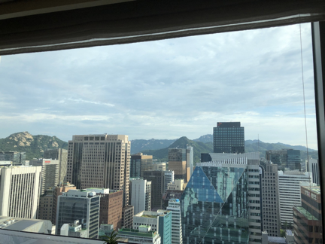
8. How tall are the buildings and what other city does this remind you of?
9. Are South Koreans scared of nuclear attack? (Hint: Would a city build buildings “up” or “below” if they were scared of nuclear attack?)
Extension
10. What is another document that you would like to see that would help develop your opinion of the US perspective?
Last Document

Life Inside the DMZ? Scary, but There’s 5G and a Great School

South Korea’s determination to keep Taesung populated comes with challenges; villagers are expected to forgo much of the freedom and services other South Koreans take for granted.
Whenever villagers venture to their rice paddies near the borderline just 1,300 feet away, they are shadowed by South Korean soldiers. They also live with a midnight-to-sunrise curfew and a door-to-door roll call every night.
Source: https://www.nytimes.com/2019/12/02/world/asia/korea-demilitarized-zone.html

- What is the South Korean Government giving people living in the DMZ?
- What do the people have to give up by living in the DMZ?
- Does this sound like protection or control, Explain?

