Korean Currency

AUTHOR INFORMATION

Author: Karen Krzystof- Bansley
State: Illinois

GENERAL INFORMATION

Lesson Grade Span: Middle (6-8)
Targeted Grade Level/Course: Social Studies
Estimated Time to Complete Lesson: 3 50-minute classes

FOCUSED QUESTION

What can you learn about Korea by studying the important Koreans featured on their currency?

and
STANDARDS (STATE/C3)

C3 Standards:

By the end of 8th grade:
D2.Geo.10.6-8. Analyze the ways in which cultural and environmental characteristics vary among various regions of the world.

NCSS Standards:

Standard 3: Continuity and Change
Standard 5: Individuals, Groups and Institutions

STUDENT & TARGET OUTCOMES

The students will know about famous Koreans who are featured on Korean won.

The students will increase knowledge about Admiral Yi Sun Shin, Yi Hwang, Yi I, Shin Samdang and Sejong the Great. They will understand that South Korea’s currency features scholars instead of politicians.

The students will be able to compare the currency of Korea to that of the United States (or their home country).

LESSON OVERVIEW

These lessons will involve student research about famous Koreans featured on Korean won. They will research the important people featured on South Korean currency in small groups. Students will then compare their new knowledge to what they know about US currency. This may require additional research by the students.

PROCEDURES

Preparation for lesson plan and teacher background:

Enlarge these images and print in color.
It is recommended that the images be laminated so that they are ready to use again.

 | 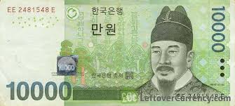 | 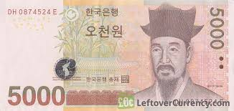
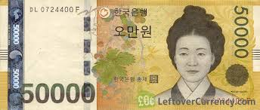 | 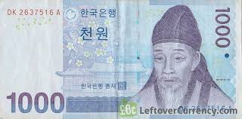
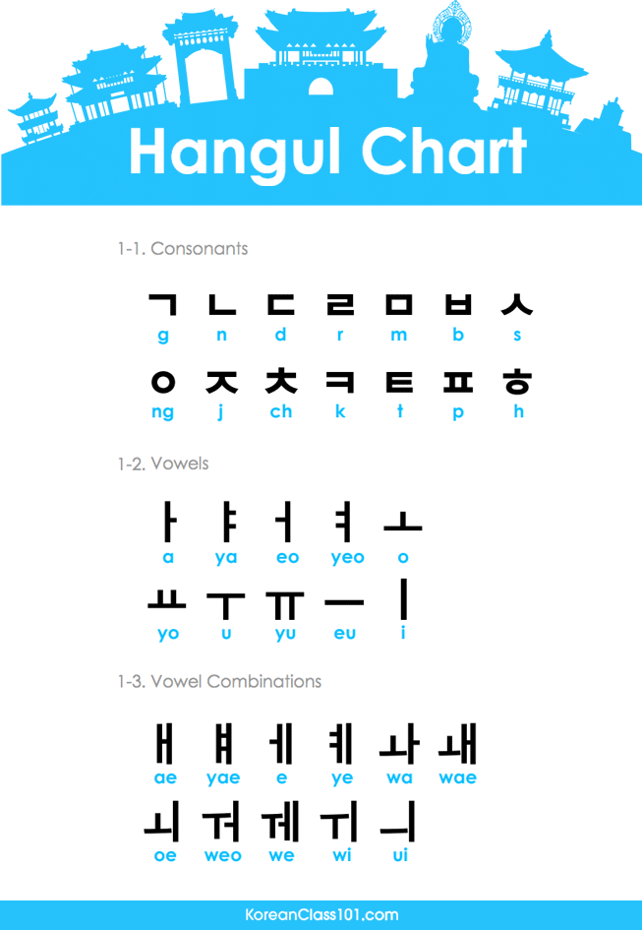 | 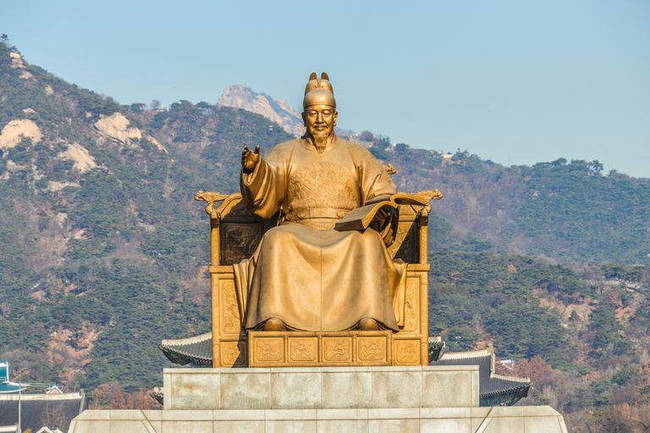 | 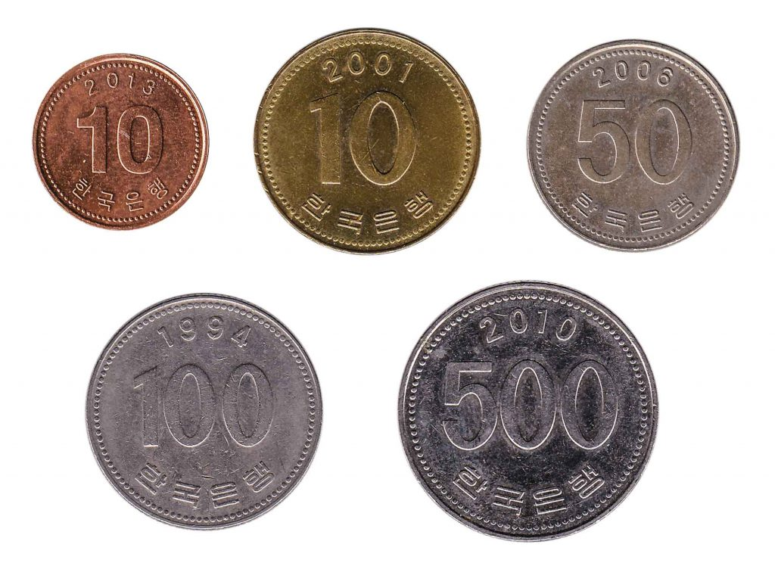

 | 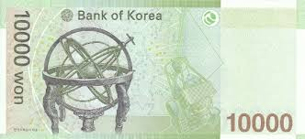  back of 10000 won note | 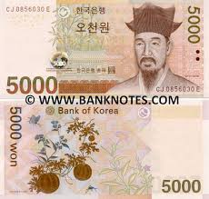
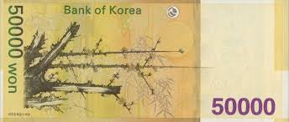  back of 50000 won note | 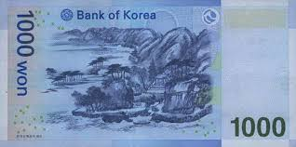

Notes about images featured above.
- This symbol is used to indicate Won which is the currency used in South Korea. | - The 10000 Won note features Sejong the Great. | - The 5000 Won note features Yi I.
- The 50000 Won note features Sin Saimdang. | - The 1000 Won note features Yi Hwang. | - The South Korean flag is pictured.
7.This Hangul chart was a significant contribution by Sejong the great. | 8. Famous Sejong the Great statue found in Seoul. | 9. Korean coins are featured. Admiral Yi Sun Shin is featured on the 100 coin.

Day 1 of Unit- 50-minute period

Breakdown:
5 minutes- Form groups of 3 and explain directions for gallery walk.
15 minutes- Gallery walk. Fill out worksheet #1.
10 minutes- Whole group discussion
10 minutes- Watch video about Korean currency and discuss. https://www.ikeneducate.org/k-culture-courses/
10 minutes- Choose topics for research which begins on day 2.

Teachers will group students into groups of 3.

Gallery Walk: Students will view several artifacts from modern Korea. Advance preparations required teacher to print and display these items.

In small groups, students will make inferences about these items based on their prior knowledge and using guided questions worksheet.

Guiding questions: (Worksheet #1. One worksheet per group)

- What features do you expect to find on currency?
- What conclusions can you draw about Korean society by examining their money?
- Why do you think this man has such a large statue dedicated to him?
- Do the characters on the Hangul chart look like our letters at all?
- Who do you think decided what the currency would look like?
- Is there anything that surprised you or that you found interesting about the money?

Artifacts include:

Korean currency images- both coins and bills- enlarged copies of each.
image of Korean flag
Feel free to add or alter based on your classroom’s needs.

Day 2 of Unit- 50-minute period
- In small groups, create posters for another gallery walk.
- Students will be assigned Korean topics to research. Suggested links are listed to initiate research. Remind students to only use information from reliable sources.
- Students will learn from others’ research during the concluding lesson.
- During concluding lesson, students will present their posters. Students will pose 2 questions to their classmates, which can be answered by reading poster. (Teacher will need to create a worksheet with these questions; therefore groups must submit them at the end of day 2. Or students can write these questions on their gallery walk posters.)

Topics: (to be assigned to groups by teacher. You may need to repeat topics depending on class size.)
1.Yi Hwang - featured on 1000 won note
https://en.wikipedia.org/wiki/Yi_Hwang
Prominent Confucion scholar of Josean period.
http://korea.prkorea.com/wordpress/english/2012/03/21/yi-hwang/
https://www.newworldencyclopedia.org/entry/Yi_Hwang

2.Yi I- featured on 5000 won note
https://en.wikipedia.org/wiki/Yi_I
scholar, politician and reformer
https://kids.kiddle.co/Yi_Hwang

3. Sejong the Great/ Hangul alphabet
featured on 10000 won note
Well known for Hangul- the Korean alphabet
https://en.wikipedia.org/wiki/Sejong_the_Great
https://www.newworldencyclopedia.org/entry/King_Sejong
aas2.asian-studies.org/EAA/EAA-Archives/6/2/421.pdf

4 Sin Saimdang-featured on 50000 won note
This is unique as this features a woman on their currency. It was issued in June of 2009.
She was an artist, writer, calligrapher and poet.
Mother of Yi I (featured on 5000 won note
Because of her early death, her son wondered about the meaning of life and death.
She was admired as a good woman and a good wife.
https://en.wikipedia.org/wiki/Sin_Saimdang

5 Admiral Yi Sun Shin/ Turtle Ship (one of the 7 world’s most outstanding battle ships)
Korean naval commander who was very successful against Japanese invasions.
aas2.asian-studies.org/EAA/EAA-Archives/6/2/421.pdf
ttps://en.wikipedia.org/wiki/Yi_Sun-sin

6. Korean flag
(This can be used as a topic of students, or you can assign more than one student group to famous Korean people listed above.)

Day 4 of Unit- 50-minute period

Part 1:

15 minutes of gallery walk. Look at completed posters by student groups.
Include handout with guided questions to consider with your group. (These guiding questions will be created by the student groups.) This worksheet will need to be created by the teacher since they will be student created.

Part 2: 15 minutes of whole group teacher led discussion using guiding questions

Guiding questions:
- What did you notice about the people chosen to be featured on the money?
- Anything in common between all the people featured on the money?
- Any differences between the people?
- What do we know about people featured on US money?
- How do you think the people featured on money should be chosen?

Some of the questions focus on the NCSS standard of continuity and change.

Part 3: 20 minutes

Assign formative assessment. Students will complete this individually. Students can use the posters for information as well as online sources

FORMATIVE ASSESSMENT- include rubric
List and explain the different formal assessments that will be used to assess
whether or not students achieved the learning goals (target outcomes).

Options for Assessment:

- Students will create a Venn Diagram which compares and contrasts Korean Won to US currency. It is suggested that students look for at least 5 facts to put in each category. (This will involve some independent research about US currency.)

- Students will create a compare/contrast paragraph which compares Korean Won to US currency.

RESOURCE LIST
List all resources needed for the lesson using APA formatting.
Make sure to attach files as a separate file.

https://en.wikipedia.org/wiki/Korean_currency

https://www1.oanda.com/currency/iso-currency-codes/KRW

https://en.wikipedia.org/wiki/Yi_Sun-sin

https://www.ikeneducate.org/k-culture-courses/
8-minute video used in introduction

https://seoulistic.com/just-for-fun/get-to-know-faces-youll-see-everyday-in-korea-whos-on-south-korean-money/

https://en.wikipedia.org/wiki/South_Korean_won

https://en.wikipedia.org/wiki/Culture_of_Korea
crafts, music, home, clothing (hanbok), cuisine, beliefs,

aas2.asian-studies.org/EAA/EAA-Archives/6/2/421.pdf
Article about Sejong

- Guiding Questions worksheet for Day #1
- What features do you expect to find on currency?
- What conclusions can you draw about Korean society by examining their money?
- Why do you think this man has such a large statue dedicated to him?
- Do the characters on the Hangul chart look like our letters at all?
- Who do you think decided what the currency would look like?
- Is there anything that surprised you or that you found interesting about the money?

- Teacher created worksheet for Day #3 (questions will be generated by students)

- Rubric
Up to 5 points- accurate list about Korean currency.
Up to 5 points- accurate list about US currency.
Up to 5 points- accurate list about the differences between Korean and US currency.

MODIFICATIONS & EXTENSIONS (OPTIONAL)

MODIFICATIONS for lower students

- Students will work in teacher selected partnerships (based on student need) or small groups.
- Print information about each person so that they can highlight and annotate the information.

EXTENSIONS for higher level students

- Acceptance Speech. Write a 1st person speech that would be one of the Korean’s response to being awarded the honor of being on currency.
- Essay: What did you learn about Korean culture by studying the people featured on Korean won?
- Chart which compares and contrasts Korean currency/ US currency/3rd country
- Higher level students can research about North Korean currency. North Korean and South Korean currency can be compared. Additionally, students can study the changes to Korean currency over the years as well. Then can learn the reasons why currency was changed over time.
- Another extension can involve students researching about women being featured on US currency. Students can research and learn that South Korea has had a female president as well, while the US has not.
https://www.cnbc.com/2019/05/22/harriet-tubman-20-bill-no-longer-coming-in-2020.html

