Metal Movable Type: The Jikji and the Gutenberg Bible

AUTHOR INFORMATION

Author: Patrick Whelan
State: Florida

GENERAL INFORMATION

Lesson Grade Span: Middle (6-8), Secondary (9-12)
Targeted Grade Level/Course: Sophomore World History with extensions to AP World History
Estimated Time to Complete Lesson: One 45-minute class

FOCUSED QUESTION

How do the printing of the Korean Jikji and the European Gutenberg Bible compare?

STANDARDS (STATE/C3)

Advanced Placement World History
Key Concept 4.1.II
Knowledge, scientific learning, and technology from the Classical, Islamic, and Asian worlds spread, facilitating European technological developments and innovation.

STUDENT & TARGET OUTCOMES

Students will describe the main features of early printing technology in Korea and Western Europe.
Students will compare features of early printing technology in Korea and Western Europe.
Students will evaluate the importance of the effects of printing technology on East Asia and Western Europe.

LESSON OVERVIEW

The main topic of this lesson is the place of Korea in the global history of printing technology. Students examine both video and written sources to determine the comparative importance of Korean and European moveable metal type printing.

PROCEDURES

The teacher begins with the question: what are some of the most important technological invention in history? Students first write down their answer, share with an elbow partner, then share with the whole class.

Follow-up question: what makes a technological invention particularly important? Students may respond with answers involving the degree of causation or change brought by the invention.

Teacher then shows the first three minutes of the video: The Greatest invention, Jikji https://www.youtube.com/watch?v=GVDsKRb9WPA [up to 3:00]

Question: What is the central claim made by this video and what evidence does the video deploy to support that claim? Are there other claims made by the video?

Optional extension questions: Are the claims made in the video reliable? The video was produced by the Voluntary Agency Network of Korea, an advocacy group that is trying to raise the profile of Korea and Korean history. How does that sourcing information influence your thoughts on the point of view of the video’s claim? How does your thoughts on what makes a technological invention particularly important reflected in these claims.

Students will use the following encyclopedia entry to answer the questions: https://www.newworldencyclopedia.org/entry/Jikji

Jikji
When was it printed?
Who printed the book?
What was the content of the book?
What was the technology used to produce the book?
What has been the cultural significance of the book?

Students will use the following encyclopedia entry to answer the questions:
https://www.newworldencyclopedia.org/entry/Johannes_Gutenberg

Gutenberg Bible
When was it printed?
Who printed the book?
What was the content of the book?
What was the technology used to produce the book?
What has been the cultural significance of the book?

Optional extension: Students read the following entry to understand the comparative influence of Asian and European printing.
https://www.newworldencyclopedia.org/entry/Printing_press

Teacher then displays images of the two printings. Teacher can explain that the Jikji was printed using a version of the Chinese language characters and would be read top down from right to left. The distinctive Korean alphabet known as Hangul was created in 1446 after the Jikji was printed. The Gutenberg Bible was printed in Latin with some pages having hand colored letters.

Optional extension question: What does the use of Chinese and Latin demonstrate about the larger cultural context of both of these printed books?

https://docs.google.com/presentation/d/1nzzPmriBNKgIi0_5I_knnREix_bbOu3J1FmXGxcgqaA/edit?usp=sharing

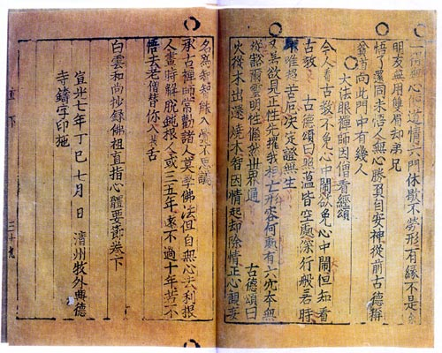

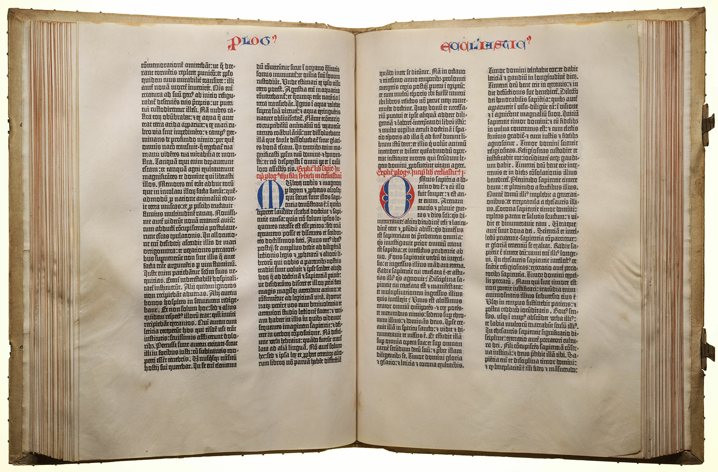

FORMATIVE ASSESSMENT

Short Answer Question

Explain one effect of printing technology on East Asian society.
Explain one effect of printing technology on Western European society.
Explain the relative importance of the printing of the Korean Jikji to the printing of the Gutenberg Bible.

One point for each correct and/or plausible answer.

RESOURCE LIST

Jikji. (2014, May 9). New World Encyclopedia. Retrieved September 8, 2019 from //www.newworldencyclopedia.org/p/index.php?title=Jikji&oldid=981402.

Johannes Gutenberg. (2018, May 12). New World Encyclopedia. Retrieved September 8, 2019 from //www.newworldencyclopedia.org/p/index.php?title=Johannes_Gutenberg&oldid=1011424.

Printing press. (2019, June 15). New World Encyclopedia. Retrieved September 8, 2019 from //www.newworldencyclopedia.org/p/index.php?title=Printing_press&oldid=1020762.

Voluntary Agency Network of Korea. (2009, March 22). The Greatest Invention, Jikji. Retrieved from https://www.youtube.com/watch?v=GVDsKRb9WPA.

MODIFICATIONS & EXTENSIONS (OPTIONAL)

For an Advanced Placement World History class, add the following optional extension questions:

Are the claims made in the video reliable? The video was produced by the Voluntary Agency Network of Korea, an advocacy group that is trying to raise the profile of Korea and Korean history. How does that sourcing information influence your thoughts on the point of view of the video’s claim? How does your thoughts on what makes a technological invention particularly important reflected in these claims.
Students read the following entry to understand the comparative influence of Asian and European printing.
https://www.newworldencyclopedia.org/entry/Printing_press

What does the use of Chinese and Latin demonstrate about the larger cultural context of both of these printed books?

