Overlapping and Competing Religions and Cultural Traditions in Korea

AUTHOR INFORMATION

Author: Evan Liddle
State: California

GENERAL INFORMATION

Lesson Grade Span: Secondary (9-12)
Targeted Grade Level/Course: World Culture/World Geography
Estimated Time to Complete Lesson: 2, 55-minute classes or 1, 90 minute class

FOCUSED QUESTION

How do religions and cultural traditions overlap or compete with one another?

STANDARDS (STATE/C3)

• D2.Soc.6.9-12. Identify the major components of culture.
• D2.Soc.7.9-12. Cite examples of how culture influences the individuals in it.

STUDENT & TARGET OUTCOMES

- Students will understand how religions and cultural traditions spread across space and time.
- Students will gain a more nuanced understanding of how people identify their religious affiliation.
- Students will be able to explain the religious situation in Korea today and compare it to their own experience in the U.S.

LESSON OVERVIEW

This lesson examines the overlap of major religious and cultural traditions in Korea. It invites students to consider the role of culture and religion in the lives of indivuals as well as the exclusivity of religious systems in Korea and East Asia. It also invites students to consider their own religions and cultural traditions and how they do or do not overlap. (In this lesson the term overlap is used, however teachers can also use the term “syncretism” when appropriate).

PROCEDURES

Day 1

Warm up: Ask students, based on geography and what they have already learned, what major religious traditions students think would be present in Korea.

Show students the Korean Flag, ask them if they see any religious symbols on the Flag
- Students might point out the Taijitu (yin-yang symbol). You can explain the Taegeuk, which also demonstrates harmony and balance, with the colors red (positive) and blue (negative) representing harmony
- Students might point out the “lines” in the corners. You can explain these are Trigrams, which in each corner represent an element, direction, season, and family position. This is another Daoist symbol.

By this time students should have made their predictions on which traditions are present

Have students use a sheet of paper for the next step.

Via either:
- A Gallery Walk (having students move around the room examining new materials)
- Group Circles (students study each new materials handed out by teachers)
- Since there are only 3 stations, double them up and divide the class into two major groups to rotate.
Introduce students to the major religious/cultural traditions of Korea via the pictures with the captions provided. Have them keep track of these on the sheet of paper.

Debrief with students
What surprised them?

Which group do they think has the highest number of adherents?

Show students the “OFFICIAL RELIGIOUS AFFILIATION IN SOUTH KOREA” and ask them to look at it and discuss with their groups/a partner.

Discuss as a class, possibly use the following:
Is Confucianism a religion? Is that why it isn’t on the survey?
Is there any religion that was not represented that they thought would be there?
Is every religion represented on this survey? Why might that be/not be?
Where are most of the major Religions in Korea from? Why might that be?

Day 2
Warm up: Ask students to quietly write and then discuss if it is possible to belong to more then one religion?
- Consider the information students learned yesterday.
- Consider the exclusivity of the Major Monotheistic Religions (Islam, Judaism, Christianity), which most students are familiar with.
- What might be the problem, belonging to more than one religion?

Tell students they are going to explore some of the overlap between the major faiths in Korea via images and writing.

Have students take notes on each image/excerpt individually for later discussion
- Teacher can project images if they need to or can’t make copies

When discussing the religious overlap:
- Ask students to identify the two religious traditions present in the image or the writing (how do they know?)
- Infer why this overlap exists.
- What the role each religion has played in Korea?
- How the beliefs of each religion might overlap on paper?
- Do any of these religions explicitly contradict one another?

Ask students to consider their own experiences and/or their own faith. Have them reflect and write briefly if they have ever encountered such religious overlap in the United States.
- Most likely students will say probably not, however some students might point out pagan influence in Christianity like Easter or Christmas.

As a class, or as an exit ticket, ask students to consider why it is that in Korea so many religious and cultural traditions overlap? Whereas in the United States, religious overlap is much rarer

ASSESSMENTS

Formative:

This lesson assumes students already have an introductory knowledge of major Asian Religious Traditions Buddhism, Shinto, Daoism, Confucian Values.

Students could be asked about those religious traditions to check for understanding before proceeding, as well as the geography of where the Korean Peninsula is within Asia.

Summative

Students should demonstrate they understand the WHAT (which religions) and WHY (the historical context, role in society, and interaction) of religious overlap in Korea. Demonstration could take several forms:
- Short written assessment, paragraph explaining overlap
- Research and oral presentation of another example of religious overlap in Korea for more advanced students
- For more visual learners a venn diagram of two religions followed by a few sentences explaining the overlap.

RESOURCE LIST

See handouts

MODIFICATIONS & EXTENSIONS (OPTIONAL)

MODIFICATIONS
Teachers can project images if needed

EXTENSIONS

Ask students to explore other examples of religious overlap/syncretism in future units.
Ask students to find more examples of overlap/syncretism in their own community and research this phenomenon.

All photos included in this document are free to use images or from the author’s personal collection, unless otherwise noted.

BUDDHISM

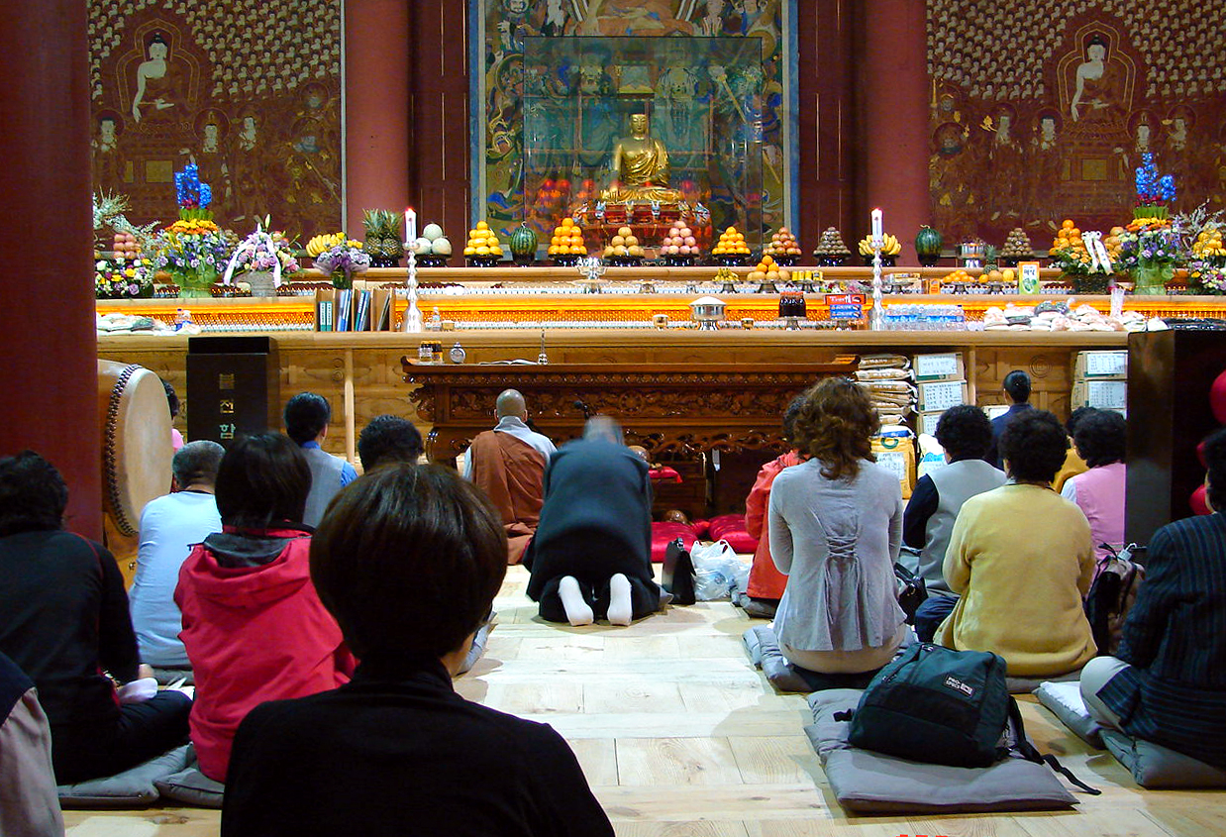

A photo of Korean Practicing Buddhism. The Temple Pictured here was built in 1395 and has been in continuous use.

Buddhism is a religion centered around the teachings of an Indian Prince name Siddartha Gautama. He believed in giving up desires and dedicating life to peaceful pursuits to achieve enlightenment. Buddhism came to Korea via China in the 8th century, and was at one point the state religion until the 1400s. Several uniquely Korean versions of Buddhism exist today.
Major symbols or images:
Large metal or wood statues of the Buddha
Swastika with prayer beads

KOREAN SHAMANISM

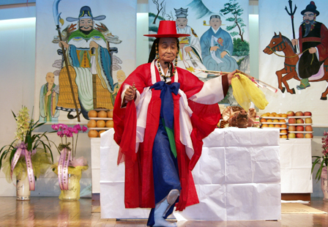
A Mudang, a traditional Korean Shamin, performs a Gut ritual to calm angry spirits

Korean Shamanism is a series of beliefs that have existed in Korea for around 3000 years. Shamanism revolves around a number of local gods who are often associated with Nature and Geography. Connecting humans to these gods are the mudang, who perform rituals, usually with elaborate ceremonies and attire

Major Symbols or Images:
Man Made Rock Piles (Cairn) which symbolize the Mountain Spirit (San-Shin)
Bent Swastikas known as Manjas

CHRISTIANITY

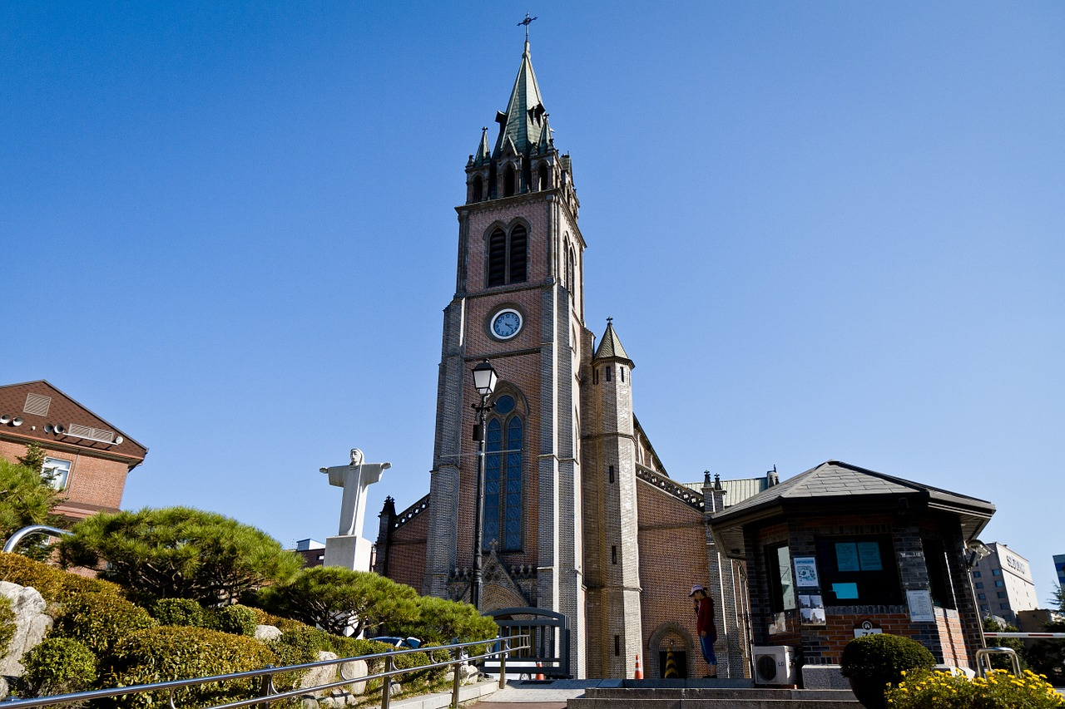
Catholic (Christian) Cathedral at Myeongdong, constructed in 1892, and the headquarters of the Catholic Church in Korea

Christianity refers to the teachings of Jesus of Nazareth a man who lived in what is now the Middle East, and was developed in Europe. Christianity believes in a single God and single Savior. Christianity first came to Korea in the 1500s from Japanese soldiers who invaded Korea seeking to occupy it.

Major Symbols:
The Christian Cross
Pictures of Jesus of Nazareth

CONFUCIANISM

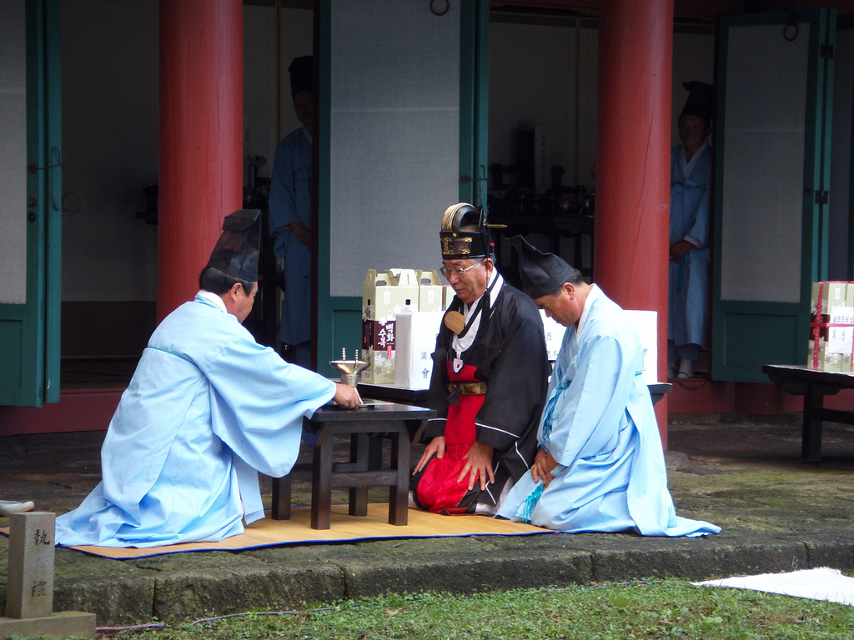
A Korean Confucian Ritual in which offerings of food are presented and burned for the spirits of the deceased.

Confucianism refers to a belief of a series of rites and rituals first laid down by a Chinese Master called Fuzi, known in English as Confucius. These values center on family and proper relationships in society, respect for elders and respect for long passed family members, which includes offerings of food and money to the spirits of the deceased. Confucianism was the state religion in Korea from the mid 1400s until the 20th century.

Major symbols and images:
Images of Confucius
The Yinyang Symbol

OFFICIAL RELIGIOUS AFFILIATION IN SOUTH KOREA

Religion | Christianity | Buddhism | Not Religious | Other
Percentage of the Population that claim to belong to that religion (as of 2015) | 28% | 16% | 56% | >1%
[Population by Gender, Age, and Religion - City/Country]. Korean Statistical Information Service (in Korean). 2015.

Day 2

Document 1
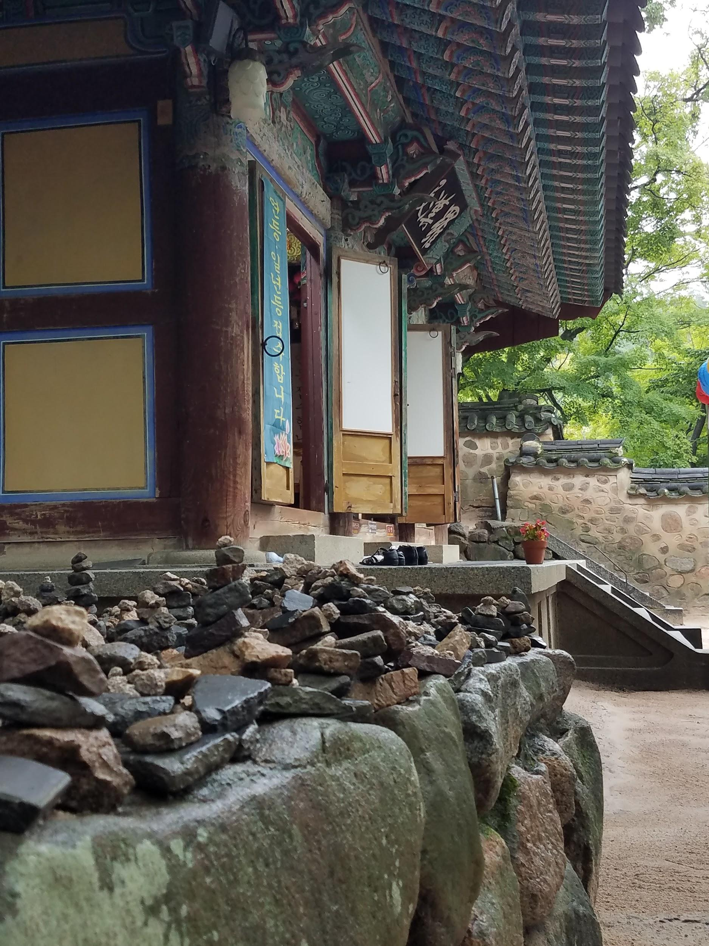
The stone piles represent wishes or desires to please the Sanshin, this photo is located just outside of the Bulguska Buddhist Temple in southern South Korea

Document 2

To Confucists who embrace the ruling philosophy, only the death of a male adult matters.To be more specific, they only counted the death of men that left at least one male descendant to be real.
Imagine someone who lost their child to premature death. by the Confucian code of ethics, it is inconceivable that the living parent would prepare a Jesa (a Confucian memorial to the ancestors of individuals) For the dead child. What is totally inconceivable in the Confucian system however was and is possible in a Gut (a Shaman ritual to calm angry spirits).

Choi Joon-sik Folk Religions, The Customs in Korea, The Social Function of the Gut

Document 3

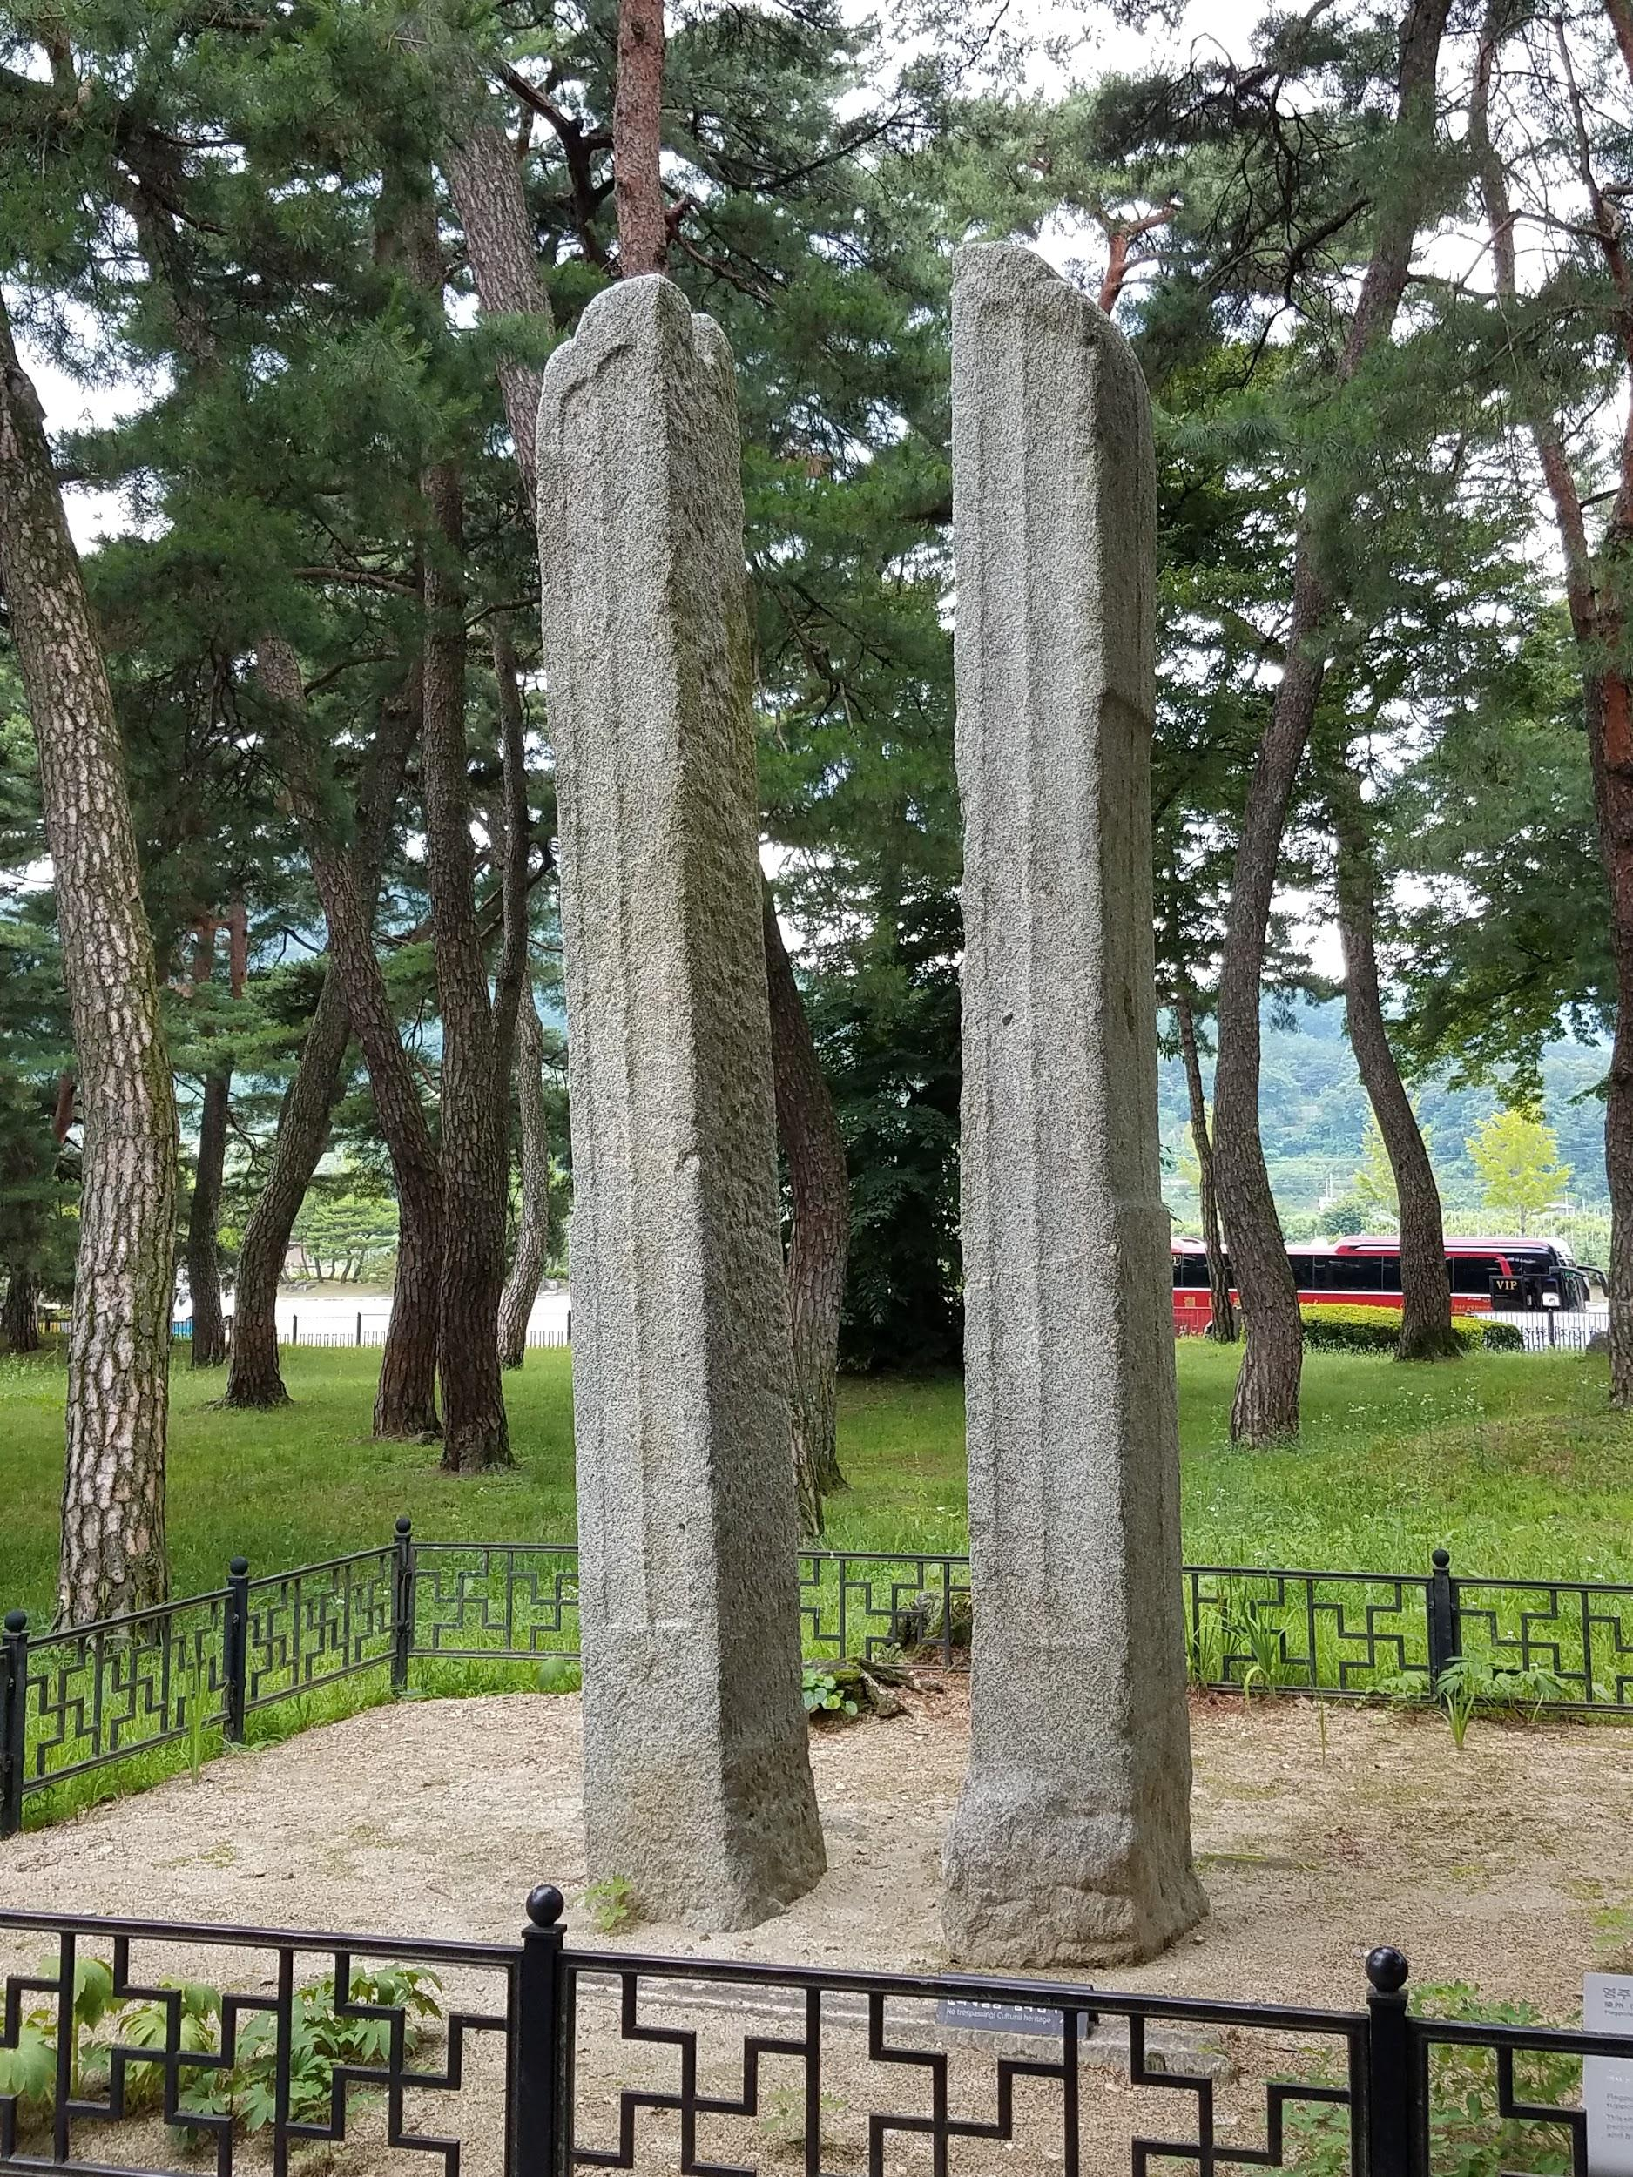
A picture of a set of flagpoles used during Buddhist Ceremonies (danggan jiju). These particular flagpoles were excavated outside of a Confucian Academy in southern South Korea

