Schools Around the World
Focused Inquiry K-2

AUTHOR INFORMATION

Author: Elaine Alvey
State: Georgia

GENERAL INFORMATION

Lesson Grade Span: K-3
Targeted Grade Level/Course: Elementary Social Studies
Estimated Time to Complete Lesson: 1, 40 minute class period (optional extension activity for second 40 minute class period)

FOCUSED QUESTION

How is school different for children around the world?

STANDARDS (STATE/C3)

- D 4.1. K-2 Construct an argument with reasons.
- SSKG2 Explain that a map is a drawing of a place and a globe is a model of Earth.
- Georgia State Social Studies Information Processing skills: Compare and contrast; analyze documents

STUDENT & TARGET OUTCOMES

- Students will be able to identify South Korea on a world map
- Students will be able to build an argument regarding the differences of school for elementary children around the world by comparing and contrasting experiences and analyzing documents
- (Extension) Students will be able to develop appropriate topical questions to ask peers who students at the Peace School, located in the Korean DMZ zone, in order to craft pen pal letters.

LESSON OVERVIEW

This inquiry leads students through an investigation of schools around the world, using a case study of elementary schools in South Korea. Students investigate the compelling question “How is school different around the world?” by evaluating images, videos and infographics about schools in a different part of the world. The formative performance tasks build on knowledge and skills through the course of the inquiry and help students see similarities and differences between their own lives and those of children living around the world. Students create an evidence-based argument about the ways in which schools are similar and different between cultures and geography.

It is important to note that this inquiry requires only introductory prerequisite knowledge of ideas and is designed to be accessible to students without previous study on these topics.
Note: This inquiry is expected to take one 40-minute class period. The inquiry time frame could expand if teachers think their students need additional instructional experiences (i.e., supporting questions, formative performance tasks, and featured sources).

Structure of the Inquiry
In addressing the compelling question “How is school different for children around the world?” students work through a supporting question, formative performance task, and featured sources in order to construct an argument supported by evidence while acknowledging competing perspectives.

Staging the Compelling Question
In staging the compelling question, “How is school different for children around the world?” teachers may prompt students with the presentation of the video clip with images from schools around the world and the video clip of children explaining why school is important to them. Teachers may also introduce the UN’s universal declaration of the rights of children. This can be used as an opportunity to discuss the rights of children and identify access to education and schooling as a central right, that not all children have access to.
This discussion can be followed with an introduction of the South Korean case study which will inform the remainder of the inquiry. Students can work to identify the Korean Peninsula on a map in order to build background knowledge and connection.
Supporting Question 1
The first supporting question—How is school similar and different for children in the United States and South Korea? —has students work with the images and video clips to create a Venn Diagram of the differences in elementary school between the two countries. The formative performance task asks students to ground the Venn Diagram in the evidence provided in the featured sources. The featured sources for this question are each related to the experiences of children in schools. Featured Source A is a video tour of an elementary school in South Korea paired with a set of images from South Korean public schools. Featured Source B is a set of photos of school lunches, so that students can identify seminaries and differences. Featured Source C is an infographic related to the school day and year length that students in South Korea experience (These are introductory statistics and presented visually, but young students may need scaffolding to make meaning of these statistics).

PROCEDURES

- Students should be introduced to the question driving the inquiry
- Students will be introduced to the case study used in this inquiry and should find Korea on a world map
- Class will watch introduction video
- Students will then analyze the documents provided in sources A, B, & C as they work to craft an argument about the differences between schools in different parts of the world
- (Extension) students will then have the opportunity to develop questions and pen pal letters to primary students at the Daesungdong Elementary School, located in Taesung Freedom Village, along the DMZ. Students will be introduced to this task using the current events stories below about this special school.
FORMATIVE ASSESSMENT

At this point in the inquiry, students have examined the school building, day, subjects, lunches and schedules of schools in South Korea. Students will have also drawn on their own experiences in order to create a Venn diagram comparing the two sets of school related experiences.

Students should be expected to demonstrate the breadth of their understandings and their abilities to use evidence from multiple sources to support their claims. In this task, students construct an evidence-based argument using multiple sources to answer the compelling question How is school different around the world? It is important to note that students’ arguments could take a variety of forms, including a detailed outline, poster, or essay.
Students’ arguments will likely vary, but could include any of the following:
- In other parts of the world, students have to wear uniforms to school.
- Classrooms around the world look mostly similar- they have tables and chairs
- Children learn similar subjects
- Children in other parts of the world have bigger/smaller classes
- The school day is longer and the school year is longer in most other countries
- School is important in most countries around the world
- The food is different/similar in these ways…
To extend their arguments, teachers may have students conduct research on the educational systems and experiences of children in other countries. Some resources appropriate for young learners can be found at the United Nations (UNICEF) children’s page.
Students have the opportunity to Take Informed Action by drawing on their understandings of schools around the world. To understand, students can learn about how many children don’t have access to education around the world. To assess the issue, students watch a video clip from the UNICEF collection and see conditions for students and teachers around the world. To act, students talk to their peers about the importance of school and education, they might choose to extend this communication to by creating a poster for the classroom or school hallway.

RESOURCE LIST

Staging the Compelling Question
Featured Source | Source A: Video of School Children Around the World

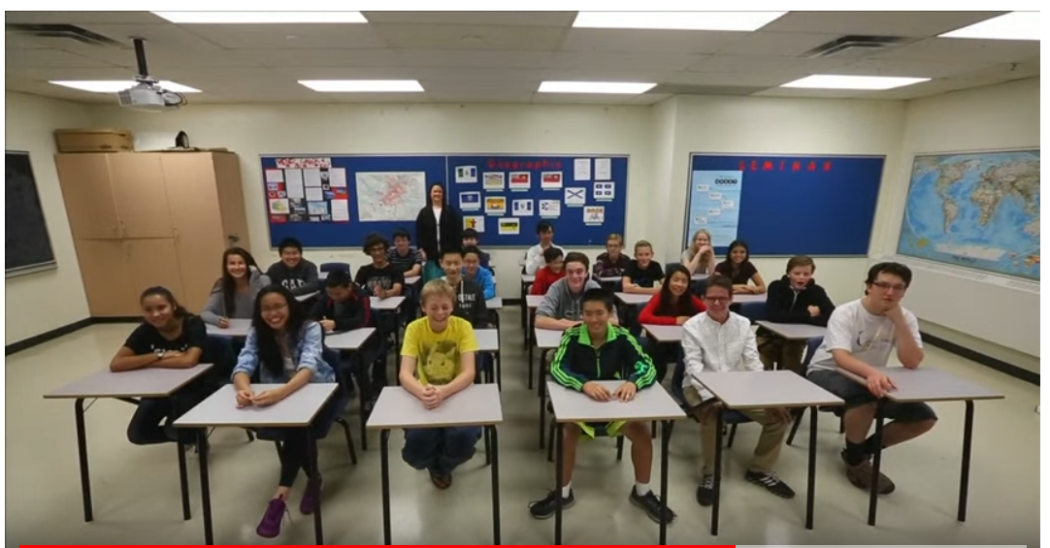

Retrieved from: https://www.youtube.com/watch?v=at2gAjtsgtk

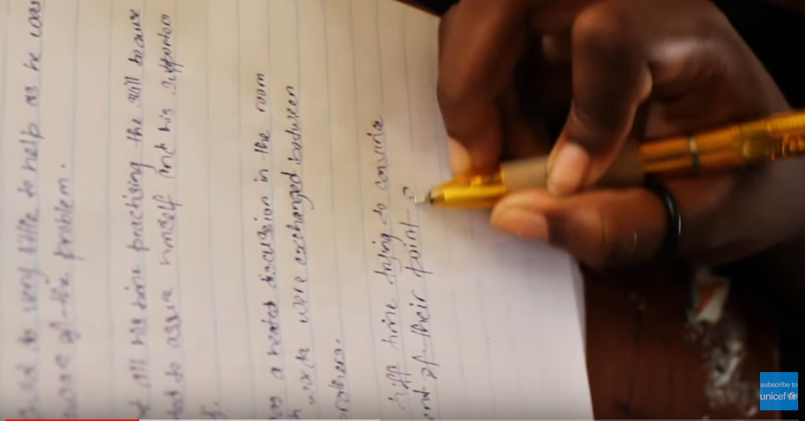
Retrieved from: https://www.youtube.com/watch?v=Un5msddQl6U
Featured Source | Source B: Children’s Universal Rights from United Nations

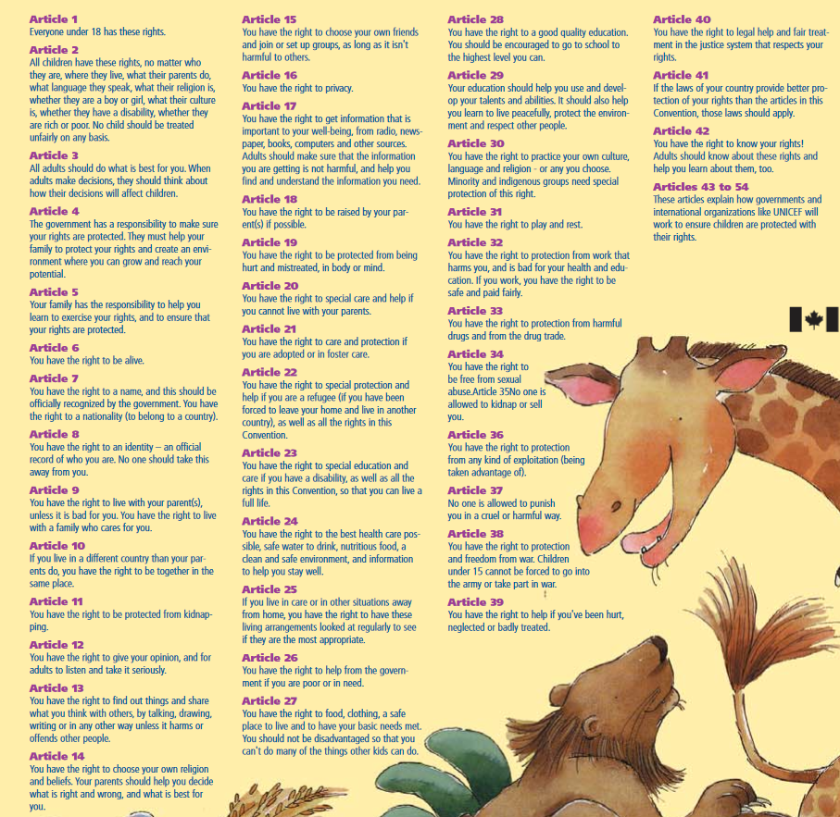

Retrieved from: https://www.unicef.org/rightsite/files/uncrcchilldfriendlylanguage.pdf

Supporting Question 1
Featured Source | Source A: Document set of schools in South Korea

Video Tour of South Korean Public Elementary School

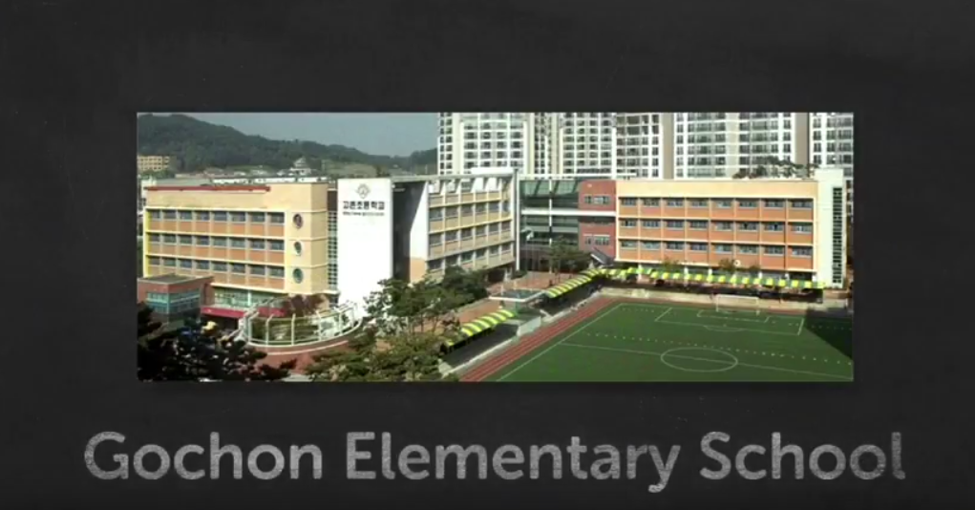

Retrieved from: https://www.youtube.com/watch?v=MNhiRpsTKfs

Photos of South Korean Elementary Schools:

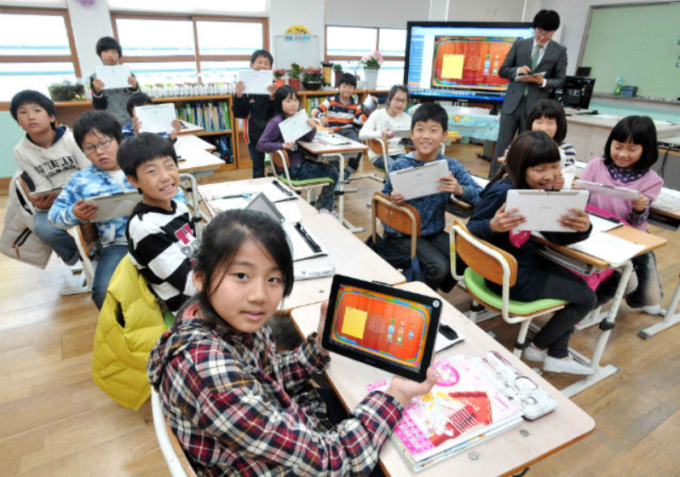
Retrieved from: http://www.koogle.tv/media/news/over-40-of-south-korean-youth-strive-to-become-athletes-artists-entertainer-or-tv-professionals/

Featured Source | Source B: School Lunches in South Korea

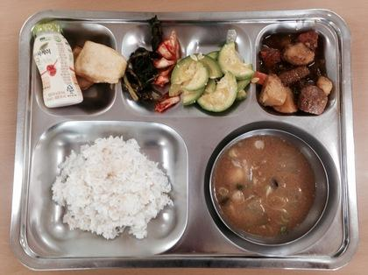
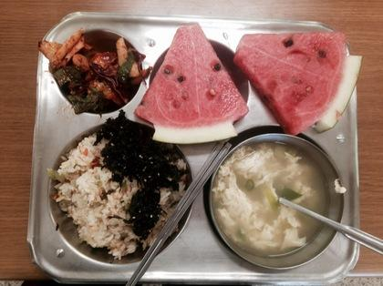
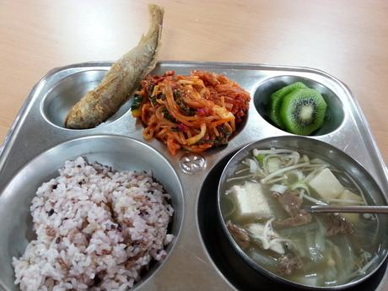

School Lunch Photos Retrieved from: https://www.huffingtonpost.com/natasha-gabrielle/school-lunches-in-south-k_b_9449058.html

Featured Source | Source C: Statistics about School in South Korea
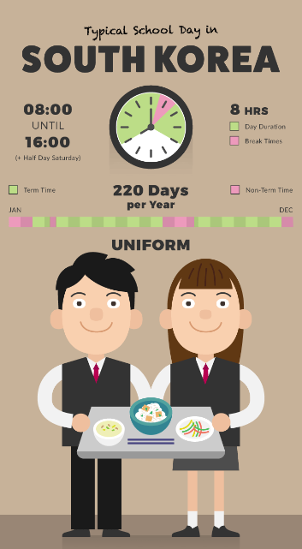

Excerpted From: https://www.shoezone.com/Blog/wp-content/uploads/South-Korea.png

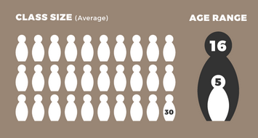
Average Class Size in South Korean Elementary School:

Average class size in United States Elementary School:
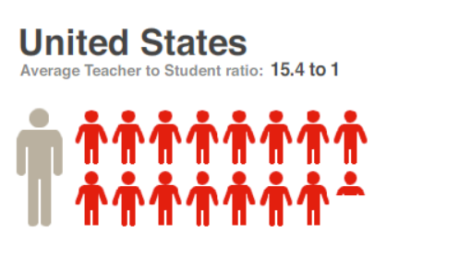

Source: National Education Association (NEA) Rankings and Estimates 2006–07. Figures refer to the ratio between students and all full-time, credentialed teaching staff in a school during the 2006-2007 school year. This is the most recent year for which figures are available.

MODIFICATIONS & EXTENSIONS (OPTIONAL)

EXTENSIONS

Is there any way the overall purpose of your lesson can have an impact as part of a larger school or community function?

- Students will then have the opportunity to develop questions and pen pal letters to primary students at the Daesungdong Elementary School, located in Taesung Freedom Village, along the DMZ. Students will be introduced to this task using the following resources.
- Resources for Extension:

https://widerimage.reuters.com/story/learning-english-in-freedom-village

https://www.army.mil/article/26848/security_battalion_soldiers_freedom_village_students_attend_baseball_game

