COntextualization MODULE OVERVIEW
SKILL: contextualization | CONTENT: AP world c.f. Key Concept 6.3
This module focuses on contextualization through an examination of South and North Korea. The two activities lead toward a document-based question (DBQ) that has students evaluate the extent to which the Cold War affected economic and technological development. | After the Korean War (1950-1953), the role of the state in the domestic economy varied, and new institutions of global associations emerged and continued to develop throughout the twentieth century.

D A Y 1 | To what extent is South Korea a manufacturing or information economy?

CLASS ACTIVITY: Box Protocol Mystery Source Analysis
Students work collaboratively to better understand the current context surrounding South Korean economic development. Students will examine secondary sources to develop an understanding of South Korea’s economic and technological developments in comparison to other states.

AP-ALIGNED ASSESSMENT: Long Essay Question
Long Essay Question—Thesis and Contextualization: Students will evaluate the extent to which the AP Course Framework, specifically Key Concept 6.3 IE, accurately explains Korean historical developments in the twentieth and twenty-first centuries.

D A Y 2 | How are North and South Korea impacted by the Cold War, economic liberalization, and Information Age technological developments?

CLASS ACTIVITY: Paired Sources about North and South Korea
Students work collaboratively to investigate the impact of the Cold War, economic liberalization, and the Information Age on North and South Korea. Students will read paired sources, one on North Korea and one on South Korea, to compare the responses of each to the three twentieth- and twenty-first-century historical developments.

AP-ALIGNED ASSESSMENT: Short Answer Questions
Short Answer Question(s): Students will answer questions about how the Cold War, economic liberalization, and the Information Age affected North and South Korea, and how the countries responded to each historical development.

D A Y 3 | CLASS ACTIVITY: Teaching the Document-Based Question  Students can write (and/or peer grade) an AP-aligned DBQ. A set of annotated Scoring Guidelines are provided for the teacher and/or student to use in assessing student work and offering feedback.

AP-ALIGNED ASSESSMENT: Document-Based Question
Document-Based Question: Evaluate the extent to which the Cold War affected economic and technological development.

COntextualization MODULE sources

D A Y 1 | AUTHOR SOURCE DATE  - KWLF Chaebols 2017  - Ahn Choong-yong Excerpt from Korea: Rags to Riches 2012  - KWLF Article on South Korean industry 2018  - KWLF Article on South Korean technological innovations 2018  - KWLF Article on South Korean technology and culture 2018  - KWLF Article on South Korean national image index 2018

D A Y 2 | AUTHOR SOURCE DATE  - Kim Il-sung Speech on North Korean economic development 1955  - Syngman Rhee Letter to President Eisenhower 1953  - Kim Il-sung Speech to the Communist Party 1956  - Edward Graham Excerpt from Reforming Korea’s Industrial Conglomerates 2003  - KWLF Article on North Korean nuclear program 2017  - Kim Dae-jung Speech: Presidential Inaugural Address 1998  - Gov’t. of North Korea Official statement on government website 2018  - T. Karako & W. Rumbaugh Graph: North Korean Nuclear Missiles 2017  - Gov’t of South Korea Chart: South Korean Internet Usage 2004

D A Y 3 | AUTHOR SOURCE DATE  - Wang Liuying et al. Propaganda poster on economic advances 1958  - Dwight Eisenhower Speech on the military-industrial complex 1961  - William Fulbright Speech on US foreign policy 1965  - CIA Intelligence Report on Ghana 1971  - CIA Intelligence Report on North and South Korea 1972  - Mikhail Gorbachev Notes from a Politburo meeting 1988  - US State Department Charts: North and South Korea Military Spending 2017

D A Y 1
Based on a 60-minute class

Lesson Question: To what extent is South Korea a manufacturing or information economy?

AP curriculum Framework reference
Key Concept 6.3—The role of the state in the domestic economy varied, and new institutions of global association emerged and continued to develop throughout the twentieth century.
E. In the late twentieth century, revolutions in information and communications technology led to the growth of knowledge economies in some regions, while industrial production and manufacturing were increasingly situated in developing economies including the Pacific Rim and Latin America.

Historical Reasoning Skill: Contextualization

OVERVIEW
Students will explore economic developments in South Korea through a structured source analysis of common and paired readings, referred to as the Box Protocol. This activity is designed to help students practice their source-analysis skills and deepen their understanding of the contextualization behind South Korea’s economic development after the Korean War and into the twenty-first century. This task is designed for students with little to no understanding of the Information Age and economic liberalization trends in the post-World War II era. Students will need prior knowledge of basic economic concepts like gross domestic product (GDP) and conglomerates to access the homework and opening stages of the activity. Students should finish the activity with a greater understanding of the role technology played in South Korea’s economic development and greater insight into unique economic strategies used by South Korea to improve its economic standing in the second half of the twentieth century.

Materials needed:
- Butcher paper or its equivalent (chart paper, extra-large sticky notes)
- Markers or colored pencils

Materials needed for:
Homework
- Chaebol Chart (p. 15)

In-Class Activity
- Box Protocol for Sources Analysis Presentation (p. 16)
- General Instructions on Box Protocol Technique (pp. 5-12)
- Common Reading: Chaebol Transformed Industry (pp. 17-18)
- Jigsaw Readings (pp. 19-27)
- #1 - South Korea Seeks to Reinvent Itself Yet Again (pp. 19-20)
- #2 - Advice from Bloomberg and the South Korean Example (pp. 21-22)
- #3 - South Korea: The Nation That Might Surprise You (pp. 23-24)
- #4 - Korea Seen as Technology Winner (p. 25-27)

SEQUENCE OF INSTRUCTION

HOMEWORK OVERVIEW
HOMEWORK— CLASS PREPARATION—CHAEBOL CHART (10 MINUTES):
Students will examine the Chaebol Chart (p. 15) at home before class.
The purpose of the homework is to
- familiarize students with the concept of the chaebol.
- prepare students to identify features of advanced economies of the twentieth and twenty-first centuries.

Teacher Notes
Students will need to know the meaning of the terms GDP and conglomerate. The teacher may need to define each.
Gross Domestic Product (GDP) is the total value of goods produced and services provided in a country during one year. It is one of the best tools for analyzing a country’s economy as increases year to year show growth while decreases show economic decline.
A conglomerate is a large corporation involved in multiple industries that are often seemingly unrelated, such as automobile manufacturing and food processing.

CLASS ACTIVITY 1 OF 6: WARM UP/INTRODUCTION
WARM UP/INTRODUCTION (5 MINUTES):
Students will analyze the pre-assigned chart for evidence to answer the following question:
To what extent is the economy in South Korea a manufacturing or information economy?

Teacher Notes
Before discussing the Chaebol Chart, write the question (above) on the board or project for students to discuss.

Teaching Tip
If students are not familiar with the difference between a manufacturing and an information economy, ask them to compare the economies of the early Industrial Revolution to the economies of present-day Silicon Valley.

Teaching Tip
The intent of this quick analysis is to familiarize students with a unique Korean economic innovation, the chaebol, by having them note that the chaebols engage in various economic activities, related to both manufacturing and information technology.

CLASS ACTIVITY 2 OF 6: BOX PROTOCOL
SETUP AND MYSTERY SOURCE (10 MINUTES):

1. setup
The Box Protocol activity structures student investigation of sources. Each investigation is divided into rounds based on specific sources. There are four rounds to the activity. The Box Protocol for Sources Analysis Presentation begins with a visual of the four rounds or boxes.

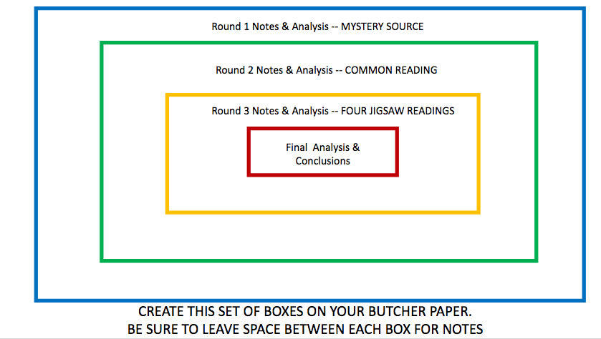
Teachers will divide students into groups of four students and give each group markers and a large piece of butcher paper, chart paper, or the like. Students will complete four rounds by filling in four concentric boxes on the large display paper as they move through the lesson. The spaces around each box serve as group note-taking space for the source analysis in each round.

2. MYSTERY SOURCE
After students have the protocol set up, ask each group to look at the Mystery Source. Have each group answer the two probing questions on the Round 1 Mystery Source slide of the presentation. Students will write their answers in the outermost (Round 1) box space on the butcher paper.
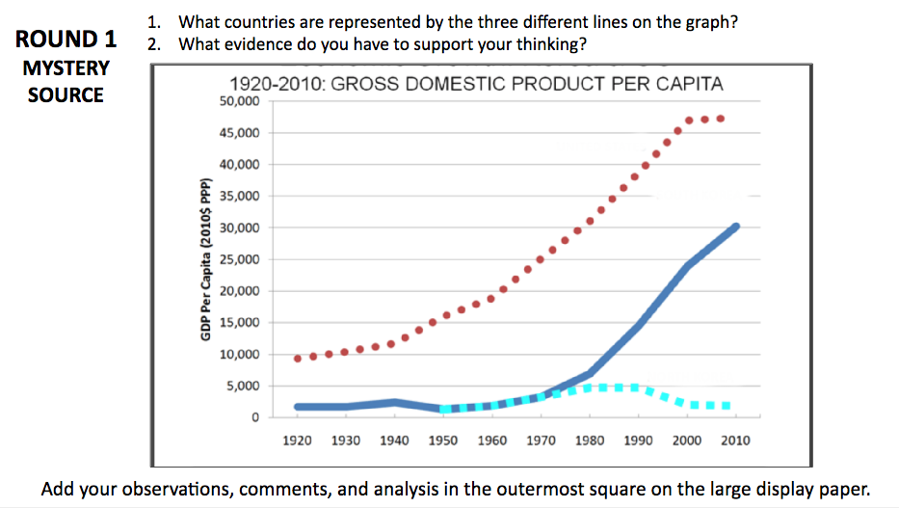
As the directions on the slide state, students should record their observations in the outermost square.

Teacher Notes
There is no right answer in this stage. Students will naturally seek to put South Korea somewhere on the graph. The other two countries are not consequential at this point.

Teaching Tip
If students have trouble at this stage, point them toward observing general trends shown on the graph and have them speculate about the different global developments in each decade that might influence the trends they see.

CLASS ACTIVITY PART 3 OF 6: BOX PROTOCOL
COMMON READING "CHAEBOL TRANSFORMED INDUSTRY" (20 MINUTES):

COMMON READING
Working individually, students will read the common reading “Chaebol Transformed Industry” (pp. 17-18). When all students have completed the reading, have them record information in the Round 2 area of the Box Protocol (instructions pictured on slide below). As the instructions note, students can record information that helps to clarify the first document (the Round 1 Mystery Source [GDP chart]), or information related to the lesson question for the day (“To what extent is the economy in South Korea a manufacturing or information economy?”), or they can record new information they find interesting or possibly relevant to the general topic of the day.
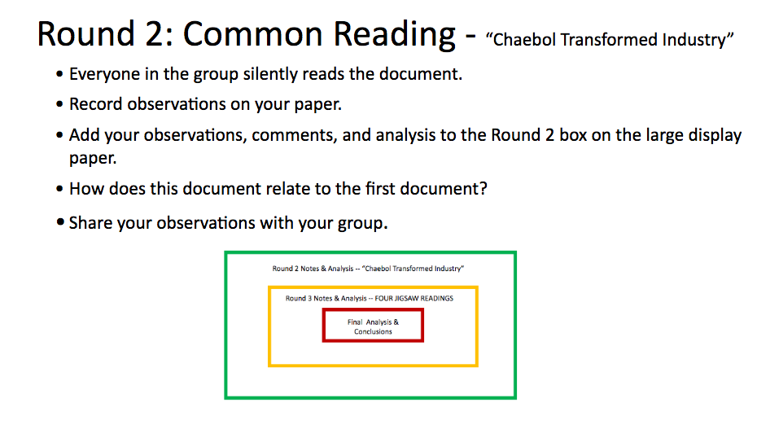

When student groups have finished recording their observations, project the Mystery Source again (shown in next slide) and have students discuss the two focus questions.
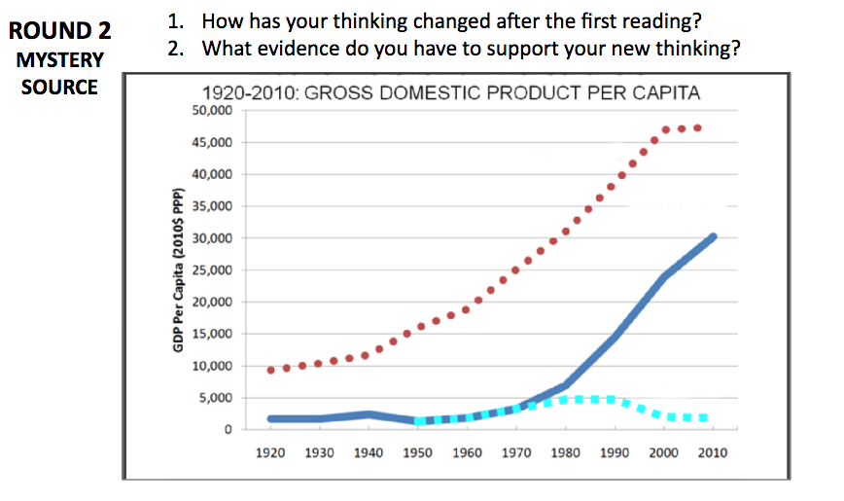

Teacher Notes
Students will likely need guidance regarding what type of information is appropriate to record on the Box Protocol. Guide them toward information that (a) clarifies the mystery document, (b) relates to the lesson question, or (c) comes from context clues, and seems to be relevant to the general discussion of the topics of the day so far: the chaebol, manufacturing economies, Information Age economies, conglomerates, GDP, etc.

Teaching Tip
This is the longest single reading of the activity, so it may take students some time. Though students need sufficient time to finish the reading, keep them focused on finishing and recording information. If this takes longer than the projected 20 minutes, the final stage and important learning will be missed.

CLASS ACTIVITY PART 4 OF 6: BOX PROTOCOL
JIGSAW READING (15 MINUTES):

1. JIGSAW READINGS
Students will complete one of four different readings in their small groups. Each reading provides new information about the technological and economic development of South Korea in the context of the global economic developments in the late twentieth and early twenty-first centuries. Because each student will be the only member in his or her group to read the article, help students focus by stressing that each student will be an expert on one article. As students finish their individual readings, they need to record observations on the Box Protocol for Round 3. After capturing their thoughts on the display paper, students will discuss what they discovered, as well.

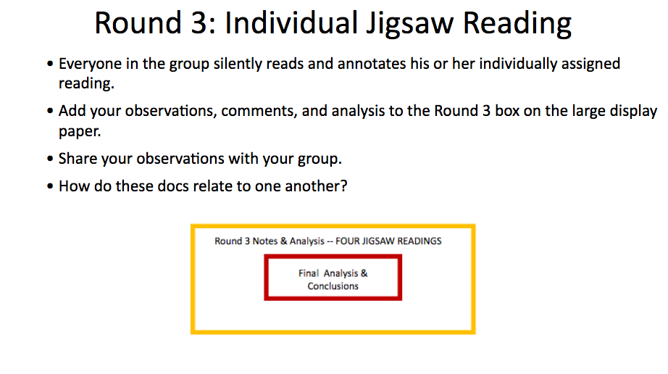

2. MYSTERY SOURCE
Once all group members have recorded and shared their observations, have students reconsider the mystery document and discuss the lesson questions on the slide (pictured below).
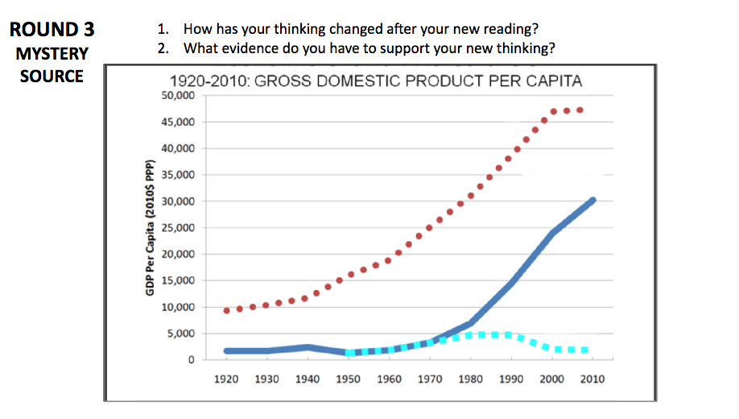

Teacher Notes
As in Round 2, students will need some guidance on the type of information to record. Teachers can guide students toward economic and technological information that is relevant to the discussion of economic development.

Teaching Tip
As this round involves students sharing information about documents that only individual students have read, the discussion of sources is important. Teachers (and students) will need to monitor the time allowed for such discussion to ensure it doesn’t interfere with moving forward into the concluding activities.

Teaching Tip
Teachers should consider implementing a class protocol or system so that each group member has equal time to share about each article. Leaving time for group reaction and connections between the articles is helpful. Encourage groups that finish early to make a list of similarities and points of connection between the articles.

Teaching Tip
The fourth reading is substantially shorter than the other three; consider assigning this reading to students who need extra time to complete reading and analysis. The fourth reading also includes some extension questions for students to consider, which helps make up for its shorter length.

CLASS ACTIVITY PART 5 OF 6: FINAL ANALYSIS & MYSTERY SOURCE REVEALED
FINAL ANALYSIS & MYSTERY SOURCE REVEALED (10 MINUTES):

1. MYSTERY SOURCE REVEAL
After Round 3 is concluded, reveal the mystery source with each line of the graph labeled. Teachers will ask students the following questions, which may also be posted for students to view.
- Was your prediction accurate?
- Which observations or pieces of evidence from the sources were most critical in guiding you toward the appropriate labels?
- What information or evidence is still missing that would have helped clarify the mystery source?

Teaching Tip
Teachers can use their discretion as to when to reveal the mystery source. This is a logical and thoughtful time in the lesson, but teachers may wish to reveal the mystery source earlier, depending on the conversation and development of the class. Teachers should use their insights and unique knowledge of the class, especially in a lesson such as this.

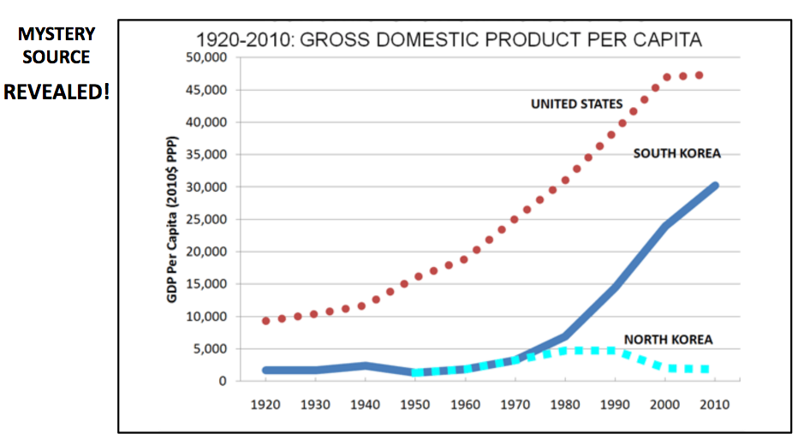

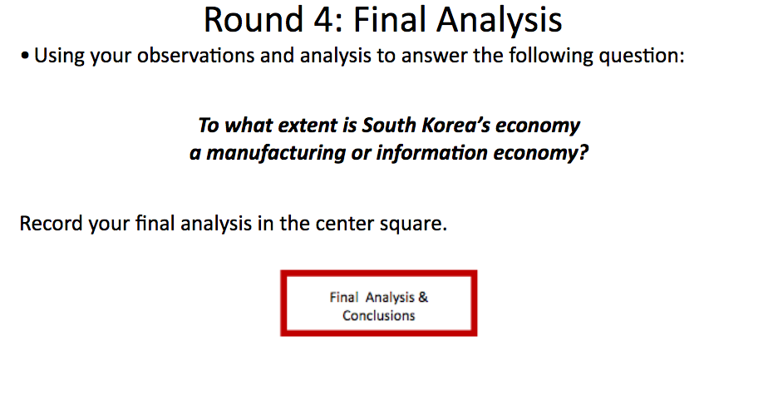

2. CENTER SQUARE
Lastly, have students complete Round Four in the center square as the slide above shows. Then have all groups share their center squares (final analyses) with the class.

3. WIDER CONTEXT (optional)
To help students contextualize the magnitude of changes South Korea’s economy has undergone in becoming a manufacturing and/or information economy, have students examine photographs from preindustrial Korea. Images can be accessed as a slide presentation here or from the website 20 color photos from the early 20th century (https://asiasociety.org/blog/asia/20-colorized-photos-early-20th-century-korea). Eleven such images are pictured in the collage below.
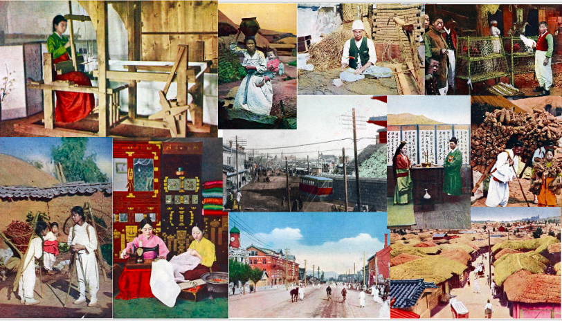

Teacher Notes
Teachers should have students complete this step using complete sentences, as if they were responding to an AP-style Short Answer Question (SAQ). Challenge students to think more broadly about the Korean context and motivation(s) for change before the advances they’ve read about in this unit. Emphasize the agricultural and pre-industrial character of the country before 1950 (or, arguably, before 1970) by encouraging brief discussions of the color photos.

CLASS ACTIVITY 6 OF 6: ASSESSMENT/CHECK FOR UNDERSTANDING

TYPE OF ASSESSMENT – EXIT TICKET
Students will write a brief response to the following prompt, either before they leave or for homework:
Based on your new learning, to what extent does the following statement accurately explain Korean historical developments in the twentieth and twenty-first century?
In the late twentieth century, revolutions in information and communications technology led to the growth of knowledge economies in some regions, while industrial production and manufacturing were increasingly situated in developing economies including the Pacific Rim and Latin America.

Teacher Notes
The goal is to have students apply what they learned today to the larger AP Key Concept 6.3. This key concept is complex and will require some discussion to ensure students understand the inherent differences implied by the College Board’s division between knowledge economies and manufacturing economies. Ask students to consider if the College Board insertion of “the Pacific Rim” implies that Korea should be considered a manufacturing and not a knowledge economy. This exercise does not have to be a formal answer like an SAQ, although—if time allows—teachers may choose to have students respond in one of the formats that requires an assertion or claim substantiated with evidence and explanation and commentary. Students may also need clarification of the Pacific Rim as a geographic region.

HOMEWORK MATERIALS

CHAEBOL CHART

Chaebols
Chaebol (plural chaebols) comes from the combination of the Korean words for wealth and clan. A chaebol is a large group of interconnected companies typically dominated by a wealthy family. These conglomerates simultaneously manage multiple, diverse product lines and services, such as automobile production, hotel management, and retail chains, with leadership positions generally held by relatives of the chairman.
History  Businesses run by families go as far back as the Joseon Dynasty. Samsung and LG were also established over 100 years ago.  Chaebols became popular after the Korean War with the rise of General Park Chung-hee (1963).  Government officials funneled relief money in the form of cheap loans to businesses that agreed to help rebuild the economy.  Example: Hyundai built the Gyeonbhu Expressway in just 2.5 years, and built a shipyard before building ships. | Products/Services  Electronics  Appliances  Engineering  Construction  Shipbuilding  Insurance  Credit Cards | Positives  Chaebols allowed for rapid development.  Conglomerates were expected to meet quotas to maintain their government connections.  GDP per capita, 1953: $67  GDP per capita, 1996: $10,315  Negatives  Lack of competition.  Chaebols held nearly two-thirds of market share by the 1990s.
Top Chaebols
Samsung
LG
Hyundai
Hanjin
Kumho
Lotte
SK Group
Newly Opened Highway in Seoul in 1970 Photo credit: Peter Solstad as part of the Korean War Veterans Digital Memorial (http://www.kwvdm.org)

Based on Carlos Tejada, “Money, Power, and Family,” The New York Times, February 17, 2017, https://www.nytimes.com/2017/02/17/business/south-korea-chaebol-samsung.html.

IN-CLASS ACTIVITY MATERIALS

box protocol for source analysis
Box Protocol for Source Analysis (complete presentation with slide-by-slide instructions linked)

MYSTERY SOURCE
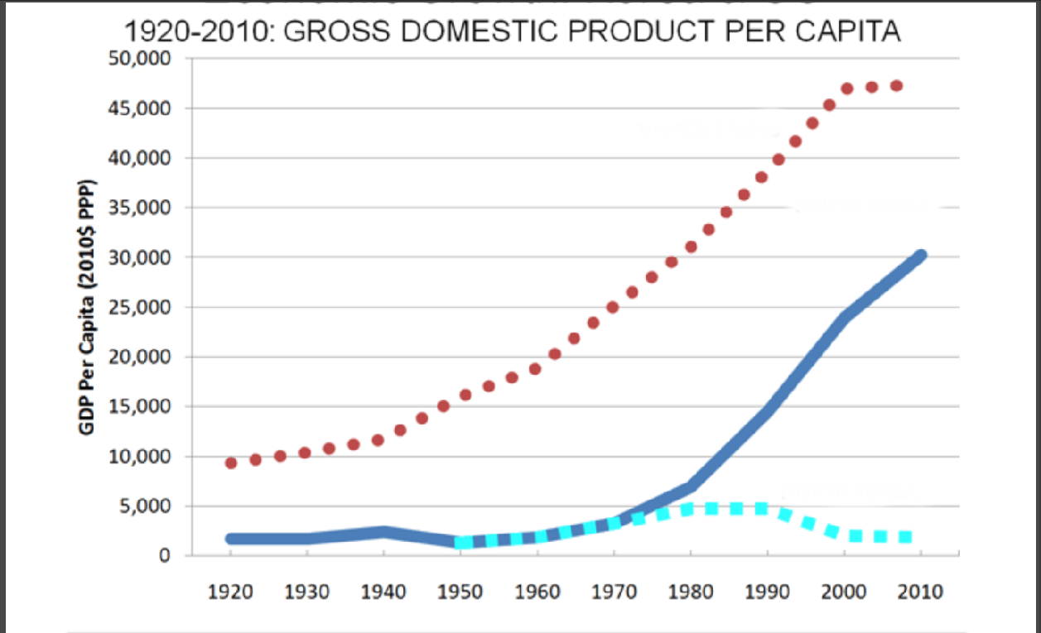

COMMON READING
Ahn Choong-yong. “Chaebol Transformed Industry.” In Korea from Rags to Riches 1950-2010: 60 Great Stories of Korean Miracles, edited by Park Eung-kyuk and Park Chang-seok, 252-260. Seoul, Korea: The Korea Institute of Public Administration, 2012.

South Korea’s industrial conglomerates, which operate many business lines simultaneously and are often controlled by a single owner or family and commonly known as “chaebol,” have been the most important driving force behind Korea’s modern “compressed” growth and industrial transformation. It is widely agreed that Korea’s modern economic development has occurred within a unique paradigm of an export-based, but government- and chaebol-led industrialization strategy with varying degrees of government intervention. Over time, the respective role of chaebol and their relationship with the government have constantly evolved to adjust to the changing international and domestic environment toward performance-based criteria.
In the past half century or so, Korea has emerged from being one of the poorest agrarian economies in the world to being a near-developed country, joining the OECD in 1996. Thanks to grants and foreign aid received during the post-Korean War period, particularly from the United States, Korea was able to escape from the poverty trap. In 1965, the per capita incomes of North Korea and the Philippines were three times that of Korea. Korea suffered from a paucity of mineral resources. For any attempt at industrialization, Korea had to import a variety of mineral resources such as oil, iron ore, copper, gold and silver. At present, however, Korea enjoys a per capita income of around $20,000, produces a number of global champion products, and represents the first example of a country evolving from an aid recipient to an aid provider.
At the outset of the birth of Korea’s modern economy initiated in its first five-year economic development plan (1962-1967), Korea adopted an export-oriented development model to take maximum advantage of almost “unlimited but educated labor forces” while providing various “carrots and sticks” in the forms of incentives and disincentives by the government and relying on foreign borrowing to finance massive capital requirements.
In the 1960s, Korea’s major exports were labor-intensive products such as wigs, plywood, footwear and low-quality clothing and apparel. At present, however, Korea has become a major exporter of semiconductors, iron and steel, ships, automobiles, electronics and electrical appliances with world-renowned brand names.
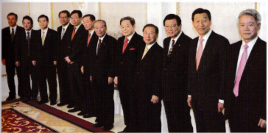
The heads of Korean chaebol, or family owned business groups, such as Samsung, LG, Hyundai, SK, and Hanwha, attend a meeting of Federation of Korean Industries in 2007. Chaebol played a crucial role in developing the Korean economy.

Korea’s leading multinationals like Samsung, Hyundai, LG and POSCO can be found next to the world’s most famous corporations on the Fortune Global 500 list. These chaebol have played a vital role in Korea achieving a “miracle performance,” as the country’s development has been described by the World Bank.
This begs the questions: How were these chaebol formed from scratch, what role have they played during Korea’s rapid economic development process and what challenges do they face in the years to come?
In some respects, the chaebol model was patterned after the Japanese pre-war zaibatsu designed to help Japan catch up with the West following the Meiji Era. Indeed, under a synergistic partnership between the government and big business, Korea dramatically shortened the typical phases of industrial transformation that took most developed nations more than a century to achieve. Korea's government-led industrial growth has been accelerated in conjunction with export expansion policies, which aimed ultimately at enhancing the international competitiveness of Korean exports.
By departing from the import substitution regime adopted by most developing countries in the 1960s, Korea’s export-based orientation has resulted in a spirit of “competition and learning” in Korean enterprises’ management practices at all levels. Winning an export order itself means that Korean export companies had passed an international test in terms of price and non-price competitiveness in an overseas market. In due process in the global market, Korean firms have been able to learn at arms’ length advanced production methods and business practices.
Provision of incentives, including unrestricted automatic access to bank credit, interest subsidies and tariff exemptions on imported intermediate goods and facilities for export activities across the board, has triggered start-ups of labor-intensive manufacturing companies of varying size, small and large alike.
The initial success of the export drive in the 1960s has provided policymakers and businesses across the manufacturing sector with a great deal of confidence, which resulted in both rapid growth as well as a sense of satisfaction, which came with winning an international “competition.” As Korea entered the 1970s, the Park Chung-hee government suddenly shifted the country's economic policy focus from light manufacturing to the “heavy and chemical industries (HCI).”

Chaebol’s Value-added Share of Korea’s GDP (%)
Rank-ordered Groups | 1973 | 1977 | 1981 | 1985 | 1989
Top 10 | 5.1 | 10.6 | 20.4 | 24.1 | 22.7
Top 20 | 7.1 | 13.3 | 26.3 | 29.5 | 26.7
Top 30 | 9.8 | 16.3 | 30.8 | 33.1 | 29.6

JIGSAW READING #1
SOUTH KOREA SEEKS TO REINVENT ITSELF YET AGAIN: THE FOURTH INDUSTRIAL REVOLUTION
The Korean War Legacy Foundation
South Korea has seen remarkable changes since the end of the Korean War in 1953. Starting out as a mostly agricultural society, the nation forged a contract between state and citizen to jumpstart industrialization. Starting with textiles, South Korean conglomerates (called Chaebols) used foreign and domestic investments to manufacture whatever was in demand. Becoming one of the “four Asian tigers," South Korea made its mark as an innovative country in the new global economy.
As technology advanced, so did South Korea. The government and corporations transitioned into production of high-tech equipment and vehicles that were high quality and low cost. When faced with the global recession of 2008, they sought innovation once again. Companies like Samsung used a large portion of their funding for research and development so they could determine the next trends in technology. This was an important shift for South Koreans as they moved away from producing whatever was demanded and started setting the global trends themselves.
Now South Korea finds itself rated as the most innovative country in the world (according to the Bloomberg Index) and continues to break boundaries in artificial intelligence and other forms of technology. The most recent Winter Olympics gave South Korea a platform to showcase its success. Arriving at the airport, one might have found a talking robot to help them find their way in any language. Not able to make it to the Olympics? Not to worry, the events were shown all across South Korea in high definition and were compatible with virtual reality. This was all possible because South Korea ramped up its internet connection to be 1,000 times faster than the typical LTE connection. (Coined “5G”, this high speed connection used the Olympics as a testing ground and will be mass marketed in a few years.) To make movement between events seamless, South Korean companies teamed up to create a fleet of self-driving cars and buses. All of these innovations showcased the connection between the South Korean government and various conglomerates like Samsung, LG, and Hyundai.
South Korea finds itself moving into a new phase of industrialization. Current President Moon Jae-in announced the Fourth Industrial Revolution, and stated that it will be focused on the public welfare. The government is looking to create jobs and support technology that serves the public. This five-year plan is one of the most ambitious in terms of job creation, with the main goal of closing the wage gap within the economy. Once again, South Korea appears to be ahead of the curve, making changes to its business plan before they are critically needed. With recent criticism falling on companies such as Amazon for working conditions, this “people-centered economy” might be the next phase in global business. Consumers are trending towards products and services that improve the lives of everyone. President Moon’s plan to reduce the maximum working hours is, therefore, right in line with this movement.
Another way that South Korea is setting itself up for future success is by branching out into the biomedical field. In the past, scientists in South Korea found it difficult to get long-term funding for research, as the government sought investments with quick returns. This led to a sort of brain drain, where South Koreans who got their PhDs in the United States tended to remain there for work. Now the government is seeing that the communications market will eventually hit a point of diminishing returns and is rethinking its role in scientific research. South Korean scientists are experiencing increased support and longer contracts. This will naturally lead to important strides in the scientific community and potentially improve the health and welfare of South Korean citizens in the future. Some worry that this level of government investment is not sustainable over longer periods of time, but others are excited by the potential discoveries.
The keen ability of the South Korean government to see future trends is heavily tied to its investment in research and development. Large amounts of state funding are earmarked for the research and development teams at each major conglomerate. South Koreans are certainly making it their business to predict what people will want in the next 10 years and beyond.
Sources:
Jo Sang-eun, “South Korean Government Unveils People Centered Economic Directives,” Asia Today, December 27, 2017, https://www.huffingtonpost.com/entry/s-korean-govt-unveils-people-centered-economic_us_5a435b8ae4b06cd2bd03dd41.
Natasha Turak, “The Coolest Tech Innovations You’ll See at South Korea’s 2018 Winter Olympics," CNBC, February 8, 2018, https://www.cnbc.com/2018/02/08/the-coolest-tech-innovations-youll-see-at-south-koreas-2018-winter-olympics.html.
Mark Zastrow, “Why South Korea Is the World’s Biggest Investor in Research,” Nature, June 1, 2016, https://www.nature.com/news/why-south-korea-is-the-world-s-biggest-investor-in-research-1.19997.

JIGSAW READING #2

ADVICE FROM BLOOMBERG AND THE SOUTH KOREAN EXAMPLE
The Korean War Legacy Foundation
The venture capitalist Jim Breyer announced recently that this is a “magical time” for international business where the most innovative nations will thrive. This is an important lesson for many countries that are experiencing stagnation in Europe and parts of Asia. However, to look at the statistics found in the 2015 Bloomberg Index on Innovative Countries, South Korea is poised to take advantage of this “magical time.” The index, based on data from the World Bank, IMF, and OECD serves as an efficient predictor of future success.
Research and Development
South Korea ranks number one for research and development, according to the most recent data. Samsung serves as a poster child for this heavy emphasis on innovative design, and is known for thriving even during the 2008 recession because it used substantial government funding on research and development. With over 14 billion dollars spent by Samsung on research and development in 2014, South Korea certainly isn’t waiting for other nations to tell them what to build.
High-Tech Companies
Bloomberg used data to determine the nations with the most tech-based companies, and ranked South Korea as number four. This is even more impressive considering that the data does not take into account the size of nations. Therefore, South Korea is rubbing shoulders with demographic giants like the United States and China.

Post-Secondary Education
One of the most important data sets pertains to attendance in post-secondary education. South Korea’s composite score makes it number one on Bloomberg’s most recent list, and knocks the United States out of the top ten. The score looks at several factors including the percentage of college-age citizens in post-secondary education, the percentage of the labor force with a post-secondary degree, and specifically how many of those graduates are in the fields of science and engineering.
Patents
Another data set that points to innovation is the number of patents earned within a year. South Korea ranks number one, in large part to Samsung. While patent lawsuits tend to go hand in hand with patents, Bloomberg still see this statistic as a good indicator of nations that are on the cutting edge of technology.
Overall Ranking
It comes as no surprise that South Korea is ranked number one on the innovative index. After considering six categories of data, Bloomberg put South Korea ahead of tech giants such as the United States and Japan. Nations in an economic slump can use this data to inspire change. Renewed focus on education and innovative research seem to be the key to success for any nation whether big or small.
An Alternative Perspective
The data sets used are an important factor in rankings. One must always be careful to check multiple sources to get the full picture. For example, the Global Competitiveness Report, created by the World Economic Forum, does not rank South Korea as number one. The indicators for their ranking include more data on government transparency and the amount of favoritism found in governmental agencies. This creates an interesting shift, because much of South Korea’s success economically is based on the direct relationship between the government and large conglomerates called chaebols. When one includes this data as a measure of success, South Korea loses its top spot. This should raise many questions for consideration. Is a strong democracy necessary for economic success? What is the most important indicator of a competitive economy? Anyone who can work through these questions stands to set himself or herself up for success in this new global economy.
Sources:
Peter Coy, “The Bloomberg Innovative Index," Bloomberg the Company, https://www.bloomberg.com/graphics/2015-innovative-countries/.
Klaus Schwab, “The Global Competitiveness Report, 2017-2018," World Economic Forum, http://www3.weforum.org/docs/GCR2017-2018/05FullReport/TheGlobalCompetitivenessReport2017–2018.pdf.

JIGSAW READING #3

SOUTH KOREA: THE NATION THAT MIGHT SURPRISE YOU
The Korean War Legacy Foundation
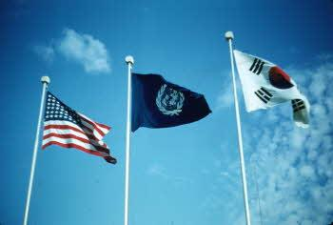
Photo Credit: Martin Rothenberg, contributed to the Korean War Veterans Digital Memorial, http://www.kwvdm.org/detail_artifact.php?no=479
When asked about South Korea, many Americans have little to say. They might reference K-Pop or the nuclear threat coming from North Korea, but they may not grasp the rapid course towards development that South Korea has taken over the past 50 years. For example, South Korea is currently ranked 18th on the United Nations Human Development Index (ahead of France and Belgium). Here are some other facts that might surprise you.
Wired for Speed
In a study done by Akamai in 2015, South Korea was found to be the nation with the fastest internet connection. And the effects of this effort are evident throughout the country. South Koreans typically have at least one smartphone (if not two). A survey in 2012 found that the cell phone penetration rate grew from roughly 38% to over 78% in just a few years. When surveying just college-age South Koreans, the rate was a staggering 97%. Perhaps this is why some joke that even their pets must have phones. If you have ever found yourself with no patience for buffering, then maybe South Korea should be on your travel list.
A Land of Luxury
South Koreans were some of the first to enjoy luxury spending after the 2008 recession, according to independent research done by McKinsey and Company. South Korea weathered the storm of global recession relatively well, and their retail sales rose over 16% just one year after the recession. This gave it the second fastest recovery rate in the world. In a recent survey, very few South Koreans said they had any guilt about buying luxury products. This consumer attitude and healthy economy make for a great shopping trip for tourists.
Working Overtime
South Koreans are known for working long hours. Known as “warrior workers” after the Korean War, this zeal for production has helped South Korea grow tremendously. However, it has also led to a declining birth rate, as citizens say they are far too busy to care for more children. A recent study found that South Koreans were working 400 more hours a year than other developed countries like the United Kingdom. In an effort to improve quality of life and birth rates, the president has recently passed a bill that will reduce the maximum working hours from 68 to 52.
On the Cutting Edge of Beauty
If you are looking for the latest cosmetics trend, look no further than South Korean markets. South Korean culture puts a heavy emphasis on a youthful, glowing appearance, and consumers are willing to pay for products that work. From snail cream to masks made from volcanic ash, you can find it all in the Seoul markets. The trends are also going global, with many tutorials online about the “Korean” skincare regimen. This is not for those with little time, however. Most tutorials call for between 10 and 18 steps, each with its own product. Men and women are equally dedicated to youthful skin, and it isn’t surprising to see South Koreans sporting an umbrella on a sunny day. They learn from an early age that no skin cream can reverse sun damage.
The Battle for Online Gaming
Teens in South Korea have caught on to the gaming trend like youth around the world. This, combined with the high internet connectivity, has led to a hot debate among adults. In 2010, the South Korean government enacted the “Shutdown” or “Cinderella” law that required minors to log off of online games before midnight. This sparked a challenge from gamers about their freedom to play when it suited them. Many argued that this law would not fix the growing issue of “internet addiction,” and many teens found ways around the internet roadblocks at night. More recently, in 2014, the law has been revised to allow teens to get parental permission for gaming after midnight, but this still remains a point of debate in South Korea.
South Korea Schools Lead the World
South Korea leads the world in public education, and especially in the field of technology. Coding and programming courses are mandatory in South Korea, and the rest of the world is starting to take notice. For example, a professor in Hawaii has created an entire teacher and student course modeled after the South Korean curriculum. Students create a completely autonomous car from scratch, forcing students and teachers to think outside the box. This focus on STEM education has led to significant advancements in artificial intelligence for South Korea, so keep an eye out for what they might create next.
Sources:
Akamai, “State of the Internet: Q3 2015,” Ed. David Belsan, https://www.akamai.com/us/en/multimedia/documents/report/q3-2015-soti-connectivity-final.pdf.
Benjamin Haas, "South Korea Cuts 'Inhumanely Long' 68-Hour Working Week" The Guardian, February 28, 2018, https://www.theguardian.com/world/2018/mar/01/south-korea-cuts-inhumanely-long-68-hour-working-week.
Brian Salsberg and Martine Jae-Eun Shin, “South Korea: Living It Up in Luxury” McKinsey and Company, August 2010, https://www.mckinsey.com/business-functions/marketing-and-sales/our-insights/south-korea-living-it-up-in-luxury.
J. Sexton, “South Korea’s Cinderella Law Finally Growing Up,” Tech in Asia, September 3, 2014, https://www.techinasia.com/s-koreas-cinderella-law-finally-growing-up-teens-may-soon-be-able-to-play-online-after-midnight-again.
Chemmie Squier, “How South Korea Became the Beauty Capital of the World," Grazia, April 6, 2016, https://graziadaily.co.uk/beauty-hair/hair/korean-beauty-products-good/.
United Nations Development Program, “Human Development Index Data," http://hdr.undp.org/en/composite/HDI.

JIGSAW READING #4

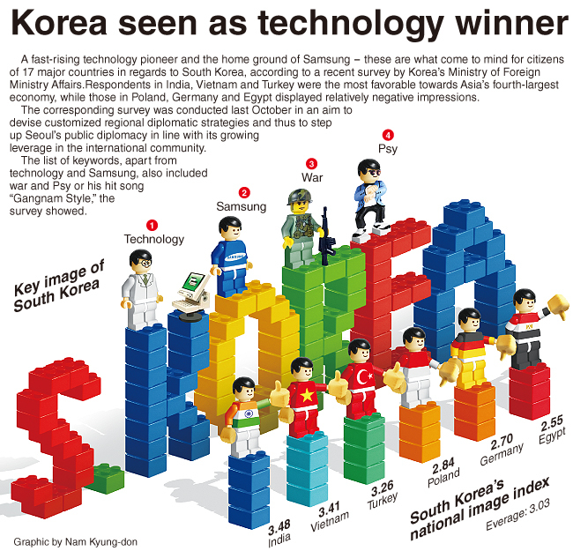
Graphic source: “Korea Seen as Technology Winner,” The Korea Herald, July 27, 2014. Used with permission of The Korea Herald.

Korea’s National Image – Appearance and Reality
The Korean War Legacy Foundation
What first comes to mind when people around the world think about Korea? Common answers from 17 major countries included “technology pioneer” and “Samsung,” according to a recent survey by Korea’s Ministry of Foreign Affairs.
Respondents in India, Vietnam and Turkey were the most favorable toward Asia’s fourth-largest economy, while those in Poland, Germany and Egypt had relatively negative impressions.
These results were part of a survey conducted in October of 2018 designed to help with customized regional diplomatic strategies by the South Korean government as its profile and economic clout continues to grow. When queried, keywords such as technology and Samsung, as well as war and Psy (or his hit song “Gangnam Style”), were common. The survey results were used to create a national image index.
These perceptions associated with technological prowess are matched by reality, as recent research by the Organisation for Economic Cooperation and Development shows. South Korea is tenth in mobile broadband subscriptions per 100 inhabitants, proving that its image as a technological, connected nation is met by reality.
OECD Mobile broadband subscriptions per 100 inhabitants, by technology, December 2017
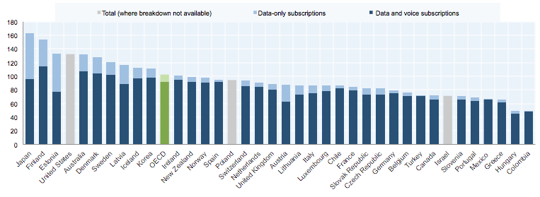Source: OECD, Broadband Portal, http://www.oecd.org/sti/broadband/oecdbroadbandportal.htm

This high-tech reality is in part due to the substantial research and development efforts of both the South Korean government and leading South Korean companies like Samsung, LG, and Hyundai. Samsung leads among corporations in patenting, according to an OECD study. From 2012-2014, Samsung was number one, with LG at fifteenth and Hyundai at sixteenth.

Top 50 patenting companies, 2012-14*
IP5 stands for the forum of the five largest intellectual property offices in the world
Source: JRC-OECD, COR&DIP© database v.1, 2017. http://www.oecd.org/sti/intellectual-property-statistics-and-analysis.htm
The government has supported technology since the 1960s. In 2008, it launched the “577” program. The “5” stands for the target of 5% of GDP spending on research and development, with a quarter supported by direct government spending and the other seventy-five percent from private sources supported by government tax incentives. The first “7” stands for the seven areas of research focus, number one continuing to be consumer electronics and automobiles from which South Korea’s global reputation is largely drawn. The second “7” set a target goal of being in the top seven major science and technology nations in the world.
Based on global image, technological infrastructure, and its private and public commitment to technological development, South Korea is well on its way to its goal.
Sources:
“Korea seen as Technology Winner,” The Korea Herald, July 27, 2014.
Joel R. Campbell, "Building an IT Economy: South Korean Science and Technology Policy," Issues in Technology Innovation Number 19, September 2012, https://www.brookings.edu/wp-content/uploads/2016/06/CTI_19-_Korea_Tech_Paper_Formatted.pdf.
Richard Stone, "South Korea Aims to Boost Status as Science and Technology Powerhouse," Science, December 23, 2008, http://www.sciencemag.org/news/2008/12/south-korea-aims-boost-status-science-and-technology-powerhouse.

