COMPARIson MODULE OVERVIEW
SKILL: COMPARISON | CONTENT: AP world c.f. Key Concept 6.3
This module focuses on comparison through an examination of South and North Korea. The two activities lead toward a document-based question (DBQ) that addresses the economic impact of differing ideologies. | After the Korean War (1950-1953), the role of the state in the domestic economy varied, and new institutions of global associations emerged and continued to develop throughout the twentieth century.

D A Y 1 | What is the state’s role in developing the economy?

CLASS ACTIVITY: Comparing North and South Korea through Sources
Students work collaboratively to compare the roles that the state, ideology, and historical developments played in the development of North and South Korea’s economies after World War II until the 1980s. During the activity, students construct evidence-based interpretations using North and South Korean sources, culminating in a thesis statement and contextualization.
AP ALIGNED ASSESSMENT: Long Essay Question (LEQ)
Long Essay Question—Thesis and Contextualization Focus: “Develop an argument that evaluates the extent to which the governments of North and South Korea differed in developing their economies.”

D A Y 2 | How did economic models, ideologies, and political structures differ between North and South Korea after 1950?

CLASS ACTIVITY: Escape Room!!!!! Comparing North and South Korea
Students work in groups to apply content knowledge from pre-assigned homework readings about North and South Korea to a sequence of puzzles in an “escape room” scenario. The activity involves some advance teacher and student preparation, but the puzzle work and group interaction reinforce material that is sometimes challenging.

AP ALIGNED ASSESSMENT: Long Essay Question (LEQ)
Long Essay Question—Thesis Writing: “Evaluate the extent to which ideologies influenced the outcome of economic or political planning in North or South Korea after 1951.”

D A Y 3 | CLASS ACTIVITY: Teaching the Document-Based Question (DBQ)  Students can practice three targeted document-based question skills: thesis writing, contextualization, and sourcing. Students do not need extensive knowledge of Korean history. Teachers could alternatively assign students to write the full AP-aligned DBQ.

AP ALIGNED ASSESSMENT: Document-Based Question
Document-Based Question: Evaluate the extent to which political ideologies affected the economies of Korea after 1945.

COMPARIson MODULE SOURCES

D A Y 1 | AUTHOR SOURCE DATE  - Mao Zedong Telegram to Filippov (Josef Stalin) 1952  - Kim Il-sung Speech to the Korean Workers' Party Central Committee 1956  - Kim Il-sung Speech to the 5th Congress of Korean Workers' Party 1970  - North Korea Propaganda poster targeted at “Young Heroes” 1985  - Syngman Rhee Letter on U.S. economic development of South Korea 1954  - Park Chung-hee Semi-autobiographical account of South Korea's progress 1971  - Kim Dae-jung Speech addressing South Korea's economy 1985  - Kwan S. Kim Working paper addressing “The Korean Miracle” 1991

D A Y 2 | AUTHOR SOURCE DATE  - C. Wolf, Jr.  and N. Levin Report on attempts to modernize North Korea 2008  - Bruce Cumings Influences on development 2005  - Jongwoo Han Political, economic, and ideological features 2013  - CIA Memorandum on economic development 1972  - Jongwoo Han Article on Korean economic development 2018

D A Y 3 | AUTHOR SOURCE DATE  - Syngman Rhee Presidential Inaugural Address 1948  - Kim Il-sung Speech, “On Eliminating Dogmatism…” 1955  - Yi Sujong “Declaration of the Seoul National Un. Students’ Assoc.” 1960  - Park Chung-hee To Build a Nation 1971  - Anonymous Student fliers and slogans 1980s  - Kim Dae-jung Presidential Inaugural Address 1998  - North Korea Publicity poster, 50th anniversary 1998

D A Y 1
Based on a 60-minute class

Lesson Question: Comparing North and South Korea—What is the state's role in developing the economy?

AP curriculum Framework reference
Key Concept 6.3—After the Korean War (1950-1953), the role of the state in the domestic economy varied, and new institutions of global associations emerged and continued to develop throughout the twentieth century.
- States responded in a variety of ways to the economic challenges of the twentieth century.
  - In communist states, such as the Soviet Union and China, governments controlled their national economies, often through repressive policies and with negative repercussions for their populations. [North Korea]
  - In new independent states after World War II, governments often took on a strong economic role in guiding economic life to promote development. [Larger contextual development]
  - In a trend accelerated by the end of the Cold War, many governments encouraged free-market economic policies and promoted economic liberalization in the late twentieth century [South Korea]

Historical Reasoning Skill: COMPARISON

OVERVIEW
This activity is designed to engage students in historical thinking as they compare sources from pre-assigned homework describing the state’s role in developing the North and South Korean economies. Each was shaped by a common past and both were set at odds during the Cold War. Students—working in collaborative pairs—will use evidence to answer questions based on their interpretation of documents, backed with evidence from one or more of the documents. Students will identify similarities and differences based on how they cooperatively answered the question. Students will use their homework, outside evidence, and collaborative work to explain, individually, the similarities and differences. At the end of class, students will construct a historical context and write a thesis statement that answers the Long Essay Question (LEQ) prompt:
After 1900, the role of the state in the domestic economy varied. New institutions of global associations emerged and continued to develop throughout the century. Develop an argument that evaluates the extent to which the governments of North and South Korea differed in developing their economies.

Materials needed for:
Pre-Assigned Homework
- Homework organizer that captures the main idea and evidence from North and South Korean sources
- Homework sources that include four North Korean (p. 9) and four South Korean (p. 13) sources dating from 1946-1991
In-Class Activity
- In-class organizer that capitalizes on student source work to answer questions pertaining to the roles of the state, ideology, and historical developments in shaping Korean economies
Assessment
- Writing Contextualization and Thesis Statements based around an LEQ prompt

SEQUENCE OF INSTRUCTION

HOMEWORK OVERVIEW
HOMEWORK (60 MINUTES):
Homework Doc (pp. 7-8)
Students will read through six to eight sources and analyze those sources by writing main idea sentences and providing textual evidence to support those main ideas. Upon completing the homework, students will work collaboratively in class to respond to the lesson question.
The purpose of this pre-assigned homework is to:
- learn new content for the class.
- begin to develop main ideas for teachers to check for understanding of sourcing.
- see what evidence students value.
- prepare students to compare in class and answer an LEQ prompt.

Teacher Notes
Students may struggle initially with this homework and should be instructed to be patient with understanding the content. Because this lesson is an exercise in building content knowledge through primary documents, it may be necessary to read a few documents before students understand connections. In addition, one document will help inform the next. It is advisable to make students aware of this, and to remind them that they will have a better understanding once they start the lesson in class.

Teaching Tip
If teachers need to shorten homework, they can remove a document for both North and South Korea. If teachers need to shorten the lesson, they can focus on the state’s role in developing the economy and either the ideologies or the historical developments.

Teaching Tip
Depending on the students’ reading strength, teachers can have students read all eight documents or just six (three from North Korea and three from South Korea). Students can also be given the choice of which documents to read. In addition, teachers can add or subtract the annotation for documents based on the students’ needs.

CLASS ACTIVITY 1 OF 3: WARM UP/INTRODUCTION
INTRODUCTION (8 MINUTES):
- Students will look at the modern differences between North and South Korea. Teachers will provide the six charts, give students time to look them, discuss what they see, pose questions, and speculate on why there are differences. Teachers will then ask students to share what they discussed and begin to make connections, then make connections between where North and South Korea stand today and the lesson question.
- Source: “Six Charts That Compare North and South Korea Today” (p. 18)
  - Students—working collaboratively—will look at and pose questions individually based upon differences between North and South Korea. [4 minutes]
  - Students then share with the whole group what they’ve noticed, and share questions. [4 minutes]

Teacher Notes
Teachers are welcome to shorten the six charts to whatever number they feel is appropriate based on time and interest. They could also jigsaw the sources in smaller, collaborative groups if they believe it will increase students’ focus.

Teaching Tip
Teachers should be aware that this source will provoke a lot of discussion and conversation, but that time spent here will detract from time devoted to the lesson. Thus, like any good opener, this source will help spark curiosity and provide deeper meaning to the lesson.

CLASS ACTIVITY 2 OF 3: COLLABORATION TO ANSWER THE LESSON QUESTION
ANSWERING THE QUESTION (42 MINUTES):
Students—working in collaborative pairs—will deploy evidence from one or more of the documents to answer questions based on their interpretation of the sources from the pre-assigned homework. Students will identify similarities and differences based on how they cooperatively answered the question. At the end of class, students will write a contextualization and thesis statement based on the comparison skill and LEQ prompt.
- Lesson Organizer (p. 21)
- SEQUENCE: (Each sequence is approximately 14 minutes.)
  - Using the lesson organizer, teachers choose two or three questions based on curricular and instructional goals and the time available.
- What role did the government play in developing the economy?
- What ideologies influenced state control over the economy?
- What historical developments helped facilitate state control over the economy?
  - Students—in pairs or cooperative groups—use their homework to provide their interpretation of the question for both North and South Korea, and support that interpretation with paraphrased evidence from the sources to complete an in-class document. [8 minutes]
  - Students discuss similarities and differences between North and South Korean documents. [3 minutes]
  - Students quickly share with the class similarities and differences. Teachers facilitate this by recording answers on a whiteboard. [3 minutes]
  - Repeat steps 1 through 4 as time allows (with at least two total repetitions). Each additional question adds nuance and complexity.

Teaching Tip
These sequences are highly structured around time, so using a timer will help keep the lesson moving along. Teachers will act as the facilitator, observing groups and managing time. If the teacher feels students need more time, shortening the lesson from three to two questions (or even just one question) is advisable.

Teaching Tip
This is a student-centered lesson, so we encourage teachers to allow students to drive the lesson based around their conclusions. To this end, students are welcome to use other documents as they see fit. Students should corroborate documents in the in-class lesson organizer to strengthen their arguments. Finally, teachers are encouraged to help students make connections within the documents, so students are focused continually on using documents.

CLASS ACTIVITY 3 OF 3: ASSESSMENT / CHECK FOR UNDERSTANDING
FORMATIVE ASSESSMENT (10 MINUTES):

EXIT TICKET:
Students will write a thesis and a contextualization based upon the LEQ prompt (p. 23) in class.
- After 1900, the role of the state in the domestic economy varied. New institutions of global associations emerged and continued to develop throughout the century. Develop an argument that evaluates the ways in which the governments of North and South Korea differed in developing their economies.

Teaching Tip
While the goal of this lesson is to write a thesis statement based on the comparison skill, many teachers believe contextualization goes hand in hand with the thesis statement. Adding contextualization is an option, based on teacher discretion.

HOMEWORK MATERIALS
What Is the State’s Role in Developing the Economy?

Directions
For each document:
- Write one clear, concise sentence that establishes the main idea for the document.
- Provide evidence from the document that supports the main idea.
 | MAIN IDEA AND EVIDENCE
DOCUMENT 1  NORTH KOREA | MAIN IDEA:
 | EVIDENCE:
DOCUMENT 2  NORTH KOREA | MAIN IDEA:
 | EVIDENCE:
DOCUMENT 3  NORTH KOREA | MAIN IDEA:
 | EVIDENCE:
DOCUMENT 4  NORTH KOREA | MAIN IDEA:
 | EVIDENCE:
DOCUMENTS 1-4 | SUMMARY OF NORTH KOREAN DOCUMENTS:

HOMEWORK MATERIALS

 | MAIN IDEA AND EVIDENCE
DOCUMENT 5  SOUTH KOREA | MAIN IDEA:
 | EVIDENCE:
DOCUMENT 6  SOUTH KOREA | MAIN IDEA:
 | EVIDENCE:
DOCUMENT 7  SOUTH KOREA | MAIN IDEA:
 | EVIDENCE:
DOCUMENT 8  SOUTH KOREA | MAIN IDEA:
 | EVIDENCE:
DOCUMENTS 5-8 | SUMMARY OF SOUTH KOREAN DOCUMENTS:

North and South Korean State/Economic Comparison Documents

north korean sources
Question: What is the state’s role in developing the economy?
Document 1 | Chairman Mao Zedong, telegram to Filippov (Josef Stalin) February 8, 1952, http://digitalarchive.wilsoncenter.org/document/113022.
Annotation | After World War II, the Korean peninsula was divided based on the location of the allied powers, with the Soviet Union in the North and the United States in the South. The dividing line, the 38th parallel, was meant to be a temporary measure with a United Nations vote to determine the fate of the country.
TO FILIPPOV [Stalin]
In a conversation he said that the Korean people throughout the country demand peace and do not want to continue the war. If the Soviet Union and China consider it advantageous to continue the war, then the Central Committee of the Workers’ Party will be able to overcome any difficulties and hold to their position. I answered that a peaceful settlement on the basis of justice and rationality is advantageous for us. I also explained to him about the favorable conditions of our side in the present military situation and about the increase in the difficulties of America…
In 1951 the Korean government collected agricultural taxes in kind in grain in the amount of 650,000 tons, which constituted too large a percentage of the entire yield. At the present time 10 percent of the population is suffering from hunger. The majority of the peasant population will be able to subsist only until April-May. If there is no assistance soon, then this will influence not only the carrying out of spring sowing but also the gathering of the harvest. They say that our government has already resolved to deliver to the Korean government 30,000 tons of grain. I do not know, is this true? If it is not true, I consider that it is necessary to prepare for timely delivery of 30,000 tons of grain in March for the purpose of providing assistance so that the peasants can engage in spring planting.
I consider that although our budget is also very strained, in 1952 we nevertheless need to plan to apportion 1,600,000 million yuan (which constitutes approximately 237 million rubles) according to the plan of 1951 budget year for rendering aid to Korea. This amount can hardly be reduced. I ask that all this possibly be planned earlier in the general budget.
I received your telegram of 22.1 [January 22] of this year. As concerns rendering aid to Korea, in our budget for 1952 we have already included expenditures of 1,500,000 million yuan (approximately equal to 222 million rubles), which somewhat exceeds the sum of the trade credit extended by China to Korea in 1951, the sum granted by China for urgent restoration of Korean railroads and also the sum granted by China for maintenance of Korean citizens located in Manchuria.
If military operations in Korea are ended, then it is assumed that expenditures for aid to Korea will be increased.
Korea will not deliver anything to us in exchange, and therefore the aforementioned amount was established as the sum of trade credit. Negotiations will be concluded soon. According to your practical observation, if military operations in Korea cease, what is necessary to restore in Korea as first priority? The army of the Chinese volunteers can render assistance as a workforce to restore the highways and agricultural economy. What other kind of aid is needed from us?
I ask you to study these questions and communicate your opinion.
MAO ZEDONG
Used with permission from Woodrow Wilson International Center for Scholars, https://www.wilsoncenter.org/

Question: What is the state’s role in developing the economy?
Document 2 | Kim Il-sung, Premier of North Korea and founder of the Korean Workers' Party Central Committee Plenum, August 30, 1956, http://digitalarchive.wilsoncenter.org/document/120166.
Annotation | Kim Il-sung reflects on the delegation he led to the USSR and other socialist states, and speaks about solidarity in the socialist bloc and peaceful reunification on the Korean peninsula. He discusses the Three-Year Plan and the blueprint for the Five-Year Plan. In Document 2, we see the operationalization of the Five-Year Plan.
Nevertheless, the lives of our people are still not completely freed from needs which were caused by the [Korean] war. The production of grain, the primary food products, and manufactured consumer articles lags behind demand and there is a great shortage of housing. By virtue of this our Party has to exert a maximum of effort for the rapid stabilization of the people's lives through a further revival and development of the economy. To do this we have to draw up a first five-year economic plan...
First of all it [is] necessary to take into consideration the current economic situation of our country in order to correctly draw up the five-year economic plan. The main task of the three-year economic plan, inasmuch as it set itself the goal of reviving all sectors of the economy to the prewar level, was chiefly the restoration of the enterprises which had previously existed. In addition, as regards the financial aspect of the matter, in the three-year plan we relied to a considerable degree on the colossal economic aid of the Soviet Union, the People’s Republic of China, and other countries of people’s democracy.
However, during the period of the first five-year plan, which we ought to accomplish, it is necessary to reconstruct and expand existing enterprises, furnish them with new equipment, and build new factories and put them into operation. We should solve the problem with resources, relying mainly on the domestic resources of our country. Therefore, when drafting the five-year plan we need to pay serious attention to consolidating the successes achieved in various sectors of the economy and to concentrate our efforts accordingly without dissipating them.
During the years of five-year plan it is necessary to conduct a careful engineering and economic accounting, strictly distinguish the priority of capital investments and, above all, to concentrate capital investments in sectors and facilities which could rapidly go into production, and to invest resources in the remaining sectors and facilities as much as possible insofar as the economic situation of the country allows. In the course of the five-year plan we should provide for extensive construction to improve the people's lives and simultaneously with them create a solid material basis of the economy of our country, relying on the successes achieved during the fulfillment of the three-year plan and the material aid of the Soviet Union and the other fraternal countries…
When drafting the five-year economic plan we should take serious note of the fact that economic ties and cooperation between the socialist countries are strengthening…
Used with permission from Woodrow Wilson International Center for Scholars, https://www.wilsoncenter.org/

Question: What is the state’s role in developing the economy?
Document 3 | Kim Il-sung, Premier of North Korea and founder of the Korean Workers' Party speech at the 5th Congress of the Korean Workers' Party, November 2, 1970, https://digitalarchive.wilsoncenter.org/document/123887.
Annotation | During the Fifth Congress, Kim Il-sung’s “Three Revolutions” (ideological, technological, and cultural revolutions) celebrated economic gains and laid the foundation for the new six-year National Plan (1971-1977).
All the working people of our country, upholding the Party’s line, unanimously rose in the struggle for the materialization of the socialist industrialization of the country and the technical reconstruction of the national economy. In response to the Party’s call of “Let us dash forward at the speed of Chollima!” [a mythical winged horse] our heroic working class and the entire working people waged an indefatigable fight to implement the Party’s line of industrialization, smashing passivism and conservatism standing in the way of their advance and surmounting all hardships and difficulties.
Thanks to the Party’s correct line of industrialization, its wise guidance for the implementation of the line and to the heroic and devoted labour struggle of our people, the difficult and complex task of industrialization which took capitalist countries a full century and even a few centuries has been creditably accomplished in our country in a very short period of only 14 years. The conversion into a socialist industrial state—this is a great event of historic significance in the struggle to step up the building of socialism and communism in our country and attain a nationwide victory for the Korean revolution. As a result of the accomplishment of socialist industrialization, our country has been provided with the firm material and technical foundations of socialism and has come to fully satisfy on its own the demands of economic construction, defence upbuilding and the people's life for industrial products and agricultural produce. The conversion of our country into an industrial state through the realization of industrialization has fortified our revolutionary base more impregnably and provided a solid asset for strong support to the revolutionary struggle of the South Korean people and for the unification of the fatherland and its future prosperity.
We must continue to intensify ideological work against revisionism among the Party members and the working people. While the Party members and working people are closely armed with the revolutionary ideas of Marxism-Leninism, they should be brought to get a clear idea of the essence and harmfulness of revisionism, and a resolute struggle should be waged to prevent the infiltration of the virus of revisionist ideology into the Party. Revisionism engenders and breeds on the soil of bourgeois ideas and spreads widely through their medium. Revisionism is also the main factor in reviving bourgeois ideas. Therefore, in order to overcome revisionism we should thoroughly uproot the noxious aftereffects of bourgeois ideas. We must further intensify the struggle against all the harmful aftereffects of the obsolete ideologies including bourgeois and feudalistic Confucian ideas among the Party members and the working people, and continue to vigorously conduct ideological education so that there may be no room for the revival of old ideologies…
Our country still remains divided and we are building socialism in direct confrontation with the U.S. imperialists, the chieftain of world reaction. By no means are we allowed to get self-complacent, indolent and lax. We must continue to equip Party members and working people firmly with the revolutionary ideas of our Party and fill them with the revolutionary militant spirit to fight out for the ultimate triumph of our revolution…
Used with permission from Woodrow Wilson International Center for Scholars, https://www.wilsoncenter.org/

Question: What is the state’s role in developing the economy?
Document 4 | “Become a Young Hero by helping build the Northline Railway,” Korea propaganda poster, 1985.
Annotation | As part of the Six-Year Plan (1971-1977), North Korea focused on “Self-Strengthening” that focused on an economy built by and for North Koreans. Here, a young woman is directing young workers building a railroad in the snow. To the left are two award insignia.

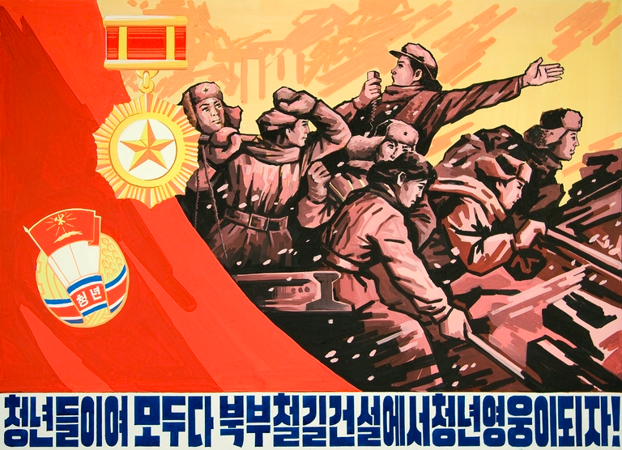
UC San Diego Digital Collections, https://library.ucsd.edu/dc/object/bb68271781

South Korean Sources

Question: What is the state’s role in developing the economy?
Document 5 | Syngman Rhee, President of South Korea, addressing James Cromwell, diplomat for the United States in a letter, March 1954, http://digitalarchive.wilsoncenter.org/document/122926.
Annotation | Less than a year after the end of the Korean War (1950-1953), Syngman Rhee (who was elected president in 1948 and, after changes to the constitution, served as president until 1960), critiques ambassador James Cromwell's proposal for a Private Enterprise Plan (which returned corporate power to Japan) and expresses concern that pro-Japanese politicians in the United States are blocking the development of the Korean economy.
If the United States Congress strictly orders the United States representative in Korea not to use the fund [aid] for anything but economic construction we will be in a position to build up our industry to such an extent that Korea will, in the course of time, once again be a self-supporting people and grateful to the United States. But certain statesmen of America are so intent in their policy to build up Japan, so that Japan will become the dominating power in Asia both militarily and economically, that all the Asiatic countries, including China will not follow the leaders of the United States. They would rather stand with the Communists than allow Japan to occupy their countries again…
In the first place, the Japanese occupation for forty years left no capitalists in the proper sense of the word. The Government has urged the people to organize stock companies, but under the Japan[ese] regime they were never allowed to raise large capital among themselves to compete with Japanese capitalists. It will take quite a little while to get the Korean business-men to band together to find a sufficiently large sum of money for business. They are trying to do all they can in this way now, but in spite of all the efforts made by the Government to encourage people it has been almost impossible. A contributing factor to this was the fluctuating money exchange rate. It is only now becoming stabilized. ECA* first and UNKRA** later forced us to double up the exchange rate every two or three months. The rate began with 35 whan to $1 seven or eight years ago, and increased so much [… that] last year it reached as high as 23,000 whan to $1. How can anybody do any business with this situation?
Under these circumstances, the Government has only one alternative and that is to start all these urgent industries with aid funds (for which the funds were given anyway) and make them pay so that Korean businessmen will see the worth in them. Then the Government will sell to those who will combine to buy it… I think that you are mistaken to call this system Governmentally monopolistic.
The government has established a Bank for Reconstruction and Rehabilitation. Through this Bank private citizens can obtain loans with which to rehabilitate industries. The Bank Head has been already appointed and the Government is now in the process of drawing up the reputations which will govern the Banking Operations…
* ECA is an export credit agency that is a private and/or government sponsored institution that acts as an intermediary between governments and exporters.
** UNKRA is the United Nations Korean Reconstruction Agency.

Used with permission from Woodrow Wilson International Center for Scholars, https://www.wilsoncenter.org/

Question: What is the state’s role in developing the economy?
Document 6 | Park Chung-hee, general, dictator and president of Republic of Korea, To Build a Nation, 1971.
Annotation | Park Chung-hee, a dictator who served as South Korea’s president from 1963 until his assassination in 1979, oversaw Korea’s speedy economic development while keeping an authoritarian control over the government. In To Build a Nation, Park reflects on this time period through government-engineered economic planning.
In 1961 the military-junta government announced the first Five-Year Economic Development Plan … the first such overall development program ever prepared for Korea. To prepare [for] it, the government mobilized all the wisdom and knowledge available and set clear goals, the primary goal being to establish a self-supporting industrial economy. The principle of free enterprise and respect for the creativity of private industry was adopted, for in this way we believed that the private sector would be encouraged to act voluntarily. Under the plan, however, the economy was not entirely free, since development of basic industries was directed by the government.
[…] The five-year plan gave priority to the following things:
- Development of energy industries such as coal production and electric power.
- Expansion of agricultural production aimed at increasing farm income and correcting the structural imbalance of the national economy.
- Development of basic industries and the economic infrastructure.
- Maximum utilization of idle resources; increased employment; conservation and utilization of land
- Improvement of the balance of payments through export promotion.
- Promotion of science and technology.

[…] The plan’s goal of 7.1 percent annual growth rate was then considered almost impossible—unprecedented not only in Korea but also in other developing countries. […] Success in the first five-year plan could not immediately bring about [a] self-reliant economy. It would be only a landmark the people had to pass on their long, painful journey toward this goal. Indeed, a self-sufficient economy and a welfare society may not be satisfactorily attained during one five-year plan or even two or more. But what can [be] begun today must not be put off until tomorrow. This common but everlasting principle was the foundation of our determination. The economy sustained a rapid rate of growth, and the industrial structure improved.
[…] One of our big problems was the shaky foundations of private industry, which was unable to carry its share of the development burden. Furthermore, the market structure was not modernized. Consequently, the government had to play the leading role in the development plan, though we knew well that such a plan must, in the long run, rely on the creativity and innovative of private industry.
In the meantime, the government tried to readjust existing systems to help accumulate private capital, with a view to laying the groundwork for an efficient market competition system.

Question: What is the state’s role in developing the economy?
Document 7 | Kim Dae-jung, political critic of President Park and future president of South Korea (1998-2003), “We Should Have a True Free Market Economy,” excerpted from Wolgan Joseon, August 1985, pp. 224-25. Translated by Minhye Kim, Program Assistant at the GW Institute for Korean Studies.
Annotation | Kim Dae-jung was a strong critic of Park’s authoritarian government and human rights violations and ran against him in 1971, losing but garnering 46 percent of the popular vote. As a strong and vocal opponent to the status quo, he was falsely arrested in 1980 and sentenced to death for treason. Under house arrest until 1987, in this passage Kim Dae-jung discusses the need for greater economic freedom in a push away from chaebols (large conglomerates). He finally became president in 1997, winning a Nobel Peace prize for opening up talks with North Korea.
I believe that a free market is the most ideal economic system that we should pursue despite its problems. I don’t think the Korean economy is truly a market economy.
First, the current economic system does not guarantee entrepreneurship nor free and fair competition. Becoming successful entrepreneurs in our country depends on the close political-business ties rather than the qualities such as creativity, risk-taking, hard-working, thrifty and strong management skills. There are so many examples that we have seen. One who could not pay a one million won [approximately $1,000] bill or a lady who worked at a restaurant could manage one hundred billion won within one to two years. A large company from the top ten major Chaebol can shut down in the blink of an eye. Korean entrepreneurs may become rich with the special favor of the Government, but they do not fulfill social responsibilities and characters as a leader of the market economy.
Second, a free market society should protect the freedom and rights of labor. Workers are one of the leading parts of [South Korea’s] economic success and have contributed to the increased export under low wages for a long time. Not only are they underpaid, but their rights to unionize are ignored. When labor workers are treated unfairly, it creates political and social unrest and eventually can be beneficial to Communists. Workers should get paid what they deserve for exceeding productivity growth, and the proper pay raises generate motivation for higher productivity that can, in turn, lead to an internationally competitive economy and higher consumers’ benefits. High rates of private savings and purchasing power from higher income can boost the economy and secure industrial funds. We know that Japan and Germany achieved a huge economic success with this kind of labor policy after the war compared to their authoritarian regimes before the war. The idea that the interests of the workers and the corporations are conflicting is a myth of the nineteenth century. In a democratic country, their interests are rather mutually complementary. Unfortunately, we still have a long way to go.
Third, the rights and interests of consumers should be protected at all cost. The purpose of an enterprise is to provide excellent customer services. However, in our country, there are many cases that consumers have to bear much responsibility for corporations’ irresponsible and greedy management. Companies sell expensive and lower-quality products to Korean consumers, promoting them as home goods, while providing quality products at low cost to wealthier customers from developed countries. It has been that way for most products such as cars and electronics from major companies, and the tendency continues.
It is important to balance between growth, economic stabilization, and the income distribution
Since the Park administration, the most noticeable changes in economic policies are imbalances and inequalities in the economy. It is important for sustainable economic development to achieve balance between growth, economic stabilization, and income distribution. But our economy was focused only on growth with a lack of stability and income distribution. People suffered from inflation, and workers and farmers received low salaries and low prices for their crops so that the economy could be stabilized. Furthermore, many recent agricultural and animal imports have made the farm economy worse. The economic situation of farmers is falling into a state of ruin much like that of workers. In a rural area, it does not matter whether farmers work on agricultural produce, animals, or special crops. The government has avoided distributing farmers’ share in a fair way through its policies. Farmers have moved from their rural homes to cities except for old people and women. Even if there remain some younger generations, they cannot get married as it is hard to meet women. For that reason, a million farmhouses are struggling with an average of two million won of debt, which they are unable to repay due to drops in crop prices. The biggest problem in the Korean economy is that it is increasingly dominated by few large conglomerates while farmers, labor workers, white collar workers, smaller businesses, and low-income workers are not paid enough. The price stabilization that the Government has bragged about was possible only through inequitable distribution of wealth and excessive imports not because of income distribution and sustainable growth. The result was reduced purchasing power in domestic markets and now we are facing a crisis in which economic growth itself is challenged. Just as a human body needs to be balanced in all aspects to be healthy, balanced economic development is a basic requirement for ideal economic growth. As such, balance is required between growth, economic stabilization, and income distribution. It is necessary not only between entrepreneurs, labor, and consumers but also between urban and rural area, between regions, and between large businesses and smaller businesses. Balanced development in each section under a free market economy – I firmly believe that it should be the main direction for our economy.

Question: What is the state’s role in developing the economy?
Document 8 | Dr. Kwan S. Kim, "The Korean Miracle (1962-1980) Revisited: Myths and Realities in Strategy and Development," Working Paper #166, November 1991, https://kellogg.nd.edu/sites/default/files/old_files/documents/166_0.pdf.
Annotation | The “Miracle on the Han” refers to the unprecedented economic growth following the devastation after the Japanese occupation (1910-1945) and the Korean War (1950-1953). During this time, the government supported and backed chaebols, which were the major agents for economic development.
An important aspect of Korean industrial policy concerns the government’s relationship to business. In Korea, the large industrial conglomerates known as chaebol[s], usually represented by the most dynamic and aggressive entrepreneurs, play the crucial role in the industrialization process. They have often in the past been used as an instrument of government policy, and in return the government inadvertently strengthened the hand of these conglomerates. Currently there are some fifty major conglomerates with each unit composed of half a dozen to fifty member firms that are horizontally and vertically integrated in the industrial structure. The breadth and speed of the rise of the chaebol[s] in Korea seems unprecedented in the history of enterprise. As Table 4-5 shows, in the period between 1973-1978 the annual rate of growth in value added contributed by the 10 largest conglomerates was as high as 30%. In terms of the share of their contribution to GDP, they accounted for 14% in 1973, rising to 23.4% by 1978. The top 46 firms, taken together, accounted for 31.8% of GDP in 1973, which rose to 43% over the same period. These measures clearly show the extent of progress in industrial integration as well as the process of concentration of wealth in Korean industry.
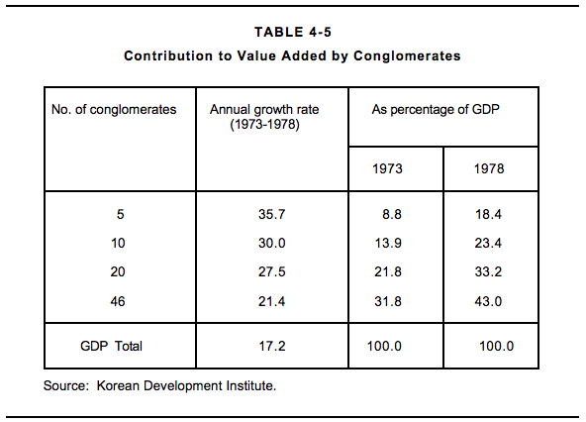
The phoenix-like rise of the chaebol[s] was mainly caused by government policies. In the earlier days of industrialization, the business environment was conducive to opportunities for forward or backward integration in industry. A broad spectrum of sectors opened up for entrepreneurs to participate in, as export demand suddenly rose in diversified areas. Access to financing was made easy, as the government provided easy credit in efforts to promote exports. Once the government was convinced the entrepreneur could succeed, this would usually have a snowballing effect, success breeding success, since the government credit was largely based on past achievements. This type of credit policy made it possible for successful entrepreneurs to launch several ventures at the same time, which eventually led to a race for empire-building in business.

IN-CLASS ACTIVITY MATERIALS
Warm-Up/Introduction

six charts that compare north and south korea today

chart 1
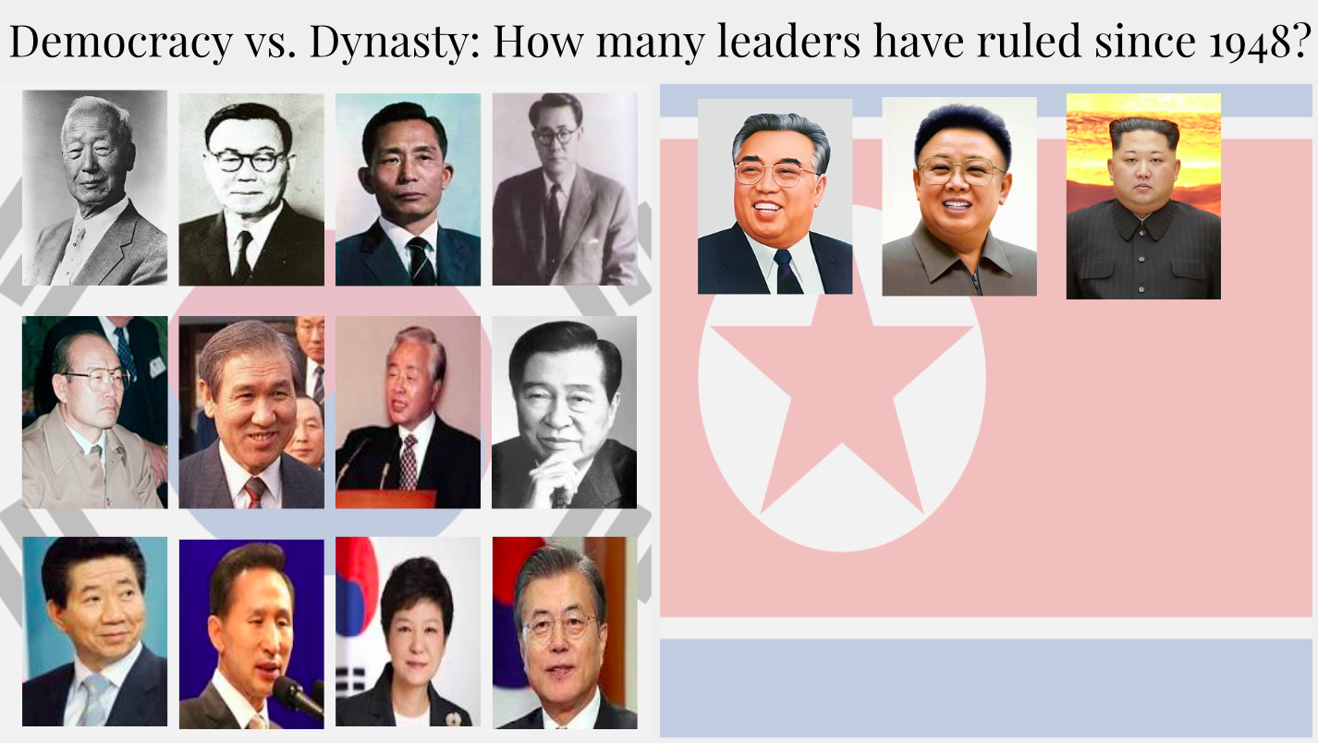
Source: CIA Fact Book

chart 2
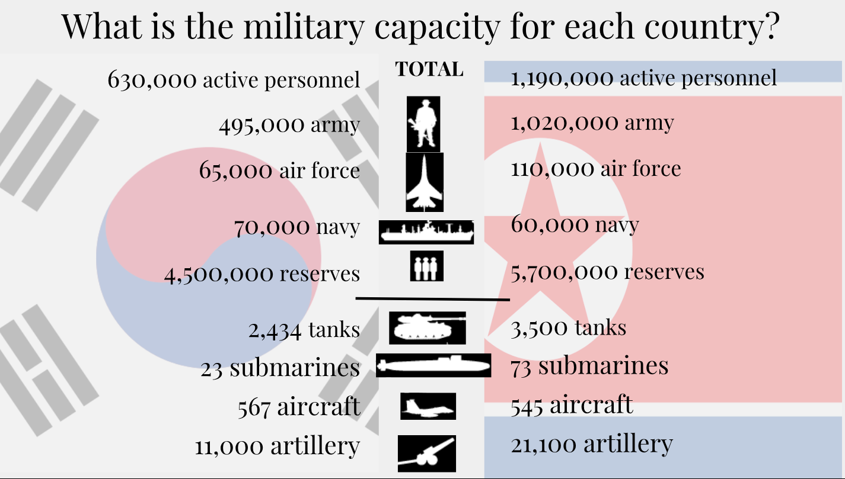
Source: Military Balance, 2017

chart 3
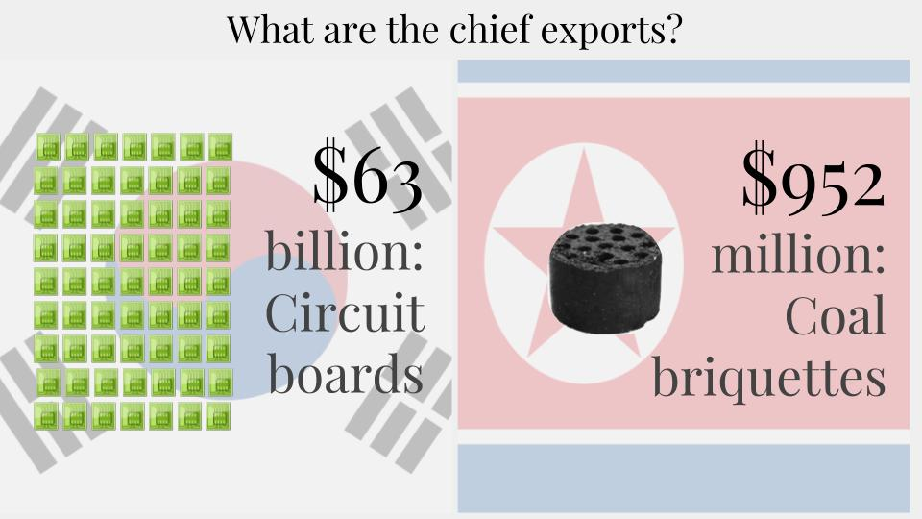
Source: Observatory of Economic Complexity

chart 4
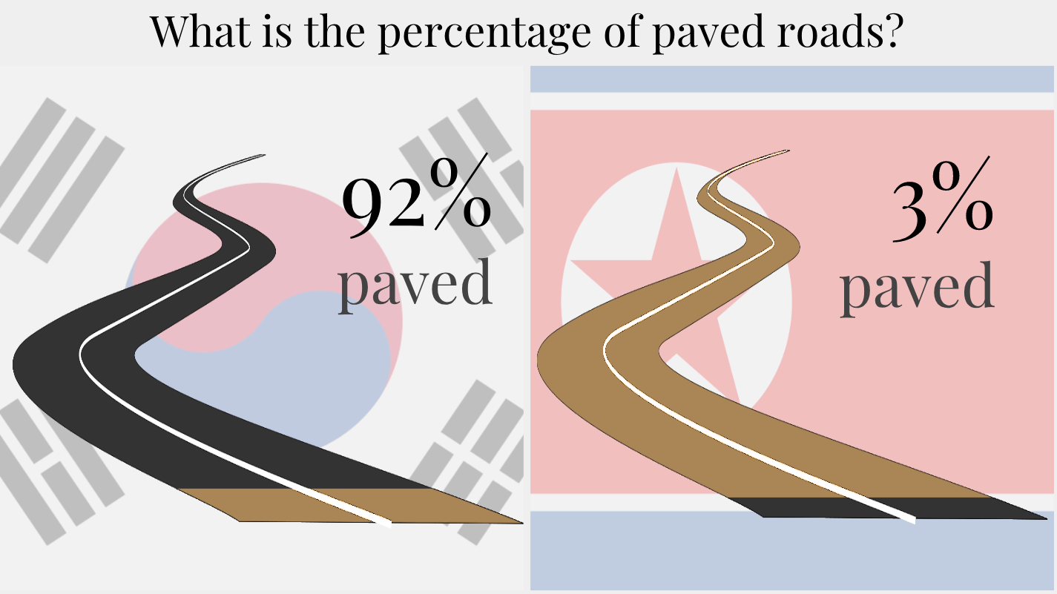
Source: CIA Fact Book

chart 5

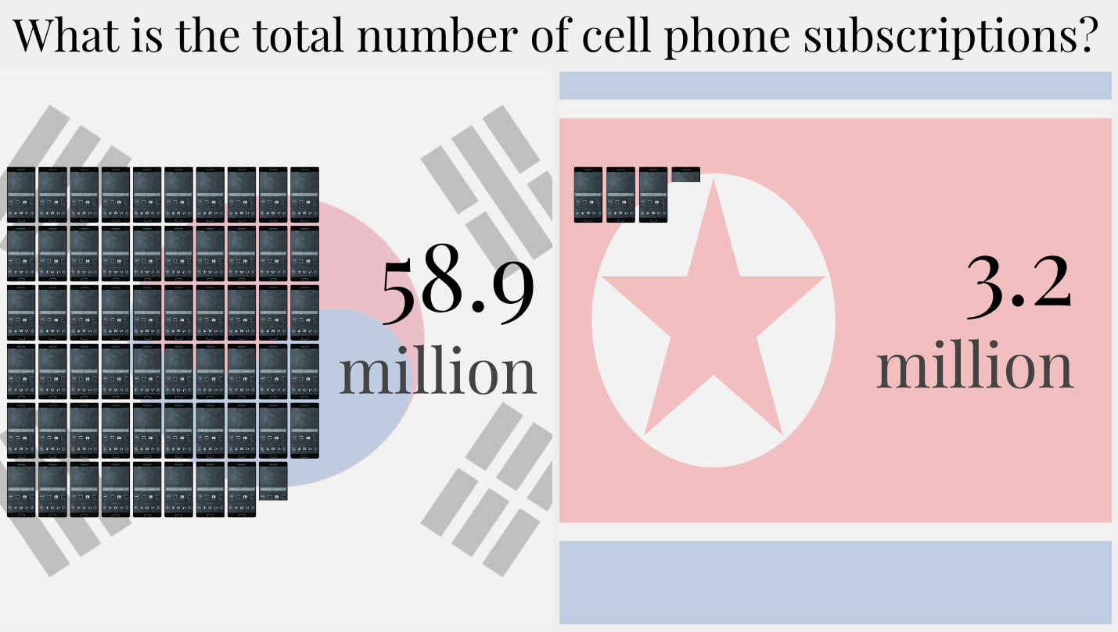
Source: CIA Fact Book

chart 6
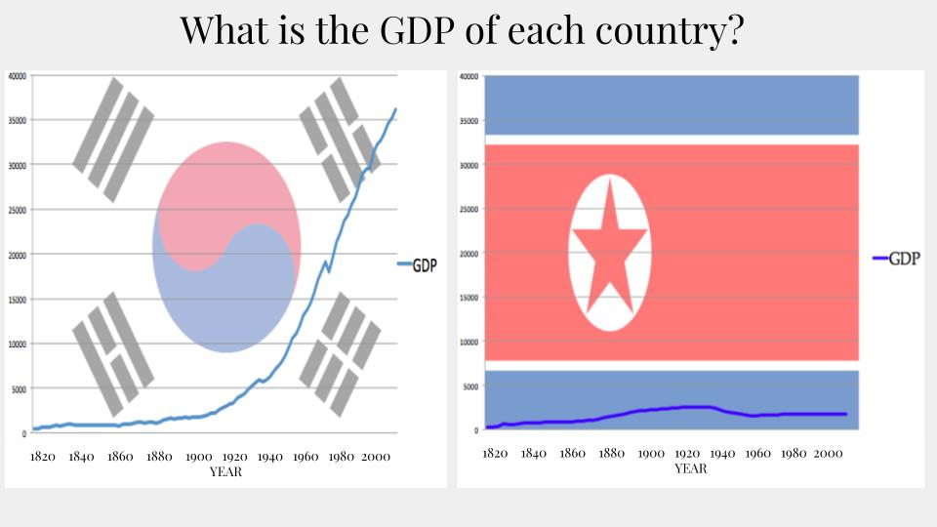
Source: The Maddison Project
In-Class Lesson Organizer

Directions
First, students will answer the question in the box labeled “Interpretation.” Second, they will list any documents supporting their interpretation in the box labeled “Evidence.” Third, they will record similarities and differences, and explain the reasons for each, in the space at the bottom of the page.

Question 1: What role did the government play in developing the economy?
NORTH KOREA | SOUTH KOREA
INTERPRETATION  EVIDENCE/DOCUMENT(S) | INTERPRETATION  EVIDENCE/DOCUMENT(S)
SIMILARITIES (WHAT and WHY?)

DIFFERENCES (WHAT and WHY)?

In-Class Lesson Organizer

Directions
First, students will answer the question in the box labeled “Interpretation.” Second, they will list any documents supporting their interpretation in the box labeled “Evidence.” Third, they will record similarities and differences, and explain the reasons for each, in the space at the bottom of the page.

Question 2: What ideologies influenced state control over the economy?
NORTH KOREA | SOUTH KOREA
INTERPRETATION  EVIDENCE/DOCUMENT(S) | INTERPRETATION  EVIDENCE/DOCUMENT(S)
SIMILARITIES (WHAT and WHY?)

DIFFERENCES (WHAT and WHY)?

ASSESSMENT MATERIALS
Long Essay Question (LEQ) Prompt
After 1900, the role of the state in the domestic economy varied. New institutions of global associations emerged and continued to develop throughout the century.
Develop an argument that evaluates the extent to which the governments of North and South Korea differed in developing their economies.

Thesis Statement:

Contextualization:

