CAUSATIon AND continuity/change MODULE OVERVIEW
SKILL: CAUSATION AND CCOT | CONTENT: AP world c.f. Key Concept 6.3 I D
This module focuses on causation and CCOT (Continuity and Change Over Time) through an examination of the political and economic development of South Korea. | Nations responded in a variety of ways to the economic challenges of the twentieth century.

D A Y 1 | How are belief systems utilized to strengthen the legitimacy of rulers or regimes?

CLASS ACTIVITY: Primary Source Investigation
Students work collaboratively to interpret a set of four sources. Students will analyze evidence to determine how several belief systems were utilized in Korea to legitimize rule.

AP-ALIGNED ASSESSMENT: Short Answer Question
Short Answer Question:
- Identify a belief system reflected in the passage provided.
- Explain how another belief system supported state-building efforts in Korea before 1450 CE.
- Explain how a belief system supported state-building efforts outside of Korea after 1450 CE.

D A Y 2 | What caused the Economic Miracle in South Korea?

CLASS ACTIVITY: Economic Miracle Mystery Investigation
Students work in jigsaw groups to analyze sources in an investigation of how South Korea was able to grow economically after the Korean War. Students are assigned one of three expert groups—corporations, government, or citizens—to explain the cause of the economic miracle in South Korea.

AP-ALIGNED ASSESSMENT: Long Essay Question
Long Essay Question: “Develop an argument that evaluates the extent to which at least one specific government in Asia guided economic development in the period after World War II.”

D A Y 3 | CLASS ACTIVITY: Teaching the Document-Based Question  Students practice up to three targeted document-based question skills: thesis writing, contextualization, and sourcing. Students then write the full essay and/or score peer essays.

AP-ALIGNED ASSESSMENT: Document-Based Question
Document-Based Question: Evaluate the extent to which Korean leaders utilized belief systems to strengthen their political power from 600 CE to the present.

Causation AND continuity/change MODULE sources

D A Y 1 | AUTHOR SOURCE DATE  - Wang Geon Ten Inunctions 943  - Anonymous Official history of the Korean Goryeo dynasty 1400  - Brian Hogarth Goryeo Buddhism 2003  - Charles Muller “Korean Buddhism: A Short Overview” 1997  - Yi Seong-gye Founding Edict 1392  - Anonymous Map of capital city, Hanyang 1822  - Mark Peterson The Neo-Confucian Foundation of the Joseon Kingdom 2009  - KWLF Chart: Confucianism and Neo-Confucianism 2018  - Park Chung-hee To Build a Nation 1971  - US Record Testimony of Ralph Clough and Bruce Cumings 1985  - Park Chang-seok Korea: From Rags to Riches 2010  - Korean Record Constitution of the Republic of Korea 1948

D A Y 2 | AUTHOR SOURCE DATE  - KWLF Images of Inchon and Busan 1950/2010  - Ahn Choong-yong “Chaebol Transformed Industry” 2010  - KWLF Introduction to Chaebols 2018  - Korean Record Constitution of the Republic of Korea 1948  - Syngman Rhee Letter to US Congressman Paul W. Shafer 1954  - Andrei Lankov “Saemaul Undong” 2012  - Park Chang-seok Korea: From Rags to Riches 2010  - Park Chung-hee To Build a Nation 1971  - Kim Dae-jung Presidential Inaugural Address 1998  - Park Chang-seok “Mr. President: A Kingpin in Nation Building” 2010

D A Y 3 | AUTHOR SOURCE DATE  - Wang Geon Ten Injunctions 943  - Xu Ching Notes from a diplomatic trip to Korea 1100  - Anonymous Official History of the Korean Goryeo dynasty 1400  - Yi Seong-gye Founding Edict 1392  - Anonymous Map of capital city, Hanyang 1822  6. Park Chung-hee To Build a Nation 1971  7. US Record Testimony of Ralph Clough and Bruce Cumings 1985

D A Y 3
Based on a 60-minute class

Lesson Question: How did Korean leaders utilize belief systems to strengthen their political power from 600 CE to the present?

AP curriculum Framework reference
Learning Objective CUL-2—Explain how religions, belief systems, philosophies, and ideologies affected political, economic, and social developments over time.
Key Concept 3.2—State formation and development demonstrated continuity, innovation, and diversity in various regions.
Key Concept 4.3.I—Rulers used a variety of methods to legitimize and consolidate their power.
Key Concept 6.2—Peoples and states around the world challenged the existing political and social order in varying ways.

Historical Reasoning Skill:
CONTINUITY AND CHANGE OVER TIME
Secondary Skills: Contextualization, Causation

OVERVIEW
This activity is designed to engage students in the particular skills involved in writing a document-based question (DBQ). Students would benefit from having had training in analyzing documents, practice in writing DBQs, and basic knowledge of belief systems such as Buddhism, Daoism, Shamanism, and especially Confucianism. Students do not need to have extensive knowledge of Korean history, although the activity for Day 1 serves as a strong content introduction to this DBQ activity. Students will have the entire class period to engage with the skills involved in writing and evaluating the DBQ, which comprises 25% of their AP World History exam score. Teachers can adapt this lesson as needed by asking students to write a full DBQ, using these directions to review the tasks needed for achievement, or by having students use the DBQ rubric to score the sample responses provided.

Materials needed for:
Homework
- Question 1 (Document-Based Question) (p. 7)
In-Class Activity
- Question 1 (Document-Based Question) (p. 7)
- Sample DBQ essays A (pp. 15-18), B (pp. 19-22), C (pp. 23-27), D (pp. 28-29), and E (pp. 30-31)
- DBQ Rubric (p. 12)
- DBQ Score Justifications (pp. 13-14)
- Highlighters in yellow, green, and pink (if possible)

SEQUENCE OF INSTRUCTION

HOMEWORK OVERVIEW
HOMEWORK (30 MINUTES):
Document-Based Question (p. 7)
1. Students will read the document-based question on belief systems and political power in Korea. In addition, for homework, students should write an introductory paragraph for contextualization and the thesis. In class, students will review their approaches and evaluate sample student essays.
The homework has two purposes:
- To prepare students to evaluate sample student responses for this DBQ.
- To have students gain practice in two of the essential tasks for the DBQ.

Teacher Notes
If teachers are not able to assign the DBQ as homework, students can take time in class to read the DBQ to prepare for reading the sample essays. With this approach, students will not have time to write their own thesis and contextualization statements unless this lesson is carried over more than one class period.

Teaching Tip
Teachers may want their students to practice writing the full DBQ rather than writing only the thesis and contextualization. Teachers can assign the DBQ as homework, but students gain most by writing the DBQ in class under conditions that more closely approximate what they will encounter on test day. Teachers might also assign more than just the thesis and contextualization tasks as homework; for example, students could also compose sourcing statements and one or two pieces of evidence beyond the document. This lesson has been designed for flexibility so that teachers can make decisions based on their students’ needs.

CLASS ACTIVITY 1 OF 4: WARM UP/INTRODUCTION
WARM UP / INTRODUCTION (5 MINUTES):
Students will share their theses and contextualization writings (assigned as homework) with a partner. The pairs will compare their different approaches, recognizing that multiple approaches can be effective for any DBQ. Teachers can solicit one or two students to share their thesis and contextualization homework to the class either by reading it aloud to the class or using a document camera (so students can read along).

Teacher Notes
Later in the lesson, students will read sample student essays in order to score them. Consequently, teachers do not need to praise or criticize the student homework during this warm-up activity.

Teaching Tip
Teachers also have the option of asking the students to turn in their homework assignments. Since the goal of the lesson is to help students focus their writing for the DBQ, teachers might ask students to revise their homework statements based on what they learned about effective claims.

CLASS ACTIVITY PART 2 OF 4: SCORING SAMPLE ESSAYS
SCORING SAMPLE ESSAYS (40 MINUTES):
Students will read the sample DBQ essays A (pp. 15-18), B (pp. 19-22), C (pp. 23-27), D (pp. 28-29), and E (pp. 30-31). The DBQ Rubric (p. 12) and DBQ Rubric Worksheet (p. 12) will assist students in identifying the various points that the essays earn. When scoring the essays, students should use colored highlighters to identify the main thesis and supporting arguments/claims (yellow highlighter), document-based evidence used to support a claim (green highlighter), and contextualization and sourcing (pink highlighter).

Teacher Notes
Students should read and mark up the essays individually. If highlighters are not available, students can put notes in the margins to correspond to the various elements of the rubric. Some students might spent a great deal of time scoring each essay. Teachers should help students manage their time by suggesting when to wrap up their scoring of one essay and move on to the next.

Teaching Tip
Teachers could have students pair-read essays in order to help students articulate their reasons for awarding rubric points. This approach may take more time but yield better understanding. If time is limited, teachers could select three essays from the five provided, being sure to choose a range of different scores so students can compare lower- and higher-scoring work.

CLASS ACTIVITY 3 OF 4: DEBRIEF
DEBRIEF (10 MINUTES):
After 40 minutes of reading and scoring the essays, students should be given access to the DBQ Score Justifications (pp. 13-14) in order to compare the scores.
Students will return to the whole group after having scored the essays and reviewing the scoring justifications. Teachers will then lead a discussion of the exercise, focusing on what students learned about how to write more effective DBQ essays.

Teacher Notes
In this discussion, teachers should help students focus on broader lessons rather than narrower points pertinent to a single essay. For example, when students mention something overly specific, teachers should respond, “How does that guide you to writing a more effective essay? How could you make your own essays better?”

Teaching Tip
Teachers can guide the discussion through the questions such as, “Before reading the DBQ sample justifications, I thought______. Now I think______.”

CLASS ACTIVITY 4 OF 4: ASSESSMENT/CHECK FOR UNDERSTANDING
ASSESSMENT (5 MINUTES):
Students will revise the thesis and contextualization statements that they wrote for homework in order to increase the complexity of their statements in light of the sample essays and scores that they reviewed in class.

IN-CLASS ACTIVITY MATERIALS
Document-Based Question
Suggested reading and writing time: 1 hour
You should spend 15 minutes reading the documents and 45 minutes writing your response.
Note: You may begin writing your response before the reading period is over.

Directions
Question 1 is based on the accompanying documents. The documents have been edited for the purpose of this exercise.
In your response, you should do the following.
- Respond to the prompt with a historically defensible thesis or claim that establishes a line of reasoning.
- Describe a broader historical context relevant to the prompt.
- Support an argument in response to the prompt using specific and relevant examples of evidence from at least six documents.
- For at least three documents, explain how the author’s point of view, author’s purpose, historical situation, and/or audience is relevant to an argument.
- Explain how at least one additional piece of historical evidence beyond those found in the documents relates to an argument about the question.
- Use evidence to corroborate, qualify, or modify an argument that addresses the prompt.

- Evaluate the extent to which Korean leaders utilized belief systems to strengthen their political power from 600 CE to the present.

DOCUMENT 1
SOURCE: Wang Geon, first king of the Korean Goryeo dynasty (918-1392), Ten Injunctions, 943 CE.
1. The success of every great undertaking of our state depends upon the favor and protection of Buddha. Therefore, the temples of both the Meditation and Doctrinal schools should be built and monks should be sent out to those temples to minister to Buddha.
2. Temples and monasteries were newly opened and built upon the sites chosen by the monk Tosǒn according to the principles of geomancy.* He said: “If temples and monasteries are indiscriminately built at locations not chosen by me, the terrestrial force and energy will be sapped and damaged, hastening the decline of the dynasty.”
6. I deem the two festivals of Yondung and P’algwan of great spiritual value and importance. The first is to worship Buddha. The second is to worship the spirit of Heaven, the spirits of the five sacred and other major mountains and rivers, and the dragon god.
* Geomancy is the belief that the Will of Heaven came from a certain arrangement of mountains, near a certain part of a river, and from facing ideal directions.
Peter H. Lee and William Theodore de Bary, eds., with and Yôngho Ch'oe Hugh H.W. Kang. Sources of Korean Tradition, Vol. 1: From Early Times Through the Sixteenth Century (Introduction to Asian Civilizations), Columbia University Press, 1996. Used with permission of Columbia University Press.

DOCUMENT 2
SOURCE: Xu Ching, a Chinese official, recorded these notes following an official diplomatic trip to Korea, early 1100s.
Korea is on the shores of the Eastern Sea, which must be situated not far from the Daoist mountains and the Islands of the Immortals. King Yejong, a devout believer in religion, started to construct a Daoist temple to receive more than ten eminently accomplished Daoist priests. Some said that when King Yejong reigned over Korea, he was constantly bent on supplying Daoists with books, wishing to replace Buddhism with Daoism. Although he never realized that goal, he seemed to have expected it to happen.
Peter H. Lee and William Theodore de Bary, eds., with and Yôngho Ch'oe Hugh H.W. Kang. Sources of Korean Tradition, Vol. 1: From Early Times Through the Sixteenth Century (Introduction to Asian Civilizations), Columbia University Press, 1996. Used with permission of Columbia University Press.

DOCUMENT 3
SOURCE: History of King Injong (1133-1146), from the Official History of the Korean Goryeo Dynasty written in the early 1400s.
The official astrologer wrote to the King: “Recently as shamanism has been widely practiced, its indecent sacrifices have increased daily. I request the king to instruct the offices concerned to expel all the shamans.” The request was granted. Many shamans were grieved by this. The powerful officials thereupon wrote the king: “Spirits being formless, we cannot know whether they are fake or real. To ban then completely is never advantageous.” The king, agreeing with this argument, rescinded the earlier prohibition.
Peter H. Lee and William Theodore de Bary, eds., with and Yôngho Ch'oe Hugh H.W. Kang. Sources of Korean Tradition, Vol. 1: From Early Times Through the Sixteenth Century (Introduction to Asian Civilizations), Columbia University Press, 1996. Used with permission of Columbia University Press.

DOCUMENT 4
Source: Yi Seong-gye, the first king of the Joseon dynasty (1392-1897), Founding Edict, 1392.
It is Heaven which created all the people of the Earth, Heaven which ordains their rulers, Heaven which nurtured them to share life with each other, and Heaven which governed them so as to enjoy peace with one another. There have been both good and bad rulers, and there have been times when people followed their rulers willingly and other times when they turned against them. Some have been blessed with the Mandate of Heaven and others have lost it. This is a principle that has remained constant.
The Privy Council and all ranks of officials together urged me to take the throne, saying: “The ancestral shrines and institutions should only be entrusted to one who is worthy, and the throne must not be left vacant for long. People’s minds are all looking up to your meritorious achievements and virtue, and you should accept the throne to rectify the situation, thereby satisfying the people’s desire.” Because the people insisted so steadfastly, I yielded finally to their will and ascended the throne.
Peter H. Lee and William Theodore de Bary, eds., with and Yôngho Ch'oe Hugh H.W. Kang. Sources of Korean Tradition, Vol. 1: From Early Times Through the Sixteenth Century (Introduction to Asian Civilizations), Columbia University Press, 1996. Used with permission of Columbia University Press.

DOCUMENT 5
SOURCE: Map of capital city, Hanyang, in 1822, illustrated in this recreation of a woodblock print (modern-day Seoul).
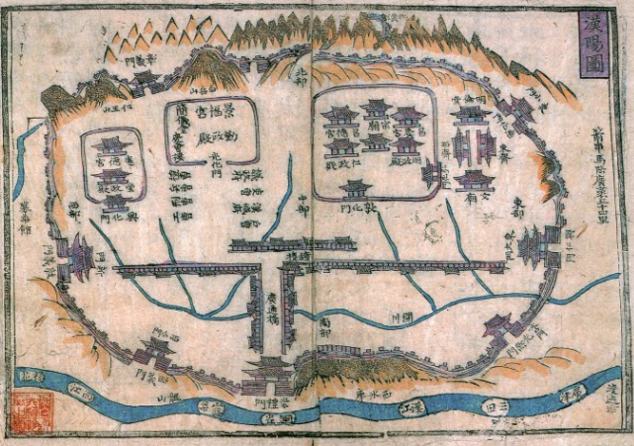
The map shows the main Confucian political institutions—such as the king’s palaces, the Confucian National University, the Confucian Ancestral Shrine, and the Six Ministries—all surrounded by mountains and rivers in a harmonious arrangement.

DOCUMENT 6
SOURCE: Park Chung-hee, president of South Korea from 1963 until his assassination in 1979, To Build a Nation, 1971.
Meanwhile, we organized a planning committee of college professors and experts with specialized knowledge in many fields. By mobilizing the maximum available expertise for government administration and policy making, we intended to hold in check the arbitrariness and rashness of the military officers. The establishment of this committee served as a turning point. Korean professors began to show positive interest in the realities of the country and to present policy recommendations on the basis of scientific analyses of the country’s situation. Even though not all of these recommendations could be justified in terms of efficiency and rationality, their advice was of great help to the revolutionary government. Thus the Confucian tradition of Yi Korea, in which scholars played a positive part in governmental affairs, seems to have been revived.

DOCUMENT 7
SOURCE: Ralph Clough and Bruce Cumings, American professors of Korean studies, testimony to the US House of Representatives Committee on Foreign Affairs, Subcommittee on Asian and Pacific Affairs, March 5, 1985.
US Congressional Representative Stephen Solarz: Why have students in Korea been the locomotive, or the engine, of political change in the country?
Professor Ralph Clough: I think this goes back to the period of Japanese control when students were active in demonstrating against the Japanese colonialism of that time.
Solarz: But the students of those days are the grandparents of today. I have the impression that over time in every decade and generation it seems to be the students who are in the forefront of the demand for political reform and democratization. Are there cultural factors that explain that?
Clough: I think so. I think it was the fact that students were in the forefront of modernization in Korea in that period, but perhaps Professor Cumings would like to comment.
Professor Bruce Cumings: I think there is a tradition that perhaps goes back even further than that, and that’s the Confucian dictum that intellectuals and students should be a moral force in society. I think students inherited that tradition, but I also think they’re free to protest up to a point, free to protest in a way that almost no one else in South Korean society is. You have the universities as sanctuaries against the regime, (but often the regime will move troops on campus—6,000 troops on campus last November) and, second, the churches. So the churches and the students have been in the forefront because they have a certain capacity to confront the regime.

rubric: document-based question (dbq)

thesis and contextualization—2 points
1 point  CONTEXTUALIZATION: Explains the broader historical events, developments, or processes immediately relevant to the question. | 1 point  THESIS: Responds to the prompt with a historically defensible thesis/claim that establishes a line of reasoning. The thesis must consist of one or more sentences located in one place, in the introduction or the conclusion.

Document Analysis: Analyzing historical evidence, and proper sourcing—3 points
2 points  Utilizes the CONTENT of the documents  to support a stated argument.  3 documents used = 1 point  6 documents used as evidence = 1 point | 1 point  SOURCING: Explains how or why the document’s HIPP* is relevant to an argument about the prompt; uses AT LEAST three of the documents.  *Historical Situation, Intended Audience,  Purpose, and Point of View
Circle if students merely describe or reference. Checkmark Doc. Evidence when students use to support argument
Document 1 ____ Doc. Evidence ____ Historical situation / Intended audience / Purpose / POV
Document 2 ____ Doc. Evidence ____ Historical situation / Intended audience / Purpose / POV
Document 3 ____ Doc. Evidence ____ Historical situation / Intended audience / Purpose / POV
Document 4 ____ Doc. Evidence ____ Historical situation / Intended audience / Purpose / POV
Document 5 ____ Doc. Evidence ____ Historical situation / Intended audience / Purpose / POV
Document 6 ____ Doc. Evidence ____ Historical situation / Intended audience / Purpose / POV
Document 7 ____ Doc. Evidence ____ Historical situation / Intended audience / Purpose / POV

Using Evidence Beyond the Documents—1 point
OUTSIDE INFORMATION: Uses at least one additional piece of specific historical evidence (beyond that found in the documents) relevant to an argument about the prompt.

Complex Understanding—1 point
COMPLEXITY: Demonstrates a complex understanding of the historical development that is the focus of the prompt, using evidence to corroborate, qualify, or modify an argument that addresses the question. Ways to earn this point include:
- Explaining the nuances of an issue by analyzing multiple variables.
- Explaining similarity and difference, continuity and change, multiple causes, or causes and effects.
- Explaining relevant and insightful connections within and across periods connected to an argument or claim.

dbq score justifications

Question 1: Evaluate the extent to which Korean leaders utilized belief systems to strengthen their political power throughout from 600 CE to the present. 7 total points.
Sample A
- The thesis is contained in the last two sentences of the first paragraph. 1 point
- The broader historical context starts in the fourth sentence of the first paragraph with the cultural influence from China and Japan and then the split of Korea as a result of the Cold War. 1 point
- The essay uses six documents to support arguments: kings used religion to maintain and strengthen rule (documents 1, 2, 3, and 5), kings used religion to justify rule (document 4), patterns of rulers using religion changed after the South and North Korea split (document 6). Document 7 is not referenced in this essay. 2 points
- An additional piece of relevant outside evidence appears on the fourth page, when North Korea’s communism is used as a reason for North Korean leaders not using religion to support their rule. 1 point
- The essay provides sourcing information for four documents: document 1 (historical situation), document 2 (author’s point of view), document 3 (purpose/author’s point of view), and document 4 (purpose). 1 point
- The last paragraph also provides a modification of the argument with a sophisticated explanation of the differences between North and South Korean rulers’ uses of religion. This essay achieves this level of complexity through qualifying the central argument. 1 point
Total Score: 7
Sample B
- The thesis is set forth in the entire first paragraph. 1 point
- The broader context is found in the second paragraph. Its relevance to the prompt is described in the last sentence of the second paragraph. 1 point
- The essay supports an argument using six documents: ruling systems utilize belief systems to justify and strength their power (documents 1 and 4), policies were used to revive Confucian tradition (document 6), students’ power was justified by Confucianism (document 7), King Yejong spread Daoism to strengthen his rule (document 2), kings did not always find religions helpful (document 3). 2 points
- An additional piece of outside evidence appears at the bottom of page 2 with the connection to the Chinese Mandate of Heaven. 1 point
- The essay provides sourcing information for four documents: document 1 (point of view), document 2 (point of view), document 4 (point of view and purpose), and document 6 (point of view). 1 point
- The essay qualifies the central argument in two places: when discussing how students, like rulers, found belief systems helpful to maintain (bottom of page 3), and in noting that some aspects of belief systems were not favored by the rulers (bottom of page 4). 1 point
Total Score: 7

Sample C
- The thesis appears in the second sentence of the first paragraph. 1 point
- The broader context appears in the second paragraph. Its relevance to the prompt is shown in the last sentence at the bottom of page 1. 1 point
- The essay supports an argument through the use of seven documents. 2 points
- The essay provides sourcing information for three documents: document 4 (purpose), document 6 (historical situation), and document 7 (historical situation). 1 point
- The uses of outside historical information on page 5 are associated with the sourcing for document 6 and 7. Since no part of an essay can count for more than one point, this essay does not receive the point for outside historical information. The essay in the last paragraph attempts to add complexity with the statement, “religion supported by the government doesn’t always strengthen their rule.” The complexity point should involve an argument that is carried through more than just one reference.
Total Score: 5
Sample D
- A weak thesis is contained in the first paragraph starting with the second sentence. The thesis is better stated in the last sentence of the essay. 1 point
- The essay attempts to provide broader historical context with the first sentence. What follows does not count as context, since it is much too vague and limited.
- The essay uses six documents to support an argument linking belief systems to political legitimacy. 2 points
- No outside information is provided in the essay.
- The essay has two successful pieces of sourcing. First with documents 1 by saying, “this would be very important to Geon, as his dynasty was a new one” (historical situation) and secondly with document 3, which explains King Injong’s approach as being influenced by the stability of his regime (historical situation). Essays need to deploy sourcing for three documents in order to earn the point.
Total Score: 3
Sample E
- The thesis is concisely presented in the last sentence of the first paragraph. 1 point
- The essay presents broader historical context in the first paragraph. The relevance to the question is bridged in the sentence immediately before the thesis. 1 point
- The essay only uses three documents individually in order to support an argument: documents 1, 5, and 6. Analyses for documents 2 and 3 are combined together, which does not represent the best way to provide specific and relevant evidence from a document. Since the essay provides correct information from at least three documents, only one out of the two points is earned for document evidence. 1 point
- The last paragraph of the essay attempts to provide outside information by explaining the historical context of the document. The outside information should be more tied to the argument in order to earn the evidence beyond the document point.
- The essay provides one example of sourcing information (document 6) at the end of the essay (historical situation).
- The essay in the last paragraph attempts to add complexity with the sentence of the essay. The complexity point should involve an argument that is carried through more than just one reference.
Total Score: 3

SAMPLE ESSAYS

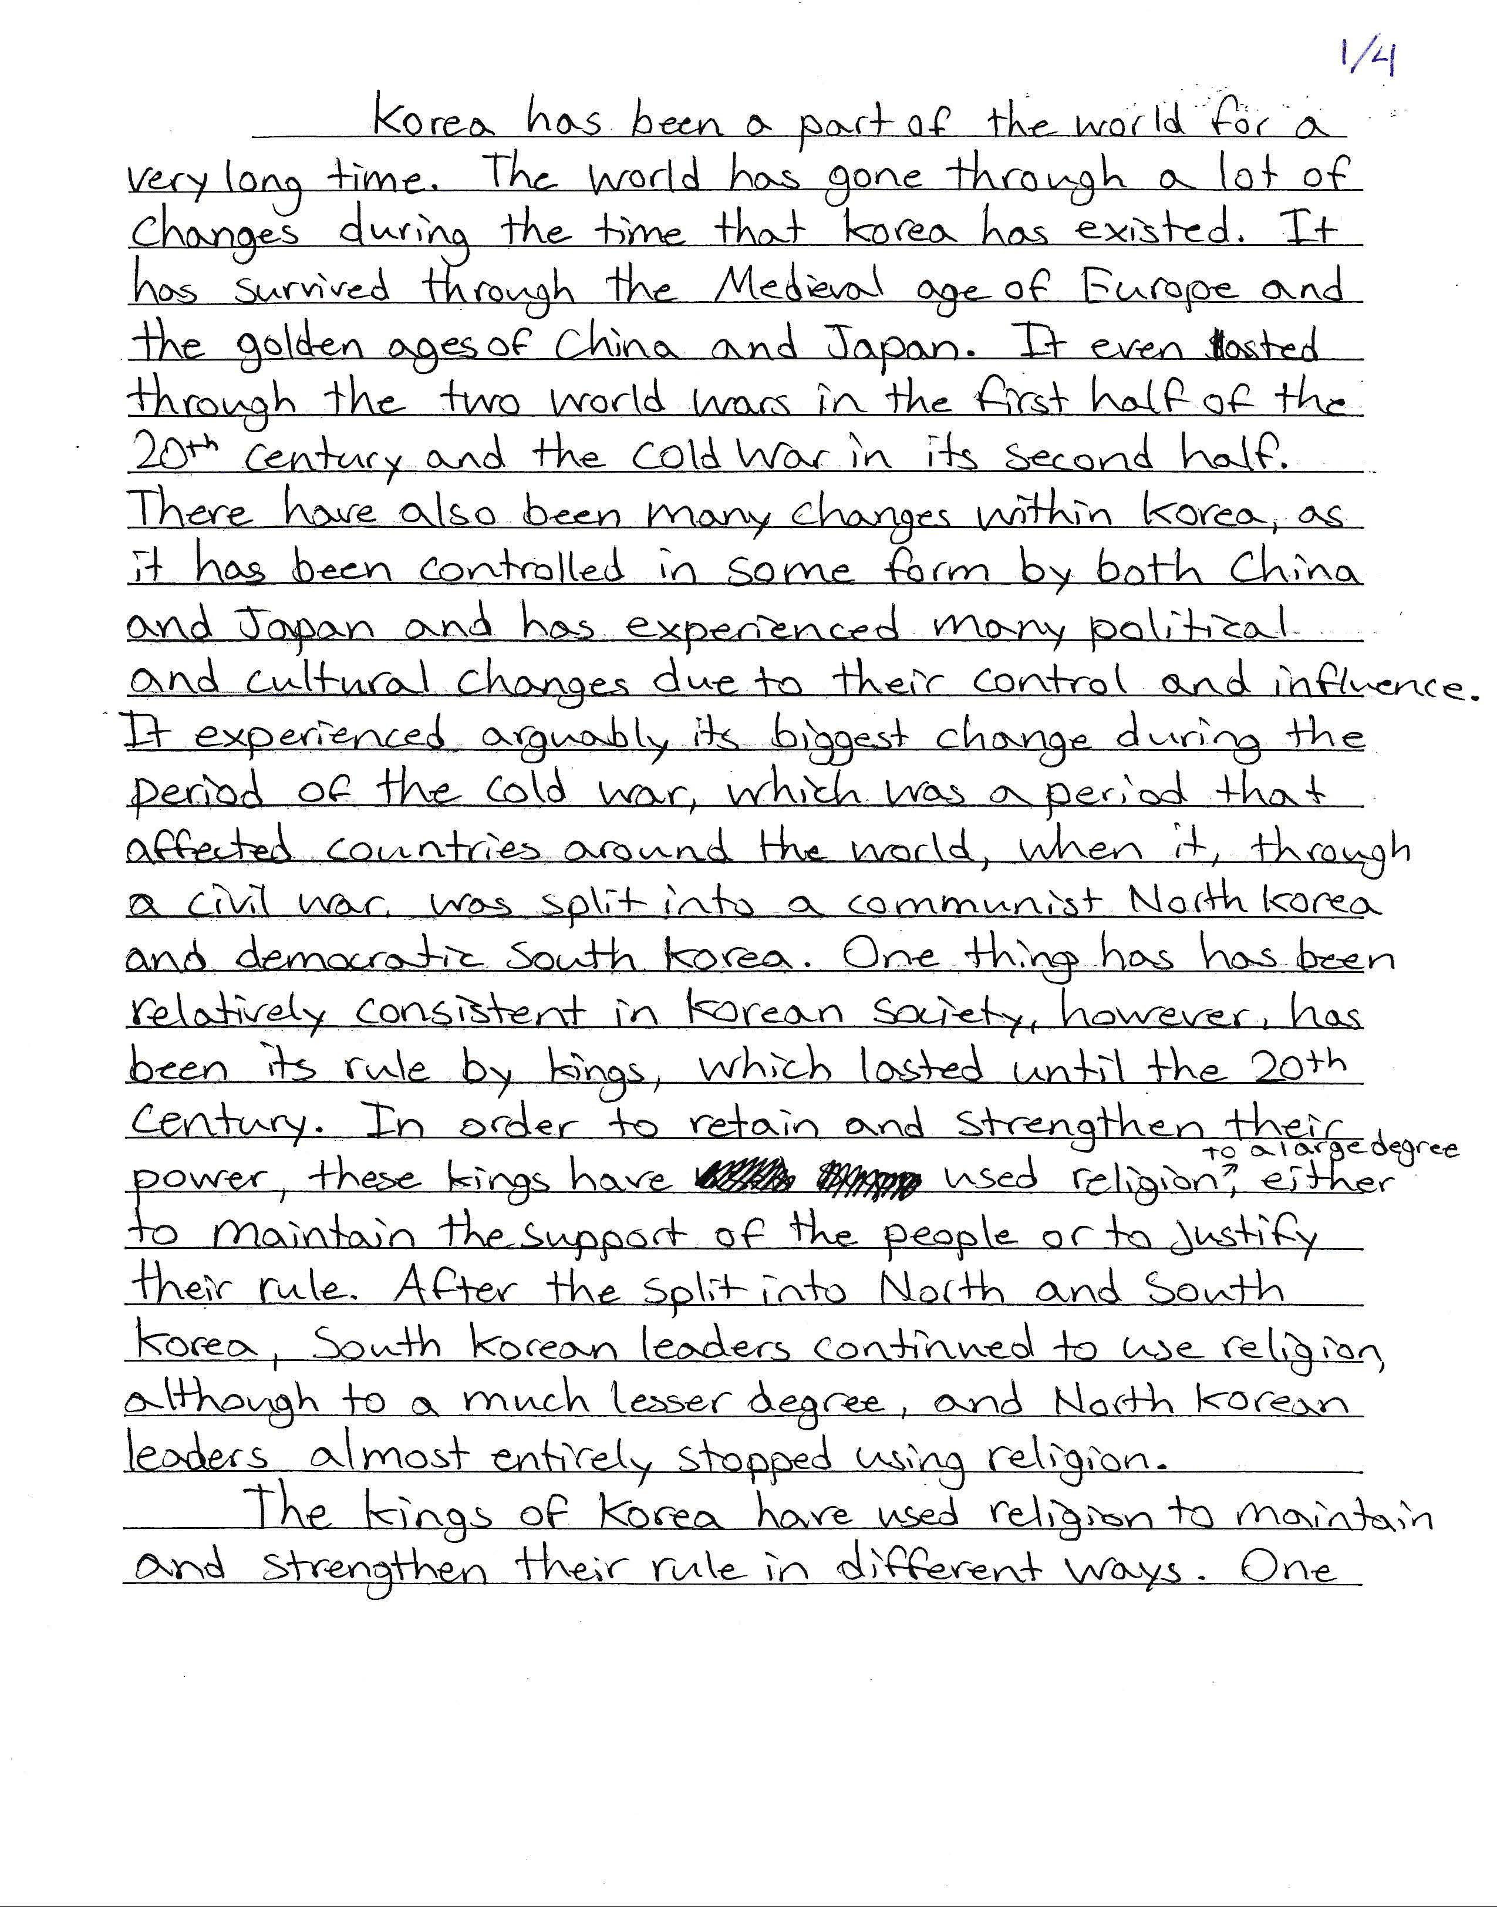
SAMPLE A
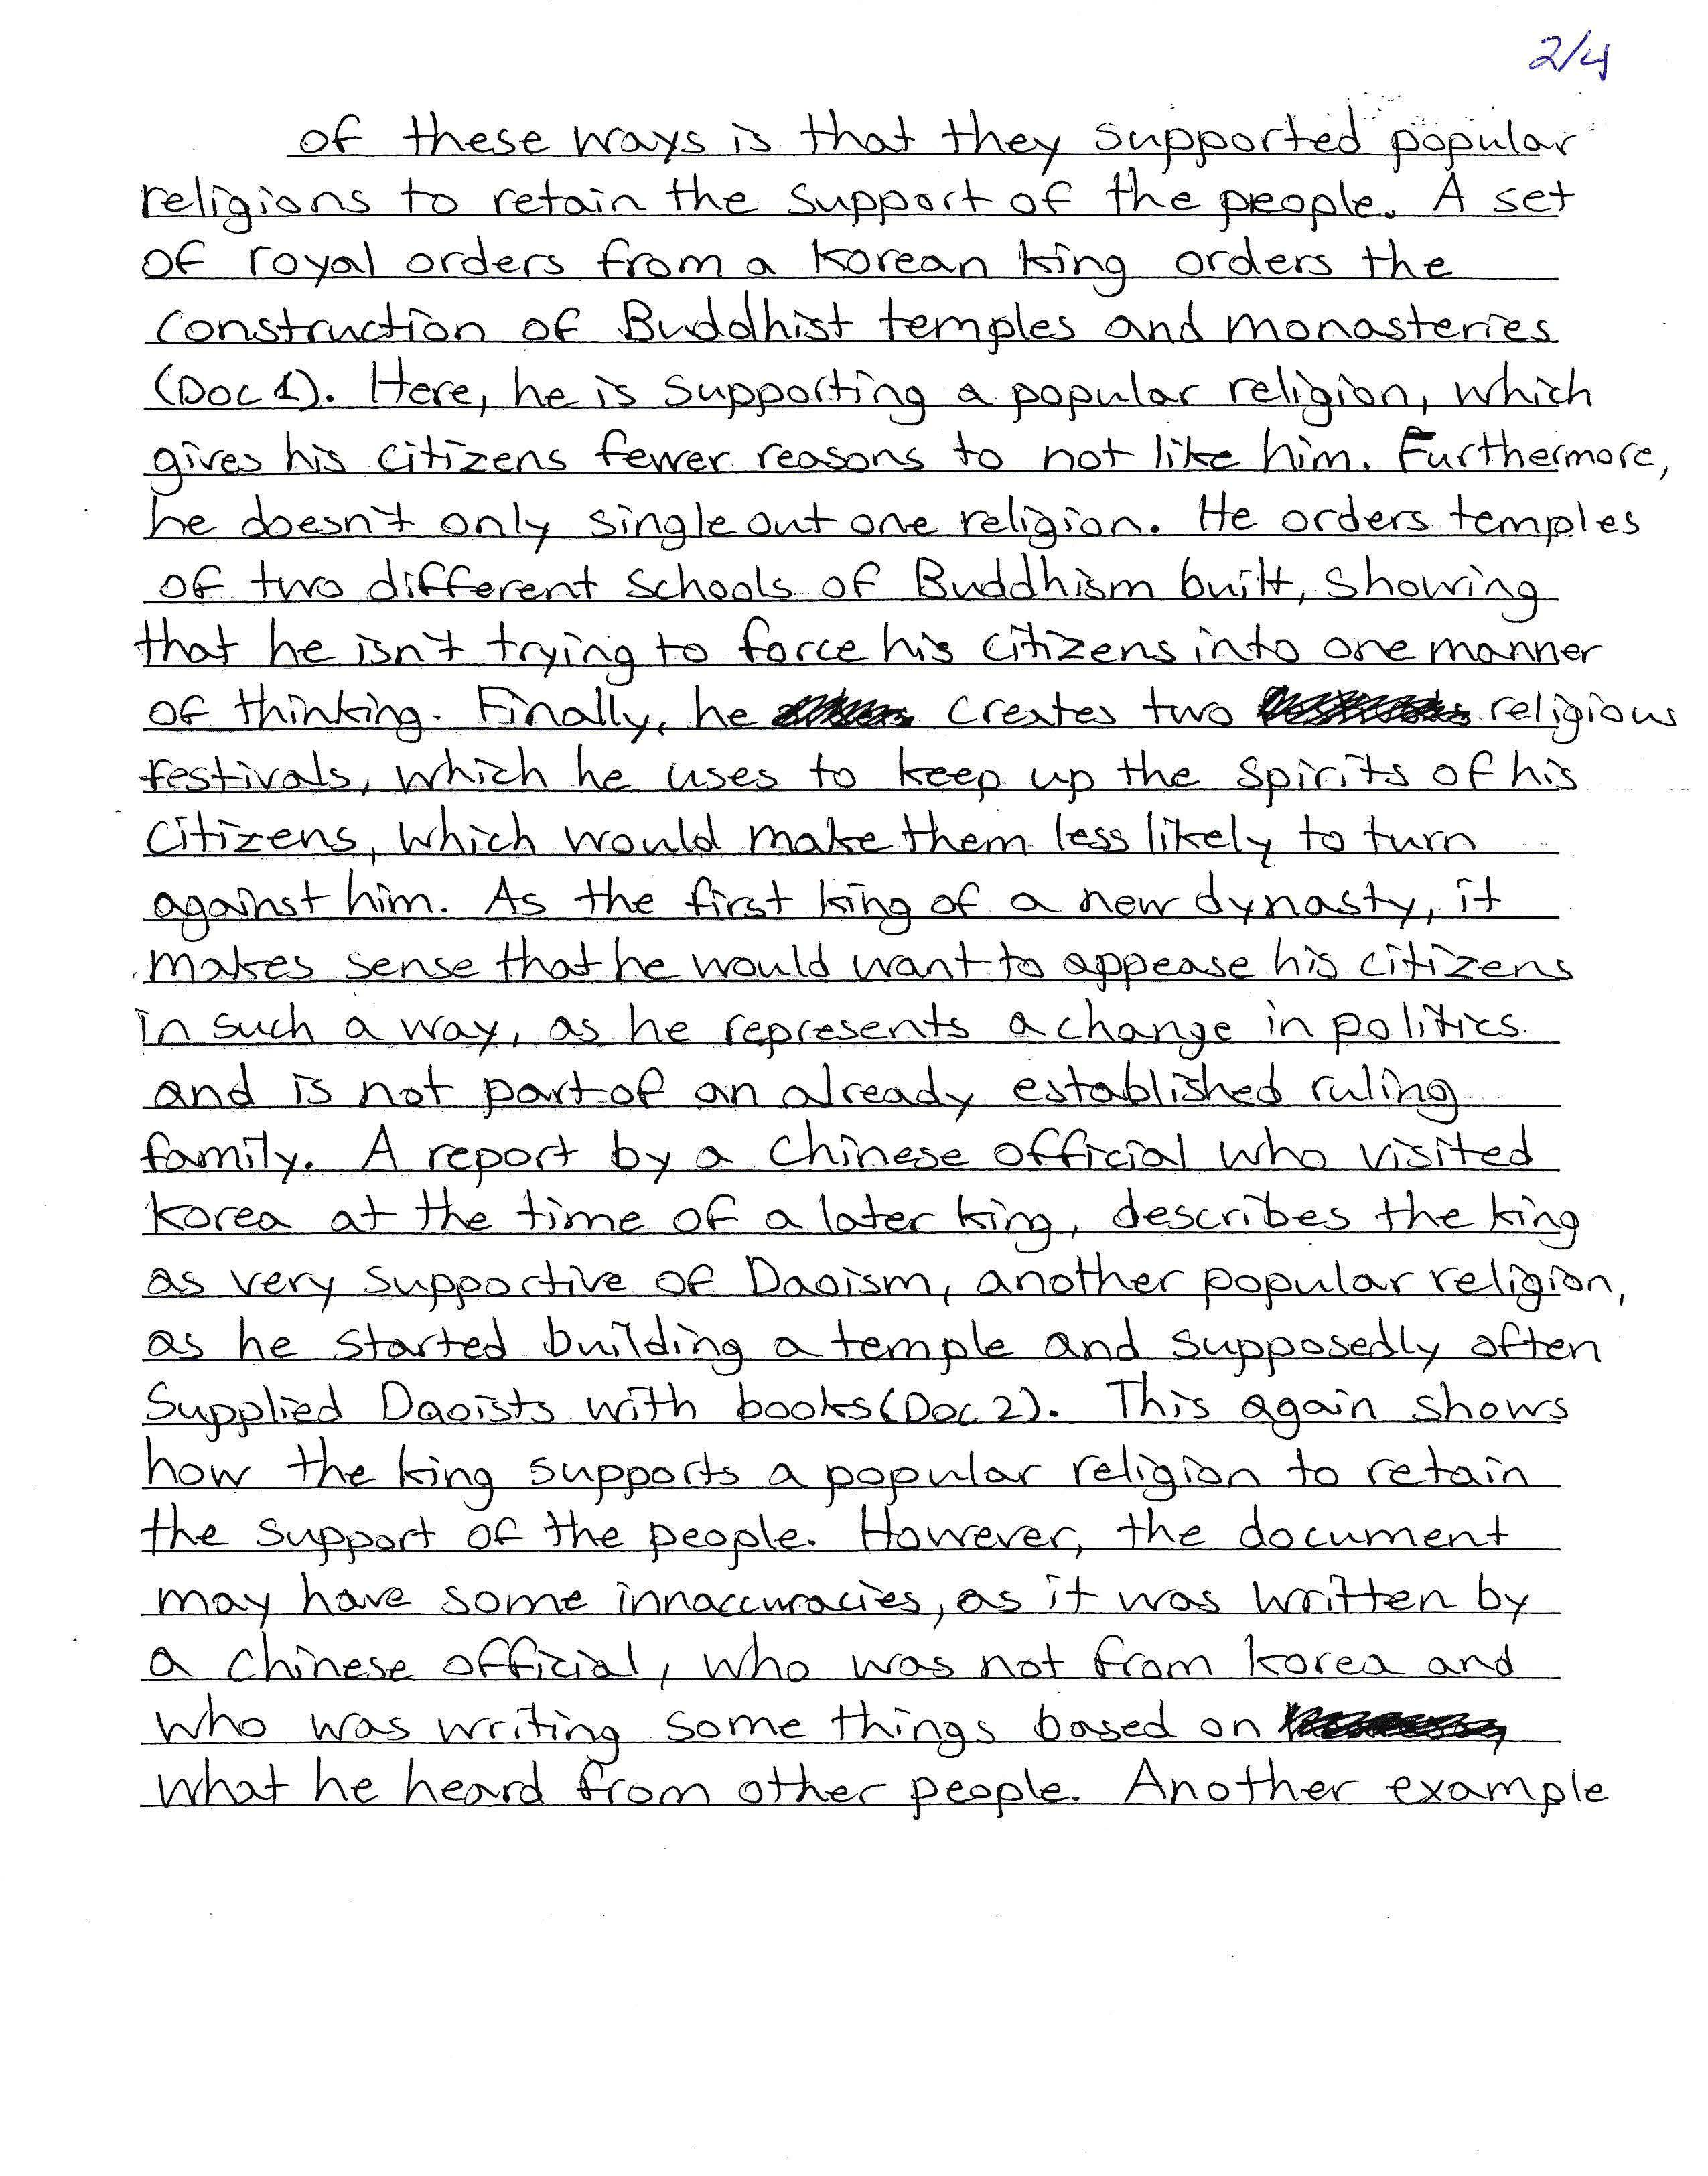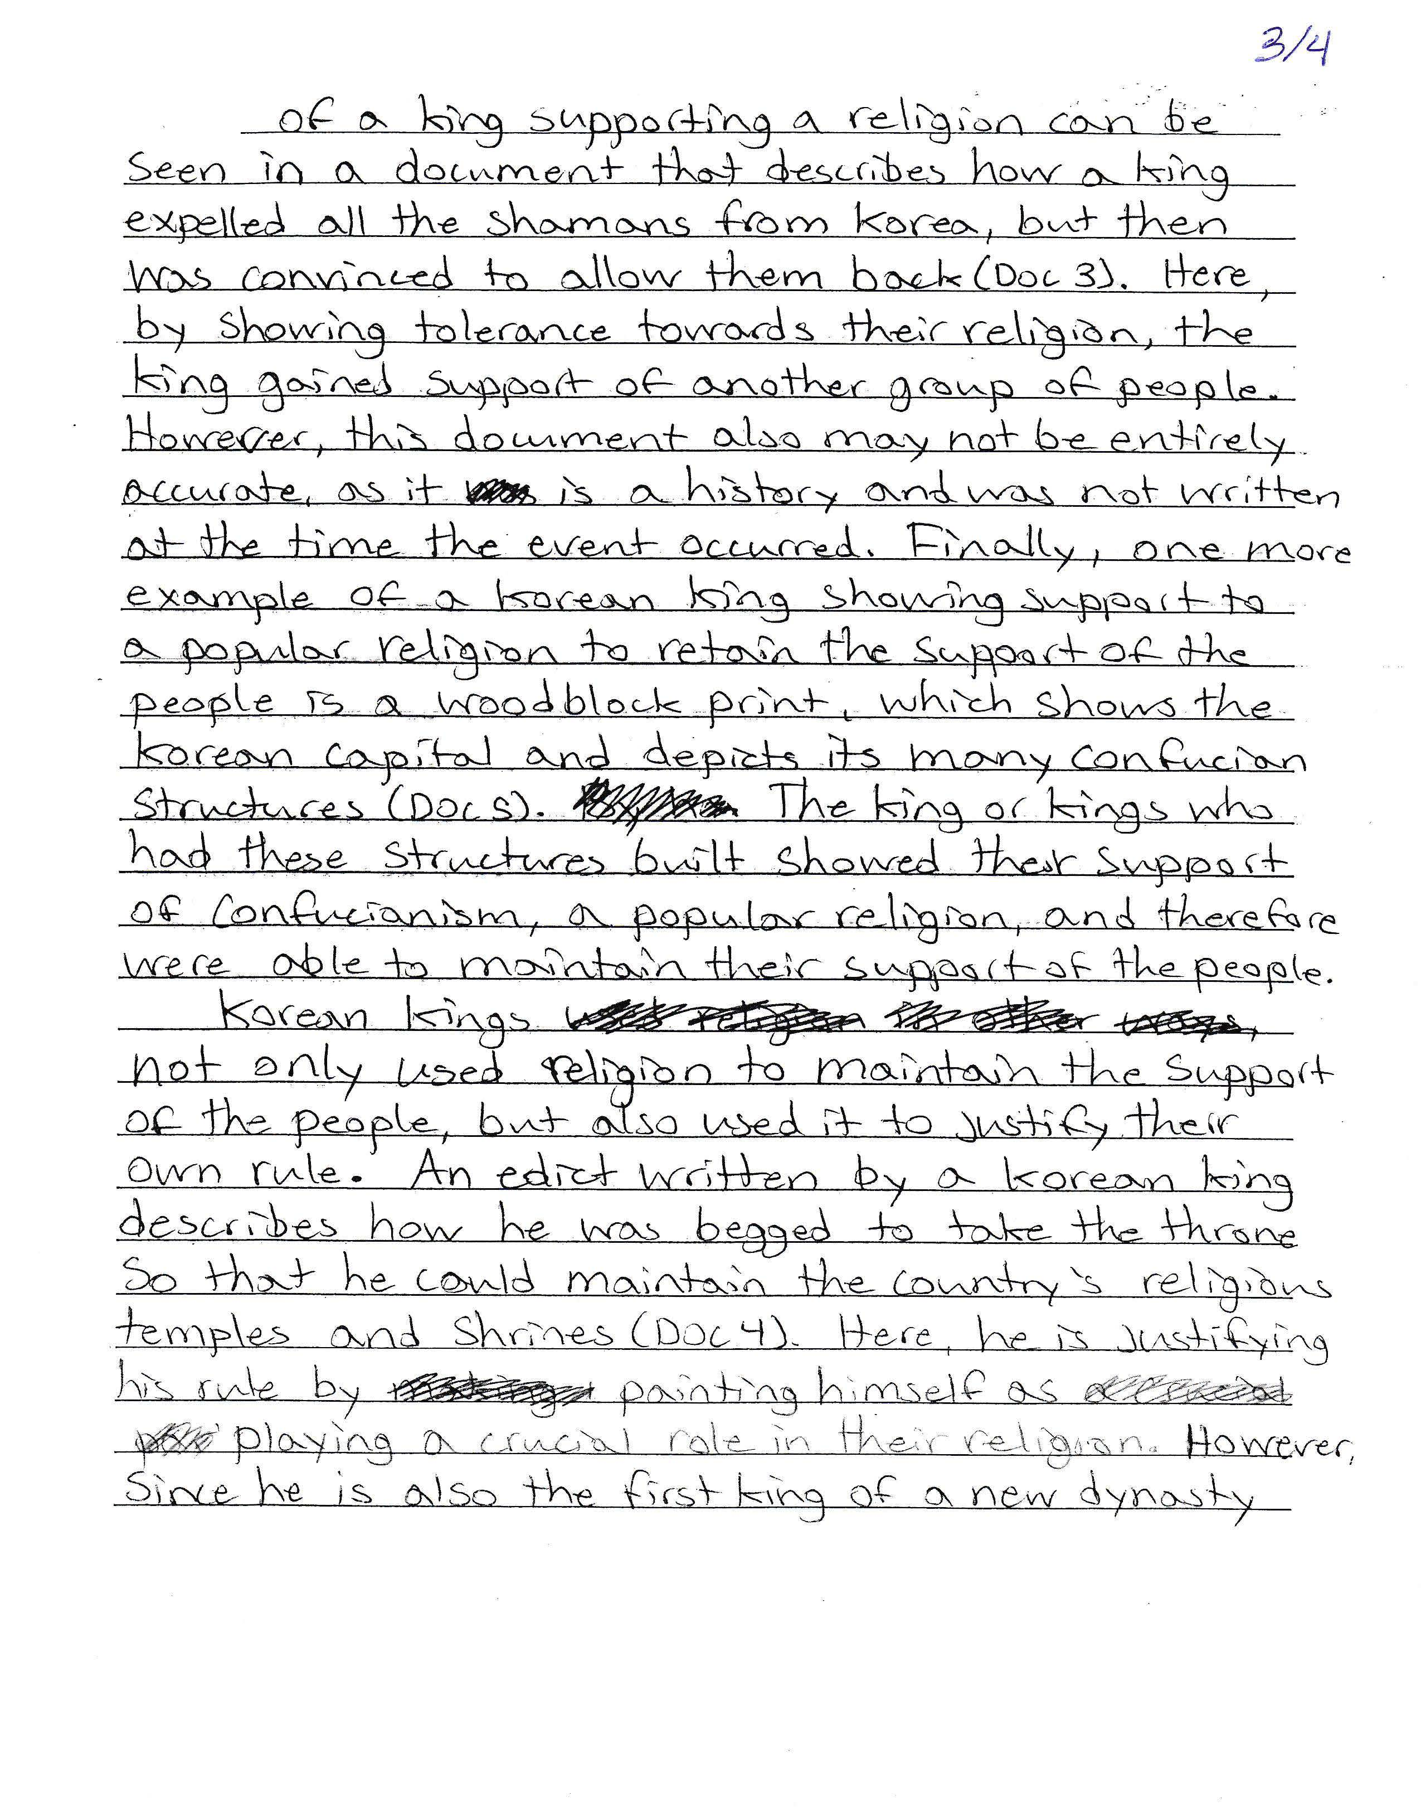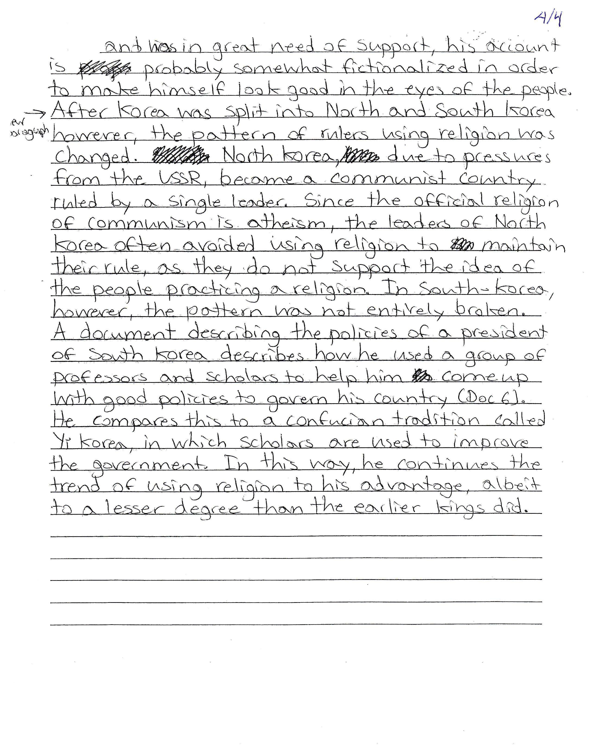

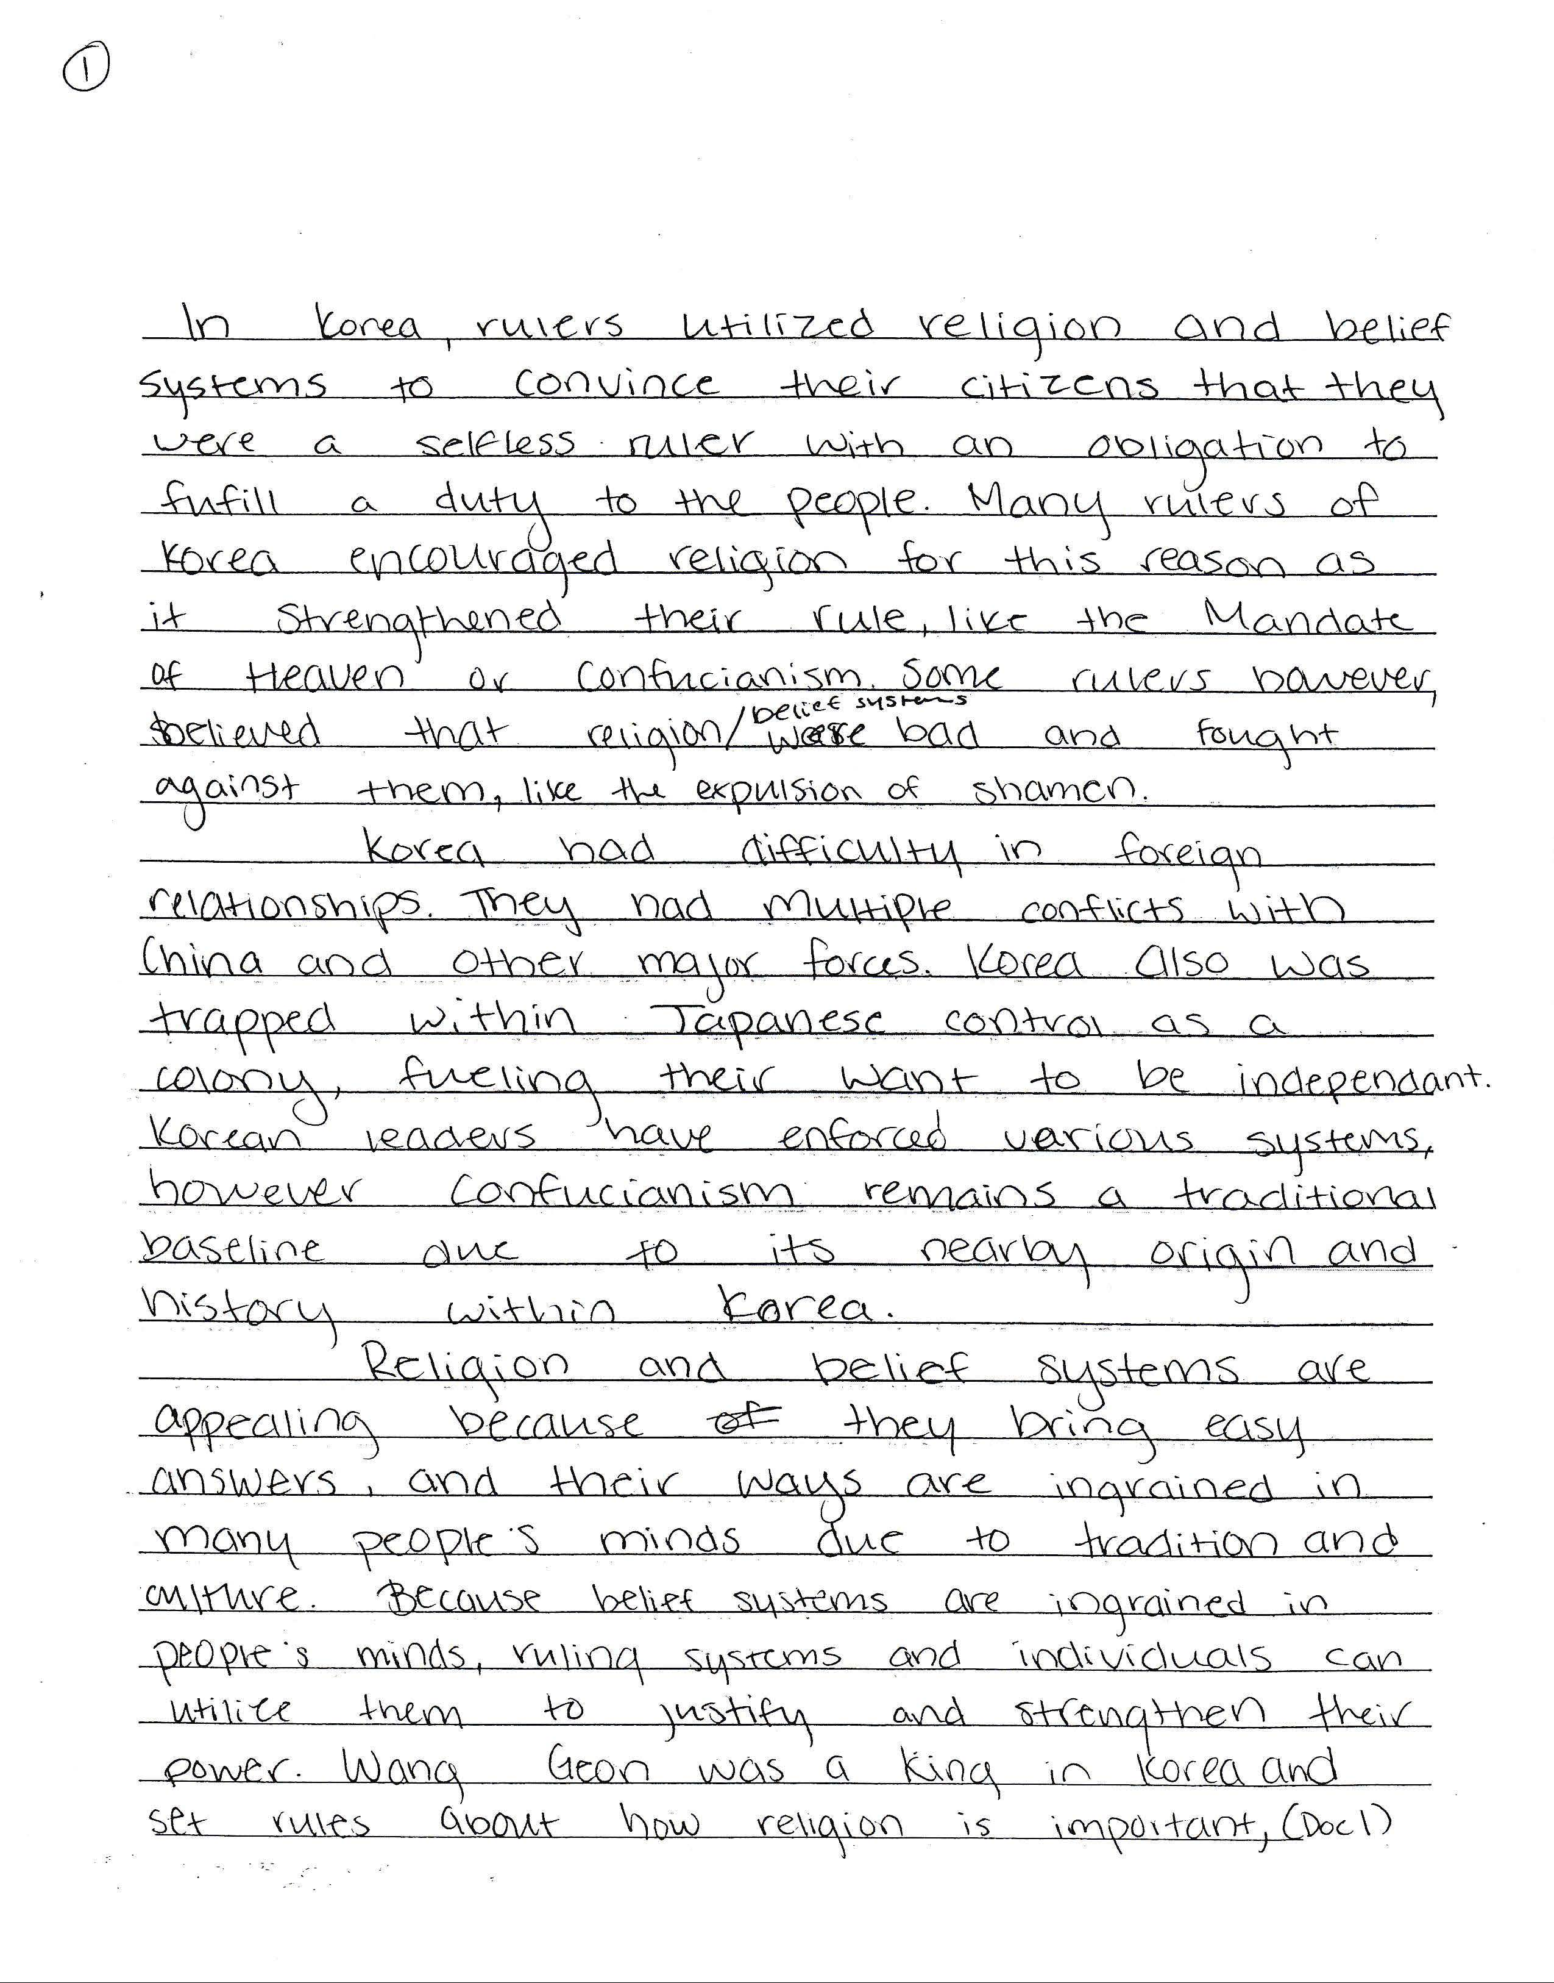
SAMPLE B
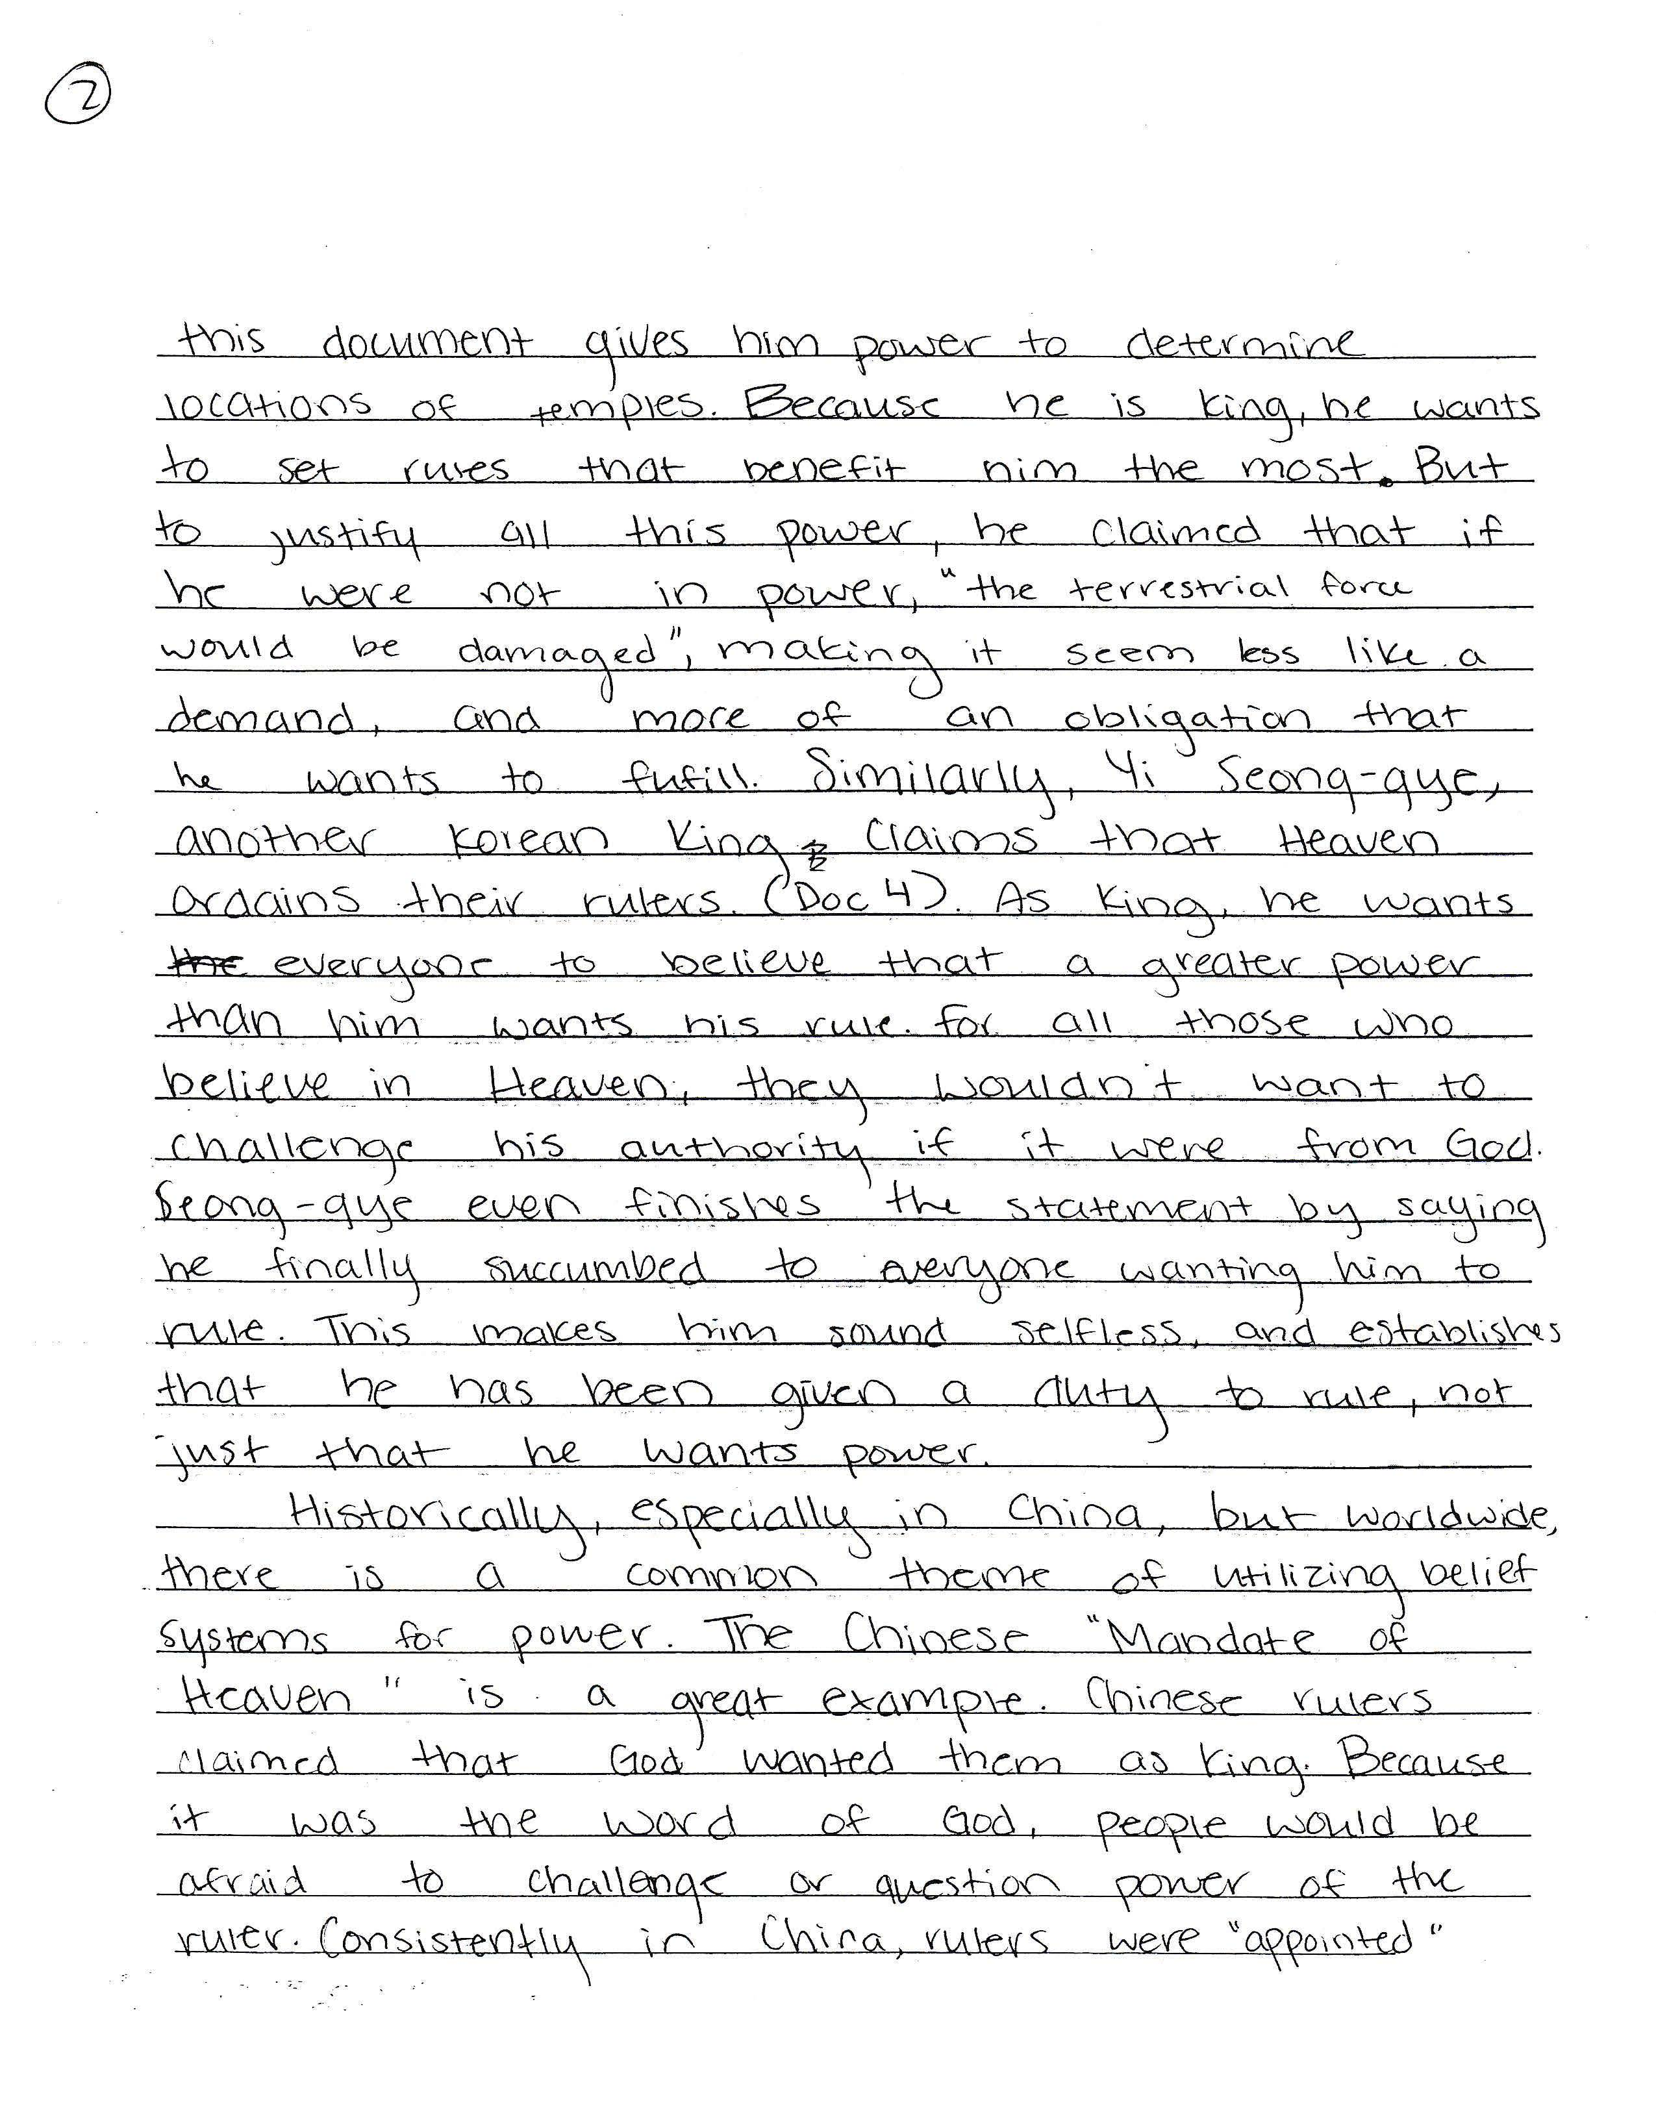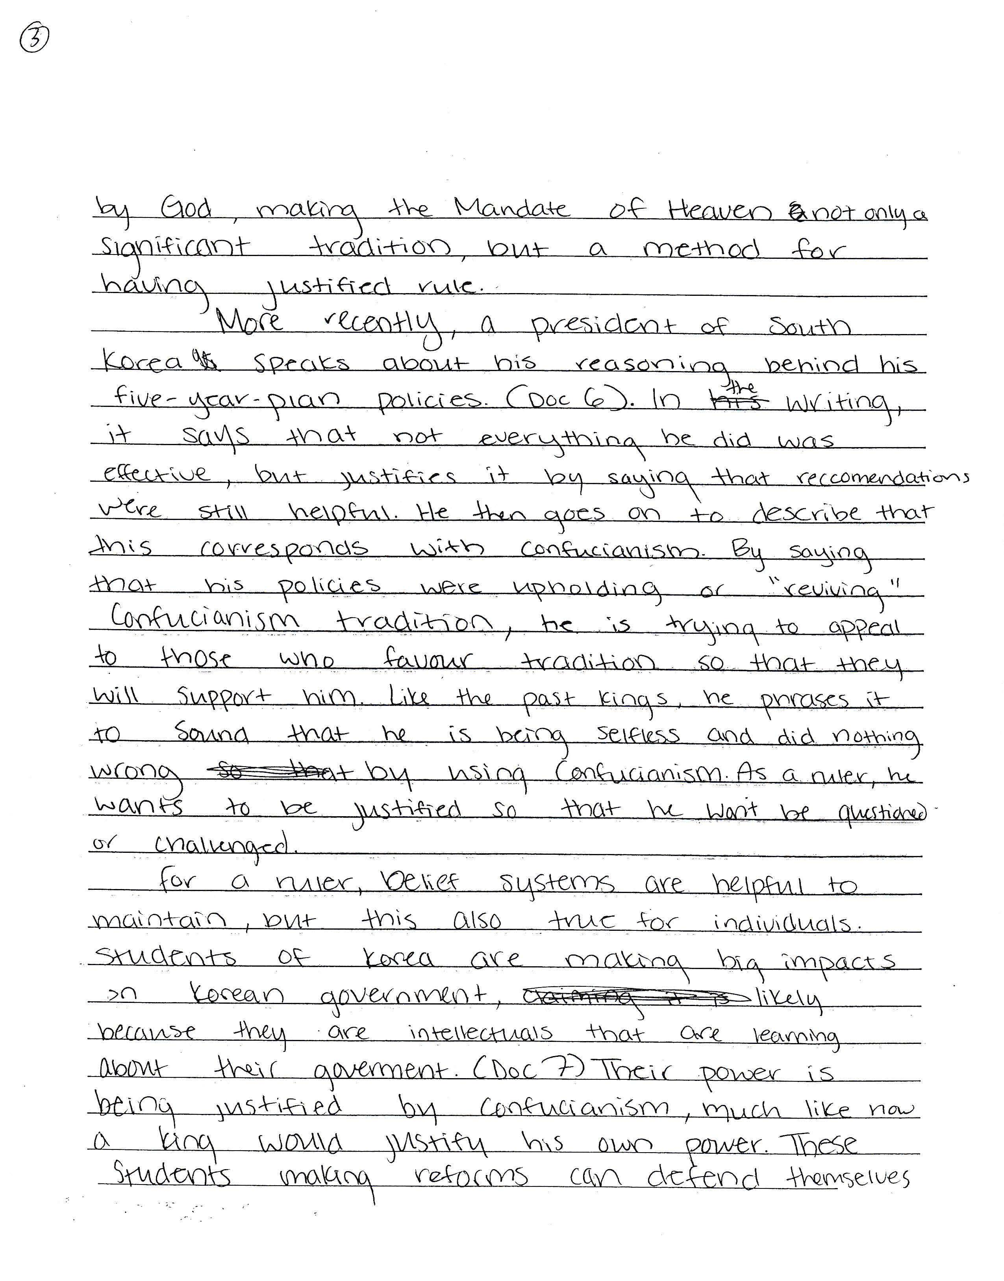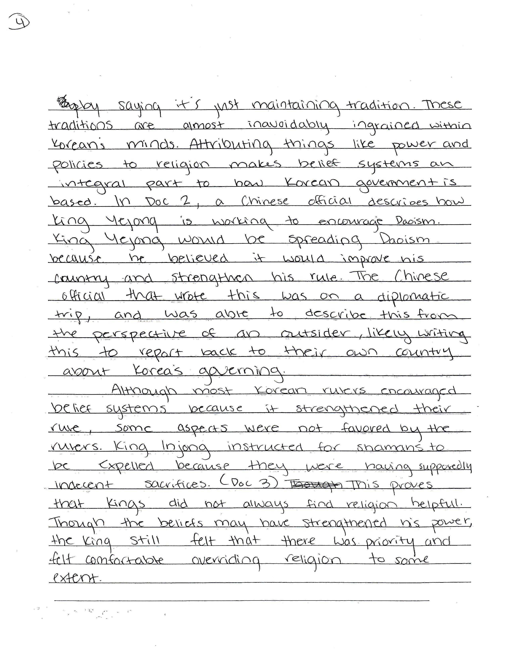

SAMPLE C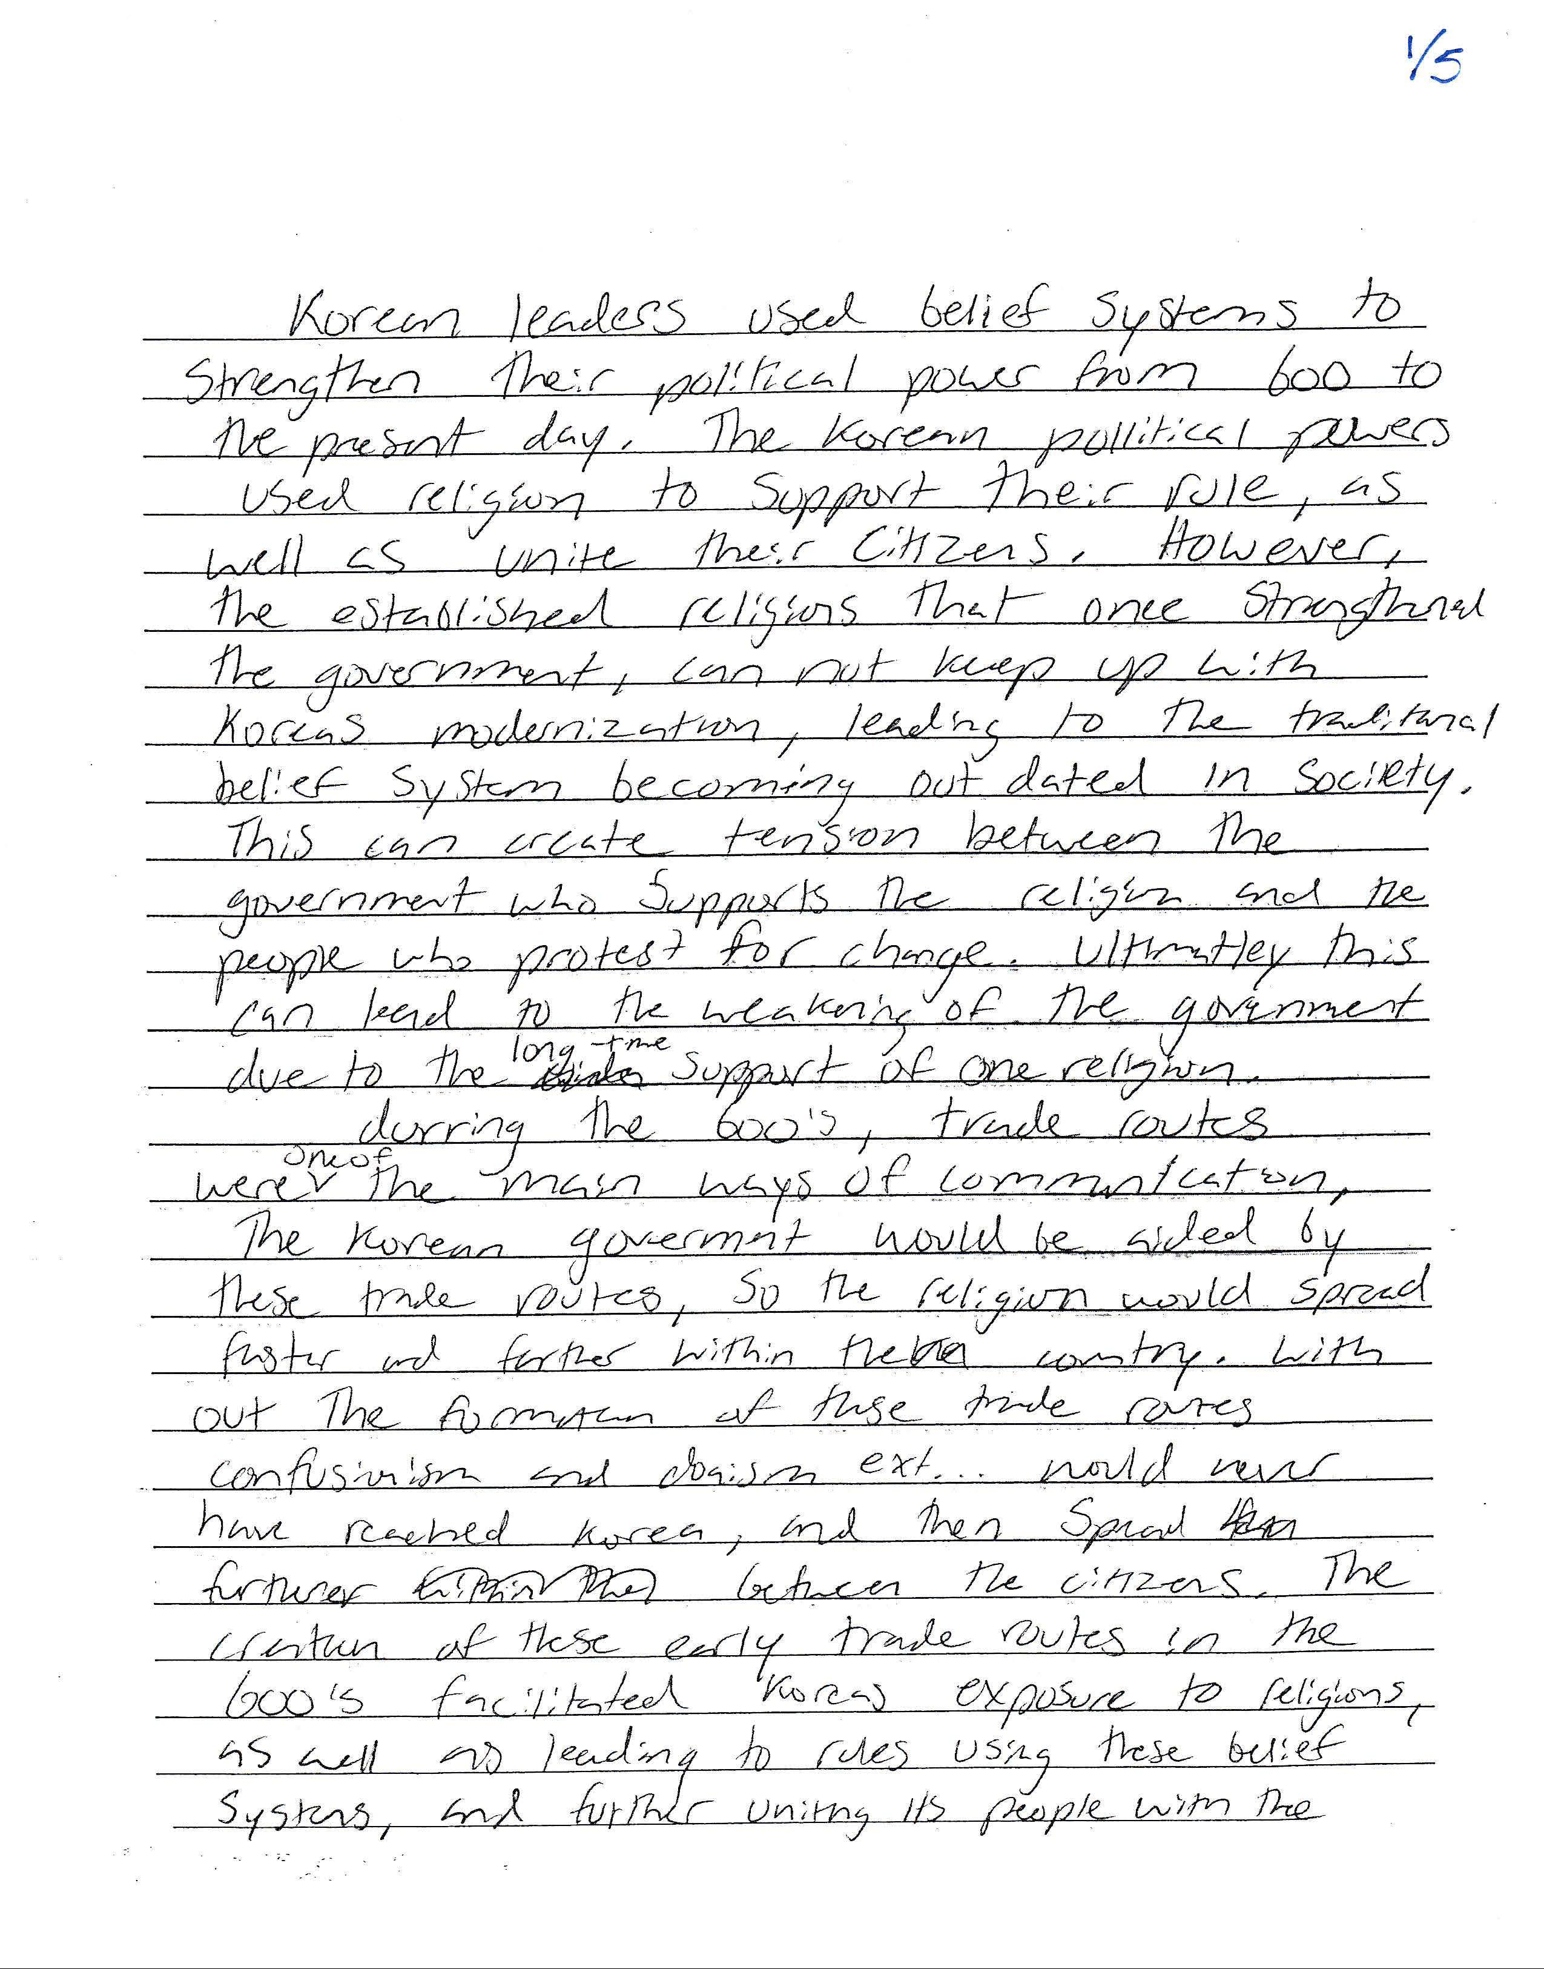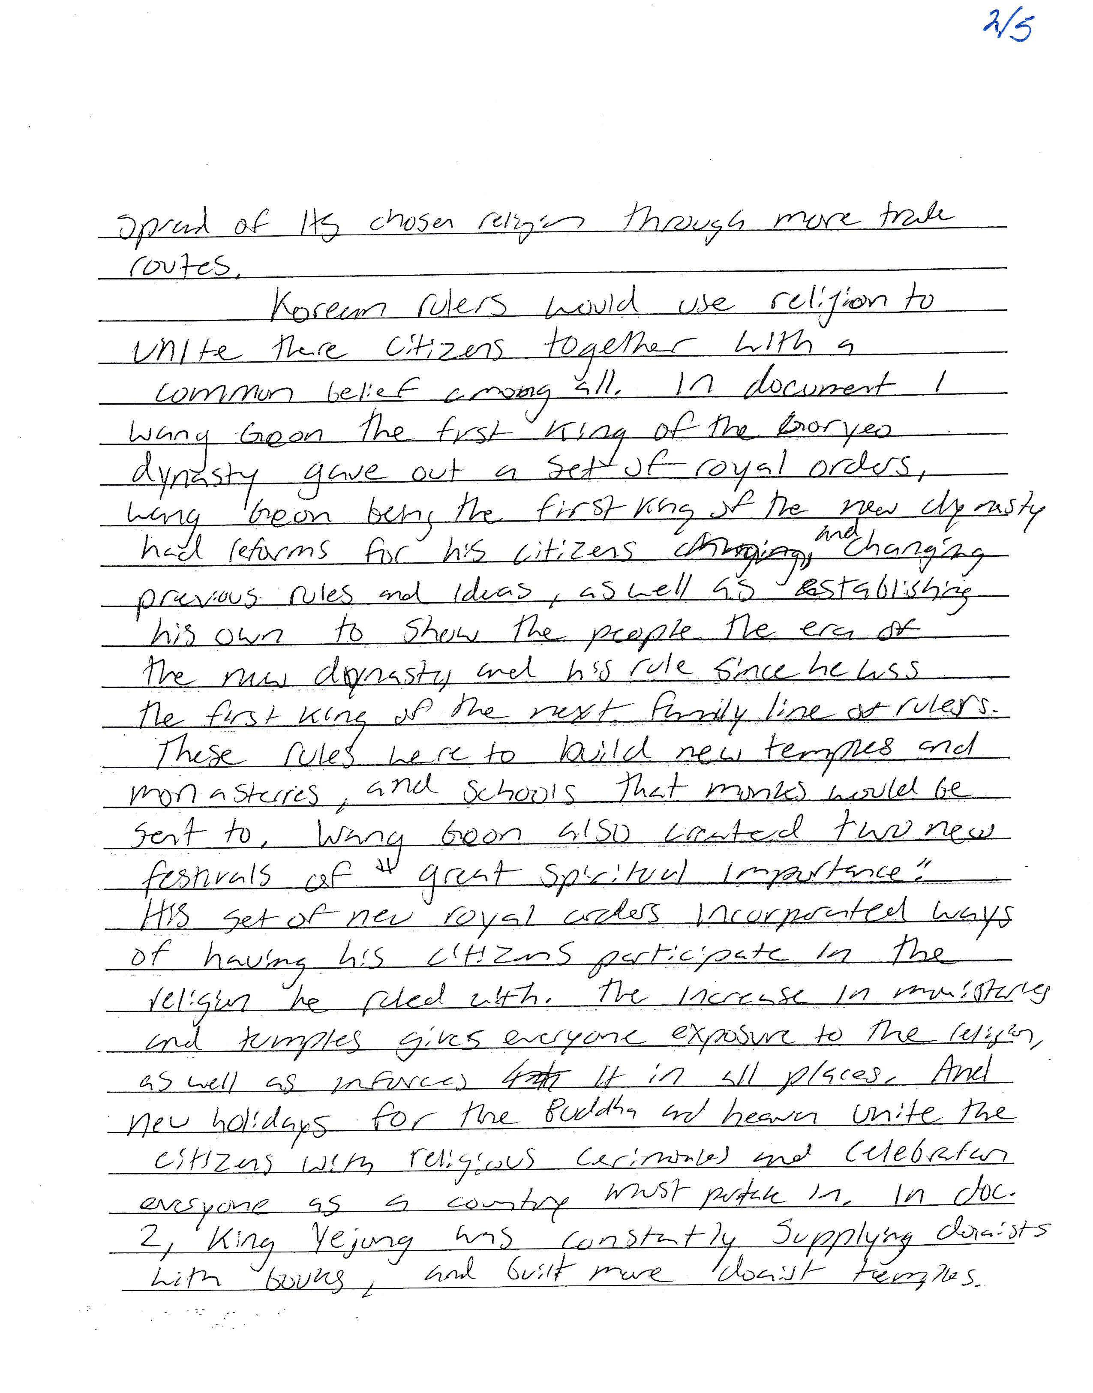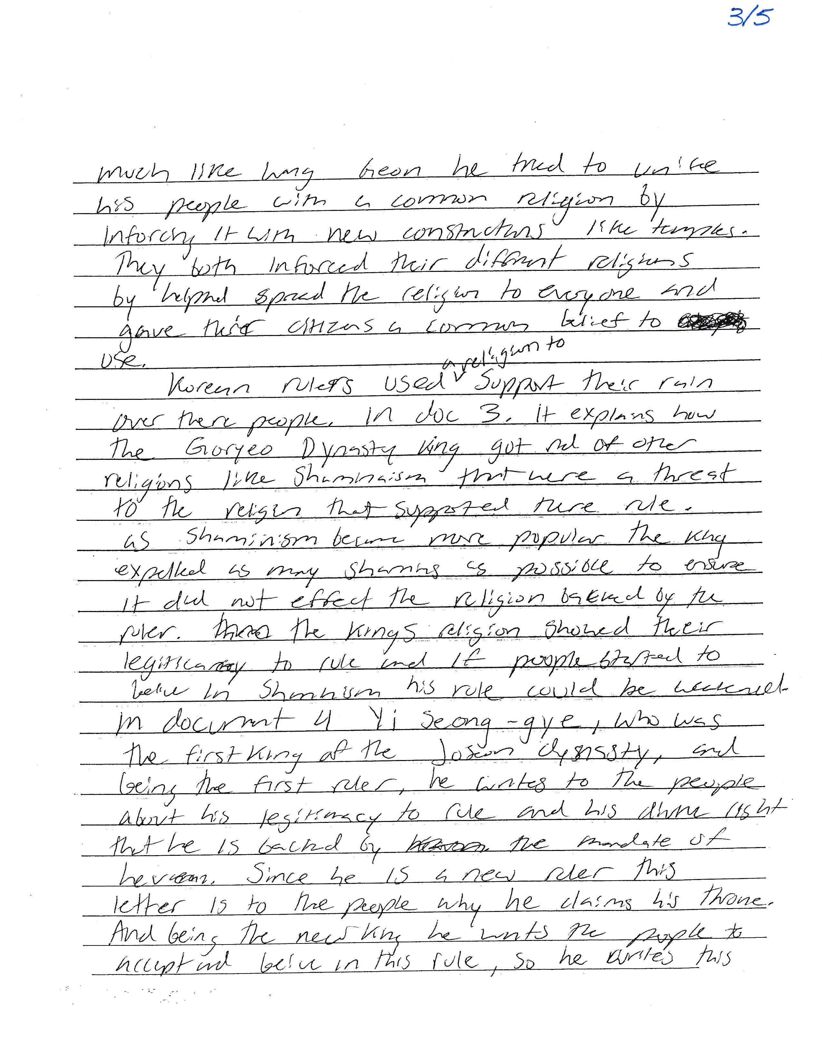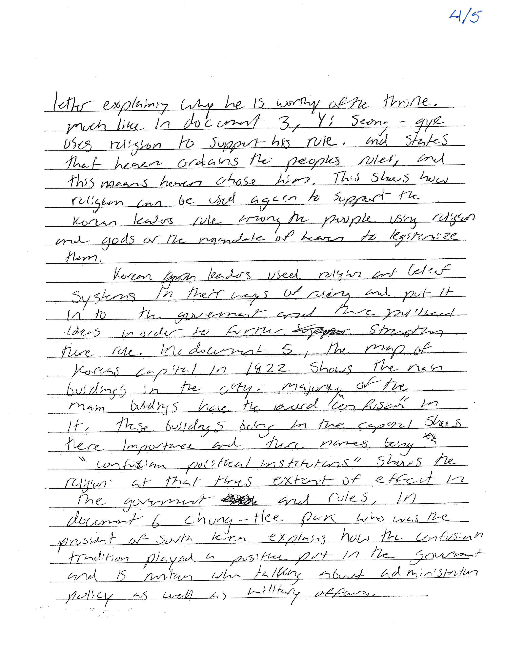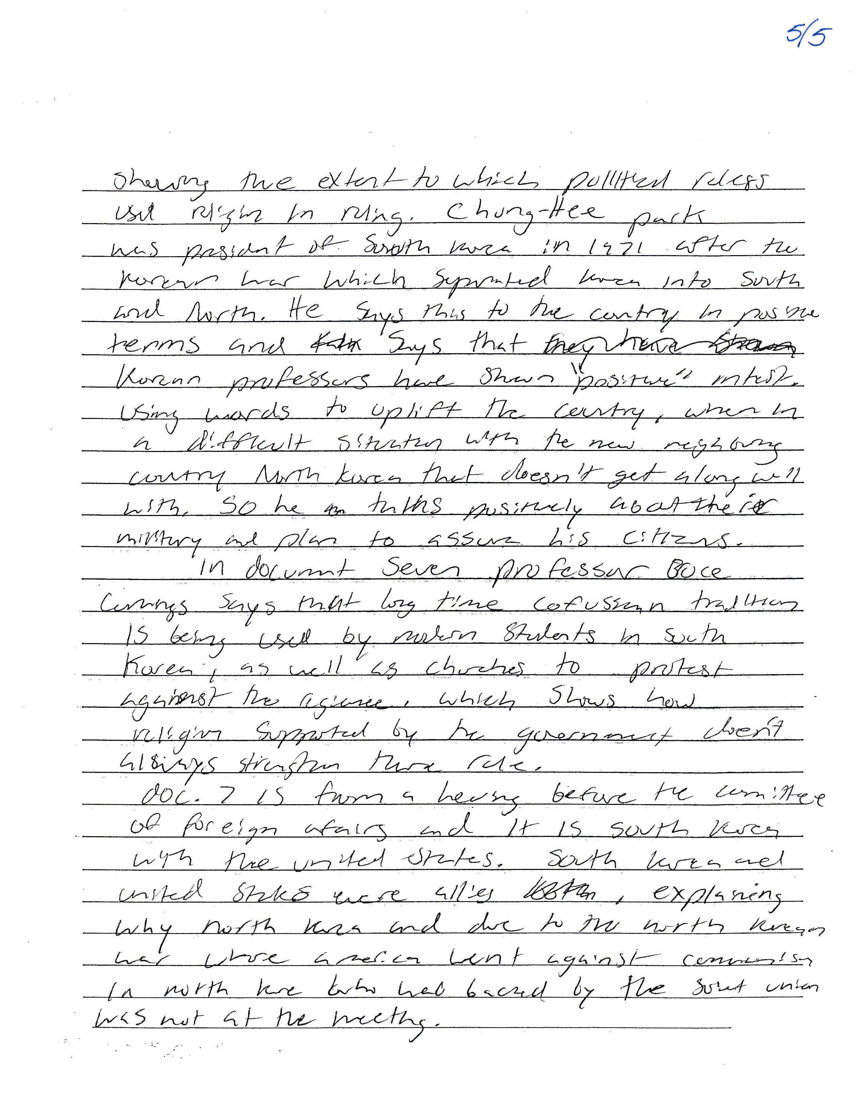

SAMPLE D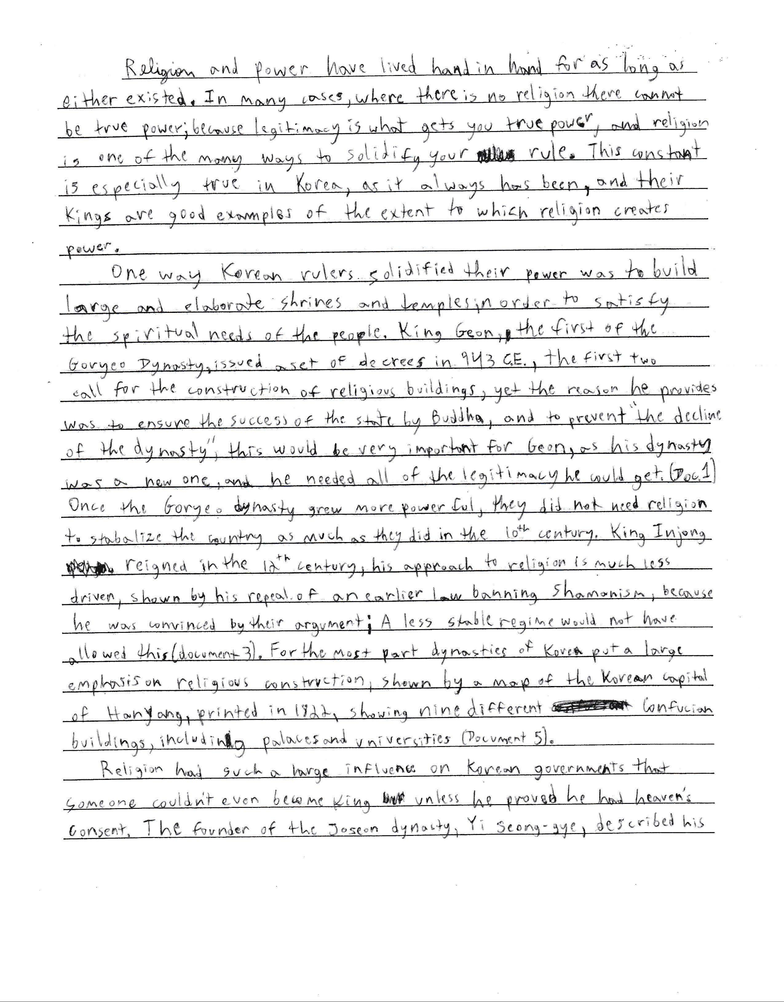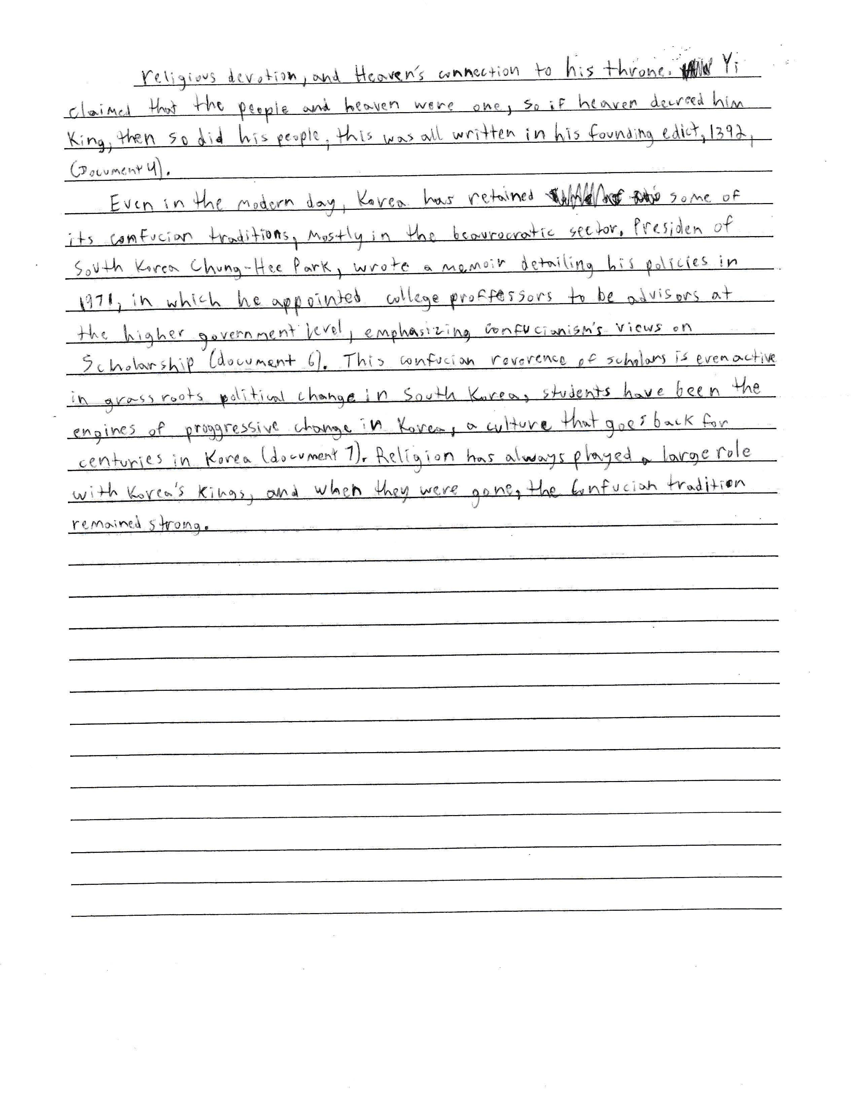

SAMPLE E