CAUSATIon AND Continuity/Change MODULE OVERVIEW
SKILL: CAUSATION AND CCOT | CONTENT: AP world c.f. Key Concept 6.3 I D
This module focuses on causation and CCOT (Continuity and Change Over Time) through an examination of the political and economic development of South Korea. | Nations responded in a variety of ways to the economic challenges of the twentieth century.

D A Y 1 | How are belief systems utilized to strengthen the legitimacy of rulers or regimes?

CLASS ACTIVITY: Primary Source Investigation
Students work collaboratively to interpret a set of four sources. Students will analyze evidence to determine how several belief systems were utilized in Korea to legitimize rule.

AP-ALIGNED ASSESSMENT: Short Answer Question
Short Answer Question:
- Identify a belief system reflected in the passage provided.
- Explain how another belief system supported state-building efforts in Korea before 1450 CE.
- Explain how a belief system supported state-building efforts outside of Korea after 1450 CE.

D A Y 2 | What caused the Economic Miracle in South Korea?

CLASS ACTIVITY: Economic Miracle Mystery Investigation
Students work in jigsaw groups to analyze sources in an investigation of how South Korea was able to grow economically after the Korean War. Students are assigned one of three expert groups—corporations, government, or citizens—to explain the cause of the economic miracle in South Korea.

AP-ALIGNED ASSESSMENT: Long Essay Question
Long Essay Question: “Develop an argument that evaluates the extent to which at least one specific government in Asia guided economic development in the period after World War II.”

D A Y 3 | CLASS ACTIVITY: Teaching the Document-Based Question  Students practice three targeted document-based question skills: thesis writing, contextualization, and sourcing. Students will write the full essay and/or score peer essays.

AP-ALIGNED ASSESSMENT: Document-Based Question
Document-Based Question: Evaluate the extent to which Korean leaders utilized belief systems to strengthen their political power through the period from 600 CE to the present.

Causation AND continuity/change MODULE sources

D A Y 1 | AUTHOR SOURCE DATE  - Wang Geon Ten Injunctions 943  - Anonymous Official history of the Korean Goryeo dynasty 1400  - Brian Hogarth Goryeo Buddhism 2003  - Charles Muller “Korean Buddhism: A Short Overview” 1997  - Yi Seong-gye Founding Edict 1392  - Anonymous Map of capital city, Hanyang 1822  - Mark Peterson The Neo-Confucian Foundation of the Joseon Kingdom 2009  - KWLF Chart: Confucianism and Neo-Confucianism 2018  - Park Chung-hee To Build a Nation 1971  - US Record Testimony of Ralph Clough and Bruce Cumings 1985  - Park Chang-seok Korea: From Rags to Riches 2010  - Korean Record Constitution of the Republic of Korea 1948

D A Y 2 | AUTHOR SOURCE DATE  - KWLF Images of Inchon and Busan 1950/2010  - Ahn Choong-yong “Chaebol Transformed Industry” 2010  - KWLF Introduction to Chaebols 2018  - Korean Record Constitution of the Republic of Korea 1948  - Syngman Rhee Letter to US Congressman Paul W. Shafer 1954  - Andrei Lankov "Saemaul Undong" 2012  - Park Chang-seok Korea: From Rags to Riches 2010  - Park Chung-hee To Build a Nation 1971  - Kim Dae-jung Presidential Inaugural Address 1998  - Park Chang-seok “Mr. President: A Kingpin in Nation Building” 2010

D A Y 3 | AUTHOR SOURCE DATE  - Wang Geon Ten Injunctions 943  - Xu Ching Notes from a diplomatic trip to Korea 1100  - Anonymous Official History of the Korean Goryeo dynasty 1400  - Yi Seong-gye Founding Edict 1392  - Anonymous Map of capital city, Hanyang 1822  6. Park Chung-hee To Build a Nation 1971  7. US Record Testimony of Ralph Clough and Bruce Cumings 1985

D A Y 2
Based on a 60-minute class

Lesson Question: What caused the Economic Miracle in South Korea?

AP curriculum Framework reference
Learning Objective CUL-2—Explain how religions, belief systems, philosophies, and ideologies affected political, economic, and social developments over time.
Key Concept 6.3—After the Korean War (1950-1953), the role of the state in the domestic economy varied, and new institutions of global association emerged and continued to develop throughout the twentieth century.
I. States responded in a variety of ways to the economic challenges of the twentieth century.
C. In newly independent states after World War II, governments often took on a strong role in guiding economic life to promote development.
D. In a trend accelerated by the end of the Cold War, many governments encouraged free-market economic policies and promoted economic liberalization in the late twentieth century.

Historical Reasoning Skills:
CAUSATION; CONTINUITY AND CHANGE OVER TIME

OVERVIEW
This activity is designed to develop student historical reasoning skills in causation and continuity and change over time (CCOT) through the use of primary and secondary sources. Students will focus on the reasons for South Korea’s economic miracle after the Korean War. This lesson is best used after students have acquired some background knowledge of the Cold War and global economic developments in the late twentieth century. Throughout the jigsaw lesson, students will use primary and secondary sources to make conclusions about how South Korea’s corporations, government, and citizens were able to achieve economic success after the Korean War. In these activities, students are asked to take on the role of a historian. Teachers should be aware that many contemporary historians grapple with this debate over South Korea’s “economic miracle” and therefore, this activity can be an opportunity to encourage diverse interpretations by students, as well.

Materials needed for:
Pre-Assigned Homework
- Access to the internet for viewing visual images and animation
- Animation of Gapminder.org data on South and North Korea
- Homework Materials Part I (pp. 8-9)
- Homework Materials Part II (p. 10)
In-Class Activity
- Expert File 1: Corporations (pp. 11-12)
- Expert File 2: Government (pp. 13-14)
- Expert File 3: Citizens (pp. 15-16)
- Jigsaw Group Handout (p. 17)
- Summary and Pie Chart Handout (p. 18)
Assessment
- Long Essay Question (LEQ) (p. 19)
- How to Complete the LEQ (pp. 20-23)
- LEQ Scoring Samples (pp. 24-34)

SEQUENCE OF INSTRUCTION

HOMEWORK OVERVIEW: PREPARATION FOR CLASS
HOMEWORK (20 MINUTES):
- Students will view the two photographic images in Homework Materials Part I (pp. 8-9): South Korea during the Korean War (Inchon) and modern-day urban South Korea (Busan). Students will write three observations about each photograph and two questions raised by the information presented.
- Students will then view an animation of an interactive chart of per capita income and life expectancy over the past two centuries. This chart uses data collected by the Gapminder website. Students will write down five observations about the data and three questions raised by the information presented in Homework Materials Part II (p. 10). Since the information on the interactive chart moves quickly, students may want to view the animation several times.

Teacher Notes
If students do not have access to the internet outside of school or are not accustomed to using technology for homework assignments, these activities can be done during the previous class period or as part of the warm up. To access the Gapminder data directly, teachers can visit www.gapminder.org and select Bubble Chart. Checking the boxes for South Korea and North Korea on the right-hand side of the screen will isolate the data for the wealth and health of both countries over time. Since viewing the Bubble Chart takes less than 40 seconds, with the most dramatic separation between the two regions at the end, teachers may want to replay the chart two or three times.

CLASS ACTIVITY 1 OF 5: WARM UP

WARM UP (10 MINUTES):
1. Students review their homework. Students should work in pairs to review their homework observations and questions for both the photographs and the animation. [4 minutes]
2. As a whole class, students provide what they consider to be the essential questions that they considered when examining the information for homework. [3 minutes]
The purpose of the warm up is to set up the Economic Miracle Mystery Investigation, and the essential question of what contributed to the South Korean economic miracle.

Teacher Notes
We would expect that the central question to emerge during the whole-class debrief would be: What caused the changes that we see in the photographs and the interactive chart? Teachers should be prepared to raise the question if it doesn’t arise organically, since this question frames the rest of the class activities.

CLASS ACTIVITY 2 OF 5: EXPERT GROUPS FOCUS ON AN EXPLANATION

EXPERT GROUPS (20 MINUTES):
1. Like many mysteries, answering questions about the causes of the South Korean economic miracle requires a team of expert detectives to focus on different explanations. Students will first work in expert groups of two or three, and focus on one of three questions:
- What were South Korean corporations doing?
- What was the South Korean government doing?
- What were South Korean citizens doing?
Although the class will have many groups, the number of students representing each of the three specialties should be similar.
2. Students will take a few minutes to review the information in their assigned expert file (Expert File 1: Corporations (pp. 11–12); Expert File 2: Government (pp. 13–14); Expert File 3: Citizens (pp. 15–16)) and answer the questions. In a later activity, students will share a quick overview of how their entity contributed to the economic miracle in South Korea; they will do this as individuals, sharing with members of the other two expert groups.

Teacher Notes
Before class, teachers should prepare the document sets for each student. Placing these in folders may help organize the materials. Each of the three expert files has at least two documents and one question to help students understand how government, corporations, or citizens affected the economy of South Korea. Teachers can decide whether students will use paper or electronic versions of the documents.

Teaching Tip
Teachers should circulate around the classroom to make sure students understand their expert group. Teachers should take time before class to review these materials so they can fill in gaps or correct common misunderstandings. For example, the students who choose corporations will most likely have no prior knowledge of chaebols (South Korean family-run conglomerates). This activity should move quickly, as students read the documents, consider the question, and report to their small groups.

CLASS ACTIVITY 3 OF 5: STUDENTS SHARE EXPERT GROUP FINDINGS

JIGSAW EXPERT GROUPS (20 MINUTES):
1. Teachers will divide students into groups of three, with one student representing each of the three expert groups (corporations, government, or citizens).
2. Each student within the jigsaw group reports on how corporations, government, or citizens contributed to the economic miracle in South Korea. The other students take notes on the Jigsaw Group Handout (p. 17).

CLASS ACTIVITY 4 OF 5: CREATE A PIE CHART

ANALYZING EFFECTS (5 MINUTES):
1. Students will work together to summarize the influence of each expert group on the growth of the South Korean economy, using the Summary and Pie Chart Handout (p. 18). The summary should explain how South Korea was able to achieve economic success after the Korean War. Each group of three students should then collaborate to make a pie chart in which they indicate the relative importance of corporations, government, and citizens in the South Korean economic miracle.

Teacher Notes
This part of the lesson can be adjusted based on the time available: Teachers can ask students to write an official summary, or to agree verbally on what to say to the class to justify the percentage breakdown on their pie chart.

CLASS ACTIVITY 5 OF 5: DEBRIEF

DEBRIEF (10 MINUTES):
In a whole-class discussion, students will share some or all of their summaries. This debriefing could take the form of a class discussion with agreed-upon points on the board, or student groups could quickly present their findings to the class using their pie charts as a reference.

Teacher Notes
Teachers should correct misunderstandings and fill in gaps of knowledge. They should also encourage diverse interpretations. Some students may put more emphasis on the government’s role or the work ethic of the people, for example.

ASSESSMENT / CHECK FOR UNDERSTANDING

FORMATIVE ASSESSMENT: LONG ESSAY QUESTION
Choice 1: Students will complete the LEQ planning sheet at home. (20 minutes)
Choice 2: Students will write the full LEQ at home. (40 minutes)
Choice 2: Students will score the sample LEQs at home. (30 minutes)

In this lesson, teachers have options for how they will help students build their writing skills using the knowledge and learning from this activity. A Long Essay Question (p. 19) is included that correlates with the content of the lesson. For those classes with students who are still developing their essay-writing skills, an instructional How to Complete the LEQ (pp. 20–23) planning sheet is also included. Perhaps most helpful of all is a set of sample student essays. Students can score these Student Samples with Score Justifications to see how accurately they graded sample LEQ responses.

Teaching Tip
Teachers may choose to have students use the next class period to build on essay-writing skills in a paired peer review of each other’s planning sheet, writing the full LEQ, or scoring the sample LEQs. Peer grading can be useful for reinforcing aspects of the rubric. If students peer grade their written LEQs, the teacher can follow up with a few comments on both the original essay and the peer grading. Whichever option teachers choose, the check for understanding is more student directed when peer grading is used.

HOMEWORK MATERIALS (PART I)

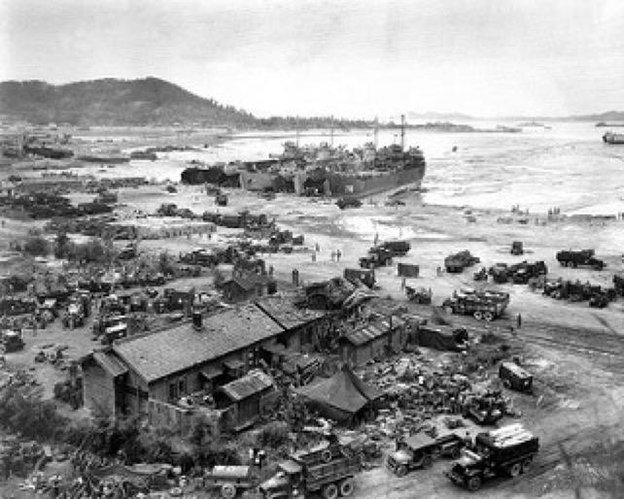
Photograph of the Inchon landing in 1950

Photograph of contemporary urban South Korea (Busan)

Homework: Visual Analysis of Photographs
Make three observations about South Korea during the Korean War (1951-1953) (Inchon).
1.

2.

3.

Make three observations about contemporary urban South Korea (Busan).
1.

2.

3.

What are two questions raised by the information presented in the two photographs?
1.

2.

Homework materials (part ii)

View the interactive chart from Gapminder.org. This interactive chart displays per capita income and life expectancy over the past two hundred years using data collected by the Gapminder site. North and South Korea are highlighted against the backdrop of other countries. Since the information moves quickly, you may want to view the interactive chart more than once.
Important Dates: 1910, Korea became a colony of Japan; 1945, Korea was liberated from Japan and partitioned into North and South Korea; 1950-1953, Korean War; 1960s, beginning of South Korean economic reforms.

Homework: Analysis of interactive chart
Make five observations about the information presented in the interactive chart.
1.

2.

3.

4.

5.

What are three questions raised by the information presented in the interactive chart?
1.

2.

3.

Expert File 1: Corporations
Use the following sources to better understand how large family corporations (chaebols) operated in South Korea. Underline important points. Then write down how Chaebols helped South Korea achieve economic success.
DOCUMENT 1
SOURCE: Ahn Choong-yong, president of the Korea Institute for International Development, “Chaebol Transformed Industry.”
South Korea’s industrial conglomerates, which operate many business lines simultaneously and are often controlled by a single owner or family and commonly known as “chaebol,” have been the most important driving force behind Korea’s modern “compressed” growth and industrial transformation. It is widely agreed that Korea’s modern economic development has occurred within a unique paradigm of an export-based, but government- and chaebol-led industrialization strategy with varying degrees of government intervention. Over time, the respective role of chaebol and their relationship with the government have constantly evolved to adjust to the changing international and domestic environment towards performance-based criteria. […]
At the outset of the birth of Korea’s modern economy initiated in its first five-year economic development plan (1962-1967), Korea adopted an export-oriented development model to take maximum advantage of almost “unlimited but educated labor forces” while providing various “carrots and sticks” in the forms of incentives and disincentives by the government and relying on foreign borrowing to finance massive capital requirements.
In the 1960s, Korea’s major exports were labor-intensive products such as wigs, plywood, footwear and low-quality clothing and apparel. At present, however, Korea has become a major exporter of semiconductors, iron and steel, ships, automobiles, electronics and electrical appliances with world-renowned brand names.
Korea’s leading multinationals like Samsung, Hyundai, LG and POSCO can be found next to the world’s most famous corporations on the Fortune 500 list. These chaebols have played a vital role in Korea achieving a “miracle performance,” as the country’s development has been described by the World Bank.
In Korea from Rags to Riches 1950-2010: 60 Great Stories of Korean Miracles, edited by Park Eung-kyuk and Park Chang-seok, 252-260. Seoul, Korea: The Korea Institute of Public Administration, 2012.

DOCUMENT 2
SOURCE: Introduction to Chaebols

Introduction to Chaebols
Chaebol (plural chaebols) comes from the combination of the Korean words for wealth and clan. A chaebol is a large group of interconnected companies typically dominated by a wealthy family. These conglomerates simultaneously manage multiple, diverse product lines and services, such as automobile production, hotel management, and retail chains, with leadership positions generally held by relatives of the chairman.
History  Businesses run by families go as far back as the Joseon Dynasty. Samsung and LG were also established over 100 years ago.  Chaebols became popular after the Korean War with the rise of General Park Chung-hee (1963).  Government officials funneled relief money in the form of cheap loans to businesses that agreed to help rebuild the economy.  Example: Hyundai built the Gyeonbhu Expressway in just 2.5 years, and built a shipyard before building ships. | Products/Services  Electronics  Appliances  Engineering  Construction  Shipbuilding  Insurance  Credit Cards | Positives  Chaebols allowed for rapid development.  Conglomerates were expected to meet quotas to maintain their government connections.  GDP per capita, 1953: $67  GDP per capita, 1996: $10,315  Negatives  Lack of competition.  Chaebols held nearly two-thirds of market share by the 1990s.  Smaller companies were unable to influence the economy, leading to civilian dissent.
Top Chaebols
Samsung
LG
Hyundai
Hanjin
Kumho
Lotte
SK Group
Based on Carlos Tejada, “Money, Power, Family,” New York Times, February 17, 2017, https://www.nytimes.com/2017/02/17/business/south-korea-chaebol-samsung.html.

How did chaebols help South Korea achieve economic success?

Expert File 2: Government
Use the following sources to better understand how the government functioned in South Korea and its role in the economy. Underline important points. Then write how the South Korean government helped the country achieve economic success.
DOCUMENT 3
SOURCE: Constitution of the Republic of Korea, 1948.

Article 7
(1) All public officials shall be servants of the entire people and shall be responsible to the people.
Article 9
The State shall strive to sustain and develop the cultural heritage and to enhance national culture.
Article 11
(1) All citizens are equal before the law, and there may be no discrimination in political, economic, social, and cultural life on account of sex, religion, or social status.
Article 32
(1) All citizens shall have the right to work. The State shall endeavor to promote the employment of workers and to guarantee optimum wages through social and economic means and shall enforce a minimum wage system under the conditions as prescribed by Act.
(2) All citizens shall have the duty to work. The State shall prescribe by Act the extent and conditions of the duty to work in conformity with democratic principles.
DOCUMENT 4
SOURCE: Syngman Rhee, president of South Korea, letter to US Congressman Paul W. Shafer, 1954.

My dear Congressman Shafer:
I write this letter with the sincerest desire on my part to set facts straight about our philosophy of government. […] As for the declared purpose of your resolution—to create a national economy based upon the rights of private property and free competitive enterprise—it is fully acceptable. I quite agree with such a goal. However I wish to point out that it would be completely untrue to imply that the Republic of Korea is a socialistic state with a government of monopolistic ownership of industry. The Republic of Korea Government believes wholeheartedly in the principles commonly recognized as the basis of free enterprise system.
DOCUMENT 5
SOURCE: Andrei Lankov, scholar from the Soviet Union who lived in both North and South Korea, excerpt from the scholarly article “Saemaul Undong.”
President Park Chung-hee, who ruled the country in the years 1961-1979, had a mission to accomplish. He wanted to transform Korea, which in those times was just a dirt-poor country, into a prosperous and successful nation—doing whatever it took to achieve this.
Park believed in capitalism. But, contrary to the modern day neoliberal economic orthodoxy, he also believed in state intervention and guidance.
The first development program, launched just after 1961, put an emphasis on industry. […]
In Korea from Rags to Riches 1950-2010: 60 Great Stories of Korean Miracles, edited by Park Eung-kyuk and Park Chang-seok, 252-260. Seoul, Korea: The Korea Institute of Public Administration, 2012.

DOCUMENT 6
SOURCE: Park Eung-kyuk and Park Chang-seok, leading scholars at state-run think tanks, excerpt from Korea: From Rags to Riches.
Park Chung-hee created four ministries to take charge of economic affairs—the Economic Planning Board, the Ministry of Commerce and Industry, the Ministry of Construction, and the Ministry of Finance—all agencies were responsible for building infrastructure for growth.
Five-year development plans, initiated in 1962 under the leadership of the powerful Economic Planning Board, provided a long-term vision while monthly meetings offered an opportunity to secure sustained attention from top political leadership, to monitor progress to reach solutions. Awards were presented for excellent export performances at the monthly meetings. On a national scale, November 30 has been designated as “Export Day” to commemorate the first achievement of $100 million in exports in 1964.
In Korea from Rags to Riches 1950-2010: 60 Great Stories of Korean Miracles, edited by Park Eung-kyuk and Park Chang-seok, 252-260. Seoul, Korea: The Korea Institute of Public Administration, 2012.

How did the South Korean government help the country achieve economic success?

Expert File 3: Citizens
Use the following sources to better understand the influence of the South Korean citizens and other people in South Korea. Underline important points. Then write down how the citizens/people helped South Korea achieve economic success.
DOCUMENT 7
SOURCE: Park Chung-hee, president of South Korea, To Build a Nation, written in 1971 about the first five-year plan, which started in 1962.

[W]e organized a planning committee of college professors and experts with specialized knowledge in many fields. By mobilizing the maximum available expertise for government administration and policy making, we intended to hold in check the arbitrariness and rashness of the military officers. The establishment of this committee served as a turning point. Korean professors began to show positive interest in the realities of the country and to present policy recommendations on the basis of scientific analyses of the country’s situation. Even though not all of these recommendations could be justified in terms of efficiency and rationality, their advice was of great help to the revolutionary government. Thus the Confucian tradition of Yi Korea, in which scholars played a positive part in governmental affairs, seems to have been revived.
The key to improving a backward economy is the way one uses human resources, for economic development is a human undertaking, impossible without combining the people’s potential into a dynamic driving force. This task requires not only strong national willpower but also the ability to translate willpower into achievement. Blueprints must be drawn and explained. If people have a sympathetic understanding of a task, they will voluntarily participate in it.
DOCUMENT 8
SOURCE: Kim Dae-jung, Presidential Inaugural Address, 1998.
My Fellow Citizens:
We will have a new century in three years. […] Unfortunately, we are now facing our greatest national crisis since June 25 [1950, the outbreak of the Korean War]. … During this year, consumer prices and unemployment ratio would increase. Incomes would drop, and many businesses would go bankrupt. All of us are required to shed sweat and tears.
… My Fellow Citizens: You have demonstrated remarkable patriotism and power even in today’s difficulties. We have accomplished a peaceful transition of power even in the midst of the IMF Crisis. You have gathered gold to overcome the national crisis and have already collected over $ 2 billion in gold. I am very proud of your patriotism, which is more valuable than gold.
Our workers share the burden and agree to no raises, despite the challenges they face every day. Businesses have built a surplus for the past three months by focusing on increased exports. This patriotic commitment and the resilience of the Korean people is earning widespread recognition across the globe…
Translated by Youngeun Kim

DOCUMENT 9
SOURCE: Park Chang-seok, managing editor of the English language newspaper The Korea Times, excerpt from the scholarly article “Mr. President: A Kingpin in Nation Building," 2010.
Korea is often mentioned as a model country which has successfully caught two birds in one shot—a thriving economy and dynamic democracy. The essential elements of success were goal-oriented executive leadership, a highly educated bureaucracy and a hardworking labor force. The glue binding them together was a “can-do” spirit inveterate among people along with an ethic that calls for parental efforts for child education and workers’ sacrifice.
In Korea from Rags to Riches 1950-2010: 60 Great Stories of Korean Miracles, edited by Park Eung-kyuk and Park Chang-seok, 252-260. Seoul, Korea: The Korea Institute of Public Administration, 2012.

How did citizens and other people in South Korea help the country achieve economic success?

Jigsaw Group Handout
What caused the economic miracle in South Korea?

EXPLAINING THE ECONOMIC MIRACLE IN SOUTH KOREA
EXPLAINING FACTOR | NOTES FROM THE EXPERT
CORPORATIONS

GOVERNMENT

CITIZENS/PEOPLE

Summary and Pie Chart Handout
Thinking back on the expert explanations in this unit, summarize how corporations, government, and people in South Korea worked to develop the nation in the changing global economy of the twentieth century:

As a group, develop a pie chart with three wedges representing the relative importance of corporations, the government, and the people in South Korea’s economic development. Be prepared to present the pie chart to the class with a justification for your weighting of the relative importance of each group.

Long Essay Question

AP World History Free Response Questions

World History Section II
Total Time: 1 Hour 30 minutes
Question 2

In your response, you should do the following:

• Respond to the prompt with a historically defensible thesis or claim that establishes a line of reasoning.
• Describe a broader historical context relevant to the prompt.
• Support an argument in response to the prompt using specific and relevant examples of evidence.
• Use historical reasoning (e.g., comparison, causation, or continuity and change over time) to frame or structure an argument that addresses the prompt.
• Use evidence to corroborate, qualify, or modify an argument that address the prompt.

2. After World War II, governments often took a strong role in guiding economic life to promote development.

Develop an argument that evaluates the extent to which at least one specific government in Asia guided economic development in the period after World War II.

[Note: For the purpose of this exercise, choose South Korea as the example.]

How to Complete the

Long Essay Question (LEQ)

South Korean Economic Development Practice
The Question
After World War II, governments often took a strong role in guiding economic life to promote development.
Develop an argument that evaluates the extent to which at least one specific government in Asia guided economic development in the period after World War II.
[Note: For the purpose of this exercise, choose South Korea as the example.]

STEP 1: Choose a Historical Reasoning Skill that best fits the question.
The LEQ will assess one of three possible historical reasoning skills. You must answer the prompt using the targeted skill you think will be the most useful in answering the question at hand. Here are your options:
- Causation (an examination of the cause and/or effect over a span of time, such as the cause and/or effect of important historical processes or patterns)
- Comparison (a comparison of two regions, ideas, religions, etc., that describes similarities and/or differences, depending on the question)
- Continuity and Change Over Time (a discussion of factors that stay the same and those that change over a time span)
Which historical reasoning skill do you think would be the best fit for this question? Why?

STEP 2: Write a thesis statement that answers the question.
Arguments are answers to the question that are defensible with evidence.
What are three possible arguments that you could make about the extent to which an Asian government (South Korea, in this case) was able to guide the economy after World War II? Use the historical reasoning skill you mentioned in STEP 1.
Possible Argument 1

Possible Argument 2

Possible Argument 3

Put an asterisk (*) next to the argument you will be able to support with the most evidence.
Think of the thesis as a road map for the reader. Each part of your thesis should tie directly to a body paragraph that directly answers the question. Be careful not to be too vague.
NOTE: You may want to skip to STEP 3 before writing your practice thesis, to identify the evidence you will use for your thesis.
Write your practice thesis in the box below.
Thesis:

STEP 3: Identify evidence you can use to support your argument.
Historical arguments need to be supported with historical evidence. Your evidence must tie specifically to an argument that answers the question.
Start by considering which events, people, and innovations are most closely tied to your argument. Brainstorm as much evidence as you can think of related to the question’s topic (the extent to which South Korea was able to guide its economy). List this evidence in the box below.
Evidence:

Next, elaborate on the items in your evidence list. Specifically, how do these events, people, and innovations help support your argument?
Impact of Evidence:

STEP 4: Explain a historical context that affects the question’s topic.
The next step is to explain the historical developments or events that affect the topic of the question (and your answer to the question) in a contextualization statement.
Towards the end of the contextualization statement, provide a “bridge” by using some of the terms of the question to link these broader contextual issues back to the question itself.
What are a few historical developments or events that help contextualize your argument? Note them below.

STEP 5: Complexity
To earn the second point for historical reasoning, your arguments must be complex. There are two common ways to accomplish the complexity needed to earn this point:
      - Going beyond the minimum by doing at least one of the following:
- Explaining both similarity and difference.
- Explaining both continuity and change.
- Explaining other causal factors of the effect identified in the essay question.
- Explaining other effects of the cause identified in the essay.

      - Exploring across time and/or space by explaining relevant and insightful connections in other places and/or time periods. This further supports your argument by showing that a similar pattern emerged in another setting or time. Any examples you use must be connected to an argument that you make in the essay.
Which argument (1, 2, or 3) do you plan to make more complex? Write the argument in the box below.
Argument:

Which strategy do you plan to use for making this argument more complex? Write it in the box below.
Strategy:

In the box below, write a few sentences that would make one of your arguments more complex.
Items that Add Complexity:

LEQ Scoring Samples
Students will benefit from reading other students’ sample essays in response to this question.
Students should read the four sample essays and score them using the six-point College Board LEQ rubric (https://apcentral.collegeboard.org/pdf/rubrics-ap-histories.pdf?course=ap-world-history).
Students should then review their scores with the scores explained in the justifications section below.

Long Essay Question Score Justifications

LEQ 1
Thesis is stated in the second paragraph counts, although it would be best if placed at the end of the first paragraph. The thesis presents three clear ways South Korea guided economic development. 1 point
Contextualization is attempted in the first paragraph. South Korea was not democratic when it was split after the Korean War. Democracy did not come for several more decades. 0 points
Evidence is plentiful and tied to topic sentences at the top of each paragraph. These topic sentences organize the evidence to support the arguments. 2 points
Analysis should frame the argument around a historical reasoning skill. This essay uses causation throughout the essay. In the last body paragraph, the skill of continuity is addressed. 1 point
Total: 4 points

LEQ 2
Thesis is not specific enough to the question. The statement “did many things” does not adequately link to how South Korea guided economic development. Only the first sentence in the sentence that follows relates to what the South Korean government did to guide economic development. 0 points
Contextualization is attempted in the first paragraph with several references to Korean political history. This historical information is not adequately bridged to the question on guiding economic development. 0 points
Evidence is provided that relates to the topic of governmental involvement in economic policy. 1 point
Analysis should use a historical reasoning skill in order to frame the argument. No claims or arguments are made that fully address the question. 0 points
Total: 1 point

leq 3
Thesis is stated clearly at the end of the first paragraph. 1 point
Contextualization is presented in a fragmentary way in the first paragraph with reference to some countries trying to catch up economically. 1 point
Evidence is presented with specificity throughout the essay. The minor errors do not detract from the overall abundance of information. The evidence is also structured around claims presented in the topic sentences of each paragraph. 2 points
Analysis comes through the use of causation throughout the essay. Each of the claims made in the topic sentences describes how South Korea caused economic development. 1 point
Total: 5 points

leq 4
Thesis is clearly stated in the last part of the first paragraph. 1 point
Contextualization is presented well at the beginning of the first paragraph. 1 point
Evidence is specific and relevant to the question. Evidence is also linked to claims made in the topic sentences of each paragraph. 2 points
The first analysis point is earned through the consistent use of the skill of continuity and change when making claims. Since the essay deploys both continuity and change, the second analysis point for complexity is earned. 2 points
Total: 6 points

Sample leqs

LEQ 1
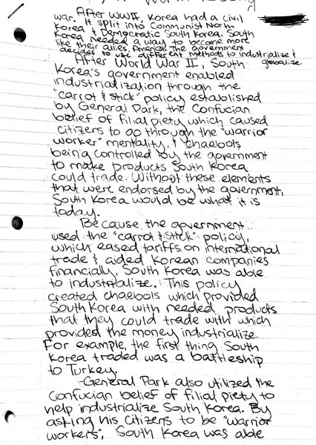

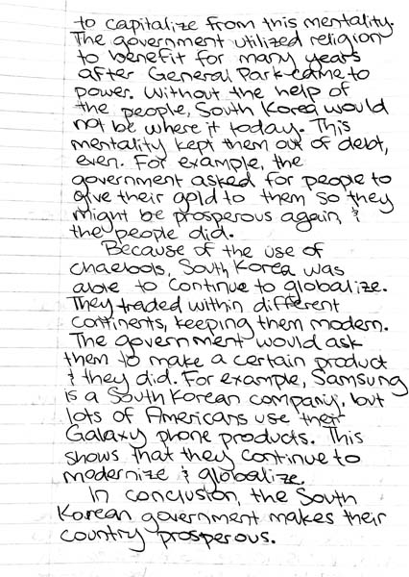

leq 2

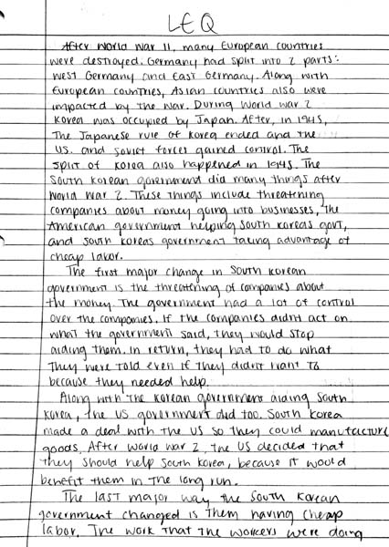

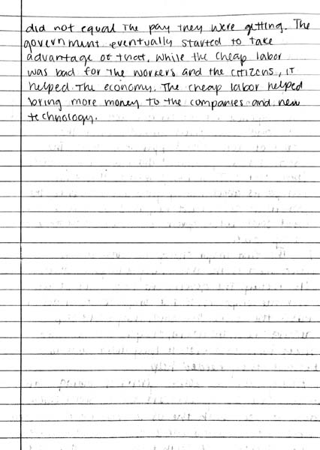

LEQ 3

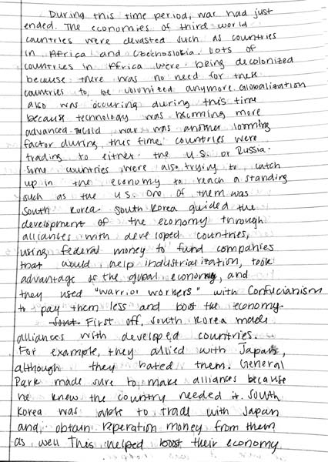

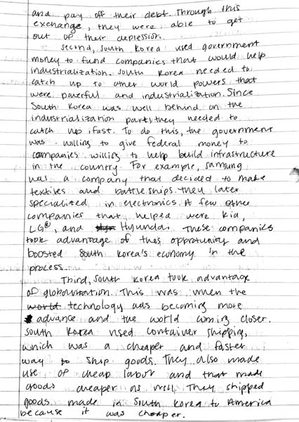

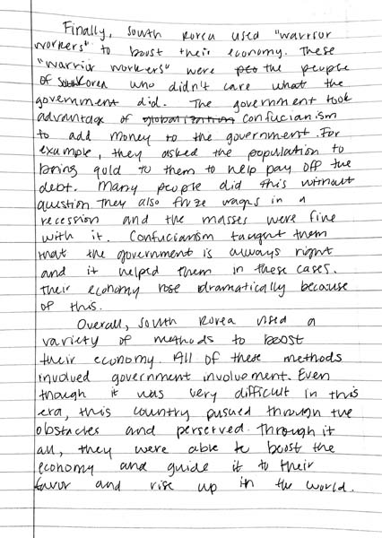

LEQ 4

