POPULATION MODULE OVERVIEW
SKILL FOCUS: Spatial Relationships, Data Analysis, Scale Analysis | CONTENT: ENDURING UNDERSTANDING SPS-2
Spatial Relationships: Describe spatial patterns, networks and explain a likely outcome in a geographic scenario using geographic concepts, processes, models, or theories  Data Analysis: Explain patterns and trends in maps and in quantitative and geospatial data to draw conclusions.  Scale Analysis: Identify the scale of analysis presented by maps, quantitative and geospatial data, images, and landscapes | Changes in population have long-and short-term effects on a place’s economy, culture, and politics.  Topic 2.9 - Aging Populations  Topic 2.7 - Population Policies

DAY  1 | How does scale affect our analysis of geographic trends?
CLASS ACTIVITY: Identify and Analyze Demographic Trends and Scales of Analysis
Students will identify and analyze demographic statistics at different scales of analysis and work collaboratively to predict challenges presented by those trends.
AP SKILL ALIGNMENT
Skill Category 2.A Describe spatial patterns, networks, and relationships.
Skill Category 3.C Explain patterns and trends in maps and in quantitative and geospatial data to
draw conclusions
Skill Category 5.A Identify the scales of analysis presented by maps, quantitative and geospatial data,
images, and landscapes

DAY 2 | What challenges are presented by an aging population?
CLASS ACTIVITY: Analyzing Population Policies in South Korea
Students will identify and analyze antinatalist and pronatalist population policies in South Korea and apply their knowledge to explain why a society may want to promote or discourage population growth.
AP SKILL ALIGNMENT
Skill Category 2.C Explain a likely outcome in a geographic scenario using geographic concepts,
processes, models, or theories.
Skill Category 3.E. Explain what maps or data imply or illustrate about geographic principles,
processes, and outcomes.

DAY  3 | CLASS ACTIVITY: Concept Mapping and AP-Aligned Assessment  Students will connect vocabulary and concepts via a concept-mapping activity and then demonstrate understanding as they answer five Multiple Choice Questions (MCQs) and one Free Response Question (FRQ) with two stimuli.  AP-ALIGNED ASSESSMENT:  Free-Response Question (FRQ) and Multiple Choice Questions (MCQs)

POPULATION SOURCES

DAY 1 | STIMULUS TYPE DESCRIPTION .  - Population Pyramid East Asia Population, 2020  - Population Pyramid Projected East Asia Population, 2050  - Data Chart East Asia Demographic Indicators  - Population Pyramid Population of South Korea, 2020  - Population Pyramid Projected Population of South Korea, 2050  - Data Chart South Korea Demographic Indicators  - Map Average Projected Annual Rate of World Population Change (%)  - Population Pyramid World Population, 2020  - Population Pyramid Projected World Population, 2050  - Data Chart World Demographic Indicators  - Graph Fertility Rates, South Korea, Selected Provinces, 2017  - Map Ratio of Elderly Population in South Korea by Province, 2010  - Population Pyramid Seoul, 2010  - Population Pyramid Jeollanam-do, 2010

DAY 2 | STIMULUS TYPE DESCRIPTION  - Population Pyramids South Korea, 1965, 1975, 1995, 2015  - Poster Antinatalist South Korean Government Poster  - Poster Antinatalist South Korean Government Poster  - Text Excerpt South Korea's Child Care Policy  - Graph South Korea’s TFR, 1960-2018  - Text Excerpt Field Note About Changing Family Sizes in Korea  - Text Excerpt Korea Endorses Loop for Birth Control  - Text Excerpt Government Support for Housing For Families With 3+ Children  - Poster Antinatalist South Korean Government Poster  - Poster Antinatalist South Korean Government Poster  - Graph Percentage of South Korean Women Using Contraception (Ages 15-49)  - Text Excerpt South Korea’s Saero-Maji Pronatalist Plan

DAY 3 | STIMULUS TYPE DESCRIPTION  - Population Pyramid Population of South Korea, 2020  - Text Excerpt “U.S. Homes Problematic for Aging Population”  - Graph Total Fertility Rate of South Korea Since 1984  - Map Average Projected Annual Rate of World Population Change (%)  - Population Pyramid Projected East Asia Population, 2050

D A Y 3
Based on a 60-minute class

Lesson Focus: Reviewing Population

AP curriculum Framework reference
Enduring Understanding SPO-2
Changes in population have long-and short-term effects on the economy, culture, and politics of places.
Topic 2.9 - Aging Populations
Topic 2.7- Population Policies

Human Geography Skills:
Spatial Relationships: Describe spatial patterns, networks and explain a likely outcome in a geographic scenario using geographic concepts, processes, models, or theories
Data Analysis: Explain patterns and trends in maps and in quantitative and geospatial data to draw conclusions.
Scale Analysis: Identify the scale of analysis presented by maps, quantitative and geospatial data, images, and landscapes

OVERVIEW
Students will work with the important terms and concepts from this module to review the essential content and skills. Working in groups, students will manipulate the important terms and concepts into a concept map that should begin with a central term or concept. Upon completing the task, groups rotate to other group concept maps to reflect on their synthesis, leading to interactive conversations and deeper review of the content as students make meaning individually and collaboratively. Then, students are given the opportunity to complete five AP-style multiple choice questions (MCQs) and one AP-style stimulus-based free response question (FRQ).

Materials needed For Day 3:
- Day 3 Handouts
  - Day 3 Student Handout (1 per student)
  - Day 3 Multiple Choice Question (MCQ) Assessment
  - Day 3 Free Response Question (FRQ) Assessment
- Day 3 Free Response Question (FRQ) Assessment Teacher Key

SEQUENCE OF INSTRUCTION

CLASS ACTIVITY 1 of 2: Concept Mapping

Class Activity (20-30 MINUTES): Concept Mapping

ACTIVITY 1: Students will consider the important terms and concepts for this module on Population in order to find relationships and more deeply understand the content. The activity also integrates the geographic skills that run through the module by asking students to explain the connections between terms and concepts. Debriefing the activity and monitoring student progress are two essential elements to this collaborative work.

Activity Procedure:
- Have students sit in groups of four to five to facilitate group work throughout the course of the activity. Mixed-ability groups are recommended to achieve the best results.
- Explain what a concept map is by showing an example (e.g., from the video below) and/or a brief video overview
  - https://tinyurl.com/geoconcept.
  - This video explains how concept maps are visual ways to express the connections between ideas and the steps to create an effective concept map (identifying main topic, organizing main points, creating map with major points and supporting details, reviewing map and looking for connections, including details, analyzing and improving the map).
- Students review the list of terms and concepts and begin to identify relationships as well as consider what the central term or concept might be.
  - Monitoring group conversations across the room and affirming good insights and/or prompting and redirecting groups that may need support is critical to ensure student understanding.
  - Students may need prompting to remain focused on connections and not definitions.
- Students display concept maps on desks or walls and groups rotate to see other concept maps.
  - Leading a discussion on similarities and differences among concept maps can reinforce conceptual knowledge
  - Groups may be given sticky notes to challenge connections between concepts with which they disagree. They can write how/why they disagree on the sticky note and place it on the concept map.
  - Taking pictures of concept maps and uploading all pictures for student access provides another opportunity for reflection and deeper learning
Teaching Tip

The list of terms and concepts for this activity is drawn from the two days of previous instruction in this module. Teachers might consider adding other terms and concepts to supplement this list depending on the scope of the unit and assessment.

Teaching Tip

If some groups work more efficiently and may seem to finish more quickly than others, having additional words or pictures or documents or even current event articles or excerpts can add a new dimension to the activity when the teacher gives those additional “cards” to groups. For example, handing out an excerpt from a recent news article on the industrial development of a country can force a group to wrestle with a current issue and make sense of it conceptually in light of their concept map.

CLASS ACTIVITY PART 2 of 2: Check for Understanding

CLASS ACTIVITY (30-40 MINUTES): AP ALIGNED ASSESSMENT

FORMATIVE ASSESSMENT: Students could complete the following assessments during class or as assigned homework or as part of another class to monitor student progress.

Activity Procedure:
- Hand out the Multiple Choice Question (MCQ) sets.
  - If this is truly formative assessment during class, consider going over the answers during class and have students who answered correctly explain their reasoning and process to the whole class.
  - Answers to the MCQs are- 1. E, 2. D, 3. E, 4. B, 5. B
- Distribute the FRQ and instruct students to complete all questions, monitoring the time and providing timing updates to simulate some of the time pressure students may feel on the day of the Exam.
  - Consider discussing answers either in small groups and/or as a class to check understanding or collect student work to provide specific, targeted feedback.
  - Consult the Teacher Key included in these resources as part of the feedback process.
Teaching Tip
If students are not already familiar with common FRQ command verbs, “discuss” and “explain” require development of an answer instead of a simple one- or two-word response.
- The following task verbs are commonly used in the free-response questions:
  - Compare: Provide a description or explanation of similarities and/or differences.
  - Define: Provide a specific meaning for a word or concept.
  - Describe: Provide the relevant characteristics of a specified topic.
  - Explain: Provide information about how or why a relationship, process, pattern, position, or outcome occurs, using evidence and/or reasoning.
  - Identify: Indicate or provide information about a specified topic, without elaboration or explanation.

Day 3 Student Handout

Name: ______________________________________________ Period: ________________

Concept Mapping

- Your group must create a central term for your list of words.
- Write this term/concept in the middle of your mind map. The concept/term should be something that demonstrates how the words are connected.
- Create a concept map that ​illustrates​​ how these terms are connected and why they are important. Keep all ​drawings/visuals​​ specific to understanding the terms. Fewer words, more visuals!!!
- Make sure to use all of the terms below, but you will also need to add in additional words as transitions.

Terms/concepts:
- Aging Population
- Birth Rates
- Death Rates
- Dependency Ratio
- Scale
- Total Fertility Rate
- Immigration Policies
- Replacement Level

- Migration Rates
- Life Expectancy
- Pronatalist Policies
- Anti Natalist Policies
- Economic Impacts
- Political Impacts
- Social Impacts
- Population Pyramids

Day 3 MCQ Assessment

Name: ______________________________________________ Period: ________________

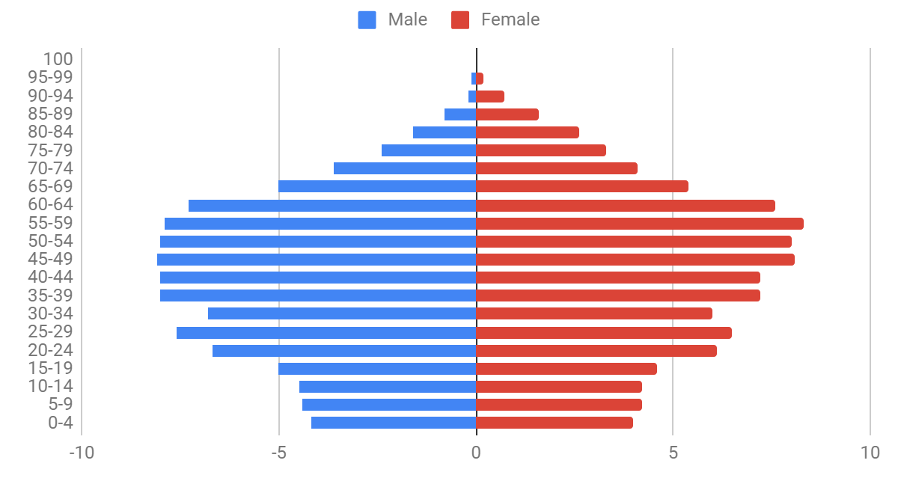
- Population pyramids, such as the one above, are a reflection of
- Unpredictable populations
- Rapidly increasing populations
- Moderately increasing populations
- Slowly increasing populations
- Declining populations

2. Based on the population pyramid above, which statement best predicts the issue this country will likely face in the future.
- Building enough schools to accommodate children
- Furnishing enough housing for their population
- Equipping women with adequate education
- Providing social services for the elderly
- Developing the infrastructure for industrialization

3. Countries with a population pyramid such as the one above, would most likely implement
- Pro-industrialization policies
- Anti-industrialization policies
- Equality policies
- Anti-natalist policies
- Pro-natalist policies

4. A recent article in the Washington Post stated: “Although we seldom think about them this way, most American communities as they exist today were built for the spry and mobile. We've constructed millions of multi-story, single-family homes where the master bedroom is on the second floor, where the lawn outside requires weekly upkeep, where the mailbox is a stroll away. We've designed neighborhoods where every day errands require a driver's license.”

The description of homes and neighborhoods in the United States is becoming an issue in many countries in North America, Western Europe, and East Asia due most directly to an increase in the _________
- Total Fertility Rate
- Aging Population
- Sex structure
- Rate of Natural Increase
- Crude Birth Rate

5. The chart above shows that, since 1984, the Total Fertility Rate of South Korea is
- Experiencing declining migration
- Below replacement level
- At replacement level
- Above replacement level
- Experiencing rapid fluctuations

Day 3 FRQ Assessment

Name: ______________________________________________ Period: ________________
- Using the map shown, identify a country that would most likely have a population pyramid similar to Pyramid A.
- Describe the Rate of Natural Increase (RNI) based on the population pyramid shown.
- Explain one social or political challenge for a country with a population pyramid similar to the one shown.
- Explain one economic challenge for a country with a population pyramid similar to the one shown.
- Describe a population policy that could address a possible issue related to the shape of the population pyramid shown.
- Explain the degree to which the scale of the data on the map above may be a disadvantage or advantage in terms of understanding population issues.
- Explain how migration could impact the population pyramid shown.

Day 3 FRQ Assessment Teacher Key
*Teachers can use this Key to guide assessment and student peer assessment.
- Using the map shown, identify a country that would have a population pyramid similar to country “A”
Albania Belarus Bulgaria Croatia Estonia Germany Greece Italy Japan Kosovo Latvia Lithuania Moldova Montenegro N. Macedonia Poland Portugal Romania Russia Serbia Slovenia Spain Ukraine

- Describe the Rate of Natural Increase based on the population pyramid shown.
- The RNI shows no growth or negative growth (accept either), since the bottom cohorts are small compared to the middle and elderly population.
Note: The command term is “describe,” so a student must do more than identify (i.e., “negative growth”) and instead must describe how/why the RNI shows no or negative growth.

C. Explain one social or political challenge for a country with a population pyramid similar to the one shown.
POLITICAL:
- Shifting demographics cause voters to have different priorities (social safety net vs. schools, etc.)
- Politicians focus more on the elderly because they are the largest demographic
SOCIAL:
- The challenge of providing for an aging population (social programs)
- Closing and/or consolidating schools due to the lack of younger population, which then creates issues with access to schools
- Closing colleges due to the lack of younger population, which then makes access more challenging
- Focusing on elderly concerns (i.e., assisted care facilities instead of preschools, etc.)

D. Explain one economic challenge for a country with a population pyramid similar to the one shown.
- Shrinking workforce
- Shrinking consumer base
- Shrinking economy
- Costs of providing elder services (i.e., Increased health care burdens)
Note: For all challenges, the explanation should include a phrase similar to “because there are many younger and older people, but not many between 16-64 (high dependency ratio).”
It is not enough simply to state the challenges; students must explain them.

E. Describe a population policy that could address a possible issue related to the shape of the population pyramid shown.
A pronatalist policy (students may also say “a policy aimed at increasing birth rates” or something similar) such as one that:
- Provides tax credits for children
- Pays for childcare
- Offers flexible work hours
- Offers maternity leave
- Has a nationalistic appeal
- Makes social claims of a happier life with more children
- Reduces access to contraceptives
Note: Students must describe a policy, not just identify one, to earn credit

F. Explain the degree to which the scale of the data on the map above may be a disadvantage or advantage in terms of understanding population issues.
- The country scale can be beneficial because, in contrast to a map at the regional scale (e.g., East Asia), each country typically controls its own policies (population and migration) and those policies will apply to the entire unit.
- The country scale is a hindrance to understanding population concerns because the country scale does not show variations within the country; for example, urban areas tend to have fewer young children than rural areas (or a lower TFR, RNI, etc.).
Note: An answer that talks about the global scale is not automatically wrong, but since the scale of analysis is at the country level the student must get to that idea for credit.

G. Explain how migration could impact the population pyramid shown.
- Guest workers or permanent migrants are often of working age, which can then alter the dependency ratio, easing the economic burden, etc.
- A population pyramid of this shape is typically associated with countries that are NICs (Newly Industrialized Countries) or MEDCs (More Economically Developed Countries), so there will likely be positive net migration, resulting in more people who are of working age.

