INDUSTRIALIZATION AND ECONOMIC DEVELOPMENT MODULE OVERVIEW
SKILL FOCUS: SPATIAL RELATIONSHIPS, DATA ANALYSIS, SOURCE ANALYSIS | CONTENT: ENDURING UNDERSTANDING SPS-7
Spatial Relationships: Describe spatial patterns, networks and explain a likely outcome in a geographic scenario using geographic concepts, processes, models, or theories  Data Analysis: Explain patterns and trends in maps and in quantitative and geospatial data to draw conclusions.  Source Analysis: Analyze and interpret qualitative geographic information represented in maps, images (e.g., satellite, photographs, cartoons), and landscapes | Industrialization, past and present, has facilitated improvements in standards of living, but it has also contributed to geographically uneven development.  Topic 7.1 The Industrial Revolution  Topic 7.2 Economic Sectors and Patterns  Topic 7.3 Measures of Development

DAY 1 | What are economic sectors and the factors that affect their development?  CLASS ACTIVITY: Understanding and Identifying Economic Sectors  Students will work collaboratively to identify and learn the five different economic sectors. Students will then use their new understanding of the economic sectors and examine maps and data sets to predict the locations of different economic sectors within South Korea.  AP SKILL ALIGNMENT  Skill Category 2.B Explain spatial relationships in a specified context or region of the world, using  geographic concepts, processes, models, or theories.  Skill Category 2.C Explain a likely outcome in a geographic scenario using geographic concepts,  processes, models, or theories.  Skill Category 4.D Compare patterns and trends in sources to draw conclusions.

DAY 2 | What are the key measures of development in a country?
CLASS ACTIVITY: Understanding and Identifying Measures of Development
Students will work collaboratively to define and learn a variety of measures of development. Students will then analyze data sets to identify changes in several measures of development in South Korea over the past 70 years and speculate as to the reasons for those changes.
AP SKILL ALIGNMENT
Skill Category 3.F Explain possible limitations of the data provided.
Skill Category 4.D Compare patterns and trends in sources to draw conclusions.
Skill Category 4.E Explain how maps, images, and landscapes illustrate or relate to geographic
principles, processes, and outcomes.

DAY 3 | CLASS ACTIVITY: Concept Mapping and AP-Aligned Assessment  Students will connect vocabulary and concepts via a concept-mapping activity and then demonstrate understanding as they answer one Free Response Question (FRQ) with two stimuli and Multiple Choice Questions (5 MCQs total).  AP-ALIGNED ASSESSMENT: Free-Response Question (FRQ) and Multiple Choice Questions (MCQs)

INDUSTRIALIZATION AND ECONOMIC DEVELOPMENT SOURCES
DAY 1 | STIMULUS TYPE DESCRIPTION STIMULUS TYPE DESCRIPTION  - Map The Global Spread of 11. Image New York Stock Exchange  Industrialization  - Image Tractor on a Farm 12. Map Outline Map of South Korea  - Image Textile Manufacturing Equipment 13. Map Population of South Korea (Dot Map)  - Image Barbershop 14. Map Road and Highway Systems of South  Korea  - Image Researcher / Scientist 15. Map Food and Beverage Services of South  Korea (Dot Map)  - Image Business Leaders 16. Map Percentage of People per Subunit  Engaged in Market Gardening in South  Korea (Choropleth map)  - Image Open Mine Site 17. Map Percentage of people Engaged in  Manufacturing in South Korea  (Choropleth map).  - Image Manufacturing Plant 18. Map Distribution of Colleges and  Universities in South Korea  - Image New York Storefronts 19. Map Distribution and Number of Hospitals  - Image University Research Facility in South Korea

DAY 2 | STIMULUS TYPE DESCRIPTION  - Data Chart Data Charts of GDP for South Korea from 1960 - 2018  - Article South Korea's GDP Surges 31,000-fold since 1953  - Data Chart South Korea’s GDP Growth (Annual Percentage) and  Annual Change from 1960 - 2018  - Data Chart South Korea’s Oil Consumption 1969 - 2018  - Article South Korea Relies on Imports to Meet about 98% of its  Fossil Fuel Consumption  - Data Chart South Korean Usage of Renewable Energies from 1990 –  2015  - Data Chart Trends in South Korea’s HDI Component Indices 1980 - 2014  - Data Chart South Korea’s HDI Trends  - Map South Korean Regions by Human Development Index in 2017

DAY 3 | STIMULUS TYPE DESCRIPTION  - Data Chart South Korea’s Greenhouse Gas Emissions Rising Quickly  - Image Researcher / Scientist  - Image Worker in Rice Field  - Image Auto Factory
D A Y 2
Based on a 60-minute class

Lesson Question: What are the key measures of development in a country?

AP curriculum Framework reference
Enduring Understanding SPS-7
Industrialization, past and present, has facilitated improvements in standards of living, but it has also contributed to geographically uneven development.
Topic 7.3 - Measures of Development

Human Geography Skills:
Data Analysis: Explain patterns and trends in maps and in quantitative and geospatial data to draw conclusions.
Skill Category 3.F Explain possible limitations of the data provided.
Source Analysis: Analyze and interpret qualitative geographic information represented in maps, images (e.g., satellite, photographs, cartoons), and landscapes.
Skill Category 4.D Compare patterns and trends in sources to draw conclusions.
Skill Category 4.E Explain how maps, images, and landscapes illustrate or relate to geographic principles, processes, and
Outcomes.

OVERVIEW
Students will identify and understand measures of development and draw conclusions about how and why these measures have changed over time in South Korea through structured source analysis of selected images, short readings, data charts, and maps of population locations in South Korea. Students will use their understanding of the measures of development to explain the changes in social and economic development in South Korea since the Korean War. Further, students will predict reasons for these changes based on their data analysis. Finally, students will evaluate the data sets and their limitations.
Materials needed For Day 1:
- Butcher Block Paper or Large Poster Paper
- Day 2 Handouts
  - Day 2 Preparation Homework Activity (1 per student)
  - Day 2 Student Handout (1 per student)
  - Key Measures of Development Term Cards (these will need to be cut out in advance (1 per team)
  - Measures of Development Data Sets #1 - 3 (1 per team)

SEQUENCE OF INSTRUCTION
HOMEWORK OVERVIEW
Note: This homework is only necessary if the teacher has not yet discussed the Key Measures of Development including Gross Domestic Product (GDP), Gross National Income (GNI) per capita, formal and informal sectoral structures of an economy, income distribution, fertility rates, infant mortality rates, access to health care, use of fossil fuels and renewable energy, literacy rates, the Gender Inequality Index (GII), and the Human Development Index (HDI).
HOMEWORK - CLASS PREPARATION - (30 MINUTES):
Students complete the Day 1 Preparation Homework Activity sheet, working with important terms related to key measures of development. Students will write down what they believe is the definition of the term. Then, students will research the correct definition and record it. Next, students draw a visual representation of the term to solidify their understanding. Finally, students will explain how this term relates to Human Geography.
The purpose of this homework is to:
- Ensure students have a basic knowledge and understanding of the Key Measures of Development.
- Prepare students to use data related to these measures of development to identify changes that have taken place in South Korea since the end of the Korean War.

Teacher Notes
Students will need to have a basic understanding of these key measures of development to complete the activities on Day 2. Teachers should advise students that they will need to research these terms as they relate to Human Geography. A basic internet search for the definition may not provide the proper description in human geographical terms, so warn students to read the definitions they find carefully to ensure they connect to the concepts of human geography.

SEQUENCE OF INSTRUCTION

CLASS ACTIVITY 1 of 4: Warm Up / Introduction

WARM UP/INTRODUCTION (10-15 MINUTES): What Makes a Country “Successful” Activity

ACTIVITY 1: Students will brainstorm factors that make a country “successful” in our modern world. This activity is designed to activate thinking about how we measure the development of a country and a country’s overall success.

Activity Procedure:
- Group students into teams of three or four.
- Students individually brainstorm, using the Brainstorming Space on their Day 2 Student Handout, different factors that make a country “successful” (two minutes).
  - Explain to students that the goal is to come up with measurable factors that would allow people to judge the “success” of a country. Encourage students to use factors that would have measurable data (like GDP and other AP Human Geography concepts).
- Teams share and discuss the list of factors each person created. As a group, they decide on the top five most important factors and explain why those factors were selected and record them in the Brainstorming Space (Day 2 Student Handout) (4 minutes).
- Groups share their top five lists. Invite students to critique other group’s lists and challenge their reasoning.
- Create a combined “Class Top Five List.”
Teacher Notes
The teacher should listen to the group discussions and redirect teams that may focus on subjective measures as opposed to measurable data. Asking teams if there is a way to measure a factor can be a good cue to help students to avoid vague generalizations.
Teaching Tip
Consider using a timer or a stopwatch so that each activity does not run too long. Offer time cues to keep students focused and working to complete the task.

CLASS ACTIVITY PART 2 of 4: Identifying and Explaining the Key Measures of Development

CLASS ACTIVITY (25 MINUTES): Identification and Review of Key Measures of Development
ACTIVITY 2: Based on Activity 1, students will review key measures of development, Students examine definitions of these key measures, and further analyze which factors are associated with “successful” countries.
Activity Procedure:
- Each team will receive one of the 9 cards (Key Measure of Development Terms cards) to examine in greater depth. Depending on class size, teachers can select the most important terms based on their previous knowledge.
- Each team will write their assigned term and how they would define the term on a large piece of paper without using other resources, including their homework. Tell students to save space as they will still need to add to the paper (4 minutes).
- Teams will rotate multiple times
  - Team Rotation 1:
    - Teams evaluate the definition and make any necessary changes or corrections. Encourage teams to be critical of the definitions and to work toward creating the best definition possible (2 minutes).
  - Team Rotation 2:
    - Teams create a visual representation of the term using the two definitions.
      - Students may struggle with this task and some may state that they are not artists, but reassure them by explaining you are not judging their artistic ability, but instead their understanding of the term and creativity in depicting it on the poster (5 minutes).
  - Team Rotation 3:
    - Teams create a thirty-second presentation of the poster and visual, having checked for accuracy and making any necessary corrections (5-10 minutes).
      - Since the poster they are presenting is not their own creation, teams will need to process the information to determine how to present it best. Remind teams that their presentations will need to be accurate and succinct.
      - Teachers should check posters and make corrections to information as needed prior to the presentations.
- Teams present their posters (5 minutes).
  - After hearing all of the presentations, students will identify the two measures of development they believe to be most important in determining the “success” of a country on Day 2 Student Handout (page 2).
- Students return to their list of factors that “make a country successful” and circle the factors which can be measured with data.
- Students categorize each factor as either economic or social using the letters E or S.
  - Have students consider whether they identified more economic or social factors.
  - Students decide whether economic or social measures are more important in determining a country’s “success” on the Day 2 Student Handout (page 2).

Teaching Tip
When teams rotate during activities, have students stand up and move around the classroom. This movement keeps students active and more alert, as they do not become too comfortable in any one location.

CLASS ACTIVITY PART 3 of 4: Examining How Measures of Development Have Changed in South Korea

CLASS ACTIVITY (20 MINUTES): Examining Data To Chart South Korea’s Changes in Development

ACTIVITY 3: Students will use their knowledge of measures of development from activity 2 to help them analyze South Korea’s growth in several different social and economic areas since the end of the Korean War.

Activity Procedure:
- Remaining in their teams, students are given a set of data containing different types of information related to the Measures of Development (see Measures of Development Data Charts From 1953 to the Present - there are three different sets). Each team will receive the same sets of data charts.
- Teams examine the data charts and determine how South Korea’s economy has changed in relation to Gross Domestic Product (GDP), Energy Use, and Human Development Index (HDI) and fill out the Measures of Development Chart on the Day 2 Student Handout (page 3). Students should note any changes or features that stand out during that time periods on the chart (15-20 minutes).
- Students record their conclusions in the Measures of Development Conclusions on the Day 2 Student Handout (page 4), considering the unique characteristics and development of South Korea that might impact the data over time.
Teacher Notes
The data sets are designed to include a variety of different types of material for students to analyze and interpret. Multiple methods of conveying the same information have been selected to require students to interpret and make connections across a variety of sources.

CLASS ACTIVITY PART 4 of 4: Check for Understanding

CLASS ACTIVITY (5-10 MINUTES): Analysis of South Korea’s Changes in Development Since the Korean War

Exit Ticket: Students will use the information gathered from their data chart analysis to draw conclusions about South Korea’s development since the end of the Korean War. They will also develop an argument whether South Korea has achieved “success” as a country, citing specific measures of development as evidence.

Activity Procedure:
- Have each student answer the following questions:
  - Has South Korea achieved “success” as a country? Why or why not?
    - Which Measures of Development would best indicate your conclusions about South Korea? Provide specific examples to support your argument.
    - Which factor is most important to determine the success of South Korea? Why? Explain.
    - What are the potential limitations of the data examined?
    - What other Measures of Development were NOT included in the data charts that may have been useful?
  - Considering this case study of South Korea, create your own Measure of Development that can be applied to measure “success” across countries.
- Collect these paragraphs or short answers as an exit ticket as students leave the class.

Day 2 Preparation Homework Activity

Name: ______________________________________________ Period: ________________

Key Measures of Development
Complete the chart below by providing your guess at the definition, the actual definition you researched, a visual representation of the definition, and an explanation of how this term relates to our study of Human Geography.
Term | My Guess at the Definition | The ACTUAL Definition | My Visual Representation of the Term | How the Term Connects to Human Geography
Gross Domestic Product (GDP)
Gross National Income (GNI) Per Capita
Income Distribution

Fertility Rates

Infant Mortality Rates
Access to Health Care

Human Development Index (HDI)

Literacy Rates

Gender Inequality Index (GII)

Day 2 Student Handout

Name: ______________________________________________ Period: ________________

Brainstorming Space
ON MY OWN  What factors make a country “successful” (remember factors must be measurable)? | TEAM’S TOP FIVE  What factors make a country “successful” (remember factors must be measurable)?
- ____________________________
Reason:

- ____________________________
Reason:

- ____________________________
Reason:

- ____________________________
Reason:

- ____________________________
Reason:

Day 2 Student Handout - Continued (page 2)

Measures of Development

After hearing each team present their assigned term, determine which TWO of these would be the best indicators in determining a “successful” country. List them below and explain why.

- Measure of Development: _____________________________________________
Explanation:
- Measure of Development: _____________________________________________
Explanation:

Measures of Development

Look at your original list of factors on the front of this sheet. Circle all of the factors that you believe can be measured in some way that will provide you with data. For factors that you believe cannot be measured, draw a line through that factor. Next, label Economic factors with an E and Social factors with an S to indicate which of your circled factors are ECONOMIC measures of development and which are SOCIAL measures of development.

 | ECONOMIC | SOCIAL
Number of YOUR Factors Related to this Type of Measure of Development

Are ECONOMIC or SOCIAL measures of development more important in determining a country’s “success?” Explain citing specific evidence.

Day 2 Student Handout - Continued (page 3)

Measures of Development Chart

Working with your teammates, note important characteristics and changes that you see reflected in the data sets provided for each of the following different Measures of Development.

Measure of Development | 1953 - 1970s | 1980-1990s | 2000 Through  the Present
Gross Domestic Product (GDP)
Energy Use | X  (This was not measured until 1990)
Human Development Index (HDI) | X  (This was not measured until 1980)

Day 2 Student Handout - Continued (page 4)

Measures of Development Conclusions
Based on your findings from the data sets.on the changes over time in the Measures of Development listed in your chart above, draw some conclusions about what may have occurred historically in South Korea during each of the time periods listed above. Finally, based off of the information you have been provided in your data sets, speculate what will happen to each of these Measures of Development in the future.

Conclusions for 1953 - 1970s:

Conclusions for 1980 - 1990s:

Conclusions for 2000 Through the Present:

Predictions for the Future:

- Gross Domestic Product (GDP):

- Energy Use

- Human Development Index (HDI)

Key Measures of Development Terms

Gross Domestic Product (GDP) per Capita | Gross National Income (GNI) per Capita
Income Distribution | Fertility Rate
Infant Mortality Rate | Access to Health Care

Key Measures of Development Terms (continued)

Human Development Index (HDI) | Literacy Rates
Gender Inequality Index (GII) | X

Key Measures of Development Terms Key for Teachers

Term: | Definition:
Gross Domestic Product (GDP) | The value of the total number of goods and services produced within a country's boundaries in a given period (normally one year). GDP does not consider goods and services produced by citizens who are outside the country and does include what is produced within the countries by foreigners. Typically measured on a per capita basis.
Gross National Income (GNI) | It is the value of goods and services produced by citizens of the country regardless of where they are located (within the country’s boundaries or abroad). Typically measured on a per capita basis.
Income Distribution | Income distribution looks at how much different socioeconomic groups in a country earn. In other words, income distribution refers to the equality or smoothness with which people’s incomes are distributed.Often it is reflected in how a nation's total GDP is distributed amongst its population. The specific measure used for income distribution is often the Gini coefficient.
Fertility Rates | The number of live births in women over a specific length of time. Fertility rate is generally expressed as the number of births per 1,000 women aged 15 to 44 in a calendar year.
Infant Mortality Rates | The infant mortality rate is the number of deaths under one year of age occurring among the live births in a given country during a given year per 1,000 live births
Access to Health Care | Access to health care means having the timely use of personal health services to achieve the best health outcomes. Access to health care consists of four components: coverage, services, timeliness, and workforce. Measurable aspects include things such as physicians per 1,000 people.
Human Development Index (HDI) | Measures three basic dimensions of human development: long and healthy life, knowledge, and a decent standard of living. Four indicators are used to calculate the index: life expectancy at birth, mean years of schooling, expected years of schooling, and gross national income per capita.
Literacy Rates | The percentage of a country's people who can read and write. Can be looked at overall and for males and females.
Gender Inequality Index (GII) | An index for measurement of gender disparity that was introduced in 2010 by the United Nations Development Programme (UNDP). According to the UNDP, this index is a composite measure to quantify the loss of achievement within a country due to gender inequality. It uses three dimensions to measure opportunity cost: reproductive health, empowerment, and labor market participation.

Key Measures of Development Data Chart Set #1 - Gross Domestic Product (GDP)

Data Set #1: GDP for South Korea, 1960–2018
Source: Tradingeconomics.com/World Bank, https://tradingeconomics.com/south-korea/gdp
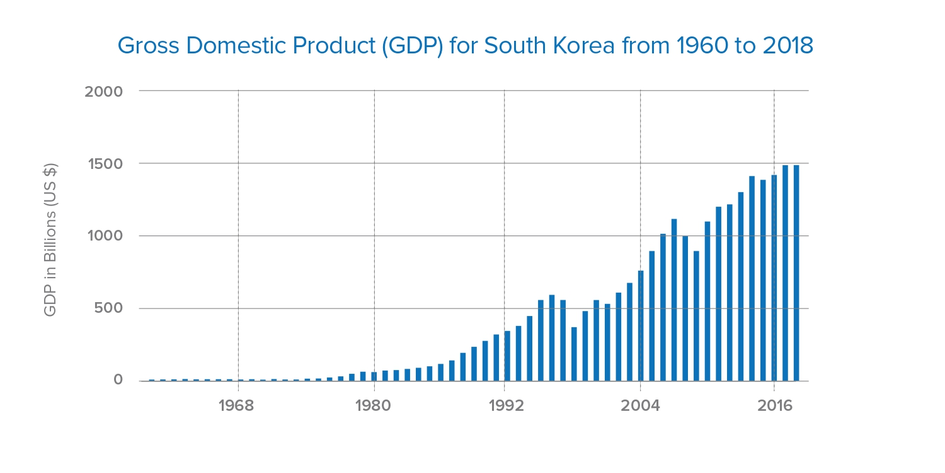

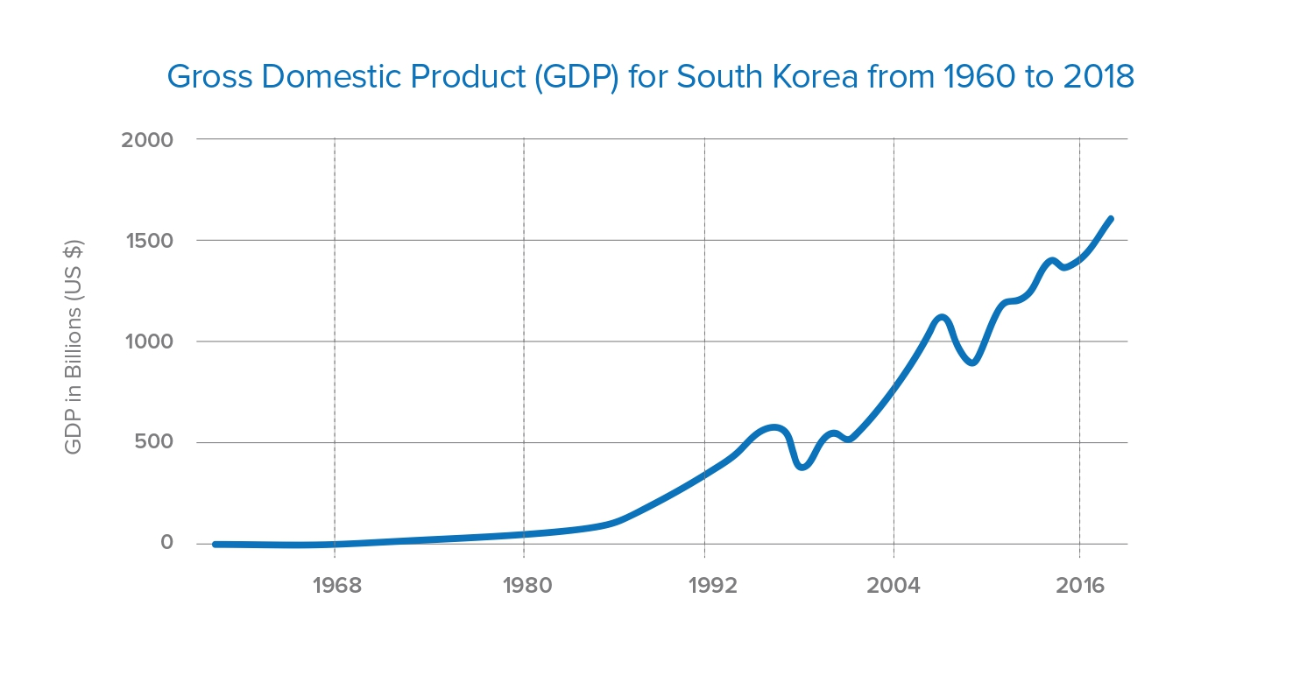

Data Set # 1 (CONTINUED) South Korea’s GDP Growth and Change in Growth Rates, 1960 - 2018
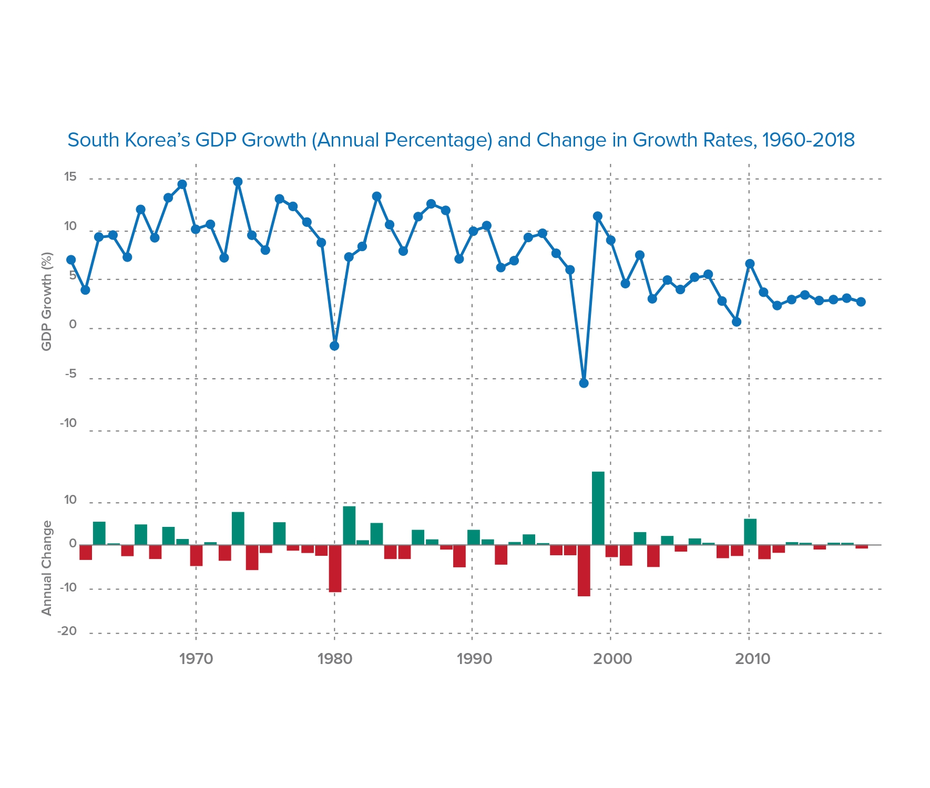
Data Set # 1 (CONTINUED) S. Korea's GDP surges 31,000-fold since 1953
SOURCE: The Korea Herald, August 10, 2015, http://www.koreaherald.com/search/list_name.php?byline=KH%EB%94%94%EC%A7%80%ED%84%B82
By KH디지털2 : Published in The Korea Herald on August 10, 2015
South Korea's gross domestic product has surged 31,000-fold since 1953, fueled by exports and competitiveness in heavy industries and consumer electronics, government data showed Monday.
According to the data by Statistics Korea, the country's nominal gross domestic product shot up from a mere 47.7 billion won ($40.9 million) in 1953, soaring to 1,485 trillion won last year. The data highlights the achievements made by Asia's fourth-largest economy 70 years after being liberated from Japanese colonial rule (1910-1945).

"During the last year of the Korean War, the country was one of the poorest in the world and barely made ends meet by relying on assistance from others, but as of last year it trailed Australia and edged past Spain in terms of economic size," the statistical agency said.

In 2014, there were only 15 countries in the world with an annual GDP exceeding $1 trillion, it said.

According to the data, exports were almost non-existent in 1953, but the country shipped out $572.7 billion last year, making it the world's sixth-largest exporting nation.

South Korea has become globally competitive in cars, ships, steel, and more recently, consumer electronics, which has helped fuel growth.

The country has also maintained a current account surplus since 1998 after being in the red before. In 2014, the surplus reached $89.2 billion, accounting for 6.33 percent of the GDP.

The gross national income per capita skyrocketed to $28,180 last year from $67 in 1953, with the per capita GDP numbers adjusted for purchasing power parity hitting $34,356.

As of last year, the country's foreign currency reserves stood at $363.6 billion, 18 times more than the $20.4 billion it held just before the 1997 Asian financial crisis.

The agency said it did not have reliable data right after liberation or during the Korean War (1950-1953) period. (Yonhap)

Key Measures of Development Data Chart Set #2 - Energy Use

DATA SET #2 South Korea’s Oil Consumption, 1965–2015
Source: BP PLC, http://www.ceicdata.com
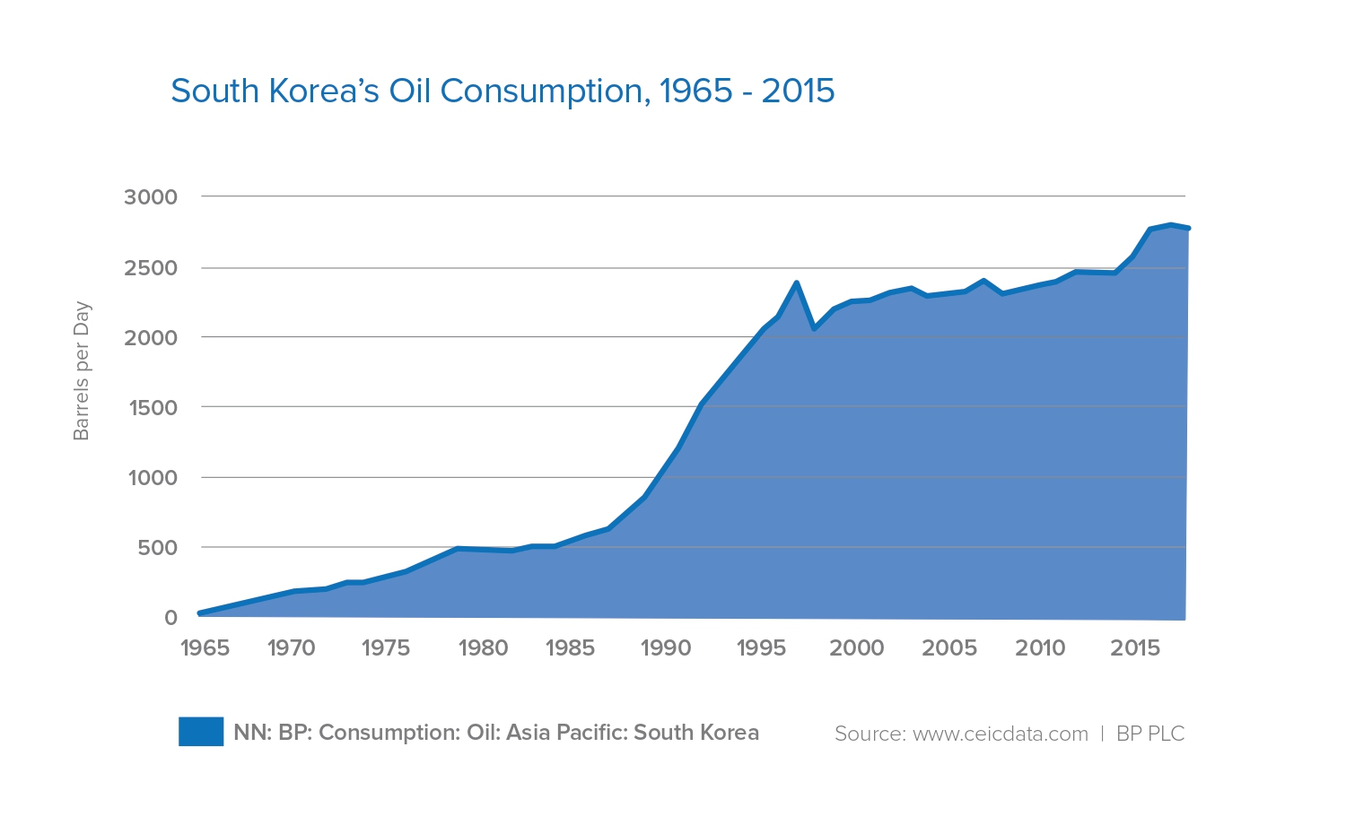

DATA SET #2 (CONTINUED) “South Korea Relies on Imports to Meet about 98% of its Fossil Fuel Consumption”
Source: U.S. Energy Information Administration, July 16, 2018, https://www.eia.gov/international/analysis/country/KOR
South Korea relies on imports to meet about 98% of its fossil fuel consumption as a result of insufficient domestic resources. The country is one of the world’s leading energy importers.
South Korea ranks among the world’s top five importers of liquefied natural gas (LNG), coal, crude oil, and refined products. South Korea has no international oil or natural gas pipelines and relies exclusively on tanker shipments of LNG and crude oil.
Despite its lack of domestic energy resources, South Korea is home to some of the largest and most advanced oil refineries in the world. In an effort to improve the nation’s energy security, oil and natural gas companies are aggressively seeking overseas exploration and production opportunities.
South Korea was the world’s eighth-largest energy consumer in 2017, according to estimates from the BP Statistical Review of World Energy 2018. South Korea’s highly developed economy drives its energy consumption, and economic growth is fueled by exports, most notably exports of electronics, semiconductors, and petrochemicals. The country also is home to one of the world’s top shipbuilding industries. Real gross domestic product (GDP) has edged up since 2015 to 3.1% in 2017 as demand for the country’s exports strengthened.
South Korea’s economy is heavily dependent on export markets, particularly within Asia. Exports in the region have increased over the past two years, which has boosted South Korea’s energy use. The country’s aging population is expected to dampen domestic energy demand and the overall economic landscape over the long term.
Although petroleum and other liquids, including biofuels, accounted for the largest portion (44%) of South Korea’s primary energy consumption in 2017, its share has been declining since the mid-1990s, when it reached a peak of 66%. This trend is attributed to the steady increase in natural gas, coal, and nuclear energy consumption, which has reduced oil use in the power sector and the industrial sector. Higher vehicle efficiencies have also reduced oil consumption.

DATA SET #2 (CONTINUED) South Korean Usage of Renewable Energies, 1990–2015
Source: WorldData.info at https://www.worlddata.info/asia/south-korea/energy-consumption.php

Usage of renewable energies
Renewable energies include wind, solar, biomass and geothermal energy sources. The term “renewable energies” means all energy sources that renew themselves within a short time or are permanently available. Energy from hydropower is only partly a renewable energy. This is certainly the case with river or tidal power plants. Otherwise, numerous dams or reservoirs also produce mixed forms, e.g., by pumping water into their reservoirs at night and recovering energy from them during the day when there is an increased demand for electricity. In 2015, renewable energies accounted for around 2.7 percent of actual total consumption in South Korea. The following chart shows the percentage share from 1990 to 2015:

Key Measures of Development Data Chart Set #3 - Human Development Index (HDI)

DATA SET #3 Trends in South Korea’s HDI Component Indices, 1980–2014
Source: United Nations Development Programme Human Development Report 2019: Inequalities in Human Development in the 21st Century. http://hdr.undp.org/sites/all/themes/hdr_theme/country-notes/KOR.pdf

DATA SET #3 (CONTINUED) South Korea’s HDI Value and Rank
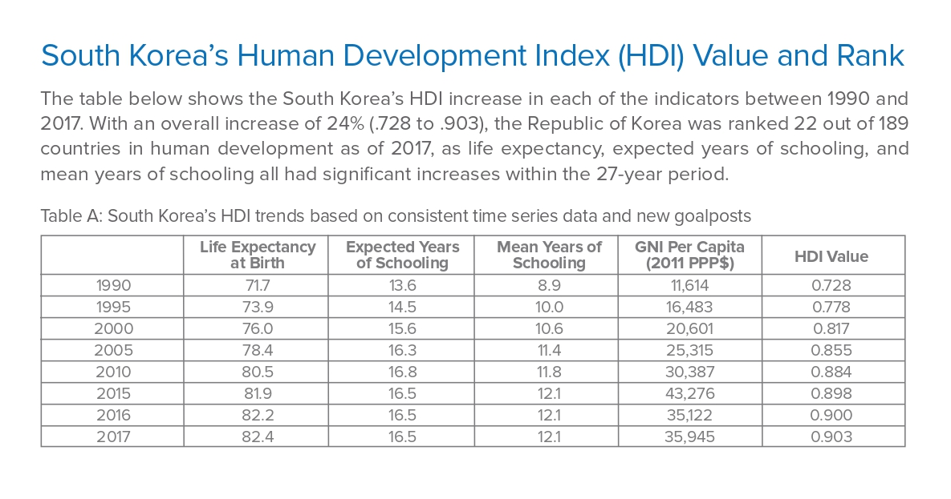

Data Set #3 (CONTINUED) South Korean Regions by Human Development Index in 2017
Source: Wikimedia Commons, Map of the South Korean regions by Human Development Index in 2017, Creative Commons Attribution-Share Alike 4.0 International license, https://commons.wikimedia.org/wiki/File:Regions_of_ South_Korea_by_HDI_(2017).svg
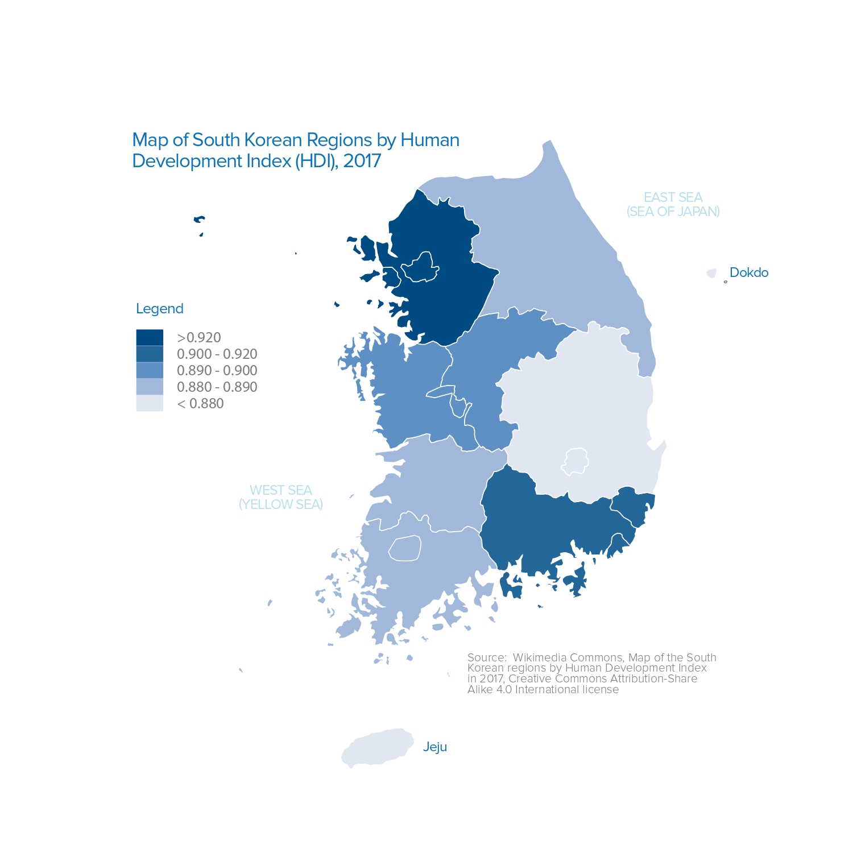
Map of the South Korean regions by Human Development Index in 2017

