CULTURE MODULE OVERVIEW
SKILL FOCUS: Source Analysis, and Concepts and Processes | CONTENT: ENDURING UNDERSTANDING SPO-3
Source Analysis: Analyze and interpret qualitative geographic information represented in  maps, images (e.g. satellite, photographs,  cartoons), and landscapes.  Concepts and Processes: Describe geographic concepts, processes, models, and theories. | Cultural practices vary across geographical locations because of physical geography and available resources.  Topic 3.2 Cultural Landscapes  Topic 3.5 Historical Causes of Diffusion  Topic 3.6 Contemporary Causes of Diffusion

DAY 1 | How do cultural landscapes reflect cultural practices?
CLASS ACTIVITY: Reading a Cultural Landscape
Students will work collaboratively to identify and understand the components that make up cultural landscapes. Students will then use their new understanding of cultural landscapes to analyze information in visual sources from South Korea for cultural and political indicators and to draw conclusions about the patterns they identify.
AP SKILL ALIGNMENT
Skill Category 4.A Identify the different types of information presented in visual sources.
Skill Category 4.C Explain patterns and trends in visual sources to draw conclusions.

DAY 2 | How does diffusion impact cultural landscapes?
CLASS ACTIVITY: Cultural Diffusion Investigation
Students will explore how the elements of the cultural landscapes are diffused by brainstorming ways cultural elements diffuse and by studying cultural diffusion of Korean culture, culminating in an analysis of how cultures change due to diffusion.
AP SKILL ALIGNMENT
Skill Category 4.D Compare patterns and trends in sources to draw conclusions.
Skill Category 4.E Explain how maps, images and landscapes illustrate or relate to geographic
principals, and outcomes.

DAY 3 | CLASS ACTIVITY: Concept Mapping and AP-Aligned Assessment  Students will connect vocabulary and concepts via a concept-mapping activity and then demonstrate understanding as they answer one Free Response Question (FRQ) with two stimuli and Multiple Choice Questions (5 MCQs total).
 | AP-ALIGNED ASSESSMENT: Free-Response Question (FRQ) and Multiple Choice Questions (MCQs)

CULTURE SOURCES
DAY 1 | STIMULUS TYPE DESCRIPTION .  - Image Card 1 The Old Seoul City Hall, built in 1925 during the Japanese occupation  - Image Card 2 The New Seoul City Hall, built in 2012  - Image Card 3A Part of a photo of the Old and New Seoul City Halls  - Image Card 3B Part of a photo of the Old and New Seoul City Halls  - Image Card 3C Part of a photo of the Old and New Seoul City Halls  - Image Card 3D Part of a photo of the Old and New Seoul City Halls  - Image Card 3E Full photo containing Images 3A, 3B, 3C, and 3D  - Image Card 4A Daytime View of the Old and New City Halls  - Image Card 4B Nighttime view of the Old and New City Halls  - Image Card 4C Side view of the Old and New City Halls  - Image Card 4D View of the Old and New City Halls from across the street  - Image Card 5A Sequent Occupance Card #1: Hagia Sophia as a Church  - Image Card 5B Sequent Occupance Card #2: Hagia Sophia as a Mosque  - Image Card 6A Cultural Detective Photo Card #1: Street in Myeong-dong  - Image Card 6B Cultural Detective Photo Card #2: Bukchon Hanok Village  - Image Card 6C Cultural Detective Photo Card #3: Christian Church, Seoul  - Image Card 6D Cultural Detective Photo Card #4: Steel works (POSCO, Pohang Iron and  Steel Company) near the river in Pohang Kyeongsangbuk-do

DAY 2 | STIMULUS TYPE DESCRIPTION  - Image 1 Diagram of the basic layout of Seoul, reflecting Geomancy principles  - Image 2 Photograph of Seoul with mountains in background  - Map City Map of Hanyang (Seoul) in 1822  - Image 3 Locations of major buildings in Seoul, reflecting Geomancy principles  - Image 4 Photo of the “Blue House,” the presidential office and residence  - Image 5 Photo of Koreatown in Manhattan  - Map Cheonggyecheon reclamation project  - Image Koreatown Manhattan  - Map BTS YouTube Views 2018  - Graph Top 10 Countries with Most BTS YouTube Views 2018  - Graph Total Exports Induced by the Korean Wave

DAY 3 | STIMULUS TYPE DESCRIPTION  - Image Church located in Seoul  - Map Number of Views of K-Pop Videos on YouTube by Country in millions, 2011  - Image Photo of Koreatown in Manhattan
D A Y 3
Based on a 60-minute class

Lesson Focus: Reviewing Culture

AP curriculum Framework reference
Enduring Understanding PSO-3
Cultural practices vary across geographical locations because of physical geography and available resources.
Topic 3.2 Cultural Landscapes
Topic 3.5 Historical Causes of Diffusion
Topic 3.6 Contemporary Causes of Diffusion

Human Geography Skills:

Source Analysis: Analyze and interpret qualitative geographic information represented in maps, images (e.g., satellite, photographs, cartoons), and landscapes

Skill Category 4.A Identify the different types of information presented in visual sources.
Skill Category 4.B Describe the spatial patterns presented in visual sources.
Skill Category 4.C Explain patterns and trends in visual sources to draw conclusions.

Concepts and Processes: Describe geographic concepts, processes, models, and theories.

Skill Category 1.A Describe geographic concepts, processes, models, and theories.
Skill Category 1.D Describe a relevant geographic concept, process, model, or theory in a specified context

OVERVIEW
Students will work with the important terms and concepts from this module to review the essential content and skills. Working in groups, students will manipulate the important terms and concepts into a concept map that should begin with a central term or concept. Upon completing the task, groups rotate to other group concept maps to reflect on their synthesis, leading to interactive conversations and deeper review of the content as students make meaning individually and collaboratively. Then, students are given the opportunity to complete five AP-style multiple choice questions (MCQs) and one AP-style stimulus-based free response question (FRQ).

Materials needed For Day 3:
- Day 3 Handouts
  - Day 3 Student Handout (1 per student)
  - Day 3 Multiple Choice Question (MCQ) Assessment
  - Day 3 Free Response Question (FRQ) Assessment
- Day 3 Free Response Question (FRQ) Assessment Teacher Key

SEQUENCE OF INSTRUCTION

CLASS ACTIVITY 1 of 2: Concept Mapping

Class Activity (20-30 MINUTES): Concept Mapping

ACTIVITY 1: Students will consider the important terms and concepts for this module on Culture in order to find relationships and more deeply understand the content. The activity also integrates the geographic skills that run through the module by asking students to explain the connections between terms and concepts. Debriefing the activity and monitoring student progress are two essential elements to this collaborative work.

Activity Procedure:
- Have students sit in groups of four to five to facilitate group work throughout the course of the activity. Mixed-ability groups are recommended to achieve the best results.
- Explain what a concept map is by showing an example (see resource) and/or a brief video overview
  - https://tinyurl.com/geoconcept.
  - This video explains how concept maps are visual ways to express the connections between ideas and the steps to create an effective concept map (identifying main topic, organizing main points, creating map with major points and supporting details, reviewing map and looking for connections, including details, analyzing and improving the map).
- Students review the list of terms and concepts and begin to identify relationships as well as consider what the central term or concept might be.
  - Monitoring group conversations across the room and affirming good insights and/or prompting and redirecting groups that may need support is critical to ensure student understanding.
  - Students may need prompting to remain focused on connections and not definitions.
- Students display concept maps on desks or walls and groups rotate to see other concept maps.
  - Leading a discussion on similarities and differences among concept maps can reinforce conceptual knowledge
  - Groups may be given sticky notes to challenge connections between concepts with which they disagree. They can write how/why they disagree on the sticky note and place it on the concept map.
  - Taking pictures of concept maps and uploading all pictures for student access provides another opportunity for reflection and deeper learning
Teaching Tip

The list of terms and concepts for this activity is drawn from the two days of previous instruction in this module. Teachers might consider adding other terms and concepts to supplement this list depending on the scope of the unit and assessment.

Teaching Tip

If some groups work more efficiently and may seem to finish more quickly than others, having additional words or pictures or documents or even current event articles or excerpts can add a new dimension to the activity when the teacher gives those additional “cards” to groups. For example, handing out an excerpt from a recent news article on the industrial development of a country can force a group to wrestle with a current issue and make sense of it conceptually in light of their concept map.

CLASS ACTIVITY PART 2 of 2: Check for Understanding

CLASS ACTIVITY (30-40 MINUTES): AP ALIGNED ASSESSMENT

FORMATIVE ASSESSMENT: Students could complete the following assessments during class or as assigned homework or as part of another class to monitor student progress.

Activity Procedure:
- Hand out the Multiple Choice Question sets.
  - If this is truly formative assessment during class, consider going over the answers during class and have students who answered correctly explain their reasoning and process to the whole class.
  - Multiple Choice Answer Key: 1. B 2. C 3. A 4.A 5. B
- Distribute the FRQ and instruct students to complete all questions, monitoring the time and providing timing updates to simulate some of the time pressure students may feel on the day of the Exam.
  - Consider discussing answers either in small groups and/or as a class to check understanding or collect student work to provide specific, targeted feedback.
  - Consult the Teacher Key included in these resources as part of the feedback process.
Teaching Tip
If students are not already familiar with common FRQ command verbs, “discuss” and “explain” require development of an answer instead of a simple one- or two-word response.
- The following task verbs are commonly used in the free-response questions:
  - Compare: Provide a description or explanation of similarities and/or differences.
  - Define: Provide a specific meaning for a word or concept.
  - Describe: Provide the relevant characteristics of a specified topic.
  - Explain: Provide information about how or why a relationship, process, pattern, position, or outcome occurs, using evidence and/or reasoning.
  - Identify: Indicate or provide information about a specified topic, without elaboration or explanation.

Day 3 Student Handout

Name: ______________________________________________ Period: ________________

Concept Mapping

- Your group must create a central term for your list of words.
- Write this term/concept in the middle of your mind map. The concept/term should be something that demonstrates how the words are CONNECTED.
- Create a concept map that ​illustrates​​ how these terms are connected and why they are important. Keep all ​drawings/visuals​​ specific to understanding the terms. FEWER WORDS, MORE VISUALS!!!
- Make sure to use all of the terms below, but you will also need to add in additional words as transitions.

Terms/concepts:

- Culture
- Cultural landscape
- Cultural imprint
- Sequent Occupance
- Religion
- Language
- Architecture
- Diffusion
- Music
- Internet
- Globalization
- Communications Technology
- Assimilation
- Acculturation
- Multiculturalism
- Syncretism
- Scale
- Politics
- Economics

Day 3 MCQ Assessment

Name: ______________________________________________ Period: ________________

- Why is contagious diffusion less common in the spread of contemporary popular culture than hierarchical diffusion?
- Due to increases in telecommuting, people are less likely to leave their home regions lessening the opportunities for contagious diffusion.
- Due to the development of the Internet, a key way popular culture is diffused, the relevance of physical proximity is diminished.
- Due to technological advances, interactions can occur instantaneously thereby reducing the relevance of time that is key in contagious diffusion.
- Due to globalization, the relevance of traditional hierarchies is enhanced.
- Due to the importance of political boundaries today, diffusion often encounters barriers at the border and therefore must leapfrog to new areas to continue to spread.

2. The diffusion of K-Pop and other types of popular music is largely dependent upon
- Migration patterns which result in enhanced interaction between countries.
- Historical patterns of influence due to colonization and imperialism.
- Access to the Internet, which allows for a potentially global audience.
- Tourism trends due to in-person interactions with celebrities.
- Population increases within Asian societies resulting in many more Asian stars.

3. Which of the following best demonstrates how the process of diffusion has resulted in
changes in the cultural landscape in many countries?
- The development of an increasing number of multicultural societies where different cultural groups co-exist.
- The trend of decreasing diversity of countries, so that each country is more likely to consist of one dominant religion and language.
- The existence of a common global culture so that there are no longer local cultures.
- The assimilation of immigrant groups into host countries so that each immigrant group is indistinguishable from the dominant native group.
- The prominence of emoticons in online discussions that allows even non-English speakers to communicate with each other electronically.

Questions 4-5 refer to the image below
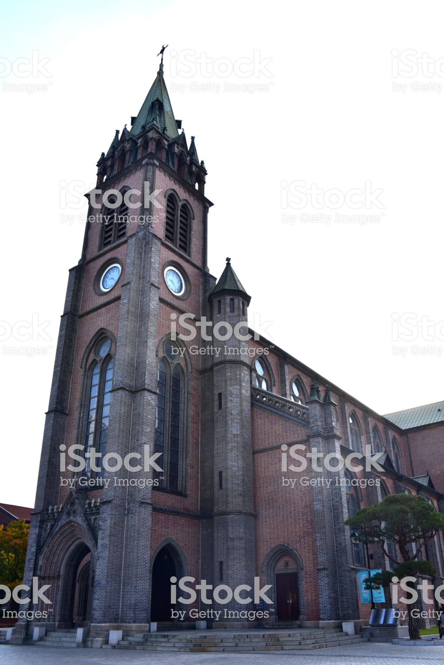

4. The above picture from Seoul, South Korea predominantly shows the diffusion of ______ in the cultural landscape.
- Religion
- Politics
- Business
- Social Norms
- Wealth

5. Even though the picture was taken in Seoul, South Korea, where in the world would the dominant building be most common in the cultural landscape?
- Middle East
- Western Europe
- South Asia
- North Africa
- Southeast Asia

Day 3 FRQ Assessment

Name: ______________________________________________ Period: ________________

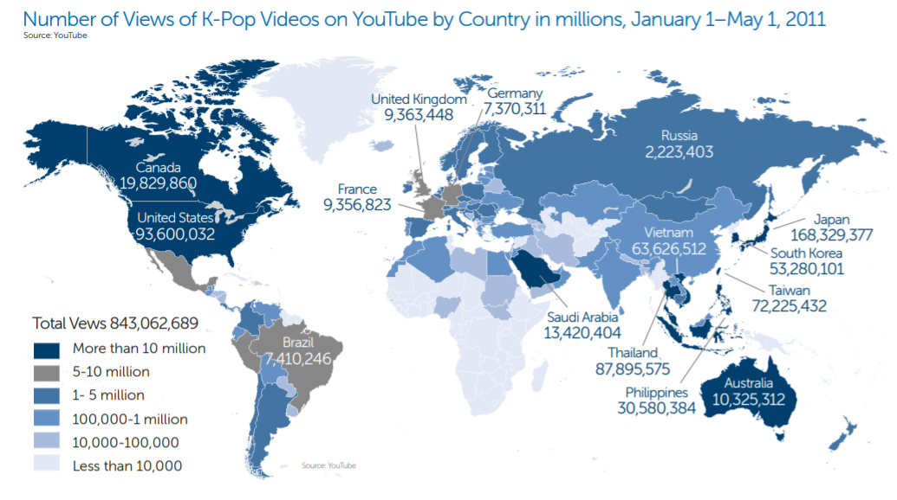
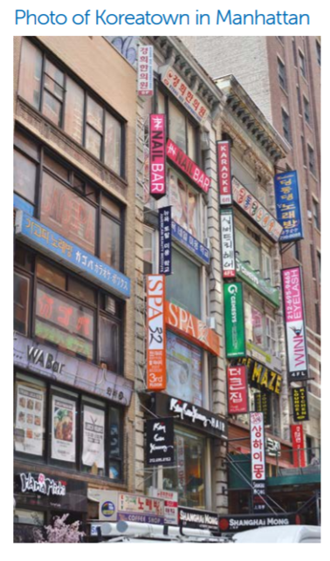

1. The diffusion of cultural traits has accelerated rapidly during the past few decades as the world has experienced time-space convergence. Such interactions have resulted in changing cultural practices.

- Define the term diffusion.
- Identify ONE characteristic of the cultural landscape shown that suggests diffusion has occurred.
- Explain ONE reason for the diffusion of the cultural trait you identified in part B.
- Explain ONE way acculturation is seen in the image.
- Compare relocation and expansion diffusion.
- Describe ONE reason for the diffusion that is present in the map.
- Describe ONE consequence of the diffusion reflected in the map and image.

Day 3 FRQ Assessment Teacher Key
*Teachers can use this Key to guide assessment and student peer assessment.

- Define the term diffusion.
Diffusion is the spread of phenomenon across space.

- Identify ONE characteristic of the cultural landscape shown that suggests diffusion has occurred.
- Language on the signs
- Architecture (Building Style)
- Type of businesses
Note: Since this is an identify part, students do not have to expand upon their answer.

- Explain ONE reason for the diffusion of the cultural trait you identified in part B.
Regardless of the answer in part B, student answers should address that migration has occurred. Since this is an explanation the student must give a why or how. So for instance the creation of an ethnic enclave (ethnic neighborhood) due to migration from Korea to New York.

- Explain ONE way acculturation is seen in the image.
- There is some English language still present despite there also being some Korean language.
- There are “American” style cars likely used by residents of the ethnic neighborhood.
- Most of the setting looks like it belongs in New York City, the language and some of the architecture is different, but otherwise it is a typical setting

- Compare relocation and expansion diffusion.
Relocation diffusion is the movement of phenomenon spatially as a result of migration which does not result in an increase influenced by the phenomenon whereas expansion diffusion results in an increase in the number of people influenced by the phenomenon.

- Describe ONE reason for the diffusion that is present in the map.
- Communications technology- videos are easily shared thanks to the Internet.
- Urbanization- there tend to be connections across major cities, regardless of physical proximity.

- Describe ONE consequence of the diffusion reflected in the map and/or image. (note: consequences can be positive or negative.
- Increased understanding or appreciation- due to more interaction with a different culture
- Decreased cultural variety/uniqueness- due to the mass spread of one style
- Cultural appropriation- non-Koreans “take over” Korean Pop

