CULTURE MODULE OVERVIEW
SKILL FOCUS: Source Analysis, and Concepts and Processes | CONTENT: ENDURING UNDERSTANDING SPO-3
Source Analysis: Analyze and interpret qualitative geographic information represented in  maps, images (e.g. satellite, photographs,  cartoons), and landscapes.  Concepts and Processes: Describe geographic concepts, processes, models, and theories. | Cultural practices vary across geographical locations because of physical geography and available resources.  Topic 3.2 Cultural Landscapes  Topic 3.5 Historical Causes of Diffusion  Topic 3.6 Contemporary Causes of Diffusion

DAY 1 | How do cultural landscapes reflect cultural practices?
CLASS ACTIVITY: Reading a Cultural Landscape
Students will work collaboratively to identify and understand the components that make up cultural landscapes. Students will then use their new understanding of cultural landscapes to analyze information in visual sources from South Korea for cultural indicators and to draw conclusions about the patterns they see.
AP SKILL ALIGNMENT
Skill Category 4.A Identify the different types of information presented in visual sources.
Skill Category 4.C Explain patterns and trends in visual sources to draw conclusions.

DAY 2 | How does diffusion impact cultural landscapes?
CLASS ACTIVITY: Cultural Diffusion Investigation
Students will explore how the elements of the cultural landscapes are diffused by brainstorming ways cultural elements diffuse, and by studying cultural diffusion of Korean culture, culminating in an analysis of how cultures change due to diffusion.
AP SKILL ALIGNMENT
Skill Category 4.D Compare patterns and trends in sources to draw conclusions.
Skill Category 4.E Explain how maps, images and landscapes illustrate or relate to geographic
principals, and outcomes.

DAY 3 | CLASS ACTIVITY: Concept Mapping and AP-Aligned Assessment  Students will connect vocabulary and concepts via a concept-mapping activity and then demonstrate understanding as they answer one Free Response Question with two stimuli (FRQ) and Multiple Choice Questions (5 MCQs total).
AP-ALIGNED ASSESSMENT:

Multiple Choice Questions (MCQs) and Free-Response Questions (FRQ)

CULTURE MODULE STIMULUS MATERIAL

DAY 1 | STIMULUS TYPE DESCRIPTION  - Image Card 1 The Old Seoul City Hall, built in 1925 during the Japanese occupation  - Image Card 2 The New Seoul City Hall, built in 2012  - Image Card 3A Part of a photo of the Old and New Seoul City Halls  - Image Card 3B Part of a photo of the Old and New Seoul City Halls  - Image Card 3C Part of a photo of the Old and New Seoul City Halls  - Image Card 3D Part of a photo of the Old and New Seoul City Halls  - Image Card 3E Full photo containing Images 3A, 3B, 3C, and 3D  - Image Card 4A Daytime View of the Old and New City Halls  - Image Card 4B Nighttime view of the Old and New City Halls  - Image Card 4C Side view of the Old and New City Halls  - Image Card 4D View of the Old and New City Halls from across the street  - Image Card 5A Sequent Occupance Card #1: Hagia Sophia as a Church  - Image Card 5B Sequent Occupance Card #2: Hagia Sophia as a Mosque  - Image Card 6A Cultural Detective Photo Card #1: Street in Myeong-dong  - Image Card 6B Cultural Detective Photo Card #2: Bukchon Hanok Village  - Image Card 6C Cultural Detective Photo Card #3: Christian Church, Seoul  - Image Card 6D Cultural Detective Photo Card #4: Steel works (POSCO, Pohang Iron and  Steel Company) near the river in Pohang Kyeongsangbuk-do

DAY 2 | STIMULUS TYPE DESCRIPTION  - Image 1 Diagram of the basic layout of Seoul, reflecting Geomancy principles  - Image 2 Photograph of Seoul with mountains in background  - Map City Map of Hanyang (Seoul) in 1822  - Image 3 Locations of major buildings in Seoul, reflecting Geomancy principles  - Image 4 Photo of the “Blue House,” the presidential office and residence  - Image 5 Photo of Koreatown in Manhattan  - Map Cheonggyecheon reclamation project  - Image Koreatown Manhattan  - Map BTS YouTube Views 2018  - Graph Top 10 Countries with Most BTS YouTube Views 2018  - Graph Total Exports Induced by the Korean Wave

DAY 3 | STIMULUS TYPE DESCRIPTION  - Image Church located in Seoul  - Map Number of Views of K-Pop Videos on YouTube by Country in millions, 2011  - Image Photo of Koreatown in Manhattan
D A Y 1
Based on a 60-minute class

Lesson Question: How do cultural landscapes reflect cultural practices?

AP curriculum Framework reference
Enduring Understanding PSO-3
Cultural practices vary across geographical locations because of physical geography and available resources.
Topic 3.2 Cultural Landscapes

Human Geography Skills:
Source Analysis: Analyze and interpret qualitative geographic information represented in maps, images (e.g., satellite, photographs, cartoons), and landscapes

Skill Category 4.A Identify the different types of information presented in visual sources.
Skill Category 4.B Describe the spatial patterns presented in visual sources.
Skill Category 4.C Explain patterns and trends in visual sources to draw conclusions.

Concepts and Processes: Describe geographic concepts, processes, models, and theories.

Skill Category 1.A Describe geographic concepts, processes, models, and theories.
Skill Category 1.D Describe a relevant geographic concept, process, model, or theory in a specified context

OVERVIEW
Students will learn the concept of a cultural landscape and the components that create the cultural landscape of South Korea. Students will examine South Korea’s physical features, agricultural and industrial practices, religious and linguistic characteristics, evidence of sequent occupance, and other expressions of culture using a structured source analysis of selected images from South Korea. This activity is designed to help students learn the essential knowledge of culture, cultural landscapes, and the diffusion of culture. Further, students will apply this knowledge to their ability to analyze geospatial data through various images, articles, and other sources. Students will use their understanding of the cultural landscape to make inferences about the culture of the people in modern-day South Korea. Students should finish the activity with a greater understanding of culture, cultural landscapes, and how culture diffuses and how these relate to South Korea.

Materials needed For Day 1:
- Day 1 Handouts
  - Day 1 Student Handout (1 per student)
  - Image Cards (1 per group)

SEQUENCE OF INSTRUCTION

CLASS ACTIVITY 1 of 4: Warm Up / Introduction

WARM UP/INTRODUCTION (10 MINUTES): Hosting an Exchange Student and defining cultural landscape

ACTIVITY 1: Students will begin to identify the aspects that make up the cultural landscape of their hometown. This activity is designed to make students aware of features that they will later be able to identify as part of the cultural landscape and to get the students to begin thinking about cultural landscapes and what information they can provide about cultures.

Activity Procedure:
- Students sit in groups of three to four to facilitate group work throughout the course of the activities. Mixed-ability groups are recommended to achieve the best results.
- Read the following scenario to your class:
  - “Your family is hosting a new exchange student from the Pitcairn Islands, considered to be one of the most remote places on earth. The exchange student arrives in your community. This is the first time she has ever seen any place outside of her home island. Since the Pitcairn Islands are a British Overseas Territory, the exchange student does speak English. After a quick tour of your town, what impression will she have of your community? What will she learn about your community’s beliefs? What features will she see that cause her to have this impression? Will what she sees give her an accurate and complete understanding about your community? What about the United States as a whole? Will her first impressions help her to understand ‘American’ culture?”
- Students brainstorm the features that the exchange student would see as she toured their community, record them in column 1 on the first page of the Day 1 Student Handout (2 minutes), and report out to the group. As each group shares, students can record any new features mentioned.
- Using column two on the first page of the Day 1 Student Handout, teams brainstorm the possible impressions of the exchange student (4-5 minutes).
- Using column three on the first page of the Day 1 Student Handout, groups discuss whether the impressions identified in column two accurately reflect their community. Encourage students to think about potential misperceptions and other sources of information or data to better understand their local culture
  - Responses could include personal interviews with a variety of people, census data, a history of the locale, etc.
- Students should write down a “guess” as to the definition of Cultural Landscape on their Day 1 Student Handout individually (1 minute) and share with an elbow partner (1 minute).
- Provide the correct definition of Cultural Landscapes and have students write the definition on their Day 1 Student Handout:
  - “The Cultural Landscape is the visible imprint of humans on the natural environment. Analyzing the cultural landscape can tell us a great deal about the people who live in a place.”
  - Explain that to understand a cultural landscape, we must act as detectives searching for clues. This reference to acting as detectives will be used later in the lesson.
Teaching Tip

Students may be concerned about writing a definition to a term (Cultural Landscape) that they are unfamiliar with for fear of being wrong. By providing students the opportunity to share their ideas and answers to questions with their peers and groups before sharing in front of the class, they will build confidence and have an opportunity to receive feedback. This often leads those students who are shy or uncomfortable speaking in front of the class to feel more comfortable when called on to provide their thoughts.

CLASS ACTIVITY PART 2 of 4: Analyzing Cultural Landscapes

CLASS ACTIVITY (25 MINUTES): Analyzing Cultural Landscapes of a Different Culture

ACTIVITY 2: Using their understanding of the definition of cultural landscape and their own cultural landscape, the students will now work to analyze cultural landscapes of a culture different than their own.
Activity Procedure:
- As students remain in their previous teams, display the image from Image Card 1, the Old Seoul City Hall, or provide each group with a copy of this image to examine. After completing Image Card 1, provide Image Card 2 of the New Seoul City Hall. Suggest that students consider questions such as: When was each building constructed? Why was it built? What message does the design of the building convey to people who look at it?.
  - Students will complete the section on “Analyzing Cultural Landscapes” for both Image Cards 1 and 2 in the Day 1 Student Handout, individually (column 1: 2 minutes per image), with a partner (column 2: 1 minute per image) and as a group (column 3: 1 minute per image).
- As a group, students should circle the Natural/Physical features and underline the Human/Cultural observations, as indicated in the section on “Analyzing Cultural Landscapes” in the Day 1 Student Handout.
Teaching Tip
For the circling and underlining activity, you may need to help students identify which observations would fall into the categories of Natural / Physical and Human / Cultural.
- Groups make guesses about the cultures they see in each image and write their thoughts in the space provided on the Day 1 Student Handout, page 2 using the sentence stems (4 minutes):
  - “We think that this culture…”
  - “because…”
Teaching Tip
Using sentence stems found on the Day 1 Student Handout page 2 (“We think that this culture…” and ”Because…”) will provide structure to students’ writing and may be beneficial in helping them to learn how to provide support for their arguments, thus reinforcing the skills necessary for success on the AP exam.
- Groups record similarities and differences on the Day 1 Student Handout in the section “Compare and Contrast Cultural Landscape Image Cards 1 and 2” (2 minutes). Distribute the four different Cultural Landscapes Image Cards 3A to 3D. Each card shows part of the photograph that is Image Card 3E..
- Distribute the four different Cultural Landscapes Image Cards A-D.
  - Each student should examine their image and write down what they see on the Day 1 Student Handout in the section “Cultural Landscape Cards 3A through 3D.” Group members should not share their images (2 minutes).
  - Next, have students arrange each of their pictures to reveal the larger image. (The full image is in Image Card 3E.) Display Image Cards 4A to 4D to show different views of the same location as that in Card 3E and the original images (Cultural Landscape Image Cards 1 and 2).
  - Have each group answer the questions under “Why Does Scale Matter?” on their Day 1 Student Handout.
- Provide students with the story of the two Seoul City Halls:
  - The new Seoul City Hall, completed in 2012, is an architectural wonder that towers over the original, colonial-era City Hall building. The Japanese built the original City Hall building in 1925 during the Japanese occupation of Korea before World War II. The new City Hall looks like a giant wave of glass about to crash over the older, Japanese creation. Some have theorized that the building’s design is intended to show the Koreans’ over-powering of the Japanese to symbolize how they threw off their oppressors and have achieved higher levels of success, but the Koreans have denied that this is the intent. After the new City Hall was completed, the original, Japanese-built, old City Hall was converted into the Seoul Metropolitan Library

- Students discuss with their groups what they found surprising about the picture (1 minute). Call on a few students to share their group's thoughts.
  - This is an opportunity to discuss that simply because something is, or appears to be, older, it is not necessarily traditional to the culture. Equally, it also means that just because something is new, it is not necessarily foreign.
- Since old City Hall was built by the Japanese during occupation, it also allows for an introduction of Sequent Occupance.
  - Ask students to identify evidence of different cultures in the pictures.
  - Use student answers as an opportunity to introduce the definition of Sequent Occupance. and students can write it on the Day 1 Student Handout, page 4:
    - Sequent Occupance is the idea that multiple societies each coming after another leave their cultural imprints on a place, each contributing to the total cultural landscape.
  - Ask students about the evidence they see of cultural imprints using Sequent Occupance Cards 5A and 5B, which depict the Hagia Sophia.
    - The Hagia Sophia was originally a Christian Orthodox Church (as seen in Sequent Occupance Card 5A), but later was converted to a mosque by the Ottoman Empire rulers (as seen in Sequent Occupance Card 5B). Now, the same building is a museum. You can point out the minarets (towers) that are characteristic of Islamic architecture in the Sequent Occupance Card 5B.

Teacher Notes

To make this activity quicker, you can have students look at each of the images as a group, instead of having students review them individually. Keep in mind that this means that students will not have any time to process the cultural landscapes they are viewing individually and therefore may get less out of the activity.

CLASS ACTIVITY PART 3 of 4: Individual Analysis of Cultural Landscapes

CLASS ACTIVITY (20 MINUTES): Individual Analysis of a Variety of Different Cultural Landscapes

ACTIVITY 3: Students will further develop their understanding of cultural Landscapes by making connections to the work that detectives do within an investigation. Using this analogy, students will apply their knowledge of cultural landscapes and sequent occupance to draw informed conclusions about cultures by examining a variety of photographs and coming to conclusions about the values of the society represented.

Activity Procedure:
- Working in their teams, students brainstorm what they think detectives do when they are analyzing a crime scene (2 minutes).
- Have students from different groups share out some of the actions that detectives take when working on an investigation.
  - Some responses should include looking for clues, taking pictures, noting things that are suspicious or out of place, etc.
- Provide each student in the group a different Cultural Detective Photo Card (Cards 6A through 6D)
- Working individually, students complete the “Time to Be a Cultural Landscape Detective” section of their Day 1 Student Handout.
  - First, record details from the photograph that may give them clues into the Cultural Landscape of the image (3-4 minutes).
  - Based on their observations, students write a summary of what the photograph reveals about the cultural landscape depicted (3-4 minutes).
  - Students record guesses regarding location (last row)
- Students share their unique image and findings with their group (1 minute per student).
  - After all students have shared their findings, have the group guess where each image is from and when they were taken. Did they all come from the same location or are they from different areas around the world?).
- After students have discussed possible locations, reveal that Cultural Detective Photo Cards 6A through 6D were all taken in South Korea. Photo Card 6A is a street in Myeong-dong, a primary shopping district in Seoul. Photo Card 6B portrays Bukchon Hanok Village, a traditional village in Seoul with a view of modern Seoul in the background. Photo Card 6C shows a Christian Church in Seoul. Photo Card 6D shows steel works (POSCO, Pohang Iron and Steel Company) near the river in Pohang Kyeongsangbuk-do. Prior to revealing this, you could ask students to guess which country is in each photo.
  - How do the images reveal cultural diversity? Ask the class what is surprising about all of the images coming from South Korea? Have them explain clues that would help them guess that they were all from South Korea, as well as anything that might have caused them to think they were not from South Korea (e.g., the Christian church).
Teacher Notes
If you do not have access to a color printer for the photographs, you may want to project the color image and have students first brainstorm individually and then work as a group or in partner pairs to summarize what the photograph reveals about the Cultural Landscape depicted. This is also a way you can speed up the activity if you are running short on time.

Teaching Tip
By placing time limits on students to share their “findings” on the Cultural Landscape of their photograph as well as requiring specific examples to support their arguments, they learn to be concise and specific in their responses which will help them on the FRQ.

CLASS ACTIVITY PART 4 of 4: Check for Understanding

CLASS ACTIVITY (5 MINUTES): Examining How Culture Spreads from One Place to Another

Exit Ticket: To prepare students to start thinking about the topic of the following class, students will brainstorm how different ideas (businesses, architectural styles, music, technology, etc.) spread from one culture to another.

Activity Procedure:
- Students brainstorm how cultures spread from one place to another. Have students answer the following question:
  - K-Pop has become a very popular music style, despite the fact that less than 5% of the world speaks Korean. This causes us to wonder, how did K-Pop become so popular? Try to come up with as many reasons as possible for the spread of ideas.
  - Collect the student responses as an exit ticket as students leave the class.

Cultural Landscape Image Card 1

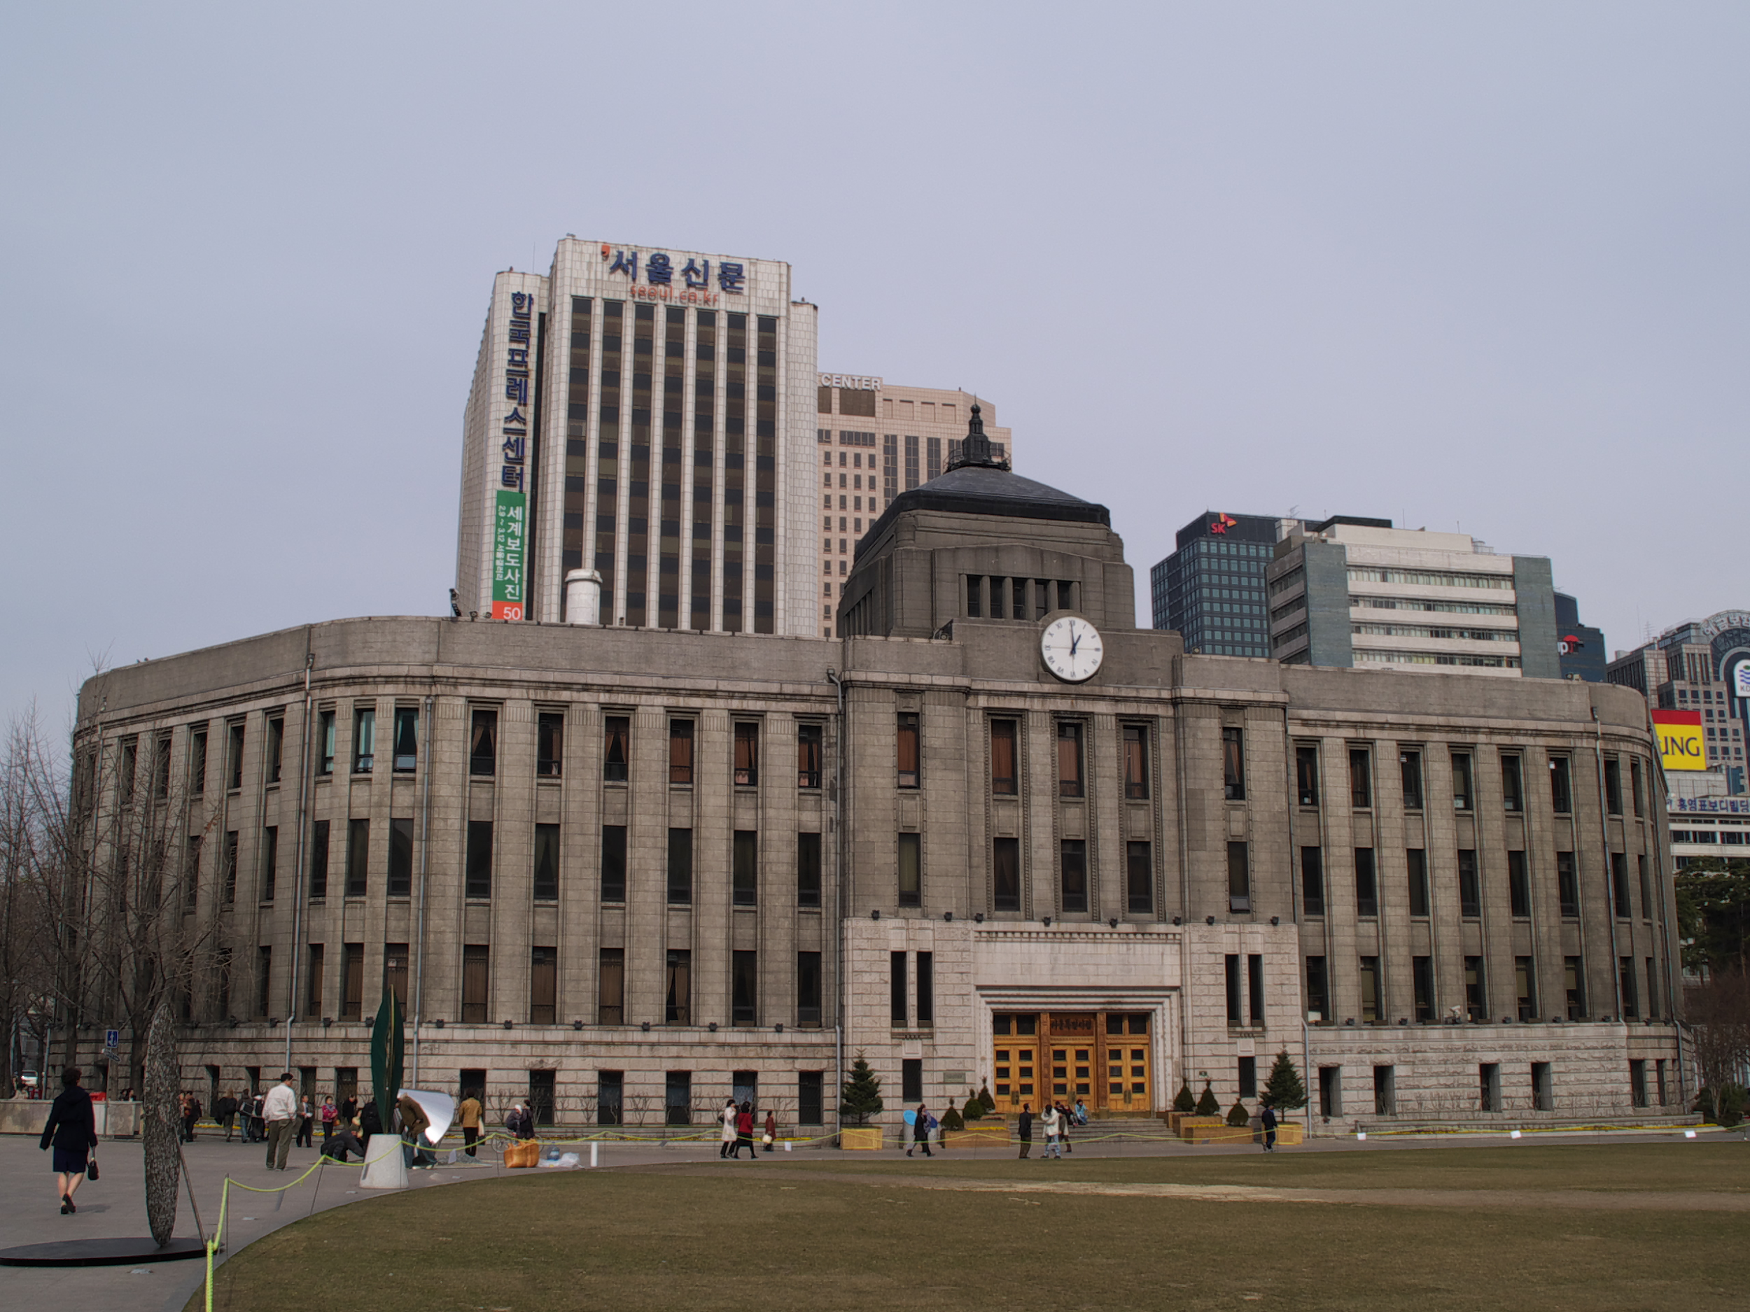

Cultural Landscape Image Card 2

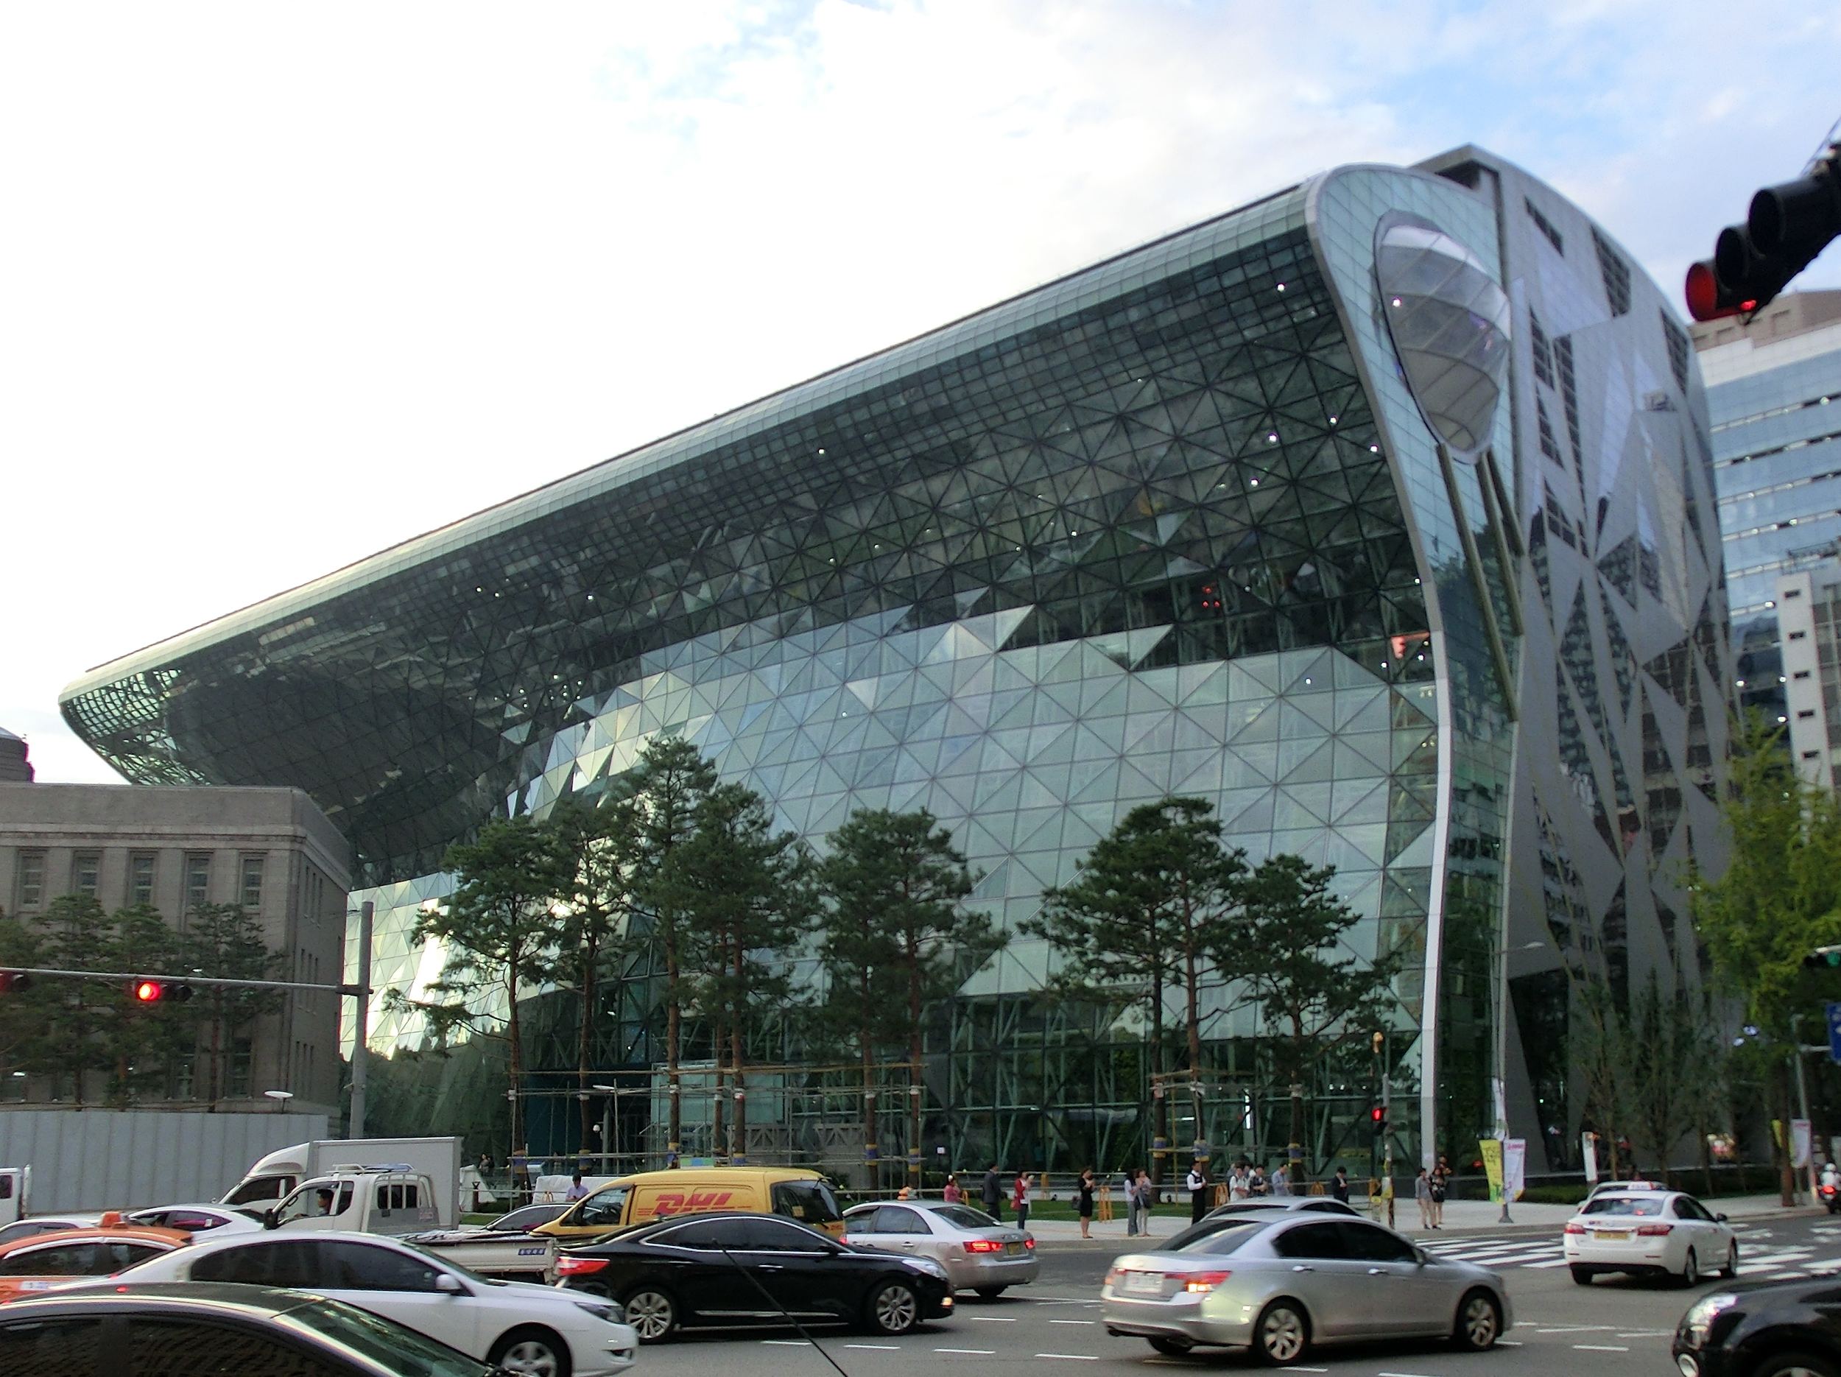

Cultural Landscape Image Card 3A

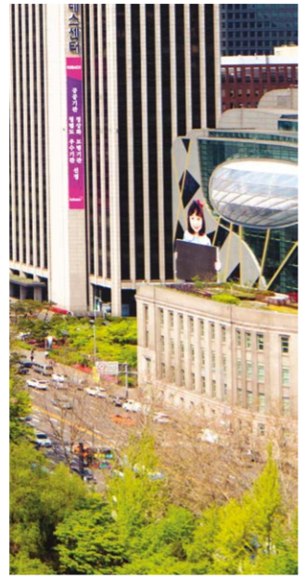

Cultural Landscape Image Card 3B

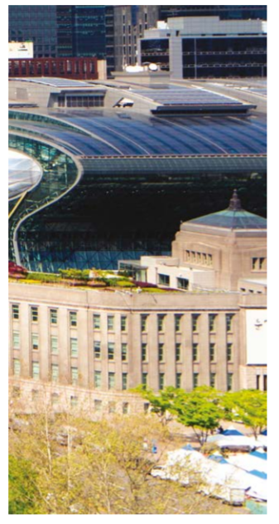

Cultural Landscape Image Card 3C

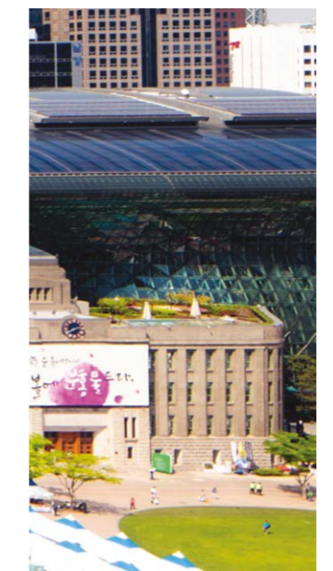

Cultural Landscape Image Card 3D

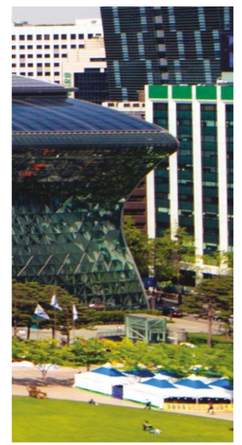
Cultural Landscape Image Cards 3E

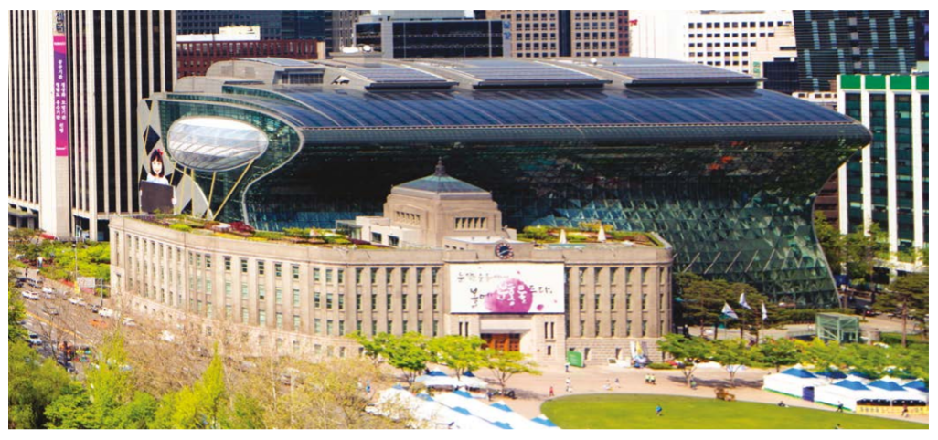

Cultural Landscape Image Card 4A
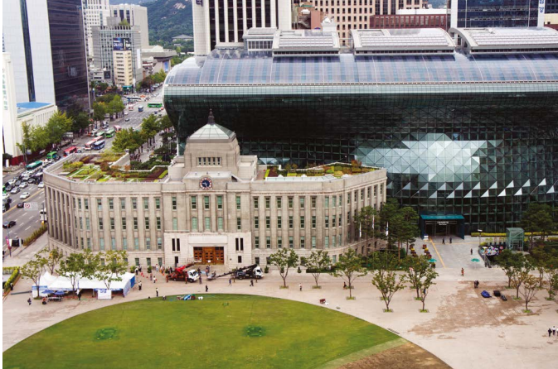

Cultural Landscape Image Card 4B
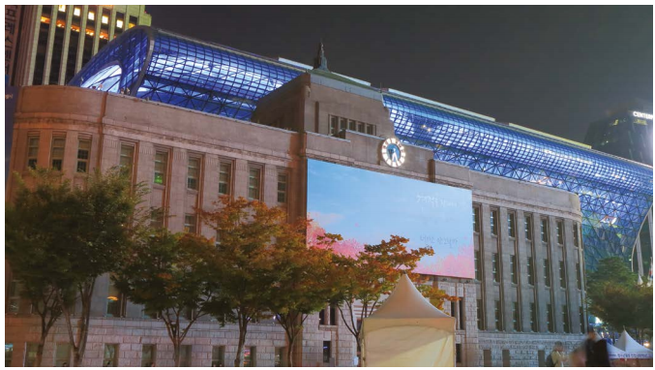

Cultural Landscape Image Card 4C
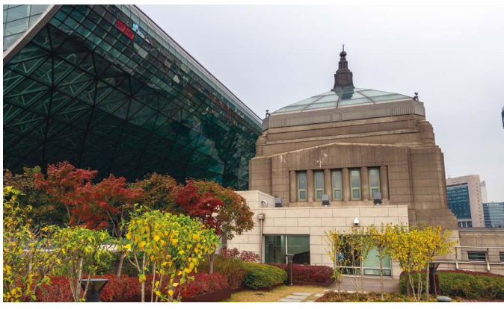

Cultural Landscape Image Card 4D
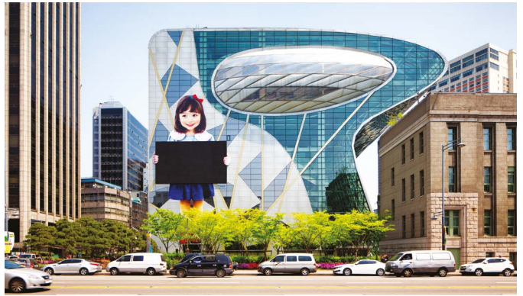

Sequent Occupance Card 5A

Hagia Sophia (as a
Christian Orthodox Church)
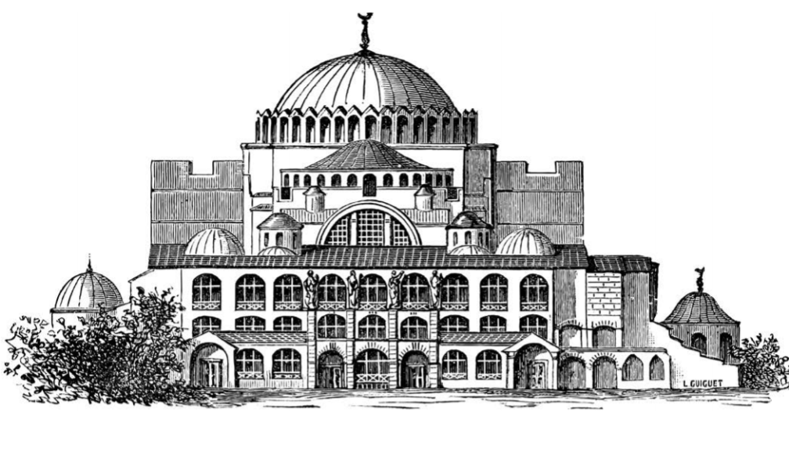

Sequent Occupance Card 5B

Hagia Sophia (as a Mosque - notice the minarets)
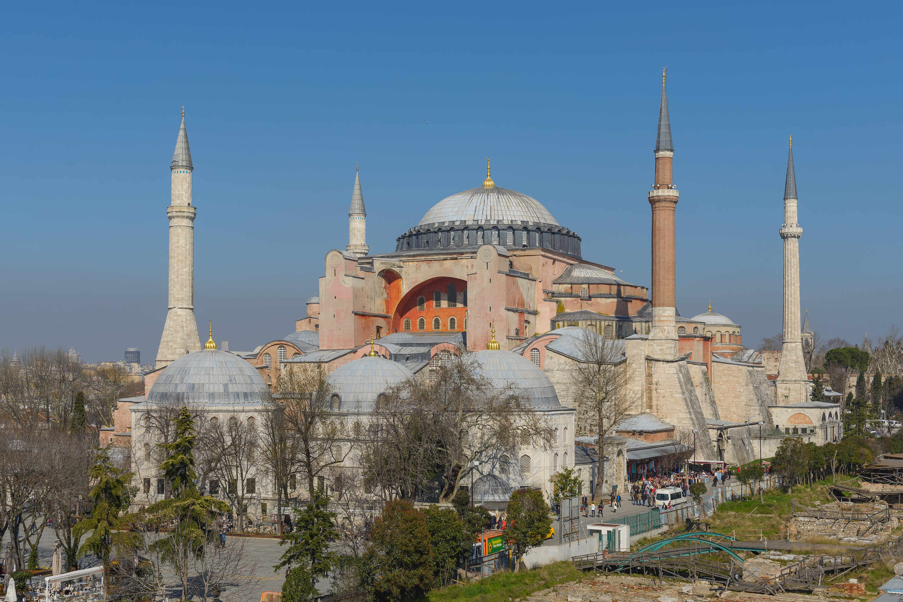

Cultural Detective Photograph Card 6A

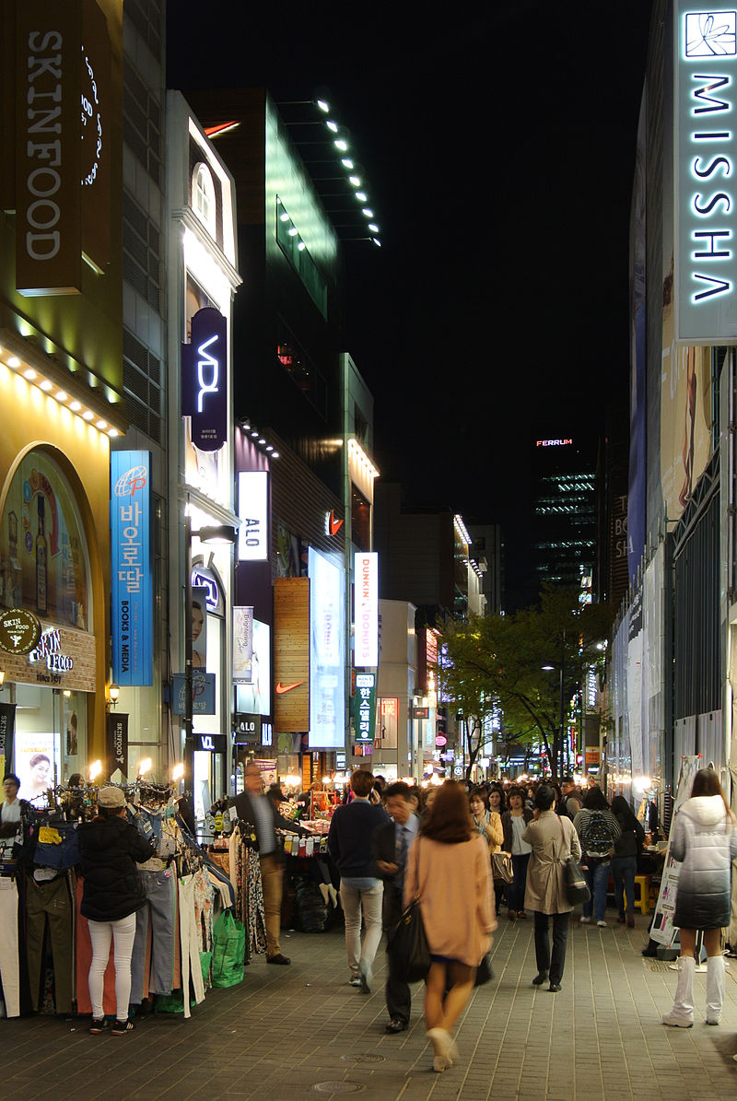

Cultural Detective Photograph Card 6B

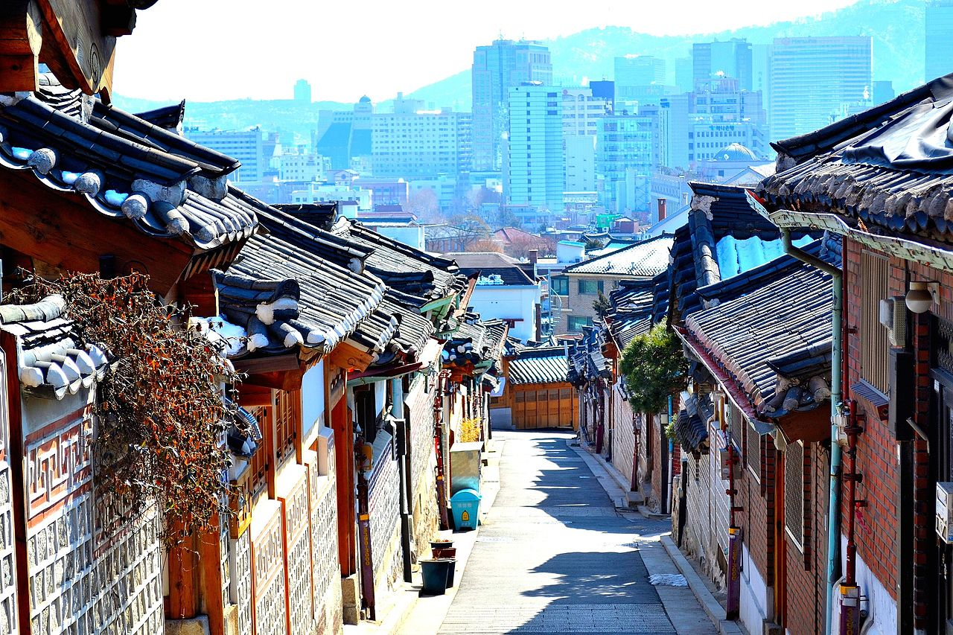

Cultural Detective Photograph Card 6C

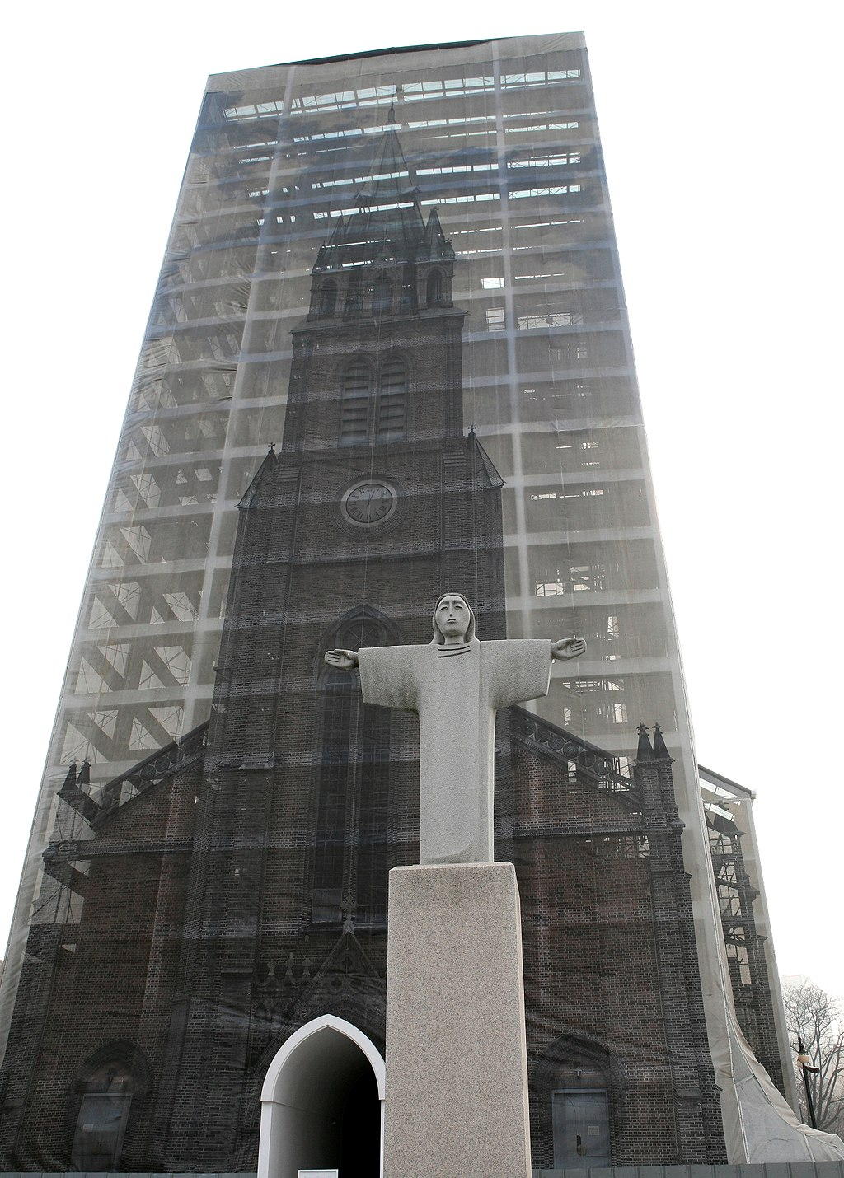

Cultural Detective Photograph Card 6D

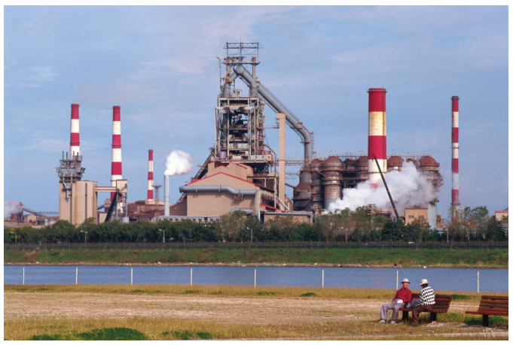

Day 1 Student Handout

Name: ______________________________________________ Period: ________________

Our Cultural Landscape
Your family is hosting a new exchange student from the Pitcairn Islands, considered to be one of the most remote places on earth. The exchange student arrives in your community and this is the first time she has ever seen any place outside of her home island. Since the Pitcairn Islands are a British Overseas Territory, the exchange student does speak English. After a quick tour of your town, what impression will she have of your community? Use the chart below to note how you think she would react.

Features the exchange student would see in your community: | Impressions or conclusions that the exchange student would make based on what she has seen: | Would her impressions be accurate? Why or why not? Explain:

Cultural Landscapes
What do YOU think is a good definition for the term Cultural Landscape? | Teacher Definition of Cultural Landscape
 | A Cultural Landscape is...
Day 1 Student Handout - Continued (page 2)

Analyzing Cultural Landscapes
Examine the images provided on the Cultural Landscapes Image Cards. Use the boxes below to write down ALL of the different things that you see in the image..

Cultural Landscape Image Card #1
What do YOU See in Image 1? | What did your PARTNER see in Image 1? | What did your GROUP see in Image1?
Cultural Landscape Image Card #2
What do YOU See in Image 2? | What did your PARTNER see in Image 2? | What did your GROUP see in Image2?

For the lists you created above, CIRCLE all of the Natural / Physical observations and UNDERLINE all of the Human / Cultural observations.

What does this information tell us about each image’s culture?

Cultural Landscape Image Card #1:

We think that this culture… (what do we think this society is like?):

Because… (point to specific evidence you saw in the image to support your thoughts on this culture):

Cultural Landscape Image Card #2:

We think that this culture… (what do we think this society is like?):

Because… (point to specific evidence you saw in the image to support your thoughts on this culture):
Day 1 Student Handout - Continued (page 3)

Compare and Contrast Cultural Landscape Image Cards #1 and #2?
Now that you have examined both images, identify several similarities and differences as you compare these cultures. Write you team’s answers below:

Similarities | Differences

Cultural Landscape Cards 3A-3D

- Jot down what you see in YOUR Cultural Landscape card here:

Why Does Scale Matter?

- Now that you see the ENTIRE image all at once, how does this help you understand why scale is so important? Explain your answer using specific examples from the images..

- After seeing the entire image, would you change your thoughts about the culture identified in Image Cards #1 and #2? Why or why not? Explain.

Day 1 Student Handout - Continued (page 4)

Sequent Occupance:

Write the definition for Sequent Occupance in your own words here:

Provide an example of Sequent Occupance:

Time to Be a Cultural Landscape Detective!

You are the lead Cultural Landscape Detective! First, write the Cultural Detective Card number in the box below. Next, using the photo on your Cultural Detective Card, brainstorm what you SEE in the photograph that may help you to understand the Cultural Landscape. After you have brainstormed what you SEE in the photograph, SUMMARIZE what your findings REVEAL about the Cultural Landscape. Share your findings and conclusions with your group, providing evidence from your photograph as to why you believe your findings are correct.

Cultural Detective Card Number ___ | My Detective Work
What do I SEE in the photograph that helps me understand the Cultural Landscape?
What does the information I have gathered TELL ME about the Cultural Landscape?
Where do you think your picture is from? Circle each description that best fits your image. | Urban / Rural  Asia / Europe / North America / South America / Africa / Australia  Where is my picture from? ________________________

