MODULE OVERVIEW
GEOGRAPHICAL SKILLS (day 3):  Human Geography Skills  5.B Explain spatial relationships across various geographic scales using geographic concepts, processes, models, or theories.  3.D Compare patterns and trends in maps and in quantitative and geospatial data to draw conclusions. | CONTENT (day 3):  This content is designed for any High School Social Studies Class. Day 1 is History-centered while Day 2 and 3 are Geography-centered.  AP Human Geography references:  Topic 7.6 Trade and the World Economy  PSO-7.A.4 Global financial crises (e.g., debt crises), international lending agencies (e.g., the International Monetary Fund), and strategies of development (e.g., microlending) demonstrate how different economies have become more closely connected, even interdependent.

D  A  Y  1 | to what extent is the coronavirus similar to the spanish flu?
CLASS ACTIVITY: Making a Claim supported by Evidence
Students will investigate primary and secondary sources on the Coronavirus/COVID-19 pandemic of 2020 and the Spanish Influenza pandemic of 1918. Students will identify similarities and differences between government responses, geographical diffusion, cultural impact, economic impact, public reaction, and the effects of the diseases themselves.
CHECK FOR UNDERSTANDING: Thesis Statement
Students will synthesize comparisons between the Coronavirus and Spanish Influenza pandemics into an argumentative claim backed by document evidence.

D  A  Y  2 | How do we slow diffusion in a globalized world?
CLASS ACTIVITY: Analyzing Quantitative Data
Students will investigate sources on the diffusion of COVID-19. Students will analyze population pyramids for five countries impacted by COVID-19.
CHECK FOR UNDERSTANDING: Making Predictions
Students will predict how the diffusion of information regarding COVID 19 impacts the diffusion of the virus.

D  A  Y  3 | What Are the Economic Consequences of a Pandemic?
CLASS ACTIVITY: Analyzing Quantitative Data
Students will analyze global economic data showing the impact of the spread of COVID-19. Students will analyze the growth of COVID-19 cases in Italy, South Korea, and the United States to identify current trends and to predict future growth as well as comparing how each country has addressed the spread of COVID-19.
CHECK FOR UNDERSTANDING: Global Impact of COVID-19
Students will analyze changes in GDP forecasts for selected countries to demonstrate their understanding of the economic consequences of COVID-19, identify successful approaches to addressing the growth of COVD-19, and finally to discuss global consequences of pandemics.

MODULE SOURCES
D  A  Y  1 | AUTHOR  WHDE Authors  WHDE Authors  WHDE Authors  WHDE Authors  WHDE Authors  WHDE Authors  WHDE Authors | SOURCE  Why was the 1918 Flu so Deadly?  The Science Behind the Flu  Art and the Spanish Flu  Government Measures to Fight the New Plague  The Largest Flu Pandemic in History  How the Flu Spread Across America  Effects of the 1918 Influenza Pandemic | DATE  March 13, 2020  March 13, 2020  March 13, 2020  March 13, 2020  March 13, 2020  March 13, 2020  March 13, 2020

D  A  Y  2 | AUTHOR  CDC  UCSUSA  Worldometers  Drew Harris  Wikimedia Commons  CDC  White House  Wikimedia Commons  CDC | SOURCE  Map of COVID 19 Cases  Exponential vs Linear Growth Curves  Graph of COVID-19 Cases- Europe vs United States  Flatten the Curve  Map of Airline Connections  Social Distancing Tweet from CDC  White House Avoid Eating Out Tweet  World Map of Urbanization Levels  Risk for COVID-19 Infection, Hospitalization, and Death by Age Group | DATE  March 11, 2021  April 9, 2018  March 14, 2021  2020  2009  March 16, 2020  March 16, 2020  2015  February 18, 2021

D  A  Y  3 | AUTHOR  WHDE Authors  WHDE Authors  WHDE Authors  WHDE Authors  WHDE Authors  WHDE Authors  WHDE Authors  WHDE Authors  WHDE Authors  WHDE Authors  WHDE Authors | SOURCE  Top 5 Markets for Motor Vehicle Parts and Accessories produced in China (2018)  Estimated Impact of COVID-19 outbreak on global tech shipments in Q1 2020  Quarterly Change in Global Smartphone Shipments 2020  Dow Jones Industrial Average, EURO STOXX 50 Average, NIKKEI 225 Average, SSE Composite Index 2/18/20 -3/12/20  Airline Revenue Losses 2020 By Region  Impacts on Airline travel and revenue  Impact on Royal Caribbean Cruises  Total Coronavirus Cases 2/15/20 -3/16/20  New Coronavirus Cases in Italy, United States, and South Korea 2/15/20 - 3/16/20  South Korea, Italy, and United States Approaches to addressing the spread of Coronavirus  Organization for Economic Cooperation and Development (OECD) Changes in GDP Growth Forecast 2020 | DATE  March 15, 2020  March 15,2020  March 27, 2021  March 15, 2021  March 27, 2021  March 15, 2021  March 15, 2021  March 15, 2021  March 16, 2020  March 15, 2021  March 15, 2021  March 15. 2021
DAY THREE
Based on a 60-minute class

Lesson Question: How do global events such as COVID-19 affect individual countries?
Social Studies Skill: Data Analysis [Geography]

OVERVIEW
Students will analyze economic consequences of economic globalization focusing primarily on the current effects of the COVID-19 on stock markets, manufacturing and trade, tourism, and comparing governmental responses. Finally, students will be able to demonstrate their understanding of the economic consequences of the COVID-19 by explaining the causes for global GDP forecasts for the first quarter of 2020 to be downgraded. Students will have the opportunity to work individually or in groups depending on the needs of your students.

Materials needed:
- In Person- Copies of the activity materials.
- Online- Post the activity materials.

SEQUENCE OF INSTRUCTION
HOMEWORK OVERVIEW
HOMEWORK (Optional) (20 Minutes):
- Using the Day 3 Homework handout students will identify and map the country of manufacture for items in their home.
- Students will analyze the patterns they see on their map and answer questions related to economic globalization as well as impacts if parts of the supply chain are impacted.
Teacher Notes
Depending on your students’ knowledge of economic globalization and interconnected economies you may decide to not assign the homework activity.

Teaching Tip
Some students may wish to dive into conspiracy theories or partisan sites that seek to politicize the health emergency. Try to guide students toward categories such as scientific investigations, pop culture, government actions, health, economic impacts, impacts on foreign countries, etc.

CLASS ACTIVITY 1: Economic Data
CLASS ACTIVITY (20 MINUTES):
- Students will analyze economic data to determine global economic impact of the COVID-19 pandemic.
- Background info to share with students- Globalization is a commonly used term that refers to our increasingly connected world. Today, political boundaries do not typically stop interactions from occurring. Globalization is especially seen in regard to business. Increasingly, products that have commodity chains that involve multiple countries. For example, perhaps your t-shirt is made from cotton grown in India, made into fabric in Mexico, sewn in South Africa, and then sold in the United States. A disruption in any part of that process causes issues for ALL of the countries involved.
- Individual Activity or Online Learning
  - If students are working on this activity individually or through an eLearning experience you may want to share with students the following information before they start the activity.
    - Refer back to the optional homework and remind students about how many goods are produced in countries with economic advantages such as lower wages, lesser environmental regulations, government incentives, etc.
    - Many final products contain parts manufactured in multiple countries
    - Stock markets measure the value of stocks measured in their index. Even though they don’t give a complete economic picture of a country, they are good at predicting confidence in a country’s economy and the impact of events on an economy.
    - Since countries are economically connected or interdependent, a situation in one country or a few countries can quickly impact other countries.

IMPORTANT Teacher Note
Class Activity 1, 2, and 3 could be adapted to group work by having groups of students analyze the graphs, data, and other sources and then answer the accompanying questions. Groups might also do some of the work as individuals and then debrief the questions or work collaboratively to answer the analysis questions. Some of these group strategies are also possible with certain online learning platforms.

CLASS ACTIVITY 2: Coronavirus Data
CLASS ACTIVITY (20 MINUTES):
- Students will analyze data related to the spread of COVID-19 using the Activity 1 - Virus Data Handout
- Individual Activity or Online Learning
  - Students will answer questions 1-3 demonstrating their understanding of the trends shown in the Total Coronavirus Cases.
    - Students should focus on the exponential growth shown in the United States and Italy graphs and the S-Curve shown in the South Korean Graph.
    - Based on the graphs students should predict cases in Italy and the United States will continue to grow and cases in South Korea will slow or stop growing
  - Students will answer question 4 to compare their predictions made in questions 1-3 with the reality that has unfolded since that time.
  - Students will answer question 5 by using all four graphs to predict which country they believe will have their number of cases slow in the future.
    - Based on the graphs, students should identify South Korea. Evidence could include the S-curve in the total cases or the drop in new cases.

CLASS ACTIVITY 3: Comparing Governmental Approaches to Address the Spread of COVID-19
CLASS ACTIVITY (20 MINUTES):
- Students will analyze data related to the spread of COVID-19
- Individual Activity or Online Learning
  - Using the Activity 3 handouts, students will read the case study for South Korea, Italy, and the United States to determine similarities and differences between each country's approach.
  - Students will note three important facts for each country and evaluate the effectiveness of each approach.
  - Using the Activity 3 Synthesis handout, students will answer the following question using evidence from Activity 1 and 2.
    - Explain how the response of South Korea, Italy, and the US have contributed to the current and predicted growth of COVID-19 cases in each country

CHECK FOR UNDERSTANDING: Global Impact of COVID-19
- Using the Check For Understanding handout, students will answer five questions demonstrating their understanding of factors that influence the spread of COVID-19 as well as economic consequences.

Day 3 Homework

Name: ______________________________________________________________________________ Period: ____________________

- Pick 10 items from your home (items can include items of clothing, technology, etc.) and identify the country they were manufactured.
- On the map below identify the countries your items were produced. Next label the items manufactured next to the country that manufactured them.
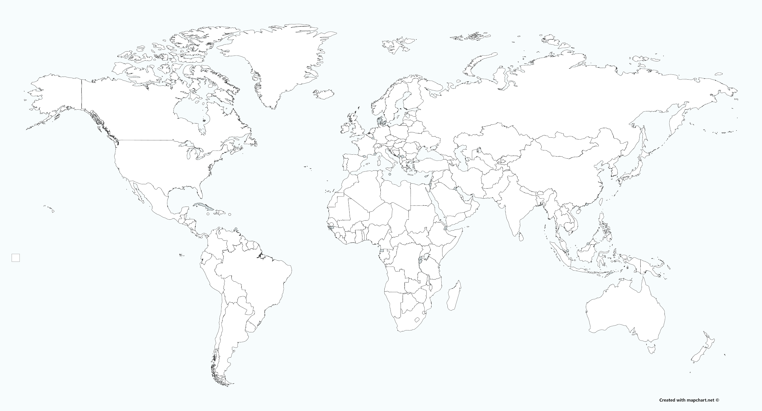
- What patterns did you see on your map?

- What technology and/or innovations in communication and transportation make the manufacturing patterns in the map possible?

- Based on countries involved in these patterns, what could happen to their economies if production in one country was affected?

ACTIVITY 1- Economic Data Set: Manufacturing Impacts
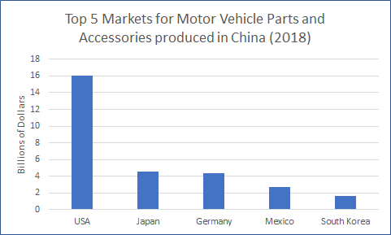
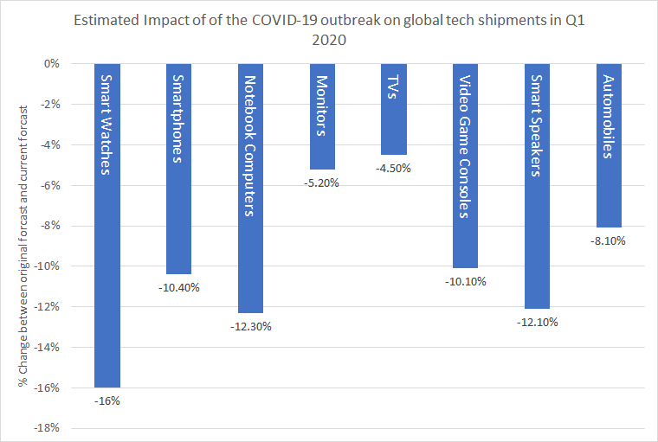
Globalization is a commonly used term that refers to our increasingly connected world. Today, political boundaries do not typically stop interactions from occurring. Globalization is especially seen in regard to business. Increasingly, products that have commodity chains that involve multiple countries. For example, perhaps your t-shirt is made from cotton grown in India, made into fabric in Mexico, sewn in South Africa, and then sold in the United States. A disruption in any part of that process causes issues for ALL of the countries involved.

The graph to the right show the impact of the spread of COVID-19 on manufacturing and supply chain for selected products during the first three months of 2020.

https://www.theverge.com/2020/2/18/21141924/coronavirus-tech-industry-impactreport-trendforcehttps://comtrade.un.org/data/
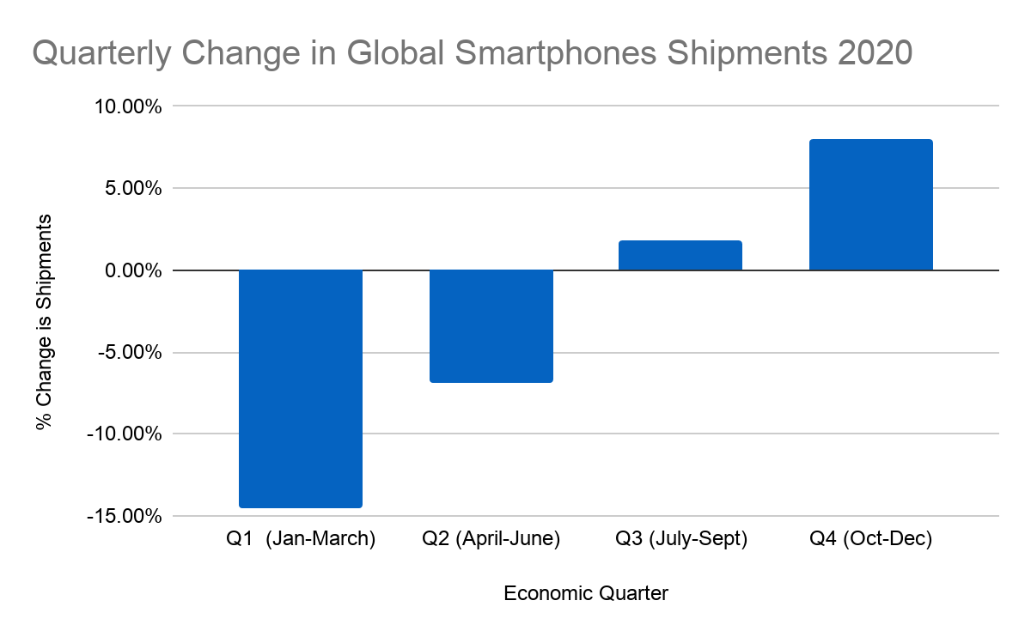
The graph to the right shows an overall look at 2020 with recalculated Quarter 1 data, and data from the rest of the year.

https://www.idc.com/getdoc.jsp?containerId=prUS46264320
Answer the following questions based on the graphs from the previous page:
- What trends can be identified in the data above?

- How do the trends demonstrate economic interdependence?

- Which country’s automobile industry would you predict to be most affected by factory shutdowns in China?

- Using the Quarterly Change in Global SmartPhones Shipments 2020 graph, predict what COVID-19’s impact on other industries such as automobiles or technology products and provide evidence to support your answer.

ACTIVITY 1 -- Economic Data Set: Stock Markets Impacts
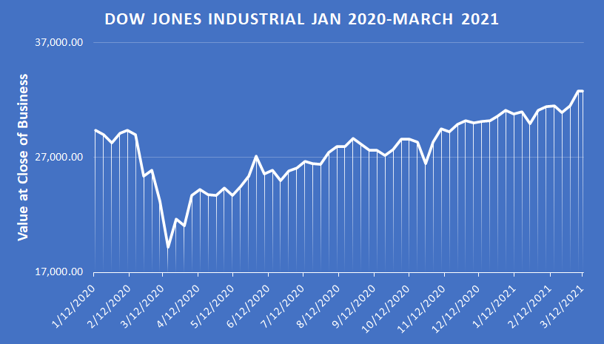 | 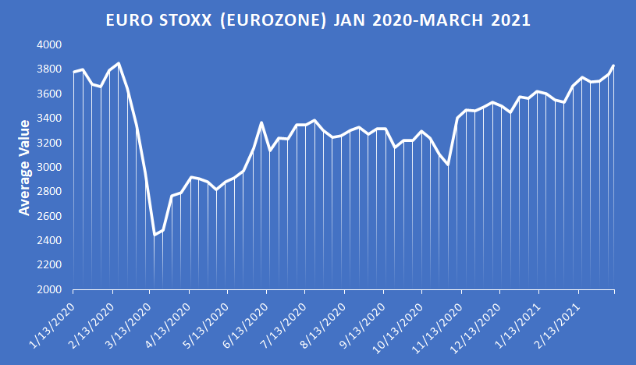
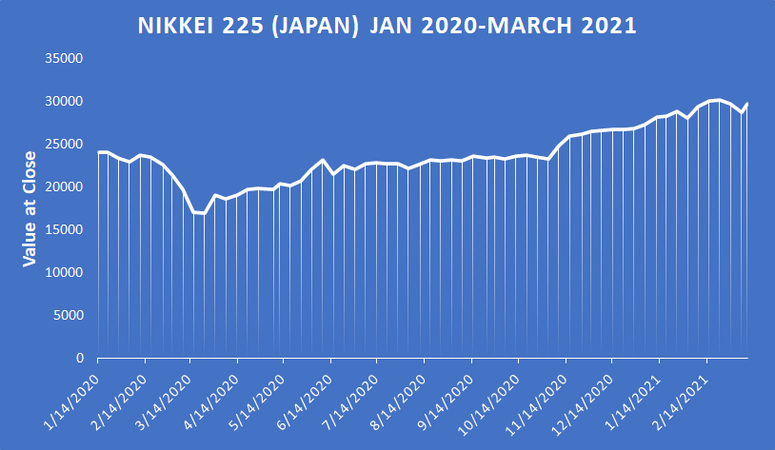 | 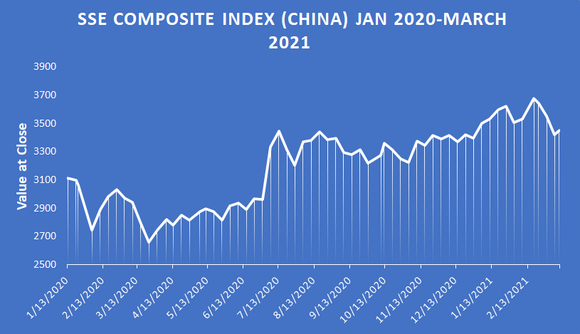
Yahoo Finance 3/14/2021

The graphs above show the value of stocks from Feb 18 - March 12, 2020 following the outbreak of the Coronavirus.
Answer the following questions:
- What trends can be identified in the data above?

- How do the trends above demonstrate economic interdependence?

- What impact has the COVID-19 had on the stock markets? (Consider including COVID-19 data from Activity 1 as part of this answer.)

ACTIVITY 1 -- Economic Data Set: Tourism Impact
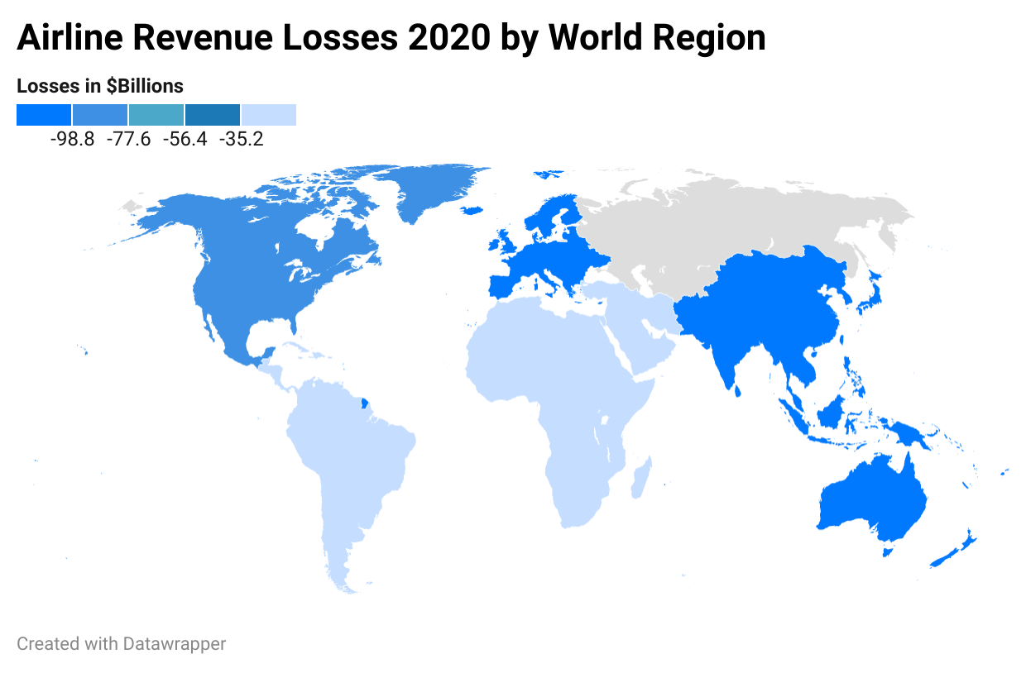
https://www.icao.int/Newsroom/Pages/2020-passenger-totals-drop-60-percent-as-COVID19-assault-on-international-mobility-continues.aspx
Travel restrictions caused by Covide-19 has caused airline revenues to drop from $838 billion in 2019 to $328 billion in 2020 caused by a 66% drop in passenger demand. Airlines hope that easing of restrictions that passenger numbers will grow in 2021, but will continue to be less than in 2019. Even with this hope, pre Covid passenger numbers will not recover until 2024 at the earliest, with domestic markets seeing recovering faster than international markets.

https://www.iata.org/en/pressroom/pr/2020-11-24-01/

The cruise line Royal Caribbean has recently reported that it has experienced its fourth straight ten figure quarterly loss*. In fact the company lost $1.4 billion in the just the fourth quarter (Sept-Dec) compared to earning $273.1 million at the same time in 2019. Even with that bad news, and the fact that U.S. cruises are still not allowed with current Covid-19 restrictions, Royal Caribbean has seen a 30% increase in future bookings in the United States giving hope that the tourist industry will begin to recover from the impact of COVID-19.

https://www.miamiherald.com/news/business/tourism-cruises/article249427065.html

Answer the following questions:
- What trends can be identified in the data above?

- How do the trends demonstrate global interdependence?

ACTIVITY 2 - CORONAVIRUS DATA ANALYSIS

Doubling Time is the amount of time it takes for a phenomenon to double. Doubling time is frequently used to calculate how long it will take for a population to double or how long it will take for an investment to double. In this case, doubling time refers to how long it takes for the number of cases of COVID-19 to double.
Use the graph “Total Coronavirus Case 2/15-3/16 to analyze the potential of growth of COVID-19 during the first months of 2020” to answer questions 1-3.
Total COVID-19 Cases Feb-March 2020
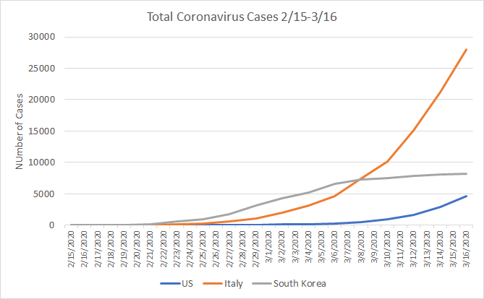
(Note: use Activity 2 Supplementary Reading on Reading Graphs)
- Compare and contrast the data for all 3 countries.
- The growth of cases in Italy and the US would be referred to as what type of growth? Why?
- The growth of cases in South Korea would be referred to as what type of growth? Why?
- Based on the graph, which country do you believe will see the number of total cases grow in the immediate future? Which country do you believe will see the cases slow in the immediate future?
Now that you have examined the data available in the first months of 2020, compare the actual COVID-19 numbers until 3/14/21. Use the graphs below to answer question 5 & 6.

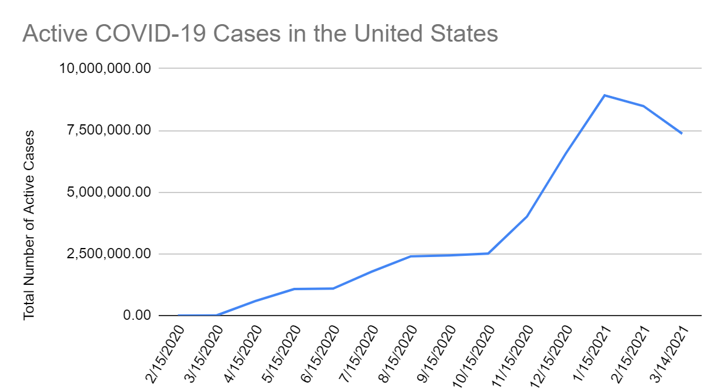

https://www.worldometers.info/coronavirus/country/us/
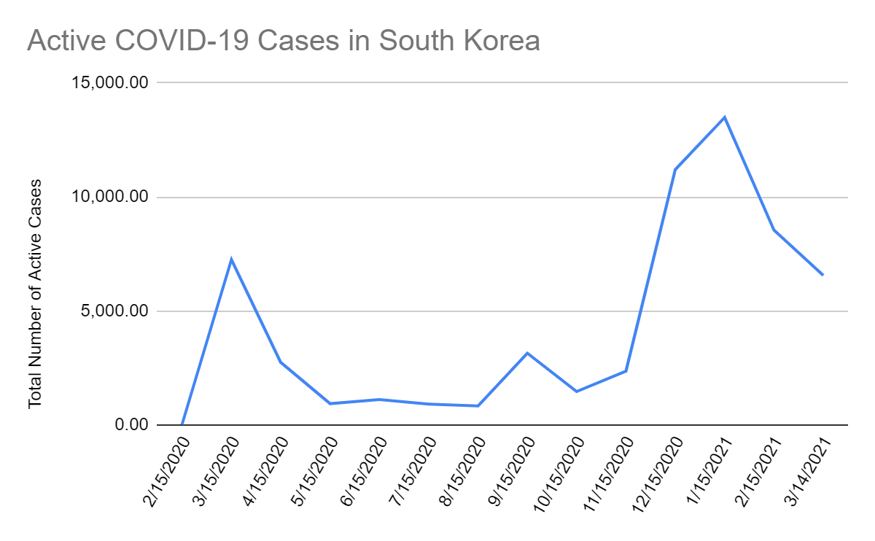

https://www.worldometers.info/coronavirus/country/

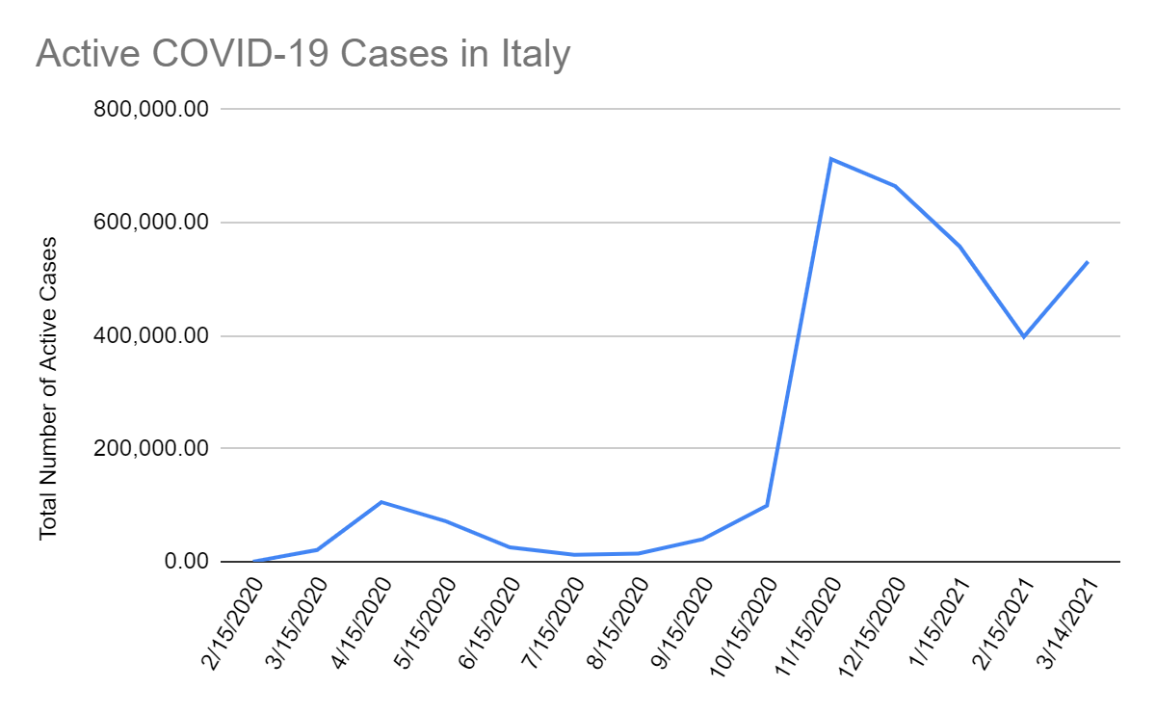

https://www.worldometers.info/coronavirus/country/italy/

- Analyze all the graphs to complete this task. Write a paragraph in which you argue…
- Which country’s growth is similar to what you predicted in the first months of 2020?
- Which country’s growth is most different from what you predicted in the first months of 2020

- Analyze all the graphs to complete this task. Write a paragraph in which you argue…

- Which country do you believe will have the number of cases fall (or continue to fall) in the future?

ACTIVITY 3: Government Approaches to Address the Spread of COVID-19
South Korea
Total Cases of Covid-19 | 96,635 as of 3/16/2021
Active Covid-19 Cases | 19 active cases as of 2/15/20  6558 active cases as of 3/14/21

What has been the government approach?
South Korea has been very aggressive in response to the spread of COVID-19, especially in testing since the outbreak in 2020. This approach can be connected to lessons learned from a MERS outbreak in 2015 that has led to increased government support to analyze samples during any outbreak. One solution has been creating drive-through clinics that increase access as well as limit human contact. This increased level of testing and medical care, including hospitalization, is covered by the South Korean government. To address costs for the health care system, child care, and the economic impacts on small and medium size businesses, the South Korean government proposed an additional spending of $13.7 billion dollars on March 4, 2020.

Because of the decisions made in the early days of the pandemic, South Korea was able to quickly test and identify those infected with Covid-19. Tracing efforts included hundreds of epidemiologists as well as using a wide variety of data sources such as credit-card purchases and closed-circuit video footage. To help with the economic impact to individuals, those who were quarantined received support from the government. South Korea’s experience with Covid-19 has not been without spikes, but the systems in place at the beginning of the pandemic have made such spikes short-lived.

Adapted from NPR report Reuters, Haaretz, and Our World in Data
3 Notes on South Korea’s Approach (and note how effective)

-

-

-

Italy
Total Cases of Covid-19 | 3,223,142 as of 3/14/2021
Active Covid-19 Cases | 3 active cases as of 2/15/20  531,251 active cases as of 3/14/21

What has been the government approach?
Italy started by testing more aggressively than other European countries but has recently slowed in testing to minimize the number of samples that need to be processed. Testing fewer people meant that infected people not displaying symptoms could still spread the virus By March 10, the Italian government proposed a $28 Billion dollar stimulus to help workers who have lost jobs, increase funds to small businesses, and potentially offer rent assistance.

Even with these approaches, many scientists believe that the Italian government did not act quickly enough to stop the spread of Covid-19. In addition, debates over the economic and social impacts of lockdowns. Italy found that loosening restrictions and ending lockdowns led to spikes in infections. These spikes coupled with the introduction of new variants of the Covid-19 virus have caused a recent growth in cases.

From March 8th to March 14th of 2021, Italy saw over 150,000 new infections. Because of this growth, Italy has reinstated a lockdown which includes a three tiered system which will leave half of Italy’s twenty regions, including the cities of Rome, Milan, and Venice, with different levels of limitations of movement based on level of infections in a region. These measures extend to all of Italy during Easter weekend in hopes of slowing the spread of this current wave of infections.

Adapted from NY Times and NY Times and Bloomberg
3 Notes on Italy’s Approach (and note how effective)

-

-

-

United States
Total Cases of Covid-19 | 29,269,590 (3/16/2021)
Active Covid-19 Cases | 12 active cases as of 2/15/20  7,365,186 active cases as of (3/14/21)

What has been the government approach?
Initial government responses were skeptical of the seriousness of the spread of COVID-19 until March 13, 2020 when a National Emergency was declared. Due to a limited supply of testing kits, early testing was limited as labs initially performed 40 to 60 tests a day. By March 15th, 2020 the government stated that 2000 commercial labs would begin to process tests, significantly increasing the number of tests. The Federal government helped to set-up drive through testing facilities similar to those in South Korea. The cost of testing and office or hospital visits remain a significant concern to many Americans without healthcare coverage.

Today the role of limiting public gatherings, school closures, and restaurant closings have been left up to individual states, counties, cities, and school districts. Vaccine development has been a major focus on the federal government's approach to addressing the pandemic with goals of vaccinating most Americans by the end of May 2021. Just as the reaction to the pandemic differs, testing practices and current vaccines distribution also differ widely, leading to some confusion about who can receive vaccines and where these vaccines are available.

The federal government has provided some financial relief during the pandemic, with the passing of the $1.9 trillion Covid Relief bill as the most recent example which includes direct payments to individuals and help for businesses, and state and local governments impacted by Covid-19.

2020 Data - Adapted from NY Times, NPR, and Market Watch Adapted from NY Times and NPR
3 Notes on the United States’ Approach (and note how effective)

-

-

-

ANALYSIS QUESTIONS
What are the most important differences in the approaches of these three governments?

What is similar in all three approaches?

ACTIVITY 3: Synthesis

SYNTHESIS QUESTION:
Use evidence from
-the government responses of South Korea, Italy, and the United States in Activity 2
-COVID-19 data in Activity 1
Explain how the responses of South Korea, Italy, and the US have contributed to the current and predicted growth of COVID-19 cases in each country.

CHECK FOR UNDERSTANDING - Global Impact of COVID-19

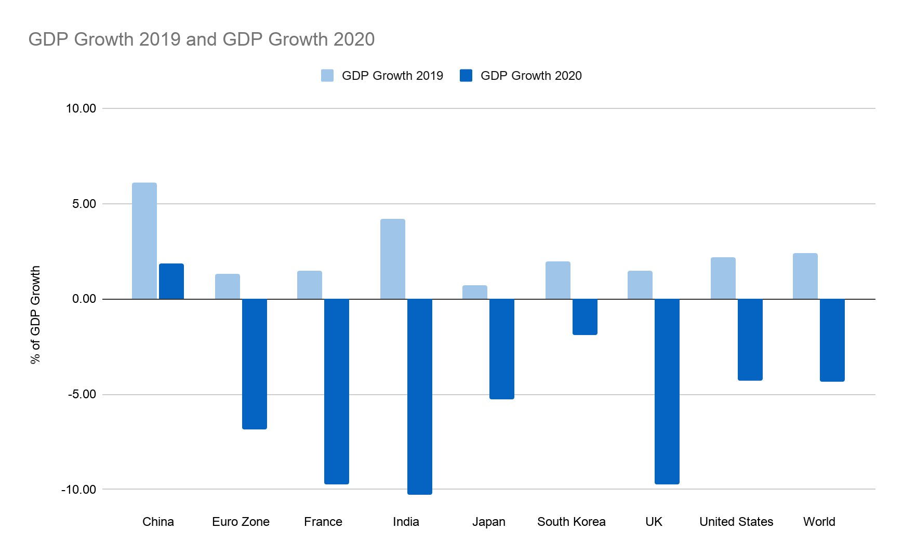

https://data.worldbank.org/indicator/NY.GDP.MKTP.KD.ZG
https://statisticstimes.com/economy/countries-by-projected-gdp-growth.php

The Graph above shows preliminary impacts of the COVID-19. Answer the following questions:
- Describe economic interdependence.

- Describe the economic data shown in the graph above.

- Identify and explain two factors that have contributed to the trend shown in the graph.

- Identify and explain which country’s approach has been most successful in addressing the growth of COVID-19 within their borders?

- Explain the relationship between local decisions and global economic impacts.

OPTIONAL / SUPPLEMENTAL

ACTIVITY 2 HANDOUT: READING GRAPHS

Graphs can help with understanding current conditions and with making predictions. When analyzing a graph here are some key things to consider.

Exponential Growth
    - Exponential Growth - Growth that occurs with the doubling of a phenomena. Doubling time is the time it takes for a phenomena to double. Typically doubling time is used when discussing population growth, but it can be applied to the spread of viruses such as the coronavirus. In this case, doubling time refers to the amount of time for the number of cases to double.

S-Curve

    - S-Curve - shows early exponential growth with a slowing of growth.

    - Trends - Graphs show us what is currently happening with a data set, but also provide information to make predictions about the future

OPTIONAL / SUPPLEMENTAL

ACTIVITY 3 HANDOUT

- Using the information for the three countries above complete the Venn diagram below.

South Korea
Italy
United States

