MODULE OVERVIEW
GEOGRAPHICAL SKILLS (day 2):  Human Geography Skills:  1.B Explain geographic concepts, processes, models, and theories.  2.D Explain the significance of geographic similarities and differences among different locations and/or at different times. | CONTENT (day 2):  This content is designed for any High School Social Studies Class. Day 1 is History-centered while Days 2 and 3 are Geography-centered.  AP Human Geography references:  Topic 3.6 Contemporary Causes of Diffusion  SPS-3.A.3 Cultural ideas and practices are socially constructed and change through both small-scale and large-scale processes such as urbanization and globalization. These processes come to bear on culture through media, technological change, politics, economics, and social relationships.  Topic 2.3 Population Composition  PSO-2.E.1 Patterns of age structure and sex ratio vary across different regions and may be mapped and analyzed at different scales.

D  A  Y  1 | to what extent is the coronavirus similar to the spanish flu?
CLASS ACTIVITY: Making a Claim supported by Evidence
Students will investigate primary and secondary sources on the Coronavirus/COVID-19 pandemic of 2020 and the Spanish Influenza pandemic of 1918. Students will identify similarities and differences between government responses, Geographic diffusion, cultural impact, economic impact, public reaction, and the effects of the diseases themselves.
CHECK FOR UNDERSTANDING: Thesis Statement
Students will synthesize comparisons between the Coronavirus and Spanish Influenza pandemics into an argumentative claim backed by document evidence.

D  A  Y 2 | How do we slow diffusion in a globalized world?
CLASS ACTIVITY: Analyzing Quantitative Data
Students will investigate sources on the diffusion of COVID-19. Students will analyze population pyramids for five countries impacted by COVID-19.
CHECK FOR UNDERSTANDING: Making Predictions
Students will predict how the diffusion of information regarding COVID 19 impacts the diffusion of the virus.

D  A  Y  3 | What Are the Economic Consequences of a Pandemic?
CLASS ACTIVITY: Analyzing Quantitative Data
Students will analyze global economic data showing the impact of the spread of COVID-19. Students will analyze the growth of COVID-19 cases in Italy, South Korea, and the United States to identify current trends and to predict future growth as well as comparing how each country has addressed the spread of COVID-19.
CHECK FOR UNDERSTANDING: Global Impact of COVID-19
Students will analyze changes in GDP forecasts for selected countries to demonstrate their understanding of the economic consequences of COVID-19, identify successful approaches to addressing the growth of COVD-19, and finally to discuss global consequences of pandemics.

MODULE SOURCES

D  A  Y  1 | AUTHOR  WHDE Authors  WHDE Authors  WHDE Authors  WHDE Authors  WHDE Authors  WHDE Authors  WHDE Authors | SOURCE  Why was the 1918 Flu so Deadly?  The Science Behind the Flu  Art and the Spanish Flu  Government Measures to Fight the New Plague  The Largest Flu Pandemic in History  How the Flu Spread Across America  Effects of the 1918 Influenza Pandemic | DATE  March 13, 2020  March 13, 2020  March 13, 2020  March 13, 2020  March 13, 2020  March 13, 2020  March 13, 2020

D  A  Y  2 | AUTHOR  CDC  UCSUSA  Worldometers  Drew Harris  Wikimedia Commons  CDC  White House  Wikimedia Commons  CDC | SOURCE  Map of COVID 19 Cases  Exponential vs Linear Growth Curves  Graph of COVID-19 Cases- Europe vs United States  Flatten the Curve  Map of Airline Connections  Social Distancing Tweet from CDC  White House Avoid Eating Out Tweet  World Map of Urbanization Levels  Risk for COVID-19 Infection, Hospitalization, and Death by Age Group | DATE  March 11, 2021  April 9, 2018  March 14, 2021  2020  2009  March 16, 2020  March 16, 2020  2015  February 18, 2021

D  A  Y  3 | AUTHOR  WHDE Authors  WHDE Authors  WHDE Authors  WHDE Authors  WHDE Authors  WHDE Authors  WHDE Authors  WHDE Authors  WHDE Authors  WHDE Authors  WHDE Authors | SOURCE  Top 5 Markets for Motor Vehicle Parts and Accessories produced in China (2018)  Estimated Impact of COVID-19 outbreak on global tech shipments in Q1 2020  Quarterly Change in Global Smartphone Shipments 2020  Dow Jones Industrial Average, EURO STOXX 50 Average, NIKKEI 225 Average, SSE Composite Index 2/18/20 -3/12/20  Airline Revenue Losses 2020 By Region  Impacts on Airline travel and revenue  Impact on Royal Caribbean Cruises  Total Coronavirus Cases 2/15/20 -3/16/20  New Coronavirus Cases in Italy, United States, and South Korea 2/15/20 - 3/16/20  South Korea, Italy, and United States Approaches to addressing the spread of Coronavirus  Organization for Economic Cooperation and Development (OECD) Changes in GDP Growth Forecast 2020 | DATE  March 15, 2020  March 15,2020  March 27, 2021  March 15, 2021  March 27, 2021  March 15, 2021  March 15, 2021  March 15, 2021  March 16, 2020  March 15, 2021  March 15, 2021  March 15. 2021
DAY 2
Based on a 60-minute class

Lesson Question: How does globalization help diffuse diseases such as COVID-19 across different populations?

Social Studies Skill: Spatial Relationships (Geography)

OVERVIEW
Students will examine the diffusion of COVID-19 and then examine the different population pyramids of five countries affected by COVID-19. The diffusion of COVID-19 is a significant global issue and also reveals one of the liabilities of increased globalization. The five focus countries were selected because they were the main countries receiving media attention for COVID-19 cases as of mid-March 2020. Furthermore, each of the focus countries represent different population structures, making the impact of the virus potentially different.

Materials needed:
In Person- Copies of the activity materials.
Online- Post the activity materials.
Create a copy of this Google Form to record student answers
(you can choose to use Google Forms to collect student responses, in person or virtually)

SEQUENCE OF INSTRUCTION

CLASS ACTIVITY: WARM-UP/INTRODUCTION
WARM-UP/INTRODUCTION (5 MINUTES):
ACTIVITY 1: COVID-19 K-W-L CHART
Have students fill out the first two columns of their KWL Chart. The K column is for what they know about COVID-19 and the W column is for what they want to know about COVID-19. At the conclusion of the lesson they will revisit the chart to fill out the L column with what they have learned. If your students completed Day 1, they should have more information to put in the K column than they will if you are using this day as a standalone.

Teacher Notes
Students likely have heard a lot of information about the COVID-19 virus. Some of the information students may “know” may be incorrect. As a result, you may want to add an additional step and have students then check their K column for accuracy. If you add this step, students will need access to the Internet and an understanding of how to filter sources for accuracy.
Teaching Tip
Consider creating a “shared” Google Doc so that all students can edit the KWL chart as a group. This allows them to add their own thinking in “real time” as part of the introduction or even as part of a homework assignment to set up the lesson.

ACTIVITY 1: What are the patterns of diffusion related to COVID-19?
CLASS ACTIVITY (20-25 MINUTES): Source Analysis
Google Form: To have students record answers using a Google Form, teachers can use this FORM. The link forces you to make a copy. Then you can share the “copied form” link with your students. Here is a screen shot of the Form to preview what students will see:
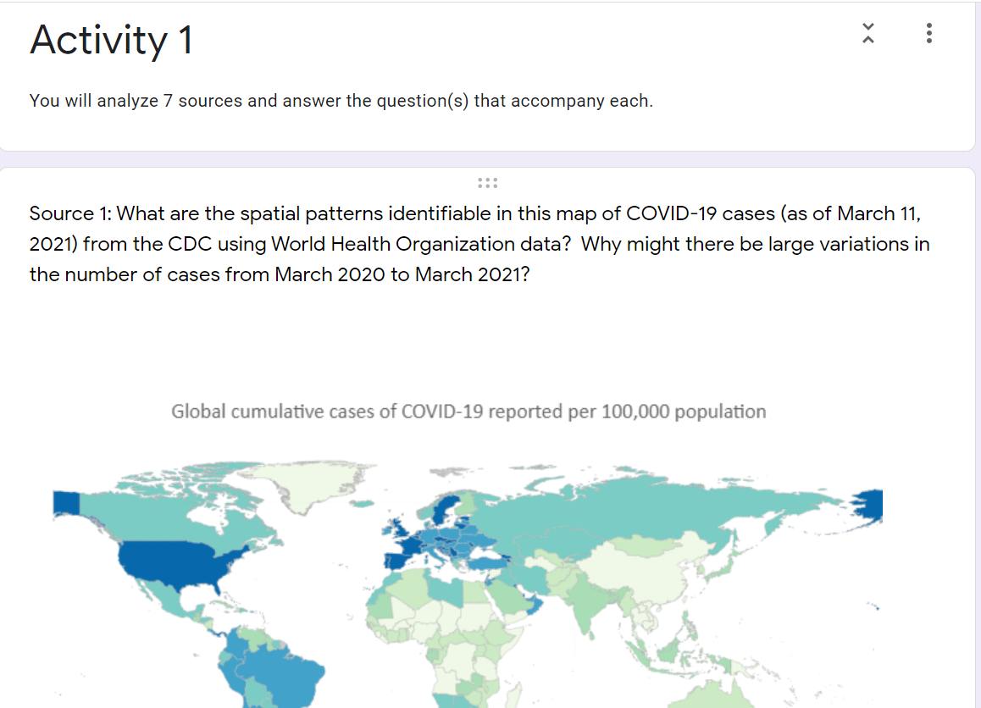
Students can record their answers in the Form and teachers can export their answers into a Google Sheet to review, grade, and/or provide feedback.

ACTIVITY 1:
Analyze 7 Sources -- Students will analyze the seven provided sources, answering the question(s) at the conclusion of each source. The recommendation is for students to analyze the sources individually, but pairs or small groups are an option as well.
Synthesis Statement -- After students have completed their analysis, they should answer the question, “Based upon the documents provided, plus any additional information you may already know, explain in your own words how COVID-19 diffused.” This should be a synthesis statement in which students demonstrate an understanding of the diffusion of the COVID-19 virus.
KWL -- Finally, students should return to add relevant information in the last column of their KWL chart.

Teaching Tip
If you are teaching this as part of the AP Human Geography course you may encourage students to consider another dimension to the diffusion of viruses such as COVID-19. Although they are diffused contagiously due to person to person contact, the diffusion of COVID-19 outside its hearth fits a hierarchical pattern due to transportation networks.

ACTIVITY 2: What are the differences in the population structures of some of the countries impacted by COVID 19?
CLASS ACTIVITY (15-20 MINUTES): POPULATION PYRAMID ANALYSIS
ACTIVITY 2:
Task 1: Students will analyze the five country population pyramids provided and answer a question that follows on the population structure of each society.

Task 2: After students have examined each pyramid individually, they should predict the order of the pyramids from youngest to oldest population structures.
(Answers: 1=Iran, 2=China, 3= United States, 4= South Korea, 5= Italy).
Students should check their answers by using a search engine such as Google to find the median age for each country (i.e. Iran “median age”).

Task 3: Students read the chart on COVID-19 deaths to understand the significance of population structure related to the spread of the virus. After students have analyzed the chart, they should answer the following question:
“Based upon this information and what you learned regarding the population structure of each of the five focus countries, which country should be most concerned about the spread of the virus and why?”
Once students have answered the question they should return to their K-W-L chart and add information learned from this activity to the last column.
Teaching Tip
If students have never seen a population pyramid previously then you may wish to show them this brief video- https://www.youtube.com/watch?v=RLmKfXwWQtE or assign them this article- https://populationeducation.org/what-population-pyramid/ so they have the background information necessary to effectively complete this activity.
An extension activity would be to have students research the mortality rates of the five focus countries to see if old age is the key factor or if instead there are also other factors.

CHECK FOR UNDERSTANDING (15 minutes)

How does the diffusion of information regarding COVID 19 impact diffusion of the virus?
The student will write a brief essay. Emphasize that there are competing viewpoints regarding the impact that the diffusion of information has had regarding the diffusion of the virus. What do students think will happen? Is the diffusion of information a positive? A negative? Why or why not?
The key is that the student should take a position based on what they do know and support that position with evidence and reasoning.
Teaching Tip
If you are conducting this lesson using Online Management Solutions then this would be a good post to a discussion board where students not only share their own responses, but also engage with their classmates to support and/or challenge the statements of others.
Regardless of whether students are online or in a face to face teaching environment, have students focus on explaining their rationale and supporting their responses.

ACTIVITY 1 -- HANDOUTS
K  What do you already know? | W  What do you want to know? | L  What have you learned?

ACTIVITY 1 -- HANDOUT

RECORD YOUR ANSWERS: Use this Google Form to record your answers.

DIRECTIONS: As you view each source be sure to answer the questions underneath each source completely. At the conclusion you will be asked to tie each of these sources together to answer the question- “How did COVID-19 diffuse?”

Source 1 - Map of COVID-19 Cases
World Health Organization Cumulative Data, CDC , March 11, 2021, https://covid.cdc.gov/covid-data-tracker/#global-counts-rates.
What are the spatial patterns identifiable in the map above?

Why might there be large variations in the number of cases from March 2020 to March 2021?

Source 2 - Exponential vs Linear Growth Curves
UCSUSA, 2018, https://blog.ucsusa.org/doug-boucher/world-population-growth-exponential
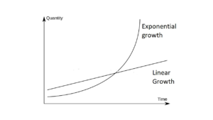
    - Exponential Growth - Growth that occurs with the doubling of a phenomena. Doubling time is the time it takes for a phenomena to double. In this case, doubling time refers to the amount of time for the number of cases to double.
    - Linear Growth - Growth that occurs with the same increase for each unit of time.
What is the difference between the two growth curves depicted above?

Source 3 - Graph of COVID-19 Cases in Europe vs United States
World O Meters, March 14. 2021, https://www.worldometers.info/coronavirus/worldwide-graphs/#europe-usa-cases
The graph above presents the cumulative number of COVID-19 cases in Europe and the United States since their initial 10,000 reported cases.. Do the curves display exponential or linear growth? Explain your answer.

Source 4 - Flattening the Curve
Drew Harris, https://drive.google.com/file/d/1YGTUc_Cm-ky7JaQQWmuaxedof8WLTLcP/view
Given the information about Italy, why would there be movements to “flatten the curve?”

Source 5 - Map of Airline Connections
Wikimedia Commons, 2020. https://commons.wikimedia.org/wiki/File:World-airline-routemap-2009.png
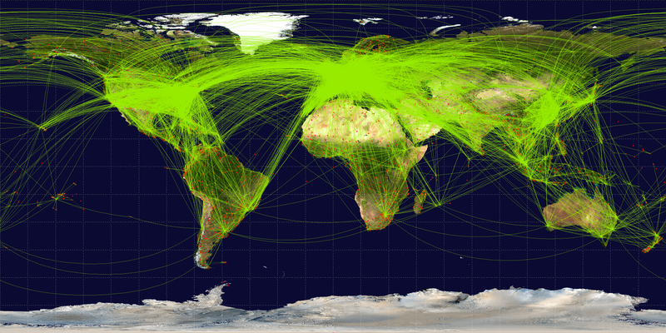
How might the airline traffic displayed above promote the diffusion of COVID-19?

Source 6- Tweets from the Centers for Disease Control (CDC) on “Social Distancing” and from the White House on Slowing the Spread, 3/16/20.
How do the above tweets attempted to impact the diffusion of COVID-19?

Source 7 - Level of Urbanization by Country, 2015
Wikimedia Commons, 2020. https://upload.wikimedia.org/wikipedia/commons/7/73/2015_World_Urbanization_Map.png.
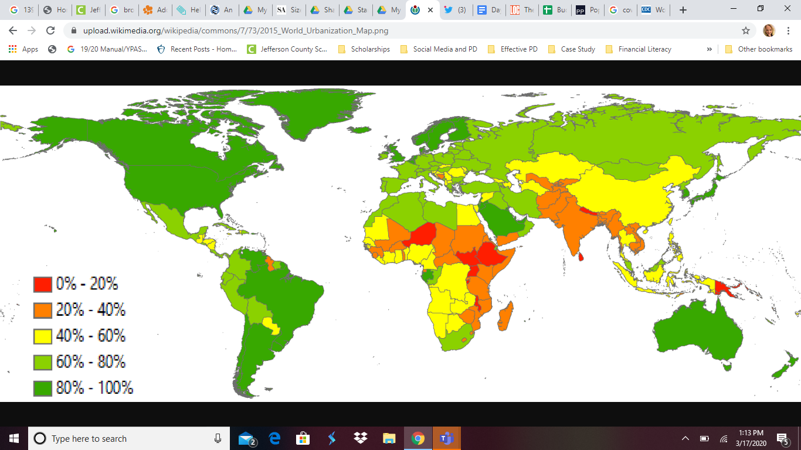
How might high levels of urbanization promote the diffusion of COVID-19?

Notice that China has overall a low level of urbanization despite being considered the hearth* of COVID-19. How might scale be useful in explaining this trend?

*hearth = where a phenomenon begins

ACTIVITY 1 -- SYNTHESIS STATEMENT
Based on the documents provided, and any additional information, explain in your own words how COVID-19 diffused.
*Write your answer here*

-When completed, please return to the KWL chart and add a bullet point or two to the L column of your chart

ACTIVITY 2 -- HANDOUT
TASK 1 -- Analyzing Population Pyramids
DIRECTIONS: As you analyze each pyramid, be sure to answer the question about the age composition of each pyramid and support your answer with evidence. After analyzing all population pyramids, answer this question:
“How does the population structure differ for five different countries (China, Iran, Italy, South Korea, and the United States) impacted by COVID-19 and why does it matter?”
Hint: When analyzing each pyramid note if it is more top heavy (which would indicate an aging population), bottom heavy (which would indicate a younger population), or evenly dispersed (which would indicate more middle aged).

Is this a young/middle-aged/aging population?
Explain.

Is this a young/middle-aged/aging population?
Explain.

Is this a young/middle-aged/aging population?
Explain.

Is this a young/middle-aged/aging population?
Explain.

Is this a young/middle-aged/aging population?
Explain.

TASK 2 -- Predicting and Identifying Population Structures
In the chart below, PREDICT the order of the pyramids using 1-5 in the second column.
(1 = the youngest population structure; 5 = oldest population structure)

After you have predicted, check your work! Using your favorite search engine, find the median age for each country (i.e. search for Iran “median age”). Enter the values found in the third column.

Country | PREDICTION (1 = young 5=oldest) | Median Age (search internet)
China
Iran
Italy
South Korea
United States

TASK 3 -- Interpreting Death Rate Data
Risk for COVID-19 Infection, Hospitalization, and Death by Age Group as of February 18, 2021
QUESTION: Based upon this information and what you learned regarding the population structure of each of the five focus countries, which country should be most concerned about the spread of the virus and why? | ANSWER:

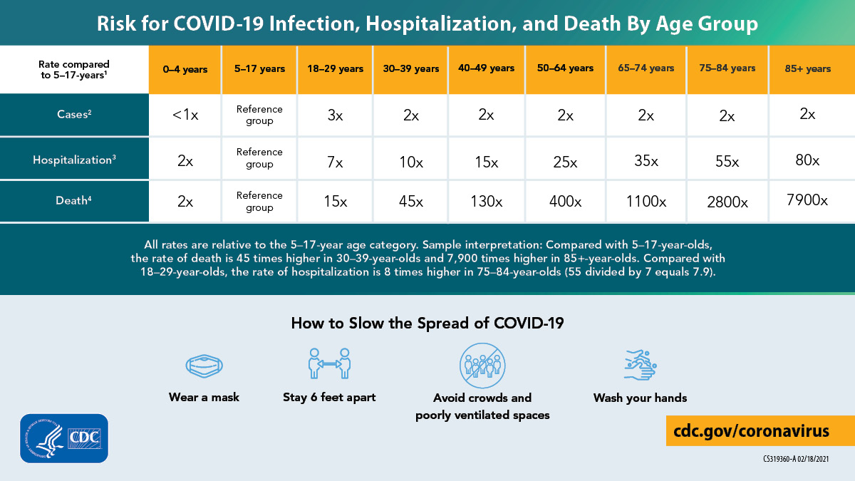
-When completed, please return to the KWL chart and add a bullet point or two to the L column

CHECK FOR UNDERSTANDING

Take a position!

How does the diffusion of information regarding COVID-19 impact diffusion of the virus?
Answer the question above, being sure to use evidence and clear reasoning to support your answer. There is not a single correct answer.
You should use information from this lesson as part of your answer.
Hint: A first step might be to consider how information diffuses. In what ways does information diffuse quickly or is hindered or is restricted in today’s world.

How does the diffusion of information regarding COVID-19 impact diffusion of the virus?

