Day 2--STUDENT HANDOUTS
Name: __________________________________________________________________

K-W-L CHART

K  What do you already know? | W  What do you want to know? | L  What have you learned?

SOURCES RELATED TO THE DIFFUSION OF COVID-19

RECORD YOUR ANSWERS: Use this Google Form to record your answers.

DIRECTIONS: As you view each source be sure to answer the questions underneath each source completely. At the conclusion you will be asked to tie each of these sources together to answer the question- “How did COVID-19 diffuse?”

Source 1 - Map of COVID-19 Cases
World Health Organization Cumulative Data, CDC , March 11, 2021, https://covid.cdc.gov/covid-data-tracker/#global-counts-rates.
What are the spatial patterns identifiable in the map above?

Why might there be large variations in the number of cases from March 2020 to March 2021?

Source 2 - Exponential vs Linear Growth Curves
UCSUSA, 2018, https://blog.ucsusa.org/doug-boucher/world-population-growth-exponential
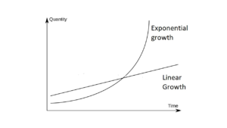
    - Exponential Growth - Growth that occurs with the doubling of a phenomena. Doubling time is the time it takes for a phenomena to double. In this case, doubling time refers to the amount of time for the number of cases to double.
    - Linear Growth - Growth that occurs with the same increase for each unit of time.
What is the difference between the two growth curves depicted above?

Source 3 - Graph of COVID-19 Cases in Europe vs United States
World O Meters, March 14. 2021, https://www.worldometers.info/coronavirus/worldwide-graphs/#europe-usa-cases
The graph above presents the cumulative number of COVID-19 cases in Europe and the United States since their initial 10,000 reported cases. Do the curves display exponential or linear growth? Explain your answer.

Source 4 - Flattening the Curve
Drew Harris, https://drive.google.com/file/d/1YGTUc_Cm-ky7JaQQWmuaxedof8WLTLcP/view
Given the information about Italy, why would there be movements to “flatten the curve?”

Source 5 - Map of Airline Connections
Wikimedia Commons, 2020. https://commons.wikimedia.org/wiki/File:World-airline-routemap-2009.png
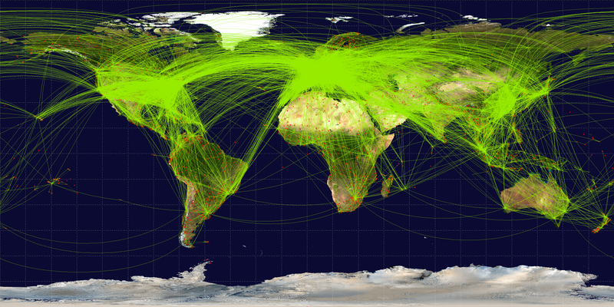
How might the airline traffic displayed above promote the diffusion of COVID-19?

Source 6- Tweets from the Centers for Disease Control (CDC) on “Social Distancing” and from the White House on Slowing the Spread, 3/16/20.
How do the above tweets attempt to affect the diffusion of COVID-19?

Source 7 - Level of Urbanization by Country, 2015
Wikimedia Commons, 2020. https://upload.wikimedia.org/wikipedia/commons/7/73/2015_World_Urbanization_Map.png.
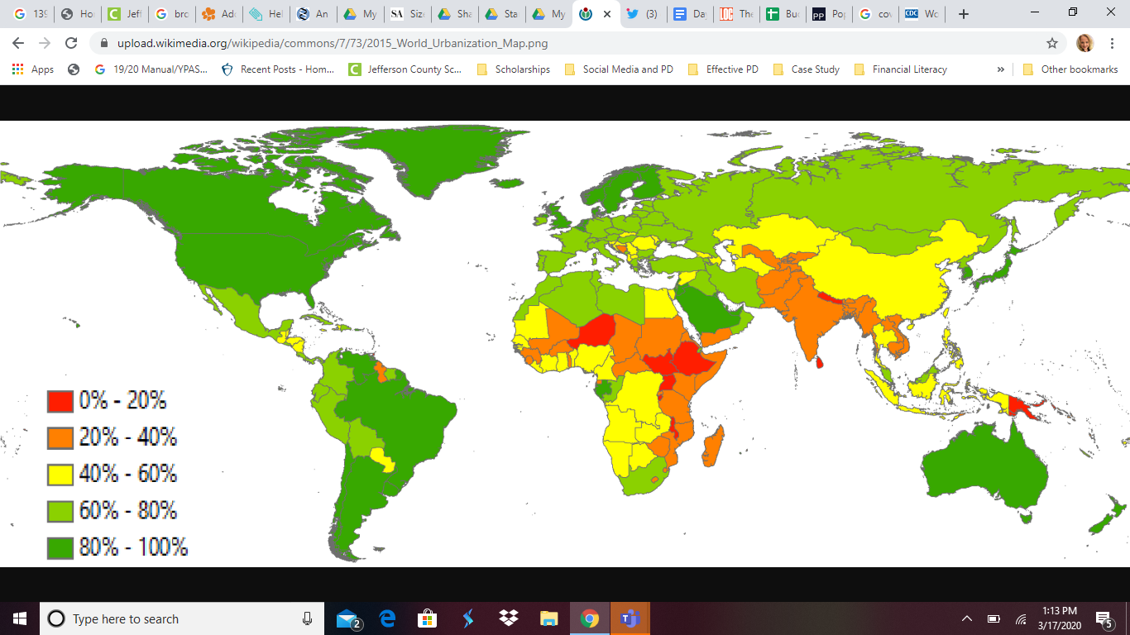
How might high levels of urbanization promote the diffusion of COVID-19?

Notice that China has overall a low level of urbanization despite being considered the hearth* of COVID-19. How might scale be useful in explaining this trend?

*hearth = where a phenomenon begins

SYNTHESIS STATEMENT
Based on the documents provided, and any additional information, explain in your own words how COVID-19 diffused.
*Write your answer here*

-When completed, please return to the KWL chart and add a bullet point or two to the L column of your chart

ANALYZING POPULATION PYRAMIDS
DIRECTIONS: As you analyze each pyramid, be sure to answer the question about the age composition of each pyramid and support your answer with evidence. After analyzing all population pyramids, answer this question:
“How does the population structure differ for five different countries (China, Iran, Italy, South Korea, and the United States) impacted by COVID-19 and why does it matter?”
Hint: When analyzing each pyramid note if it is more top heavy (which would indicate an aging population), bottom heavy (which would indicate a younger population), or evenly dispersed (which would indicate more middle aged).

Is this a young/middle-aged/aging population?
Explain.

Is this a young/middle-aged/aging population?
Explain.

Is this a young/middle-aged/aging population?
Explain.

Is this a young/middle-aged/aging population?
Explain.

Is this a young/middle-aged/aging population?
Explain.

PREDICT AND IDENTIFY POPULATION STRUCTURES
In the chart below, PREDICT the order of the pyramids using 1-5 in the second column.
(1 = the youngest population structure; 5 = oldest population structure)

After you have predicted, check your work! Using your favorite search engine, find the median age for each country (i.e. search for Iran “median age”). Enter the values found in the third column.

Country | PREDICTION (1 = young 5=oldest) | Median Age (search internet)
China
Iran
Italy
South Korea
United States

INTERPRET DEATH RATE DATA
The chart below shows the fatality rate by age for COVID-19 as of February 29, 2020.
QUESTION: Based upon this information and what you learned regarding the population structure of each of the five focus countries, which country should be most concerned about the spread of the virus and why? | ANSWER:

Source: WorldoMeter
-When completed, please return to the KWL chart and add a bullet point or two to the L column

CHECK FOR UNDERSTANDING

Take a position!

How does the diffusion of information regarding COVID-19 impact diffusion of the virus?
Answer the question above, being sure to use evidence and clear reasoning to support your answer. There is not a single correct answer.
You should use information from this lesson as part of your answer.
Hint: A first step might be to consider how information diffuses. In what ways does information diffuse quickly or is hindered or is restricted in today’s world.

How does the diffusion of information regarding COVID-19 impact diffusion of the virus?

